Hydrodynamic Cavitation: Unveiling the Phenomenon and its fundamentals
Ankit Kumar Deshmukhª, H K Rohitª, Avinash Chandra Gautam^{b}, Mukul Sainª, Anamika Singh^{c}
ªPhD scholar, Department of Dairy Engineering, ICAR-NDRI, Haryana, India
^{b}PhD scholar, Department of Dairy Technology, ICAR-NDRI, Haryana, India
^{c}PhD scholar, Department of Dairy Microbiology, CoDST, GADVASU, Punjab, India
- Introduction
The quest for novel and effective processing methods is never-ending in the ever-changing world of current food production. Researchers, engineers, and food scientists have all been drawn to the fascinating phenomena known as hydrodynamic cavitation. This phenomenon, which has its origins in the complex interactions between fluid dynamics, has shown that it has the power to completely transform a variety of processes in the food business, from enhanced mixing and emulsification to new methods of food preservation and waste reduction. When a liquid flows through a narrow passageway or experiences abrupt changes in flow velocity, a complex fluid dynamics phenomenon called hydrodynamic cavitation takes place. This causes vapor-filled cavities or bubbles to form in the liquid, which then violently collapse. Hydrodynamic cavitation, in contrast to other types of cavitation, is exclusively caused by the velocity of the fluid(Gogate & Pandit, 2004). Other types of cavitation frequently incorporate outside influences like mechanical vibrations or acoustic waves. Rapid hydrodynamic cavitation bubble collapse results in severe localised energy release that manifests as microjets, shockwaves and high temperatures. The potential implications of this energy on physical, chemical, and mechanical processes make hydrodynamic cavitation an important topic for research across many industries.
Hydrodynamic cavitation, a phenomena where rapid variations in fluid velocity result in the creation and implosive collapse of vapor-filled bubbles, has a history that is connected to the study of fluid dynamics itself. It is a fantastic example of how adaptable behaviour under challenging circumstances may have transformational results. When vapor-filled cavities form, expand, and suddenly, violently collapse within a liquid, shockwaves, microjets, and extremely high temperatures are created. These transitory and dynamic circumstances offer a fresh platform for manipulating molecules, starting reactions, and altering physical attributes. The importance of hydrodynamic cavitation is found in its capacity to produce strong mechanical and chemical effects within a liquid medium. Due to its potential to revolutionise traditional processes, increase efficiency, and open up new applications, this phenomenon has attracted the interest of researchers, engineers, and a variety of industries. The following are some significant details emphasising the importance of hydrodynamic cavitation:
Improved Mixing and Emulsification:
Processes for mixing and emulsifying substances can be significantly improved by hydrodynamic cavitation. Components that would be difficult to mix uniformly in the absence of turbulent flow patterns and microscale vortices are effectively mixed by the violent collapse of cavitation bubbles. For industries like food processing, where stable emulsions and consistent textures are essential for high-quality products, this capability has immediate implications.
Accelerated Reactions and Mass Transfer :
When cavitation bubbles burst, energy is released that can speed up mass transfer rates and start chemical reactions. This has uses in fields like chemical production and pharmaceuticals where quick reactions and higher yield are desired. This aspect may help the food industry extract flavours, colours, and bioactive substances from natural sources more effectively.
Sustainable Processing :
Hydrodynamic cavitation offers a more environmentally friendly substitute for conventional processing methods that might involve using chemical additives or high temperatures. The localised energy produced by cavitation can improve processing without the use of excessive heat or additives, promoting more environmentally friendly and long-lasting procedures.
Food Preservation and Waste Reduction :
Hydrodynamic cavitation has mechanical and acoustic impacts that can harm the cellular structures of microorganisms, rendering them inactive. This reduces the need for thermal treatments and chemical preservatives, making it a promising method for food preservation. Hydrodynamic cavitation can also be used to turn food byproducts and waste into useful resources, addressing sustainability and waste management issues.
Novel Product Development :
Hydrodynamic cavitation's particular conditions can lead to the development of novel food products with improved textures, flavours, and nutritional profiles. Food technologists can achieve unheard-of results that satisfy changing consumer preferences by meticulously controlling cavitation parameters.
In essence, hydrodynamic cavitation is a revolutionary method of manufacturing and processing. It is a flexible tool with applications in a wide range of industries because of its capacity to harness strong energy within a liquid medium without using strong external forces or high temperatures. The potential of hydrodynamic cavitation to transform industries like food processing becomes even more exciting and promising as researchers work to better understand the mechanisms and optimise the process parameters.
- Cavitation
Cavitation is a physical phenomena that takes place over a brief period of time, usually on the scale of milliseconds, and is characterised by the development, expansion, and collapse of cavities filled with vapour or gas. When the local liquid pressure reaches the saturation pressure at a specific temperature, the transition from the liquid phase to the vapour phase takes place. The mechanical and acoustic impacts of hydrodynamic cavitation can harm the cellular structures of microorganisms, inactivating them (Badve et al., 2013). Cavitation was first perceived as a detrimental phenomenon because to its adverse effects on equipment, such as equipment corrosion, heightened noise and vibration levels, and substantial damage to surfaces such as pipelines, pumps, valves, and marine propellers (Cvetković et al., 2015). By implementing appropriate measures, these limitations can be mitigated or reduced. Through the use of enhanced pipeline or cavitation device designs and sound insulation materials, it is possible to reduce the vibration and noise produced during the cavitation process. Furthermore, as stated by Simpson and Ranade (2018), the utilization of swirl has the potential to redirect the zone of cavitation away from solid surfaces and towards the axis of the device. This has the advantageous effect of reducing or even eliminating the possibility of surface erosion. Hence, the incorporation of a swirling component into the process through venturi or orifice type devices could potentially serve as a viable approach to mitigate the aforementioned limitations. In addition to the aforementioned methodologies, The effects of various grooved suction-side surfaces on a Venturi section were investigated in a study by Danlos et al. (2014). The objective was to assess their potential in mitigating sheet cavity instability, with the aim of reducing erosion and/or noise. The findings of the study demonstrated the feasibility of this approach.
In general, Cavitation is a phenomena characterized by the rapid production, expansion, and eventual implosion of small bubbles or voids, occurring within a brief temporal scale of milliseconds. This process releases a significant amount of energy. Local consequences of cavitation events can be characterized by the creation of exceedingly high temperatures (ranging from approximately 1000 to 5000 K) and pressures (ranging from approximately 100 to 5000 bar). The hydrodynamic and geometric characteristics of the reactor's operation have a substantial influence on the levels of pressures and temperatures. Hence, the ensuing results are indeed remarkable, and analogous phenomena occur concurrently at numerous sites within the reactor. This method includes the addition of discrete energy input, and although while the overall energy input is the same, the energy lost per unit volume (in the form of pockets) is substantially higher by many orders of magnitude than in traditional methods. The phenomenon of energy concentration occurs inside highly localized regions, which are abundant in number (Adewuyi, 2001; Gogate and Pandit, 2001).
Cavitation-based methodologies, such as a mechanically agitated contactor, hold the potential to serve as a more energy-efficient alternative to traditional reactors. By increasing the impeller's diameter or, alternatively, speeding up rotation to increase the exchange rates between the reactor's active and passive zones, one can improve the active zone of a conventional stirred reactor. Unfortunately, both methods significantly increase global energy use. The power consumption in stirred reactors shows a direct relation to N³ d⁵, where N stands for rotational speed and d for impeller diameter. In contrast, cavitation has the ability to simultaneously enhance transport mechanisms and augment the intrinsic rate of chemical reactions with significantly reduced energy inputs. This is achieved by the generation of localized regions characterized by exceedingly high temperatures and pressures.
- Classification of Cavitation
Based on the exact method by which it is produced, cavitation is frequently divided into four major groups. According to Mancuso et al. (2016), there are four distinct categories of cavitation, including optic cavitation (OC), hydrodynamic cavitation (HC), particle cavitation (PC), and acoustic cavitation (AC).
3.1 Acoustic cavitation: It is a phenomena wherein the application of acoustic waves causes tiny gas-filled bubbles to develop, expand, and eventually burst in a liquid media. In this method, sound waves with a frequency range of 16 KHz to 100 MHz, also known as ultrasound, are used to change the liquid's pressure. The word "sonochemistry" refers to the chemical modifications induced by the phenomenon of cavitation resulting from the propagation of sound waves. Acoustic cavitation is a phenomenon brought on by the application of high-intensity ultrasonic radiation with frequencies ranging from tens of kilohertz to tens of megahertz. The expansion that occurs repeatedly when ultrasonic pulses are applied to liquids. The mechanical vibration of liquids can be induced by the alternating phases of compression and rarefaction. Expansion cycles generate negative pressure, causing the separation of molecules. Compression cycles, conversely, generate a state of positive pressure and exert force in a certain direction (Vajnhandl & Majcen Le Marechal, 2005). The aggregation of molecules. The occurrence of vapor-filled cavities that develop and then collapse is known as cavitation. As they expand until they reach a certain size, nuclei have the ability to efficiently store ultrasonic energy. Particles of this kind frequently have diameters on the range of tens of microns, according to Bang and Suslick (2010). Cavitation is a phenomena that happens when a bubble expands to a critical size, experiences a significant radial displacement, reaches its maximum size, and then rapidly collapses. The application of low-frequency and high-intensity ultrasound has been observed to induce enhancements in reaction speeds and yields in liquid-phase processes, mostly attributed to its ability to modify the state of the medium.
3.2 Hydrodynamic cavitation: it is a phenomenon that arises from alterations in pressure resulting from modifications in velocity induced by the system's geometry. One example of how the transfer of pressure and kinetic energy might occur is through the utilization of flow through orifices, venturi tubes, and other similar components, which rely on the specific geometry of the system.
3.3 Optic Cavitation: The high intensity photons (specifically laser photons) disrupt the liquid continuum, resulting in the occurrence of optic cavitation. The technique employed by OC involves the utilization of a pulsed laser's light to generate a solitary cavitation bubble within liquid substances (Tomita & Shima, 1986). The aforementioned process can lead to the formation of highly concentrated plasmas consisting of free electrons, which subsequently undergo explosive vaporization and mechanical expansion. The transfer of this particular form of energy to the atomic system occurs through processes of recombination and collision subsequent to optical breakdown. The application of increased pressures can lead to the generation of shock waves, which in turn can cause the formation of bubbles due to the surpassing of the spinodal limit, even at temperatures below the critical point of water (Tinne et al., 2014). Optical cavitation (OC) possesses the capability to generate localized bubbles within liquids with high precision, facilitating controlled investigations into the behavior of these bubbles, their collapse dynamics, and the emission of shock waves.
3.4 Particle cavitation: Cavitation happens when an elementary particle beam, such as a proton, strikes a liquid, such as in a bubble chamber, causing a rupture. When an elementary particle, such a proton, ruptures a liquid inside of a bubble chamber, particle cavitation (PC) is created. A superheated liquid's production of bubbles is what causes this phenomena. A short-lived ionisation trail is created when a charged particle moves through a liquid medium. The energy released causes an immediate local warming to occur. The liquid may expand as a result of warming, in which case a line of tiny bubbles may appear later. Electron microscopy has been used to record the phenomena of cavitation in rubber particles inside reinforced versions of nylon, polycarbonate, polystyrene, PVC, urethane-methacrylate resins and epoxy. This observation holds true for both thermoplastic and thermosetting materials, as reported by Bucknall et al. in 1994. The significance of personal computers in enhancing resilience is generally recognized.
In order to generate intensities that are enough for physical and chemical applications, it is commonly observed that OC and PC exhibit limitations and are mostly employed for cavitation involving a single bubble. Academic research has focused a lot of emphasis on the two types of cavitation, AC and HC, particularly in the area of wastewater treatment. Acoustic cavitation (AC) is a phenomena that occurs when sound waves, notably those with ultrasound (16 kHz–100 MHz) frequency range, cause changes in liquid pressure. Many different fields, including chemical synthesis, biotechnology, waste stream treatment, polymer degradation, and the petrochemical sector, have made extensive use of the AC or sono-chemical processes (Wang et al., 2021). The active cavitation zone is constrained to the area around the transducers, making its extension difficult and creating difficulties for amplification. Nevertheless, the ultrasonic cavitation process consumes a greater amount of energy. HC technology has several advantages compared to AC technology. Firstly, HC technology has the capability to function on a wide scale, allowing for efficient and effective implementation in various applications. Secondly, HC technology exhibits increased energy efficiency, resulting in reduced energy consumption and lower operational costs. Lastly, HC technology is characterized by its straightforward equipment, which simplifies installation and maintenance processes (Barik & Gogate, 2018). The energy efficiency of the ultrasonic cavitation disinfection process and the DYNAJETS®, a jet nozzle HC reactor used in their study, were compared by Loraine et al. The findings showed that DYNAJETS® outperformed ultrasonic disinfection techniques in terms of power efficiency by a factor of 10 to 100. In their study, Senthilkumar et al. (2000) employed a 50 L HC setup and utilized two orifice plates to investigate the breakdown reaction of potassium iodide (KI) aqueous solution. This reaction is recognized as a representative example of an ultrasound-induced reaction. The study conducted by B. Wang et al. (2021) in the Chemical Engineering Journal 412 revealed that the amount of iodine released by HC was found to be three times greater than that released by AC, under the condition of equivalent energy input, as reported by Senthil Kumar et al. (2000). In various industrial applications, notably in the treatment of industrial effluent containing refractory substances like, antibiotics, pesticides and colours, hydrodynamic cavitation (HC) provides a possible route for process intensification.
Two main processes are responsible for the breakdown of organic compounds in wastewater: (1) the interaction of free radicals within the cavitation bubble, at the bubble's boundary with its surroundings, and throughout the entire solution; and (2) the occurrence of pyrolysis either inside the bubble or in its immediate vicinity. The dominant mechanism can be determined by analyzing the properties of the chemical, as well as the pattern and severity of cavitation (Rajoriya et al., 2017). In some circumstances, the strength of the shockwaves created by the collapsing cavity can also assist in the breaking of molecular bonds, namely those present in complex, high-molecular-weight compounds. The process of oxidation/mineralization of contaminants is expedited by the breakdown of intermediates.

- Hydrodynamic Cavitation and its Fundamentals
When a fluid flow hits constrictive or irregular geometries, such as holes or sharp edges, the compression phenomena takes place. Due to the acceleration of velocity and the ensuing pressure oscillations in the flow, this causes a drop in static pressure since the pressure is turned into kinetic energy (Wilcox, 2006). separation as a notion. According to Yan and Thorpe (1990), cavitation happens when the static pressure falls below the regional saturated vapour pressure. Sheet cavitation is a phenomenon that occurs in liquids when there are negative pressure gradients, typically resulting from boundary layer separation or wall-flow reversal on a solid surface. There is a potential for cavity oscillation, instability, heightened cavitation intensity, and increased cloud shedding. The performance of valves, pumps, propellers, and hydrofoils can be adversely affected by the recurring phenomenon known as sheet to cloud cavitation. The phenomenon known as super-cavitation refers to the occurrence of cavitation that extends beyond the item undergoing cavitation and travels in conjunction with the wake (Crowe et al., 2006). Additionally, the creation of cavities in a swirling pattern caused by the rotation of fast-moving particles can cause the phenomena of vortex cavitation.
The phenomenon of hydraulic cavitation can be elucidated by employing the Bernoulli theorem.The Bernoulli equation states that liquid pressure and kinetic energy have an inverse relationship, with the former decreasing as the latter increases. When the localised pressure falls to the cavitation threshold pressure, which is often less than the saturated vapour pressure associated with the current temperature, cavities begin to form and grow. According to Sežun et al. (2019), the size of the cavitation bubbles created varies depending on the current flow conditions between a few nanometers and a few millimetres. When the pressure equals or surpasses the vapour pressure, cavities collapse. As seen in Figure 1, this process causes the production of micro-jets, which in turn cause turbulence downstream of the constriction. Turbulence intensity is influenced by the geometric characteristics of structures and the flow conditions of the liquid.
The volume of cavities created and the force of the turbulence both influence how intense the cavitation is in HC. The term "hydrodynamic cavitation" refers to a phenomena that is defined by a dimensionless number known as the cavitation number (Cv). It may be found in the following Eq. (1):
$C_{v}=\frac{P_{1}-P_{2}}{\frac{1}{2}{ρv}_{0}^{2}}$ 1
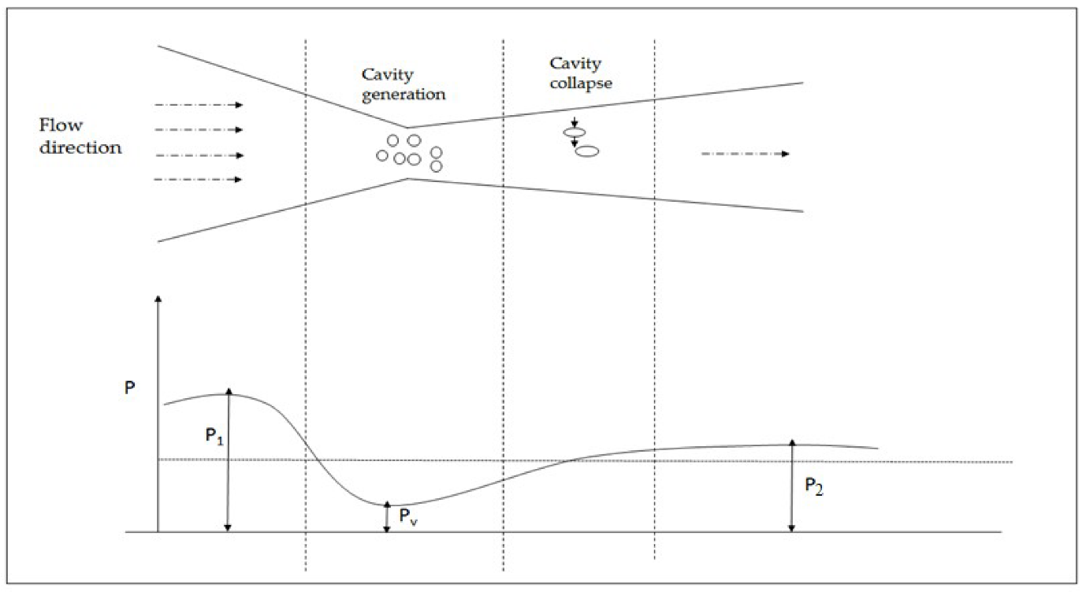
Figure 1: Hydrodynamic cavitation (HC) reactor's various cavitational events at various stages with a pressure profile: adapted from (Thanekar & Gogate, 2018)
where $ρ$is the density of the liquid, v0 is the device's throat velocity, and Pv is the liquid's vapour pressure. P2 is the downstream pressure after complete recovery. For all traditional cavitation devices, including orifice or venturi devices, Cv drops with an increase in operating intake pressure because the velocity at the cavitating device's throat (v0) increases with the operating inlet pressure. The Cv at which cavitation starts to happen is known as the cavitation inception number, or Cvi. According to research, cavitation normally begins at Cvi = l under ideal conditions, and there are observable cavitational consequences at Cv = 1. However, because there are typically minor quantities of dissolved gases and suspended particles, cavities can commonly be produced at Cv values exceeding 1. In order to initiate cavitation, dissolved gases and suspended particles produce the necessary nuclei. (Simpson & Ranade, 2018). The shape of the flow and the size or dimension of the constriction are other factors that have an impact on the value of Cvi. Yan and Thorpe claim that while the cavitation inception number does not vary for a certain orifice with the liquid velocity, the Cvi grows almost linearly with the diameter ratio. The lower the Cv value, normally, the higher the cavitation intensity is because the frequency of cavitation events and the created cavities rise at a smaller Cv despite the intensities of cavity collapse dropping. However, when the Cv drops below a specific point, choked cavitation, also known as super-cavitation, will occur. Because there are more cavities in this situation, they begin to coalesce with one another and form a cavity cloud, which will lower the collapse pressures (Yan & Thorpe, 1990). According to Sezun et al., there are three general categories into which HC may be divided: attached cavitation, developed or cloud shedding cavitation, and super-cavitation. A considerable number of vapour bubbles are affixed to the surface of the constriction and have assumed the shape of an attached cloud, according to the attached cavitation phenomena. Additionally, as the flow velocity or static pressure in the system increases, the previously connected cavitation cloud becomes unstable and starts to shed off the core cavitation structure, either fully or partially. The developed or cloud shedding cavitation stage is at that point. Super-cavitation happens when the flow velocity is increased further or the system pressure is decreased (Sežun et al., 2019). Developed shedding cavitation is more aggressive than attached cavitation and super-cavitation. At various cavitational phases, the flow state will alter. Depending on the degree of cavitation, many flow regimes may occur in the flowing system. During the early phases of cavitation, the single liquid phase first appears as a two-phase foamy medium in the cavitation zone. The flow then transforms from a two-phase bubbly flow to a two-phase annular jet flow, in which the annular vapour cloud surrounds the liquid core at the centre, during the stage of choked cavitation. When choked cavitation develops, more energy and active radicals cannot be created. The critical Cv is the Cv at which choked cavitation begins. . When utilising HC for wastewater treatment, the cavitation condition should be midway between cavitation initiation and choked cavitation. There is normally an ideal Cv between Cvi and critical Cv. Whether by numerical modelling or experiment, it is essential to identify the appropriate Cv for a certain reactor in order to provide the maximum cavitational effect. Cv values between 0.1 and 0.2 are said to offer improved deterioration efficiency (Saharan et al., 2011., Rajoriya et al., 2017). The cavitational circumstances were also described using Vichare et al.'s cavitation number (Cv'), as indicated in equation. (2).
Cv' = $\frac{C_{v}}{\frac{Total peimeter of holes}{Perimeter of pipe}}$ 2
Total hole perimeter Pipe circumference, the definition of Cv' is useful since it took into consideration how the flow geometry impacts cavitation when assessing the impact of the hole perimeter or hole number. The definitions of Cv and Cv' help researchers assess and partially explain the events and results of the HC process. However, it is necessary to realise that there are certain viewpoints that claim the cavitation number is not a good predictor of the beginning or severity of cavitation.
- Reactors of Hydrodynamic Cavitation
Moreover, these devices exhibit a high level of user-friendliness, as they are designed to be uncomplicated and require less maintenance. However, it is important to remember that cavitation is more likely to occur close to solid walls, making orifice- or venturi-based systems vulnerable to problems like clogging and erosion (Šarc et al., 2017). The limitations of rotating type devices in generating intense cavitation conditions and inducing impactful effects in various industries stem from the significant operating and maintenance expenses required to achieve high pressure and speed.
In comparison to the venturi and orifice, the ability to regulate cavitational intensity is far more limited. As a result, a lot of researchers are working to improve rotating type HC devices' functioning right now. By using vortex-based hydrodynamic cavitation (HC) reactors, cavitation is produced within of vortex flow patterns. Vortex-induced hydrodynamic cavitation reactors produce cavitation when there is vortex flow. Contrary to rotational HC reactors that depend on stators and rotors, vortex-based HC reactors may create a vortex without the aid of any mechanical parts. These reactors are the subject of the discussion in this context. Vortex-type hydrodynamic cavitation (HC) devices have garnered significant attention in recent times for their potential use in water treatment and disinfection.
.

5.1 Venturi based HC reactor
Venturi typically consists of three main components: a divergent part, a throat, and a converging section. Given a particular pressure drop across it, the smooth converging and diverging parts of the Venturi are intended to guarantee the creation of a quicker velocity at the throat. Additionally, the venturi achieves a lower Cv compared to the orifice under the same conditions. Due to the existence of smooth diverging parts, the cavities have the capacity to stay inside the low-pressure area for an extended period of time, allowing them to expand to their maximum dimensions before collapsing.
The venturi orifice type HC reactor, which is frequently used in research investigations, is schematically depicted in Figure 2. A pump, a holding tank, two pressure gauges, a rotameter, control valves, and the HC device make up the closed-circuit device. The tank is fitted with a cooling jacket or cooling coil to maintain the temperature of the liquid in motion. By changing the control valve, the flow of the main circuit may be controlled. The fluid's input pressure may be controlled by varying the flow rate. The pressure at the reactor's inlet and outlet is measured, respectively, using two pressure gauges. The hydraulic parameters of the reactors can be examined by utilizing a rotameter to measure the fluid flow via the mainline.
.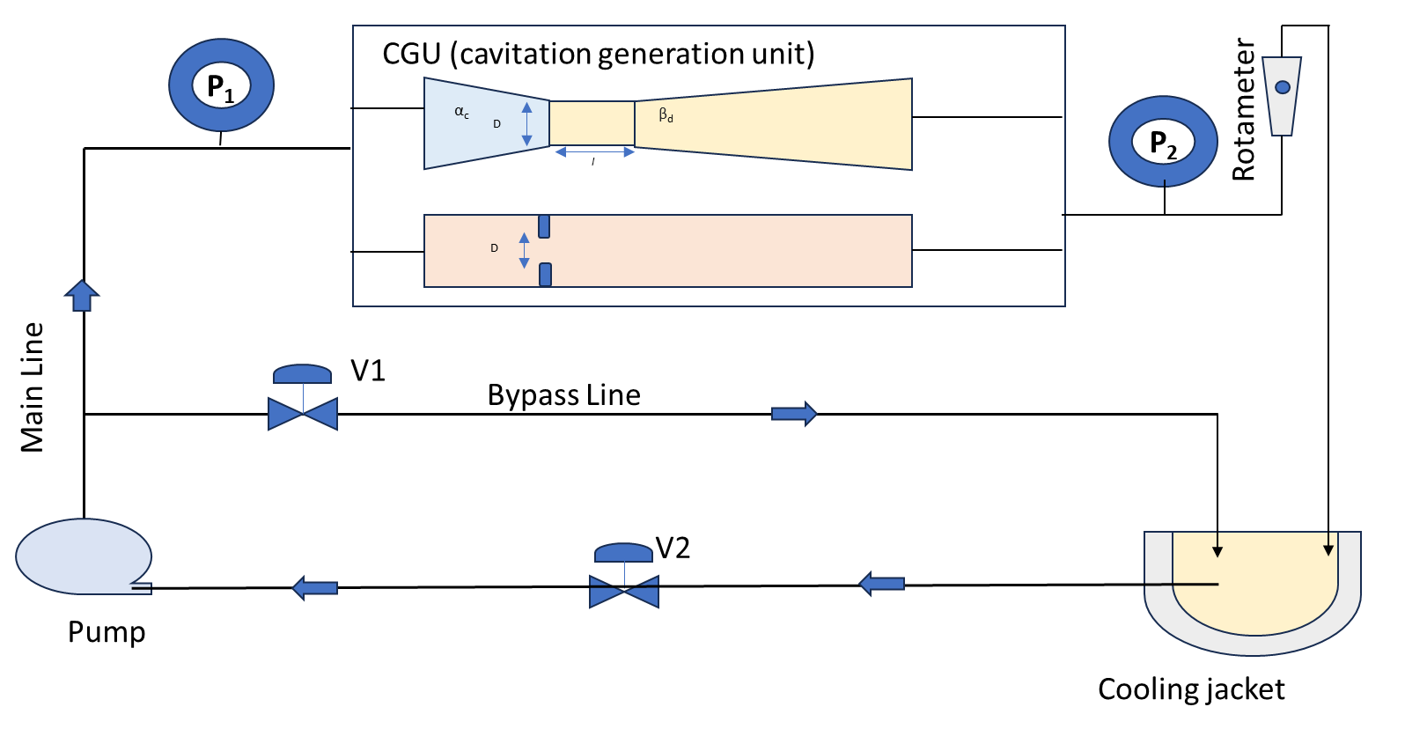
Figure 2: The HC reactor with an orifice and venturi. D is the venturi tube or orifice plate's throat diameter, α_{c} is the half convergence angle, β_{c} is the half divergence angle, and l is the throat length.: adapted from(Wang et al., 2021).
Based on its geometric characteristics, the venturi may be divided into three different types: circular venturi, elliptical venturi, and slit venturi. Circular and slit venturi are the venturi forms that have been the subject of the most extensive investigation. The Venturi effect's geometrical factors have a big impact on when cavitation happens. It is crucial to optimise the venturi's operational and geometrical features in order to get the required degree of cavitational intensity. The influence of the divergence angle, the ratio of the throat's diameter to its length (or, in the case of a slit venturi, the ratio of the slit height to its length), and the ratio of the throat's perimeter to its open area (α) have all been taken into account in a number of academic studies that looked at the optimisation of the geometrical parameters of the venturi.
5.1.1 Throat's diameter/height to length ratio's effect:
The ratio between the throat's diameter or height and length can help determine the cavity's maximum size before it collapses. Depending on how long the neck is, the cavities can stay in the low-pressure zone for a certain amount of time. With an emphasis on the throat height/diameter to length ratios of 1:1, 1:2, and 1:3, Kuldeep and Kumar performed research to evaluate the cavitation efficiency of numerous HC reactors. The results in the research show that, among the three ratios examined, the venturi demonstrates an ideal ratio of 1:1. According to this specific example, it is thought that this parameter has a negligible effect on the quantity of cavities and the pace of their expansion (Kuldeep & Saharan, 2016). On the other hand, because there are fewer cavities naturally present in the orifice plate than in the venturi, the influence of throat length on cavitation behaviour is more obvious in the case of orifice type hydrocarbon (HC) reactors. The production of additional cavities inside the area of lower pressure is correlated with an increase in neck length. According to research, greater ratios of width to height (W/H) and length to height (L/H) have a beneficial effect on the enhancement of cavitation volume. It should be emphasised, too, that the effect of L/H on cavitation volume enhancement is relatively less significant. The expansion of the neck and solid surface is caused by an increase in the width-to-height ratio (W/H), claim Abbasi et al. (2020). As a result, this expansion causes the number of bubbles to grow as well as the shear area to expand.
5.1.2 Divergence angle’s effect:
The production and dynamic behavior of cavities in the venturi are principally determined by the dimensions and geometry of the throat and convergent section. The amount of cavities created and the force at which they collapse determine the overall impact of cavitation (Kumar & Pandit, 1999). Moreover, the morphology of the diverging segment influences the upper limit of the cavities' dimensions that can develop, as well as their temporal persistence. The diverging section's structural design efficiently reduces the likelihood of premature cavity collapse. The pressure recovery rate of venturi type HC devices is significantly influenced by the divergence angle. Rajoriya et al. (2016) found that whereas a lower divergence angle promotes smooth pressure recovery and easy cavity formation, a bigger divergence angle causes a quick collapse of the cavity. In general, when the divergence angle grows, the rate of pressure recovery also rises..
Kuldeep and Kumar ran simulations with three different half-divergence angles: 5.5°, 6.5°, and 7.5°, in an effort to maximise the rate of pressure recovery. When the half divergence angle was adjusted at 6.5°, as opposed to the other half of the mentioned divergence angle, the ideal cavitation yield was found to be possible.. The cavities experienced sudden collapse as a result of the significant divergence angle. If the divergence angle had been reduced, it is expected that the pressure recovery would have exhibited a more gradual transition, allowing the cavities to reach their maximum size prior to rupture. Consequently, this would result in higher levels of cavitational intensities (Kuldeep & Saharan, 2016).
5.2 Orifice type HC reactor
Extensive research has been conducted on the orifice plate owing to its superior efficiency in generating extreme cavitation conditions compared to other hydraulic control devices. The orifice plate is a simple and straightforward design option since it may accommodate more holes within a given cross-sectional area of the pipe. Cavitation is a fleeting phenomena brought on by the rapid constriction and subsequent expansion of an orifice, as opposed to the venturi, which has gradually converging and diverging parts. Additionally, the pipeline's fast expansion causes an instant pressure recovery, which causes the hollow to collapse quickly and violently. When boundary layer separation occurs during the flow of liquid through a constriction, a significant amount of energy is lost, which causes a persistent drop in pressure. Consequently, a pronounced fluid turbulence characterized by exceptionally high intensity emerges in the downstream region of the constriction. The amount of the pressure drop has an effect on the strength of the flow, and the degree of turbulence or the geometry of the constriction determines both of these factors (Adnaevic et al., 2019). The geometric properties of the orifice plate, including elements like the number of holes, the size of the holes, and the geometry of the orifice, can be changed to obtain a higher intensity of cavitation or cavitational yield.
The amount of the pressure drop has an effect on the strength of the flow, and the degree of turbulence or the geometry of the constriction determines both of these factors (Adnaevic et al., 2019). The geometric properties of the orifice plate, including elements like the number of holes, the size of the holes, and the geometry of the orifice, can be changed to obtain a higher intensity of cavitation or cavitational yield. Studies on the cavitational impact of the orifice plate frequently focus primarily on one or more of the following factors: There are two crucial variables that matter in this situation. The initial parameter, represented as α, is the ratio of the total perimeter to the total flow area. The ratio of the pipe's throat to its cross-sectional area is represented by the second parameter, denoted by the symbol β.
5.2.1 Total perimeter to total flow area (α) ratio’s effect
The ratio between the aggregate perimeter of the orifice and the entire flow area is used to quantify the impact of the orifice plate form. The overall perimeter of the orifice and the total area accessible for fluid flow are two crucial elements that affect the design of orifice-type hydraulic control devices. The whole circumference of the hole determines the shear layer's area. The influence of the turbulence within the shear layer and its spatial extent on the cavitational yield has been observed. The phenomenon of cavitation is enabled by the enlargement of the collective boundary of the cavities (Song et al., 2019). The overall flow area, which also affects the number of passes the fluid makes through the orifice during a certain operational duration, determines the fluid flow rate. The overall perimeter and the total flow area are both influenced by the quantity and size of the holes.
The parameter's definition serves to quantify the influence of the geometry of HC devices on cavitation behavior, hence enhancing comprehension of the analysis pertaining to the impact of geometry parameters on cavitational yield. The size, quantity, and shape of holes in the orifice plate are the determining factors. To enhance the efficiency of extracting internal lipids from wet microalgae, Lee et al. conducted optimization of the HC devices. This optimization involved the utilization of 12 distinct orifice plates, which were selected according on specific criteria and values. In addition, Lee et al. (2011) conducted a correlation study on a number of factors, such as flux, flow rate at the orifice plate, Cv, and rotations per minute. It is noteworthy to observe that the optimal lipid yield is not achieved by either the highest magnitude or the lowest count of cavitations. The researchers provided an explanation for the observed phenomenon, attributing it to the surge pressure resulting from variations in flow rate within the HC reactor. Additionally, they noticed that raising the steam proportion and the quantity of fluid rotations improved the effectiveness of oil extraction while simultaneously lowering the magnitude of pressure fluctuations. Consequently, it is likely that an ideal value for evaluating the many effects on a particular process might exist.
5.2.2 Total flow area to the cross-sectional area of the pipe (β) ratio’s effect
The ratio of the total flow area or the area of the hole opening to the pipe cross-sectional area is represented by another measure called as. It may be altered by changing the diameter and number of perforations in the plates. The parameter specifies the effective area of the orifice while the pipe's diameter stays constant. As a result, variations in cause changes in the flow rate through the orifice and the number of rotations. The parameter is frequently connected to the turbulence intensity, which affects how long the bubble persists. An alternative to the parameter is the parameter ', which denotes the value of the orifice to pipe diameter ratio. While maintaining a fixed pipe size, Moholkar and Pandit investigated the behaviour of bubbles for two different values of '. The findings showed that and the degree of turbulence intensity are inversely related. The permanent head loss equals to 73% of the pressure differential across the orifice when the ratio of the orifice diameter to pipe diameter is 0.5. The permanent head loss corresponds to 60% of the pressure differential across the orifice when the ratio is 0.75. The permanent head loss decreases in direct proportion to the ratio rise. Additionally, it can be shown that greater values of'cause bubbles to last longer and that this is followed by a decrease in turbulence severity. In the presence of turbulence, cavitation occurs immediately, claim Moholkar and Pandit (1997). Additionally, when turbulence increases, the violent collapse of cavities results in the creation of pressure pulses of large amplitude. It has been discovered that when comparing plates with holes of the same dimension, plates with more holes show less cavitational activity. Additionally, the concentration of cavitation bubbles into larger holes has the potential to decrease the cavitational yield.
5.3 Rotational type HCRs
In elementary rotating HCRs (ERHCRs), such as an HSH or mixer, cavitation is caused by a zone that is swept by high-speed impellers or other sharp blades. The fluid is propelled by the rotors, and as it accelerates, the static pressure decreases due to viscosity. Mechanical impact and shear force are the only treatment effects that take place before the rotor reaches the crucial rotational speed. Both HSHs and mixers are commercially available and easy to operate. Instead of employing impellers to create cavitation, Advanced Rotational HCR (ARHCRs) (Figure 3) commonly use a circular disc or cylinder with several dimples or gaps (cavitation generating units, CGUs) operated by a high-speed motor. Eq. 3 can be used to describe the fluid behaviour in ARHCRs, where r and are the rotor's radius and rotational speed, respectively.
$\frac{V_{1}^{2}}{2g}+\frac{p_{1}}{ρg}=\frac{\sqrt{V_{1}^{2}+ωr^{2}}}{2g}+\frac{P_{2}}{ρg}+H_{cavitation}+H_{friction}+H_{minor}+H_{viscosity}$ 3
The flow regions within Axial-Flow Rotating Hydrodynamic Cavitation Reactors (ARHCRs) that remain undisturbed by the rotor are identified as subscripts 1 and 2. Initially, the fluid is pumped into the undisturbed area of these devices with an axial velocity of v1. As the fluid enters the disturbed region, it is propelled by the rotor with a linear velocity of wr due to viscosity effects. Based on the velocity triangle, the actual flow velocity and direction can be calculated as as $\sqrt{V_{1}^{2}+ωr^{2}}$ and $θ=arctan\frac{ωr}{v}$ (considering the radial flow direction). Subsequently, the incoming flow divides into two streams. One portion impacts the back edge of the CGU, leading to a separation region with low pressure (Badve et al., 2013). The other portion enters the CGU, generating an internal vortex. Cavitation can occur in both the separation region and the vortex center. ARHCRs are categorized into batch and continuous types based on their operational mode. Older devices, commonly used in laboratory-scale mechanism research, employ switch valves at the inlet and outlet to trap fluids within the reactor's internal chamber for a specified duration to achieve desired results. Continuous-type ARHCRs, featuring scaled-up dimensions, offer significantly higher cavitation intensities and treatment capabilities compared to batch-type ARHCRs, which have limited treatment capacity (Chipurici et al., 2019). The treated fluids can be directly delivered to the subsequent process, referred to as non-circulation treatment, or they can be stored in a tank connected to the HC system, known as circulation treatment.

The geometry and arrangement of the CGUs in particular, which make up the ARHCR structure, is crucial for disinfection as well as other applications. So far, on the effects of geometrical factors, no research has been done. Using ARHCRs achieve significantly better performance than NRCHRs without any structure. They have a great potential for optimisation, as shown by this(Sun & Yoon, 2018). By taking into consideration exterior factors, ARHCRs' geometrical structure may be improved and studied internally using the computational fluid dynamics (CFD) approach. Given the difficulty in capturing good spatial and temporal CFD methods to ARHCRs, cavitation fluctuations There is currently no way to exactly characterise the flow characteristics..
A significant portion of the structure of ARHCRs, including the shape and positioning of CGUs, is required for disinfection and other applications. Geometrical effects have not yet been the subject of any studies. Without any structure optimisation, ARHCRs outperform NRCHRs in terms of performance, showing how highly optimised they are (Sun & Yoon, 2018). For investigating the internal and exterior properties of ARHCRs and further improving their geometrical structure, the computational fluid dynamics (CFD) approach can be a practical and economical instrument. Because it is so challenging to capture both the spatial and temporal fluctuations of cavitation, effective CFD techniques to ARHCRs have not yet been devised. Furthermore, cavitation and water contaminants may seriously harm the structures through erosion (Zhang et al., 2017), making it crucial to extensively examine the corresponding damage processes and the resilience of ARHCRs.
5.4 HCRs based on vortex
Two popular types of vortex-based hydrodynamic cavitation reactors are the vortex diode and the swirling jet cavitation reactor. They produce a vortex flow without the need for any moving parts. The cylindrical whirling cavitation chamber is the location where the phenomenon of cavitation is generated. The generation of a swirling jet occurs as a result of the circular circulation of water within the cavitation chamber. A central pressure that is lower than the water vapour pressure causes cavitation bubbles to form. The swirling jet is then launched from the swirling cavitation chamber and strikes the combined chamber's bottom surface, causing a sudden rise in pressure and the cavitation bubbles to explode. Figure 3(a) demonstrates that a vortex diode typically consists of three component parts: an axial port, a chamber in the shape of a disc, and an intake tangential port (Kulkarni et al., 2009). The tangential port is used to bring the flow into the vortex diode chamber, creating a quickly whirling flow. Cavities begin to emerge around the axis of rotation as a result of the low-pressure area that is created by the whirling action. According to Sarvothaman et al. (2019), the physical separation between the cavitating zone and the solid walls of the HC device reduces the possibility of reactor clogging and erosion in this specific situation. A performance analysis of 11 diodes with various sizes but the same geometric design as shown in Figure 3(b) was carried out by Kulkarni et al. These diodes have diameters (dC) that vary from 25 to 150 mm and aspect ratios (dC/h, where h is the diode's height) that fall between 4 and 6. Assuming that the aspect ratio of the diodes stays constant, the study shows that an increase in diode size, especially the diameter, will result in a larger diodicity. According to Kulkarni et al. (2009), larger diodes have a broader operating range of flow rates, which can contribute to the stabilization of the vortex and thus enhance its intensity.

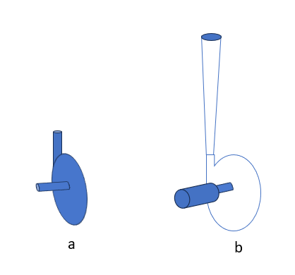
Figure 3: (a) Typical diode geometry (b) Kulkarni et al., diode geometry adapted from (Kulkarni et al., 2009)

- Conditions for optimum operation
It is crucial to optimise the system's input pressure, the geometry of the constriction used to create cavitation, and the physicochemical characteristics of the liquid medium. Several important elements should be considered in relation to this matter (Gogate & Pandit, 2001; Vichare et al., 2000;Senthil Kuma et al., 2000).
- Depending on the kind of equipment, the system's rotor speed and inlet pressure are as follows: To avoid supercavitation, employ increased pressures or rotor speeds but keep them below a particular ideal value. (Shirgaonkar & Pandit, 1998)
- The initial radius of the nuclei and the physicochemical properties of liquids: The selection criteria are similar to those employed for acoustic cavitation in order to reduce the initial diameters of the nuclei.
- The size of the cavity-creating constriction, such as a hole in an orifice plate: The application specifies that optimisations be done. Larger diameters are recommended for applications requiring intense cavitation, such as the degradation of complex chemicals like Rhodamine B (Sivakumar & Pandit, 2002) on the other hand, smaller diameters with a higher density of holes should be used for applications requiring less intense cavitation, like KI decomposition.
- The ratio of the orifice plate's holes' cross-sectional area to the pipe's overall cross-sectional area, or the free area available for the flow,: For high cavitation intensities and the subsequent desired beneficial effects, lower free areas must be utilised (Gogate & Pandit, 2001; Vichare et al., 2000)

- Mechanical, Thermal & Chemical effect Hydrodynamic cavitation
Comparing the magnitude of temperature and pressure associated with the collapse of individual cavities to the intensity of cavitation caused by ultrasonic, the former is noticeably lower. However, it is worth noting that the chemical effects resulting from hydrodynamic cavitation share similarities with the sonochemical process (Senthil Kumar et al., 2000). Figure 5 illustrates the consequences resulting from the collapse of a bubble. Nevertheless, with the manipulation of geometrical and operating factors, as previously shown, it becomes feasible to exert effective control over the frequency and, to some degree, the strength of these cavitation occurrences. Figure 4 depicts three fictitious areas where the mechanical and chemical effects of the falling hole could be felt.
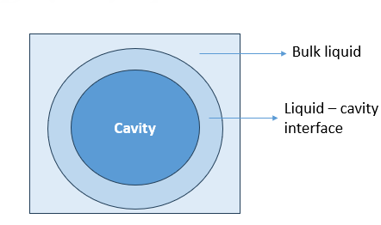
Figure 4 diagrammatic illustration of collapsing cavity zones: adapted from (Gogate & Pandit, 2001)
The interior of the hollow can be conceptualized as a microenvironment characterized by elevated temperatures. High pressures and temperatures are present inside the cavity due to the cavitational collapse's adiabatic nature.The occurrence of pyrolysis in the cavity's contents, which often include volatile solvents and solutes/reactants, is caused by the breakdown of this connection. The amount of free radicals produced is greatly influenced by the frequency and magnitude of the cavitation events. The methodology employed by Sochard et al. (1998) and Naidu et al. (1994) provides a comprehensive account of the procedure utilized to estimate the quantity of free radicals within the designated cavitating circumstances.
The temperature in the area where the cavity and liquid meet is sufficiently high to cause reactions to start via the free radical mechanism. According to Krishna et al. (1989), the capacity of the solute to concentrate at the interface and the activation energies necessary for bond breakage dictate the relative efficiency of solute reactions.
If the free radicals in the cavity and interface region have long half-lives, they have the potential to go towards the bulk liquid and interact chemically with it. In addition to the collapse of cavities, the rate at which cavities are transported is influenced by flow conditions and flow-generated turbulence. In the context of heterogeneous systems, cavitation exerts a notable physical influence through its ability to enhance mass and heat transport processes. The present understanding encompasses the primary ramifications of cavitation.
1. shock waves are produced.
2. Liquid microjet formation
3. turbulence between surfaces
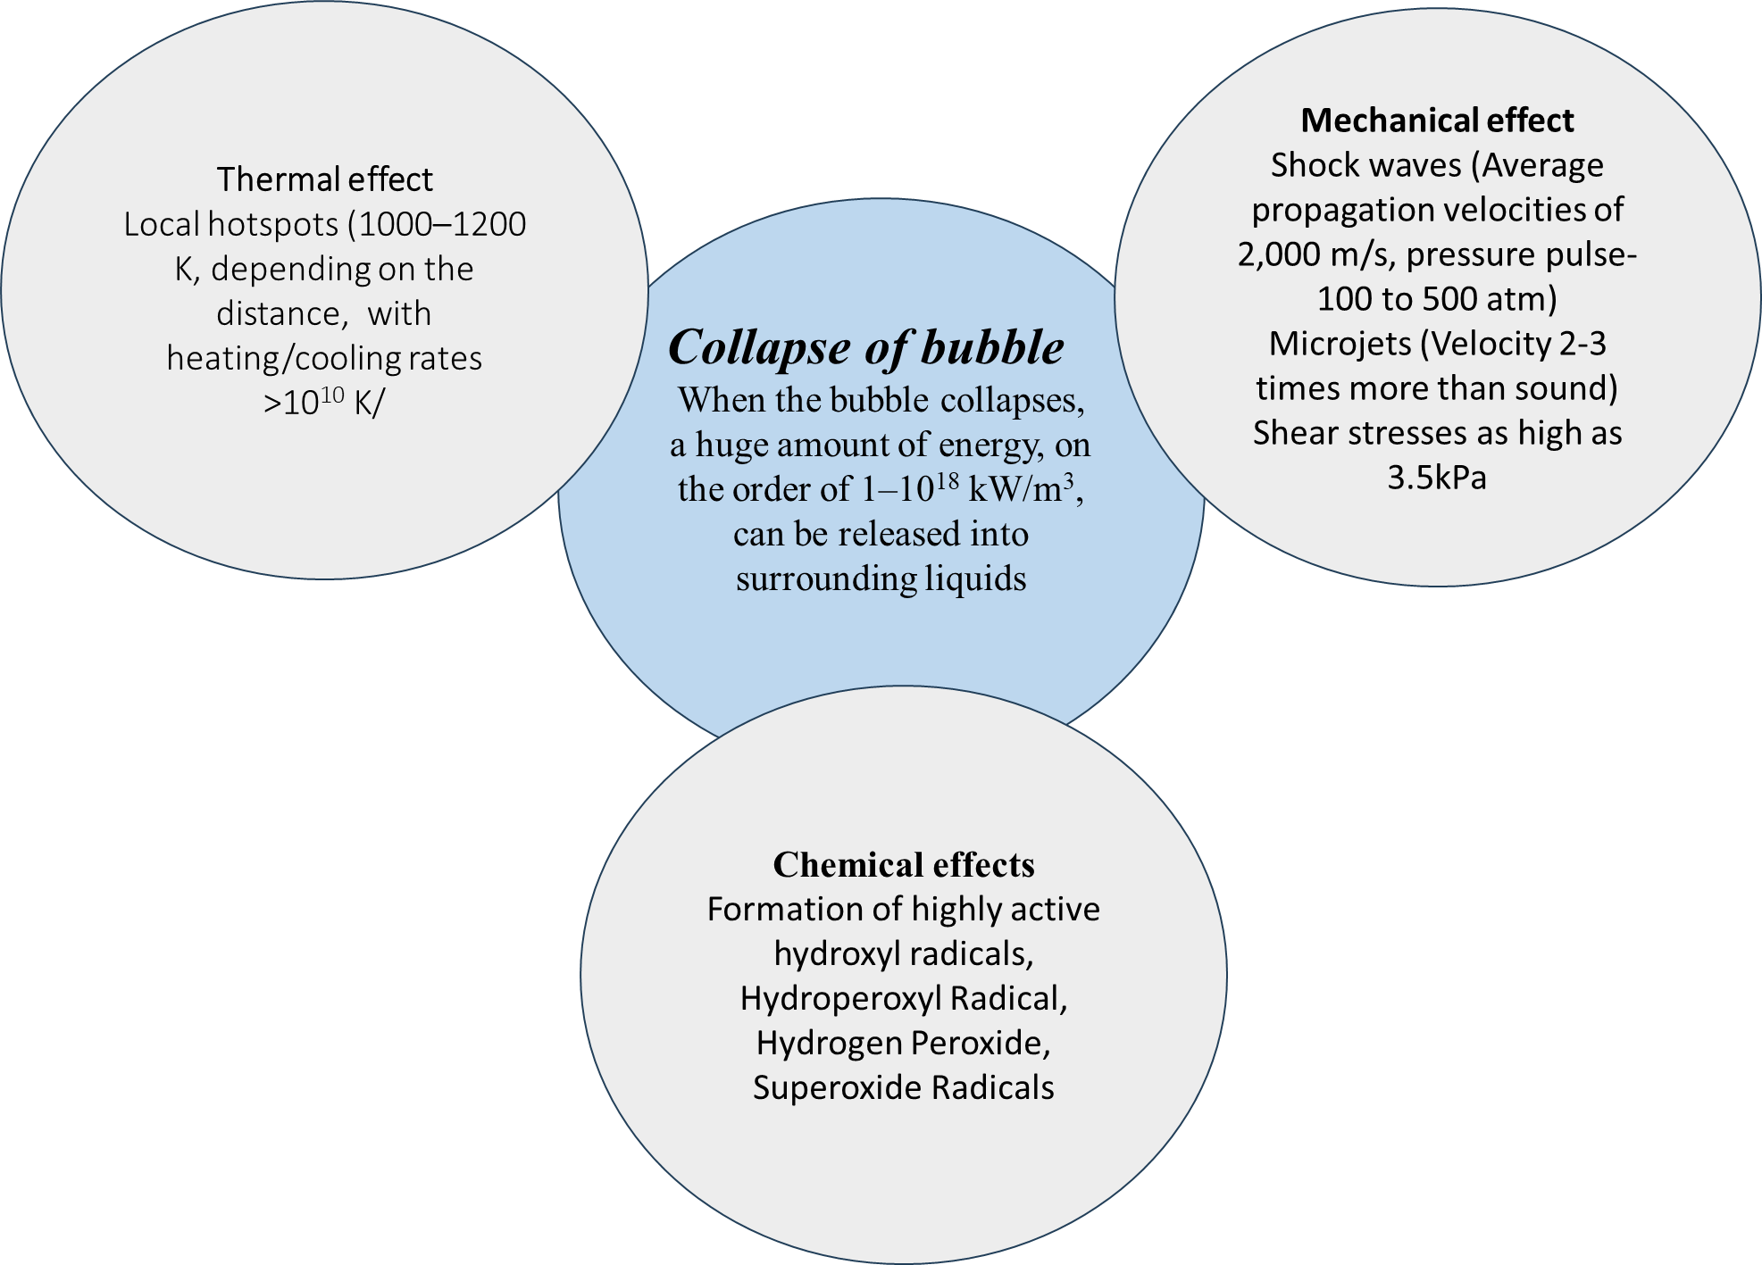
Figure 5: Mechanical, thermal & chemical effect of bubble collapse

8. Hydrodynamic cavitation's advantages and disadvantages
Some of the principal advantages of hydrodynamic cavitation are as follows:
1. As will be discussed in more detail in the steps that follow, reactions that call for somewhat difficult circumstances can be easily carried out under ambient settings.
2. It is one of the most energy- and cost-effective methods of producing cavitation.
3. The equipment needed to create cavitation is simple.
4. These reactors need extremely little upkeep.
5. It's simple to scale up the aforementioned procedure.
The amount of cavitational intensity and the frequency of cavitation occurrences may be controlled by adjusting the operational and geometric parameters inside the reactor(Gogate & Pandit, 2000). However, it is crucial to remember that, as measured by temperature and pressure, hydrodynamic cavitation causes a much lower intensity of collapse for individual cavities than acoustic cavitation (Moholkar & Pandit, 1997; Senthil Kumar et al., 2000). Pressure recovery downstream of the constriction is one of the drawbacks of hydrodynamic cavitation reactors. The overall permanent pressure head loss in these reactors at an orifice to pipe diameter ratio of 0.5 is calculated to be around 73% of the orifice pressure difference. Consequently, increasing the pump's discharge pressure is required to produce higher cavitation intensities. It is important to stress once more that the circumstances may be much improved by changing the reactor's design and operating parameters, which will affect the fluid's turbulent structure. Similar to acoustic cavitation reactors, hydrodynamic cavitation reactors function poorly when used with viscous fluids.. In this particular context, the generation of cavitation is a formidable challenge, while the pumping of very viscous substances incurs significant costs, hence exerting a notable influence on the overall economic aspects of the operation.
- Applications of hydrodynamic cavitation

Due to its exceptional capacity to cause physical and chemical changes in fluids, hydrodynamic cavitation has drawn substantial attention in a number of domains. Research and literature suggest a wide range of applications for hydrodynamic cavitation. Here are some notable examples:

- Wastewater Treatment:
Hydrodynamic cavitation can effectively break down organic pollutants and disrupt cell structures, aiding in the degradation of contaminants in wastewater. It has been explored as an energy-efficient method for enhancing oxidation processes and reducing the concentration of pollutants.

- Chemical Synthesis:
Researchers have looked at the use of hydrodynamic cavitation as a sustainable and environmentally friendly way to improve chemical processes. The intense pressure fluctuations and high temperatures generated during cavitation can lead to increased reaction rates and yield improvements in processes like biodiesel production, polymerization, and nanoparticle synthesis.

- Emulsification and Mixing:
Hydrodynamic cavitation can be employed to create stable emulsions by disrupting larger droplets into smaller ones. This is valuable in industries such as food and cosmetics, where the uniform distribution of ingredients is crucial. The process can also aid in mixing liquids with disparate viscosities.

- Enhanced Mass Transfer:
Cavitation bubbles can develop and burst, increasing the contact area between phases (such liquid-solid or gas-liquid), allowing for effective mass transfer. This property is beneficial in applications such as extraction, absorption, and stripping processes.

- Water Disinfection:
According to studies, hydrodynamic cavitation can produce free radicals and reactive oxygen species, both of which have antibacterial capabilities. This makes it a potential method for water disinfection and pathogen inactivation.

- Nanomaterial Fabrication
Hydrodynamic cavitation can induce nucleation and particle growth in solutions, leading to the synthesis of nanoparticles. The controlled conditions within cavitation zones can influence particle size and morphology, making it suitable for tailored nanomaterial production.

- Degassing
Cavitation-induced microbubbles can facilitate the removal of dissolved gases from liquids, such as degassing water for industrial processes or removing dissolved oxygen in beverages.

- Enhanced Digestion and Extraction:
Hydrodynamic cavitation has demonstrated potential in the food and beverage sector for boosting digestion and extraction processes, resulting in higher yields and product quality.

- Crystallization:
In order to facilitate the regulated development of crystalline products for use in a variety of applications, such as the production of medicines and chemicals, cavitation bubbles can serve as nucleation sites for crystallisation..

- Cell Disruption:
Hydrodynamic cavitation has been explored for cell disruption in biotechnology and biofuel production. The mechanical forces generated during cavitation can disrupt cell membranes, releasing intracellular components.

As research and technology continue to advance, hydrodynamic cavitation is likely to find new applications and refinements in existing fields. However, it's important to note that while hydrodynamic cavitation offers numerous benefits, careful consideration of process parameters, system design, and potential side effects is essential to ensure safe and efficient implementation in various applications.
- Conclusion
Hydrodynamic cavitation has a highly promising potential for reducing the pollutant burden in various wastewater sources, whether used alone or in combination with other advanced oxidation processes. Determining the superiority of different cavitation reactors poses a challenge due to the substantial variations in geometric and operational properties across several types of such reactors. The combined impacts of numerous operational factors might affect a particular HC reactor's hydraulic characteristics or decreasing efficiency.
To ascertain the ideal operating circumstances for each hydrocarbon configuration, more research is required. The Response Surface Methodology (RSM) is a practical method that takes into account all relevant factors affecting reaction performance in decision-making processes. Previous studies have provided evidence that the hybrid process utilizing HC exhibits superior degrading efficiency in comparison to the exclusive use of HC. Heterogeneous catalysis (HC) has the potential to accelerate overall reaction kinetics, decrease the need for oxidising chemicals, and improve pollutant compound degradation when combined with other advanced oxidation processes (AOPs). The structure and composition of the reactants both have an impact on how much degradation occurs. The best combination of AOPs depends on the unique properties of various types of pollutants. Further investigation is required to determine the optimal approach for degrading target contaminants. Although HC or other HC-based hybrid approaches have the potential to treat wastewater or provide disinfection, more work still has to be done in this area.
In summary, hydrodynamic cavitation (HC) demonstrates promise as an effective approach for treating and disinfecting low-concentration wastewater. However, it is important to acknowledge that significant advancements are required before its widespread implementation in industrial settings can be realized. In order to achieve this goal, we have offered a number of ideas for additional research, including: (1) Researching the microscopic mechanisms of HC and the pathways by which pollutants degrade is essential in order to improve the effectiveness of HC removal and mineralization. If the CFD modelling technique is used to optimise different geometric properties of the reactor or operating conditions, the experimental verifications will be more convincing. The outlet pressure value should be carefully stated in studies examining the operational parameters of HC devices since it significantly affects cavitation behaviour. Additionally, additional research is needed to determine the outlet pressure or the relationship between the intake and output pressures. To fully comprehend the synergistic effect and underlying mechanism brought about by the combination of hydraulic cavitation with other advanced oxidation processes, more research and clarification are necessary. The performance of various HC reactors or hybrid technologies should be compared using uniform standards. (6) The bulk of research projects are still carried out at the laboratory level, with only a small number of pilot-size experiments being conducted, despite the relative simplicity of upscaling on a larger scale. Additionally, it is feasible to improve the design of the HC reactor wastewater treatment system in order to lower construction costs.. In order to address the issue of wastewater treatment, it is possible to employ either identical or distinct types of hydrocarbon (HC) reactors, either in a series or parallel configuration.
References
Abbasi, E., Saadat, S., Karimi Jashni, A., & Shafaei, M. H. (2020). A novel method for optimization of slit Venturi dimensions through CFD simulation and RSM design. Ultrasonics Sonochemistry, 67, 105088. https://doi.org/10.1016/j.ultsonch.2020.105088
Adewuyi, Y. G. (2001). Sonochemistry: Environmental Science and Engineering Applications. Industrial & Engineering Chemistry Research, 40(22), 4681–4715. https://doi.org/10.1021/ie010096l
Adnađevic, B. K., Jovanovic, J. D., Petkovic, S. D., & Rankovic, D. P. (2019). Removal of Diuron from Waste Waters by Hydrodynamic Cavitation. Russian Journal of Physical Chemistry A, 93(13), 2650–2655. https://doi.org/10.1134/S003602441913003X
Badve, M., Gogate, P., Pandit, A., & Csoka, L. (2013). Hydrodynamic cavitation as a novel approach for wastewater treatment in wood finishing industry. Separation and Purification Technology, 106, 15–21. https://doi.org/10.1016/j.seppur.2012.12.029
Bang, J. H., & Suslick, K. S. (2010). Applications of Ultrasound to the Synthesis of Nanostructured Materials. Advanced Materials, 22(10), 1039–1059. https://doi.org/10.1002/adma.200904093
Barik, A. J., & Gogate, P. R. (2018). Hybrid treatment strategies for 2,4,6-trichlorophenol degradation based on combination of hydrodynamic cavitation and AOPs. Ultrasonics Sonochemistry, 40, 383–394. https://doi.org/10.1016/j.ultsonch.2017.07.029
Bucknall, C. B., Karpodinis, A., & Zhang, X. C. (1994). A model for particle cavitation in rubber-toughened plastics. Journal of Materials Science, 29(13), 3377–3383. https://doi.org/10.1007/BF00352036
Chipurici, P., Vlaicu, A., Calinescu, I., Vinatoru, M., Vasilescu, M., Ignat, N. D., & Mason, T. J. (2019). Ultrasonic, hydrodynamic and microwave biodiesel synthesis – A comparative study for continuous process. Ultrasonics Sonochemistry, 57, 38–47. https://doi.org/10.1016/j.ultsonch.2019.05.011
Crowe, Clayton, T., & Efstathios, E. M. (2006). Basic concepts and definitions." Multiphase flow handbook.
Cvetković, M., Kompare, B., & Klemenčič, A. K. (2015). Application of hydrodynamic cavitation in ballast water treatment. Environmental Science and Pollution Research, 22(10), 7422–7438. https://doi.org/10.1007/s11356-015-4360-7
Danlos, A., Méhal, J.-E., Ravelet, F., Coutier-Delgosha, O., & Bakir, F. (2014). Study of the Cavitating Instability on a Grooved Venturi Profile. Journal of Fluids Engineering, 136(10), 101302. https://doi.org/10.1115/1.4027472
Gogate, P. R., & Pandit, A. B. (2000). Engineering design method for cavitational reactors: I. Sonochemical reactors. AIChE Journal, 46(2), 372–379. https://doi.org/10.1002/aic.690460215
Gogate, P. R., & Pandit, A. B. (2001). HYDRODYNAMIC CAVITATION REACTORS: A STATE OF THE ART REVIEW. Reviews in Chemical Engineering, 17(1), 1–85. https://doi.org/10.1515/REVCE.2001.17.1.1
Gogate, P. R., & Pandit, A. B. (2004). A review of imperative technologies for wastewater treatment I: Oxidation technologies at ambient conditions. Advances in Environmental Research, 8(3–4), 501–551. https://doi.org/10.1016/S1093-0191(03)00032-7
Krishna, C. M., Kondo, T., & Riesz, P. (1989). Sonochemistry of alcohol-water mixtures. Spin-trapping evidence for thermal decomposition and isotope-exchange reactions. The Journal of Physical Chemistry, 93(13), 5166–5172. https://doi.org/10.1021/j100350a029
Kuldeep, & Saharan, V. K. (2016). Computational study of different venturi and orifice type hydrodynamic cavitating devices. Journal of Hydrodynamics, 28(2), 293–305. https://doi.org/10.1016/S1001-6058(16)60631-5
Kulkarni, A. A., Ranade, V. V., Rajeev, R., & Koganti, S. B. (2009). Pressure drop across vortex diodes: Experiments and design guidelines. Chemical Engineering Science, 64(6), 1285–1292. https://doi.org/10.1016/j.ces.2008.10.060
Kumar, P. S., & Pandit, A. B. (1999). Modeling Hydrodynamic Cavitation. 22(12), 1017–1027. https://doi.org/10.1002/(SICI)1521-4125(199912)22:12%3C1017::AID-CEAT1017%3E3.0.CO;2-L
Lee, H., Gojani, A. B., Han, T., & Yoh, J. J. (2011). Dynamics of laser-induced bubble collapse visualized by time-resolved optical shadowgraph. Journal of Visualization, 14(4), 331–337. https://doi.org/10.1007/s12650-011-0094-x
Mancuso, G., Langone, M., Laezza, M., & Andreottola, G. (2016). Decolourization of Rhodamine B: A swirling jet-induced cavitation combined with NaOCl. Ultrasonics Sonochemistry, 32, 18–30. https://doi.org/10.1016/j.ultsonch.2016.01.040
Moholkar, V. S., & Pandit, A. B. (1997). Bubble behavior in hydrodynamic cavitation: Effect of turbulence. AIChE Journal, 43(6), 1641–1648. https://doi.org/10.1002/aic.690430628
Naidu, D. V. P., Rajan, R., Kumar, R., Gandhi, K. S., Arakeri, V. H., & Chandrasekaran, S. (1994). Modelling of a batch sonochemical reactor. Chemical Engineering Science, 49(6), 877–888. https://doi.org/10.1016/0009-2509(94)80024-3
Rajoriya, S., Bargole, S., & Saharan, V. K. (2017). Degradation of a cationic dye (Rhodamine 6G) using hydrodynamic cavitation coupled with other oxidative agents: Reaction mechanism and pathway. Ultrasonics Sonochemistry, 34, 183–194. https://doi.org/10.1016/j.ultsonch.2016.05.028
Rajoriya, S., Carpenter, J., Saharan, V. K., & Pandit, A. B. (2016). Hydrodynamic cavitation: An advanced oxidation process for the degradation of bio-refractory pollutants. Reviews in Chemical Engineering, 32(4). https://doi.org/10.1515/revce-2015-0075
Saharan, V. K., Badve, M. P., & Pandit, A. B. (2011). Degradation of Reactive Red 120 dye using hydrodynamic cavitation. Chemical Engineering Journal, 178, 100–107. https://doi.org/10.1016/j.cej.2011.10.018
Šarc, A., Stepišnik-Perdih, T., Petkovšek, M., & Dular, M. (2017). The issue of cavitation number value in studies of water treatment by hydrodynamic cavitation. Ultrasonics Sonochemistry, 34, 51–59. https://doi.org/10.1016/j.ultsonch.2016.05.020
Sarvothaman, V. P., Simpson, A. T., & Ranade, V. V. (2019). Modelling of vortex based hydrodynamic cavitation reactors. Chemical Engineering Journal, 377, 119639. https://doi.org/10.1016/j.cej.2018.08.025
Senthil Kumar, P., Siva Kumar, M., & Pandit, A. B. (2000). Experimental quantification of chemical effects of hydrodynamic cavitation. Chemical Engineering Science, 55(9), 1633–1639. https://doi.org/10.1016/S0009-2509(99)00435-2
Sežun, M., Kosel, J., Zupanc, M., Hočevar, M., Vrtovšek, J., Petkovšek, M., & Dular, M. (2019). Cavitation as a Potential Technology for Wastewater Management – An Example of Enhanced Nutrient Release from Secondary Pulp and Paper Mill Sludge. Strojniški Vestnik – Journal of Mechanical Engineering, 65(11–12), 641–649. https://doi.org/10.5545/sv-jme.2019.6328
Shirgaonkar, I. Z., & Pandit, A. B. (1998). Sonophotochemical destruction of aqueous solution of 2,4,6-trichlorophenol. Ultrasonics Sonochemistry, 5(2), 53–61. https://doi.org/10.1016/S1350-4177(98)00013-3
Simpson, A., & Ranade, V. V. (2018). Modelling of hydrodynamic cavitation with orifice: Influence of different orifice designs. Chemical Engineering Research and Design, 136, 698–711. https://doi.org/10.1016/j.cherd.2018.06.014
Sivakumar, M., & Pandit, A. B. (2002). Wastewater treatment: A novel energy efficient hydrodynamic cavitational technique. Ultrasonics Sonochemistry, 9(3), 123–131. https://doi.org/10.1016/S1350-4177(01)00122-5
Sochard, S., Wilhelm, A.-M., & Delmas, H. (1998). Gas-vapour bubble dynamics and homogeneous sonochemistry. Chemical Engineering Science, 53(2), 239–254. https://doi.org/10.1016/S0009-2509(97)85744-2
Song, L., Yang, J., Yu, S., Xu, M., Liang, Y., Pan, X., & Yao, L. (2019). Ultra-high efficient hydrodynamic cavitation enhanced oxidation of nitric oxide with chlorine dioxide. Chemical Engineering Journal, 373, 767–779. https://doi.org/10.1016/j.cej.2019.05.094
Sun, X., Liu, J., Ji, L., Wang, G., Zhao, S., Yoon, J. Y., & Chen, S. (2020). A review on hydrodynamic cavitation disinfection: The current state of knowledge. Science of The Total Environment, 737, 139606. https://doi.org/10.1016/j.scitotenv.2020.139606
Sun, X., & Yoon, J. Y. (2018). Multi-objective optimization of a gas cyclone separator using genetic algorithm and computational fluid dynamics. Powder Technology, 325, 347–360. https://doi.org/10.1016/j.powtec.2017.11.012
Thanekar, P., & Gogate, P. (2018). Application of Hydrodynamic Cavitation Reactors for Treatment of Wastewater Containing Organic Pollutants: Intensification Using Hybrid Approaches. Fluids, 3(4), 98. https://doi.org/10.3390/fluids3040098
Tinne, N., Kaune, B., Krüger, A., & Ripken, T. (2014). Interaction Mechanisms of Cavitation Bubbles Induced by Spatially and Temporally Separated fs-Laser Pulses. PLoS ONE, 9(12), e114437. https://doi.org/10.1371/journal.pone.0114437
Tomita, Y., & Shima, A. (1986). Mechanisms of impulsive pressure generation and damage pit formation by bubble collapse. Journal of Fluid Mechanics, 169(1), 535. https://doi.org/10.1017/S0022112086000745
Vajnhandl, S., & Majcen Le Marechal, A. (2005). Ultrasound in textile dyeing and the decolouration/mineralization of textile dyes. Dyes and Pigments, 65(2), 89–101. https://doi.org/10.1016/j.dyepig.2004.06.012
Vichare, N. P., Gogate, P. R., & A. B. Pandit. (2000). Optimization of Hydrodynamic Cavitation Using a Model Reaction. 23(8), 683–690.
Wang, B., Su, H., & Zhang, B. (2021). Hydrodynamic cavitation as a promising route for wastewater treatment – A review. Chemical Engineering Journal, 412, 128685. https://doi.org/10.1016/j.cej.2021.128685
Wilcox, D. C. (2006). Turbulence Modeling for CFD (3rd ed.).
Yan, Y., & Thorpe, R. B. (1990). Flow regime transitions due to cavitation in the flow through an orifice. International Journal of Multiphase Flow, 16(6), 1023–1045. https://doi.org/10.1016/0301-9322(90)90105-R
Zhang, P., Meng, Z. N., Zhu, H., Wang, Y. L., & Peng, S. P. (2017). Melting heat transfer characteristics of a composite phase change material fabricated by paraffin and metal foam. Applied Energy, 185, 1971–1983. https://doi.org/10.1016/j.apenergy.2015.10.075

