TEZPUR: A PLACE OF ICONIC BEAUTY

Kanak Ch. Bordoloi

Tezpur is one of the most beautiful cities of Assam. It is best known as the cultural capital of the state of Assam on the North Bank of Brahmaputra. Geographically, Tezpur is located in 26.633 latitude and 98.800 longitudes at 74 meters elevation above the sea level. The town is situated 175 kilometers northeast of Guwahati.
With the sustaining beauty and vivacious natural surroundings of river and hills, Tezpur attracts various tourists of national and international level.
Tezpur emerges also as the blooming field for the famous Assamese cultural icons Jyoti Prasad Agarwala, Bishnu Prasad Rabha and Phani Sarmah. It is the place where eminent literary pioneer and the first President of Asom Sahitya Sabha Padmanath Gohayeen Baruah lived. Moreover, the world famous music maestro Dr. Bhupen Hazarika also passed his childhood days at Tezpur. The city holds an iconic image as a clean city not only of Assam but among all the cities in the country. With very congenial and serene atmosphere and the habitats of peace loving people of heterogeneous communities, Tezpur deserves the attention and interests of various people in the state.
The city is treasured with historically rich memories and archeological findings and has been renowned as an epitome of rich ancient culture and civilization.
Historical study reveals that Tezpur town is endowed with historical ruins and various archaeological findings of the 8th to 9th century like Bamuni Hills and the stone gate at Da-Parbatia which reflect the shining example of the architecture around the 4th century AD.
The modern look of Tezpur as one would see now was founded by the British Colonial administration during 1835.It so appears that Nature has bestowed all the treasures of beauty and charm upon Tezpur that mere a glimpse at it would make anyone extremely excited.
“Agnigarh” is one of the most beautiful spots in Tezpur . The term Tezpur was used from ancient time as a ‘protection with fire’. Agnigarh is a small hill which stands on the bank of river Brahmaputra and it traces back to the ancient historical event in Assam in the reign of Demon King Bana. According to Hindu mythology , Banasura was a very powerful thousand- armed ‘asura’ (Demon) who terrorized even the heavenly blessed ‘Devatas’. Bana was a true devotee of lord ‘Shiva’ . He had a very beautiful daughter ‘Usha’ and he built the wall of fire (Agnigarh) on this hilltop to protect her from the reach of Anirudha, her lover, the grandson of Lord Krishna. Usha saw Anirudha in her dream only and fell in love. She gave his description him to her friend Chitralekha who was a famous artist and Chitralekha promised to bring Anirudha so that Usha could get married with him. When Bana learnt this plan he built ‘Agnigarh’ as the safest means of protection. Finally, Usha - Anirudha’s love episode ends with a terrible fight between ‘Hari’ (Krishna) and ‘Hara’ (Shiva) and the bloodshed led to naming of the town ‘Tezpur’ (‘Tez’ means Blood and ‘pur’ means area).
Agnigarh, in present days, is developed to a beautiful park with circular stairway leading to the peak of the hillock and flourished with rich sculptures depicting various scenes relating to the story of Usha, Anirudha and the ‘Hari-Hara battle’. This Agnigarh park, constructed much later, provides a panoramic view of the mighty river Brahmaputra and stands as the very attractive tourist spot where from the whole Tezpur Town can be viewed. Tezpur College, Deputy Commissioner’s bungalow and SP bungalow are on the foothills of Agnigarh and the spot is connected to ‘Ganesh Ghat’ on the bank of Brahmaputra.

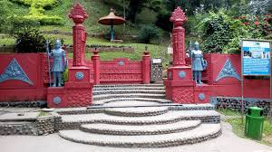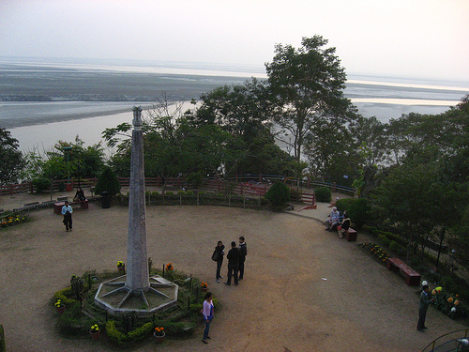
Agnigarh Park at Tezpur

2. BHAIRAVI DEWALAYA OR MAI THAN
Bhairabi Dewalaya is one of the most renowned holy temples of the North East India. It is situated in the periphery of Tezpur town. The temple is dedicated to Goddess Durga and the backdrop of the temple provides a beautiful view of the Kalia Bhomora Bridge built across the Brahmaputra river. It is located near the historically famous Bamuni Hills. Local people of the place refer to this temple as Maithan also. According to legends, Usha the daughter of Asura King Banasura, had made regular visits to this temple for worshipping Goddess Durga.
The entrance to the temple is made of very long staircase that leads to the main shrine of the temple. The unique work represents 9th century architectural carvings with the sculpted idols inside the temple. Many people believe that sacrifices of animals and creatures on particular day at this temple reduce the pains and sufferings of life. This belief leads to the sacrifice of goat and buffalos, especially during the time of Durga puja.The Durga Puja is celebrated in a very grand way in this temple.
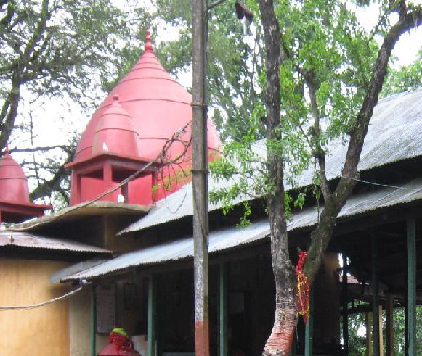
Bhairabi Dewalaya, Tezpur.
3. THE ANCIENT HISTORICAL RUINS OF THE STONE GATE AT DA PARBATIA
Assam is the state of oldest and finest representation of architectural splendour. As a part of it, Tezpur is a city with famous ancient architechtural ruins and the best example can be seen in the Da-Parbatia Temple ruins. “In this iconoclastic art in Assam in the form of the ruins of the door-frame of the Da-parbatia temple, we can see the sculptural remnants of an ancient temple of the sixth century overlying the ruins of another Shiva temple built of bricks during the Ahom period. Archaeological excavations were done here in 1924 which have unearthed a sixth century antiquity in the form of a stone door frame with extensive carvings. The stone carvings of Da-Parbatia temple display the characteristic style of the early Gupta School of architectural sculptures. The two legs of the door-frame have the stone carvings of the two Goddesses Ganga and Yamuna. Both of them are standing at the bottom with garlands in their hands.”* The statue placed in the middle place of the Gate is believed to be of ‘Lakulish Shiva’ who emerged in Gujarat during 2nd Century A.C and spread spiritual thoughts to the North East Part of India. The whole frame is elaborately decorated with beautiful ornamental foliage. These ancient ruins are named after the name of the village Da parbatia situated 8 kilometres west from Tezpur town.
(*Internet Sources).

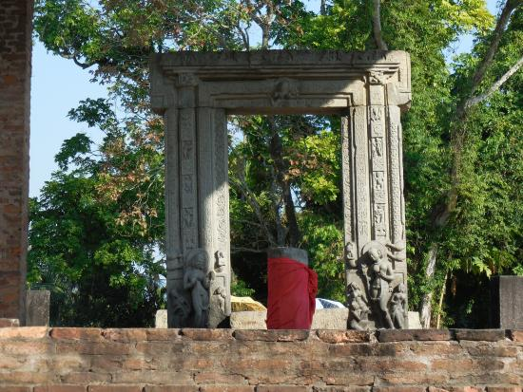
Da-Parbatia Temple ruins
4. MAHABHAIRAV TEMPLE
Tezpur is a city of many holy temples. Mahabhairab is such a notable and most visited Shiva temple that bears greater historical importance since the ancient days. The Temple is located on the northern part of Tezpur town, Assam. Archaeological sources reveal that the temple was built during 8th to 10th century A.D. by the kings of the Salastambha dynasty which is evident by the presence of huge stone pillars scattered all around the temple. Other popular beliefs are that this temple was established by king Bana in the pre-historical times as he was a great devotee of Shiva and he regularly came to this holy shrine for worshipping.
Some archaeological sources want to say that the original temple was destroyed during the Islamic invasions of the Middle Ages. It was again rebuilt by the successive kings and rulers, until it was heavily damaged by the catastrophic earthquake of 1897.The present look of the temple was the result of renovation done much later. The temple is now managed by the Government of Assam through a managing committee headed by the Deputy Commissioner, Sonitpur district. Many people from various parts of India and abroad make usual visits to see and offer puja. During the time of Mahashiva Ratri, there is a big Mela or Fair with numerous devotees attending it. Mahashivaratri is a marked Hindu religious festival celebrated on the Chaturdashi Tithi of Krishna Pakhsya in the month of Fagun, (the Hindu lunar month). It is said that the Shiva Linga in this temple is a kind of holy living stone that grows every year and it is the largest Shiva Linga in the world.

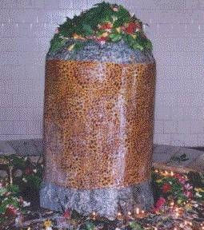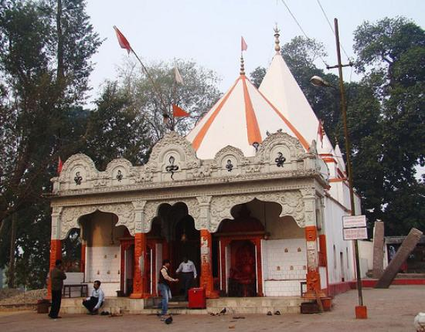
THE LARGEST SHIVA LINGA IN THE WORLD MAHABHAIRAV TEMPLE

4. LGB Regional Mantel Hospital

A notable contribution of British to Tezpur was the establishment of the ‘Assam Lunatic Asylum’ on 1st April 1876. Presently, this Asylum is named as “Lokapriya Gopinath Bordoloi Mental Hospital’. On the directive of the Hon’ble Supreme Court of India in 1999, the Mental Hospital had been made under control of the North Eastern Council (NEC). This hospital is situated in Kolibari, Tezpur on the way to the temple Bhairabi Dewalaya or ‘Mai Than’.

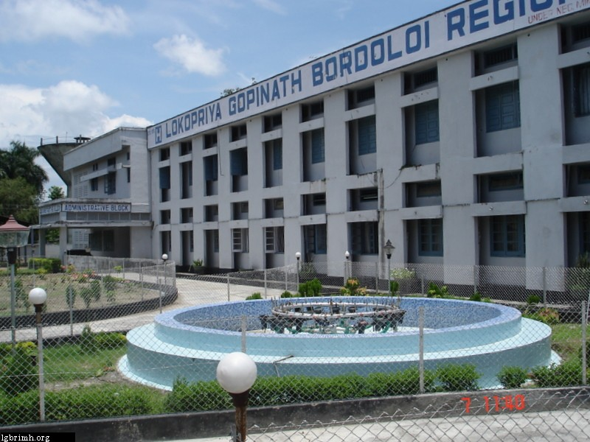

6. BAMUNI PAHAR & the PANCH DEVTA TEMPLE:-

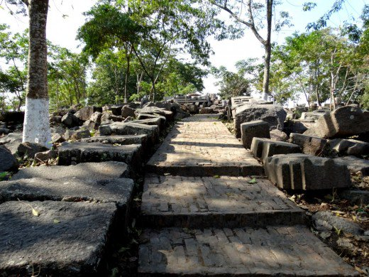

As already mentioned, Tezpur is the treasure of religious and cultural resources, it would be appropriate to refer to the ‘PANCH DEVATA’ temple situated on the top of ‘Bamuni Pahar’ or ‘Bamuni Hills’ near the Brahmaputra. This holy temple consists of five God and Goddesses namely Shiva, Devi, Bishnu, Surya and Ganesha. The temple was made of stone with engraved design therein. The main feature of Bamuni Pahar is that the whole hill is seen in three distinct parts covered by the stone. This temple is believed to be erected in the early part of the Middle ages.

7. HALESWAR DEWALAYA:-
Haleswar temple is another very holy and popular ‘Shiva Temple’ in Tezpur. It stands at about ten kilometer north from Tezpur town on the road side towards Lakhimpur. It is said that a farmer (Halowa) found the holy ‘SHIVA LINGA’ while he was ploughing and set it up with devotion. ‘Holeswar’, the term might have been evolved from this term ‘halowa’ finding ‘Iswar’ or God. The famous Ahom King Rudra Singha had constructed the temple in Haleswar in 1705 A.D.

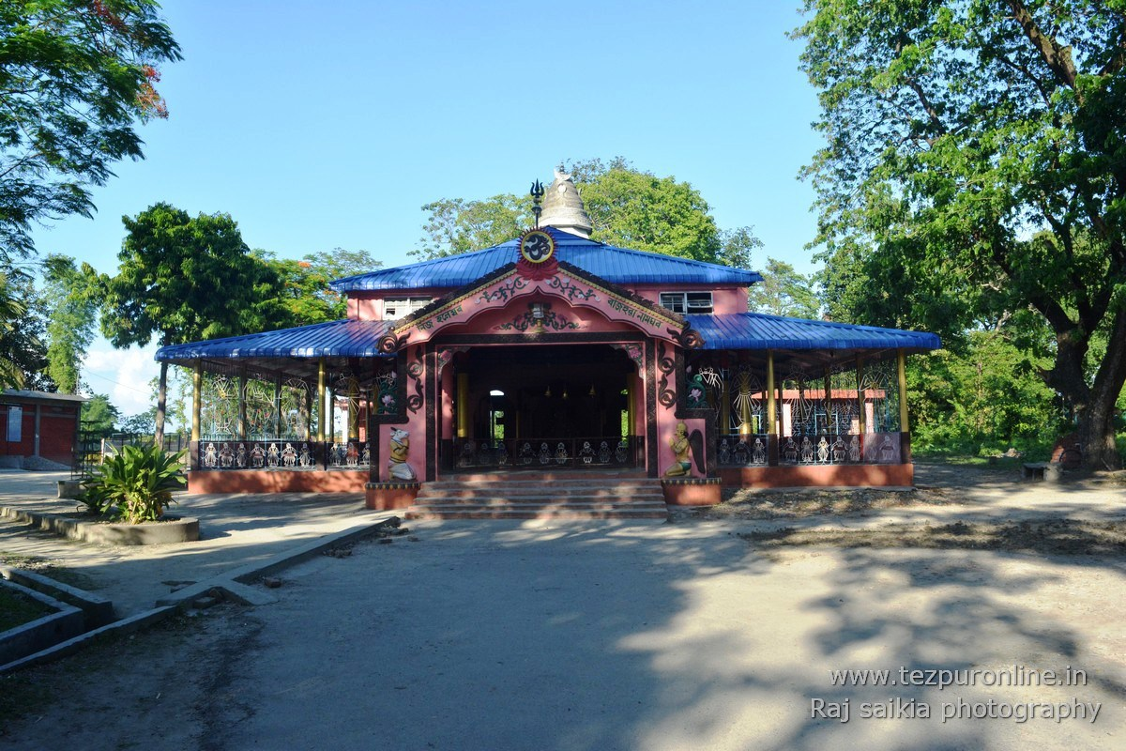

8. SALONIBARI AIRPORT:-
Near to Haleswar temple, Salanibari Airport of Tezpur is located. This Airport had been constructed by British Royal Indian Air Force in 1942 during the World War II. The Airfield covers 22 acres of land and is very important for India because of the fact that Indo-China international border (MC-MOHAN Line) is near to it (less than 350 Kms on road). The Tezpur Salanibari Airport bears greater defence importance for the operationalization of MIG21 fighters (now shifted to Chabua) and for present use as the airbase for SUKHOI fighter planes.

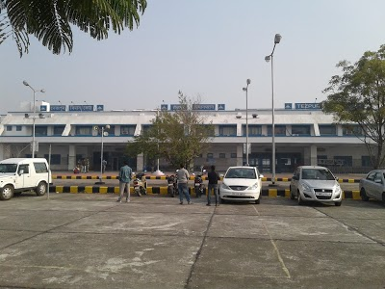

9. KALIA BHOMORA BRIDGE:-
The beauty of Tezpur is much enhanced by the Kalia Bhomora Bridge on river Brahmaputra connecting Tezpur (Sonitpur) of North bank with Nagaon district of south bank. This 3 kilometre long concrete bridge construction started in 1981 and was opened for public in 1987. The bridge is named after the great Ahom General Kalia Bhomorah Borphukan who planned to build a bridge in this place during the 16th century. The approach to the north part of this bridge is welcomed with wall-graved paintings of the cultural bearings of the North Eastern states.

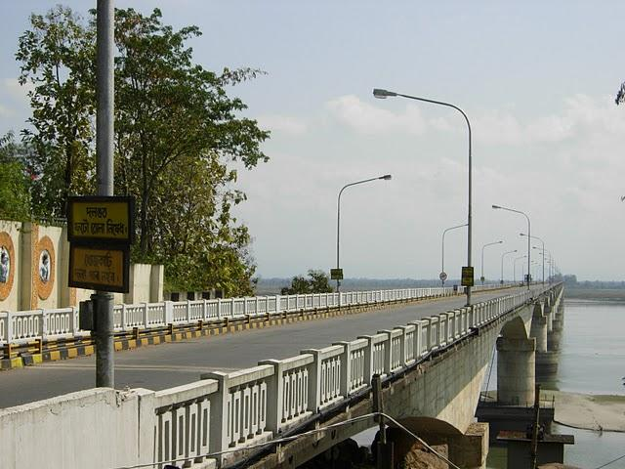

10. BISHNU RABHA SAMADHI STHALL:-
Bishnu Prasad Rabha was cremated in a ground near Bhairabi Dewalaya on the bank of Brahmaputra. People of Tezpur along with few organizations had made efforts to commemorate him setting up a park on this cremation ground. It is a very beautiful tourist spot with the children park inside.

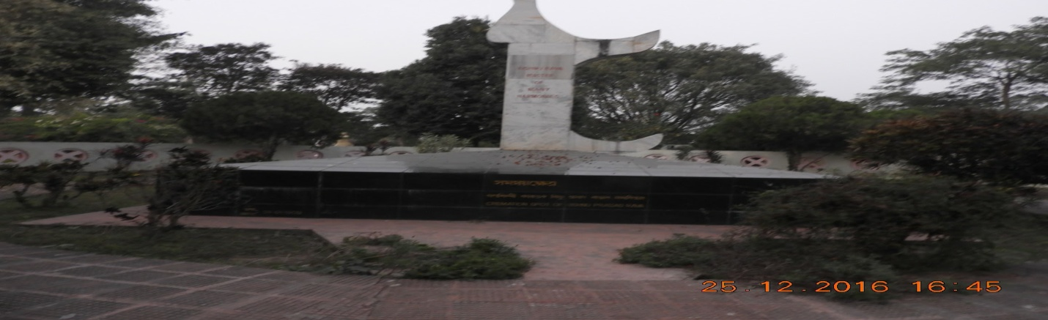

11. Tezpur University:
Tezpur University is a world ranking university which was established in 1994 at Napam, Tezpur. It is a university imparting multi discipline educational programmes of graduation and post graduation level including research scope. The courses offered are unique in features for quality and transactional inputs.

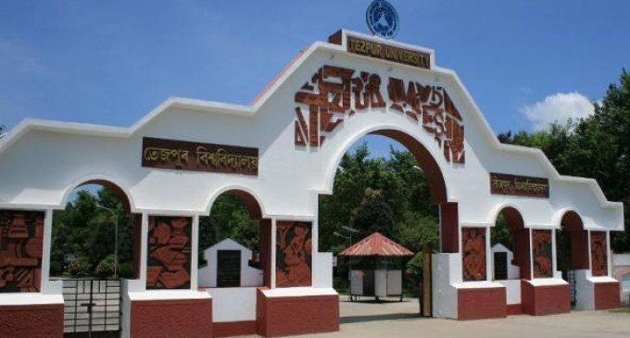

12. Tezpur: the place of Cultural, Literary and Musical icons of Assam:-
Padmanath Gohain Barua (1871- 1946) was the first President of Asom Sahitya Sabha (1917) . He lived in Tezpur and contributed a lot to the development of Assamese literature.
Jyoti Prasad Agarwala (1903 – 1951) lived whole life at Tezpur. He was the first Assamese film producer. He was a prominent dramatist and lyricist, music maker and enriched Assamese culture with his immortal creations. He is popularly honoured as Rupkonwar.
Bishnu Prasad Rabha (1909 – 1969): Bishnu Prasad Rabha was a renowned figure of Assam with his multi dimensional contributions to the fields of music, drama, poetry, social organization and politics. He is honoured with love of the people as Kalaguru.

Phani Sarmah (1910 ---1970): Phani Sarmah was born in Tezpur and he was a playwright, actor and director of Assamese drama. He is popularly called as Natasurya.
Dr Bhupen Hazarika ( 1926—2011): Bhupen Hazarika lived his school days in Tezpur. He is a world famous singer, music director and composer. He was the first Assamese person to be honoured with the most prestigious Dada Saheb Phalke Award (1992).
These prominent personalities are the PRIDE OF ASSAM.

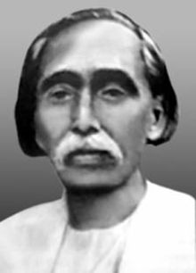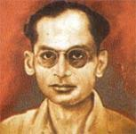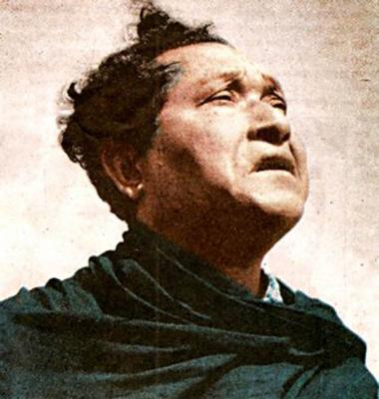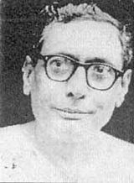
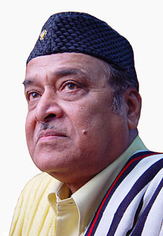
Padmanath Gohain Barua Jyoti Prasad Agarwala Bishnu Prasad Rabha Phani Sarmah Dr. Bhupen Hazarika

************************************************
Select Bibliography:
- Sahityar Year Book Edited by Santanu Koushik Baruah
- Internet Sources.

