IoT & Smart Home System: A New Way of Management
Mrs. Sushma M. Pingale
Assistant Professor, Department of Computer Science, SNBP College of ACS & MS, Pune, India
Abstract- A smart home system makes our life quite easy. Smart home is the term commonly used to define a residence where household devices / home appliances could monitor and control remotely. The Internet of Thins (IoT) refers to a network of physical devices, vehicles, appliances and other physical objects which are embedded with sensors, softwares and network connectivity that allows them to collect and share data. A smart home system is major application of IoT . This paper represents the IoT technologies that can be integrated in smart home system to make ease out the home automation tasks. Also presents the problems and challenges come in IoT.
Keywords: IoT(Internet of Things), smart home, home automation, security.
- Introduction
Today’s world becomes smarter day by day because of internet. It provides anytime, anywhere connectivity with anyone. As many advancement in technology such as sensors, transmitters, receivers, processors etc. are now available in very reasonable rate. Today internet is now expanding towards Internet of Things.
Nowadays IoT (Internet of Things) is widely used in day-to-day life. It becomes an integral part of our life. Let's us look closely at our mobile phone which contains GPS Tracking, brightness, Voice detection, Face recognition etc. These components have their own individual features, but what about if these all communicate with each other to provide a better environment? For example, the phone brightness is adjusted based on my GPS location or my direction. Connecting everyday things embedded with electronics, software, and sensors to internet enabling to collect and exchange data without human interaction called as the Internet of Things (IoT).The term "Things" in the Internet of Things refers to anything and everything in day to day life which is accessed or connected through the internet.
Implementing IoT system in home and city leads them to become as smart home. Smart home or smart city make life quite easier and smarter. Starting from energy management where the power controls system in the AC appliances where we use the thermostat, all this is managed to cut down the power consumption that's taking place. A door management system, security management system, water management system are the part of this as well. Still, these are vital things that stand out in the smart home system. The limitation of IoT in smart home application stops where our imagination stops. Anything that we wish to automate or want to make our life easier can be a part of smart home, a smartphone system as well. Fig.1 shows some smart home automation services .
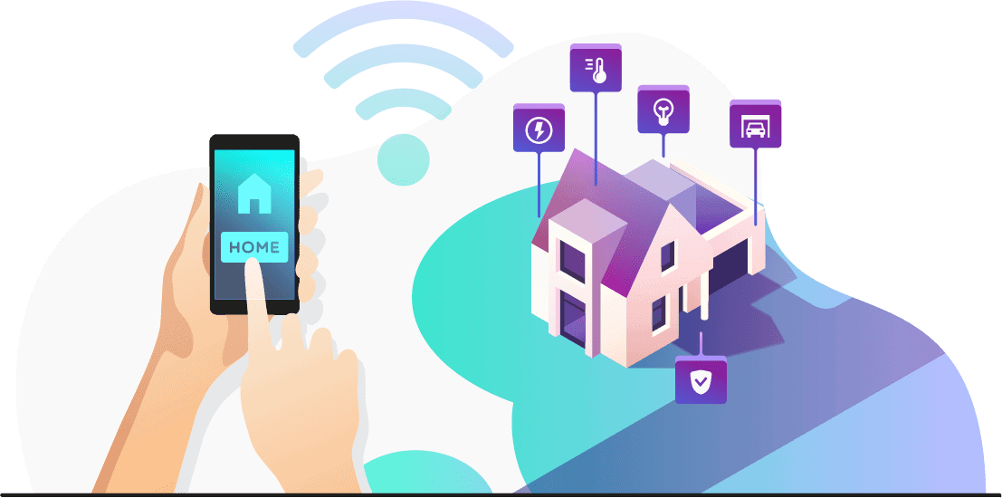
Fig. 1 Smart home automation services

- Review of Literature

Baoan Lia, Jianjun Yub,a discussed the current situation of IoT in detail. They presented the design of a smart home system based on IoT and different service component technologies with the help of software architecture and main modules.
Brijendra Singh, Muhammad Zubir Khan, Senthil J. analyzes various applications and challenges in the development of smart home environment using IoT. They found most of the home appliances are based on home security and provided energy efficient and cost effective solutions.Also they identified other challenges such as privacy, scalability, global standards, reasonable cost, device connectivity etc.
Jyotsna Gabhane, Shradha Thakare, Monika Craig presented the problems and challenges in IoT and smart home system using IoT. Also they highlighted some solutions which would help to overcome some problems and challenges.
Mohamed Abd EI-Latif Mowad, Ahmed Fathy, Ahmed hafez presented the hardware implementation of a multiplatform control system for house automation and combines both hardware and software technologies and the result of system showed the classification as comfortable, private, secure and economic system with great flexibility and reliability.
Rohit Kadam, Pranav Mahamunj,Yash Parikh presented a home energy management which is based on a different sensors to minimize the domestic energy waste according to our habits. By calculating the home power consumption and simulation of rooms lighting, they found the satisfactory result.
- Applications of Internet of Things(IoT)

A.Agriculture: In agriculture, devices using IoT technology can sense soil moisture and nutrients, with weather data, better control smart irrigation and fertilizer systems. If the sprinkler systems dispense water only when needed, for example, this prevents wasting a precious resource.

B. Consumer Use: For the citizen, IoT devices in the form of wearable and smart homes make life easier. Wearable cover accessories such as Smartphones, Apple watches, health monitors, etc. These devices improve entertainment, network connectivity, health, and fitness. Smart homes take care of things like activating environmental controls, privacy and security controls so that our house is at peak comfort when we come home.

C. Healthcare: IoT based hospitals monitor their patients’ health at home, thereby reducing hospital stays while still providing up to the minute real-time information that could save lives. In hospitals, smart beds keep the staff informed as to the availability, thereby cutting wait time for free space. Putting IoT sensors on critical equipment means fewer breakdowns and increased reliability, which can mean the difference between life and death.

D. Insurance: Even the insurance industry can benefit from the IoT revolution. Insurance companies can offer their policyholders discounts for IoT wearables such as Fitbit. By employing fitness tracking, the insurer can offer customized policies and encourage healthier habits.

E. Manufacturing: The world of manufacturing and industrial automation is another achievement of IoT. RFID and GPS technology can help a manufacturer track a product from its start on the factory floor to its placement in the destination store, the whole supply chain from start to finish. These sensors can gather information on travel time, product condition, and environmental conditions. Sensors attached to factory equipment can help identify bottlenecks in the production line, thereby reducing lost time and waste. Other sensors mounted on those same machines can also track the performance of the machine, predicting when the unit will require maintenance, thereby preventing costly breakdowns.
- Applications of Smart Home System

- Lighting: Lighting in the home can be adjusted automatically to meet the requirements of an individual. For example, when we go inside the house, the lights may be automatically switched ON without clicking a button. Also when we leave the house, the system may automatically switch down the lights to save energy. If people begin watching a movie, the lights may be set decrease automatically so that they do not disturb other people in home.
- Smart Bathrooms: In smart bathrooms, IoT technology may make our daily routine more convenient. If no one is in the bathroom, special sensors can detect movement and switch off the water automatically. Smart shower controls may also recognize people and set their preferred water temperature and pressure, as well as limit the amount of time spent in the shower to save water.
- Smart Kitchen: In Smart Kitchen, smart sensors will detect the leakage of gas. As soon as it detects the gas an alert message is send to the user and exhaust fan will be automatically switched on. We have additional sensors which will continuously monitor the oxygen level and the temperature of the room. Special built-in applications keep track of whether the user has enough food in the fridge (and record it if necessary), offer recipe suggestions, and assess the nutritional worth of meals.
- Security Systems: When we leave the house, the smart controllers can lock the entrance, close the shutters, switch off electronic gadgets, and ensure that our home is safe from human and animal intruders. Users may use the app on their phones to check on their homes and manage the temperature, humidity, and lighting remotely.
- Home Appliances: Smart appliances with the management are here and also provide status information to the users remotely. Smart washer/dryer can be controlled remotely and notify when the washing and drying are complete. Smart refrigerators can keep track of the item store and send updates to the users when an item is low on stock.
- Gardens: Sensors may be quite useful for people who want to cultivate their own veggies, fruit, and herbs at home. Users may check on the app to see whether the temperature is correct, if the plant is sufficiently hydrated, and if it is receiving enough sunshine. The software can track the present status of the soil, determine whether it has adequate moisture, and, if necessary, activate a smart irrigation system. The sensor recognizes when the amount of moisture reaches the ideal level and turns off the watering system, preventing water waste. IoT technology has resulted in a true breakthrough in gardening, which will fundamentally change the way plants are grown in the future.
- Doors and Windows: Our future doors will not require keys. The smart door may utilize face recognition to unlock your home. Any visitors who are not recognized as residents must be restricted inside the building by a resident. The doors may also be set to open as you approach your house and close as you depart. They can also set off a chain reaction in other gadgets in your house. The entry door may detect the authorized users and open, followed by the light turning on; other doors in the house may then open, and the TV and coffee machine may be switched on.
Smart windows can be programmed to respond to signals from other appliances as well as triggering events. You won't have to bother about closing the windows when you leave the house since the system will check for you and close them if necessary. Windows can be programmed to close or open at specific times, and shutters can open or close based on the time of day. As a result, the shutters may be raised in the morning and dropped at night. Weather conditions such as rain, snow, storms, or severe winds can potentially trigger these devices.

V.Technical Approach

Proposed System: As we enter the twenty-first century, mobile phones have become an integral part of our daily lives in today's innovation-driven environment. Cell phones aren't just for talking on the phone. With the use of cell phones, we are attempting better monitoring on local devices. The proposed task is to administer our cell phone's systems to all machines. The proposed device has practical insight circuits that are connected to house hardware. Every single household appliance's reputation can be built with the help of a buyer from afar using a person's cell phone.
Proposed System Functionality: The proposed system will provide the following features:
1. Watch the ongoing events with alerts
2. Control lights and fans
3. On/Off various apparatus

Procedure given for the proposed system
The first stage will be to create a chronology and read related works. We can begin implementing the layout and automation approach for the executable after looking into the benefits and drawbacks of past studies on the issue of home automation systems. The project's timeline is determined by the project's flowchart.
1. If a user wishes to switch on or off any home appliance he first needs to open the application integrated with the appliance and then press the button as displayed on the screen.
2. Once the button is pressed the application will send a message to the server containing the information about the action performed by the user.
3. The server will then send the desired commands to the Raspberry Pi with the help of IOT techniques and will wait for the execution of the commands.
4. Raspberry Pi is an integrated device having all instructions already loaded by the programmer accordingly to perform the different actions.
5. The signal is then received by a relay board which is an array of relays and switches having both input and output terminals. Every relays and switches are independently programmable. These boards help in switching appliances by controlling the flow of signal (voltage) through them.

VI. Problems and Challenges

With all the benefits of smart home technology, There are some problems, issues and key challenges in the smart home system.
Privacy and Security: As the applications of IoT are increasing rapidly, more devices are connected to the internet in a smart home system. Therefore there is a higher risk of malicious attack. Major requirements of smart home security and privacy are confidentiality, integrity, availability, authenticity, authorization, etc. Most of the devices available in market are more focused on connectivity but lack of security and are easily attacked by hackers. An attacker can get access to victims home and he would break the whole smart home system. Authentication is necessary to secure smart home system from an attacker. Server has to give access only authenticate users.
Connectivity: Connectivity is also the problem in any IoT system. It also comes into challenge that how to achieve connectivity at any place at any time. Since internet 4G services are used, sometimes it could have signal problem hence it will not connected every time.
Lack of Global Standards: Standardization is very essential for IoT environment as it is expanding globally. Lack of standards in IoT based smart home solutions remains great challenge because of heterogeneity of connecting devices and fractured solutions.
Interoperability: Interoperability means two or more systems can exchange the information without any disturbance. It is a significant challenge in smart home system in terms of communication and connectivity. Further these interoperability issues create problems such as development of cross-platform IoT based architecture, incompatibility of devices with other devices etc.
Affordable cost: As the number of devices increases in smart home system, cost of sensory networks, resource utilization is also increases. Affordable price plays a vital role in converting traditional home into smart home.

VII. Conclusion

This paper is based on the meaning of smart home and IoT .This article aims to analyze various applications and challenges in the development of IoT based smart home environments. We found that most of the applications are based on home security and home management to reduce the human efforts or domestic energy waste according to human efforts. Also it provide cost effective solutions for home management. There are some problems and challenges found in IoT and Smart Homes. We have identified security and privacy as a major challenge in most smart home applications.New technologies and methodologies would be help to minimize them.

REFERENCES
[1] J.Gabhane, S.Thakare, M. Craig, “Smart Homes System using Internet of Things: Issues,Solutions and Recent Resaerch Directions”,International Research Journal of Engineering and Technology,,vol.04,Issue:05, May 2017
[2] Mohamed Abd EI-Latif Mowad, Ahmed Fathy, Ahmed Hafez, “Smart home automated control system using android applicationand microcontroller”, International Journal of Scientific & engineering Research, vol.5,issue 5, May-2014.

[3 ] Z. Shouran, A. Ashari and T. Priyambobo, “ Internet of things(IoT) of smart home:privacy and security”,International Journal of Computer Applications,vol.182,no.39,pp.3-8,2019.
[4] Brijendra Singh, Muhammad Zubair Khan, Senthil J.,”Applications and challenges in IoT based smart homes”, International Journal of Mechanical Engineering,vol.6 no.3 December,2021.
[5]Rohit Kadam, Pranav Mahamunj, Yash Parikh,”Smart Home System”, International Journal of Innovative Research in advanced Engineering(IJIRAE),vol.2 Issue 1January 2015.
[6] https://www.simform.com/blog/home-automation-using-internet-of-things
[7] https://www.analyticssteps.com/blogs/9-applications-iot-home-automation

