**Phyto synthesis of Zinc Oxide Nanoparticles Mediated by Flavonoid Fraction Extracted From Melia Dubia Bark and Its Antioxidant, Anticancer and Photocatalytic Activity**

**Rosaline Vimala1..J*, Stella Bharathy2..M, Agila3.A, Margret Sheela 4.S and Vimala5.S**

**PG And Research Department of Chemistry, Holy Cross College (Autonomous) Tiruchirappalli-620 002.**

**Corresponding author E-mail:** [**rosalinevimala@hcctrichy.ac.in**](mailto:rosalinevimala@hcctrichy.ac.in)

**Orcid ID: 0000-0003-1245-3560**

**Abstract:**

Numerous phytochemicals have been successfully tested for their strong biological activity, and the results have been positive. For the "green" synthesis of metal nanoparticles, flavonoids found in plant materials function as reducing and electrostatic stabilising agents. In addition, these nanomaterials are useful for treating different cancer cells as well as harmful microbes. Hence, in the present research work flavonoids was used in the preparation of zinc oxide nanoparticles. Flavonoids’ decreased bioavailability due to its poorer solubility in aqueous medium limits the use of such dietary flavonoids. Numerous drug-delivery technologies are being researched as a means of overcoming bioavailability restrictions. To increase the therapeutic efficacy of flavonoids, flavonoids-mediated Zinc oxide nanoparticles were created here using a green method of synthesis. XRD, SEM, EDAX, FTIR, UV-Visible spectroscopy, and zeta potential were used to characterise ZnONPs. According to the findings, ZnONPs dispersion had a maximal UV-visible absorption at about 376nm. The synthesised nanoparticles are found to be irregular and spherical shape. They were further examined for their antioxidant and anticancer activity. Zinc oxide nanomaterials were tested for its catalytic activity in the degradation of Methylene blue and Rhodamine. The rate of free radical scavenging was between 85 and 93 % and the IC50 value of ZnONPs is 10 µg/ml shows that it has good cytotoxicity effect on MCF-7 cell line. The nanoparticle degraded 78.74% of methylene blue at 270mins and 68.02% of Rhodamine has been degraded within 480 minutes.

Key words: Flavonoids, XRD, SEM, EDAX, FTIR, UV-Visible spectroscopy, Zeta potential, methylene blue, Rhodamine, MCF-7 cell

line and IC50.

**Introduction:**

The development of novel techniques for creating nanoscale materials is the focus of nano chemistry, which belongs to the chemical and materials sciences. These materials have been studied for usage in a variety of fields, including biotechnology, complex materials, electronics, nanodevices and systems, medicine, and even the textile industry, which has intrigued scientists [1][2][3][4]. Nanomaterials' numerous practical uses can be attributed to their distinctive optical, catalytic, electrical, and physical characteristics [4,5]. Nanotechnology has the potential to improve energy usage regulation, assist in environmental cleanup, and address significant health problems. According to reports, nanotechnology parts will boost fabrication and construction at remarkably decreased costs because they will be smaller, less expensive, lighter, and more functional while requiring less energy and raw resources to produce it.

Green nanotechnology with potential benefits for sustainability, protection, and the general safety of humanity, is an interesting and rapidly developing field of science and technology [5]. In order to lessen risks to both human health and the environment, the green chemistry methodology presents a desirable approach to the synthesis, processing, and use of less dangerous chemicals [6]. The strategy necessitates a thorough comprehension of the raw materials, particularly in relation to their creation into nanomaterials and the ensuing bioactivities that pose minimal or no risks to people and the environment. The promise of reduced potential dangers allows us to engineer nanoparticles from available natural sources. Widespread interest is continually being drawn to the employment of biological agents as reducing, capping, and stabilising agents in the synthesis of MNPs [7]. The process uses microbes and plant products as reducing agents [8], creating safe conditions that are good for both humans and animals [9].

Because of the ability to metabolise heavy metals, plants may be involved in the conversion of metal ions into MNPs. The first plant apparently employed for the creation of AgNPs was lucerne sprouts [10]. The manufacture of MNPs has since been investigated using a number of bioactive compounds, including gold, silver, zinc, iron, copper, and platinum, as well as several plant species. Studies have demonstrated that a variety of substances, including proteins, amino acids, polysaccharides, and phytochemicals including flavonoids, alkaloids, tannin, and polyphenols found in plants, work together to reduce and stabilise MNPs [11,12]. Synthesis and purification are quicker and simpler with the plant-derived technique than they are with the microbial-mediated approach [10].

According to WHO it is found that over 80% of global population rely on medicinal plants to take care of their basic medical needs. India is one among the 12 megadiversity country with 45000 species of plants available. So, much of them are being explored for their medicinal properties. Based on their abundant supply of secondary metabolites, such as flavonoids, alkaloids, phenolics, terpenoids, tannins, glycosides, quinones, steroids, and saponins, medicinal plants have varied therapeutic qualities [13]. However, because they are unable to penetrate the lipid bilayer of cells, the majority of these chemicals have minimal absorption, which reduces their bioavailability and effectiveness [14]. Hence, in this particular study, the Flavonoids extracted from *Melia dubia* bark was used in the synthesis of Zinc Oxide nanoparticle and evaluate its biological efficacy as well in the degradation of dyes namely Methylene blue and Rhodamine.

**Experimental methods:**

**Collection, Extraction and Separation of Flavonoid Fraction from**

The bark of *Melia dubia* was collected in Trichy district and it was authenticated by Rapinate herbarium, St. Joseph’s College,

Trichy. The bark of *Melia dubia* was ground for a few minutes and sieved. From this about 50g of the dried powder was placed into the Soxhlet extractor. Using hexane as a solvent, first the extraction was carried out to remove non-polar materials. After the completion of extraction, the crude material was concentrated at below 40º C using rotary evaporator under reduced pressure. The left-over residual material of the bark was extracted with non-polar solvent Viz., chloroform followed by polar solvents namely ethyl acetate, ethanol, methanol to get flavonoid rich portion in the same way as done for hexane extract. The crude extracts were concentrated for quantitative estimation of flavonoids.

Methanol extract of *Melia dubia* bark was subjected to column chromatography for the separation of bioactive fraction

namely flavonoids. In the TLC the spots were developed in ethyl acetate: acetic acid: water: n-butanol solvent system. The spot was

collected and is subjected for characterization of flavonoids.

**Screening Test for Flavonoid:**

The separated fraction was subjected to alkaline reagent test and reduction test using magnesium and hydrochloric acid solutions to confirm the presence of flavonoids in it.

Their presence is further confirmed by examining the fraction using UV-Visible and FT-IR spectra.

**Synthesis Of Zinc Oxide Nano Material from Flavonoid Rich Fraction:**

About 35ml of Flavonoid’s rich fraction and 15ml of zinc acetate (0.001M) was taken in a 100ml beaker. The beaker is kept over a magnetic stirrer. The solution is stirred continuously for three hours until the solution turns yellow, maintained at a temperature of 40˚C. Then the solution is taken, cooled and kept overnight in refrigerator for the completion of the reaction. Then the mass is filtered using Whatman filter paper to separate the compound from the supernatant liquid. The residue is centrifuged to remove impurities and then it is dried in air oven for 8hrs at 80˚C for thorough reduction leading to the formation of zinc oxide nanoparticle. This is confirmed by the change in the intensity of colour.

**Characterisation Of Synthesised Nano Material:**

Analytical techniques, including energy-dispersive X-ray (EDX), Fourier transform infrared (FTIR), ultraviolet-visible (UV-Vis), and X-ray diffraction (XRD) Zeta potential analyses, to characterise the produced ZnONPs were employed. The generation of ZnONPs was principally confirmed using a UV-Vis spectrophotometer (UV Confirm 1800, Shimadzu, Japan), and the spectrum was recorded in the 300-500 nm region using methanol as a reference. The produced materials' phase and information on unit cell dimensions were determined using XRD. To determine the properties of functional groups resulting from the conjugation between nanomaterial and adsorbed biomolecules, the FTIR spectrophotometer (IRAffinity-1S, Shimadzu, Japan) was used. The produced powdered sample's FTIR spectra was captured using KBr pellet method in a wide wavenumber range (400-4000 cm1) with 20 scans and a resolution of 2 cm1. The produced material's surface morphology and elemental composition were investigated using a SEM with EDX (JEOL Jsm-6480 LV). By scanning the sample with a concentrated electron beam from an electron gun while providing a 15 kV acceleration voltage, a high-quality surface image of the sample was created. The zeta potential was measured using a Zeta sizer (Nano-ZS; Malvern Instruments Ltd., Malvern. The nanoparticles solutions were diluted in distilled water placing 50 *μ*L of the sample in 2 mL of distilled water.

**Anti-oxidant activity by DPPH method:**

0.3 mM solution of DPPH reagent was prepared by dissolving 11.82 g of DPPH in 100 mL of methanol. Sample stock solution was made by 0.01g in one mL(100mg/mL) and from that different concentration were prepared such as 5, 25, 50, 100, 200, 400 µg/mL. One mL of different concentration of sample solution was mixed with two mL of DPPH reagent and allowed to reach room temperature. Thirty minutes later, the absorbance was recorded at 517nm and the percentage of radical scavenging activity i.e. anti-oxidant activity was calculated by following standard formulae. Control reading was recorded by one mL of solvent with two mL of DPPH reagent.



**Ab of control** - Control Absorbance, **Ab of test**- Test solution Absorbance

The IC50 values were calculated by linear regression of plots, where the abscissa represented the concentration of the tested sample and the ordinate the average percent of radical scavenging activity.

**Anti- Cancer Activity:**

**Source Of Chemical and Reagents:**

Dulbecco’s Modified Eagle’s Medium, streptomycin, penicillin-G, L-glutamine, phosphate buffered saline, 3-(4,5 dimethylthiozol-2-yl)-2,5-diphenyltetrazoliumbromide, 2’7’diacetyl dichloro fluorescein, sodium dodecyl sulphate, trypan blue, trypsin-EDTA, ethylene diamine tetra acetic acid, acridine orange, ethidium bromide, rhodamine-123, Striton X-100, ethanol, dimethyl sulfoxide (DMSO), and bovine serum albumin were purchased from Sigma Aldrich Chemicals Pvt. Ltd (India). All other chemicals used were of analytical grade, purchased from Hi media Laboratories Pvt. Ltd., India.

**Cell Culture Maintenance:**

Human breast cancer MCF-7 cell lines were procured from the Cell repository of National Centre for Cell Sciences (NCCS), Pune, India. Dulbecco`s Modified Eagle Media(DMEM) was used for maintaining the cell line, which was supplemented with 10% Fetal Bovine Serum (FBS). Penicillin (100 U/ml), and streptomycin (100 μg/ml) were added to the medium to prevent bacterial contamination. The medium with cell lines was maintained in a humidified environment with 5% CO2 at 37°C.

**MTT Assay:**

The cytotoxicity of ZnONPs on MCF-7 cells was determined by the method of Mosmann, (1983).

**Evaluation of the degradation property of biosynthesized ZnONPs on methylene blue dye and Rhodamine:**

The catalytic activity of the nanomaterial was tested for its reduction behaviour of methylene blue and Rhodamine dye. About 3ml of the test sample (each of the dye material of 0.1M) treated with 500µg/ml of flavonoid mediated ZnONPs stirred using a magnetic stirrer was evaluated for its percentage removal by recording its absorbance using UV-Visible spectrophotometer for every 30 minutes interval. The percentage removal was calculated with the help of the standard calibration curve obtained by measuring the absorbance of untreated methylene blue of varied concentrations (0.1M to 1M) using the formula.

$$\% of Dye Degraded=\frac{I.C-F.C}{I.C}×100$$

Where,

***I.C***- Initial Concentration of the dye

***F.C***- Final Concentration of dye

**RESULTS AND DISCUSSION**

**Thin Layer Chromatographic Analysis of separated bioactive compound:**

Melia dubia leaf extracts in methanol were separated and collected using column chromatography as a fraction. Ethyl acetate, acetic acid, water, and n-butanol were utilised as the mobile phase for the elution of spots in preparative TLC in the ratio of 7:1:1:0.25. Similar spot-showing fractions were pooled and further taken for purification. The chosen mixed fraction is once further purified using column chromatography**.** The dried solid powder developed spot with Rf value of 0.36.

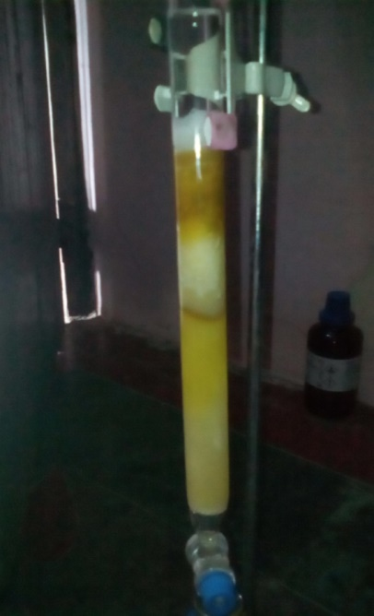

**Figure-1: Separation of bioactive principle by Column chromatography**

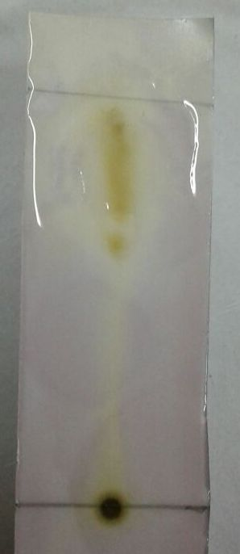

**Figure-2: TLC of Dried material**

**Confirmation of flavonoid in Methanolic Extract:**

The screening tests for flavonoids include the magnesium, alkaline reagent, and hydrochloric acid reduction tests. The positive results for flavonoids are displayed in figures 3 and 4, which support the presence of flavonoid components in methanol extract.

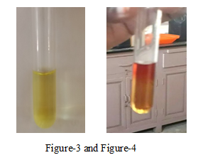

**UV-Visible Spectra of flavonoid fraction:**

From the result of UV spectral studies two absorption peaks at 298nm and 354nm, it is due to two aromatic rings in flavonoid nucleus as seen in figure-5. This is an indication for the presence of flavonoids in the separated fraction.

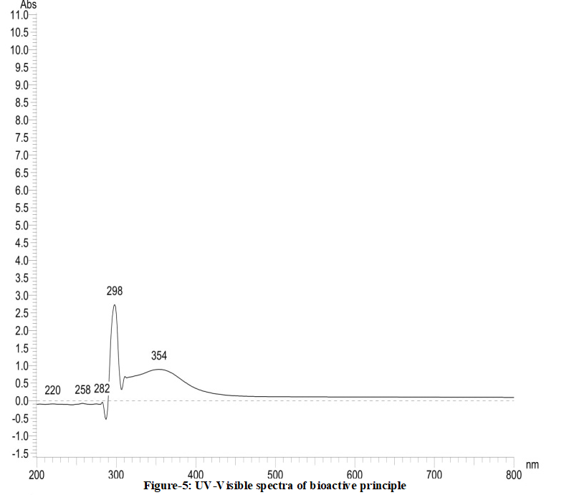

**Figure-5: Electronic Spectra of flavonoid fraction**

**FT-IR Study:**

Fourier-Transformation Infrared spectroscopy done for the separated fraction shows vibrational frequency of C=O, and free OH at 3365 cm-1, 1612 cm-1 which are the characteristic peaks for flavonoid compounds apart from the other peaks in the spectra(figure-6).

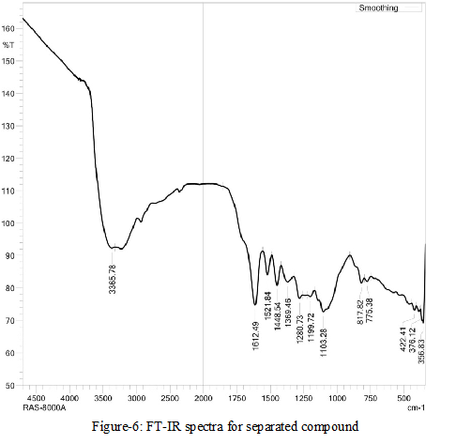

Figure-6: FT-IR of separated flavonoid fraction

**Characterization of ZnO Nanoparticles:**

The characterization study of zinc oxide nanoparticles was done with the various characterization techniques such as UV-Visible spectroscopy, FT- IR spectroscopy, Scanning Electron Microscopy (SEM), Energy Dispersive X-ray spectroscopy (EDX), X-ray Diffraction spectroscopy (XRD) and the stability was determined by finding its zeta potential.

**UV- Visible Spectroscopic Analysis:**

A colour change confirms the preliminary identification of ZnONP formation. Initially the flavonoid fraction is light in yellow colour and after adding Zinc acetate it changes into dark yellow which support the ZnONPs formation (figure-7a and 7b). The characterization of ZnONPs by UV- visible spectroscopy is one of the most powerful techniques. The spectrum of the absorption of the light by zinc oxide nanoparticles were observed in the UV range of 376nm with the sample using methanol as the reference since it is soluble in it. The peaks are observed at 376nm is due to the phenomenon of surface Plasmon resonance which occurs due to the excitation of molecules that is the surface plasmons present on the outer surface of the zinc oxide nanoparticles which gets excited to the presence of applied electromagnetic radiation as seen in figure-8.

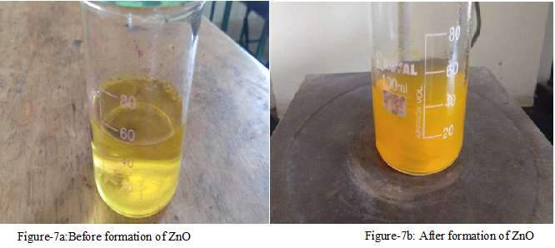

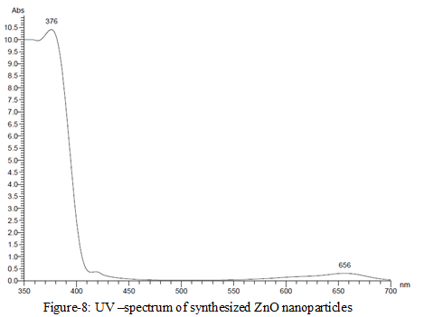

**Figure-8: UV-Visible Spectrum of Synthesised ZnO Nps**

**FT-IR Spectroscopic Analysis:**

The result of FT-IR spectrum of ZnO nanoparticles obtained by the bio-reduction process were studied. In the flavonoid fraction of the extract peaks (from figure-6) are observed at 3365.78 cm-1,1612.49 cm-1,1521.84 cm-1,1448.54 cm-1,1369.46 cm-1, 1280.73 cm-1,1369.46 cm-1,1103.28 cm-1,817.82 cm-1,775.38 cm-1 which are associated with NH stretching, C=C stretching, C-O stretching, C-H bending, O-H stretching, C-O stretching-H stretching, C-Cl stretching, C-H bending. In the bio synthesized zinc oxide nanoparticles(figure-9) the peaks are observed at 3427.36 cm-1,2938.09 cm-1, 2142.77 cm-1, 1863.85 cm-1, 1600.69 cm-1, 1296.05 cm-1, 971.03 cm-1, 879.94 cm-1,726.62 cm-1,688.29 cm-1,597.78 cm-1 which are associated with N-H stretching, C-H stretching, C≡N stretching, C=O stretching, C=C stretching-O stretching, C=C bending, C=C bending=C bending ,C-Br stretching-Cl stretching. The *Melia dubia* plant extract shows broad peak at 3365.78 cm-1 which indicate the presence of OH group or carboxyl groups and after synthesis of ZNOPs there is a shift in the broad peak to the left at 3427.36 cm-1 indicating that compound having (mostly flavonoid’s) OH group is involved in the reduction process. The peak at 1612.49 cm-1 in compound are shifted to 1600.69 cm-1 in synthesized ZNOPS which indicates the compound having C=O function group may involve in the reduction process.



**Figure-9: FT-IR spectrum of biosynthesized ZnO nano particle**

**Scanning Electron Microscope (Sem):**

The morphological information like the size and shape of the biosynthesized ZnO nanoparticles were studied by the scanning electron microscope. From the result of SEM images (figure-10a and 10b), it is found that, the nano rectangular size of ZnO was formed.

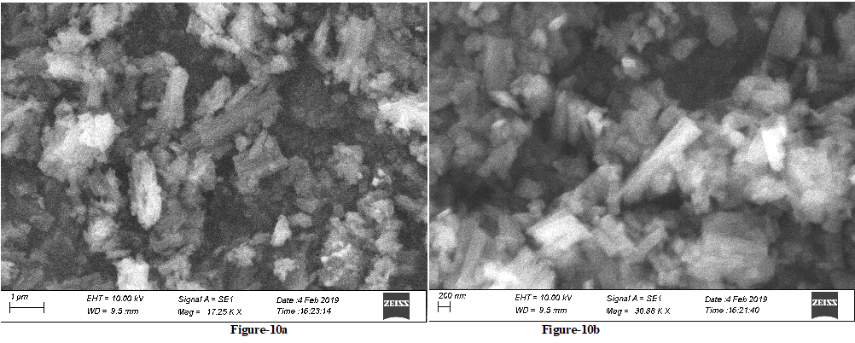

**X-Ray Diffraction Analysis Spectroscopy:**

The powdered XRD result, figure-11, confirms the ZnO plane in bio synthesized material. The graph shows the main planes corresponding to 2θ values of 32.23°, 33.15°, 37.49°, 39.62°, and 41.32°. The peaks are good agreement with the literature report (JCPDS File no.5-0566). The location of the peaks is compared with the literature values and the presence of zinc oxide particles is confirmed from figure-11.



**Figure-11: XRD pattern of flavanoid-Zinc oxide nano material**

**EDX Analysis:**

Figure-12 shows the EDX spectrum of ZnO nanoparticles. EDX spectrum shows three peaks which are identified as zinc and oxygen that reveals that pure ZnO nanoparticles has been prepared.



**Figure-12: EDX analysis of ZnO nano particles**

**Zetapotential:**

The zetapotential associated with the stability of the zinc oxide nanoparticle is found to be -12.2mV as shown in figure-13. The value is associated with the agglomeration which is seen in almost all systems where a high zeta potential shows that the agglomeration is less.



**Figure-13: Zeta Potential Distribution for ZnO nanoparticle**

**Anti-oxidant Activity of Bio-Synthesized ZnO Nanoparticles:**

Radical scavengingactivity of biosynthesized ZnO obtained using flavanoid portion separated from methanol extract of *Melia dubia* bark was determined by DPPH assay method. The results reveal that, the ZnO material shows greater inhibitory effect towards antioxidant activity. 0.1mg of ZnO exhibits 85.54% of inhibition and it gets increased when increase the amount of ZnONPs. The IC50 value of the synthesized ZnO Nps is 0.059 mgand its results are displayed in Table-1. When the amount of ZnONP increases the absorption is decreased and % of Inhibition is increased which is shown in figure-15.

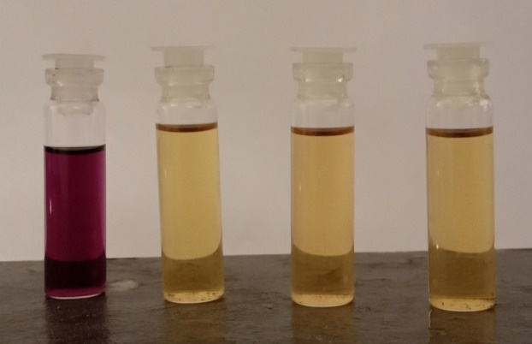

**Figure-14:DPPH assay method**

**Table-1: Antioxidant Assay for flavanoid-Zinc oxide nano particle**

|  |  |  |  |  |
| --- | --- | --- | --- | --- |
| **S.No.** | **Weight of the Nano material(mg)** | **Sample OD** | **Control OD** | **% Inhibition** |
|  | 0.1 | 0.250 | 1.73 | 85.54 |
|  | 0.2 | 0.229 | 1.73 | 86.76 |
|  | 0.3 | 0.197 | 1.73 | 88.61 |
|  | 0.4 | 0.150 | 1.73 | 91.32 |
|  | 0.5 | 0.112 | 1.73 | 93.52 |

**Figure-15: Graphical representation of percentage of inhibition Vs amount of ZnONps**

**In-vitro breast cancer activity of Flavanoids mediated Zinc Oxide nanoparticle by MTT assay method**

The Human breast cancer cells were treated with increasing concentration of NPs (2.5-40 µg/ml) for 24 h and the results are expressed as a percentage of the control value in presenting as a cell cytotoxicity ratio for MCF-7 cells using MTT assay. Data are presented as mean ± SD asterisks indicate statically different experiments compared to control. Concentration verses cell viability percentage result of ZnO Nps produced from flavonoid fraction is shown in figure-16. The IC50 value is obtained from the concentration verses cell viability graph. It referred the 50% of cell is destroyed by the biosynthesized zinc oxide nanoparticle and lower IC50 value means higher anticancer activity of the compound. The IC50 value is found to be 10 µg/ml.Figure-17 shows the morphological changes in control and NPs treated human breast cancer MCF-7 cells for 24 h.

**Cytotoxicity of the Flavanoids mediated Zinc Oxide nanoparticle**

Cytotoxicity level of the flavanoids mediated zinc oxide nanoparticle was evaluated from the IC50 value got from concentration verses cell viability graph. It has been reported that when the IC50 value is below 20 µg/ml it shows cytotoxicity effect on MCF-7 cells, 21 µg/ml to 40 µg/ml is weak cytotoxicity and above 40 µg/ml is not considered as toxic. The IC50 value of flavanoids mediated zinc oxide nanoparticle is 10 µg/ml shows that it has good cytotoxicity effect on MCF-7 cell line.

Photomicrograph (40x) represents morphological changes in MCF-7 cells such as shrinkage, detachment, membrane blebbing and distorted shape induced by NPs treatment (10 and 30 µg/ml for 24 h) as compared with control(figure-17). Control showed normal intact cell morphology and their images were captured by light microscope. The nanoparticle has destroyed the cells when the concentration was found to be 30 µg/ml as compared to the control.

**Figure-16: Anti-proliferative effects of Nanoparticles on the activity of cytotoxicity in MCF-7 cells.**

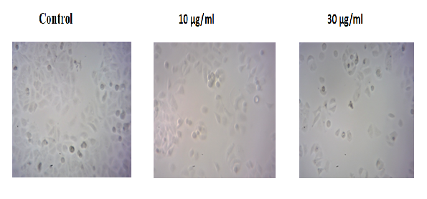

**Figure-17:** morphological changes in MCF-7 cells

**Photocatalytic Degradation of Methylene Blue And Rhodamine Dye Using Phytosynthesized ZnONps:**

Zinc oxide nanomaterials were found to have good catalytic activity in the degradation of organic dyes and other chemicals. Standard graph of methylene blue and Rhodamine are shown in figure-18. Untreated and biosynthesized ZnONPs treated methylene blue dye and Rhodamine UV-Visible spectral results are shown in figures-19 and 20. From the tables-2 and 3 and the figures clearly explain that untreated dye materials show maximum absorbance, while ZnONPs treating methylene blue and Rhodamine exhibits lower absorbances. Flavonoids mediated zinc oxide nanoparticles have suppressed or degraded 78.74% of methylene blue at 270mins and 68.02% of Rhodamine has been degraded within 8 hours. (Table-2 and 3).

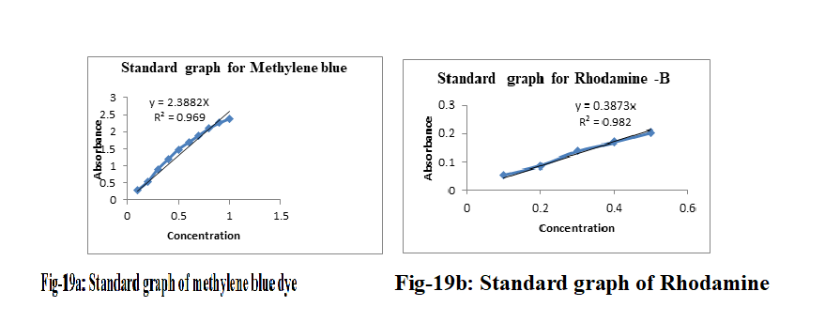

**Figure-18: Standard Calibration Curve for Methylene Blue and Rhodamine-B**

**Table-2: Results of percentage of degradation of methylene blue dye by Flavanoids mediated ZnONPs**

|  |  |  |  |
| --- | --- | --- | --- |
| **S. No.** | **Time in Minutes** | **Absorbance** | **% of dye degradation** |
| 1 | 0 | 0.2475 | 0 |
| 2 | 30 | 0.21936 | 11.37 % |
| 3 | 60 | 0.19304 | 22.00 % |
| 4 | 90 | 0.15954 | 35.54 % |
| 5 | 120 | 0.13077 | 41.16 % |
| 6 | 150 | 0.1024 | 58.63 % |
| 7 | 180 | 0.07832 | 68.36 % |
| 8 | 210 | 0.0699 | 71.76 % |
| 9 | 240 | 0.06419 | 74.06 % |
| 10 | 270 | 0.05262 | 78.74 % |

**Table-2: Results of percentage of degradation of Rhodamine by Flavanoids mediated ZnONPs**

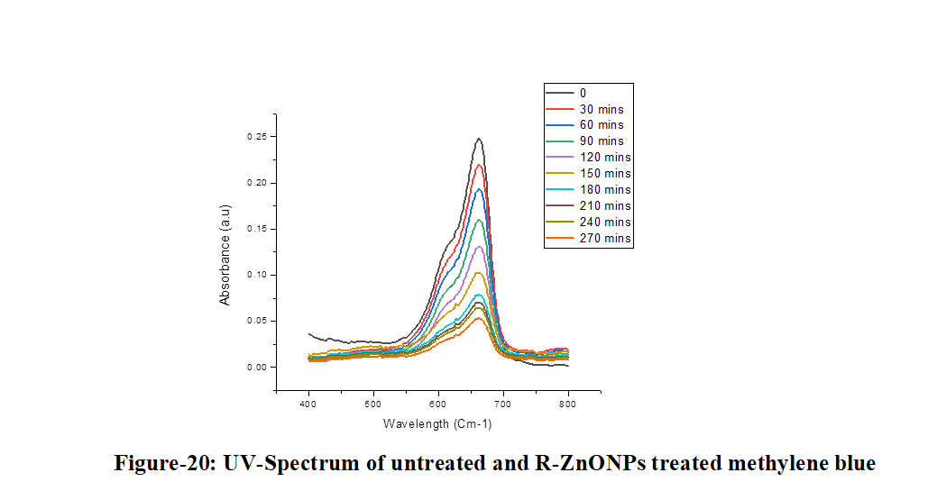

|  |  |  |  |
| --- | --- | --- | --- |
| **S.No** | **Time in hours** | **Absorbance** | **% dye degradation** |
| 1 | 0 | 0.18257 | 0 |
| 2 | 1 | 0.16014 | 13.28% |
| 3 | 2 | 0.13766 | 26.59% |
| 4 | 4 | 0.10915 | 43.36% |
| 5 | 6 | 0.08941 | 55.17% |
| 6 | 8 | 0.06768 | 68.02% |

**Figure-19: UV-Spectrum of Untreated and treated ZnONps in the degradation of Methylene Blue**

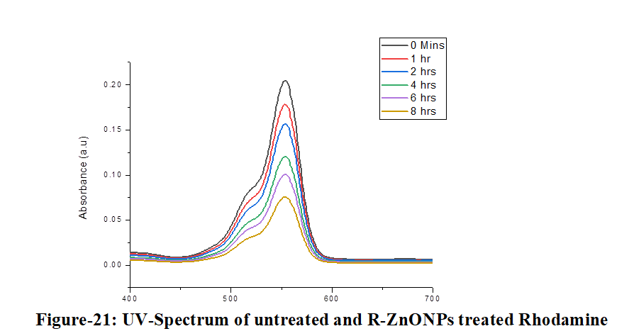

**Figure-20: UV-Spectrum of Untreated and treated ZnONps in the degradation of Rhodamine**

**Conclusion:**

As a result of the research indicated above, it was determined that the investigated plant contained flavonoids in the separated fraction which was confirmed from TLC, UV-Visible and FT-IR spectra. The bio reduction of zinc acetate solution using flavonoid’s rich portion of methanolic extract obtained from *Melia dubia* bark were successfully obtained. Zinc oxide nanoparticles have been appropriately characterized using UV- Visible spectroscopy, SEM and XRD analysis. FTIR analysis revealed the efficient capping and stabilization properties of these ZnONPs. The XRD patterns confirmed the purity, phase composition and nature of the synthesized nanoparticles. Zinc oxide nanoparticles were confirmed from the EDAX spectrum.The particles also exhibit good antioxidant activity and cytotoxicity towards MCF-7 cell lines which shows that it greater efficacy towards human breast cancer.

**References:**

1. Dikshit, P.; Kumar, J.; Das, A.; Sadhu, S.; Sharma, S.; Singh, S.; Gupta, P.; Kim, B. Green Synthesis of Metallic Nanoparticles: Applications and Limitations. J. Catal. 2021, 11, 902.
2. Salem, S.S.; Fouda, A. Green Synthesis of Metallic Nanoparticles and Their Prospective Biotechnological Applications: An Overview. Biol. Trace Elem. Res. 2020, 199, 344–370.
3. Abdelbasir, S.M.; Shalan, A.E. An overview of nanomaterials for industrial wastewater treatment. Korean J. Chem. Eng. 2019, 36, 1209–1225.
4. Patra, J.K.; Baek, K. Green Nanotechnology: Factors Affecting Synthesis and Characterization. J. Nanomater. 2014, 2014, 1417305.
5. Ovais, M.; Khalil, A.T.; Ayaz, M.; Ahmad, I.; Nethi, S.K.; Mukherjee, S. Biosynthesis of metal nanoparticles via microbial enzymes: A mechanistic approach. Int. J. Mol. Sci. 2018, 19, 100.
6. Da Silva, B.F.; Pérez, S.; Gardinalli, P.; Singhal, R.K.; Mozeto, A.A.; Barceló, D. Analytical chemistry of metallic nanoparticles in natural environments. TrAC Trends Anal. Chem*.* **2011**, *30*, 528–540.
7. Shah, M.; Fawcett, D.; Sharma, S.; Tripathy, S.K. Green Synthesis of Metallic Nanoparticles via Biological Entities Green Synthesis of Metallic Nanoparticles via Biological Entities. Materials **2015**, *8*, 7278–7308.
8. Elbagory, A.M.; Meyer, M.; Cupido, C.N.; Hussein, A.A. Inhibition of Bacteria Associated with Wound Infection by Biocompatible Inhibition of Bacteria Associated with Wound Infection by Biocompatible Green Synthesized Gold Nanoparticles from South African Plant Extracts. Nanomaterials **2017**, *7*, 417.
9. Bar, H.; Bhui, D.K.; Sahoo, G.P.; Sarkar, P.; De, S.P.; Misra, A. Green synthesis of silver nanoparticles using latex of Jatropha curcas. *Colloids Surf. A Physicochem.* Eng. Asp*.* **2009**, *339*, 134–139.
10. Mittal, A.K.; Chisti, Y.; Banerjee, U.C. Synthesis of metallic nanoparticles using plant extracts. Biotechnol. Adv. 2013, 31, 346–356.
11. Espinosa, J.C.M.; Cerritos, R.C.; Morales, M.A.R.; Guerrero, K.P.S.; Contreras, R.A.S.; Macías, J.H. Characterization of silver nanoparticles obtained by a green route and their evaluation in the bacterium of pseudomonas aeruginosa. Crystals 2020, 10, 395.
12. Thakkar, K.N.; Mhatre, S.S.; Parikh, R.Y. Biological synthesis of metallic nanoparticles. Nanomed. Nanotechnol. Biol. Med. 2010, 6, 257–262.
13. Ahmad, T.; Bustam, M.A.; Irfan, M.; Moniruzzaman, M.; Asghar, H.M.A.; Bhattacharjee, S. Mechanistic investigation of phytochemicals involved in green synthesis of gold nanoparticles using aqueous Elaeis guineensis leaves extract: Role of phenolic compounds and flavonoids. Biotechnol. Appl. Biochem. 2019, 66, 698–708.
14. Plants, M.; Van Wyk, B.B.; Van Oudtshoorn, B. Turning folklore into an ethnomedicinal catalogue. S. Afr. J. Sci. 2009, 105, 250.
15. Singh, S.; Krishna, T.H.A.; Kamalraj, S.; Kuriakose, G.C.; Valayil, J.M.; Jayabaskaran, C. Phytomedicinal importance of Saraca asoca ( Ashoka ): An exciting past, an emerging present and a promising future. Curr. Sci. 2015, 109, 1790–1801.