SYNTHESIS, STRUCTURAL AND ELECTRICAL PARAMETERS OF PURE AND Cu DOPED ZnS NANOPARTICLES
N.KALAISELVI¹, K.U.MADHU²
¹ Department of Electronics, S.T.Hindu College, Nagercoil– 629002
² Department of Physics, S.T.Hindu College, Nagercoil– 629002,
Abstract
The structural and electrical parameters of both pure and copper doped ZnS nanoparticles are reported in this paper. The nanoparticles were prepared by co-precipitation method. The influence of the dopant on the structural behavior was examined by Powder X-ray diffraction analysis. The dielectric constant(εr), dielectric loss factor(tanδ), and the electrical conductivity measurements were carried out for the pure and doped samples.

Keywords: Co-precipitation method, Structural behavior, Electical conductivity.

Introduction
Among the II-VI semiconductors, ZnS is one of the most important one with a wide direct bandgap of 3.77 eV, which has remarkable properties and can be used in a variety of applications, including optical coating, electro-optical modulator, light guides, optical sensors, phosphors, reflectors. , dielectric filter, window material, stool screen and other light emitting materials. Compared with bulk ZnS, nanosized ZnS has unique physical and chemical properties such as surface to volume ratio, quantum size effect, surface and volume effect and macroscopic quantum tunneling effect, higher optical absorption, chemical activity and heat resistance, catalysis and low melting . temperature [1, 2, 3]. ZnS is also a low-cost and non-toxic material having high resistance to photochemical degradation[4] Compared to ZnO nanostructures, on the other hand, ZnS nanostructures have not been studied in great detail [5]. Using several methods the synthesis of ZnS nanoparticles have been carried out, such as wet chemical [6-8, 9], microemulsion [10], chemical vapor deposition [11], hydrothermal technology [12], etc. In this chapter, we deal with the synthesis and characteristics of zinc sulphide nanoparticles obtained by co-precipitation method. Co-precipitation is also a simple method for synthesising nanoparticles that can be made in a variety of sizes. The purpose of the study is to synthesize the pure and Cu doped zinc sulphide nanoparticles and the changes of dopping Cu on its structural and electrical properties.
Experimental Detail
Co-precipitation method was used in the preparation of ZnS nanoparticles. Sodium sulphide (Na₂S.7H₂O) and zinc acetate (Zn (CH₃COO)₂ · 2H₂O). were used as the reactants.
Cupric acetate (Cu (CO₂CH₃)₂ · H₂O) was used as a dopant and distilled water was used as a solvent.
In a typical process of pure ZnS nanoparticles, zinc acetate and sodium sulphide were taken in 1:3 molecular ratio and dissolved separately in 200 ml of distilled water. Under stirring condition of zinc acetate solution, sodium sulphide solution was added drop wise. The mixing mode is continued until a precipitate is obtained. The obtained precipitate was in colloidal state. It was washed several times with distilled water and then with acetone to remove organic impurities. Washed samples were dried in atmospheric air and collected. Similar, procedure were carried out for the preparation of both 5wt% and 10 wt% Cu doped ZnS nanoparticles for the preparation doped ZnS nanoparticles.
Characterization
The crystal structure of pure and doped samples were analyzed by the powder x-ray diffraction. AC electrical measurements were made by the conventional parallel plate capacitor method using an Agilent 4284A LCR meter at various temperatures and frequencies.
Results & Discussion
Figure 1 to 3 shows The PXRD pattern of pure and Cu (5 and 10 wt %) doped ZnS nanoparticles. All the diffraction peaks present in the PXRD pattern of pure and Cu doped ZnS nanoparticles can be indexed using the JCPDS file (05-0566) data. From the PXRD pattern the average size of the crystal and lattice parameters were determined .The Scherer formula was used to find the average crystallite size and it is found to be 3-4 nm. The average particle size increase with increase in the addition of dopant. It confirms that the enclosure of dopant into the host matrix. The peaks corresponding to Cu were not indexed in the PXRD pattern of Cu-doped ZnS nanoparticles because only a small amount of copper acetate was added as an impurity.But significant changes in the position of host peaks were noticed in the PXRD pattern of Cu doped ZnS nanoparticles. From the indexed PXRD pattern the structure of prepared pure and Cu doped ZnS nanoparticles were found to be cubic with lattice parameter a = 5.368(4) Ǻ. For all samples of ZnS doped with Cu ions, strong absorption peaks were observed to the lattice planes of (111), (220) and (311) [13,14]. The doping causes the peak broadening and decrease in the intensity of the peaks. The sharpness of the peak exhibits the nanoparticles are perfectly crystallized.

Table 1: Average grain size
System(with expected) | Grain size(nm)
Pure ZnS | 3.11
5wt% Cu doped ZnS | 3.86
10wt% Cu doped ZnS | 4.74

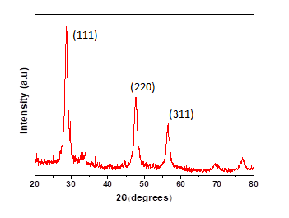
Figure:1 PXRD pattern for pure ZnS nanoparticles

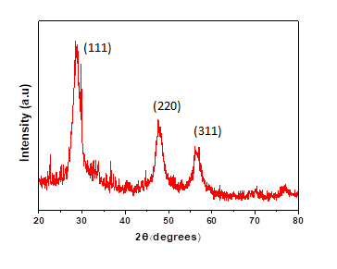
Figure 2: PXRD pattern (5 wt% Cu doped ZnS NP)

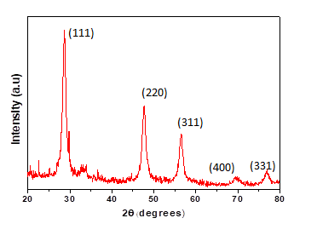
Figure 3: PXRD pattern (10 wt% Cu doped ZnS NP)

The behavior of electrical parameters like dielectric constant, dielectric loss factor and AC electrical conductivity in relation to frequency and temperature is shown in Figures 4-12. The variation of the dielectric constant at different frequencies and temperatures is shown in Figures 4-6. The dielectric constant of all prepared samples were found to be increased as temperature increases and decreases as frequency increases.
Figures 7 to 9 shows how the variation occurs for dielectric loss with frequency and temperature. The dielectric loss coefficient was found to be increasing as temperature increases and decreasing as frequency increases in all prepared samples. The relaxation time of the charge transport caused the dielectric constant to change in the applied field. In heterogeneous structures, space charge polarization dominated and this leads to a decrease in the dielectric constant as the frequency increases. 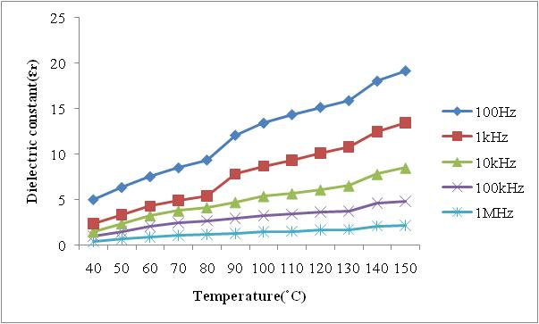
Figure 4: Dielectric constant for pure ZnS nanoparticles
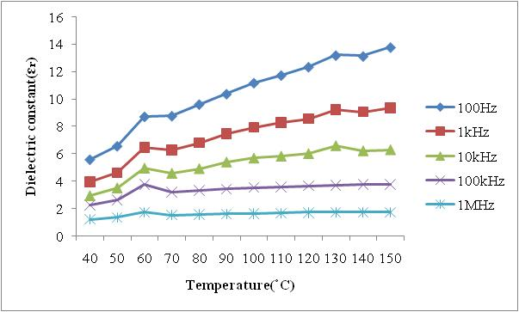
Figure 5: Dielectric constant for 5wt% Cu doped ZnS nanoparticles

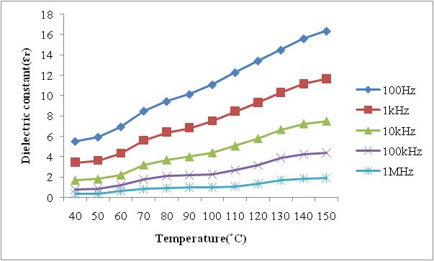
Figure 6: Dielectric constant for 10wt% Cu doped ZnS nanoparticles

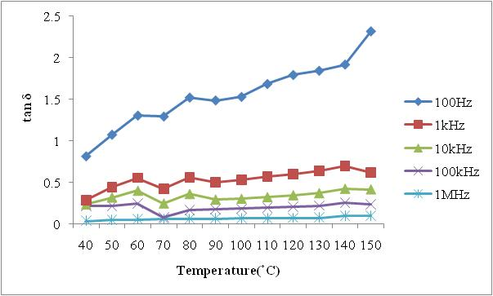
Figure 7: tan δ for pure ZnS nanoparticles
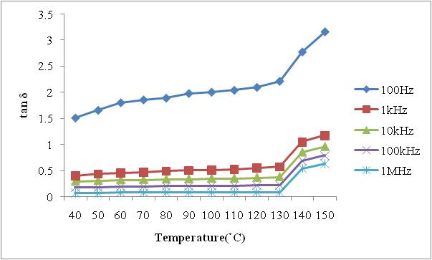
Figure 8: tan δ for for 5wt% Cu doped ZnS nanoparticles

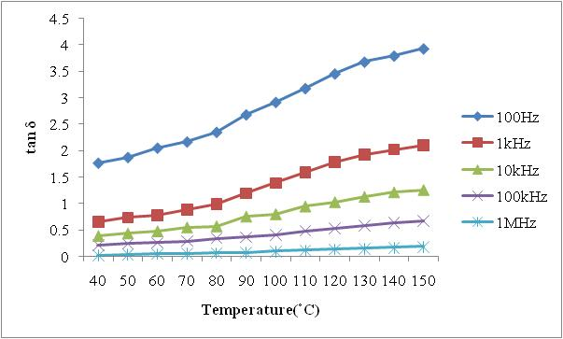
Figure 9: tan δ for 10wt% Cu doped nanoparticles

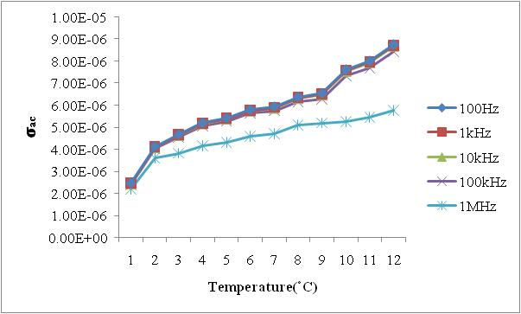
Figure 10: $σ_{ac}$ for pure ZnS nanoparticles

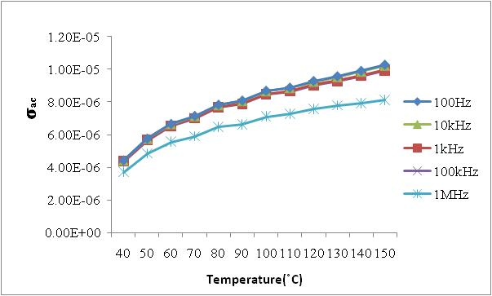

Figure 11: $σ_{ac}$ for 5 wt% Cu doped ZnS nanoparticles

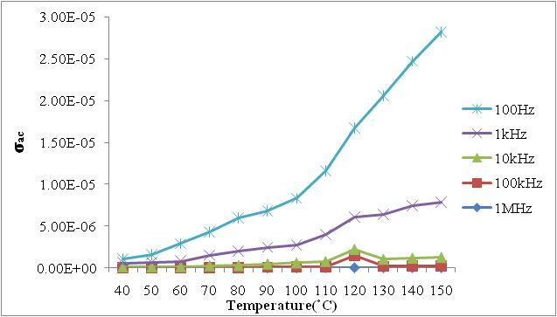

Figure 12: $σ_{ac}$ for 10 wt% Cu doped ZnS nanoparticles

The variation of AC electrical conductivity with frequency and temperature is shown in Figures 10 - 12. It was observed that for all the prepared samples, AC electrical conductivity increases with increasing temperature and frequency. Here, the AC electrical conductivity increases with increasing frequency, and thus the conduction mechanism of the fabricated samples is a local conduction mechanism. Also, the conduction process was due to small polaron hopping, as the conduction increases with frequency.The conductivity of the material is low at low temperatures because the mobility of ion is very low at low temperatures. When the temperature increases the mobility of ion increases thereby increasing the space-charge polarization which in turn the value of capacitance [15 ,16].

Conclusion:
The chemical co-precipitation method was adopted in the preparation of Pure and Cu-doped ZnS nanoparticles. X-ray diffraction pattern was used to study the structural properties, the particle sizes increase from 3.1 nm to 4.7 nm with a cubic structure. Dielectric constant and dielectric loss factor increase with increasing temperature and decrease with increasing frequency. AC conductivity values ​​were observed to be increased as the temperature and frequency increases. The obtained results showed a good performance of nanostructured materials.

References:

1. Kaur N, Kaur S, Singh J, Rawat M. A ,”Review on Zinc Sulphide Nanoparticles: From Synthesis, Properties to Applications”, J Bioelectron Nanotechnol ,1(1) 5, 2016.

2 . lC.S. Pathak , M.K. Mandal , V. Agarwala ,”Synthesis and characterization of zinc sulphide nanoparticles prepared by mechanochemical route “ Superlattices and Microstructures,Vol 58, Pages 135-143, 2013.
3.Ong HC, Chang, “ RPH. Optical constants of wurtzite ZnS thin films determined by spectroscopic ellipsometry”, Appl Phys Let, 79(22): pages 3612–314,2001.
4.Dilpazir S, Siddiq M, Iqbal , “A. Synthesis of zinc sulphide nanostructures by Co-precipitation: effects of doping on electro-optical properties”. Kenkyu J Nanotechnol Nanosci, 1: 34–9, 2015.
5. X. Fang, T. Zhai, U. K. Gautam, L. Li, L. Wua, Y. Bando and D.Golberg, “ZnS nanostructures: From synthesis to applications,” Progress in Materials Science, vol. 56, pages. 175-287, 2011.
6. A. A. Khosic, M. Kundu, L. Jatwa, S. K. Deshpande, U. A.Bhagwat, M. Sastry and S. K. Kulkarni, “Green luminescence fromcopper doped zinc sulphide quantum particles,” Applied PhysicsLetters, Vol. 67, pages 2702–2704, 1995.

7. N. Dixit, H. Soni, M. Chawda and D. Bodas, “Study of electrical and optical properties of Mn doped ZnS clusters,” Materials Letters, vol. 63, pages 2669-2671, 2009.

8. H. Soni, M. Chawda and D. Bodas, “Electrical and optical characteristics of Ni doped ZnS clusters,” Materials Letters, vol. 63, pages 767-769, 2009.

9. D. Denzler, M. Olschewski and K. Sattler, “Luminescence studiesof localized gap states in colloidal ZnS nanocrystals,” J. Applied Physics, vol. 84, pages. 2841-2845, 1998.

10. J. Zhang, B. Han, J. Liu, X. Zhang, G. Yang and H. Zhao, “Sizetailoring of ZnS nanoparticles synthesized in reverse micelles and recovered by compressed CO2,” The Journal of Supercritical Fluids, vol. 30, pages. 89-95, June 2004.

11. T. Zhai, Z. Gu, Y. Ma, W. Yang, L. Zhao and J. Yao, “Synthesis of ordered ZnS nanotubes by MOCVD-template method,” Materials Chemistry and Physics, vol. 100, pages. 281-284, December 2006.

12. T. T. Q. Hoa, L. V. Vu, T. D. Canh and N. N. Long, “Preparation of ZnS nanoparticles by hydrothermal method,” J. Physics, vol. 187, pages 012081-012087, 2009. [APCTP-ASEAN Workshop on Advanced Materials Science and Nanotechnology

13. M. Navaneethan, J. Archana, K.D. Nisha, Y. Hayakawa, S.Ponnusamy and C.Muthamizhchelvan,“Temperature dependence of morphology, structural and optical properties of ZnS nanostructures synthesized by wet chemical route,” J. Alloys and
Compounds, vol. 506, pages. 249-252, 2010.

14. Tran Thi Quynh Hoa, Le Van Vu, Ta Dinh Canh and Nguyen Ngoc Long, “Preparation of ZnS nanoparticles by hydrothermal method”, Journal of Physics: Conference Series 187 (2009) 012081

15.Y.T.Ravikiran,M.T.Lagare,M.Sairam,N.NMallikarjuna,B.Sreedhr,S.Manohar,A.G.MacDiarmid, andT.M.Aminahavi, “Synthesis, characterization and low frequency AC conduction of polyaniline/niobium pentoxide composites", Synthetic Metals ,156, pages1139-1147, 2006.

16.M.M.Abdullah, M.Ajmal khan,G.Bhagavan narayana,and M.A.Wahab,”Science of advanced materials” vol’,3,1,2011.

