TOPIC- PRESSURE OF SEXUAL TABOOS AGAINST WOMEN IN THE CONTEXT OF THE VIRGINITY TEST OF WOMEN

Table of Contents
1.1 Rationale of research 5
1.2 Research Aim 5
1.3 Research objectives 5
1.4 Significance of research 5
1.5 Structure of dissertation 6
2.1 Impact of the Pressure of sexual taboos against Women in the Context of virginity tests in India 7
2.2 Challenges Faced by women who are pressured to Pass the virginity test 8
2.3 Strategies to mitigate sexual taboos in India 10
2.4 Theoretical Framework 10
2.5 Conceptual framework 11
3.1 Research Philosophy 12
3.2 Research Approach 12
3.4 Data collection method 12
3.5 Inclusion and exclusion criteria 12
3.6 Data Analysis 13
3.7 Ethical Considerations 13
3.8 Research timeline 13
4.1 Key Findings 15
4.2 Thematic analysis 15
4.2.1 Theme 1: Pressure of sexual taboos against Women in the Content of virginity tests in India 15
4.2.2 Theme 2: Challenges Faced by women who are pressured to Pass the virginity test 16
4.2.3 Theme 3: Strategies to mitigate sexual taboos in India 17
4.3 Discussion 18
5.1 Conclusion 20
5.2 Linking with objectives 20
5.3 Recommendations 21
5.4 Research Limitations 21
5.5 Future Scope 22
References 23

List of figures
Figure 1.1: Dissertation structure 6
Figure 2.1: Opinion of Indian Youth on sex before Marriage 7
Figure 2.3: White bedsheet test for virginity 8
Figure 2.3: Conceptual framework 10
Figure 3.1: Research timeline 13
Figure 4.1: Blood stain virginity test 14
Figure 4.2: Stopping virginity test 15
Figure 4.3: Rallies for stopping virginity test 16

1.1 Rationale of research
The virginity test is an inhumane action levied upon women in many developing countries. India is one such country where women still have to pay for the virginity test in order to get married. Moreover, this test decides whether a woman should be respected or not and such an immoral taboo is threatening the lives of many women in the rural and urban areas of the country. Even after the Delhi high court gave its verdict against the opening of the virginity test, there are still several villages and cities where the test is performed on women (Thapliyal, 2023). The major problem that lies beyond such a test is the mental trauma that is faced by women. Many women suffer from depression and anxiety before giving the test and are scared to meet their physical needs before marriage. This research focuses on the pressure faced by Indian women due to the sexual taboos in society and the mental trauma that ruins their physical and psychological well-being.

1.2 Research Aim
The aim of this research is to analyse the pressure faced by Indian women due to sexual taboos in the context of virginity tests.

1.3 Research objectives
- To explore the impact of the pressure of sexual taboos against women in the context of virginity tests in India.
- To evaluate challenges faced by women who are pressured to pass the virginity test.
- To recommend strategies to mitigate sexual taboos in India.

1.4 Significance of research
The significance of this research is to make the society aware of the pressure that is faced by women and the injustice that is done in the name of the virginity test. Every woman has the freedom to express their sexual needs, however, the pressure due to sexual taboos is traumatising where Indian women are unable to meet their sexual needs (World Health Organization, 2018). This research shall make the governing bodies aware of the injustices that are occurring in society and levy strict policies to punish those who aim to conduct and encourage any form of virginity test on women.

1.5 Structure of dissertation
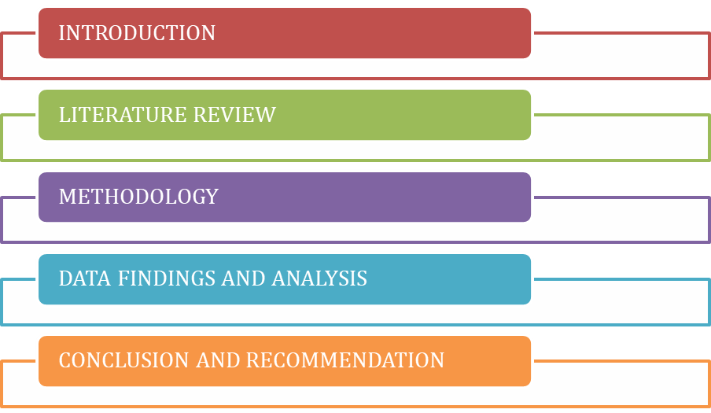
Figure 1.1: Dissertation structure
(Source: Developed by the researcher)

2.1 Impact of the Pressure of sexual taboos against Women in the Context of virginity tests in India
Sexual taboos that led to virginity tests aimed to test if the women had any form of physical relationship before marriage. However, having sexual relations with men before marriage is not a crime and it is a choice of women which cannot be penalized. The virginity test restricts women from fulfilling their physical needs which have a significant impact on their mental health (Preya, 2019). Many women face depression and anxiety when they are unable to meet their physical needs. As a result, they are also pressured by their family members to pass the virginity test to get respect and dignity in society. Overall, it reflects that the dignity of women lies in their vaginas which pressurised them to stay uneducated about their basic physical needs. Indian women face challenges even after marriage in the aspect of making sexual relationships with their husbands as they are given no education about having sexual pleasure. The image depicts a survey that was conducted among Indian youth. As per the survey, the young generation of India was asked about sex before marriage and 66% denied its existence and only 20% replied that it is acceptable (Statista, 2020). Some of the respondents accepted that sex before marriage is possible but it is not for them. Such answers reflect that Indian youth fear societal norms and they have neutralised the fact that physical needs have to be repressed in order to get dignity and respect.
Figure 2.1: Opinion of Indian Youth on sex before Marriage
(Source: Statista, 2020)

2.2 Challenges Faced by women who are pressured to Pass the virginity test
As stated by Abdelouahed and Ellerby (2019), hymen rupture in women can occur during excessive mental stress, swimming, running or any other physical activities that require rigorous movement of the legs. However, virginity tests in India are done by chewing if the hymen is intact and rupturing of the hymen reflects that women have lost their virginity. This is a major challenge for athletic women who have ruptured their hymen using rigorous physical exercise. Moreover, such a practice is often conducted by using white bed sheets during the first night of sexual intercourse between husband and wife. Family members of the groom use this technique to test the virginity of the bride (Singh et al. 2020).
Figure 2.3: White bedsheet test for virginity
(Source: Sharma, 2022).)
There are cases where the bride is divorced if she does not shed blood while having sexual intercourse for the first time with her husband. As per a new report, the bride was beaten by her in-laws and her family had to pay 10 lakh rupees as she failed to pass the virginity test on her first night with her husband (Economic Times, 2022). This is a common problem in different parts of the country where “Dowry” and “domestic violence” are faced by women if they cannot pass the virginity test. Such sexual taboos keep constant pressure on Indian women to say virgin and pass the test to be respected after marriage. There is an urgent need to apply strategies that can mitigate the challenges in Indian society that are levied due to sexual taboos (Singh et al. 2020). The virginity test reflects how inequality in Indian society is prevalent. Women who are termed “Kumari '' have to give a virginity test, however, men or “Kumar” are not asked to give any such tests. In Indian society. Women are treated as “objects” where their freedom, feelings and thoughts are suppressed by using the myth of “virginity”.

2.3 Strategies to mitigate sexual taboos in India
Sexual taboos need to be mitigated and it is the responsibility of citizens as well as the government to prevent such taboos from impacting the dignity of women. Women’s identity cannot be judged by their sexual relationship and strategies have to be deployed to prevent any form of virginity test (Abdelouahed and Ellerby, 2019). In order to mitigate such sexual taboos and the challenges derived from them, the government of India has to be strict enough to deploy police that can prevent and penalise wrongdoers. Moreover, policemen have to be aware of such malpractices and penalise the family of the bride or groom who supports the virginity test and pressures women to pass it (Singh et al. 2020). On the other hand, charitable institutions and NGO workers must spread awareness about how virginity tests can lead to stress and virginity among women. Sex education must be a subject in school so that women can understand that having a sexual relationship is a physical need and there is no need to suppress it.

2.4 Theoretical Framework
Cognitive theories of depression were analysed when patients felt to prioritise their feelings and mental needs (LeMoult and Gotlib, 2019). Cognitive theory reflects that depression and anxiety occur due to disruptive thoughts and judgements. In Indian society, women are depressed because they cannot express or prioritise their feelings about sexual needs, and they are often judged by their elders if they try to establish sexual relations before marriage. On the other hand, psychological and behavioural issues are also faced by Indian women when their needs are not prioritised by their family members. Such issues can lead to depression and mental instability can be caused in future if the sexual taboos are not removed from society.

2.5 Conceptual framework
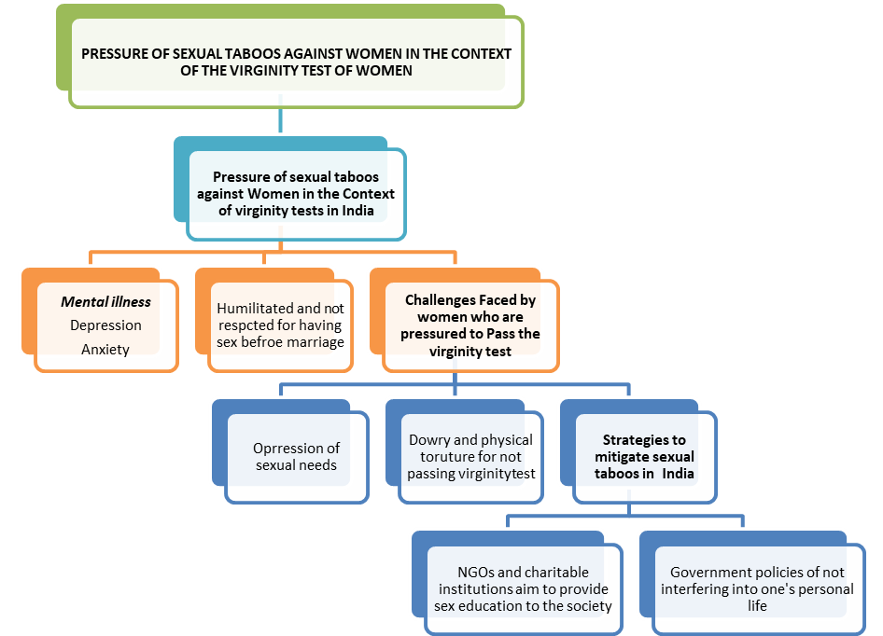
Figure 2.3: Conceptual framework
(Source: Developed by the researcher)

3.1 Research Philosophy
The study has used the interpretivism philosophy that has encouraged the researcher to understand the topic in-depth. Through this philosophy, the research can produce high-validity data (Snyder, 2019). On the other hand, positivism limits a study to generalise the results which would be insufficient in solving the challenges faced by women who are pressured to pass the virginity test.

3.2 Research Approach
For researching the pressure created on women for virginity tests the study has pursued using the inductive approach. This approach helps a study in being more flexible and generate new theories (Snyder, 2019). On the other hand, the use of deductive was avoided as it can bring out wrong assumptions at times.
3.3 Research Design
The research has pursued the use of the explanatoryresearch design that has helped in explaining the issues of virginity tests that are faced by women in details. It allows a researcher to analyse facts effectively to understand the issue deeply (Gupta and Gupta, 2022). It helped in gaining an in-depth understanding of the topic and meeting the research objectives effectively.

3.4 Data collection method
For determining the medical aspect of the virginity test the study has chosen to use a secondary data collection method. It is a useful method as it exposes a study to the vast majority of sources (Snyder, 2019). The study has utilised qualitative data. On the other hand, the primary data collection could have been affected by including biased information.

3.5 Inclusion and exclusion criteria
The study has included articles that are published in the last five years. It has ensured that the articles have their author's name to ensure their validity. The study has ensured that the articles are relevant to the topic. The articles that are published and have no authors’ names have been excluded. Articles with a lack of references have been excluded.

3.6 Data Analysis
The study used thematic analysis in order to extract proper information regarding the topic. In this, the researcher has generated relevant themes that are related to the topic in order to answer the research questions.

3.7 Ethical Considerations
It was ensured that all the data had been gathered from a trustworthy site. All the secondary data collected have been referenced appropriately. It has been ensured that no data has been pirated in any way. Data protection act 1998 is followed in this research and the information are stored safely in computers with the help of string passwords (Lowe, 2021).

3.8 Research timeline
Figure 3.1: Research timeline
(Source: Developed by the researcher)

4.1 Key Findings
Gorar (2021) stated that the virginity of females relates to the subordination of a woman. It is considered a means to safeguard the honour of a family. The World Health Organisation has acknowledged the negative impact on females caused by virginity tests. Negative impacts can be reflected by disrespecting the woman if she has lost her virginity before the marriage. Similarly, Gaber and Rasoul (2019) described that virginity is considered to hold significant value for women in India as it gives her dignity as “Kumari”. Nunu et al. (2020) opined that sexual taboos like virginity and more could have an impact on both their mental and physical health.

4.2 Thematic analysis

4.2.1 Theme 1: Pressure of sexual taboos against Women in the Content of virginity tests in India
Virginity in women is considered an honour for them and their families in India. The virginity requirement in a female family member is related to the subordination of women. In India, it is perceived as a way to protect the family’s honour. Gorar(2021) stated that the virginity in young girls is controlled in the form of three different ways. First, through a bloody sheet after first sexual intercourse on the wedding night. Second is the virginity tests and certifications in case the bride fails to bleed on the wedding night (Sikder et al., 2021). The third way includes controlling their virginity through hymen-repairing surgeries. Although, second and third practices might provide an option for participation or can be imposed by others in the family of the girl.
Figure 4.1: Blood stain virginity test
(Source: Sikder et al., 2021)

4.2.2 Theme 2: Challenges Faced by women who are pressured to Pass the virginity test
The virginity testing has been condemned for several decades by various international organisations that fight against women’s rights violations. Virginity testing is considered a way of controlling a woman’s body. It has been established as a human rights violation. According to Gaber and Rasoul (2019), the law has prohibited performing such tests without the woman’s consent. It was found that women are required to be virgins until they are married. Furthermore, the forced virginity test by the family members often leaves a mental scar of self-blaming. It results in a reduction in self-esteem.
Figure 4.2: Stopping virginity test
(Source: Sikder et al., 2021)

4.2.3 Theme 3: Strategies to mitigate sexual taboos in India
Sexual and reproductive health is considered an important challenge, especially in Indian society. According to Nunu et al. (2020), sexual taboos tend to have an impact on the mental health of an individual. Therefore, it is important to take advantage of government initiatives such as Adolescent Reproductive and Sexual Health. Shukla et al. (2022) stated that this helps generate awareness of healthy reproductive health among both married couples and unmarried youth.
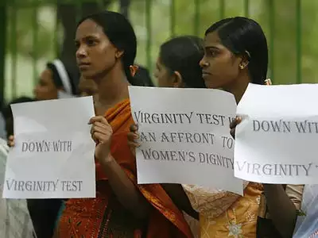
Figure 4.3: Rallies for stopping virginity test
(Source: Jadav, 2023)

4.3 Discussion
From the findings, it was understood that virginity being treated as a way of protecting family honour tends to impact the mental health of a woman. Nunu et al. (2020) described that it tends to put mental pressure due to such tests. In the literature, it was found that virginity tests tend to push women to depression and anxiety. Preya (2019) stated that the virginity tests tend to restrict women from fulfilling their physical needs and impact their mental health. Furthermore, it was found that the methods that are used to control virginity are the blood sheet test (Singh et al. 2020). From the findings, it was discovered that there are two more methods that are used to test a woman’s virginity. These methods are virginity certification and repairment surgeries. Gaber and Rasoul (2019) described that virginity tests tend to violate human rights when forced by others. This led the government to prohibit such tests without the consent of the woman. The main strategies that can help with diminishing the virginity tests challenges faced by the women. Nunu et al. (2020) added that these include an initiative that is launched by the Indian government that can help in educating and providing support for both married and unmarried youth.

5.1 Conclusion
The research has summarised the agony of women in India. In a world where the United Nations has been given the freedom to express its views in any societal and administrative manner, India is a society that pressurises women to give virginity tests. Virginity tests are forcing Indian girls to oppress their sexual needs before marriage. Moreover, girls are not given proper education about physical needs, and they are not aware of their sexual needs. As a result, it has a negative impact on the female body where depression and anxiety are the major issues among women. On the other hand, it is clear from the literature review section that government policies need to be strict enough to penalise doctors and family members who aim to perform any kind of virginity test on women. Moreover, there are several cases where the in-laws of a woman have physically and mentally tortured her for not shedding blood on her first sexual intercourse with her husband. The sexual taboo of making “sex before marriage” as a sin must be stopped and women must be free to reveal their sexual needs. Thematic analysis has made it clear that family members leave, so the woman plays a major role in creating her depression and anxiety when she is forcedto give a virginity test before marriage. Moreover, Indian society is talking about physical needs as a “sin” which does not allow women to know about the needs of the body and unknowingly it impacts their mental well-being as well.

Linking with objectives
Objective 1: “To explore the impact of the pressure of sexual taboos against women in the context of virginity tests in India” is met in the literature review chapter and the thematic analysis section.
Objective 2: “To evaluate challenges faced by women who are pressured to pass the virginity test” is completely established in the second and fourth chapter of this dissertation.
Objective 3: “To recommend strategies to mitigate sexual taboos in India”is met in the upcoming section of this chapter.

5.3 Recommendations
Addition of sex education in the school curriculum
Sex education has to be added to every school curriculum in India, irrespective of public and private schools (Iaizzo et al., 2021). Sex education must be given to students irrespective of their gender so that children can understand the needs of the body and nurture them. Similarly, not only students, but teachers must also understand the issues related to virginity tests. Education about sexual needs and awareness about the prevention of virginity tests must be spread among elders as well.
Legal policies to penalise the wrongdoer
The government of India must take strict action to penalise doctors and family members who pressurise a woman to give a virginity test (Delgross, 2019). Similarly, policemen must monitor the wrongdoer in society and keep a track of in-laws who mentally and physically torture a woman for not passing the virginity test. The wrongdoers must be jailed, and they must be fined a hefty amount so that the pressure against women can be reduced.

5.4 Research Limitations
The limitation of the research is that it could not conduct an elaborate primary quantitative analysis where a survey would be the mode of data collection. Using a survey as a data accretion mode would help the reach to include women of India as the respondents of the research. The current challenges faced by them in the progressive society would be analysed in detail and more data about societal pressure and sexual taboos could be explored.

5.5 Future Scope
The future scope of this research is to conduct similar research on other countries that include the oppression of women in society. Moreover, academic practitioners can include women participants in future research so that the real-life challenges faced by them in daily life can be informed by the reader.

References
Abdelouahed, H. and Ellerby, K., (2019). Hymenorrhaphy, or the Search for Lost Virginity. Recherches en psychanalyse, 27(1), pp.18a-25a.
Delgross, S., 2019. The Mythological Role of the Hymen in Virginity Testing. Articulāte, 24(1), p.4.
Economic times (2022). Bride beaten by in-laws after 'failed virginity test', khap asks her family to pay Rs 10 lakh. Available at: https://economictimes.Indiatimes.com/news/new-updates/bride-beaten-by-in-laws-after-failed-virginity-test-khap-asks-her-family-to-pay-rs-10-lakh/articleshow/94005461.cms [Accessed on 07.04.23]
Gaber, M.A. and Rasoul, R.M., 2019. Societal and cultural values toward female sexuality. Menoufia Medical Journal, 32(3), p.1030.
Gorar, M., 2021. Female sexual autonomy, virginity, and honour-based violence with special focus on the UK. Journal of International Women's Studies.
Gupta, A. and Gupta, N., 2022. Research methodology. SBPD Publications.
Iaizzo, R.S., Diez, M.L. and Fernández, N.P., 2021. Psychological well being and fertility: habits that increase happiness in women increase their reproductive capacity. Fertility and Sterility, 116(3), pp.e366-e367
Jadav, R., (2023). These siblings are using WhatsApp to campaign against virgin. Available at: https://timesofindia.indiatimes.com/home/sunday-times/these-siblings-are-using-whatsapp-to-campaign-against-virginity-tests/articleshow/62490705.cms [Accessed on 07.04.23]
LeMoult, J. and Gotlib, I.H., 2019. Depression: A cognitive perspective. Clinical Psychology Review, 69, pp.51-66.
Lowe, D., 2021. Post-Brexit will EU Data Protection Law Still Impact on Police Investigations into Terrorism and Organised Crime?. Expert Witness Journal.
Sikder, S.S., Ghoshal, R., Deosthali, P., Jaishwal, C. and Roy, N., 2021. Mapping the health systems response to violence against women.
Nunu, W.N., Makhado, L., Mabunda, J.T. and Lebese, R.T., 2020. Strategies to facilitate safe sexual practices in adolescents through integrated health systems in selected districts of Zimbabwe: a mixed method study protocol. Reproductive Health, 17(1), pp.1-16.
Preya, M.N.V., (2019). Voice of the Voiceless: Rejuvenating Dispositions in Kamala Markandaya’s Two Virgins. Language in India, 19(3), pp.154-160.
Sharma, D., (2022). First Night Means Virginity Test of Bride: Kukdi Pratha of Rajasthan. Available at: https://www.sinceindependence.com/rajasthan/first-night-means-virginity-test-of-bride-kukdi-pratha-of-rajasthan [Accessed on 07.04.23]
Shukla, A., Kumar, A., Mozumdar, A., Acharya, R., Aruldas, K. and Saggurti, N., 2022. Restrictions on contraceptive services for unmarried youth: a qualitative study of providers’ beliefs and attitudes in India. Sexual and Reproductive Health Matters, 30(1), p.2141965.
Singh, S.K., Vishwakarma, D. and Sharma, S.K., (2020). An epidemiology of premarital sexual behaviour in India: exploring gender differences. Journal of Health Management, 22(3), pp.389-412.
Snyder, H., 2019. Literature review as a research methodology: An overview and guidelines. Journal of business research, 104, pp.333-339.
Statista, (2020). Opinion on sex before marriage among Indian youth in 2019. Available at: https://www.statista.com/statistics/1051675/India-sex-before-marriage-opinion-among-youth/ [Accessed on 07.04.23]
Thapliyal, N. (2023). Virginity Test Is Sexist, Can’t Be Performed On Female Accused In The Name Of Finding Truth: Delhi High Court. Available at: https://www.livelaw.in/news-updates/virginity-test-sexist-gender-bias-right-to-dignity-female-detainee-accused-delhi-high-court-220962#:~:text=Calling%20it%20a%20form%20of,of%20the%20Constitution%20of%20India. [Accessed on 07.04.23]
World Health Organization, (2018). Eliminating virginity testing: an interagency statement (No. WHO/RHR/18.15). World Health Organization.

