(Importance of bond strength in endodontics: A Review.)

Adityaraj Kate1 – Atharva Khadse² – Swanand Pachpore³ – Pradeep Jadhav⁴

¹UG student, School of Mechanical Engg, Dr. Vishwanath Karad MIT-WPU, Pune
² UG student, School of Mechanical Engg, Dr. Vishwanath Karad MIT-WPU, Pune
³Assitance professor, School of Mechanical Engg., Dr. Vishwanath Karad MIT-WPU, Pune
⁴Professor, School of Mechanical Engg., Bharati Vidyapeeth (Deemed to be) University, College of Engineering, Pune

Keywords:
Adhesive
Endodontics
Push-out bond

Abstract:

Purpose: Assessing bond strength is a key factor in the success of dental restorations. Ejection testing is a common method for evaluating the bond strength of dental restorative materials and tooth structure. This study aimed to assess the bond strength of gutta-percha root canal sealants using the push test and reviewed relevant research articles.

Methodology: The review of bond strength and failure mode of sealers based on more than 60 papers published from 2000 to till date. A comprehensive literature search was performed to identify relevant studies evaluating the bond strength of root canal sealants using the push test. Selected studies were analysed and summarized to provide an overview of current knowledge on assessing the bond strength of root canal sealants.

Findings: The results of this study demonstrate that the push test is a reliable method to assess the bond strength of root canal sealants. The pushout test provides a quantitative measurement of the bond strength between the composite and the tooth substrate. The pushout test can also provide information on the failure mode of the bond. The results of this study can help clinicians and researchers select appropriate sealants and assess their bond strength using standardized protocols.

- Introduction:
The push test is a common method for evaluating the bond strength of a restorative material to a tooth. It involves applying a compressive force to the restorative material, which is in a prepared tooth cavity. A force is applied in a direction perpendicular to the bond plane and the resulting displacement is measured. This displacement can be used to calculate the bond strength between the restorative material and the tooth structure. Several factors can affect the results of a push test, including the type of restorative material, preparation method, and type of tooth structure. Additionally, the type of force applied during the test can also affect the results. In general, the push test is a valuable method for assessing the bond strength of dental restorations. Standardized protocols and careful consideration of factors that may affect results are essential to ensure reliable results.[1]
Failure of bond strength occurs when the adhesive loses its ability to maintain the bond, resulting in the separation of the two surfaces. Understanding the failure modes of bond strength is critical in developing effective adhesives and ensuring the longevity and durability of bonded materials.[2] The failure mode can be adhesive, cohesive, or mixed.[3], [4] Adhesive failure occurs at the interface between the composite and the tooth substrate, cohesive failure occurs within the composite material, and mixed failure involves a combination of both adhesive and cohesive failures.[5], [6] Factors that can contribute to bond strength failure include inadequate surface preparation, poor adhesive selection, environmental factors such as temperature and humidity, and stress on the bonded surfaces.[7] In the present article, articles from 2010 to till date selected through various online data base such as Elsevier, Science direct, etc.[8]

Literature Review:

The use of an adequate method for evaluation of the adhesion of root canal filling materials provides more reliable results to allow comparison of the materials and substantiate their clinical choice.[9]The aims of this study were to compare the shear bond strength (SBS) test and push-out test for evaluation of the adhesion of an epoxy-based endodontic sealer (AH Plus) to dentin and guttapercha, and to assess the failure modes on the debonded surfaces by means of scanning electron microscopy (SEM). In this study, the SBS test to root dentin was proved to be a feasible and reproducible method. Although it produced significantly lower bond strengths than the push-out method, SBS test was easier to perform, which allowed testing guttapercha and dentin specimens in a similar manner. Additionally, it provided homogenous results with considerably low variation of bond strength.[10] The aim of the study is to compare the push-out bond strength of bioceramic and epoxy sealers. Both the sealers exhibited higher push-out bond strength after treatment with GA with no significant difference between 5% and 17% GA. Bio C sealer with GA as final irrigant showed higher bond strength than Dia-Proseal (P < 0.05). The push-out bond strength of the sealer was significantly affected by the final irrigation solution used.[11] The highest push-out bond strength was seen with Bio C sealer after treatment with GA with no significant difference between 5% and 17% GA.[12] The techniques [single cone (SC) and warm vertical compaction (WVC)] on the push-out bond strength (PBS) of gutta-percha (GP) with three calcium silicate-based sealers (CSBSs).[13] the WVC method did not affect the PBS of the premixed CS and BCH. However, the heatbased root canal obturation method negatively impacted the BR’s PBS.[14] CS can be used with standard GP since the PBS of the SC technique was equal to the WVC[15], [16] To evaluate the push-out bond strength of experimental apatite calcium phosphate coated gutta-percha (HAGP) compared to diferent commercially available coated gutta-percha root obturation points. Gutta-percha (GP) is the standard root canal obturation material that has many advantages such as biocompatibility, nonstaining, and radiopaque.[17] HAGP showed promising results to be used as root canal flling material in combination with bioceramic sealer.[18]
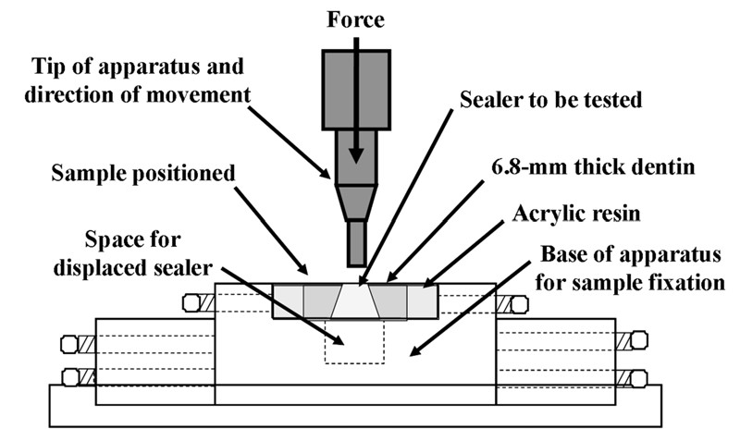
Figure 1: Schematic drawing of the push-out test.[18]

To evaluate the push-out bond strength of premixed and powder-liquid bioceramic sealers with or without gutta-percha (GP) cone. All S samples displayed a significantly greater resistance to displacement than the samples obturated with GP-S (P < 0:05). Push-out test without gutta-percha cone presents higher bond strength for bioceramic sealers. Powder-liquid calcium silicate-based sealers present greater bioactivity related to alkalinization potential and calcium ion release.[19] To evaluate the micro hardness of erosive root dentin when Casein Phosphopeptide–Amorphous Calcium Phosphate (CPP-ACP) was used as a final irrigant and its influence on resin sealer bonding tested by push-out bond strength method. Use of CPP-ACP on root dentin is clinically significant because Improved micro hardness of erosive root dentin was observed,No statistically significant difference between the push-out bond strength of EDTA + NaOCl and EDTA + NaOCL + CPPACP groups was noted. CPP-ACP is not affecting the bond strength of resin sealer to root dentin.[20] To assess dentin–post bond strength and mode of failure through tensile strength testing of two endodontic post systems: CAD/CAM custom-milled fiber posts vs Splendor SAP. There was no significant difference between groups regarding tensile bond strength to root dentin. The tensile bond strength observed for the CAD/CAM and Splendor SAP post systems was similar. Adhesive failure was predominant in both groups; however, the CAD/CAM custom-milled fiber posts failed predominantly at the dentin–resin cement interface, whereas Splendor SAP posts failed mostly at the post–resin cement interface.[21] To evaluate the effect of root canal cross-sectional shape on single-cone root filling bond strength, as well as to determine the percentage of guttapercha-filled areas (PGFA) and sealer-filled areas (PSFA), establishing a relationship between these variables.[22] In canals with round cross-sections, the single-cone root filling had higher percentage of gutta-perchafilled areas and bond strength values.[23] Higher percentage of gutta-percha-filled areas resulted in higher bond strength to dentine.[24] To compare the push-out bond strength exhibited by root fillings performed with either C-Point and Endosequence® BC sealer™ (BC Sealer) or gutta-percha and AH Plus® after the instrumentation of oval canals with either the Self-Adjusting File (SAF) System or WaveOne (WO) reciprocating file.[25] In oval canals, the instrument used and the root filling material significantly affected the push-out values of root fillings. The highest value was recorded in oval root canals instrumented with the SAF System and filled with C-Point and BC sealer, whereas the lowest strength was noted in oval canals instrumented with WaveOne and filled with gutta-percha and AH Plus sealer. [26], [27]

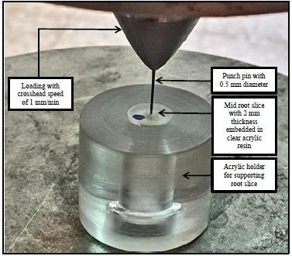
Figure 2: Push-out-test-process
This study evaluates the effect of two thermoplastic obturation systems (MicroSeal and Obtura II) on bond strength of different sealers to intraradicular dentin. MicroSeal and Obtura II techniques, using AH plus sealer, increased the resistance to displacement of the filling material, when compared with lateral compaction. Moreover, when used with Epiphany SE, these obturation systems did not affect the bond strength of the material to root dentin.[28] The purpose of this study was to evaluate the effect of immediate and delayed post space preparation on the sealing ability of two root canal obturation techniques by using micro- computed tomography imaging and a push-out test. The percentage volume of voids and bond strength of apical gutta-percha were similar and were not significantly influenced by the timing of post space preparation or the obturation,technique.[29][30]

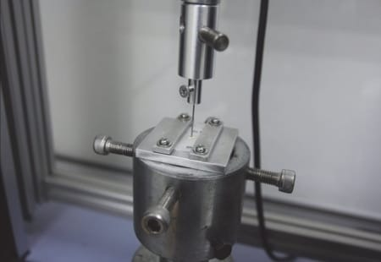
a) Position and alignment of the specimen in the universal testing machine.

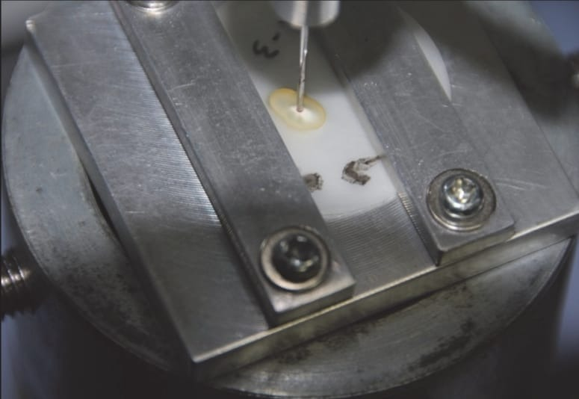
(b) Only the root flling material was in contact with the plunger.[18]
Figure 3:Push-out test using universal testing machine

The purpose of this study was to investi- gate the influence of gutta-percha solvents on the bond strength of fiberglass post to root canal dentin. The control group exhibited significantly higher bond strength compared with the eucalyptol group in the cervical and middle thirds (P < 0.05); however, the control group did not differ significantly from the xylene and orange oil groups (P > 0.05).[31], [32] No significant difference was observed between the values for the xylene, orange oil, and eucalyptol groups (P > 0.05). [33] The aim of this in vitro study was to evaluate the effect of MTA-based sealer (MTA Fillapex), eugenol-based sealer (Dorifill) and an epoxy resin sealer (AH Plus) on the bond strength of fiber posts cemented with a self-etch adhesive. The maximum (4.45±0.09 MPa) and minimum (1.02±0.03 MPa) bond strength values were recorded in the control and Dorifill groups, respectively. The mean push-out bond strength values were similar for MTA Fillapex and AH Plus sealers (P>0.05).[34], [35] However these values were significantly higher than that of the Dorifill sealer (P<0.05).Sealer type affected the bond strength of the fiber posts and MTA Fillapex decreased the dislodgment resistant of the fiber post. [36] To compare the effects of different sealers on fiber post bond strength. Methods: Sixty teeth were divided into 4 groups according to obturation method: GI, gutta-percha without any sealers; GII, gutta-percha and AH26 resin-based sealer; GIII, RealSeal point and RealSeal resin-based sealer, GIV, Guttaflow.The highest bond strength was observed in the control group (2.95±1.12), and the least was in the Guttaflow group (1.15±0.78). There was a significant difference between bond strengths of the control and Guttaflow groups and between AH26 and Guttaflow groups (p<0.05). The failure mode was mainly adhesive between dentin and resin cement in all groups. [37] To investigate push-out bond strength (PBS) of fiber post to radicular dentin after using different cementation,techniques[38], [39]One-step RX-MC-Monoblock technique using self-adhesive cement and core foundation composite resin material multicore flow when cured simultaneously exhibited the highest bond integrity of post retention compared to other cementation technique. [40] Gutta-percha with a sealer cement has been used for many years as a fill for root canal therapies, new materials and techniques have been recently developed that could increase the success rate of endodontic treatments The differences between groups AH-Plus C.L. and the BC-Sealer were found on the adhesion force that was applied in the different thirds of the root canal[41]. The sealer cement BC- Sealer proved to be the material with better adhesion in all thirds of the root canal being significantly more noticeable in the apical third. The two cements sealants are effective for the adhesion at the root canals, used correctly. Any of these, well used, will grant anyone an acceptable result. [42] This study aimed to assess the effect of application of Q Mix and common root canal irrigating solutions on the bond strength of fibre post to root dentin The maximum and minimum bond strength values were noted in Q Mix and NaOCI groups in both the middle and coronal third of the root, respectively .But, there was no significant difference between the push-out bond strength in the middle or coronal third of the root (p = 0.054). Adhesive failure was the most common mode of failure in all groups.[43]
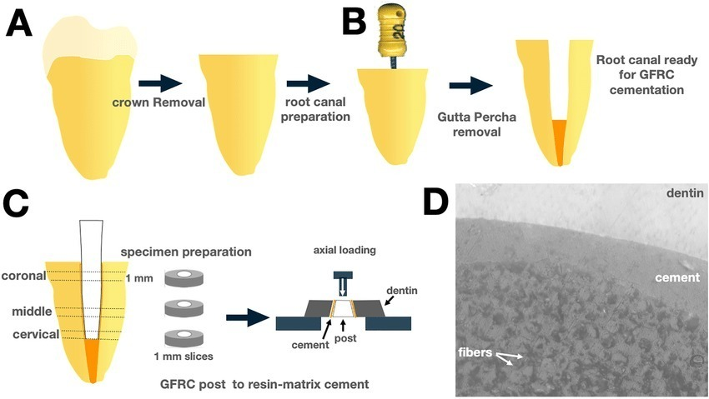
Figure 4: Process of material filling

To appraise the outcome of file systems and activation of the final irrigant on the push-out bond strength of root fillings in oval canals. Single-rooted mandibular premolars (n = 180) with oval canals were divided into three groups (n = 60) for instrumentation: ProTaper Next (PTN), WaveOne (WO), and Self-adjusting File (SAF). The mean push-out bond strength values appear in Table 1. [21]The analysis of the data by the three-way ANOVA manifested that the instrumentation protocol and type of root filling had a significant impact on the dislocation resistance of both filling materials (p < 0.05), while the bond strength was unaffected by the irrigant activation technique (p > 0.05) [44] To assess the influence of various canal-drying techniques on the push-out bond strength between radicu- lar dentine and both MTA Fillapex and iRoot SP sealers. Canals dried with only 1 paper point and obturated with the iRoot SP sealer (subgroup 2B) showed significantly higher bond strengths to the root canal wall compared to all other subgroups (p < 0.05), except for subgroup 1B (p > 0.05). [45] A new bundled glass fiber-reinforced resin post was developed to be used in post- endodontic restoration. We evaluated the bond strength of a single prefabricated glass fiber post (GFP) and a bundled glass fiber-reinforced resin post (GT), used alone or combined, to restore weakened It can be concluded that for weakened roots, higher bond strength values were found when customizing the GFPs with composite resin or when associating them with thinner fibers, such as the bundled glass fiber-reinforced resin post. In addition, adhesion to deeper thirds of the root canal remains a challenge for adhesive dentistry and is not related to the design of the post. [46]

Findings: In the present study, the null hypothesis was partially accepted, insofar as the results showed no significant intergroup difference regarding tensile bond strength. However, the null hypothesis was rejected for failure mode, as the two groups differed significantly in this respect.[21] Bond strength of adhesives to enamel is more compared to dentin, so dentin mineralization or remineralization adds to its improved bonding. CPP-ACP, treatment prior to usage of etch-and-rinse and self-etching adhesive systems can improve the bond strength of adhesive resins to enamel.[20] In oval canals, bond strengths were higher when the SAF system was used. and when the filling was made with C-Point and BC sealer.[47]–[49] The coronal canal sections had higher bond strengths than the apical sections.[50]The highest bond strength was measured for oval root canals instrumented with the SAF System and filled with C-Point and BC sealer, whereas the lowest strength was measured for oval canals instrumented with Wave One and filled with gutta-percha and AH Plus sealer.[26]The single-cone root tilling must be used with caution due to variations in three-dimensional root canal morphology. In canals with a cross-section that is not round. this technique requires a greater amount of sealer. which can reduce the root tilling bond strength.[24] Bio-ceramic sealers promote biomineralization process, improving adhesion through mineral deposition in the root canal sealer-dentin interface.[51][53] The push-out test was performed after 30 days of PBS immersion of the specimens to simulate the clinical contact with body fluids and to evaluate the bond strength after the biomineralization process.[19]Most adhesive failures occurred between the sealer and the GP cone, probably because sealers present stronger chemical and/or physical bonds to dentin than to the main GP core.[54], [55] AH Plus presented higher push-out bond strength values than Epiphany SE.[56] epoxy-based sealers (AH Plus) penetrate deeper into the micro irregularities because of its flowability and long polymerization time, which in turn enhances the mechanical interlocking between sealer and dentin.[57] Although Active GP, BCG, HAGP, and conventional GP groups were used with the same sealer, they yielded different bond strength values.[58] This can be an indicator for bonding behaviour of the coated materials to the sealer.[59]–[61] It was reported that Active G has nonhomogeneous coating filler on the cones surface which may contribute to reduce bonding to the sealer.[18]

Conclusion:
The following conclusion can be drawn,

The advantage of the thin slice push-out in test over the tensile and shear strength test is that it is less affected by small changes in structure and stress during the applied load, and it iseasy to set up the specimen for testing.

Softening of root canal dentin raises many questions about the prognosis of root canal treatment.Erosion of the root canal causes a change in the properties of affects its interaction with the filling material and therefore the coronal seal. Itcan also cause root collapse. Dentin properties such as strength, hardness and sealant adhesion to dentin can be adversely affected and efforts should be made to minimize these properties.

REFRENCES:
[1] A. M. Pawar et al., “Can Type of Instrumentation and Activation of the Final Irrigant Improve the Obturation Quality in Oval Root Canals? A Push-Out Bond Strength Study,” Biology (Basel), vol. 11, no. 1, Jan. 2022, doi: 10.3390/biology11010059.
[2] P. Sarraf, A. Assadi, N. Kiomarsi, F. Mohammadian, A. Assadi, and A. R. Shamshiri, “Effect of Intracanal Medicaments on Pull-Out Bond Strength of Fiber Post Cemented with a Self-Adhesive System,” Eur J Dent, vol. 13, no. 3, pp. 420–425, 2019, doi: 10.1055/s-0039-1694313.
[3] M. S. Barreto et al., “Effect of intracanal irrigants on bond strength of fiber posts cemented with a self-Adhesive resin cement,” Oper Dent, vol. 41, no. 6, pp. e159–e167, Nov. 2016, doi: 10.2341/15-246-L.
[4] B. Gandhi, S. Bollineni, R. K. Janga, D. Saraswati, and M. R. Babu, “Evaluating the effect of CPP-ACP as a final irrigant in improving the micro-hardness of erosive root dentin and its influence on the bond strength of self etch resin sealer - An in-vitro study,” Journal of Clinical and Diagnostic Research, vol. 10, no. 8, pp. ZC53–ZC56, Aug. 2016, doi: 10.7860/JCDR/2016/20819.8272.
[5] C. Y. Mao, J. J. Zhao, W. Wang, and X. H. Gu, “Effects of EDTA irrigation and water storage on the bonding durability of different adhesive resin cements to intra-radicular dentin,” J Zhejiang Univ Sci B, vol. 15, no. 4, pp. 399–404, 2014, doi: 10.1631/jzus.B1300227.
[6] E. Sukuroglu, Y. Aslan, E. Nagas, S. Canay, and D. P. Senyilmaz, “Effect of root canal sealers on the push-out bond strengths of tooth-colored posts to root dentine,” J Adhes Sci Technol, vol. 29, no. 16, pp. 1680–1689, Aug. 2015, doi: 10.1080/01694243.2015.1038954.
[7] K. H. Almadi, M. F. Alkahtany, and B. Almutairi, “Influence of synthetic and natural photosensitizers activated by photodynamic therapy on extrusion bond strength of fiber post to radicular dentin,” Pak J Med Sci, vol. 37, no. 7, pp. 1912–1917, Nov. 2021, doi: 10.12669/pjms.37.7.4331.
[8] P. B. Alves et al., “Bond Strength Evaluation between Different Glass Fiber Post Systems to Restore Weakened Roots,” Journal of Composites Science, vol. 6, no. 9, Sep. 2022, doi: 10.3390/jcs6090252.
[9] M. F. Reyhani, N. Ghasemi, S. Rahimi, A. S. Milani, and E. Omrani, “Effect of different endodontic sealers on the push-out bond strength of fiber posts,” Iran Endod J, vol. 11, no. 2, pp. 119–123, Mar. 2016, doi: 10.7508/iej.2016.02.009.
[10] R. Ferreira, M. Prado, A. De Jesus Soares, A. A. Zaia, and F. J. De Souza-Filho, “Influence of Using Clinical Microscope as Auxiliary to Perform Mechanical Cleaning of Post Space: A Bond Strength Analysis,” J Endod, vol. 41, no. 8, pp. 1311–1316, Aug. 2015, doi: 10.1016/j.joen.2015.05.003.
[11] A. Keerthivasan, J. Ardhra, S. Vidhya, L. V. Amirtharaj, K. Rajkumar, and M. Sekar, “Push Out Bond Strength of a Glass Fibre Post to Root Dentine Pretreated with Proanthocyanidin and Phytosphingosine – An In Vitro Study,” Eur Endod J, vol. 6, no. 2, pp. 230–234, 2021, doi: 10.14744/eej.2021.22931.
[12] A. AlHelal et al., “Comparison of adhesive bond strength among fiber reinforced post and core with different cementation techniques: In vitro study,” J Appl Biomater Funct Mater, vol. 19, Nov. 2021, doi: 10.1177/22808000211058867.
[13] B. Ciapała, K. Górowski, W. I. Ryniewicz, A. Gala, and J. E. Loster, “The effect of root canal rinsing protocol on the push-out bond strength to the dentin cementation of the fiber post,” Folia Med Cracov, vol. 61, no. 4, pp. 81–92, Dec. 2021, doi: 10.24425/fmc.2021.140006.
[14] P. Sarraf, A. Assadi, N. Kiomarsi, F. Mohammadian, A. Assadi, and A. R. Shamshiri, “Effect of Intracanal Medicaments on Pull-Out Bond Strength of Fiber Post Cemented with a Self-Adhesive System,” Eur J Dent, vol. 13, no. 3, pp. 420–425, 2019, doi: 10.1055/s-0039-1694313.
[15] C. Retana-Lobo, M. Tanomaru-Filho, J. M. Guerreiro-Tanomaru, M. Benavides-García, E. Hernández-Meza, and J. Reyes-Carmona, “Push-Out Bond Strength, Characterization, and Ion Release of Premixed and Powder-Liquid Bioceramic Sealers with or without Gutta-Percha,” Scanning, vol. 2021, 2021, doi: 10.1155/2021/6617930.
[16] R. D. Silva-Neto, M. D. Sousa-Neto, J. D. Pécora, R. G. Palma-Dibb, and A. E. Souza-Gabriel, “Wear profile of canal wall surfaces and bond strength of endodontic sealers after in situ acid challenge,” Int Endod J, vol. 51, no. 3, pp. 364–374, Mar. 2018, doi: 10.1111/iej.12858.
[17] S. Demırbuga, K. Pala, H. S. Topçuoğlu, M. Çayabatmaz, G. Topçuoğlu, and E. N. Uçar, “Effect of different gutta-percha solvents on the microtensile bond strength of various adhesive systems to pulp chamber dentin,” Clin Oral Investig, vol. 21, no. 2, pp. 627–633, Mar. 2017, doi: 10.1007/s00784-016-1929-6.
[18] A. Y. Al-Haddad, M. G. Kutty, and Z. A. Che Ab Aziz, “Push-Out Bond Strength of Experimental Apatite Calcium Phosphate Based Coated Gutta-Percha,” Int J Biomater, vol. 2018, 2018, doi: 10.1155/2018/1731857.
[19] C. Retana-Lobo, M. Tanomaru-Filho, J. M. Guerreiro-Tanomaru, M. Benavides-García, E. Hernández-Meza, and J. Reyes-Carmona, “Push-Out Bond Strength, Characterization, and Ion Release of Premixed and Powder-Liquid Bioceramic Sealers with or without Gutta-Percha,” Scanning, vol. 2021, 2021, doi: 10.1155/2021/6617930.
[20] B. Gandhi, S. Bollineni, R. K. Janga, D. Saraswati, and M. R. Babu, “Evaluating the effect of CPP-ACP as a final irrigant in improving the micro-hardness of erosive root dentin and its influence on the bond strength of self etch resin sealer - An in-vitro study,” Journal of Clinical and Diagnostic Research, vol. 10, no. 8, pp. ZC53–ZC56, Aug. 2016, doi: 10.7860/JCDR/2016/20819.8272.
[21] M. de Souza Guimarães et al., “In Vitro Evaluation of Bond Strength to Dentin of Two Post Systems: Computer-aided Design and Computer-aided Manufacturing Fiber Posts vs Splendor Single Adjustable Post,” Journal of Contemporary Dental Practice, vol. 23, no. 4, pp. 388–392, Apr. 2022, doi: 10.5005/jp-journals-10024-3325.
[22] B. N. Portugal, V. C. B. Leitune, and T. A. F. de Melo, “Influence of photosensitizing agent and number of photodynamic therapy sessions on resistance of fiberglass posts to displacement within the canal,” G Ital Endod, vol. 35, no. 1, pp. 10–17, Jun. 2021, doi: 10.32067/GIE.2021.35.01.18.
[23] K. Al Ahdal et al., “Influence of different photosensitizers on push-out bond strength of fiber post to radicular dentin,” Photodiagnosis Photodyn Ther, vol. 31, Sep. 2020, doi: 10.1016/j.pdpdt.2020.101805.
[24] R. D. Pereira, M. Brito-Júnior, G. B. Leoni, C. Estrela, and M. D. de Sousa-Neto, “Evaluation of bond strength in single-cone fillings of canals with different cross-sections,” Int Endod J, vol. 50, no. 2, pp. 177–183, Feb. 2017, doi: 10.1111/iej.12607.
[25] Z. Qamar et al., “Effect of photosensitizers on modulating bond strength of different luting cements used for cementation of resin modified composite fiber posts.”
[26] A. M. Pawar, S. Pawar, A. Kfir, M. Pawar, and S. Kokate, “Push-out bond strength of root fillings made with C-Point and BC sealer versus gutta-percha and AH Plus after the instrumentation of oval canals with the Self-Adjusting File versus WaveOne,” Int Endod J, vol. 49, no. 4, pp. 374–381, Apr. 2016, doi: 10.1111/iej.12455.
[27] A. Carrillo Varguez et al., “Comparative in vitro Study of the Bond Strength on Dentin of Two Sealing Cements: BC-SEALER and AH-PLUS,” Revista Mexicana de Ingenieria Biomedica, vol. 37, no. 2, pp. 115–122, May 2016, doi: 10.17488/RMIB.37.2.6.
[28] Z. H. F. N. Horiuchi et al., “Effect of thermoplastic filling techniques on the push-out strength of root sealing materials,” Braz Oral Res, vol. 30, no. 1, 2016, doi: 10.1590/1807-3107BOR-2016.vol30.0001.
[29] W. Long, J. Li, Y. Liu, and H. Jiang, “Effect of obturation technique with immediate and delayed post space preparation on apical voids and bond strength of apical gutta-percha,” Journal of International Medical Research, vol. 47, no. 1, pp. 470–480, Jan. 2019, doi: 10.1177/0300060518814604.
[30] B. N. Portugal, V. C. B. Leitune, and T. A. F. de Melo, “Influence of photosensitizing agent and number of photodynamic therapy sessions on resistance of fiberglass posts to displacement within the canal,” G Ital Endod, vol. 35, no. 1, pp. 10–17, Jun. 2021, doi: 10.32067/GIE.2021.35.01.18.
[31] F. A. Alonaizan et al., “Effect of photodynamic therapy and ErCrYSGG laser irradiation on the push-out bond strength between fiber post and root dentin,” Photodiagnosis Photodyn Ther, vol. 27, pp. 415–418, Sep. 2019, doi: 10.1016/j.pdpdt.2019.06.022.
[32] K. H. Almadi, M. F. Alkahtany, and B. Almutairi, “Influence of synthetic and natural photosensitizers activated by photodynamic therapy on extrusion bond strength of fiber post to radicular dentin,” Pak J Med Sci, vol. 37, no. 7, pp. 1912–1917, Nov. 2021, doi: 10.12669/pjms.37.7.4331.
[33] O. A. Guedes et al., “Effect of gutta-percha solvents on fiberglass post bond strength to root canal dentin,” J Oral Sci, vol. 56, no. 2, pp. 105–112, Jun. 2014, doi: 10.2334/josnusd.56.105.
[34] A. Maletin, D. Markovic, I. Neskovic, B. Ramic, T. Veljovic, and I. Ristic, “Application of a novel modification of the microbond test for evaluation of adhesive bond strength between fiber posts and dual-cure dental resin cement,” Medical Science Monitor, vol. 25, pp. 3397–3405, 2019, doi: 10.12659/MSM.914151.
[35] B. Ciapała, K. Górowski, W. I. Ryniewicz, A. Gala, and J. E. Loster, “The effect of root canal rinsing protocol on the push-out bond strength to the dentin cementation of the fiber post,” Folia Med Cracov, vol. 61, no. 4, pp. 81–92, Dec. 2021, doi: 10.24425/fmc.2021.140006.
[36] K. Ghanadan, S. Ashnagar, L. R. Omrani, and M. Mirzaee, “Effect of different endodontic sealers on push-out bond strength of fiber posts,” Braz J Oral Sci, vol. 14, no. 2, pp. 166–170, 2015, doi: 10.1590/1677-3225v14n2a13.
[37] M. F. Reyhani, N. Ghasemi, S. Rahimi, A. S. Milani, and E. Omrani, “Effect of different endodontic sealers on the push-out bond strength of fiber posts,” Iran Endod J, vol. 11, no. 2, pp. 119–123, Mar. 2016, doi: 10.7508/iej.2016.02.009.
[38] N. Scotti, R. Rota, and E. Berutti, “Otturazione endodontica e restauri adesivi: esiste un legame?,” Giornale Italiano di Endodonzia, vol. 27, no. 1. pp. 59–62, Jun. 2013. doi: 10.1016/j.gien.2013.05.005.
[39] S. A. Alsubait, “Effect of calcium silicate-based endodontic sealer on the retention of fiber posts cemented at different time intervals,” Saudi Dental Journal, vol. 33, no. 7, pp. 718–723, Nov. 2021, doi: 10.1016/j.sdentj.2020.04.002.
[40] A. AlHelal et al., “Comparison of adhesive bond strength among fiber reinforced post and core with different cementation techniques: In vitro study,” J Appl Biomater Funct Mater, vol. 19, Nov. 2021, doi: 10.1177/22808000211058867.
[41] Z. Qamar et al., “Effect of photosensitizers on modulating bond strength of different luting cements used for cementation of resin modified composite fiber posts.”
[42] A. Carrillo Varguez et al., “Comparative in vitro Study of the Bond Strength on Dentin of Two Sealing Cements: BC-SEALER and AH-PLUS,” Revista Mexicana de Ingenieria Biomedica, vol. 37, no. 2, pp. 115–122, May 2016, doi: 10.17488/RMIB.37.2.6.
[43] F. Afkhami, M. Sadegh, A. Sooratgar, and M. Amirmoezi, “Comparison of the effect of QMix and conventional root canal irrigants on push-out bond strength of fiber post to root dentin,” Clin Exp Dent Res, vol. 8, no. 1, pp. 464–469, Feb. 2022, doi: 10.1002/cre2.500.
[44] A. M. Pawar et al., “Can Type of Instrumentation and Activation of the Final Irrigant Improve the Obturation Quality in Oval Root Canals? A Push-Out Bond Strength Study,” Biology (Basel), vol. 11, no. 1, Jan. 2022, doi: 10.3390/biology11010059.
[45] T. Taşdemir et al., “Bond strength of calcium silicate-based sealers to dentine dried with different techniques,” Medical Principles and Practice, vol. 23, no. 4, pp. 373–376, 2014, doi: 10.1159/000362619.
[46] P. B. Alves et al., “Bond Strength Evaluation between Different Glass Fiber Post Systems to Restore Weakened Roots,” Journal of Composites Science, vol. 6, no. 9, Sep. 2022, doi: 10.3390/jcs6090252.
[47] A. I. Romo Tobías et al., “Evaluation of the sealing capability and morphological fit of prefabricated dowels and fiber-reinforced composite resin: An in vitro study.”
[48] D. N. Ratih, N. I. Sari, P. Santosa, and N. M. N. Kaswati, “Time-Dependent Effect of Chitosan Nanoparticles as Final Irrigation on the Apical Sealing Ability and Push-Out Bond Strength of Root Canal Obturation,” Int J Dent, vol. 2020, 2020, doi: 10.1155/2020/8887593.
[49] D. N. Ratih, N. I. Sari, P. Santosa, and N. M. N. Kaswati, “Time-Dependent Effect of Chitosan Nanoparticles as Final Irrigation on the Apical Sealing Ability and Push-Out Bond Strength of Root Canal Obturation,” Int J Dent, vol. 2020, 2020, doi: 10.1155/2020/8887593.
[50] Z. H. F. N. Horiuchi et al., “Effect of thermoplastic filling techniques on the push-out strength of root sealing materials,” Braz Oral Res, vol. 30, no. 1, 2016, doi: 10.1590/1807-3107BOR-2016.vol30.0001.
[51] D. N. Ratih, N. I. Sari, P. Santosa, and N. M. N. Kaswati, “Time-Dependent Effect of Chitosan Nanoparticles as Final Irrigation on the Apical Sealing Ability and Push-Out Bond Strength of Root Canal Obturation,” Int J Dent, vol. 2020, 2020, doi: 10.1155/2020/8887593.
[52] H. H. Yu et al., “Location of MMPs in human radicular dentin and the effects of MMPs inhibitor on the bonding stability of fiber posts to radicular dentin,” J Mech Behav Biomed Mater, vol. 129, May 2022, doi: 10.1016/j.jmbbm.2022.105144.
[53] D. Donnermeyer, N. Vahdat-Pajouh, E. Schäfer, and T. Dammaschke, “Influence of the final irrigation solution on the push-out bond strength of calcium silicate-based, epoxy resin-based and silicone-based endodontic sealers,” Odontology, vol. 107, no. 2, pp. 231–236, Apr. 2019, doi: 10.1007/s10266-018-0392-z.
[54] W. Long, J. Li, Y. Liu, and H. Jiang, “Effect of obturation technique with immediate and delayed post space preparation on apical voids and bond strength of apical gutta-percha,” Journal of International Medical Research, vol. 47, no. 1, pp. 470–480, Jan. 2019, doi: 10.1177/0300060518814604.
[55] C. Veeramachaneni, S. Aravelli, and S. Dundigalla, “Comparative evaluation of push-out bond strength of bioceramic and epoxy sealers after using various final irrigants: An <i>i… Comparative evaluation of push-out bond strength of bioceramic and epoxy sealers after using various final irrigants: An in vitro study.” [Online]. Available: https://www.jcd.org.in/printarticle.asp?issn=0972-0707;year=2022;volume=25;issue=2;spage=145;epage=150;aulast=Veeramachaneni
[56] S. B. Haralur, A. S. Alqarni, M. A. Asiri, and A. K. Asiri, “Effect of customisation, root canal reshaping and acid etching on push-out bond strength of fiber post in flared, MTA repaired root canal,” Technology and Health Care, vol. 28, no. 1, pp. 35–44, 2020, doi: 10.3233/THC-181586.
[57] Z. H. F. N. Horiuchi et al., “Effect of thermoplastic filling techniques on the push-out strength of root sealing materials,” Braz Oral Res, vol. 30, no. 1, 2016, doi: 10.1590/1807-3107BOR-2016.vol30.0001.
[58] D. N. Ratih, N. I. Sari, P. Santosa, and N. M. N. Kaswati, “Time-Dependent Effect of Chitosan Nanoparticles as Final Irrigation on the Apical Sealing Ability and Push-Out Bond Strength of Root Canal Obturation,” Int J Dent, vol. 2020, 2020, doi: 10.1155/2020/8887593.
[59] V. L. Rosa e Silva et al., “The impact of provisional intraradicular retainers cementation with temporary methacrylate-based resin in the bond strength of glass fiber posts to root dentin,” J Mech Behav Biomed Mater, vol. 135, Nov. 2022, doi: 10.1016/j.jmbbm.2022.105486.
[60] Z. A. Al Jeaidi, “Influence of resin cements and root canal disinfection techniques on the adhesive bond strength of fibre reinforced composite post to radicular dentin,” Photodiagnosis Photodyn Ther, vol. 33, Mar. 2021, doi: 10.1016/j.pdpdt.2020.102108.
[61] K. de A. A. Franceschini, Y. T. C. Silva-Sousa, F. C. Lopes, R. D. Pereira, R. G. Palma-Dibb, and M. D. de Sousa-Neto, “Bond strength of epoxy resin-based root canal sealer to human root dentin irradiated with Er,Cr:YSGG laser,” Lasers Surg Med, vol. 48, no. 10, pp. 985–994, Dec. 2016, doi: 10.1002/lsm.22496.

