A Review on Applications of Copper Catalyzed Azide Alkyne Click Chemistry in Postmodification of Polymers

Suraj D. Jadhav and Sanjay S. Ankushrao*
Department of Chemistry
Vivekanand College (Empowered Autonomous)
Kolhapur-416 212 (MS) India.
*sanjayankushrao@vivekanandcollege.ac.in

Yuvraj S. Patil
Department of Chemistry
Arts, Science and Commerce College, Naldurg
Osmanabad-413 623 (MS) India.
Patilyuvraj377@gmail.com

Anil A. Ghanwat
School of Chemical Sciences
Punyashlok Ahilyadevi Holkar University,
Solapur-413 255, (MS) India
anil.ghanwat@gmail.com

ABSTRACT
In recent years, there has been a lot of interest in the progress of polymers through modification into graft copolymers. Click chemistry was used to synthesize graft copolymers, mostly through the Copper catalyzed Azide-Alkyne cycloaddition process, in order to get a high yield of product quickly. For postmodification, the clickable group on the polymer backbone was grafted by different polymer or chains. This succinct review emphasizes the most recent research on grafted copolymers produced by copper catalyzed azide alkyne click chemistry.
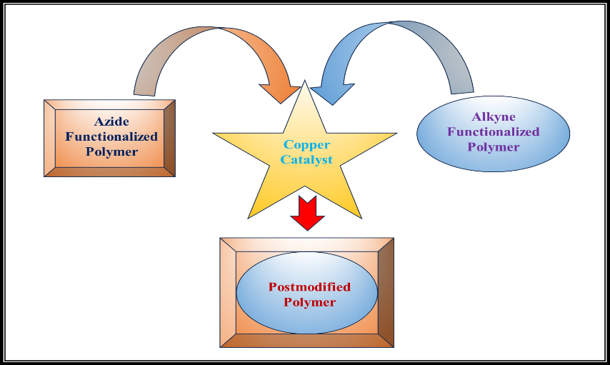

Keywords— Click chemistry, Copper catalyzed Azide-Alkyne cycloaddition, Graft polymer.

I INTRODUCTION
Postmodification of polymers is an interdisciplinary phenomenon encompassing materials science, engineering, physics, and other fields in order to teach the best experience of existing qualities to desired end-goal applications. Graft polymer synthesis typically entails two steps- polymerization and their grafting [1]. The purpose of postmodification of polymers molecular structure is often to improve its response, thermal durability, natural sensitivity and reactivity, connection, physical impact response, mobility, stiffness, and other properties [2]. In general, innovative postmodification originate from highly efficient and effective click reactions that are aided by easily available multifunctionalized monomers and effective catalysts [3].
The term "click chemistry” refers by Sharpless and his coworkers to a class of nearly perfect reactions that are highly efficient with atom economy and stereospecific. Click reactions generally requires simple conditions, easily accessible reactants and generates harmless by-products which can be easily removed [4]. Further, Sharpless and Meldal reported a new Huisgen-type [3+2] azide-alkyne cycloaddition in 2002. In this reaction CuSO4/sodium ascorbate used as a catalyst and resulted in the high yield production of 1, 4-disubstituted 1, 2, 3-triazoles [5-6].
According to study of W. H. Binder and his colleague, CuAAC has been widely used in the grafting of polymers, due to its superior properties. CuAAC has been developed into an efficient polymerization technology while still meeting the aforementioned criteria for an organic reaction to evolve into a polymerization reaction. Fig. 1 depicts the reaction mechanism of copper catalyzed azide-alkyne Cycloaddition [7].

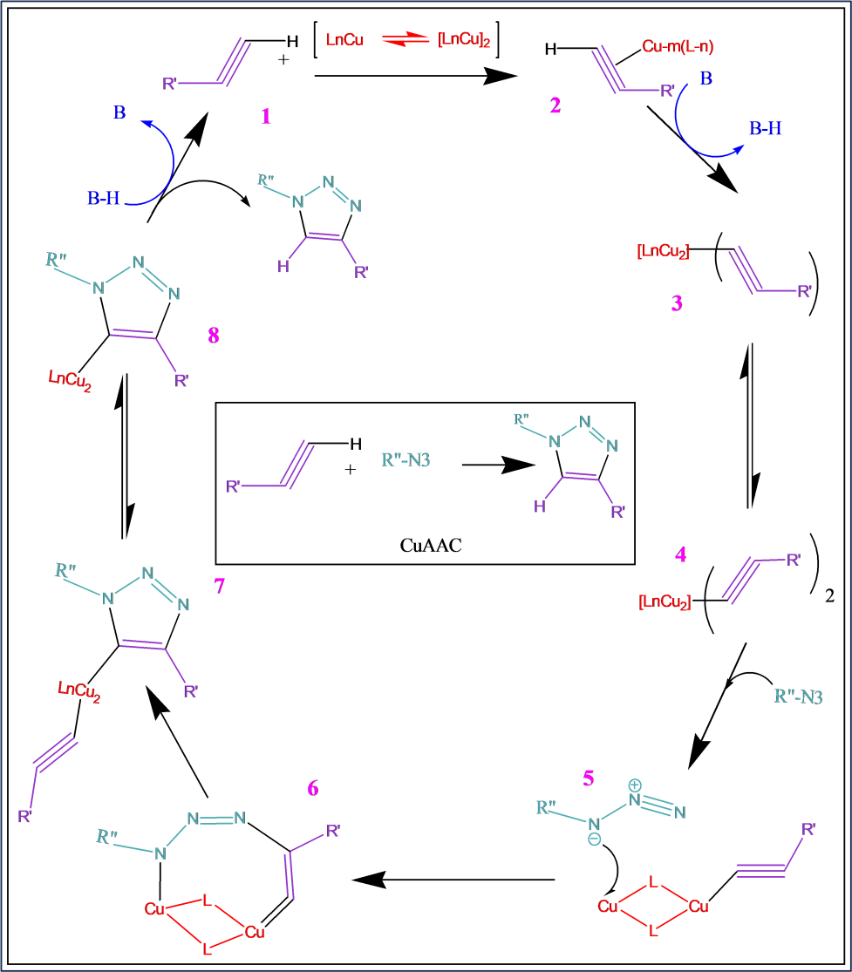
Figure1. Reaction Mechanism of CuAAC click reaction.
ABBREVIATIONS
β-CD : β-cyclodextrin
(β-CD)-g- HPEG : (β-cyclodextrin)-graft-Methyl allyl polyoxyethylene
CuAAC : Copper catalyzed Azide-Alkyne Cycloaddition
CuNPs : Copper nanoparticles
DMF : Dimethylformamide
DMSO : Dimethyl sulfoxide
HMTETA : Hexamethylenetetramine
HA-FA : Hyaluronic acid- Ferulic acid
HA-FA-g-HEG : Hyaluronic acid- Ferulic acid-graft- Hexa(ethylene glycol)
HEG : Hexa(ethylene glycol)
HPEG : Methyl Allyl Polyoxyenthylene
HMTETA : Hexamethyltriethylenetetramine
P3HT : Poly(3-hexylthiophene)
PCL : Polycaprolactone
PCL-b-PDMA : Polycaprolactone-block- poly(2-dimethylaminoethyl methacrylate)
PDMA : Poly(2-dimethylaminoethyl methacrylate)
PECH : Poly(epichlorohydrin)
PECH-g-PMMA : Poly(epichlorohydrin)-graft- Poly(methylmethacrylate)
PEG : Poly(ethylene glycol)
PEG-g-PPX : Poly(ethylene glycol) )-graft-Poly(p-xylylenes)
PEO : Poly(ethylene oxide)
PEtOx : poly(2-ethyl-2-oxazoline)
P(GMA) : Poly(Glycidyl methacrylate)
PHEA : Poly(2-hydroxyethyl acrylate)
PHEA-g-PEG : Poly(2-hydroxyethyl acrylate)-graft-Poly(ethylene glycol)
Plina : Poly(linoleic acid)
PLina-g-PCL : Poly(linoleic acid)-g-poly(caprolactone)
PMDETA : N,N,N′,N’,N′′ -pentamethyl diethylene triamine
P(MeOx-co-PentOx): Poly(2-methyl-2-oxazoline-co-2-pentyl-2-oxazoline)
P(MeOx-co-PentOx)-g-PEtOx):Poly(2-methyl-2-oxazoline-co-2-pentyl-2-oxazoline)-graft-poly(2-ethyl-2-oxazoline)
PMMA : Poly(methylmethacrylate)
PNIPAAm : Poly(n-isopropylacrylamide)
PNIPAAm-g-PPX:Poly(n-isopropylacrylamide)-graft-Poly(p-xylylenes)
PPA : Poly (propargyl 2-ylidene-acetate)
PPO : Poly(propylene oxide)
PPO-g-PVA : poly(propylene oxide)-graft-Poly(vinyl alcohol)
PPT : Poly(thiophene)
PPX : Poly(p-xylylenes)
PSB : Poly(sulfobetaine methacrylate)
PSB-g-PPX : Poly(sulfobetaine methacrylate) )-graft-Poly(p-xylylenes)
PSf : Polysulfone
PSf-g- PDMA : Polysulfone-graft-poly(2-dimethylaminoethyl methacrylate)
PSf-g-PNIPAAm : Polysulfone-graft- Poly(n-isopropylacrylamide)
PT-g-(PCL-b-PDMAEMA):Polythiophene-graft-poly(caprolactone-block-dimethylaminoethyl methacrylate)
PT-g-PEO : Poly(thiophene)-graft-poly(ethylene oxide)
PT-g-P3HT : Poly(thiophene)-graft-poly(3-hexylthiophene)
PT-g-PMMA : Poly(thiophene)-graft-poly(methylmethacrylate)
PVA : Poly(vinyl alcohol)
PVC : Polyvinyl chloride
PVC-g-PCL : Polyvinyl chloride-graft- Polycaprolactone
PVC-g-PMMA : Polyvinyl chloride-graft- poly(methylmethacrylate)
TPOM : tetrakis (2-propynyloxymethyl)-methane

II LITERATURE REVIEW
In order to create grafted polymers, A. E. Masucci and his colleagues developed a versatile method for side chain engineering. Grafted copolymers were produced by different alkynyl PEO, PMMA, and P3HT side chains conjugate with azido PT backbones via CuAAC click reactions. The grafting-to technique was used to create the PT-g-PEO, PT-g-PMMA and PT-g-P3HT. Following postmodification, nano precipitation techniques were utilized to convert into nanoparticles. These grafted copolymer architectures can enhance the fluorescence of polymer nanoparticles. Additionally, this gives the potential to serve as materials for various therapies, sensors, and imaging applications [8].
P. Chen and his coworkers utilize the CuAAC to conjugate azido PSB, PEG and PNIPAAm on substrates of alkynyl PPX through chemical vapor deposition. It has enhanced the PSB, PEG, and PNIPAAm-modified surfaces ability to resist cellular and platelet adherence. According to their research, using grafted polymers to create antifouling surfaces on a range of substrates is an easy way to create surfaces for use in immunoassay, biosensor, biomaterial, and other diagnostic applications [9].
By varying the amount of succinic-acid substitution, T. Nishimura and another researcher created the amphiphilic grafted copolymers through CuAAC. This grafted polymer was consisted of succinic-acid-modified (PPO-g-PVA) with a range of varied main-chain persistence lengths. UV or visible light is not absorbed by this grafted copolymer, which means there is no spectroscopic absorbance interference between the membrane proteins and the surfaces of the discs. As a result, succinic-acid-modified (PPO-g-PVA) grafted copolymer nanodiscs might be useful as a cutting-edge tool for understanding the work of proteins membrane [10].
According to research by H. Salehi and his colleagues, using azido PSf with alkynyl PNIPAAm synthesized the amphiphilic PSf-g-PNIPAAm via CuAAC. PSf-g-PNIPAAm used for the production of thermo-responsive thin film composite-forward osmosis membranes [11]. Similar to this, azido PSf with alkynyl PDMA created the hydrophilic PSf-g-PDMA via CuAAC. PSf-g-PDMA used for the manufacture of pH-responsive thin film composite-forward osmosis membranes [12]. Both grafted copolymers were characterized highly porous, hydrophilic.
U. Haldar and his coworkers constructed graft copolymer by click chemistry. Azido PT as the backbone conjugated with alkynyl PCL-b-PDMAEMA through CuAAC click reaction. PT-g- (PCL-b-PDMAEMA) are extremely pH responsive, water soluble, and exhibit pH-dependent aggregation, forming micelles, vesicles, and multivesicular aggregates as the pH is raised from 3 to 7 to 10. For the creation of next-generation bioelectronic, opto-electronic, and energy storage devices, the organic mixed electronic and ionic conductivity property of their grafted copolymer was particularly intriguing [13].
M. Saletti and his colleagues developed a click reactions crosslinking technique to obtain cross-linked HA derivatives for use in the production of hydrogels. Alkynyl functionalized HA-FA coupled with Azido functionalized HEG via CuAAC were quickly crosslinked. The shear-thinning ratio of HA-FA-g-HEG is totally within the range of a healthy synovial fluid shear-thinning ratio (70-250), making it appear to be a potential treatment for osteoarticular diseases. They demonstrated the perfect biocompatibility of the HA-FA grafted copolymers [14].
The PLina-g-PCL grafted copolymers were developed by S. Alli using azido PLina and alkynyl PCL. CuAAC click reactions enabled the production of PLina-g-PCL in large quantities and with high molecular weights. By adopting this technique, graft copolymers can be produced quickly and efficiently. This approach is particularly useful for preparing PLina with functional groupings. These results and the biocompatibility of PLina and biodegradability of PCL were used to promote the utilization of PLina-g-PCL grafted copolymers in the biomedical field [15].
A novel monovinyl β-CD monomer is used to create polycarboxylate superplasticizers, β-CD grafted on the end of the side chain, according to B. Li's research. As the first attempted to combine the steric hindrance effects of polyoxyethylene and β-CD during the synthesis of polycarboxylate superplasticizer. (β-CD)-g- HPEG is created by grafting azido (β-CD) on the Alkynyl polyoxyethylene (HPEG) via a CuAAC click reaction [16].
B. Savaş and his colleagues used a "click" chemistry to graft terminally Alkynyl PMMA to azido PECH in order to produce the PECH-g-PMMA comb-type graft copolymers via CuAAC click reaction. Through the use of polymers containing PECH and PMMA units, this work can give well-characterized materials with a variety of biomedical application possibilities [17]. Similar to this, they created the PVC-PMMA grafted copolymer by using a CuAAC to graft azido PVC to terminally alkynyl PMMA [18]. Further, T. Öztürk's research indicates that CuAAC was used to make PVC-g-PCL brush-type graft copolymers utilizing alkynyl PVC and terminally azido PCL. FT-IR, 1H-NMR, SEM, TGA, and GPC studies were used to characterize this
graft copolymer [19].
Through post-modifications of block copolymers, P. Shang and associates synthesized hydrogel. In this work, azido mPEG block copolymer was grafted with the alkynyl P(GMA) block copolymer and TPOM via CuAAC. This hydrogel itself was responsive to temperature and was also used for repairing tissue injuries [20].
CuAAC was used by S. Nagane and his colleagues to postmodify azido co-polyester with alkynyl phenyl acetylene and ethynyl-4-nitrobenzene. Stress-strain measurements were used to characterize the postmodified polyesters and compared to a similar azido co-polyester. The cross-linked polymers showed lower percentage elongation at break and higher tensile strength and Young's modulus [21].
Postmodified PHEA-g-PEG was created by L. Xiao and associates through grafting the azido PEG side chain using the CuAAC click reaction onto the alkynyl PHEA portion of the backbone. The AFM image revealed the shapes of cylinders, spheres, and "beads on a string" belonging to the random distribution of PHEA-g-PEG and PEG. While the GPC and 1H NMR data confirmed that the grafting density was 100% [22].
Li and colleagues used CuAAC to post-modify alkynyl-functionalized PPA with different azido compounds, including benzyl azide and 1-azido-2, 3, 4, 5, 6-pentafluorobenzene, among others. It was established that the CuAAC reaction to PPA is a highly successful method for post-modification. Also, it has demonstrated good functional group tolerance with a broad substrate scope and practically quantitative conversions (90%) [23].
Glaive and colleagues showed how to synthesize P(MeOx-co-PentOx)-g-PEtOx through alkynyl functionalized PEtOx combined with azido P(MeOx-co-PentOx) via CuAAC. This family of hydrophilic and biocompatible copolymers has the potential to be used as bioreactors in the biomedical area due to its self-assembling characteristics [24].

Table 1. Mostly used catalyst, base and solvent for CuAAC click reactions
Catalyst | Base | Solvent | Ref.
CuBr | PMDETA | Tetrahydrofuran (THF) | [8]-[24]
CuCl | HMTETA | DMSO
CuSO4.5H2O | Sodium ascorbate | DMF
CuNPs |  | Deionized water  tert-butanol: water (1:1)

Table 2. Overview of copper Sulphate click reactions in grafted copolymers.
Sr.  No. | Clickable groups |  | Catalyst/  Conditions | Grafted polymer | Ref.
 | Azide | Alkyne
1 | PT | PEO | Cu(I)Br/  PMDETA/  THF/65°C/16hr | PT-g-PEO | [8]
 |  | PMMA |  | PT-g-PMMA
 |  | P3HT |  | PT-g-P3HT
2 | PSB | PPX | Copper (II) ulphate/ Sodium ascorbate/ Deionized water/ r.t./8hr | PSB-g-PPX | [9]
 | PEG |  |  | PEG-g-PPX
 | PNIPAAm |  |  | PNIPA-g-PPX
3 | PPO | PVA | Cu(I)Br/  PMDETA/  DMSO/  65°C/72hr | PPO-g-(PVA-COOH) | [10]
4 | PSf | PNIPAAm | Cu(I)Cl/  PMDETA/  DMF/r.t./  72hr | PSf-g-PNIPAAm | [11]
5 |  | PDMA |  | PSf-g- PDMA | [12]
6 | PT | PCL-b-PDMA | Cu(I)Br/  HMTETA / THF/ r.t./ 24hr | PT-g-(PCL-b-PDMAEM) | [13]
7 | HEG | HA-FA | CuSO4.5H2O / sodium ascorbate/ tert-butanol: water 1:1 /r.t./Overnight | HA-FA-g-HEG | [14]
8 | Plina | PCL | Cu(I)Cl/  PMDETA/  DMF/  40°C /24hr | PLina-g-PCL | [15]
9 | β-CD | HPEG | CuSO4.5H2O / Sodium ascorbate/ DMSO: water (3:1) /  70°C /24hr | (β-CD)-g- HPEG | [16]
10 | PECH | PMMA | Cu(I)Br/  PMDETA/  DMSO/  35°C/48hr | PECH-g-PMMA | [17]
11 | PVC |  | Cu(I)Br/  PMDETA/  DMF/  35°C/72hr | PVC-g-PMMA | [18]
12 | PCL | PVC | Cu(I)Br/  PMDETA/  DMF/35°C /72hr | PVC-g-PCL | [19]
13 | PEG block copolymer | P(GMA) block copolymer | CuSO4.5H2O / Sodium ascorbate/ Deionized water/ r.t. | Hydrogel | [20]
 |  | TPOM | Cu(I)Cl/  PMDETA/  DMF/r.t. /24hr
14 | Co-polyester | Phenyl acetylene | Copper (II) sulfate/ Sodium ascorbate/ DMF/r.t./ Overnight | Post-modified-Polyester | [21]
 |  | Ethynyl-4-nitrobenzene
15 | PEG | PHEA | Cu(I)Br/ PMDETA/  DMF/50°C /12hr | PHEA-g-PEG | [22]
16 | benzyl azide | PPA | Cu(I)Br/  PMDETA/  THF/ r.t./ 24hr | Post-modified-  PPA | [23]
 | 1-azido-2,3,4,5,6-pentafluorobenzene
17 | P(MeOx-co-PentOx) | PEtOx | CuNPs/ DMSO/ 80°C-Microwave/ 40min. | P(MeOx-co-PentOx)-g-PEtOx | [24]

III CONCLUSION
CuAAC has significant advantages in postmodification of polymers. It has been amply demonstrated that postmodified polymers can vary in composition, architectural style, and intended applications. Given its tremendous impact over the last few years, the CuAAC click reaction appears to have made extremely advancements in polymer science. Future click-type reactions will appear, offering strong, useful chemical tools for researching precursor materials with the possibility for post-modification by straightforward chemical processes.

IV ACKNOWLEDGMENT

Authors Suraj D. Jadhav and Sanjay S. Ankushrao honestly thanks "Mahatma Jyotiba Phule Research and Training Institute (MAHAJYOTI), Maharashtra (India)" for providing research fellowship.

REFERENCES
- D. Huang, A. Qin, and B. Z. Tang, “Encyclopedia of Polymer Science and Technology,” Wiley. 2021, pp. 1–31.
- M. Arslan, G. Acik, and M. A. Tasdelen, Polymer Chemistry, vol. 10, 2019, pp. 3806–3821
- A. J. Qin, Y. Liu, and B. Z. Tang, Macromol. Chem. Phys. 216, 2015, pp. 818–828.
- H. C. Kolb, M. G. Finn, and K. B. Sharpless, Angew. Chem. Int. Ed. 40, 2001, pp. 2004–2021.
- V. V. Rostovtsev, L. G. Green, V. V. Fokin, and K. B. Sharpless, Angew. Chem. Int. Ed. 41, 2002, pp. 2596–2599.
- C. W. Tornøe, C. Christensen, and M. Meldal, J. Org. Chem. 67, 2002, pp. 3057–3064.
- W. H. Binder and R. Sachsenhofer, Macromolecular Rapid Communications, 28, 2007, pp. 15–54.
- A. E. Masucci, M. Ghasemi, C. W. Pester, and E. D. Gomez, E. D. Materials Advances, 4, 2023, pp. 2586–2594.
- P. J. Chen, H. Y. Chen, and W. B. Tsai, Polymers, 14, 2022, pp. 1-10.
- T. Nishimura, Y. Hatatani, M. Ando, Y. Sasaki and K. Akiyoshi, Chemical Science, 13, 2022, pp. 5243–5251.
- H. Salehi, A. Shakeri, R. G. H. Lammertink, Journal of Membrane Science, 661, 2022, pp. 1-12.
- H. Salehi, A. Shakeri, H. Mahdavi, R. G. H. Lammertink, Desalination, 496,2020, pp.1-12.
- U. Haldar, S. Mondal, S. Hazra, S. Guin, L. Yeasmin, D. P. Chatterjee, and A. K. Nandi, European Polymer Journal, 168, 2022, pp. 1-10.
- M. Saletti, M. Paolino, L. Ballerini, G. Giuliani, G. Leone, S. Lamponi, M. Andreassi, C. Bonechi, A. Donati, D. Piovani, A. G. Schieroni, A. Magnani, and A. Cappelli, Pharmaceutics, 14, 2022, pp. 1-24.
- S. Alli, Journal of Chemical Science, 133, 2021, pp. 1-16.
- B. Li, R. Gao and L. Wang, Journal of Applied Polymer Science, 139, 2022, pp. 1-13.
- B. Savaş, T. Öztürk, E. Meyvac, and B. Hazer, SN Applied Sciences, 2,2020, pp.1-8.
- B. Savaş, and T. Öztürk, Journal of Macromolecular Science, Part A: Pure and Applied Chemistry, 57, 2020, pp. 819–825.
- T. Öztürk, E. Meyvacı, and T. Arslan, Journal of Macromolecular Science, Part A: Pure and Applied Chemistry, 57(3), 2020, pp. 171–180.
- P. Shang, J. Wu, X. Shi, Z. Wang, F. Song, and S. Liu, Polymers, 11, 2019, pp.1-15.
- S. S. Nagane, S. Verma, B. V. Tawade, P. S. Sane, S. A. Dhanmane, and P. P. Wadgaonkar, European Polymer Journal, 116, 2019, pp. 180–189.
- L. Xiao, J. Li, W. Li, W. Li, and G. Huang, G. Journal of Polymer Science, 59(1), 2021, pp. 100–107.
- Z. Li, H. Mutlu, P. Theato, and S. Bräse, European Polymer Journal, 156, 2021, pp. 1-8.
- A. S. Glaive, C. Amiel and G. Volet, European Polymer Journal, 179,2022, pp. 1-12.

