Comparative Analysis of bioresources and nanoparticles as additives in Non Damaging Drilling Fluid using Python Software for interpretation

Sharahnan Puzari¹, Saqlain Musthak Choudhury², Abhishek Saikia², Arnab Dutta², Dibyajyoti Satnami², Prasenjit Talukdar^{2*}, Borkha Mech¹
¹Department of Petroleum Technology, Dibrugarh University, Dibrugarh, Assam, India
²Department of Petroleum Engineering, Dibrugarh University, Dibrugarh, Assam, India

Abstract
In the present scenario, a lot of research and development has been called for development of special drilling fluid additives for the preparation of non damaging drilling fluid (NDDF) so as to tackle the problems faced with the use of conventional drilling fluid in reservoirs of interest. The concept of non-damaging drilling fluid has been introduced with the prime aim of retention of rheological, filtration, pH, thermal degradability properties of the fluid so as to make it compatible with the formations in contact and to reduce environmental footprint. However, it has been observed that drilling fluids used in the present context in oil and gas industry needs improvement with the modifications in additives to discover new reservoirs of probable hydrocarbon reserves. This research project primarily incorporates the use of bioresources as feasible additives and demonstrates a comparative analysis with nanoparticles such as silica, multiwalled carbon nanotube and zinc oxide. The plan of research of the current project work includes use of the fruit part of banana and potato as drilling fluid additive in NDDF sample in the form of composites to develop an environment friendly sample making it industry ready. The novelty of work lies in the use of bio resources which are abundantly available in the environment and the comparative analysis with artificial nanoparticle on the basis of inherent properties of drilling fluid will definitely bring out a positive outcome in the field of drilling with the use of Python software for graphical analysis of the datasets.
Keywords: Non Damaging Drilling Fluid; Rheology; Filtration; Lubricity; Filter Cake; Silica; Multi Walled Carbon Nanotube; Zinc Oxide; Dried Banana and Potato.
- Introduction
Drilling fluids are the class of fluids circulated through the casing tubing annulus and out through the drill string. They serve various purposes including lifting of cuttings, cooling of drill bit, maintenance of hydrostatic unit, retention of rheology etc. [1]. The selection of drilling fluids are primarily governed by different factors including viscosity, filtration loss, lubricity, filter cake, density, gel strength, water/oil/synthetic make up quality which are important [2]. The use of powdered grass as sustainable drilling fluid additive has also been found out by researchers in the recent days which yielded significant results in the enhancement of viscosity, yield point etc. [3]. Studies have suggested the rheological behaviour of 1-ethyl-3-methylimidazolium tosylate (EMIMTsO) and its dispersions with aligned and nonaligned multiwalled carbon nanotubes (MWCNTs). The values of viscosity (in Pa-s) at high shear rate for EMIMTsO + nonaligned MWCNTs were 0.178, 0.069, 0.024 and 0.012, and for EMIMTsO + aligned MWCNTs were 0,302, 0.084, 0.030 and 0.016 for corresponding temperatures of 25, 50, 75, and 100°C respectively [4]. A.R. Ismail et al. investigated the applicability of multi-walled carbon nanotube (MWCNT) with nanosilica additives for enhancing the filtrate volume properties of WBDF. Using 0.01 ppb of MWCNT, the filtrate volume was obtained to be 4.5 ml [5]. Studies have evaluated the performance of sodium carboxymethyl cellulose (NaCMC) synthesized from cocoa pod husk (cocoa NaCMC) as a filtration agent. The increase in quantity of cocoa NaCMC in the drilling mud formulation leads to decrease in all filtration parameters and is independent of size of the particle of the filtration agent used [6]. The effect of TiO₂ NPs on two different WBMs – Polyanionic Cellulose (PAC) and Hydroxyethyl Cellulose (HEC) was studied. Before the hot rolling tests it was found that the AV (Apparent Viscosity) for the PAC containing drilling fluids was 2 to 3.5 higher than that for the same concentration of HEC. However after hot rolling test for 16 hrs at 110 °C, it was found that AV for the samples reduced by 12 % and 34 % for PAC samples and 14% and 24% for HEC sample respectively [7] . Graphene oxide (GO) and phosphorylated graphene oxide (PGO) were synthesised by researchers from graphite electrode waste (GrW) or spent pot lining (SPL) from industrial aluminum wastes. The PV value of water-based mud with commercial additive was 17 cp. On addition of GO, PGO 70 (ratio H3PO4 = 70 mL/ g GO) and PGO 90 (ratio H₃PO₄ = 90 mL/ g GO) PV reduced and the values obtained were 7, 2 and 1 cp respectively [8]. The authors used Poly (sodium p-styrene sulfonate) modified Fe₃O₄ nanoparticles in WBM and observed the fluid loss and rheological properties of the same. The optimum concentration of 0.1 wt% of the NPs demonstrated best filtration properties yielding less filtration loss and thinner filter cake [9]. The conversion of Energy Cane Bagasse into cellulose nanofibers (CNFs) has provided the potential as high value added additives in bentonite based WBM. It was also observed by the authors that only 0.5 wt% of the formulated CNFs exhibited excellent rheological and fluid loss characteristics which may be attributed by their three dimensional structure [10]. The recent studies in the arena of drilling fluid have been carried out by the researchers with fly ash and rice husk as potential additives. With the developed drilling fluids, AV, YP (Yield Point) and PV increased by 35%, 32%, 28%, respectively with fly ash for the 12.5 wt% concentration while the parameters increased by 19%, 27%, 14%, respectively with the 4 wt% rice husk ash. On the other hand, developed drilling fluid resulted in a 10% and 12% reduction in fluid loss for fly ash and rice husk ash at 12.5 wt% and 4 wt% concentrations [11]. The addition of organoclays such as organo-montmorillonite (OMt), organo-sepiolite (OSep) and organo-palygorskite (OPal) in oil based drilling fluid were taken into account by researchers. Synergetic use of OMt and fibrous OC is a promising method to enhance the rheological properties and thermal stability of oil-based drilling fluids [12]. The authors looked at the rheological characteristics of the drilling fluid that contained two different types of NPs, SiA (acidic surface modification SiO₂) and SiC (fummed SiO₂). SiC retained substantially high viscosity after hot rolling at 77 °C than it did after rolling at room temperature against the base fluid, SiA [13]. The researchers observed the rheological characteristics of WBM with SiO₂ NP addition. With the inclusion of the NP, the traditional WBM sample also showed an increase in YP from 10 to 36.5 lb/100 ft², which will significantly enhance the wellbore cleaning process and offer dynamic cutting suspension at the same time. The gel strength values (Gel _{10sec} and Gel _{10min}) of the mud were observed to be between 6 and 9 lbf/100ft² with the varied SiO₂ NP concentrations [14]. Authors examined how temperature affected the rheological characteristics of a clay nanoparticle (NP) and water-based bentonite drilling mud. The bentonite-based drilling fluid's YP was raised by 10% and 21%, respectively, by the addition of 0.2 percent clay NPs with 2 percent and 8 percent [15]. The performance of olefin-based drilling fluids with the addition of cellulose nanocrystal (CNC) derivatives from sulfuric acid hydrolysis of cotton fibres that were functionalized with poly(N-isopropylacrylamide) (PNIPAM) chains by free radicals was investigated by the author (CNC-g-PNIPAM copolymers). To better comprehend the filtering behaviour, Ultra Turrax® was used to create water-in-oil dispersions. Due to its attraction for the nonpolar medium and the existence of the -CH2-CHR- main chains, it was possible to see that the CNC-g-PNIPAM2 formed an opaque dispersion after being stirred in olefin [16]. Ma et al. claimed that adding CNTs to a suspending medium enhances the base viscosity, but that this viscosity enhancement impact lessens as a function of raising the system's shear rates. Some CNT suspensions tended to exhibit a substantially higher shear-thinning effect as compared to conventional fibre or glass suspensions [17]. 1-ethyl-3-methylimidazolium tosylate (EMIMTsO) and its dispersions with aligned and nonaligned multiwalled carbon nanotubes were examined for their rheological behaviour by R. PamiesC et al (MWCNTs). Aligned and nonaligned multiwalled carbon nanotubes were used to compute the viscosity values of EMIMTsO at various shear rates at 25, 50, 75, and 100°C (MWCNTs) [4]. The traditional water-based mud (WBM) system was created by Babak et al. by mixing 24 g of bentonite with 350 cm³ of deionized water to create 24 lb/bbl of drilling fluid. The initial filtrate volume for the WBM system was 28.4 cm³ at 30 minutes. This value became 26.3 cm³ when 1 vol. percent functionalized CNTs were added to the sample [18]. Chih-Chun Teng et al. used varied phrs (parts per hundred parts of PP resin by mass) of MWCNT to examine the impact of various multiwalled carbon nanotube (MWCNT) contents and various melt flow index (MFIs) on the rheological and dynamic mechanical characteristics of polypropylene (PP) (0, 1, 2, 3, 5, 7.5, 10 phr). The molten MWCNT/PP composites had greater viscosity than clean PP when the shear rate was between 102 and 103 s⁻¹ [19]. M. Sedaghatzadeh et al. investigated the rheological characteristics when MWCNT was added to a water-based drilling fluid. In their investigation of a well's annular viscosity, they discovered an increase of annular viscosity of 6% at the top and 12.2% at the bottom [20]. Similar research was conducted by Al-Saba et al. to examine the effects of Al₂O₃, CuO, and MgO NPs (1-100nm) at 0.5 and 1.5 vol percent on the rheological characteristics of the fluid. The bentonite content of the base fluid was 7% WBM. With the addition of the NPs, the drilling fluid's YP significantly enhanced, with MgO (0.5 vol percent) NP showing a particularly noteworthy 231 percent rise in value over the basic fluid. Al₂O₃ nanoparticles at 0.5 percent by volume produced the greatest increase in gel strength. [21]. The rheological characteristics of a produced copper oxide/polyacrylamide (CuO/PAM) nanocomposite were investigated in WBM by Saboori et al. When the concentration of CuO/PAM nanocomposite in brine solution increased (37.5 and 24.9 cP respectively) as opposed to 27.5 and 17.5 cP respectively (fresh water) at 10 g concentration of nanocomposite [22]. Fe₂O₃ NPs were also examined by Vryzas et al. in relation to traditional WBM. With the addition of the NPs (2.5 w/w percent), the YP value at 78°F increased by four times, from 3.41 Pa to 13.04 Pa, indicating improved cutting suspension capacity [23]. In order to improve the rheological characteristics of drilling fluid at 23 °C and 14.7 psi, Smith et al. produced aluminium oxide NPs. Properties including AV, PV, YP, and gel strength (Gel 10s, Gel 10 mins) showed a declining tendency with the rise in concentrations of the NPs in the drilling fluid when the NP concentration was recorded between 0.2 and 0.5 wt percent [24]. The objective of the study is to develop a modified drilling fluid with enhanced properties in terms of good rheological properties, filtration properties and thermal degradation of the drilling fluid. The addition of bioadditives will definitely prove beneficial in the context of reduction of environmental footprint.
- Experimental Analysis
  - Materials Used
During the experimental analysis, distilled water was base fluid and Micronised Calcium Carbonate (MCC) as the weighing agent. For the base sample, Polyanionic Cellulose (PAC, Regular and Low Viscosity Grade) as fluid loss agent, XC Polymer as viscosifier, Choline Chloride and Potassium Chloride as clay inhibitor in formations, Formaldehyde as bacteriocide and Linseed oil and Polyol as lubricating agent as depicted in Table 1. At the later stages of the research work, the other components such as Pregelatinised Starch (PGS), Banana and Potato as potential bioadditives and nanoparticles such as MWCNT, SiO₂ and ZnO.
Table 1 Composition of Conventional NDDF Sample with agent specification
Sl. No. | Agent Specification | Agents Used | Composition of Conventional NDDF Sample
1. | Base Fluid | Distilled Water | 1500ml
2. | Weighing and Bridging Material | Calcium Carbonate | MCC: 8.5%(W/V)
3. | Viscosifier | XC-Polymer | 0.3%(W/V)
4. | Fluid Loss Control Agent | Polyanionic Cellulose | PAC(LVG):0.5%(W/V)  PAC(RG):1.05%(W/V)
5. | Clay Shale Inhibitor | Potassium Chloride, Choline Chloride and Polyol | KCL: 5%(W/V)  Choline Chloride: 2.5%(W/V)  Polyol: 2.5%(W/V)
6. | Non-Biodegradation Agent | Formaldehyde | 0.15%(V/V)
7. | Lubricating Agent | Linseed Oil and Polyol | Linseed Oil: 0.8% (V/V)

  - Methods Employed
    - Rheological Analysis
The NDDFs as in Table 2 were prepared by weighing all the requisite chemicals using the digital SCALETEC weighing balance and thereafter mixed in the Hamilton Beach Mixer apparatus. The rheological analysis was done using the M3600 Grace Viscometer at 600 and 300 rpm respectively at various shear rates.

    - Filtration Analysis
The filtration loss studies were carried out with the help of Fann Dead Weight Filter Press and the filter cake formed on the filter paper was measured for thickness using vernier callipers.
    - pH Analysis
pH measurements were done in the Labtronics Microprocessor pH meter to enhance accuracy during the investigation for determination of acidity or basicity of the prepared drilling fluid samples.
    - Thermal Degradation Analysis
Thermal Degradation analysis was done by using the M3600 Grace Viscometer at 600 and 300 rpm respectively at various shear rates at a temperature range of 27 to 90 °C.
3. Sample Nomenclature
Table 2. Sample Nomenclature of the prepared NDDF Sample
Sl. No. | Sample No. | Sample Name
1. | I | PAC (RG+LVG) NDDF
2. | II | PGS+ PAC (SL) NDDF
3. | III | Banana 1.5 % NDDF
4. | IV | Banana 3 % NDDF
5. | V | Banana 4.5 % NDDF
6. | VI | Potato 1.5% NDDF
7. | VII | Potato 3% NDDF
8. | VIII | Potato 4.5% NDDF
9. | IX | Composite of Banana and Potato 3% NDDF
10. | X | MWCNT 0.001% NDDF
11. | XI | ZnO 0.001% NDDF
12. | XII | SiO₂ 0.001% NDDF

4. Results and Discussion
  - Rheological Analysis
4.1.1 Viscosity vs. Temperature (All NDDF Samples) 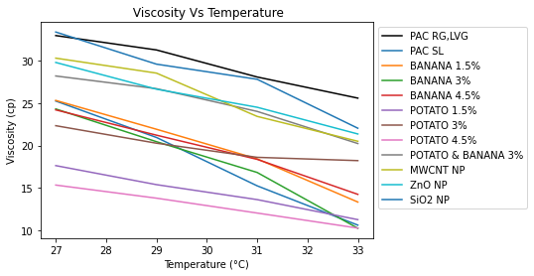

Figure 1 Graphical analysis of viscosity vs. temperature of the NDDF samples
Generally for liquids viscosity decreases with increase in temperature and the same is evident from Figure 1 that the viscosity of the mud samples decrease significantly upon increase in temperature. Amongst all the samples banana 1.5% and 4.5% samples have shown a smooth decrease in viscosity as compared to all other prepared samples which is a clear evidence of perfect viscoelastic property of the drilling fluid at 27, 29, 31 and 33°C respectively. Amongst potato samples, the decrease in viscosity is quiet irregular and on the other hand the same is the case for nanoparticles.
Table 3 Viscosity versus Temperature of the NDDF Samples
Sample No. | Parameter (s) | Temperature (°C)
 |  | 27 | 29 | 31 | 33
I | Viscosity(cP) | 33 | 31.1 | 28.1 | 25.6
II |  | 25.2 | 20.9 | 15.2 | 10.5
III |  | 25.3 | 21.9 | 18.4 | 13.3
IV |  | 24.3 | 20.4 | 16.8 | 10.2
V |  | 24.2 | 21.2 | 18.3 | 14.2
VI |  | 17.6 | 15.3 | 13.6 | 11.2
VII |  | 22.3 | 20.2 | 18.6 | 18.2
VIII |  | 15.3 | 13.7 | 12.0 | 10.2
IX |  | 28.2 | 26.7 | 24.0 | 20.2
X |  | 30.3 | 28.5 | 23.2 | 20.5
XI |  | 29.8 | 26.6 | 24.5 | 21.3
XII |  | 33.4 | 29.6 | 27.8 | 22.0

It is clearly visible from the Table 3 that nanoparticles exhibited higher plastic viscosity values as compared to all other samples with the range from 20.5 to 33.4 cP which is due to the entangled network structure amongst the nanoparticles. Henceforth it can be inferred that banana samples has exhibited viscosity retention effectively as compared to other prepared drilling fluid samples.
    - Viscosity vs. Temperature (Banana, Potato and Nanoparticle Samples)
From Table 3 we have inferred that banana samples have shown quite impressive and smooth reduction of viscosity with increase in temperature as shown in Figure 2 but amongst the prepared concentrations of banana samples, 3% has shown great reduction in viscosity with increase in temperature. From Table 3 we have inferred that potato samples have shown reduction of viscosity with increase in temperature as shown in Figure 3 but amongst the prepared concentrations of potato samples, 4.5% has shown great reduction in viscosity with increase in temperature.

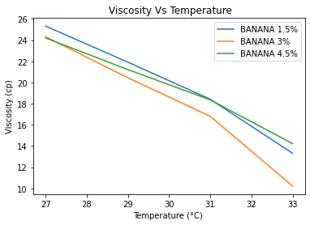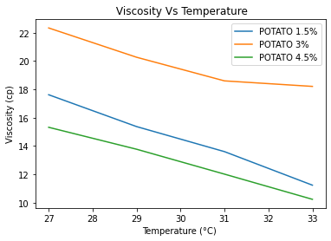
Figure 2 Viscosity vs. Temperature (Banana Samples) Figure 3 Viscosity vs. Temperature (Potato Samples)

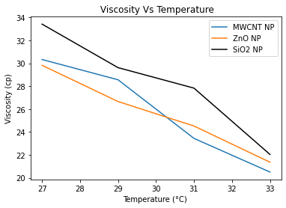
Figure 4 Viscosity vs. Temperature (Nanoparticle Samples)
From Table 3 we have inferred that MWCNT, ZnO, SiO₂ NP Samples have shown reduction of viscosity with increase in temperature as shown in Figure 4 but amongst the prepared concentrations of different NP samples, MWCNT has shown great reduction in viscosity with increase in temperature.
    - Gel Strength vs Shear Stress (Potato)
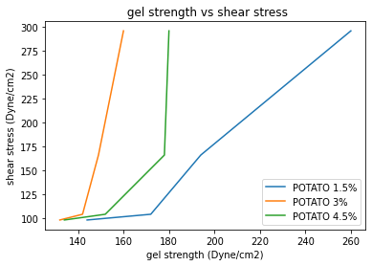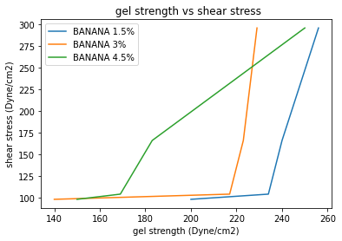

Figure 5 Viscosity vs. Temperature (Potato Samples) Figure 6 Viscosity vs. Temperature (Banana Samples)

Table 4 Gel Strength vs Shear Stress of NDDF Samples
Sample No | Parameter (s) | Shear Stress (dyne/cm²)
 |  | 98 | 104 | 166 | 296
Sample I | Gel strength (dyne/cm²) | 212 | 254 | 276 | 298
Sample II |  | 211 | 214 | 222 | 223
Sample III |  | 200 | 234 | 240 | 256
Sample IV |  | 140 | 217 | 223 | 229
Sample V |  | 150 | 169 | 183 | 250
Sample VI |  | 144 | 172 | 194 | 260
Sample VII |  | 132 | 142 | 149 | 160
Sample VIII |  | 134 | 152 | 178 | 180
Sample IX |  | 120 | 135 | 152 | 179
Sample X |  | 214 | 266 | 270 | 290
Sample XI |  | 220 | 246 | 261 | 283
Sample XII |  | 230 | 258 | 266 | 280

From Figure 5, it can be observed that the gel strength values of the potato NDDF samples have been increasing with a corresponding increase in temperature which shows the suspendibilty characteristic of the potato samples. This may be attributed to the fact that the cross linking structure of the starch with the clay particles of the clay components of the drilling fluid system. Amongst the different concentrations of potato samples under investigation, 1.5% potato has shown better gel strength values. From Figure 6, it can be observed that the gel strength values of the banana NDDF samples have been increasing with a corresponding increase in temperature which shows the suspendibilty characteristic of the banana samples. Amongst the different concentrations of banana samples under investigation, 4.5% banana has shown better gel strength values. From Figure 7, it can be observed that the gel strength values of the nanoparticle NDDF samples have been increasing with a corresponding increase in temperature which shows the suspendibilty characteristic of the nanoparticle samples also depicted in Table 4. Amongst the different nanoparticle samples under investigation, SiO₂ nanoparticle has shown better gel strength values at constant shear stress of 98, 104, 166 and 296 dyne/cm².
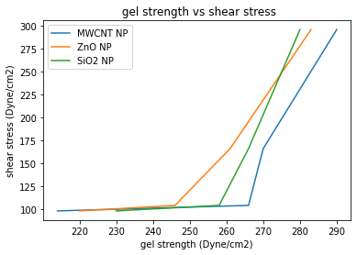
Figure 7 Gel Strength vs. Shear Stress (Nanoparticle Samples)

    - Shear Stress vs. Viscosity (Potato, Banana, Nanoparticle Samples)

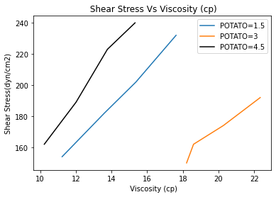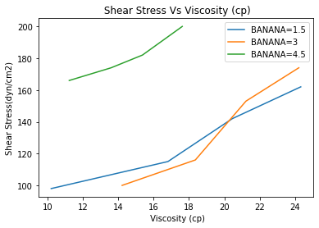
Figure 8 Shear Stress vs. Viscosity (Potato Samples) Figure 9 Shear Stress vs. Viscosity (Banana Samples)

It is been generally observed that drilling fluids exhibits pseudo plastic behavior following different models such as Bingham plastic model, power law model and Herschel Buckley model. They thereby shows increasing trend of viscosity against increasing shear stress which is due to the fact that the stress applied on the mud system with the corresponding increase in shear rate results in increase in viscosity. From Figure 8, it can be seen that potato 1.5% sample has shown a smoother transition of an increasing trend of viscosity with shear stress. From Figure 9, it can be seen that banana 3% sample has shown a smoother transition of an increasing trend of viscosity with shear stress. From Figure 10, it can be seen that MWCNT sample has shown a smoother transition of an increasing trend of viscosity with shear stress.

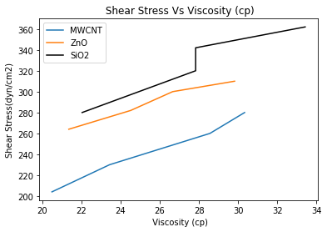
Figure 10 Shear Stress vs. Viscosity (Nanoparticle Samples)

    - Marsh Funnel Viscosity
From Figure 11, it is evident that the marsh funnel viscosity is reported to be 89 seconds for the banana and potato composite sample followed by PGS sample. This may be attributed to the fact that the composite sample forms entangled network like structure amongst the molecules leading to a significant increase in the corresponding viscosity values.
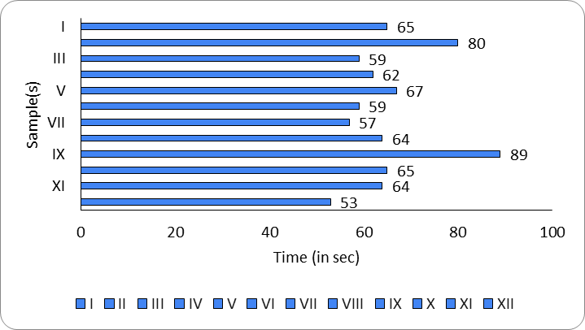
Figure 11 Marsh Funnel Viscosity of the prepared NDDF Samples

4.2 Filtration Loss Analysis
For a conventional drilling fluid the filtration loss should be minimum so that the mud that serves varied purposes such as maintenance of hydrostatic pressure, cooling of drill bit, providing necessary lubrication, lifting of cuttings to surface, etc. is not lost unnecessarily to the formation of interest. As shown in Figure 12 describes the filtrate loss of different samples for analysis in this research work. It has been observed from the above data that the optimum or minimum filtrate loss is against Sample IV (Banana 3%) which depicts that upon addition of dried banana to the NDDF sample has significantly reduced the filtration loss as compared to others. Consequently the filtrate loss values of potato samples ranges between 3.9 to 5.6 ml which is quite impressive. However, this will lead to comparatively high fluid loss to the formation causing formation damage, which have shown significant compatibility with the formation in view of reduced value of filtration loss.
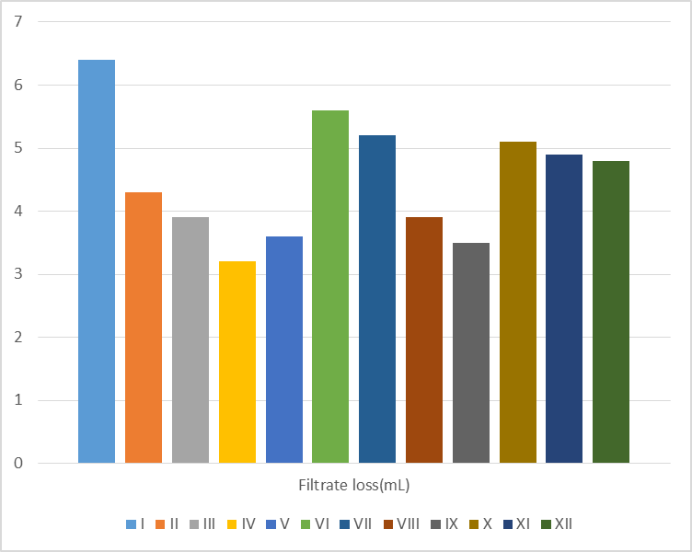
Figure 12 Filter Cake Thicknesses of the NDDF Samples
4.3 Filter Cake Analysis
The quality of the drilling fluid system chosen is largely dependent on strength and thickness of the filter cake. The current research also investigates the mud cake thickness of the prepared NDDF samples. It has been observed from Figure 13 that the Samples IX (Potato+Banana 3%) and XII (SiO₂) depicted the formation of the thinnest filter cakes. On the other hand, banana Samples (III, IV, V) have exhibited the formation of thin filter cakes of 0.07, 0.06 and 0.08 mm respectively as compared to the conventional ones that is 0.12 mm. The reason behind this may be attributed to the fact that banana dried sample when added to the mud system exhibited deflocculating characteristics which led to the dispersion of the clay plates and hence to the formation of a thinner filter cake. However, potato samples have not shown promising results in this regard.

Figure 13 Filter Cake Thicknesses of the NDDF Samples (y-axis is scaled in mm)

4.4. pH Analysis
pH measurements of the prepared NDDF samples were done using the Labtronics Microprocessor Digital pH meter. Figure 14 depicts the values of different samples under investigation for non damaging drilling fluid.

Figure 14 Filter Cake Thicknesses of the NDDF Samples
It is conventionally observed that the pH value of drilling fluid samples generally ranges from 6.5 to 8. From the experimental analysis we have inferred that NDDF samples with potato as a potential additive (Sample VI, VII, and VIII) has shown best results in terms of optimum pH values within the range of 7 approximations. On the other hand conventional NDDF samples with PAC and PGS samples exhibited slight acidic nature which may lead to extensive formation damage while carrying out circulation operations. The samples (X, XI, XII) containing MWCNT, ZnO and SiO₂ nanoparticles have shown better pH results with basic nature with an exception for the silica sample. Similarly the banana additive samples of the prepared NDDF had a balanced pH value however comparatively not suitable for sandstone formations.
4.5. Thermal Degradation Data Analysis
Table 5 Thermal Degradation of prepared NDDF samples
Sl. No. | Sample(s) | Shear Rate  (1/s) | Temperature (°C) | Gel  (dyne/cm²) | Viscosity  (cP)
1. | I | 1021.38 | 27 | 282.89 | 33
 |  |  | 29 | 276.68 | 31.1
 |  |  | 31 | 272.12 | 28.1
 |  |  | 33 | 269.89 | 25.6
 |  |  | 90 | 266.00 | 24.9
2. | II | 1021.38 | 27 | 220.22 | 25.2
 |  |  | 29 | 213.57 | 20.9
 |  |  | 31 | 200.98 | 15.2
 |  |  | 33 | 200.78 | 10.5
 |  |  | 90 | 198.00 | 9.8
3. | III | 1021.38 | 27 | 240.98 | 25.3
 |  |  | 29 | 231.42 | 21.9
 |  |  | 31 | 223.89 | 18.4
 |  |  | 33 | 210.78 | 13.3
 |  |  | 90 | 206.00 | 10.9
4. | IV | 1021.38 | 27 | 259.89 | 24.3
 |  |  | 29 | 240.11 | 20.4
 |  |  | 31 | 221.76 | 16.8
 |  |  | 33 | 199.42 | 10.2
 |  |  | 90 | 190.00 | 9.0
5. | V | 1021.38 | 27 | 274.89 | 24.2
 |  |  | 29 | 252.64 | 21.2
 |  |  | 31 | 246.46 | 18.3
 |  |  | 33 | 238.12 | 14.2
 |  |  | 90 | 230.00 | 12.8
6. | VI | 1021.38 | 27 | 278.88 | 17.6
 |  |  | 29 | 256.24 | 15.3
 |  |  | 31 | 242.23 | 13.6
 |  |  | 33 | 240.64 | 11.2
 |  |  | 90 | 237.00 | 8.9
7. | VII | 1021.38 | 27 | 210.76 | 22.3
 |  |  | 29 | 200.15 | 20.2
 |  |  | 31 | 174.56 | 16.8
 |  |  | 33 | 145.83 | 10.2
 |  |  | 90 | 126.00 | 7.9
8. | VIII | 1021.38 | 27 | 220.36 | 15.3
 |  |  | 29 | 182.46 | 13.7
 |  |  | 31 | 174.34 | 12.0
 |  |  | 33 | 161.20 | 10.2
 |  |  | 90 | 149.00 | 8.8
9. | IX | 1021.38 | 27 | 178.78 | 28.2
 |  |  | 29 | 165.89 | 26.7
 |  |  | 31 | 157.47 | 24.0
 |  |  | 33 | 146.32 | 20.2
 |  |  | 90 | 131.00 | 18.0
10. | X | 1021.38 | 27 | 289.49 | 30.3
 |  |  | 29 | 268.46 | 28.5
 |  |  | 31 | 251.22 | 23.2
 |  |  | 33 | 246.99 | 20.5
 |  |  | 90 | 239.00 | 17.8
11. | XI | 1021.38 | 27 | 298.43 | 29.8
 |  |  | 29 | 276.53 | 26.6
 |  |  | 31 | 266.44 | 24.5
 |  |  | 33 | 258.17 | 21.3
 |  |  | 90 | 251.00 | 18.8
12. | XII | 1021.38 | 27 | 272.12 | 33.4
 |  |  | 29 | 266.42 | 29.6
 |  |  | 31 | 253.33 | 27.8
 |  |  | 33 | 246.87 | 22.0
 |  |  | 90 | 243.00 | 19.1

In all the samples as evident from Table 5, the thermal degradation of properties like shear stress, gel and viscosity has been analysed after 2 weeks from the preparation of the drilling fluid with constant shear rate of 1021.38 s⁻¹ with temperature up to 90 °C. The values of the viscosities of sample I, IV, IX and XII has been observed to have decreased from initial values of 33, 24.3, 28.2 and 33.4 to 25.6, 10.2, 20.2 and 22.0 (in cP) with increase in temperature from 27 to 90° C. Viscosity of Sample IX has been seen to have deteriorated the least. The values of the gel strength of sample I, IV, IX and XII has been observed to have decreased from initial values of 282.89, 259.89, 278.78 and 272.12 significantly. Sample IX and XII gel strength values were seen to have deteriorated the least with a percentage decrease of about 15%.
- Python as a Graphical Interpretation Medium
In the present research work, Python has been used with the assistance of Matplotlib library function as depicted in Figure 15. Matplotlib is a comprehensive Python library for creating static, animated, and interactive visualizations making data interpretation a straight forward and tranquil process with huge sets of data generated in oilfield. The platform used is Google colab and PyCharm software.
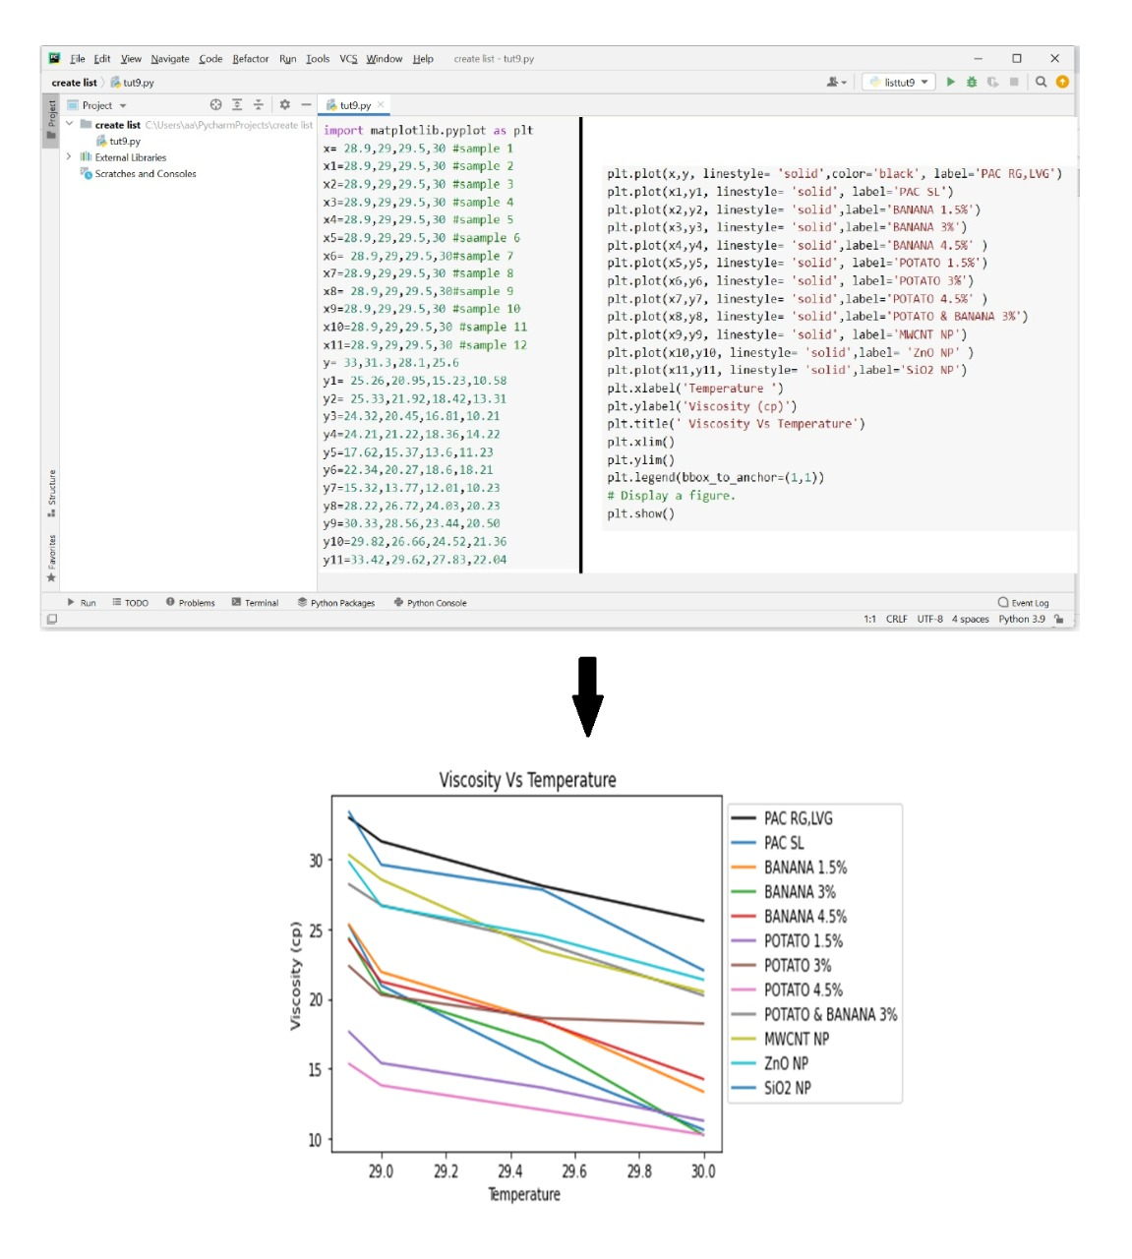
Figure 15 Graphical Interpretation of the data generated in section 4.1.1 using Python

6. Conclusion
This research work is a culmination of the approach to develop a novel drilling fluid and make it industry ready. The abundant bioresources available in the vicinity of the locality is set under investigation to draw comparative analysis with artificial nanoparticles on the basis of rheology, filtration, pH and thermal degradation analysis.
The following points can be noted in the context of the final completion of the research work.
- The viscosity values decreased with increase in temperature. This is because of the fact that momentum transfer and increase in thermal agitation is caused by free motion of the molecules in liquid fraction.
- The viscosity increases linearly with the increase in shear stress which is due to the fact of increase in viscous nature of the fluid with the increase in agitation.
- The gel strength values increased significantly with increase in shear stress for the all the samples. However, improved results have been obtained in case of composite of banana and potato sample followed by silica nanoparticle that depicts the fact that bioresource composite will effectively help in lifting of cuttings and suspendibility as compared to the silica nanoparticle as an additive in the drilling fluid system.
- Furthermore, the graphical analysis part of the interpreted results was done using the Python software with the input data for rheological properties.
- Furthermore, pH values were well maintained in the NDDF samples with banana as additives having a basic concentration for the overall drilling fluid system as compared to MWCNT, silica and zinc oxide nanoparticle.
- After a gap of two weeks, the thermal degradation examination depicted the extent of degradation of the components of the fluid systems and consequently the nanoparticles and PGS samples have shown better thermal withstanding capacity wherein the bioresources lagged behind in the same.
- Overall, it can be seen that composite bioresource samples and banana standalone have shown improved behaviour in terms of filtration, pH, rheology etc. and can be an advantage over the nanoparticles.
- Furthermore, the economic feasibility and availability of the bioresources under investigation is a far better option as compared to the nanoparticles.
Acknowledgement
The authors are grateful to the Department of Petroleum Engineering and Petroleum Technology, Dibrugarh University for providing the necessary laboratory facilities to carry out the research work. Consequently, the authors would like to acknowledge Oil India Limited, Duliajan for providing the raw chemicals required for the purpose of experimental investigation.

References
[1] P. Talukdar, S. Kalita, A. Pandey, U. Dutta, and R. Singh, “Use of Tannate derived from Tea Waste as Drilling Fluid Additive,” vol. 13, no. 16, pp. 12463–12468, 2018.
[2] B. Borah and B. M. Das, “A review on applications of bio-products employed in drilling fluids to minimize environmental footprint,” Environ. Challenges, vol. 6, no. August 2021, p. 100411, 2022, doi: 10.1016/j.envc.2021.100411.
[3] M. E. Hossain and M. Wajheeuddin, “The use of grass as an environmentally friendly additive in water-based drilling fluids,” Pet. Sci., vol. 13, no. 2, pp. 292–303, 2016, doi: 10.1007/s12182-016-0083-8.
[4] R. Pamies, C. Espejo, F. J. Carrión, A. Morina, A. Neville, and M. D. Bermúdez, “Rheological behavior of multiwalled carbon nanotube-imidazolium tosylate ionic liquid dispersions,” J. Rheol. (N. Y. N. Y)., vol. 61, no. 2, pp. 279–289, 2017, doi: 10.1122/1.4975108.
[5] A. R. Ismail, W. R. W. Sulaiman, M. Z. Jaafar, A. Aftab, A. A. Razi, and Z. H. Ibupoto, “The application of MWCNT to enhance the rheological behavior of drilling fluids at high temperature,” Malaysian J. Fundam. Appl. Sci., vol. 12, no. 3, pp. 95–98, 2017, doi: 10.11113/mjfas.v12n3.423.
[6] W. N. Aggrey, N. Y. Asiedu, B. N. Tackie-otoo, and S. Adjei, “Archive of SID Performance of Carboxymethyl Cellulose Produced from Cocoa Pod Husk as Fluid Loss Control Agent at High Temperatures and Variable ( Low and High ) Differential Pressure Conditions-Part 1 Archive of SID,” pp. 22–38, doi: 10.22078/jpst.2019.3550.1570.
[7] M. Beg, P. Kumar, P. Choudhary, and S. Sharma, “Effect of high temperature ageing on TiO2 nanoparticles enhanced drilling fluids: A rheological and filtration study,” Upstream Oil Gas Technol., vol. 5, no. February, p. 100019, 2020, doi: 10.1016/j.upstre.2020.100019.
[8] E. Kusrini, F. Oktavianto, A. Usman, D. P. Mawarni, and M. I. Alhamid, “Synthesis, characterization, and performance of graphene oxide and phosphorylated graphene oxide as additive in water-based drilling fluids,” Appl. Surf. Sci., vol. 506, p. 145005, 2020, doi: 10.1016/j.apsusc.2019.145005.
[9] Z. Wang, Y. Wu, P. Luo, Y. Tian, Y. Lin, and Q. Guo, “Poly (sodium p-styrene sulfonate) modified Fe3O4 nanoparticles as effective additives in water-based drilling fluids,” J. Pet. Sci. Eng., vol. 165, pp. 786–797, 2018, doi: 10.1016/j.petrol.2018.03.001.
[10] C. Liu et al., “Cellulose nanofibers from rapidly microwave-delignified energy cane bagasse and their application in drilling fluids as rheology and filtration modifiers,” Ind. Crops Prod., vol. 150, no. December 2019, p. 112378, 2020, doi: 10.1016/j.indcrop.2020.112378.
[11] E. Yalman, G. Federer-Kovacs, T. Depci, H. Al Khalaf, V. Aylikci, and M. G. Aydin, “Development of novel inhibitive water-based drilling muds for oil and gas field applications,” J. Pet. Sci. Eng., vol. 210, p. 109907, 2022, doi: 10.1016/j.petrol.2021.109907.
[12] G. Zhuang, Z. Zhang, and M. Jaber, “Organoclays used as colloidal and rheological additives in oil-based drilling fluids: An overview,” Appl. Clay Sci., vol. 177, no. November 2018, pp. 63–81, 2019, doi: 10.1016/j.clay.2019.05.006.
[13] J. Vargas et al., “Effect of silica nanoparticles on thermal stability in bentonite free water-based drilling fluids to improve its rheological and filtration properties after aging process,” Offshore Technol. Conf. Bras. 2019, OTCB 2019, 2020, doi: 10.4043/29901-ms.
[14] A. O. Gbadamosi, R. Junin, Y. Abdalla, A. Agi, and J. O. Oseh, “Experimental investigation of the effects of silica nanoparticle on hole cleaning efficiency of water-based drilling mud,” J. Pet. Sci. Eng., vol. 172, pp. 1226–1234, 2019, doi: 10.1016/j.petrol.2018.09.097.
[15] M. Fereydouni, S. Sabbaghi, R. Saboori, and S. Zeinali, “Effect of Polyanionic Cellulose Polymer Nanoparticles on Rheological Properties of Drilling Mud,” Int. J. Nanosci. Nanotechnol., vol. 8, no. 3, pp. 171–174, 2012.
[16] M. Ant, “Polymer-Decorated Cellulose Nanocrystals as Environmentally Friendly Additives for Olefin-Based Drilling Fluids,” 2021.
[17] A. W. K. Ma, K. M. Yearsley, F. Chinesta, and M. R. MacKley, “A review of the microstructure and rheology of carbon nanotube suspensions,” Proc. Inst. Mech. Eng. Part N J. Nanoeng. Nanosyst., vol. 222, no. 3–4, pp. 71–94, 2008, doi: 10.1243/17403499JNN153.
[18] B. Fazelabdolabadi, A. A. Khodadadi, and M. Sedaghatzadeh, “Thermal and rheological properties improvement of drilling fluids using functionalized carbon nanotubes,” Appl. Nanosci., vol. 5, no. 6, pp. 651–659, 2015, doi: 10.1007/s13204-014-0359-5.
[19] C. C. Teng et al., “Effect of MWCNT content on rheological and dynamic mechanical properties of multiwalled carbon nanotube/polypropylene composites,” Compos. Part A Appl. Sci. Manuf., vol. 39, no. 12, pp. 1869–1875, 2008, doi: 10.1016/j.compositesa.2008.09.004.
[20] M. Sedaghatzadeh, A. A. Khodadadi, and M. R. T. Birgani, “An Improvement in Thermal and Rheological Properties of Water-based Drilling Fluids Using Multiwall Carbon Nanotube (MWCNT),” Iran. J. Oil Gas Sci. Technol., vol. 1, no. 1, pp. 55–65, 2012, [Online]. Available: http://ijogst.put.ac.ir.
[21] M. T. Al-Saba, A. Al Fadhli, A. Marafi, A. Hussain, F. Bander, and M. F. Al Dushaishi, “Application of nanoparticles in improving rheological properties of water based drilling fluids,” Soc. Pet. Eng. - SPE Kingdom Saudi Arab. Annu. Tech. Symp. Exhib. 2018, SATS 2018, pp. 1–10, 2018, doi: 10.2118/192239-ms.
[22] R. Saboori, S. Sabbaghi, and A. Kalantariasl, “Improvement of rheological, filtration and thermal conductivity of bentonite drilling fluid using copper oxide/polyacrylamide nanocomposite,” Powder Technol., vol. 353, pp. 257–266, 2019, doi: 10.1016/j.powtec.2019.05.038.
[23] Z. Vryzas, O. Mahmoud, H. A. Nasr-El-din, and V. C. Kelessidis, “Development and testing of novel drilling fluids using Fe2O3 and SiO2 nanoparticles for enhanced drilling operations,” Int. Pet. Technol. Conf. IPTC 2015, vol. 2015-Janua, 2015, doi: 10.2523/iptc-18381-ms.
[24] S. R. Smith, R. Rafati, A. Sharifi Haddad, A. Cooper, and H. Hamidi, “Application of aluminium oxide nanoparticles to enhance rheological and filtration properties of water based muds at HPHT conditions,” Colloids Surfaces A Physicochem. Eng. Asp., vol. 537, pp. 361–371, 2018, doi: 10.1016/j.colsurfa.2017.10.050.

