Tribological Study on Automotive Braking Using Laser Surfaces Texturing's Effect

Prem Ananth M* Sivaramapandian J Rohit Antony R Prathish Srimen R and Prathap A

Mechanical Engineering Department, Sri Venkateswara College of Engineering, Chennai, Tamil Nadu, India.

*premananth@svce.ac.in
Abstract

Most commercial vehicles use disc brake system for braking. Brake pads are usually worn out due to frictional force caused on material surface. Increasing WR (WR) enhances life of the brake pad material. Hence, laser engraving method is used to improve the WR of the braking material. It is highly practical to investigate friction and wear. Any mechanical system's capability to perform needs adequate friction and wear characteristics. Improving the WR of braking system by studying the wear properties of materials like Aluminum Alloy and Mild steel material is also of great importance. In this paper, different patterns of dimples are inscribed on the surface of the material and an experiment investigation carried out using ‘pin on disc’ (POD) tribometer to study the wear characteristics and also to find the most efficient material-pattern combination.

Keywords: Pin-on-disc, COF, Surface Engraving, Sliding Friction, Wear.

Introduction

The study of interacting surfaces in relative motion is known as tribology. It entails researching and putting wear, lubrication, and friction principles to use. The performance of many machines in our daily lives relies heavily on the interaction of moving contacting surfaces. These surfaces often require lubrication to ensure their longevity and enhance energy efficiency. This specialized area of study falls under the umbrella of tribology, a unique branch of science. Tribology is a multidisciplinary subject that encompasses a significant portion of the curriculum in typical undergraduate science or engineering programs. Its significance in today's world cannot be overstated, as a substantial amount of energy is lost due to friction in mechanical components. Let's examine brake systems to learn more about this field of study. A braking system is a crucial component of a machine that applies controlled force to a moving surface in order to slow it down or bring it to a controlled stop. Kinetic energy is converted to thermal energy and dissipated into the atmosphere throughout this process. Disc brakes are frequently used in the field of vehicle engineering and are frequently actuated hydraulically. Every braking operation is based on the core idea of orchestrating a regulated friction process that accelerates deceleration and efficiently transforms motion into heat energy.
Disc brakes offer several advantages, with one of the most notable being their resistance to wear. These brakes maintain a cool temperature even after repeated applications, and their brake pads can be easily replaced. The brake disc serves as the rotating component within a wheel's disc brake assembly, serving as the surface against which the brake pads are applied. Typically, these discs are crafted from cast iron. The brake pads are meticulously designed for optimal friction, embedding brake pad material into the disc as they wear evenly. The coefficient of friction plays a pivotal role in the braking system's performance, and it can vary depending on the specific materials used for the brake rotor.
The force slowing brake disc is
F=2C_{f.pad}F_{pad}

As the braking system is an essential part of safety, the structural materials used in brakes should have a variety of qualities, including being wear resistant, lower in weight, and having a good thermal capacity.

Material Selection and its properties

En30B

EN30B is typically used in manufacturing Gears, shafts, high-duty bolts, high-duty spindles, and other parts demand the highest strength, toughness, or WR. This steel needs to be shocked while it is still annealed and then heat treated as follows to permit machining: Harden in air (or oil for larger areas larger than 212" in diameter) at 810°C or 830°C. If necessary, temper at a maximum temperature of 250 °C.
Melting point | : 1425°C
Density | : 8.08g/𝑐𝑚³
Specific gravity | : 7.65
Modulus of elasticity in tension | : 365 Gpa
Tensile strength minimum | : 717 N/𝑚𝑚²
Yield strength minimum | : 713 N/𝑚𝑚²
Hardness | : Rockwell 233

Aluminum Alloy 7075

Aluminum, one of the most lightweight metals available for commercial use, boasts a density that's approximately one-third that of both steel and copper. This remarkable property, stemming from its low density, contributes to its exceptional strength-to-weight ratio, making it highly advantageous for various industries, particularly transportation. Although pure aluminum doesn't possess significant tensile strength, it can be strengthened by introducing alloying elements such as manganese, silicon, copper, and magnesium. These additives not only tailor the alloy to specific purposes but also enhance the overall strength of aluminum. In regions with cold climates, aluminum proves especially beneficial, as it maintains its toughness even at lower temperatures, further bolstering its tensile strength compared to steel.
Melting point | : 477- 635 °C
Density | : 2.81 g/cc
Specific gravity | : 2.73
Modulus of elasticity in tension | : 71.7 Gpa
Tensile strength ultimate | : 572Mpa
Yield strength minimum | : 503Mpa
Hardness | : Rockwell 87HRB

  - Mild Steel
At all times, even common kitchen items like spoons and pans are made of mild steel. This article primarily focuses on examining mild steel's numerous qualities and emphasizing their importance in the production of metallic objects. Due to its affordability, mild steel dominates the world market for steel production, making up about 90% of all steel products.
Melting point | : 1350 to1530°C
Density | : 7900 kg/𝑚³
Specific gravity | : 7900kg/𝑚³
Modulus of elasticity in tension | : 210 Gpa
Tensile strength minimum | : 47 kgf/𝑚𝑚²
Yield strength minimum | : 32 kgf/𝑚𝑚²

- Experimental Setup:
The POD is used to examine the Wear characteristics of material during sliding. EN30B serves as disc, while Mild Steel and Aluminum Alloy acts as pin specimen. The experiment is conducted with 20% density. A sliding distance of 90 meters and a speed of 2 meters per second are used in the POD test. The coefficient of friction for each textured pin surface is determined and then compared.
Mild steel and Aluminum Alloy are machined then polished into a pin of dia, length are 8 mm and 28 mm respectively. As said the various patterns; such as circle, hexagon, Ellipse and the combination of these three were designed in AutoCAD software. The “Laser Surface Texturing” (LST) is done on pin using laser marking system supported by AutoCAD software. The A diode-pumped Yttrium enriched fiber source contains a laser. Following laser parameters were followed for texturing the pins. Wavelength: 1064 nm; Power: 80W; Pulse: 20 kHz pulsating fiber laser beam. 200 rpm speed. No of passes: 1.

Parameters:
Laser Type | Diode pumped Nd: YAG fiber laser
Laser Power | 20 W
Laser Wavelength | 1064 nm
Marking Field | 200*200 mm
Maximum Scanning Speed | 10000 mm/sec
Ambient Operating Temperature | 40° C

Pin-On-Disc Test

POD tribometer in Figure.1 was used for ‘tribological properties’ in this research. The test procedure is as follows: The pin surface was first made level so that it could carry the load across its whole initial cross-section. This was accomplished by grinding the pin specimen's surfaces using emery paper (80 grit size) before tests. In second stage, "run-in-wear" was performed. By skipping this stage, the first turbulent period linked to the friction and wear curves is avoided. The third and last stage is the actual testing, often known as constant or steady state wear.

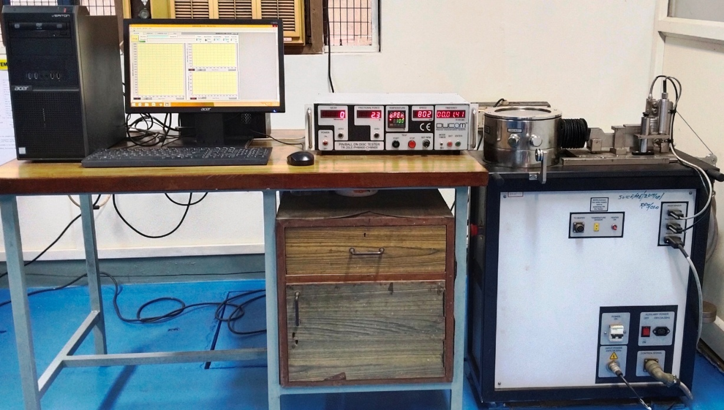

Fig. 1 Pin on Disc Machine

  - Laser engraving method:

A method applied to surface engineering is LST as shown in Figure 2 is adopted to enhance the material tribo characteristics. Using a laser to create patterned microstructures on the surface of the materials can improve load capacity, wear rates, lubrication lifetime, and reduce friction coefficients. Excimer lasers are less frequent than Nd-YAG and CO2 lasers because to their low ablation rates and lengthy LST times. In our case Nd-YAG laser is used to form dimple like pattern on the surface of the specimen.
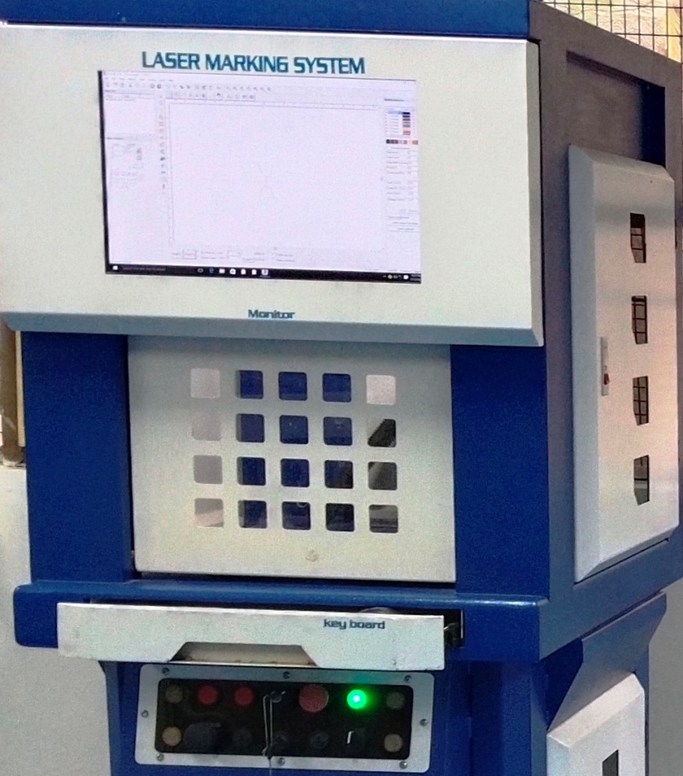

Fig. 2 Laser Marking Machine

  - Surface texturing:

However it is generally accepted that texture optimization should be done depending on the particular requirements of applications, surfaces with textures can always improve tribological performance. Laser marking operation is depicted in Figure 3. Texturing of Hexagonal, Circular, Ellipse dimple and a combination all these dimples (cir+hex, hex+ellipse, circle+ellipse) were formed over the pin's mirror-finished surface as shown in Figure 4. The LST was done on the specimen with a ‘Nd:YAG’ laser beam. Depth of dimple is 2.5 micron.

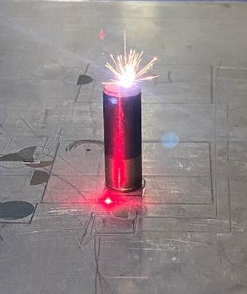

Fig. 3 Laser Marking Operation

Fig. 4 Surface Texturing pattern on specimen

Design Calculations of Brake pad

Area of pin specimen, A = $\frac{πd^{2}}{4}$= $\frac{πd^{2}}{4}$ = 78.53981 ${mm}^{2}$

For a Circular dimple:
- Area of a circular dimple=$\frac{πd^{2}}{4}$ = $\frac{π{×0.1}^{2}}{4}$ = 7.85398x${10}^{-3}$ ${mm}^{2}$
- Dimple density=> $∂c=\frac{Ac}{Sc^{2}}$
Where,$∂c$-Dimple density (Taken as 20%)
Ac- Area of circular dimple
Sc- Distance between centre of two dimples

Dimple Density=>20/100=0.00785398/S$c^{2}$
=>S$c^{2}$= 0.039265
=>Sc= 0.198mm
- No.of dimples = A x$∂c$/Ac
= 78.53981×$\frac{0.2}{7.85398×{10}^{-3}}$ = 2000 dimples

For a Hexagonal dimple:

- Area of hexagonal dimple= $3\sqrt[2]{3} \frac{a^{2}}{2}$
Where, a= side length of the hexagon
Area of hexagonal dimple =>7.85398x${10}^{-3}$= $3\sqrt[2]{3} \frac{a^{2}}{2}$
=>3.0229983=$a^{2}$
=>a=0.005498${mm}^{2}$
For a Elliptical dimple:

- Area of elliptical dimple= $2(1+\sqrt{2} )(a^{2})$
Where, a= side length of the ellipse
Area of elliptical dimple => 7.85398x10⁻³ = π x a x b = 2.4999 x 10⁻³= a x b
=>2.4999 x 10⁻³/0.07= a
=>A=0.0357mm

Weight Loss
Acetone is tried to properly clean the metal and composite test samples . The next step is to weigh each sample is digital balance with an accuracy of 0.1 mg. The sample is then prepared for the wear test by mounting it on the tribometer's pin holder. The precise wear rates of the materials have been determined by
W is specific wear rates in mm³/N
F is applied load in N.

‘Wear and Coefficient of friction:
The outcomes of a tribo-system can be described as a friction coefficient and rate of wear. In contrast to the material characteristics of the bodies, coefficient friction as well as wear rate characterize the state of being in contact between the bodies. Although they can be considered the material characteristics of the bodies in particular specific contact circumstances. In any circumstance of contact, friction and wear are connected to one another and can be thought of as two different types of responses from a single tribo-system. Modern friction and wear management techniques include multi-phase alloying and composite structuring in addition to conventional lubrication techniques like soft or hard film coating. Roughness, hardness, ductility, oxide film, reaction layer, and adhesive transfer all play a vital part in the wear mechanisms, which we must first understand in order to investigate the tribo-characteristics of materials. Wear is the occurrence of mechanical and/or chemical damage that impairs the quality of the materials in contact with each other. Friction is the force that develops between two contact surfaces when they are moving relative to one another.

Wear Calculation
- Coefficient of friction, μ = Frictional Force (N) / Normal Load (N)

- Sliding Velocity, U = πDN (m/s) / 60 x 1000
D is the Wear track diameter (mm)
N is the Disc Speed (rpm)
- Sliding Distance, D = πDNT (m/s) / 60000
T is the Testing Time (seconds)

- Mass Loss, M = m₁ ₋ m₂ (g)
m₁ is pin mass (before test) (g)
m₂ is pin mass (after test) (g)

- Volume Loss (Wear Volume), V =Mass Loss (M) x 1000 (mm³) / Density of the Pin Specimen (ρ) g/cm³

- Specific Wear Rate (SWR) =Volume Loss (V) (mm³/Nm) / Load x Sliding Distance (D)

  - Specific wear rate for pin specimen

Material | Dimple shape | Weight  (W1)  grams | Weight  (W2)  grams | Mass oss,  M  (g) | Volume Loss,  V  (g) | Specific Wear Rate,  (SWR)  $$\frac{mm³}{Nm}$$
Aluminum Alloy | Circle | 6.175 | 6.102 | 0.073 | 36.5 | 8.11${×10}^{-3}$
 | Circle+ Hexagon | 6.723 | 6.15 | 0.073 | 36.5 | $$8.11×{10}^{-3}$$
 | Circle+ Ellipse | 6.193 | 6.134 | 0.059 | 29.5 | $$6.55×{10}^{-3}$$
 | Hexagon | 6.235 | 6.0162 | 0.072 | 36 | $$8×{10}^{-3}$$
 | Ellipse | 6.163 | 6.112 | 0.051 | 28.5 | $$5.66×{10}^{-3}$$
 | Hexagon +Ellipse | 6.203 | 6.144 | 0.059 | 29.5 | $$6.55×{10}^{-3}$$
Mild Steel | Circle | 17.169 | 17.080 | 0.089 | 44.5 | $$9.88×{10}^{-3}$$
 | Circle+ Hexagon | 17.200 | 17.098 | 0.102 | 51 | $$11.33×{10}^{-3}$$
 | Circle+ Ellipse | 17.204 | 17.183 | 0.101 | 50.5 | $$12.2×{10}^{-3}$$
 | Hexagon | 17.258 | 17.047 | 0.161 | 80.5 | $$17.88×{10}^{-3}$$
 | Ellipse | 17.216 | 17.118 | 0.098 | 49 | $$10.86×{10}^{-3}$$
 | Hexagon +Ellipse | 17.197 | 17.015 | 0.182 | 91 | $$20.2×{10}^{-3}$$

Results and Discussions

The following graphs shown in Figures. 5 and 6 depicts the different values of coefficient of friction for various dimple structures and untextured pin vs Sliding Distance. From the following graphs we can evidently prove that which dimple structure has less wear rate in terms of coefficient of friction. Plot between COF and sliding distance are plotted, major inference analyzed from most of the graphs is as time goes the wear also increases this is because temperature goes on increasing which softens the material.

Fig. 5 Coefficient of Friction Vs Sliding Distance of Mild steel

Fig. 6 Coefficient of Friction Vs Sliding Distance of Aluminium Alloy
Initial sudden contact rise the value of Coefficient of friction against frictional force because there occurs an adhered contact between the two materials which makes it to remain constant. At the final stage the adhered layer gets removed and sticks to the disc surface thereby increasing the coefficient of friction again.

Fig. 7 Wear Vs Different combinations of Texturing and Materials

As we can clearly see from the graphs shapes like hexagon tends to increase wear in most of the cases while the shapes like ellipse and circle tends to decrease the wear rate this trend is attributed due to sharp nature of edges in hexagon while there is slightly curved edges in ellipse and circle which majorly decreases the wear rate as shown in Figure. 7. A clear trend is also observed in case of the combination of circle and ellipse dimple where wear rates are decreasing to a large level than in other cases.
Dimples tend to reduce the wear rate because of lower surface contact between the two wearing surfaces and those wear debris will be filling the dimple without falling making it less polluting and environmental friendly in brake pad application. Mild steel has the higher wear rate this is because of it has a good adherence property with the disc which makes it more comfortable for larger adherence wear so the wear is greater in mild steel.

Conclusions

Using Laser engraving method different dimples where made on the surface of the specimen and with the aid of POD tribo-meter, the characteristics of wear were examined and determined. The following bar graph shows the wear rate determination.

- From the bar graph above we are able to see that Aluminum circle + Hexagon has the highest wear rate.
- Among Aluminum, Aluminum with hexagonal dimple has the lowest wear rate of 57.874$\frac{mm³}{Nm}$.
- Among steel, Steel with elliptical dimple has the lowest wear rate of 94.083$\frac{mm³}{Nm}$.

References:

1. Geiger M., Roth S., Becker W. Influence of laser-produced microstructures On the tribological behavior of ceramics. Surf. Coat. Technol. 1998; 100:17–22.

2. L.M. Vilhena, M. Sedlaček, B. Podgornik, J. Vižintin, A. Babnik, J. Možina Surface texturing by pulsed Nd: YAG laser Tribol. Int., 42 (2009), pp. 1496-1504.

3. M. Varenberg, G. Halperin, I. Etsion Different aspects of the role of wear debris in fretting wear. Wear (2002), pp. 902-910.

4. Etsion Improving tribological performance of mechanical components by LST Tribol. Lett., 17 (2004).

5. Dunn, J.V. Carstensen, K.L. Wlodarczyk, E.B. Hansen, J. Gabzdyl, P.M. Harrison, J.D. Shephard, D.P. Hand Nanosecond laser texturing for high friction applications Opt. Lasers Eng., 62 (2014), pp. 9-16.

6. Xing, Youqiang Deng Jianxin, Feng, Xiuting, Yu, Sheng Effect of LST on Si 3 N 4 /TiC ceramic sliding against steel under dry friction Materials &amp; Design (1980-2015) Volume 52, December 2013, Pages 234-245

7. Bharatish, A., H. N. Narasimha Murthy, G. Aditya, B. Anand, B. S. Satyanarayana, and M. Krishna. 2015.“Optics &amp; Laser Technology Evaluation of Thermal Residual Stresses in Laser Drilled Alumina Ceramics Using Micro-Raman Spectroscopy and COMSOL Multiphysics.” Optics &amp; Laser Technology, 70:76–84.

8. Vora, H.D., and N.B. Dahotre.2015. “Multiphysics Theoretical Evaluation of Thermal Stresses in Laser Machined Structural Alumina.” Lasers in Manufacturing and Materials Processing2(1):1–23.

9. Amanov, A., R. Tsuboi, O. Hironobu, and S. Sasaki.2013. “The Influence of Bulges Produced by LST on the Sliding Friction and Wear Behavior.” Tribology International60: 216–223.

10. WuZe, Deng Jianxin, ZhangHui, Lian Yunsong, ZhaoJun Tribological behavior of textured cemented carbide filled with solid lubricants in dry sliding with titanium alloys Wear Volumes 292–293, 15 July 2012, Pages 135-143.

