Nanotechnologies in Oral Surgery
- Sthitaprajna Lenka, Professor, Department of Oral and Maxillofacial Surgery, Institute of Dental Sciences, Siksha O Anusandhan (Deemed to be University), Bhubaneswar, Odisha, India; Email: sthitaprajnalenka@gmail.com
- Karishma Rathor, Tutor, Department of Public Health Dentistry, Institute of Dental Sciences, Siksha O Anusandhan (Deemed to be University), Bhubaneswar, Odisha, India; Email: krishrrathor@gmail.com
- Santosh Kumar Subudhi, Professor, Department of Oral and Maxillofacial Surgery, Institute of Dental Sciences, Siksha O Anusandhan (Deemed to be University), Bhubaneswar, Odisha, India; Email: sthitaprajnalenka@gmail.com
- Nitish Kumar Panda, Department of Oral and Maxillofacial Surgery, Institute of Dental Sciences, Siksha ‘O’ Anusandhan (Deemed to be University), Bhubaneswar, Odisha, India
- Ananya Bej, Post Graduate Trainee, Department of Oral and Maxillofacial Surgery, Institute of Dental Sciences, Siksha O Anusandhan (Deemed to be University), Bhubaneswar, Odisha, India; Email- ananya17bej@gmail.com
- Swagata Sahoo, Post Graduate Trainee, Department of Oral and Maxillofacial Surgery, Institute of Dental Sciences, Siksha O Anusandhan (Deemed to be University), Bhubaneswar, Odisha, India; Email- swagatasani793@gmail.com
----------------------------------------------------------------------------------------------------------------
ABSTRACT:
Diagnostic imaging, surgery, dentistry, and other fields have all undergone numerous dramatic developments with the help of nanotechnology. Monitoring numerous severe diseases, including cancer, genetic anomalies, neurological disorders, cardiovascular diseases, etc., has demonstrated its most significant potential. Medicine can be used for improvised medication therapy, suture material, surgical tools, visualization techniques, and the prevention, diagnosis, and planning of numerous diseases. As a result, it raised the bar for research conducted by scientists and medical professionals in dentistry, clinical trials, the creation of dental equipment, and the management and care of patients. Using nanotechnology in various oral and maxillofacial surgery procedures could have long-term repercussions.
Keywords- Nanoparticle, Nanodentistry, Nano-implant, Nanomaterials, Nanomedicine, Photodynamic therapy, Oral leukoplakia, Tumor
----------------------------------------------------------------------------------------------------------------
INTRODUCTION
In the hard and soft tissues of the maxillofacial region, oral maxillofacial surgery, a subspecialty of dentistry, deals with diagnosing and treating various abnormalities. These facial bone abnormalities must be treated surgically, and bone implants or other bone-forming biocompatible materials must be placed. Materials with poor biocompatibility characteristics can occasionally cause post-operative infection, facial skin discolouration, and discomfort. The superior biocompatibility, human safety, and expertise of modern nanomaterials, which operate at atomic, macromolecular, or micromolecular levels in the range of 1 to 100 nanometers, produce better results. As a result, nanotechnology has enhanced healthcare by offering top-notch techniques for identifying and preventing diseases, as well as a variety of therapies like gene therapy and drug delivery. The lower morbidity and mortality rates for head and neck cancers are among the best illustrations of how nanotechnology has an impact.
DEFINITION & CLASSIFICATION OF NANOTECHNOLOGY
Nanotechnology is a young area that uses materials with nanostructures that range in size from 1 to 100 nm. Richard P. Feynman gave a brief overview of nanotechnology in 1959. In a 1974 publication, Norio Taniguchi of Tokyo Science University gave the original definition of nanotechnology: "Nanotechnology" refers to the processing, separation, consolidation, and deformation of materials by a single atom or molecule. K. Eric Drexler made it well-known. The International Organization for Standardization defines nanomaterials as "Materials with any nanoscale dimension or having internal nanoscale surface structure." With the development of technology, there are various classification schemes based on crystalline form origin, particle size, shape, or dimension
Organic-based, Inorganic-based, carbon-based and ceramic Based.
B. Based on dimension, Nanomaterial can be classified as
1. Nanorods, Nanowires
2. Particles, quantum dots, hollow spheres.
C. Based on phase composition, nanomaterials are of,
1. Single-phase solids- Crystalline and amorphous layers.
2. Matrix composites- coated particles
3. Multi-phase systems- colloids aero gels and ferrofluids
WHAT ARE THE NANOMATERIALS?
There are Few Examples of Nanomaterial, such as
- Nanotubes: These are carbon rods about half the size of a DNA molecule. These tools are used to pinpoint the precise site of genetic modifications and detect the presence of changed Genes.
- Dendrimers: High-branched macromolecules with regulated three-dimensional structures that enable the attachment of other molecules, such as contrast agents, to the surface of cancer cells, medications, etc.
- Nanoscale Cantilevers: These are the flexible beams which bind to molecules associated with cancer.
- Nanoshell: By varying the thickness of the layers, microscopic beads contain a silica core and a metallic outer layer, often gold. Near-infrared light may be absorbed by beads, producing a powerful heat that kills cancer cells.
- Nanopores: They are little openings that let one strand of DNA at a time pass through. These nanopores increase the efficiency of DNA sequencing.
- Digital dental imaging: Low radiation doses produce high-quality pictures with nano phosphor scintillation.
- Quantum dots: Their ability to attach to proteins specific to cancer cells has been used in the optical detection of gene proteins and cell assays in tumour and lymph node samples, essentially bringing tumours to light. When exposed to ultraviolet light, they can glow brightly.
Synthesis of Nanoparticles: There are two main techniques in synthesizing nanoparticles.
- Top-down technique: Microscopic material gets assembled into a compound structure, and these molecules are rearranged to get the desired properties.
- Bottom-up technique: The custom-made molecule can self-replicate by designing and synthesizing. Small structures are created using bigger ones to guide their assembly, as depicted in Fig. 1.
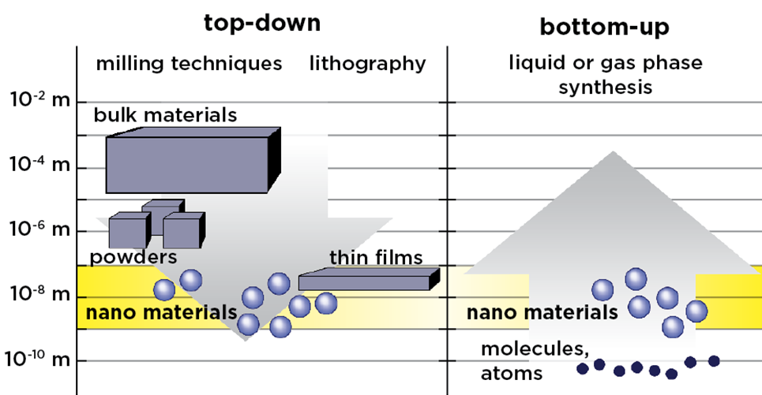
Figure 1. Synthesis of nanoparticle
Dental and maxillofacial surgery and the use of nanotechnology
One of the most fatal diseases affecting people is oral cancer, which has a high fatality rate. The survival rate for oral squamous cell carcinoma, the sixth most prevalent cancer worldwide, has not yet increased. Early oral cancer detection is essential for increasing survival rates. To detect diseases sooner, clinical diagnostics using nanotechnology has been created. It can deliver highly toxic medications to malignant cells after detecting even one cancerous cell in vivo. Nanoshells, quantum dots, and super-magnetic Materials utilized for cancer detection include nanoparticles (NPs), nanowires, and recently created nanosponges. Individual cancer cells can be located using certain cross-linkers, such as particular antibodies against cancer cells. On the surfaces of individual cancer cells, a unique collection of lipid-coated, targeted quantum dots quantifies a number of distinct indicators. For delivering drugs and genes, investigating DNA structures, and other purposes, various types of NPs are utilized. They comprise therapeutic nanocrystals and polymers such as dendrimers, fullerenes, liposomes, and inorganic NPs.
Treatment of oral cancer
Chemotherapy-induced systemic toxicity is one of cancer treatment's most frequent side effects. The effects of treatment include mouth burning and hair loss. By precisely localizing and killing cancer cells with nano-drug delivery, nanotechnology helps lower systemic toxicity by lowering the dosages of anti-cancer medications needed. The most recent development in cancer therapy is nanotechnology, which offers a glimmer of hope for bettering cancer treatments by working at two primary levels, such as giving a pharmaceutical agent new quality and directing the agent directly to the tumour. Thus, treatment through Nanotechnology includes blood-brain barrier-crossing medication delivery devices, nonviral gene delivery systems, nanomaterials for brachytherapy, and nano-vectors for gene therapy. Their targeted administration of localized nanodrugs to cancerous tissue preserves neighbouring healthy tissues. Using magnetic nanoparticles for medication delivery therapy that targets tumours is another option. They are intravenously delivered directly to target the tissue at the cancer site. Due to their nano size, they only need a small amount of medication to reduce the tumour and reduce systemic toxicity.
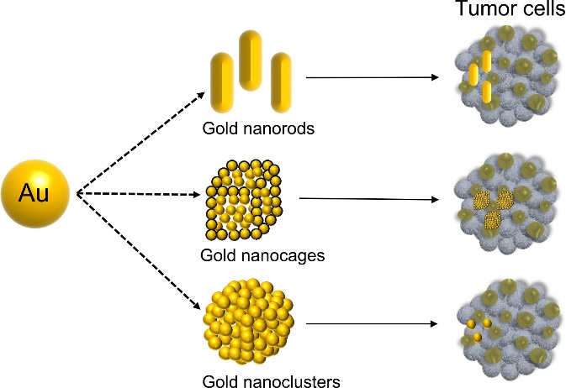
Figure 2. Use of gold nanoparticles in identifying the tumour cell

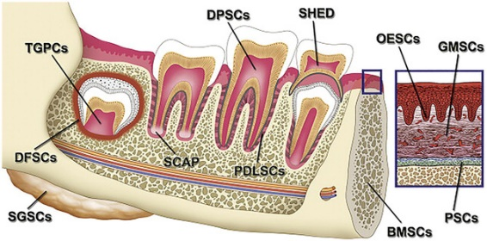
Figure 3. Adult stem cell sources in the oral and maxillofacial area.
Suture needles: It uses the Sandvik Bioline RK91 needle, a nanoscale stainless steel crystal produced in Sweden. Additionally, nano-tweezers are being created, which will soon make cell surgery conceivable.
Trans-dermal drug delivery system – This Bypass, which is the first-pass metabolism and has a more focused action when it enters the systemic circulation, causes only mild toxicity.
Surface-modified vertical silicon nanowires: These deliver bio-molecules in mammalian cells without modification of their Chemical structures. Hence, it allows the assessment of phenotypic sequences, small molecules, DNA, RNA, peptides, and proteins.
Safety dental syringes: After removing the needle from the patient's tissue, wrap it with a sheath to lessen the chance of an unintentional needle prick injury. For instance, Safety dental syringes and Ultra Safety Plus XL syringe
Nano-encapsulation: These include hollow spheres, nanotubes, and core shells made of nano-composite materials, all being extensively researched as the greatest means of controlled drug administration. Minocycline and arestin, for instance
Computer-controlled local anaesthesia system (CCLAD) (WandTM/ CompuDentTM system) – These use a light handpiece and foot control to regulate the flow rate of local anaesthetic solutions. The jet injection method uses mechanical force to generate enough pressure to force LA through a small aperture, resulting in a thin column of fluid that can penetrate sensitive tissues.
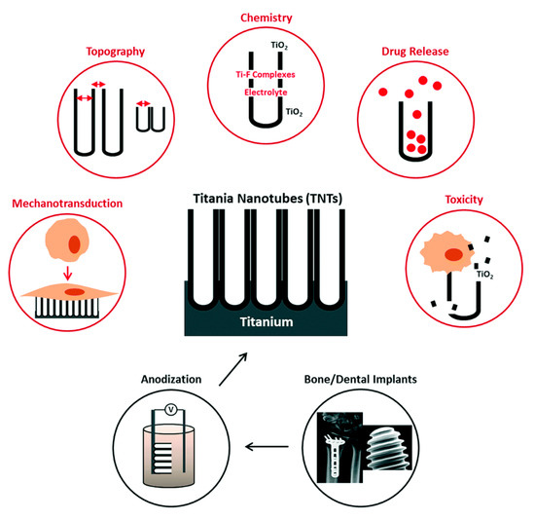
Figure 4. Titania nanotubes (TNTs)-infused electrochemically anodized dental implants for improved bioactivity and local treatment
CONCLUSION
More than many other recent breakthroughs combined, the application of nanotechnology has the potential to alter the dental healthcare system fundamentally. Advanced nanomaterials offer more promising outcomes than traditional ones for techniques used in diagnosis and treatment. Utilizing nanoparticles in oral and maxillofacial surgery can aid in preventing and treating diseases, including oral cancer, orofacial pain management, suture needles, and surface-modified vertical silicon nanowires, among others. By combining the fields of nanomaterials research and biotechnology, nanoparticles have the potential to revolutionize the way we treat and prevent oral diseases by offering both preventative and diagnostic methods. They might help with mending dental tissue that has been damaged.
References
  - Drexler K.E. Nanotechnology: From Feynman to Funding. Bull. Sci. Technol. Soc. 2004; 24:21–27. doi: 10.1177/0270467604263113.
  - Freitas R.A., Jr. Nanodentistry. J. Am. Dent. Assoc. 2000; 131:1559–1565. doi: 10.14219/jada.archive.2000.0084.
  - McKenna G. Nutrition and Oral Health. Springer; Berlin/Heidelberg, Germany: 2021.
  - Nelson S.J. Wheeler’s Dental Anatomy, Physiology and Occlusion-E-Book. Elsevier Health Sciences; Amsterdam, The Netherlands: 2014.
  - Palumbo A. Gingival Diseases-Their Aetiology, Prevention and Treatment. Intech; Manila, Thailand: 2011. The anatomy and physiology of the healthy periodontium; pp. 1–21.
  - Sasalawad S.S., Sathyajith N.N., Shashibhushan K., Poornima P., Hugar S.M., Roshan N.M., Reviews M. “Nanodentistry”-The Next Big Thing Is Small. Int. J. Contemp. Dent. Med. Rev. 2014;2014
  - Bapat R.A., Joshi C.P., Bapat P., Chaubal T.V., Pandurangappa R., Jnanendrappa N., Gorain B., Khurana S., Kesharwani P. The use of nanoparticles as biomaterials in dentistry. Drug Discov. Today. 2018; 24:85–98. doi: 10.1016/j.drudis.2018.08.012.
  - Yudaev P., Chuev V., Klyukin B., Kuskov A., Mezhuev Y., Chistyakov E.J.P. Polymeric Dental Nanomaterials: Antimicrobial Action. Polymers. 2022; 14:864. doi: 10.3390/polym14050864.
  - Limeback H. Comprehensive Preventive Dentistry. John Wiley & Sons; Hoboken, NJ, USA: 2012.
  - Sawarkar H.A., Kashyap P.P., Kaur C.D., Pandey A.K., Biswas D.K., Singh M.K., Dhongade H.K. Antimicrobial and TNF-α Inhibitory Activity of Barleria prionitis and Barleria grandiflora: A comparative Study. Indian J. Pharm. Sci. 2016; 50:409–417..
  - Pitts N.B., Zero D.T., Marsh P.D., Ekstrand K., Weintraub J.A., Ramos-Gomez F., Tagami J., Twetman S., Tsakos G., Ismail A. Dental caries. Nat. Rev. Dis. Primers. 2017; 3:17030. doi: 10.1038/nrdp.2017.30.
  - Larsen T., Fiehn N.E. Dental biofilm infections–An update. Apmis. 2017; 125:376–384. doi: 10.1111/apm.12688.
  - Soumo G., Sangamitra A. Review of Nanotechnology in dentistry. J. Adv. Med. Dent. Sci. Res. 2021; 7:65–67.
  - Weir M.D., Kaner P., Marin A., Andrianov A.K. Ionic Fluoropolyphosphazenes as Potential Adhesive Agents for Dental Restoration Applications. Regen. Eng. Transl. Med. 2021; 7:10–20. doi: 10.1007/s40883-020-00192-w.
  - Baier R.E. Surface behaviour of biomaterials: The theta surface for biocompatibility. J. Mater. Sci. Mater. Med. 2006;17:1057–1062. doi: 10.1007/s10856-006-0444-8. [PubMed] [CrossRef] [Google Scholar]

