Leadership in 2023
By Abhishek Singh

‘When you were made a leader, you weren’t given a crown, you were given the responsibility to bring out the best in others’ – Jack Welch.

In 2023 more than ever, leaders are expected to be more human experts and less strategy experts. The organizations expect leaders to be ones who can bring behavioral changes in their team. Today it is expected that It is a leader’s ability to make everyone in their team feel important, by building and maintaining a successful relationship with one’s team. A leader should ensure that his team believes that he genuinely cares about them professionally and personally, people will be more open to him as a person and as their leader, if there is sincerity in the approach. They will go over and beyond their call of duty to help you and as a result the organization achieves its goals and purpose.

What is Leadership?

The Oxford dictionary defined leadership as the action of leading a group of people or an organization. McKinsey & Company defines leadership as a set of behaviors used to help people align their collective direction, to execute strategic plans and to continually renew an organization. Leadership is always a process of influencing others to achieve a common goal. It is a complex and multifaceted concept, and there is no single definition that captures all of its nuances. However, there are some key characteristics that are common to all effective leaders. A leader must have:
- Vision: A leader must have a clear vision for the future. He must be able to articulate a compelling goal that others can rally behind.
- Communication: A leader must be able to communicate effectively with their followers. He must be able to clearly explain their vision and inspire others to follow them.
- Decision-making: A leader must be able to make sound decisions under pressure. He must be able to weigh the pros and cons of different options and choose the best course of action.
- Problem-solving: A leader must be able to identify and solve problems. He must be able to think differently and should come up with out of the box solutions.
- Motivation: A leader must be able to motivate and inspire their followers. They must be able to create a positive and productive work environment.
- Empowerment: A leader must empower their followers to take initiative and make decisions. They must trust their followers to do their jobs and give them the resources they need to succeed.
- Integrity: A leader must be honest and trustworthy. They must be someone that their followers can look up to and respect.
- Adaptability: A leader must be adaptable and willing to change. They must be able to adjust their leadership style to the needs of the situation.

Leadership is essential for any organization or group that wants to achieve its goals. A good leader can inspire and motivate their followers to work together towards a common goal. They can also help to create a positive and productive work environment where everyone feels valued and respected.

Leadership is also important for society as a whole. Good leaders can help to solve problems, create positive change, and make the world a better place. They can also inspire others to become leaders themselves, creating a ripple effect that can have a positive impact on the world.
‘You don’t inspire your teammates by showing them how amazing you are. You inspire them by showing them how amazing they are.’ – Robyn Benincasa
Leadership style is the way a leader influences, motivates, and guides the followers to achieve a common goal. There are different types of leadership styles, such as autocratic, democratic, laissez-faire, transformational, transactional, servant, and situational. Each style has its own advantages and disadvantages, depending on the context, the nature of the task, and the characteristics of the followers. Let us compare and contrast three leadership styles: autocratic, democratic, and transformational, and discuss their implications for organizational performance and employee satisfaction.
Autocratic leadership style is characterized by a high degree of control and authority over the followers. The leader makes all the decisions without consulting or involving the followers and expects them to obey without question. The leader also sets clear rules and standards, and monitors and evaluates the followers' performance closely. This style is effective when the leader has expert knowledge and skills, when the task is urgent or complex, and when the followers are inexperienced or unskilled. However, this style can also have negative consequences, such as low morale, high turnover, resistance, and resentment among the followers, especially if they are competent and creative.
Democratic leadership style is characterized by a high degree of participation and collaboration between the leader and the followers. The leader solicits input and feedback from the followers and encourages them to share their ideas and opinions. The leader also delegates authority and responsibility to the followers and empowers them to make decisions within their scope of work. This style is effective when the leader wants to foster a sense of ownership and commitment among the followers, when the task is ambiguous or creative, and when the followers are skilled and motivated. However, this style can also have drawbacks, such as slow decision making, conflict resolution, and lack of direction and accountability among the followers.
Transformational leadership style is characterized by a high degree of inspiration and influence over the followers. The leader articulates a clear and compelling vision and mission for the organization and aligns them with the values and goals of the followers. The leader also challenges and stimulates the followers to think creatively and innovatively and provides them with support and recognition. The leader also serves as a role model for the followers, and demonstrates charisma, confidence, and integrity. This style is effective when the leader wants to create a culture of change and innovation in the organization, when the task is complex or long-term, and when the followers are diverse and talented. However, this style can also have limitations, such as unrealistic expectations, ethical dilemmas, and dependency on the leader.
It is important to note that leadership style is an important factor that affects organizational performance and employee satisfaction. Different leadership styles have different strengths and weaknesses, depending on the situation, the task, and the followers. Therefore, leaders should be flexible and adaptable in choosing and applying their leadership style according to the changing circumstances.
2023 is seeing more economic uncertainty than the pandemic years of 2020 and 2021. The biggest challenge for leaders is managing teams through economic uncertainty while increasing team productivity without burning teams out. With remote and hybrid work being the norm of the year, flexibility in team management is a key take-out for any leader. Similarly, leadership in today’s job market will have to commit to the mental and physical well-being of employees.
The critical traits that the leaders need to showcase in 2023 has been developed by a management consultancy firm, Brave Insights and the same is tabled below:
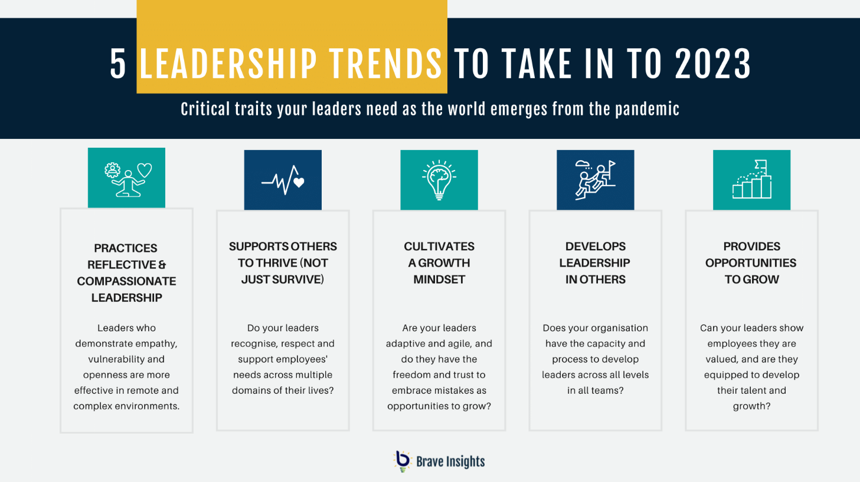
Source: https://www.braveinsights.com/

A very interesting fact in the years post pandemic to note is that despite wider economic disturbances there are growing number of people looking for work and very few people are quitting. And hence it is more likely that leaders who will be able to influence behavioral change within the team the lead will lead the world. As Indra Nooyi, former Chairman and CEO PepsiCo, once said, ‘I think the fundamental role of a leader is to look for ways to shape the decades ahead, not just react to the present, and to help others accept the discomfort of disruptions to the status quo.’

