TWO-DIMENSIONAL MATERIALS AND THEIR APPLICATIONS
S.Usha¹, M. Karunakaran^{1*}, K. Kasirajan² and S. Prabakaran¹
¹Thin Film and Nanoscience Research Lab, PG and Research Department of Physics, Alagappa Government Arts College (Affiliated to Alagappa University, Karaikudi), Karaikudi 630 003, Tamilnadu, India.
²Division of Advanced Materials Engineering, Kongju National University, Budaedong 275, Seobuk-gu, Cheonan-si, Chungnam 31080, Republic of Korea
Corresponding Author e-mail: tvdkaruna@gmail.com
Abstract
Two-dimensional (2D) materials, commonly referred to as 2D nanomaterials, are a relatively recent development in the field of materials science but have already demonstrated enormous promise for revolutionizing a range of industries, from electronics to medicine. A special class of nanomaterial known as two-dimensional materials has two dimensions that are bigger than the standard one hundred nm limitation but only a thin third dimension. One of the key advantages of 2D materials is their large surface area, which makes them excellent for catalytic reactions. Because of their exceptional electrical conductivity, they are also employed in electronics and energy storage devices. Due to their thin, flat structure, 2D materials, also known as van der Waals heterostructures, can be layered or stacked in a variety of ways to develop unique materials with specialized properties. This opens up a plethora of possibilities for novel, ground-breaking applications.

1. Introduction:
New scientific breakthroughs and discoveries in a variety of fields have been made possible by ongoing advancements in science and technology [1]. In the age of scientific discovery, materials at the nano- and atomic scale have undergone intensive research to create new materials that enhance the elemental output in several applications [2]. The development of nanotechnology in the twenty-first century is altering how people view the world in many ways [3]. Technology has undergone a revolution thanks to nanotechnology, which has greatly advanced the sectors of health, materials, electronics, and others. Nano-based materials are utilized specifically in biomedical applications, such as the treatment of cancer, the healing of wounds, the production of pharmaceuticals, etc. [4] Nanomaterials are categorized as zero-dimensional (0D) to three-dimensional (3D) materials as a result of technological development. Quantum dots are an example of a zero-dimensional material, whereas nanowires, nanoribbons, and nanotubes, are examples of one-dimensional materials; single-atom-thick materials, like graphene, are examples of two-dimensional materials; and nanocones, nano balls are examples of three-dimensional materials.[5] A material's behavior and qualities are influenced by its size. Therefore, as the size is reduced to the nanoscale, the electrical, chemical, mechanical, and optical characteristics of a material significantly improve [6]. As an illustration, 2D materials are stronger than 3D materials and have a greater surface area-to-volume ratio, which accelerates reactions. Among them, Two-dimensional (2D) materials provide an appealing environment for theoretical study and promise technological improvements in a range of applications. Since the discovery of graphene's extraordinary physical properties in 2004, there has been a lot of interest in a variety of 2D compounds, such as the transition metal dichalcogenides (MoS2, WS2, WSe2, and Bi2Se3, etc) Layered double hydroxides, MXene and black phosphorus [7]. This has recently been shown to be highly accurate. These 2D materials could display fascinating physical characteristics like, extremely high carrier mobility at room temperature, the subatomic hall execution, a significant amount of potential precise surface area, and outstanding transparency in sight [8]. The fast advancement of study in ultrathin 2D nanosheet, which has been at the forefront of scientific fields like chemistry, physics, materials science, science, medicine, and biology, is being driven by the appearance of these unique features [9]. All 2D materials, as seen above, consist of layers of atoms stacked on top of one another and connected by a variety of forces. However, these materials may be broken down into three different categories: the graphene family, Hexagonal Boron Nitride, and 2D Chalcogenides [10]. In this chapter, we discussed some of the important classifications and synthesis as well as applications of two-dimensional materials and their application.
2. Family of Graphene
Scientists have always been fascinated by the unusual characteristics of carbon. Due to developments in material science involving carbon allotropes like graphite, fullerenes, Buckyballs, and other carbon allotropes at the nanoscale, this interest has increased recently [11]. In addition to possessing cutting-edge mechanical and electrical qualities, these structures also adhere to quantum confinement principles, which improve their optical, chemical, and bio-interfacing features. There are two approaches used to create graphene-based material Top-down and bottom-up [12]. Top-down processes, such as mechanical exfoliation, chemical exfoliation, liquid-phase reduction, etc., are those that reduce the size of graphite material from bulk to single-layered graphene [13]. Bottom-Up approaches, such as chemical vapor deposition (CVD), epitaxy, and lithography, are used when individual atoms are placed one at a time to produce an even carbon layer [14].
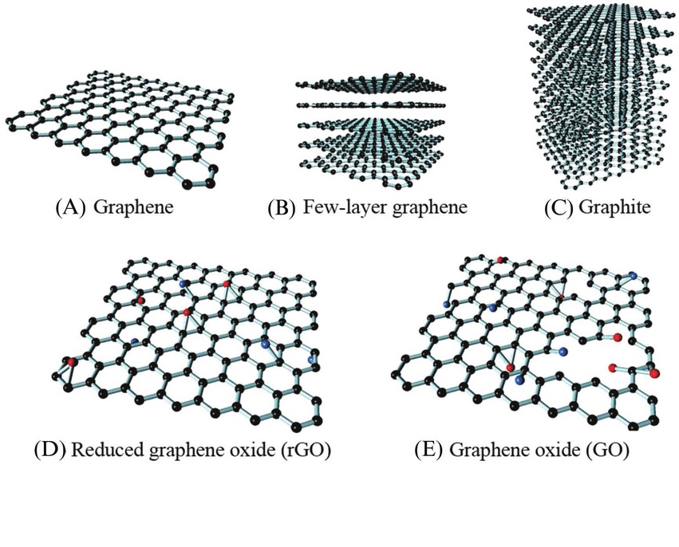
Fig 1. Schematic Representation of the Graphene Family
2. Hexagonal Boron Nitride
In terms of hardness and structural similarity, hBN is identical to graphite. Since hBN is the isoelectric counterpart of graphite and exhibits many of the same physical characteristics and structural characteristics, it is frequently referred to as "white graphite." Since it is not found in nature, it is synthesized [15]. hBN has a wide range of uses in industrial processes in become apparent in protection coatings, composites, fluids, and insulators thanks to its special properties, which include strong resistance to oxidation, superior thermal conductivity, beneficial insulation value, chemical substances inertness, outstanding friction, non-toxicity, and conservation of natural resources [16]. Continuous research is being done to create novel processes for the synthesis of nanomaterials because of the remarkable features of materials at the nanoscale and the growth of their use in industry. However, there has not yet been a large-scale, high-yield approach that is guaranteed to produce a considerable quantity of boron nitrides [17].
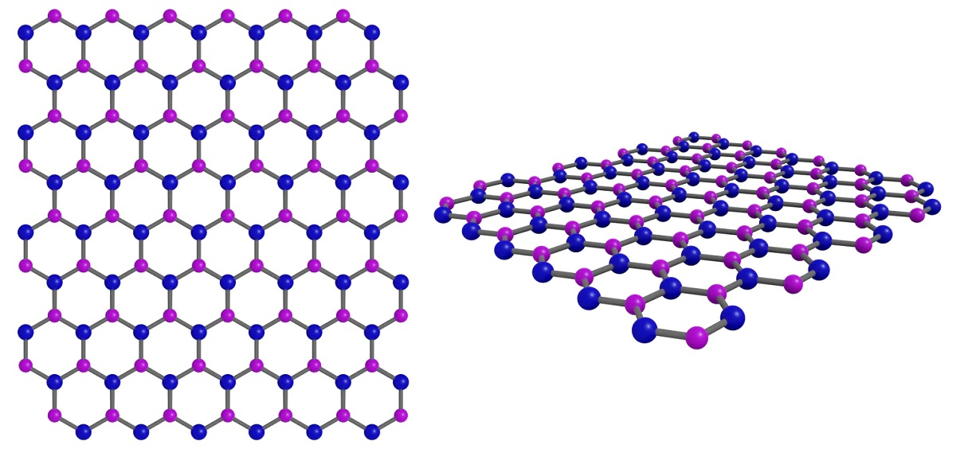
Fig.2. Graphical representation of Hexagonal Boron Nitride
3. Two-Dimensional Material Chalcogenides:
The layered structure of the majority of transition metal dichalcogenides (TMDs) is similar to that of graphites. The stoichiometric MX₂ is formed in TMDs by sandwiching each transition metal (M) atom between two chalcogens (X), resulting in a unit layer that is three atoms thick [18]. The interlayer connections are covalent, but the interlayer bonds between two MX₂ slabs are typically van der Waals bonds. The weak van der Waals bonds allow the TMDs to exfoliate down to single layers. Due to the relatively high number of possible transition metal and chalcogen combinations, TMDs with a variety of electrical configurations may be produced [19]. The top-down and bottom-up methodologies used in other 2D nanomaterials' synthesis processes are also used in the production of MX₂. These nanoparticles are created using techniques including chemical synthesis, CVD, mechanical cleavage, and liquid exfoliation [20].
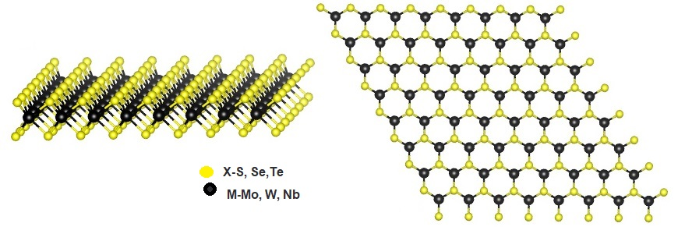
Fig.3. Structure representation of Two Dimensional Material Chalcogenides
4. Xenes Group
Two-dimensional mono-element compounds called xenes have distorted hexagonal or trigonal lattice structures. The 2D Xenes can include group IIIA, IVA, and VA elements when X = Si, B, Sn, Ge, P, and Sb. These elements are referred to as borophene, silicene, germanene, stanene, phosphorene, and antimonene, respectively. 2D Xenes encourage alternating out-of-plane atomic configurations, which results in an anisotropic lattice structure in contrast to the flat structure of graphene. Due to their abundant components and unique structures, 2D Xenes possess extraordinary physical, chemical, and mechanical properties, making them attractive agents for biosensors, bioimaging, therapeutic delivery, and theranostics [21].
5. Synthesis Strategies:
The search for techniques to produce 2D materials with regulated thickness and lateral dimensions has, however, always been a difficult topic [22]. Strong chemical bonding and anisotropic crystal formation may be the root causes of this. Van der Waals solids, layered ionic solids, and non-layered materials might be used as the typical classification of crystalline structures according to the kind of chemical bonding [23]. When it comes to generating various sorts of materials, each synthetic approach has advantages and downsides. As a result, we will concentrate on the many synthetic methods for producing two-dimensional crystals. Based on the concept of generating two-dimensional materials, we may divide synthetic procedures into top-down and bottom-up strategies [24]. These two major types are distinguished by the processes involved in the development of nanometer-sized structures.
5.1 Top-down Approaches:
Top-down and bottom-up strategies are frequent approaches. Various exfoliating techniques are essential top-down strategies. These methods struggle to produce high-quality 2D materials when compared to other methods in the area. Liquid-phase exfoliation is characterized by agglomerations, varied shapes, random distribution on surfaces, and constrained size. On the other side, mechanical exfoliations may control design adjustments, produce high-quality 2D sheets, and improve areas. If correctly implemented, the bottom-up approach known as chemical vapor deposition (CVD) may be used in a variety of circumstances [25].
5.2 Bottom-Up Approaches:
In the bottom-up process, nanoscale materials are constructed from atomic or molecule precursors that are allowed to react and increase in size or self-assemble into more complicated structures [26]. This method is highly useful for fabricating ultrathin, superior nanocomposites with enormous lateral dimensions. None of the aforementioned methods can be used to exfoliate materials with stacked bulk crystals [27]. Using the aforementioned methods, large-scale production is often inexpensive. Atomic or molecule sources are used in bottom-up techniques to create nanoscale materials. After that, 2D materials may be created effectively and efficiently. In contrast, the top-down approach carves nanoscale structures by carefully removing components from larger or bulk substances [28]. Textural intermolecular forces solids are exfoliated by mechanical forces or ultrasonic waves, whereas chemical reactions are initiated by biological processes. During exfoliation, mass partners of 2D materials are typically their forebears. After many layers have been exfoliated, it is predicted that the intermolecular forces between the succeeding layers will weaken. Free energy or remotely transmitted electrical and chemical energy can both be used to power vehicles. Surfactants, polymers, or liquid-liquid interfaces are frequently utilized to capture and balance exfoliated sheets [29].
6. Applications
Beyond graphene, 2D nanomaterials have also been used in a variety of applications across several sectors. Other than graphene, the most promising uses for 2D nanomaterials are listed below. Sensors and transistors: The construction of field-effect transistors involves the use of 2D semiconductor materials like Two Dimensional Material Chalcogenides and black phosphorus [30]. Such 2D nanomaterials are excellent candidates for this application because they have a modest band gap and strong charge mobility. Photodetectors [31]: For photodetectors, different Two Dimensional Material Chalcogenides and black phosphorus are very helpful since they have strong charge mobility features and a band gap in the optical or near-infrared range. Energy electrodes [32], the best materials for electrodes used in ion batteries are materials that are electrically with a large surface area per unit volume ratio to store high densities of ions. This is accomplished by using graphene. However, 2D MoS₂ has also attracted a lot of interest in this area recently. It has been processed in a way that causes the development of a metallic 1T phase. Compared to electrodes built on graphene, these electrodes with metallic 1T phases have better power and energy densities [33]. Topological insulators are substances that are electrically insulating except for their edges, where they efficiently conduct electrons. While Two Dimensional Material Chalcogenides WTe₂ is switched between topological insulators and superconductors using an electric field, experiments with the Xenes are being conducted as topological insulators [34]. Pharmaceutical delivery systems, two-dimensional nanomaterials are being studied extensively for this purpose [35]. They provide greater oversight over release kinetics as well as the ability to absorb several drug molecules [36-37]. 2D nanomaterials have the potential to improve the mechanical properties of composite hydrogels and therapeutic nanocomposites in the field of biomedical sciences [38].
7. Conclusion:
Several applications have proven 2D materials to be particularly promising options. This material is superior to others due to its straightforward synthesis processes, high yields, and manageable features. The visual, electrical, and catalytic uses of this substance set it apart from similar substances. These characteristics have been used for a variety of purposes, including energy production, catalysis, and bio-sensing. Regarding their features, synthesis techniques, functionalizing agents, and uses, this chapter attempted to highlight the numerous 2D materials that are now on the market. Due to their enormous potential, 2D materials and their composites are the subject of an increasing amount of study to develop practical applications.
Reference:
- Shanmugam, V. et al. (2022) ‘A review of the synthesis, properties, and applications of 2D materials’, Particle &amp; Particle Systems Characterization, 39(6), p. 2200031. doi:10.1002/ppsc.202200031.
- Baig, N., Kammakakam, I. and Falath, W. (2021) ‘Nanomaterials: A review of synthesis methods, properties, recent progress, and challenges’, Materials Advances, 2(6), pp. 1821–1871. doi:10.1039/d0ma00807a.
- Bayda, S. et al. (2019) ‘The history of nanoscience and nanotechnology: From chemical–physical applications to nanomedicine’, Molecules, 25(1), p. 112. doi:10.3390/molecules25010112.
- Pingale, P. et al. (2023) ‘An emerging era in manufacturing of drug delivery systems: Nanofabrication Techniques’, Heliyon, 9(3). doi:10.1016/j.heliyon.2023.e14247.
- Paras et al. (2022) ‘A review on low-dimensional nanomaterials: Nanofabrication, characterization and applications’, Nanomaterials, 13(1), p. 160. doi:10.3390/nano13010160.
- Khan, Ibrahim, Saeed, K. and Khan, Idrees (2019) ‘Nanoparticles: Properties, applications and toxicities’, Arabian Journal of Chemistry, 12(7), pp. 908–931. doi:10.1016/j.arabjc.2017.05.011.
- Schmidt, H., Giustiniano, F. and Eda, G. (2015) ‘Electronic Transport Properties of transition metal dichalcogenide field-effect devices: Surface and interface effects’, Chemical Society Reviews, 44(21), pp. 7715–7736. doi:10.1039/c5cs00275c.
- Mir, S.H., Yadav, V.K. and Singh, J.K. (2020) ‘Recent advances in the carrier mobility of two-dimensional materials: A theoretical perspective’, ACS Omega, 5(24), pp. 14203–14211. doi:10.1021/acsomega.0c01676.
- Zhang, H. (2015) ‘Ultrathin two-dimensional nanomaterials’, ACS Nano, 9(10), pp. 9451–9469. doi:10.1021/acsnano.5b05040.
- Kang, K., Chen, S. and Yang, E.-H. (2020) ‘Synthesis of transition metal dichalcogenides’, Synthesis, Modeling, and Characterization of 2D Materials, and Their Heterostructures, pp. 247–264. doi:10.1016/b978-0-12-818475-2.00012-x.
- Aqel, A. et al. (2012) 'Carbon nanotubes, science, and technology part (I) structure, synthesis and characterization', Arabian Journal of Chemistry, 5(1), pp. 1–23. doi:10.1016/j.arabjc.2010.08.022.
- Thangadurai, T.D. et al. (2022) 'A review on graphene quantum dots, an emerging luminescent carbon nano lights: Healthcare and Environmental Applications', Materials Science and Engineering: B, 278, p. 115633. doi:10.1016/j.mseb.2022.115633.
- Bonaccorso, F. et al. (2012) ‘Production and processing of graphene and 2d crystals’, Materials Today, 15(12), pp. 564–589. doi:10.1016/s1369-7021(13)70014-2.
- Ikram, R., Jan, B.M. and Ahmad, W. (2020) 'Advances in the synthesis of graphene derivatives using industrial wastes precursors; prospects and challenges', Journal of Materials Research and Technology, 9(6), pp. 15924–15951. doi:10.1016/j.jmrt.2020.11.043.
- Late, D.J., Bhat, A. and Rout, C.S. (2019) ‘Fundamentals and properties of 2D materials in general and sensing applications’, Fundamentals and Sensing Applications of 2D Materials, pp. 5–24. doi:10.1016/b978-0-08-102577-2.00002-6.
- Bai, C. et al. (2021) ‘Mussel-inspired facile fabrication of dense hexagonal boron nitride nanosheet-based coatings for anticorrosion and antifriction applications’, Materials Today Nano, 15, p. 100129. doi:10.1016/j.mtnano.2021.100129.
- Rasul, M.G. et al. (2021) '2D boron nitride nanosheets for polymer composite materials, npj 2D Materials and Applications, 5(1). doi:10.1038/s41699-021-00231-2.
- Choi, W. et al. (2017) ‘Recent development of two-dimensional transition metal dichalcogenides and their applications’, Materials Today, 20(3), pp. 116–130. doi:10.1016/j.mattod.2016.10.002.
- Voiry, D., Mohite, A. and Chhowalla, M. (2015b) ‘Phase engineering of transition metal Dichalcogenides’, Chemical Society Reviews, 44(9), pp. 2702–2712. doi:10.1039/c5cs00151j.
- Rafiei-Sarmazdeh, Z., Morteza Zahedi-Dizaji, S. and Kafi Kang, A. (2020) ‘Two-dimensional nanomaterials’, Nanostructures [Preprint]. doi:10.5772/intechopen.85263.
- Gogotsi, Y. and Anasori, B. (2023) ‘The rise of Mxenes’, MXenes, pp. 3–11. doi:10.1201/9781003306511-2.
- Alam, S. et al. (2021) ‘Synthesis of emerging two-dimensional (2D) materials – advances, challenges and prospects’, FlatChem, 30, p. 100305. doi:10.1016/j.flatc.2021.100305.
- Bian, R. et al. (2021) ‘Recent progress in the synthesis of novel two-dimensional van der waals materials’, National Science Review, 9(5). doi:10.1093/nsr/nwab164.
- Wang, J., Li, G. and Li, L. (2016) ‘Synthesis strategies about 2D materials’, Two-dimensional Materials - Synthesis, Characterization and Potential Applications [Preprint]. doi:10.5772/63918.
- Naikoo, G.A. et al. (2022) ‘2D materials, synthesis, characterization and toxicity: A critical review’, Chemico-Biological Interactions, 365, p. 110081. doi:10.1016/j.cbi.2022.110081.
- Zavabeti, A. et al. (2020) ‘Two-dimensional materials in large-areas: Synthesis, properties and applications’, Nano-Micro Letters, 12(1). doi:10.1007/s40820-020-0402-x.
- Hinterding, R. and Feldhoff, A. (2018) ‘Two-dimensional oxides: Recent progress in Nanosheets’, Zeitschrift für Physikalische Chemie, 233(1), pp. 117–165. doi:10.1515/zpch-2018-1125.
- Timmerman, M.A. et al. (2020) ‘Metal oxide nanosheets as 2D building blocks for the design of novel materials’, Chemistry – A European Journal, 26(42), pp. 9084–9098. doi:10.1002/chem.201905735.
- Gao, E. et al. (2018) ‘Mechanical exfoliation of two-dimensional materials’, Journal of the Mechanics and Physics of Solids, 115, pp. 248–262. doi:10.1016/j.jmps.2018.03.014.
- Baig, N. (2023) ‘Two-dimensional nanomaterials: A critical review of recent progress, properties, applications, and Future Directions’, Composites Part A: Applied Science and Manufacturing, 165, p. 107362. doi:10.1016/j.compositesa.2022.107362.
- Liu, C. et al. (2021) ‘Silicon/2d-material photodetectors: From near-infrared to mid-infrared’, Light: Science &amp; Applications, 10(1). doi:10.1038/s41377-021-00551-4.
- Forouzandeh, P. and Pillai, S.C. (2021) ‘Two-dimensional (2D) electrode materials for supercapacitors’, Materials Today: Proceedings, 41, pp. 498–505. doi:10.1016/j.matpr.2020.05.233.
- Xu, C. et al. (2020) ‘Miniaturized high-performance metallic 1T-phase mos2 micro-supercapacitors fabricated by temporally shaped femtosecond pulses’, Nano Energy, 67, p. 104260. doi:10.1016/j.nanoen.2019.104260.
- Kou, L. et al. (2017) ‘Two-dimensional topological insulators: Progress and prospects’, The Journal of Physical Chemistry Letters, 8(8), pp. 1905–1919. doi:10.1021/acs.jpclett.7b00222.
- Zhang, H. et al. (2020) ‘Recent advances of two-dimensional materials in smart drug delivery nano-systems’, Bioactive Materials, 5(4), pp. 1071–1086. doi:10.1016/j.bioactmat.2020.06.012.
- Ouyang, J. et al. (2022) ‘2D materials-based nanomedicine: From discovery to applications’, Advanced Drug Delivery Reviews, 185, p. 114268. doi:10.1016/j.addr.2022.114268.
- Shen, X. et al. (2022) ‘Bio-interactive nanoarchitectonics with two-dimensional materials and environments’, Science and Technology of Advanced Materials, 23(1), pp. 199–224. doi:10.1080/14686996.2022.2054666.
- Liu, J., Hui, D. and Lau, D. (2022) ‘Two-dimensional nanomaterial-based polymer composites: Fundamentals and Applications’, Nanotechnology Reviews, 11(1), pp. 770–792. doi:10.1515/ntrev-2022-0041.

