Machine Learning and Deep Learning Applications

Introduction
Before going to know about ML let us know what is a Machine?
A machine is a device with several parts that work together to perform a task. Machine learning, is a sub-class of artificial intelligence. Artificial intelligence is a wide discipline of generating intelligent machines. Mostly artificial intelligence work includes machine learning as intelligent behavior needs extensive information or knowledge. Deep learning is a subgroup of machine learning. Deep learning had been analyzed and implemented in various applications.
Fig 1: Example for AI
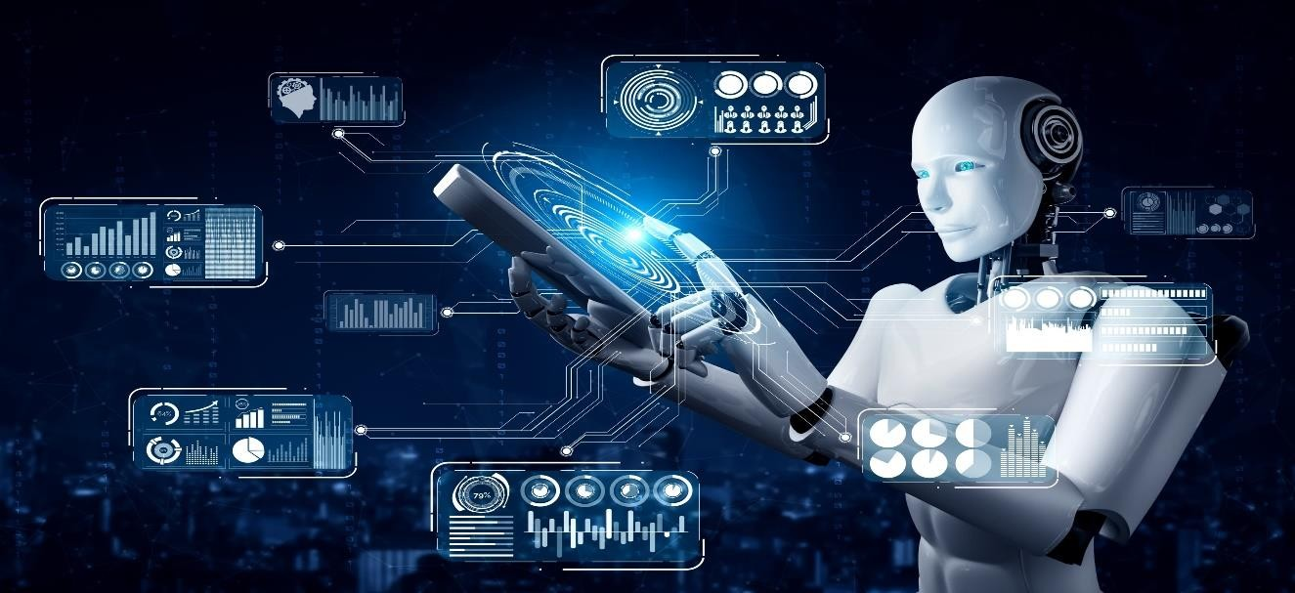

We are using machine learning in our daily life even without knowing it such as Google Maps, Google assistant, Alexa, etc. Machine learning and deep learning models are capable of different types of learning. In essence, you can think of deep learning as a branch of machine learning that's trained on large amounts of data and deals with many computational units working in tandem to perform predictions.
Artificial Intelligence (AI) can be understood as an umbrella that consists of both Machine learning and deep learning.

Most of the people think that machine learning, deep learning, as well as artificial intelligence as the same buzzwords. But in actuality, all these terms are different but related to each other.

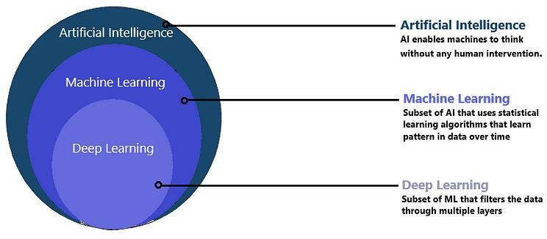

What is Machine Learning?
Machine learning (ML) is a type of artificial intelligence (AI) that allows software applications to become more accurate at predicting outcomes without being explicitly programmed to do so. Machine learning algorithms use historical data as input to predict new output values.

AI is used to make intelligent machines/robots, whereas machine learning helps those machines to train for predicting the outcome without human intervention.

How does Machine Learning work?
Machine Learning uses algorithms and techniques that enable the machines to learn from past experience/trends and predict the output based on that data. However, firstly, machine learning access a huge amount of data using data pre- processing.
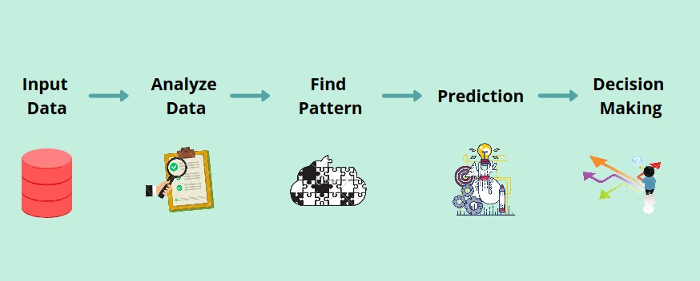
Fig 2: Process of Machine Learning

Further, this data is fed through some techniques and algorithms to machines, and then based on previous trends; it predicts the outputs automatically.

Applications Of Machine Learning
A mechanism for learning – if a machine can learn from input, then it does the hard work for us. This is where machine learning comes into action.
Some of the most common examples are:

- Image Recognition
- Speech Recognition
- Recommender Systems
- Fraud Detection
- Self - Driving Cars
- Medical Diagnosis
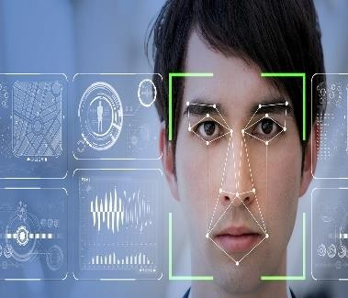
- Stock Market Trading

Image Recognition
Image Recognition is one of the reasons behind the boom one could have experienced in the field of Deep Learning. The task which started from classification between cats and dog images has now evolved up to the level of Face Recognition and real-world use cases based on that like employee attendance tracking.

Speech Recognition
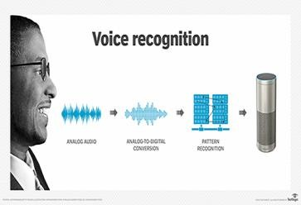

Speech Recognition based smart systems like Alexa and Siri have certainly come across and used to communicate with them. In the backend, these systems are based basically on Speech Recognition systems. These systems are designed such that they can convert voice instructions into text.

Recommender Systems

As our world has digitalized more and more approximately all tech giants try to provide customized services to its users. This application is possible just because of the recommender systems which can analyze a user’s preferences and search history and based on that they can recommend content or services to them.

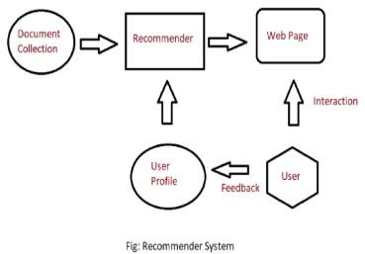

Fraud Detection

In today’s world, most things have been digitalized varying from buying toothbrushes or making transactions of millions of dollars everything is accessible and easy to use. But with
this process of digitization cases of fraudulent transactions and fraudulent activities have increased. Identifying them is not that easy but machine learning systems are very efficient in these tasks.

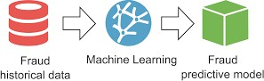

Self - Driving Cars

It would have been assumed that there is certainly some ghost who is driving a car if we ever saw a car being driven without a driver but all thanks to machine learning and deep learning that in today’s world, this is possible and not a story from some fictional book.

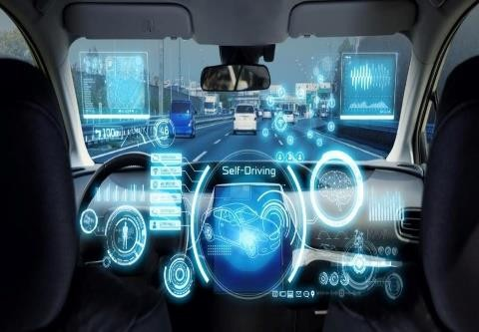

Even though the algorithms and tech stack behind these technologies are highly advanced; but, at the core it is machine learning which has made these applications possible.

Medical Diagnosis
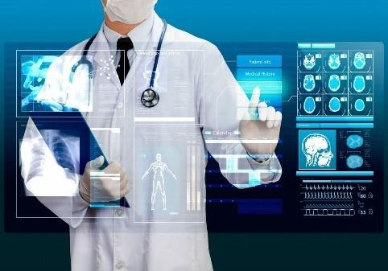

If you are a machine learning practitioner or even if you are a student then you must have heard about projects like breast cancer classification, Parkinson’s Disease Classification, Pneumonia Detection, and many more health-related tasks which are performed by machine learning models with more than 90% of accuracy.

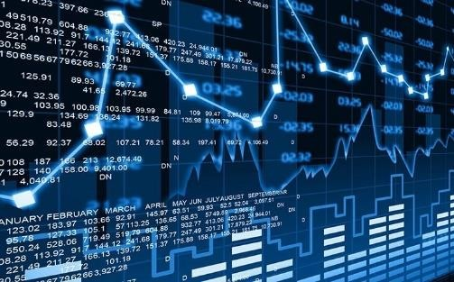
Stock Market Trading

Stock Market has remained a hot topic among working professionals and even students because if you have sufficient knowledge of the markets and the forces which drives them then you can make fortune in this domain. Attempts have been made to create intelligent systems which can predict future price trends and market value as well.

What is Deep Learning?
Deep learning is defined as the subset of machine learning and artificial intelligence that is based on artificial neural networks. In deep learning, the deep word refers to the number of layers in a neural network.

Deep Learning is a set of algorithms inspired by the structure and function of the human brain. It uses a huge amount of structured as well as unstructured data to teach computers and predicts accurate results. The main difference between machine learning and deep learning technologies is of presentation of data. Machine learning uses structured/unstructured data for learning, while deep learning uses neural networks for learning models.

BASIC STRUCTURE OF DEEP LEARNING
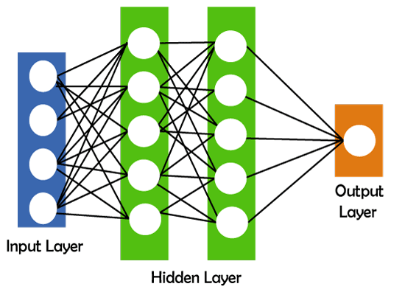

How does deep learning work?
There are a few simple steps that deep learning follows:

- Calculate the weighted sum
- Use this weighted sum in step1 as input for the activation function.
- The activation function adds bias and decides whether the neuron should be triggered or not.
- Predict output at the output layer.
- Compare predicted output and actual output and accordingly use the backpropagation method for improving the performance of the model. In this step, the cost function plays a vital role in reducing the error rate.
Applications of deep learning
- Virtual Assistants
- Chatbots
- Entertainment
- Image Coloring
- Language Translations
- Adding sounds to silent movies

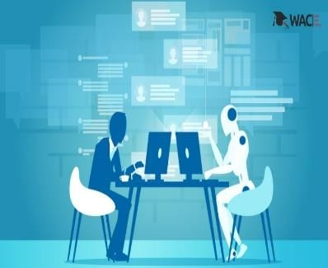
Virtual Assistants

Virtual Assistants are cloud-based applications that understand natural language voice commands and complete tasks for the user. Amazon Alexa, Cortana, Siri, and Google Assistant are typical examples of virtual assistants. They need internet connected devices to work with their full capabilities. Each time a command is fed to the assistant, they tend to provide a better user experience based on past experiences using Deep Learning algorithms.

Chatbots

Chatbots can solve customer problems in seconds. A chatbot is an AI application to chat online via text or text- to-speech. It is capable of communicating and performing actions similar to a human. Chatbots are used a lot in customer interaction, marketing on social network sites, and instant messaging the client. It delivers automated responses to user inputs. It uses machine learning and deep learning algorithms to generate different types of reactions.

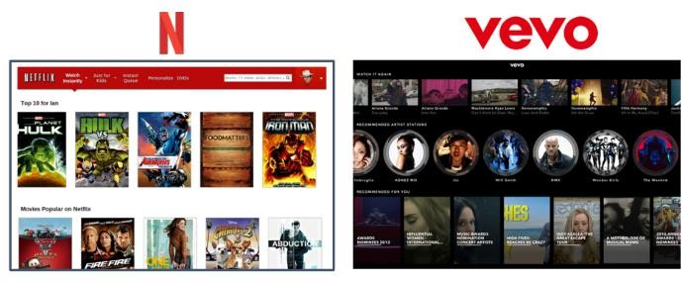

Entertainment

Companies such as Netflix, Amazon, YouTube, and Spotify give relevant movies, songs, and video recommendations to enhance their customer experience. This is all thanks to Deep Learning. Based on a person’s browsing history, interest, and behavior, online streaming companies give suggestions to help them make product and service choices. Deep learning techniques are also used to add sound to silent movies and generate subtitles automatically.

Image Coloring

Image colorization has seen significant advancements using Deep Learning. Image colorization is taking an input of a grayscale image and then producing an output of a colorized image.
Chroma GAN is an example of a picture colorization model. A generative network is framed in an adversarial model that learns to colorize by incorporating a perceptual and semantic understanding of both class distributions and color.
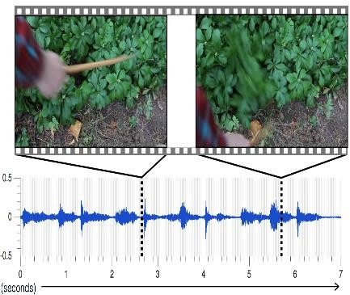

Language Translations

Machine translation is receiving a lot of attention from technology businesses. This investment, along with recent advances in deep learning, has resulted in significant increases

in translation quality. According to Google, transitioning to deep learning resulted in a 60% boost in translation accuracy over the prior phrase-based strategy employed in Google Translate. Google and Microsoft can now translate over 100 different languages with near-human accuracy in several of them.

Adding Sounds to Silent Movies

In order to make a picture feel more genuine, sound effects that were not captured during production are frequently added. This is referred to as "Foley." Deep learning was used by researchers at the University of Texas to automate this procedure. They trained a neural network on 12 well-known film incidents in which filmmakers commonly used Foley effects. Their neural network identifies the sound to be generated, and they also have a sequential network that produces the sound. They employed neural networks to transition from temporally matched visuals to sound creation, a completely another medium!

