Synthesis and Characterization of nickel oxide nanoparticles and their
Applications in antibacterial and
electrochemical analysis

G.Mahalakshmi P.Ponnarasi K.Vanasundari K.Balachandran
Assistant Professor Ph.D Researcch Scholar, Assistant Professor Associate Professor
Department of Physics, Department of Physics, Department of physics Department of physics
Government Arts College(A), Government Arts College(A), Arignar Anna Government Arts College Arignar Anna Government Arts College
Karur-639005,Tamilnadu, India Karur-639005,Tamilnadu, India Musiri- 621211, Tmailnadu,India. Musiri- 621211, Tmailnadu, India

Abstract
Nickel oxide nanoparticles have wide range of uses in biomedicine, catalysis, optoelectronic materials, sensors, pollution control, and more. In this article, to prepare copper-doped nickel oxide nanoparticles and the leaf aqueous extract was used as a stabilizer and reducing agent for nickel oxide synthesis. The unique of this synthesis is camellia sinensis leaves, because no other publications having copper doped nickel oxide assisted with c.sinensis leaves extract. UV-Vis, FTIR, and X-ray diffraction techniques were used to determine the bandgap energy, functional groups, and crystalline size of the prepared nickel oxide nanoparticles. The band gap values of nickel oxide nanoparticles are 4.1, 3.7 and 3.1 eV. The leaves extract mediated sample has lower band gap when compared to other samples. The FTIR spectrum confirms the metal oxide groups present in the prepared sample. From X-ray diffraction, the synthesized nanoparticles are cubic structures with good crystallinity. The crystalline size and strain values are determined using Scherrer and W-H methods. Electrochemical and antibacterial analysis applications were carried out for prepared nanoparticles. When compared to bare and cu doped nickel oxide, the leaf extract assisted nanoparticles has high specific capacitance value at 30 mV/s that is 101F/g. The antibacterial testes were examined using different bacterial strains and the inhibition response was reported. The Pseudomonas aeruginosa, Bacillus subtilis bacterial strains has excessive efficacy in leaves assisted nanoparticles.
Key words: Nickel oxide, XRD, Electrochemical analysis, Antibacterial

- Introduction
“Recently, the synthesis or fabrication of metallic oxide nanoparticles (NPs) has acquired an extremely good quantity of attention from scientists globally. These NPs endure specific properties (e.g. biological, mechanical, thermal, electrical, catalytic, and optical properties) as compared to bulk substances with similar chemical compositions. Metal oxide NPs are regularly used in biomedical sciences, optics, drug delivery, optoelectronic devices, bio-sensing, catalysis, antimicrobial activities, and chemical sensors” [1]. “NiO nanoparticles (NPs) can be synthesized by distinctive techniques, such as aqueous, microemulsion, solvothermal, chemical precipitation, sol-gel, warm decay, and combustion and microwave irradiation [2]. In general, materials and reagents used in factories, industry, laboratories, and medicinal applications, such as antibacterial ceramics, antibacterial clothing, and antibacterial plastics as well as water pollution, and the use of antibacterial materials in various aspects of life such as hospitals, air quality control, and air purifier, have posed a threat to human health and the environment. As a result, developing low-cost, environmentally friendly approaches, such as green chemistry, to reduce and eventually eliminate these harmful compounds and pollutants from the environment and groundwater has become a significant issue” [3]. Battery electrodes, photo-electron devices, ion storage materials, sensors such as gas sensors, magnetic materials, catalysts, electro chromic films, anticancer and cytotoxic activity are just a few of the applications for NiO NPs. NiO NPs are also bactericidal against both gram-positive and gram-negative pathogens. Among the several chemical and physical methods for creating nanomaterials, the green synthesis approach has piqued researchers' curiosity. Because this method of green synthesis is easy, inexpensive, uses less temperature, energy, and pressure, and is environmentally benign [4]. Researchers are working to develop green synthesis techniques for the manufacture of NiO nanoparticles (NiO NPs) using harmless, eco-friendly, and renewable materials such as those generated from natural sources such as plants, bacteria, yeast, fungi, and microalgae, as environmental concerns grow. In terms of simplicity, better reduction efficiency, easier availability, and large content of a wide spectrum of bioactive compounds, plants are seen to be the most promising candidate. Phytochemicals with a wide variety of reductive capacities in plant extracts, such as polyphenols, terpenoids, flavonoids, alkaloids, sugars, proteins, and others, play a critical role in influencing the morphology, size, and yield of nanoparticles during synthesis [5]. Furthermore, plant extract-mediated nanoparticles exhibit greater stability, bicompatibility, and biosafety than chemically produced nanoparticles. Moringa oleifera (leaf) [6], Calotropis gigantea (leaf) [7], Monsonia burkeana (leaf) [8], Euphorbia heterophylla (leaf) [9], Tamarix serotina (flower) [10], were used in the green synthesis of NiO NPs. In the literature, Hydrangea paniculata (flower) [11], Vernonia amydalina (leaves) [12], Callistomon viminalis (floral extract) [13], Areca catechu (leaves) [14], Geranium wallichianum (leaves) [15], Populus ciliate (leaves) [16], Calendula officinalis (leaves) [17], Okra (leaves) [18], have all been mentioned.

- Synthesis work

A. Leaf Extract Preparation
Fresh Camellia Sinensis leaves were harvested in the Ooty rural district of Tamilnadu. The leaves were gathered, cleaned with distilled water, and dried for three days at room temperature. A mechanical grinder is then used to smash the dry leaves into a fine powder. 1g Camellia sinensis powder was dissolved in 100ml distilled water and 70% of ethanol stirred at 80°C for 2 hours. A tea brown coloured solution was generated during the process. The obtained extract was then allowed to cool to room temperature before being filtered and used for synthesis.

B. Synthesis of Cu Doped NiO nanopowders
Nickel nitrate was dissolved in 100 ml distilled water with stirring for a few minutes, after that certain amount of copper sulfate was added into the above solution. Then 20 ml of leaf extract is added to the solution with continuous stirring for one hour, and then NaOH was added dropwise to the solution with continuous stirring for 4hrs. The precipitate was collected and kept at 100°C. The prepared sample was washed with ethanol and distilled water several times. Then the precipitate was collected and kept at 500°C for 3hrs. Finally, Black color Camellia Sinensis assisted with Cu-doped NiO nanopowder was obtained. The synthesis procedure was portrayed in Figure1.

- Result and Discussion

A. X-ray diffraction study
The structural statistics and crystallinity of NiO nanoparticles is studied by XRD sample. X-ray diffraction pattern of synthesised samples is shown in Figure.2. Five sturdy Bragg peaks with their maxima centered at 2θ = 37.15°, 43.35°, 62.96°, 75.40° and 79.1° are observed. The determined diffraction peaks which correspond to the (111), (200), (220), (311), (222) planes are nicely assigned to the cubic shape of NiO. The absence of impurity peaks shows the excessive purity of synthesized samples. The excessive purity of NiO is usually accredited by loss of detecting any more peaks for the duration of the XRD Pattern. The observed peaks are well matched with standard JCPDS card (04-0835).
The average crystalline size was calculated by using Debye Scherrer formula
$$D= \frac{kλ}{β cosθ}$$
Where β is full width at half maximum intensity (FWHM), λ (0.154nm) is x-ray wavelength and θ is the Bragg’s angle.
Lattice constant was calculated by using the given formula
$$a=d \sqrt{h^{2 }+l^{2}+l^{2}}$$
The dislocation density was estimated to using the below formula
$$δ=\frac{1}{D^{2}}$$
The strain values of the prepared samples were evaluated using Williamson-Hall (W-H) plot analysis, as illustrated in Figure 3. A W-H plot (also known as a uniform deformation model) is a graph that combines 4sinθ on the x-axis with βcosθ on the y-axis. A W-H plot can be linearly fitted to provide values for the slope and intercept, which are later used to calculate the sample's strain (ε) and average crystallite size (D), respectively. The crystalline size of NiO nanoparticles estimated using the Debye-Scherer formula and W-H plot [19], [20]. The calculated values are presented in Table 1. In this study it is seen that as the crystalline size of the nanopowder decrease when adding the leaf extract of camellia sinensis.

B. Fourier Transform Infrared spectroscopy analysis
FTIR was used to recognize functional groups of phytomolecules applied for synthesizing Cu-doped NiO-NPs. The FTIR spectral findings of prepared samples are shown in Figure 4. The FT-IR spectrum of NiO-NPs several peaks that were detected within the range of 400–4000 cm⁻¹. The observed peak at 3439 cm⁻¹ is related to the O–H stretching vibrations of H₂O molecules. In addition, the showed vibration, in the range of 2928 cm⁻¹ is correspondent to the C-H Stretching vibration. Another peak of 1638 cm⁻¹ can be attributed to the stretching vibrations of C=C, whereas the sharp band at 1127 cm⁻¹ refers to C–N vibration. Finally, the band at 400–450 cm⁻¹ is associated with the Metal oxide stretching vibration [18].

C. UV-Visible spectrometer analysis
The optical absorption spectrum of the pure NiO, Copper doped NiO and Cu doped NiO with Camellia sinensis plant extract nanoparticles samples was carried out using UV-Visible spectrometer and the spectrum is unveiled in Figure 5. These spectra show the absorbances of the samples after dispersing them in Distilled water. The absorption peaks of the prepared samples detected in the range of 200-400nm. The energy bandgap was for the prepared samples is calculated by using the given formula
$$E_{g}= \frac{hc}{λ}$$
E_{g} is Energy gap, h is the Plancks constant, c is the velocity of light and λ is wavelength [21]. The band gap value of leaf extract assisted copper doped nickel oxide sample has lower than that of pure nickel oxide and Copper doped nickel oxide samples. The calculated bandgap values are 4.32, 3.78 and 3.11 eV corresponding to NiO, copper doped NiO and leaf extract assisted copper doped NiO samples. Expected results are seen in UV-Visible spectroscopy for leaf extract meadiated sample.

D. Antibacterial analysis
Synthesized nickel oxide nanoparticles were evaluated for tis antibacterial effect against Klebsiella pneumoniae, Pseudomonas aeruginosa, Bacillus subtilis and Staphylococcus aureus by using well diffusion method. 50µl of the nanoparticle was poured in the well. The plates were incubated in sterilization chamber itself for 30 min to allow the extract to diffuse into the medium. All plates were incubated overnight for 24 hours at 37°C. After 24 hours of incubation, the inhibition zone of each plate were measured and recorded in millimetre (mm).
Table 2 depicts the zone of inhibition of pure nickel oxide, copper doped nickel oxide and copper doped nickel oxide nanoparticles from Camellia sinensis extracts against four pathogens. The bacterium organisms employed in this investigation were “Gram-negative (Klebsiella pneumoniae, Pseudomonas aeruginosa) and Gram-positive (Bacillus subtilis, Staphylococcus aureus). These are human pathogens that can cause a variety of diseases such as skin infections, pneumonia, toxic shock syndrome, urinary tract infections, vomiting, diarrhea, anaemia, kidney infections, and lung infections”, as well as wound infections. The surfaces of the nickel oxide nanoparticles may have reacted directly with the bacterial outer membrane, causing the membrane to break and the organism to be killed [22].
“Pure nickel oxide, copper doped nickel oxide, and leaf extract assisted copper doped nickel oxide nanoparticles were tested for antibacterial efficacy against gram positive Klebsiella pneumoniae, Pseudomonas aeruginosa, and gram negative Bacillus subtilis and Staphylococcus aureus bacterial strains”. Figure 6 and Figure 7 represents the antibacterial effect of pure nickel oxide, copper doped nickel oxide and leaf assisted copper doped nickel oxide nanoparticles. The nanoparticles were effective against all bacterial strains. In comparison to the pure and copper doped nickel oxide nanoparticles, leaf extract assisted copper doped nickel oxide shows a high efficacy for both gram negative and gram positive bacterial strains.
The phytochemicals present in complex form are great candidates for reduction and stabilising potential in fabrication of nanoparticles. These biomolecules found in plants provide defense against microorganisms without the necessity for external sources. Thus, it contains naturally occurring antioxidant and antibacterial capabilities. So, when these biological entities mix with metallic sources, they increase the antibacterial activity of biologically synthesised nanoparticles. The significant bactericidal activity of nickel oxide nanoparticles could be attributed to biomolecules adsorbed on the nanoparticles surface. As reported by several researches, the bactericidal potential of nanoparticles is caused by ROS generation. Furthermore, nanoparticles affect membranes (membrane proteins) and cause bacterial cell death. Similarly, surface imperfections in the symmetry of nanoparticles cause bacterial inhibition and cell damage [23], [24].

E. Cyclic voltammetry analysis
Electrochemical analysis was carried out via cyclic voltammetry method. In this cyclic voltammetry using their electrode pattern namely calomel platinum, glassic carbon and synthesised nanoparticles. The electrolytic solution is tetra butyl amino ferric chloride for this entire analysis. The following equation can be utilized to calculate the specific capacitance C (F/g), which is one of the most important parameters for assessing the electrochemical performance of supercapacitors.
$$C_{s}= \frac{1}{2 × Δv × ∆m ×ν}\int{I dv}$$
Where C_{s} is a specific capacitance of NiO electrode (Fg⁻¹), ∫ I dV represents the area under CV curve,$∆v$ represents the potential window, $∆$m is the mass of active NiO (g) $ν$ is the scan rate (mVs⁻¹). The value of specific capacitance is decrease with increase the scan rate from 30 to 150 (mVs⁻¹). The decrease in specific capacitance with scan rate is due the electrolyte ions do not find sufficient time to avail all active sites of the electrode. At a low scan rate, the ions from the electrolyte can utilize all the available sites in the active electrode material. From Figure 8, Figure 9, Figure 10 represents the cyclic voltammetry graphs for nickel oxide, copper doped nickel oxide and camellia sinensis assisted nickel oxide nanoparticles.
The specific capacitances of prepared sample values are calculated at different scant rates (30 to 150mV/s). Figure 11 shows the specific capacitance vs scan rate plot of prepared samples. The pure nickel oxide has 70, 56, 39 and 29 F/g copper doped nickel oxide nanoparticles specific capacitance is 80, 72, 43 and 33 F/g and leaf extract mediated nickel oxide nanoparticles specific capacitance at different scan rates (30 to 150mV/s) and found to be 101, 88, 49 and 40 F/g respectively. “The results confirm that the specific capacitances of leaf extract assisted nanoparticles is 1.44 times higher than that of pure nickel oxide and 1.26 times higher than that of copper doped nickel oxide nanoparticles, thus suitable for application in supercapacitor or electrochemical devices” [25], [26].

F. Electrochemical Impedence analysis
Mixed Kinetic and Diffusion Control
Electrochemical reactions taking place on the electrode and the electrolyte influence the total electrode impedance. Figure 12 depicts the Nyquist plot for the generated samples, where the semicircle represents the charge-transfer resistance functioning in parallel with the double-layer capacitance at high frequencies. A straight line with a 45° slope can be seen at intermediate frequencies, suggesting semi-infinite diffusion. At low frequency, this near-vertical line is correlated to the well-known redox capacitance characteristic of nickel oxide nanoparticles [27], [28].
The Warburg impedance is utilized in the equivalent circuit model in exceptional circumstances where kinetic and diffusion control of semi-infinite linear diffusion have an impact on an electrochemical system. The resistor (R₁) is connected in series with the resistor (R₂), W is warburg impedence and in parallel with the surface deposited double layer capacitor (C₁). Typical impedance that reflects mass transfer resistance is diffusion control. The impedance is affected by the potential fluctuations frequency. The Warburg-impedance rises as a result of the reactants requirement for low frequency dispersion. It is not able to construct a Randles Cell fake cell because no single component can precisely mimic Warburg impedance. This circuit shows a cell in which polarisation is generated by a combination of kinetic and diffusion mechanisms [29], [30].

4. Conclusion
This study reports on the production of copper doped nickel oxide nanoparticles utilizing copper as a dopant and camellia sinensis leaves extract as a reducing agent. The XRD pattern indicated that the nanoparticle had a cubic shape. The materials possess the appropriate functional groups. From the FT-IR, the Ni-O stretching vibration was recorded at 428, 434, and 447 cm⁻¹ for pure nickel oxide, copper doped nickel oxide and leaf assisted copper doped nickel respectively. The UV- Vis absorption spectra revealed the reduction of bandgap values in leaf assisted copper doped nickel oxide nanoparticles. Electrochemical tests on nickel oxide electrodes, such as cyclic voltammetry, showed enhanced properties for Camellia sinensis assisted copper doped nickel oxide nanoparticles and have excellent capacitance value. In comparison to pure and copper doped nickel oxide, leaf extract assisted copper doped nickel oxide shows a high efficiency for both gram negative and gram positive bacterial strains. We propose that Camellia sinensis-assisted copper doped nickel oxide nanoparticles be utilised to medicinal applications.

References
- M. Hafeez, R. Shaheen, B. Akram, M. Naeem Ahmed, Zain-ul-Abdin, Sirajul Haq, S. Ud Din, M. Zeb, and M. A. Khan , “Green Synthesis of Nickel Oxide Nanoparticles using Populus ciliata leaves Extract and their Potential Antibacterial Applications”, S. Afr. J. Chem., vol. 75, pp. 168–173, July 2021.
- K. Varunkumar, R.Hussain, G. Hegde and A.S. Ethiraj, “Effect of calcination temperature on Cu doped NiO nanoparticles prepared via wet-chemical method: Structural, optical and morphological studies”, Materials Science in Semiconductor Processing, vol. 66, pp.149-156, August 2017.
- S.Ghazal, N. Khandannasab, H.A. Hosseini, Z.Sabouri, A.Rangrazi and M.Darroudi, “Green synthesis of copper-doped nickel oxide nanoparticles using okra plant extract for the evaluation of their cytotoxicity and photocatalytic properties”, Ceramics International, vol. 47, no. 19, pp. 27165-27176, June 2021.
- G. Theophil Anand, R. Nithiyavathi, R. Ramesh, S. John Sundaram, and K. Kaviyarasu, “Structural and optical properties of nickel oxide nanoparticles: Investigation of antimicrobial applications”, Surfaces and Interfaces, vol. 18, pp.100460-100466, February 2020.
- A. A. Ezhilarasi, J. J. Vijaya, K. Kaviyarasu, L. J. Kennedy, R. J. Ramalingam and H. A. Al-Lohedan, “Green synthesis of NiO nanoparticles using Moringaoleifera extract and their biomedical applications: Cytotoxicity effect of nanoparticles against HT-29 cancer cells”, J. Photochem. Photobiol. B, Biol., vol.164, pp.352-360, October 2016.
- M.I. Din, A.G. Nabi, A.S. Rani, A. Aihetasham, & M. Mukhtar, “Single step green synthesis of stable nickel and nickel oxide nanoparticles from Calotropis gigantea: Catalytic and antimicrobial potentials”, Environmental Nanotechnology, Monitoring and Management, vol. 9, pp.29-36, May 2018.
- P. Kganyago, LM. Mahlaule-Glory, MM. Mathipa, B. Ntsendwana, N. Mketo, Z. Mbita, NC. Hintsho-Mbita, “Synthesis of NiO nanoparticles via a green route using Monsonia burkeana: The physical and biological properties”, J Photochem Photobiol B. vol.182, pp.18-26. May 2018.
- K. Lingaraju, H. Raja Naika, N.Bhushana, K.Jayanna, S.Devaraja and G. Nagaraju, “Biosynthesis of Nickel oxide Nanoparticles from Euphorbia heterophylla (L.) and their biological application”, Arabian Journal of Chemistry, vol. 13, no. 3, pp. 4712-4719. March 2020.
- M. A. Nasseri, F. Ahrari andB Zakerinasab, “A green biosynthesis of NiO nanoparticles using aqueous extract of Tamarix serotina and their characterization and application”, Applied Organometallic Chemistry, vol.30, no.12, pp. 978–984. November 2019.
- M.Kundu, G.Karunakaran and D.Kuznetsov, “Green synthesis of NiO nanostructured materials using Hydrangea paniculata flower extracts and their efficient application as supercapacitor electrodes”, Powder Technology, vol. 311, pp.132-136. January 2017.
- A.B. Habtemariam and M. Oumer, “Plant Extract Mediated Synthesis of Nickel Oxide Nanoparticles”, Mat Int, vol.2, pp. 0205-0209. April 2020.
- A.Sani, D.Hassan, AT.Khalil, A.Mughal, A.El-Mallul, M.Ayaz, Z.Yessimbekov, ZK. Shinwari and M. Maaza, “Floral extracts-mediated green synthesis of NiO nanoparticles and their diverse pharmacological evaluations”, J Biomol Struct Dyn, vol. 39, no. 11, pp.4133-4147. July 2021.
- U.R. Shwetha, C.R. Rajith Kumar, M.S. Kiran, V.S.Betageri, M.S. Latha, R .Veerapur, G. Lamraoui, AA. Al-Kheraif, AM. Elgorban, A. Syed, C.Shivamallu, SP. Kollur, “Biogenic Synthesis of NiO Nanoparticles Using Areca catechu Leaf Extract and Their Antidiabetic and Cytotoxic Effects”, Molecules, vol. 26, no.9, pp.2448-2458. April 2021.
- B.A.Abbasi, J. Iqbal, T. Mahmood, R. Ahmad, S. Kanwal and S. Afridi, “Plant-mediated synthesis of nickel oxide nanoparticles (NiO) via Geranium wallichianum: characterization and different biological applications”, Materials Research Express, vol. 6, no.8, pp. 0850a7. May 2019.
- Z. Sabouri, A.Akbari, H.A. Hosseini, A. Hashemzadeh, and M. Darroudi, “Eco-Friendly Biosynthesis of Nickel Oxide Nanoparticles Mediated by Okra Plant Extract and Investigation of Their Photocatalytic, Magnetic, Cytotoxicity, and Antibacterial Properties”, Journal of Cluster Science, vol.30, pp.1425-1434.April 2019.
- M. Hafeez, R. Shaheen, B. Akram, M.Naeem Ahmed, Zain-ul-Abdin, Sirajul Haq, S. Ud Din, M. Zeb and M.A. Khan, “Green Synthesis of Nickel Oxide Nanoparticles using Populus ciliata leaves Extract and their Potential Antibacterial Applications. S. Afr. J. Chem., 2021, vol. 75, pp.168–173. July 2021.
- Y.Zhang, B.Mahdavi, M.Mohammadhosseini, E.Rezaei-Seresht, S. Paydarfard, M.Qorbani, M.A.M Karimian, N. Abbasi, H.Ghaneialvar, E.Karimi, “Green synthesis of NiO nanoparticles using Calendula officinalis extract: Chemical charactrization, antioxidant, cytotoxicity, and anti-esophageal carcinoma properties”, Arabian Journal of Chemistry, vol.14, no.5, pp. 103105-103115. March 2021.
- S. Ghazal, N. Khandannasab, H.A. Hosseini, Z. Sabouri, A. Rangrazi, and M.Darroudi, “Green synthesis of copper-doped nickel oxide nanoparticles using okra plant extract for the evaluation of their cytotoxicity and photocatalytic properties”, Ceramics International, vol.47, no.19, pp.27165–27176. June 2021.
- Z.Sabouri, A.Rangrazi, M.S. Amiri, M.Khatami and M.Darroudi, “Green synthesis of nickel oxide nanoparticles using Salvia hispanica L. (chia) seeds extract and studies of their photocatalytic activity and cytotoxicity effects”, Bioprocess Biosyst Eng., vol. 44, pp. 2407–2415. July 2021.
- R. Goel, R. Jha, and C. Ravikant, “Investigating the structural, electrochemical, and optical properties of p-type spherical nickel oxide (NiO) nanoparticles”, Journal of Physics and Chemistry of Solids, vol.144, pp.109488-109499. April 2020.
- Q.Abbas, “Understanding the UV-Vis Spectroscopy for Nanoparticles”, J Nanomater Mol Nanotechnol, vol.8, no.3.May 2019.
- A.A.Urabe and W.J Aziz, “Biosynthesis of cobalt oxide (Co₃O₄) nanoparticles using plant extract of Camellia sinensis (L.) Kuntze and Apium graveolens L. as the antibacterial application, World News of Natural Sciences, vol.24, no.2019, pp.356-364. 2019.
- S.Majeed and M.S.B. Abdul Samad, “Plant Mediated Synthesis of Silver Nanoparticles and its Antibacterial Effect”. J Pure Appl Microbiol., vol.13, no. 2, pp. 1267-1272. June 2019.
- J. Iqbal, B.A. Abbasi, R. Ahmad, M. Mahmoodi, A. Munir, S.A. Zahra, A.Shahbaz, M. Shaukat, S.Kanwal, S.Uddin, T.Mahmood and R.Capasso, “Phytogenic Synthesis of Nickel Oxide Nanoparticles (NiO) Using Fresh Leaves Extract of Rhamnus triquetra (Wall.) and Investigation of Its Multiple In Vitro Biological Potentials”, Biomedicines, vol. 8, no.5, pp.117-133. May 2020.
- P. Naresh Kumar Reddy, DPMD Shaik, D.Nagamalleswari, K.Thyagarajan, P.Vishnu Prasanth, “Electrochemical Activity of TiO₂ Nanoparticles in NaOH Electrolyte via Green Synthesis Using Calotropis gigantea Plant Leaf Extract”, Indian Journal of Science and Technology vol. 14, no.34, pp. 2766-2772. October 2021.
- K. Nguyen, N.D. Hoa, C.M. Hung, D.T. Thanh Le, N. Van Duy and N.Van Hieu, “A comparative study on the electrochemical properties of nanoporous nickel oxide nanowires and nanosheets prepared by a hydrothermal method”, RSC advances, vol. 8, no. 35, pp. 19449–19455. May 2018.
- S.Motupally, C.C. Streinz and J.W. Weidner, “Proton Diffusion in Nickel Hydroxide Films: Measurement of the Diffusion Coeffifficient as a Function of State of Charge”, J. Electrochem. Soc., vol.142, no.5. May 1995.
- A.Ehsani, M.G.Mahjani and M.Jafarian, “Electrochemical impedance spectroscopy study on intercalation and anomalous diffusion of AlCl₄ ions into graphite in basic molten salt”, Turk J Chem. vol. 35 (2011), pp.735 – 743. May 2011.
- W.Choi, HC. Shin, JM. Kim, JY. Choi, WS. Yoon, “Modeling and Applications of Electrochemical Impedance Spectroscopy (EIS) for Lithium-ion Batteries”, J. Electrochem. Sci. Technol., Vol. 11, No.1, pp. 1-13. October 2019.
- Basics of Electrochemical Impedance Spectroscopy. https://www.gamry.com/application-no...-spectroscopy/ (accessed Feb 8, 2019).

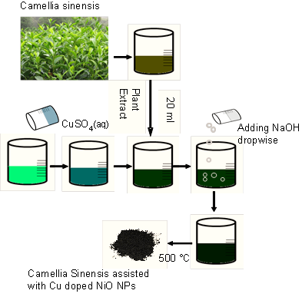
Figure 1.Synthesis procedure of nickel oxide nanoparticles
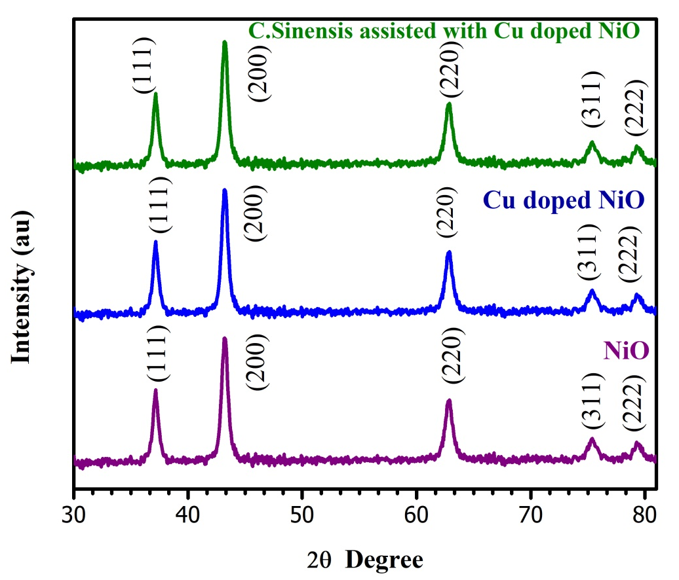
Figure 2. X-ray diffraction pattern of prepared nanoparticles
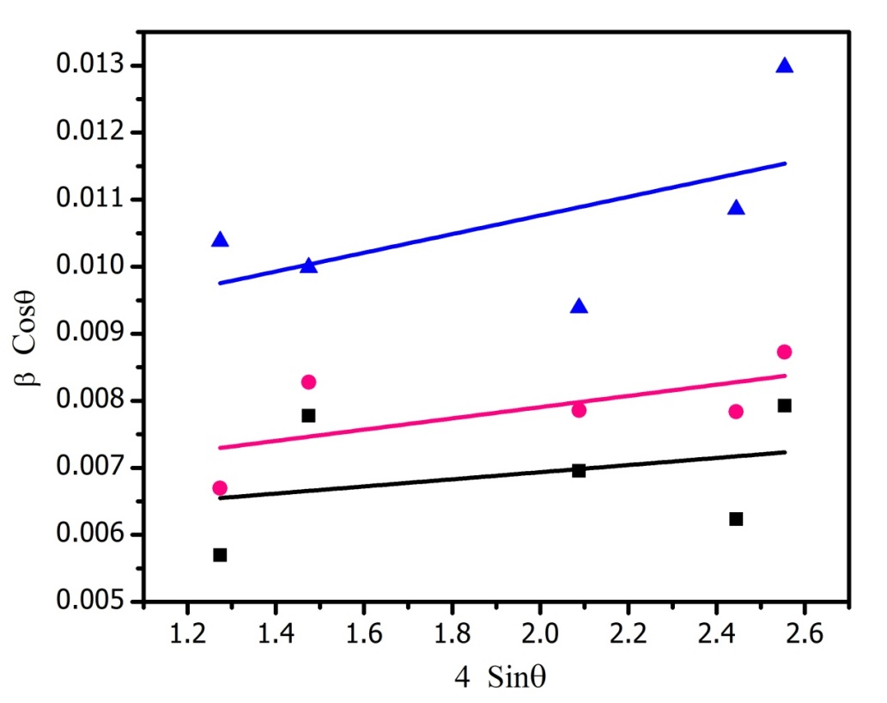
Figure 3.Williamson-Hall plot of synthesized nanoparticles

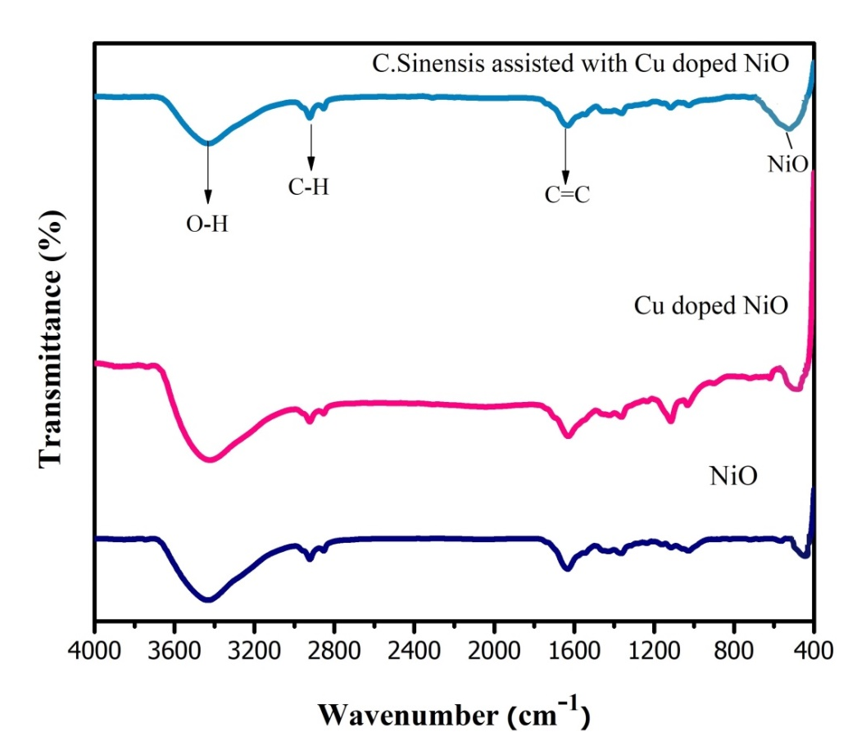
Figure 4.FTIR spectrum of synthesized nanoparticles

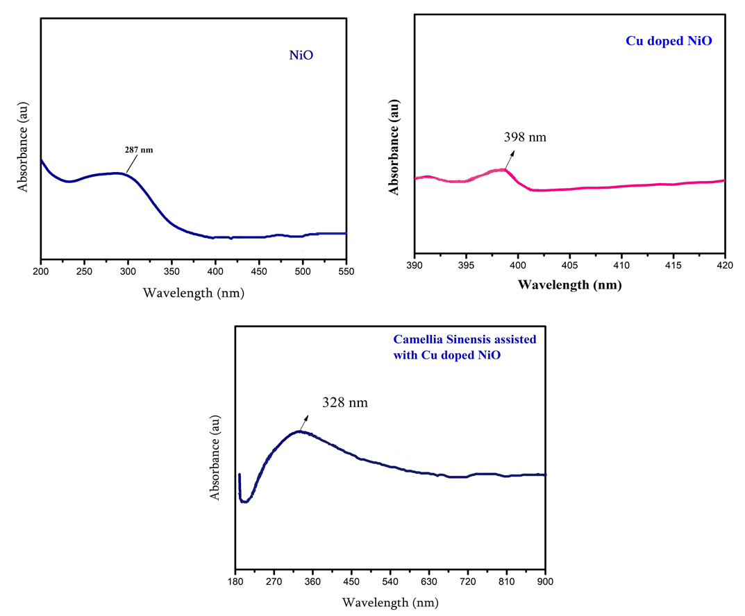
Figure 5. UV- visible absorption spectrum

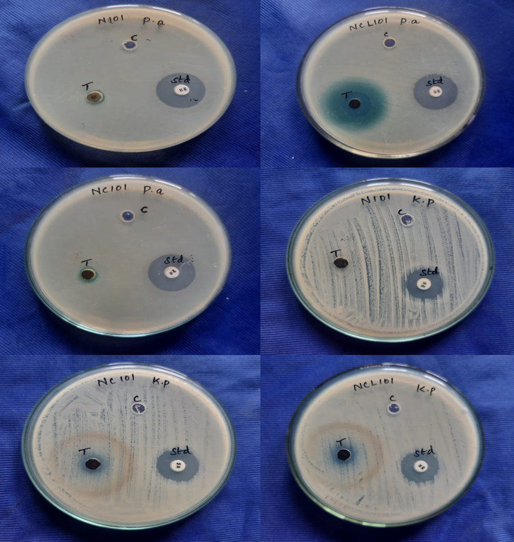
Figure 6. Antibacterial activity of prepared NiO, Cu doped NiO Camellia sinensis assisted with Cu doped NiO NPs against Gram negative (Klebsiella pneumoniae, Pseudomonas aeruginosa) bacterial pathogens
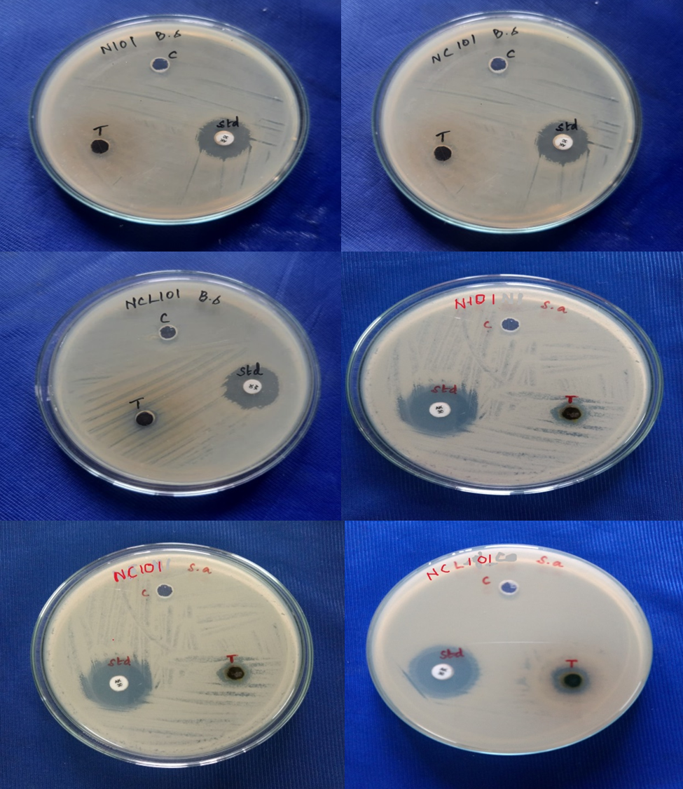
Figure 7. Antibacterial activity of prepared NiO, Cu doped NiO Camellia sinensis assisted with Cu doped NiO NPs against gram positive (Bacillus subtilis, Staphylococcus aureus) bacterial pathogens

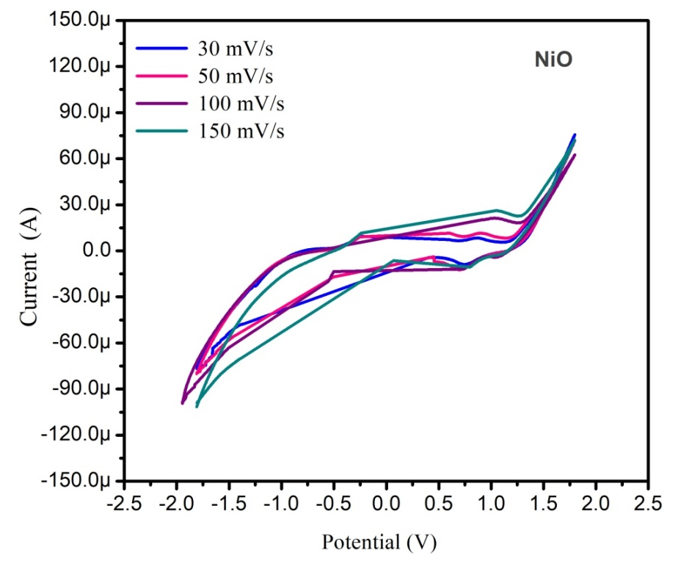
Figure 8. Pure nickel oxide nanoparticles cyclic voltamettry curves at different
Scanrates
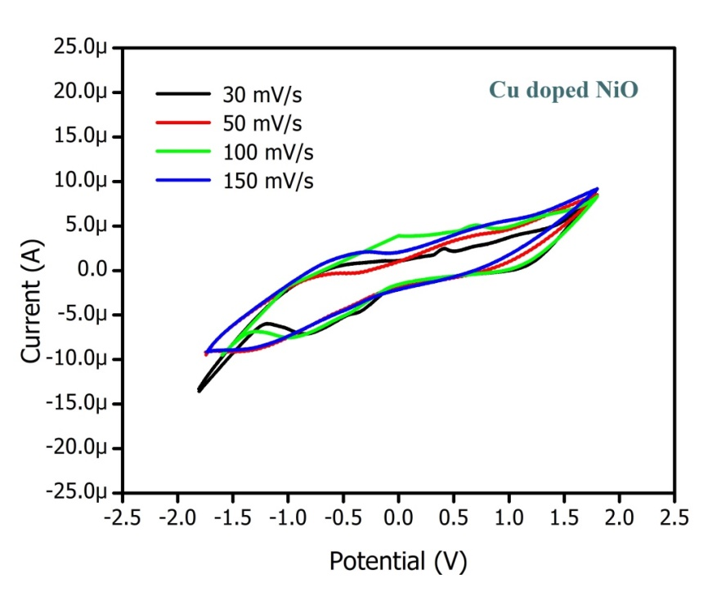
Figure 9. Copper doped nickel oxide nanoparticles cyclic voltamettry curves at
different scanrates
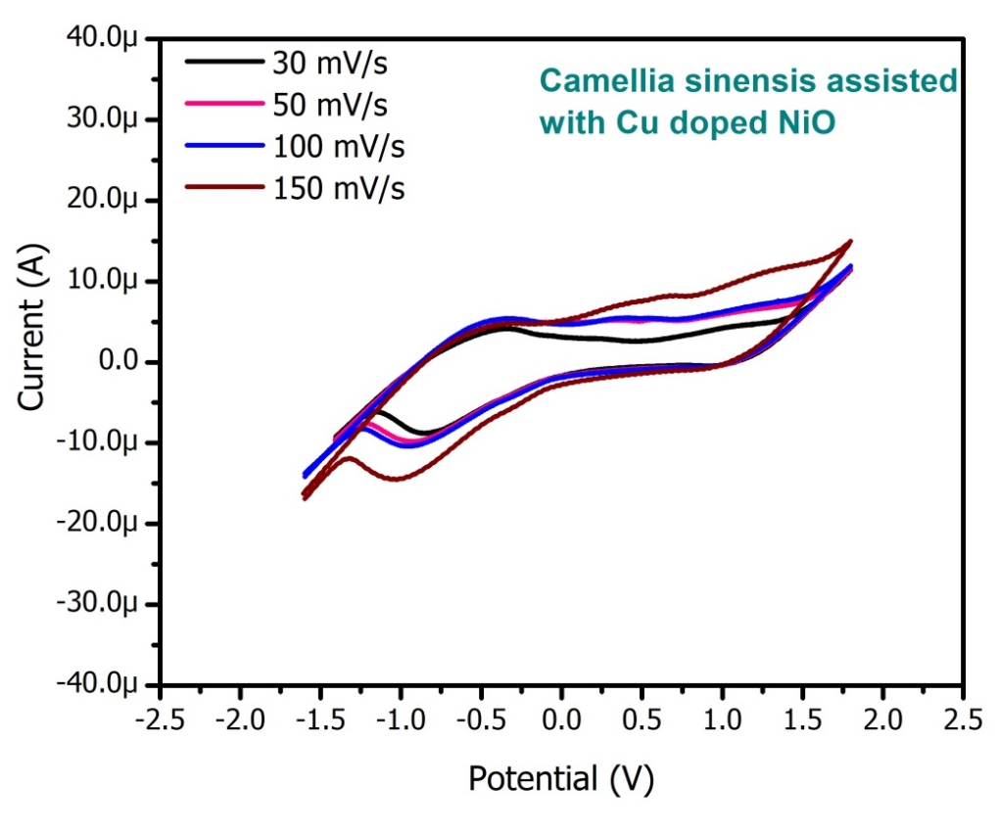
Figure 10. Leaf extract assisted copper doped nickel oxide nanopartilces cyclic
voltamettry curves at different scanrates
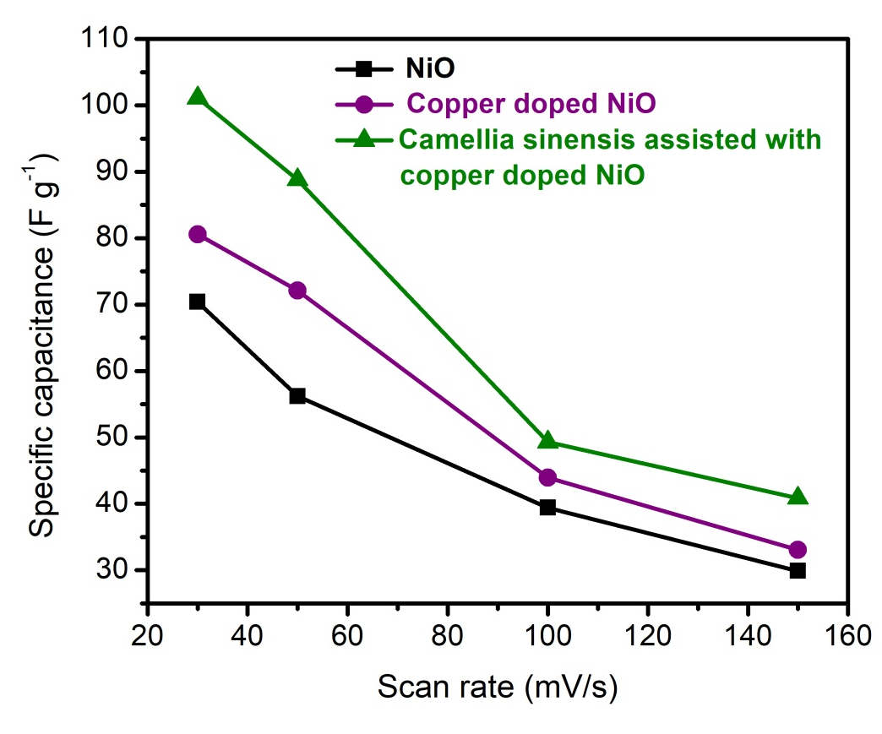
Figure 11. Specific capacitance Vs Scan rates

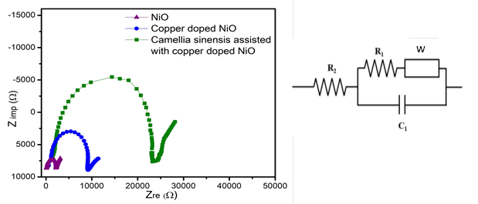
Figure 12. Nquist plot of prepared nanoparticles and Equivalent circuit

Table1. Average crystallites size and lattice strain estimated from Debye Scherrer and Williamson-Hall method
Sample | Scherrer method |  | Lattice constant  a (Å) | W-H plot method
 | D (nm) | δ×10¹⁵  (m⁻²) |  | D (nm) | ε×10⁻³
NiO | 21.1 | 2.51 | 4.183 | 20.5 | 0.531
Copper doped NiO | 23.2 | 3.19 | 4.186 | 21.0 | 0.839
Camellia sinensis assisted with copper doped NiO | 17.1 | 5.41 | 4.179 | 17.0 | 1.20

Table2. Inhibition values of different bacterial strains
Sample name | Klebsiella pneumoniae | Pseudomonas aeruginosa | Staphylococcus aureus | Bacillus subtilis
NiO | 1 | 13 | 7 | 8
Copper doped NiO | 8 | 12 | 5 | 12
Camellia sinensis assisted with copper doped NiO | 14 | 20 | 12 | 18

