A Study on Awareness of Children with Special Needs Among Anganwadi Workers of Ladakh
K. Sunita Seshadri*; Ravi Kumar**
*Deputy Director & **Special Educator, Child Guidance Centre, NIPCCD, Ministry of Women & Child Development, Regional Centre, Mohali, Punjab.

Introduction
The Saksham Anganwadi Service Scheme is an initiative of the Government of India aimed at transforming the lives of women and children in 1975, and it is one of the World’s largest project addressing the issues of women and children in the country. The scheme focuses on enhancing the quality of services provided by Anganwadi workers and improving the overall infrastructure of these centers. Under the Saksham Anganwadi Scheme, Anganwadi workers receive comprehensive and specialized training on early childhood development, nutrition, health, and education. The National Institute of Public Co-operation and Child Development, under the Ministry of Women and Child Development, is designated to train all the functionaries of Anganwadi Services Scheme. The training programs aim to enhance their knowledge and skills to deliver high-quality services to children and their families. The scheme promotes the use of technology, such as mobile applications and tablets, to streamline data collection, monitoring, and reporting processes. This helps in efficient record-keeping, tracking child development, and accessing relevant information. The scheme emphasizes the need for improved infrastructure at Anganwadi centers and focuses on the Holistic Development of Children with an inclusion policy. This includes provisions for safe and child-friendly learning spaces, clean drinking water facilities, adequate toilets, and nutrition-specific infrastructure like kitchen gardens, Supplementary Nutrition, Health Check-ups etc,.
Right of Persons with Disabilities (RPWD) Act is a legislation enacted by the government in 2016. It aims to protect and promote the rights of persons with disabilities. The RPWD Act provides an expanded framework that recognizes a broader range of disabilities, ensures equal opportunities, non -discrimination, and full participation in various aspects of life. It includes provision for education, employment, accessibility, reservation, and the establishment of commissions at the National and State level to safeguard the rights of persons with disabilities. Overall, the RPWD Act strives to create a more inclusive and barrier-free society for persons with disabilities in India. It seeks to create an inclusive society that respects and upholds the rights of all individuals, irrespective of their abilities. It recognizes a broader range of disabilities and extends the scope of entitlements and benefits available to persons with disabilities. The Act recognizes 21 categories of disabilities including physical, sensory, intellectual, mental, and multiple disabilities as well as specific conditions such as autism, cerebral palsy, and hearing impairments. This expanded definition ensures a more inclusive approach to disability.
The role of Anganwadi workers in the Rights of Persons with Disabilities (RPWD) Act is primarily focused on raising awareness, providing support, and ensuring the inclusion of persons with disabilities in their communities. Although the RPWD Act does not specifically mention the involvement of Anganwadi workers, their work aligns with the spirit and objectives of the Act as they are the Villages’ first outpost for delivering services at grassroots level. Anganwadi workers can raise awareness about the rights of persons with disabilities and the provisions of the RPWD Act among community members, including parents, caregivers, and local authorities. Anganwadi workers play a crucial role in the early identification of disabilities in children. The RPWD Act recognizes the importance of early screening and intervention. Anganwadi workers, through their regular home visits and interactions during the delivery of various services, can identify developmental delays or signs of disabilities at an early stage. Keeping this in view the present study was envisaged.

Objectives of the Study
- To study the level of awareness among Anganwadi workers about children with special needs;
- to determine the effectiveness of the lectures delivered on Children with Special needs among Anganwadi workers;
- to find the level of knowledge related to Children with Special needs among Anganwadi workers; and
- to determine the level of awareness among Anganwadi workers about the RPWD act in the context of education.
Review of Literature
In a cross-sectional study conducted by G.P. Mathur (1995) to evaluate the role of Anganwadi workers in the detection and prevention of disability in children below 6 years of age. The study was conducted in randomly selected 10 Anganwadi centers in ICDS urban project in Gorakhpur. Aanganwadi workers were provided with a 6-day orientation and training to detect disabilities in children below 6 years of age. Amongst 1545 children, 126 subjects were found disabled by Anganwadi Workers, among which 118 were further verified disabled cases by pediatricians. The study concluded, Anganwadi workers can help in early detection and proper management of childhood disabilities. In another cross-sectional study on Developmental Delay and Disability among under 5 children in Rural ICDS Block in the Alappuzha district situated in South Kerala by MKC Nair et al (2009), children under 5 yrs. of age, residing in 191 Anganwadi areas representing 8 panchayats were included in the study. The study found that early detection of developmental delay would help in providing early intervention and it will be easy to prevent childhood disabilities.
Vidya L Rao, Komala M. (2016) conducted a cross-sectional study on The Awareness among Aanganwadi workers about children with developmental delays in Mysore city. The study concluded that Anganwadi Workers have a good awareness of children with developmental delays. The study suggests that in the first 3-5 years. of life are critical for a child’s development and early detection of developmental delay can minimize the problems of disabilities. Tapan Kumar Basantia, Jahangir Hussain Alan (2020), conducted a descriptive cum explorative study on Rehabilitation Mechanisms for Special Group Children in Anganwadi centers under the ICDS project of Assam. The survey was conducted in 36 Anganwadi centers. The findings signified that the rehabilitation of special group children at their early age level was very important and Anganwadi plays a very decisive role in that. The study indicates that there was a great need to provide special facilities for special group children in the Anganwadi center to cater to the special needs of special group children.
Further, Mansingh Meena, Satish Kumar Gupta (2022) conducted a study on awareness among Anganwadi workers toward children with Intellectual disabilities in the district of Karauli, Rajasthan. T-test was taken from the sample to evaluate the effect of the awareness program. The findings of the study revealed that there is a significant improvement in the level of awareness among Anganwadi Workers. The present study has also found that there is a great need to orient the Anganwadi workers on special education to children with Intellectual Disability. Triveni Goswami Vernal (2023) conducted a study on the rights of persons with disabilities in India. Provision, Promises, and Reality. The researcher conducted a telephonic interview with several patient advocates who have been vocal about disability rights in India. In conclusion, although many programs and acts have been started in India for disabled persons still there is a huge gap between what could have been achieved and what has been achieved till now.
In conclusion, all the above studies emphasized the importance of awareness among Anganwadi Workers would prevent childhood disability and also would help in the early detection and intervention of children with special needs.
Rationale
Aanganwadi workers operate at the grassroots level, allowing them to directly engage with communities, especially in rural and remote areas. Their presence enables them to identify persons with disabilities and provide necessary support services, ensuring that no one is left behind. Aanganwadi workers conduct regular check-ups and growth monitoring of children. They can observe developmental delays and signs of disabilities at an early stage, facilitating timely intervention and support, which is crucial for positive outcomes. Aanganwadi workers have a unique opportunity to raise awareness about disabilities and the rights of persons with disabilities. By educating and sensitizing community members, they foster an inclusive environment in line with the Rights to Persons with Disabilities Act's objectives. Aanganwadi workers can connect families with healthcare professionals, early intervention centers, and specialized agencies. This ensures that persons with disabilities receive appropriate assessment, diagnosis, and access to services as mandated by the RPWD Act. The study would help us to understand the Anganwadi worker’s awareness of children with special needs in difficult terraces i.e. Ladakh.
Methodology
In this study, a sample size of 256 Anganwadi workers was selected from Ladakh (Leh & Kargil). The sampling method used was purposive sampling. This study is to find out the level of awareness among the Anganwadi workers of Ladakh by using a survey design. The universe of the study was 600 Anganwadi centers, which are functional in the region representing a diverse range of locations and communities. Data was collected by using a self-developed questionnaire of 20 questions on special needs children with multiple choice consisting of four options for each question. The Inclusion criteria were Anganwadi workers from Ladakh who attended 10 days orientation programme on Saksham Aangawadi Services Scheme.
Variables:
• Independence variables: The Rights of Persons with Disabilities Act, 2016.
• Dependent variables: Awareness among Anganwadi workers.

Finding:
Question no. | Right answer | Wrong answer | Percentage
1 | 256 | 0 | 100
2 | 256 | 0 | 100
3 | 255 | 1 | 99.6
4 | 245 | 11 | 95.7
5 | 235 | 21 | 91.7
6 | 136 | 120 | 53.1
7 | 225 | 31 | 87.8
8 | 220 | 36 | 85.9
9 | 248 | 8 | 96.8
10 | 239 | 17 | 93.3
11 | 227 | 29 | 88.6
12 | 176 | 80 | 68.7
13 | 226 | 30 | 88.2
14 | 242 | 14 | 94.5
15 | 186 | 70 | 72.6
16 | 227 | 29 | 88.6
17 | 234 | 22 | 91.4
18 | 144 | 112 | 56.2
19 | 137 | 119 | 53.5
20 | 163 | 93 | 63.6
The study used questionnaire consisting of 20 questions which has multiple choice of options i.e. A, B, C & D. Mean percentage = 83.4 %

Table 1 shows the total number of right and wrong responses of each question with percentage
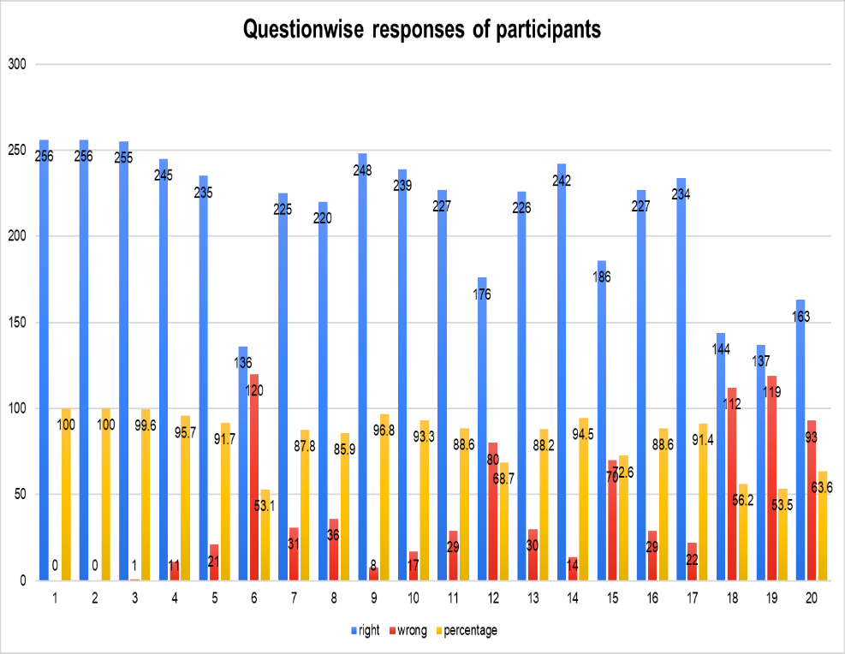
When asked to Anganwadi workers about a year of RPWD Act enforcement, it was found that all the respondents (256) were able to answer the question correctly after the completion of the session. When asked about the number of Disabilities in India as per the RPWD Act, it was found that all the respondents answered correctly. In regard to the question on the full form of the RPWD Act, 99.6 percent were able to answer it correctly after the orientation training. The Anganwadi workers were asked about the minimum percentage for disabled persons to get the benefits and concessions, 95.7 percent respond correctly. When enquired about how much percentage of employment decided for persons with disabilities as per RPWD Act 2016 and it was found that 91.7 percent answered it correctly. In regard to the term used for a person who has difficulty in learning and 53.1 percent of Anganwadi workers responded correctly whereas when asked in which disability a person uses a wheelchair, it was found that 87.8 percent of the Anganwadi Workers answered correctly. Similarly, when enquired about a person who continuously rubs his eyes and water comes from them suffers, about 85.9 percent of the respondents replied correctly. Further, it was also found that about the unit to measure sound, the majority of respondents (96.87%) mentioned the answer as decibels. When asked about the condition in which there is a partial or complete loss of hearing and 93.3 percent gave the correct answer. Regarding the question about dwarfism and 88.6 percent knew the correct answer However, when enquired about the symptoms of mental illness and 68.7 percent answered correctly. The study also found about the term used for repetitive speech and 88.2 percent of the respondents answered it correctly. When asked about cerebral palsy and symptoms of speech and language disability, about 99.5 percent and 72.6 percent of the Anganwadi Workers responded correctly respectively. In relation to blood disorders characterized by lack of blood clotting proteins about 88.6 percent of respondents answered it correctly whereas, about multiple disabilities, 91.5 percent of them answered it correctly. Regarding the question about the percentage of reservations in higher education for persons with disabilities, only 56.2 percent of Anganwadi workers were aware. The study also found out about the term which is being used in place of handicap, about 53.5 percent of respondents answered it correctly. Similarly, when asked about the condition in which the Red Blood Cells become sickle-shaped and 63.6 percent of Anganwadi workers answered correctly.
Discussion
The Rights of Persons with Disabilities Act implementation was important because earlier there was no comprehensive legislation in India and there is a lack of sensitization related to disabilities. There were various myths and misconceptions still prevalent about persons with disabilities and they are discriminated against by society. The long journey of a disabled individual from exclusion to inclusion is not to be forgotten. There were no provisions for a community-based rehabilitation programme. The stereotypical attitude of parents, relative’s community, and neighbourhood have always been a great challenge to tackle. There was a great need to provide a barrier-free (i.e. Physical barriers, Educational barriers, Attitudinal barriers) environment for children with special needs. The RPWD Act implementation provides access to right based approach, inclusive education, and employment for disabled persons without discrimination. Buildings, campuses, and various facilities are made accessible to children with special needs. The importance of awareness and training of Anganwadi workers could prevent disabilities right from the womb of the mother. Early Identification and intervention is the only way to prevent childhood disabilities.
Conclusion
In this present study, the researcher concluded that 83.4 percent of Anganwadi workers have knowledge of the RPWD Act after the training provided to them. Hence, it seems that training sessions are an effective way to provide knowledge and create awareness among Anganwadi workers about the rights of children with special needs.
Recommendations
- The present study recommends that training should be a continuous part of the work of Anganwadi workers in relation to disabilities and legislation. However, to improve the quality of life of children with special needs community engagement and training of other stakeholders like rehabilitation centers, paramedical staff, rehabilitation professionals, ASHA workers, social workers, sarpanch, and teachers should be mandatory.
- There should be proper screening and regular assessment camps. Refresher training should be provided from time to time.
- IEC (information education communication) materials like pamphlets, and leaflets should be printed in local languages and need to be distributed. Local nukkad natak can also be performed to create awareness at the grass root level. It is important to bring attitudinal change in the community.
References
Mathur G. P, Mathur S, Singh Y.D, Kushwaha, Lele S.N (1995). Detection and prevention of childhood disability with the help of anganwadi workers. Indian Paediatrics, vol 32
Nair MKC, George B, Padmamohan J, Sunitha RM, Reshmi VR, Prasanna GL, Leena ML (2009). Developmental delay and disability among under 5 children in a Rural ICDS Block. Indian Paediatrics, vol 46
Nair, M.K.C., Princly, P., Leena, M.L. et al (2014). CDC Kerala 17: Early Detection of Developmental Delay / Disability Among Children Below 3 y in Kerala - A Cross Sectional Survey. Indian Journal of Paediatrics, vol 81, 156–160
Rao Vidya L, Komala M (2016). The awareness among anganwadi workers about children with developmental delays. Asian mirror- International journal of research, vol 3
Basantia T.P, Alom J.H. (2020). Rehabilitation mechanisms for special group children: a study of anganwadi centres under integrated child development services projects. Journal of critical reviews vol 7
Meena M, Gupta Kumar S (2022). A study on awareness among anganwadi workers towards children with Intellectual Disabilities. International journal of creative research thoughts (IJCRT), Vol 10
Goswami V, Triveni (2023) Rights of persons with Disabilities in India: provisions, promises and reality. BAU Journal - Society, Culture and Human Behaviour, Vol. 4

