Difference In Palmprint Ridge Density of Males and Females

Sibin Benzen , Assistant Professor

Department of Forensic Science,

School Of Allied Health Sciences,

Vinayaka Mission Research Foundation (Deemed to be University)

AVMC&H Campus, Puducherry

ABSTRACT
The aim of the present work was to study the difference in Palmprint crest viscosity of males and ladies as a system of coitus identification. The four prominent areas were anatomized on the win prints that included central prominent part of the thenar eminence( P1), hypothenar region; inner to the proximal axial triradius( P2), medium mount; proximal to the triradius of the alternate number( P3) and side mount; proximal to the triradius of the fifth number( P4). The mean win print crest viscosity was significantly advanced among women than men in all the designated areas in both hands except for the P3 area in the right hand. Statistically significant differences were observed in the win print crest viscosity between the different win areas in men and women in right and left hands.
No significant right- left differences were observed in the win print crest viscosity in any of the four areas of win prints among men. In women, right- left differences were observed only in the P3 and P4 areas of win prints. The win print crest viscosity is a sexually dimorphic variable; its mileage for estimation of coitus in forensic identification may be limited owing to significant lapping of values. In addition, crest viscosity can be considered as a morphological point for individual variation.
Keywords: Palmprint, Ridge Density, Thenar, Hypothenar, Medial Mount, Lateral Mount

- INTRODUCTION
The region between wrist and finger is referred as palm and the impression left by the friction ridges of a palm is termed as palm print. The recovery of palm print is an important method of Forensic science. Moisture and grease on a palm result in palm print on the surface such as glass or metal. Human palm prints are rich in features that are unique and stable ^{[1]}.
Major palm print features include top lines, wrinkles, crests, singular points, and ramifications points. Palmprints are rich in physical characteristics of skin patterns similar as lines, points and textures, which give stable and distinctive information sufficient for separating an individual from a large population. In addition, mortal win prints are also abundant with texture features that contain crest ending and crest bifurcation. Also, it has numerous features videlicet figure point, Delta point point, top lines feature and eventually the wrinkles feature. All these features are uprooted with different styles. A palm print is different from a point in that it also contains details that can be used to compare one win to another, similar as texture, hacks, and marks.
A disunion crest is a raised area of the epidermis on the integers( fritters and toes), win of hand, or sole of bottom that's made up of one or further connected crest units of disunion crest skin. The skin occurs in a corrugated fashion with elevated crests broken up by lower furrows. In other words, this skin isn't flat and smooth like other skin. disunion crest skin is slightly elastic in nature and assists in gripping objects and shells. disunion crests form in the uterus by the fourth month of fetal development and remain unchanged and absolute for a person's continuance, only putrefying after death. These unique factors make disunion crest skin ideal for use in particular identification
a. History of Palmprint
Once disunion crest skin was honored as precious and dependable for particular identification, different people began to work on systems for taking these prints and also organizing them. Faults had preliminarily used printer’s essay to take the fingerprints of his subjects. In the early twentieth century, American chemical mastermind John A Dondero( 1900 – 1957) developed new inks for the purpose of recording prints, including special essay for bottom printing babe. Edward Henry, with the backing of two Indian civil retainers, developed a system for classifying and form mass amounts of point cards. This system is the one participated by Ferrier and is still known moment as the Henry System. With the arrival of automated identification systems, use of Henry’s system has declined
Once disunion crest skin was honored as precious and dependable for particular identification, different people began to work on systems for taking these prints and also organizing them. Faults had preliminarily used printer’s essay to take the fingerprints of his subjects. In the early twentieth century, American chemical mastermind John A Dondero( 1900 – 1957) developed new inks for the purpose of recording prints, including special essay for bottom printing babe. Edward Henry, with the backing of two Indian civil retainers, developed a system for classifying and form mass amounts of point cards. This system is the one participated by Ferrier and is still known moment as the Henry System. With the arrival of automated identification systems, use of Henry’s system has declined.
- COLLECTION PROCEDURE
Healthy Individualities progressed between 20 to 60 times were included in the study after taking informed concurrence. A clean plain glass plate was slightly smeared with black duplicating essay with the help of a comber. The subjects were asked to apply their hand on the smeared plate and also transfer them on to a white paper. Regular pressure was applied to gain the win prints.[1] Palm prints were attained from both right and left hands. The samples are collected by using various collection tools such as

      - Duplicating ink ( Black)
      - Ink roller
      - Inking glass plate
      - Ink cleaning supplies
      - Palm print cards for recording the prints
      - Rulers, Markers and Magnifying lens
      - Transparent OHP sheet

- ANALYSIS OF PALM PRINT
The palmprints were taken in a paper also dissect the sample by using the hand lens and 5 mm × 5 mm(0.5 cm) pronounced transparent OHP distance. The transparent OHP distance was placed on the win print sample in the defined area to be anatomized. The count was carried out transversely on a forecourt for measure crest viscosity or the number of given crests. The crests were counted with the help of a hand lens.( 2) This value represents the number of ridges in 25 mm square area and reflects the crest density value. also the crest viscosity of the four prominent areas were anatomized on the win prints that included central prominent part of the thenar eminence( P1), hypothenar region; inner to the proximal axial triradius( P2), medium mount; proximal to the triradius of the alternate number( P3) and side mount; proximal to the triradius of the fifth number( P4) were recorded, organized totally and statistically dissect.[3][4]

CONCLUSION
Palmprints have important role in determining the gender of an individual. The coitus differences in win print crest viscosity can indeed be precious in identification of a dismembered hand during medico legal examinations to establish the identity of an individual in cases of mass disasters mass homicides.[5] In this environment, the coitus difference in the crest viscosity in the fingerprints and win prints becomes applicable. Despite its reputation as an infallible means of identification. It has significant limitation when it comes to forensic individualization. The ridge pattern of palm print develops during pregnancy and remains unchanged until death, when it is altered by decomposition. The identification of sex is crucial in forensics. Analysis of Palmprints can be used to identify the offender. The prints attained from the crime scene are matched with the suspects to confirm their involvement in crime.[6][7][8]

The present study was conducted to study the difference in Palmprint crest viscosity in males and ladies and it has been successful to determine that, ladies tend to have grater crest viscosity than males. Ladies have advanced crest viscosity in both right and left hand except medium mount( P3) region. It's apparent that statistically significant difference exists in the Palmprint crest viscosity among the different areas of manly and womanish in right and left hand. therefore, it's concluded that crest viscosity in Palmprint pattern is a stylish parameter for identification of gender. This study would be helpful in gender determination in utmost of the cases where Palmprints are set up and other attestations are destroyed or not enough for identification.

APPENDIX

Male Palmprint Sample

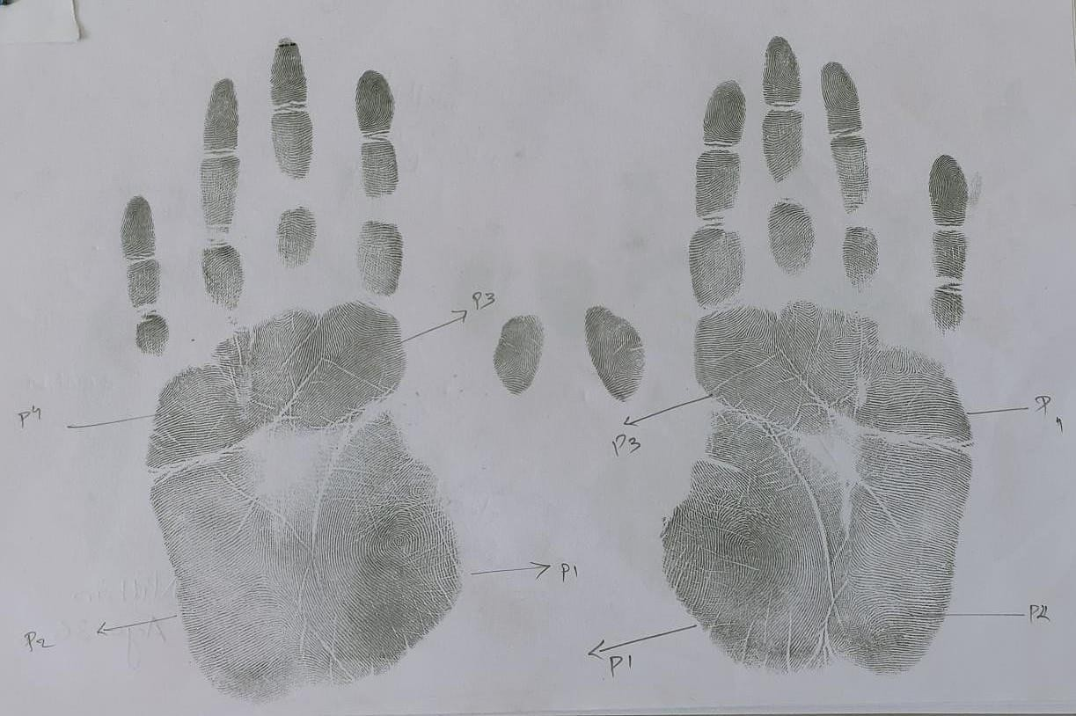
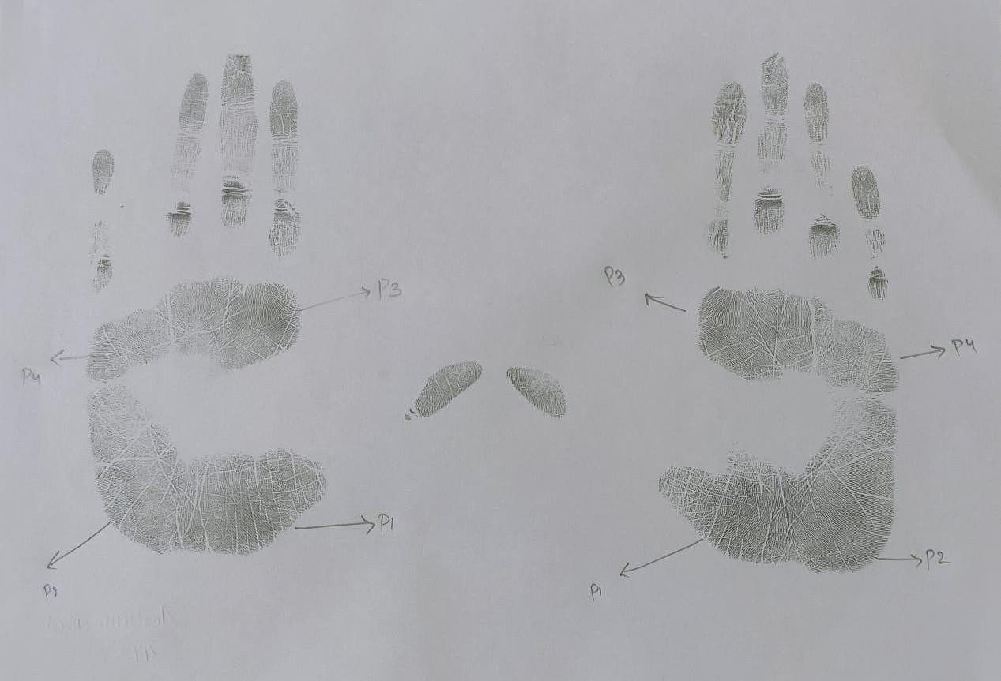

Female Palmprint Sample

REFERENCES

Fathelrahman Idris Ali, Altayeb Abdalla Ahmed, Sexual and topological variability in palmprint ridge density in a sample of Sudanese population, Forensic Science International: Reports, Volume 2, 2020, 100151, ISSN 2665-9107, https://doi.org/10.1016/j.fsir.2020.100151
- Yaacob, R., Hadi, H., Ibrahim, H. et al. Evaluating the potential application of palmprint creases density for sex determination: an exploratory study. Egypt J Forensic Sci 12, 26 (2022). https://doi.org/10.1186/s41935-022-00282-6
- Badiye, Ashish & Kapoor, Neeti & Mishra, Swati. (2019). A novel approach for Sex determination using palmar tri-radii: A pilot study.. Journal of Forensic and Legal Medicine. 65. 10.1016/j.jflm.2019.04.005
- Gornale, S.S., Patil, A., Hangarge, M., Pardesi, R. (2019). Automatic Human Gender Identification Using Palmprint. In: Luhach, A.K., Hawari, K.B.G., Mihai, I.C., Hsiung, PA., Mishra, R.B. (eds) Smart Computational Strategies: Theoretical and Practical Aspects. Springer, Singapore. https://doi.org/10.1007/978-981-13-6295-85

Sánchez-Andrés A, Barea JA, Rivaldería N, Alonso-Rodríguez C, Gutiérrez-Redomero E. Impact of aging on fingerprint ridge density: Anthropometry and forensic implications in sex inference. Sci Justice. 2018 Sep;58(5):323-334. doi: 10.1016/j.scijus.2018.05.001. Epub 2018 May 3. PMID: 30193658

Taduran RJ, Tadeo AK, Escalona NA, Townsend GC. Sex determination from fingerprint ridge density and white line counts in Filipinos. Homo. 2016 Apr;67(2):163-71. doi: 10.1016/j.jchb.2015.11.001. Epub 2015 Nov 12. PMID: 26619792.

Pattanawit Soanboon, Somsong Nanakorn, Wibhu Kutanan, Determination of sex difference from fingerprint ridge density in northeastern Thai teenagers, Egyptian Journal of Forensic Sciences, Volume 6, Issue 2, 2016, Pages 185-193, ISSN 2090-536X, https://doi.org/10.1016/j.ejfs.2015.08.001.
- Ahmed AA, Osman S. Topological variability and sex differences in fingerprint ridge density in a sample of the Sudanese population. J Forensic Leg Med. 2016 Aug;42:25-32. doi: 10.1016/j.jflm.2016.05.005. Epub 2016 May 12. PMID: 27227288.

