IoT Based Solar Panel Monitoring System
Mahitha Mohan^{1,a)}Thangavel K^{1, b)}, Balaprakash V^{1, c)}
1 Department of Electronics
Hindusthan College of Arts & Science
Coimbatore, Tamilnadu, India,641028
Abstract
With the help of IoT, organizations can see in real time how their systems actually function, gaining insights into anything from equipment performance to supply chain and logistics activities. Businesses may automate procedures and save money on labor thanks to IoT. Additionally, it reduces waste, enhances service delivery, lowers the cost of manufacturing and delivering items, and provides transparency into customer transactions. As a result, IoT is among the most significant technologies of modern life, and it will gain momentum as more companies recognize how linked gadgets can help them stay competitive. The suggested solar panel monitoring system, which combines the Internet of Things, LCD display, changeable component, voltage sensor, current sensor, battery, and solar panel, may offer important information about energy generation, consumption, and storage. By using this technology, users are able to remotely check their solar panel systems' output of voltage and current as well as the battery's level of charge. Utilizing this information will help you save money and use energy more efficiently. People who use the internet of things can live and work more intelligently and have total control over their life. IoT is crucial to business in addition to providing smart home automation devices.
1. INTRODUCTION
One of the most widely used and economically advantageous sources of renewable energy worldwide is solar energy, which is rising quickly. Systems using solar panels have gained popularity because of their effectiveness, environmental friendliness, and long-term cost savings. To guarantee that these solar panel systems are operating at their best and producing the most energy possible, it is essential to continuously monitor their performance. There are many ways to monitor solar panel installations, including by employing Internet of Things (IoT) technologies. IoT technology makes it possible to remotely monitor and manage solar panel installations, giving important information about how much energy is produced and used. The solar panel system is linked to the internet in this suggested system via an ESP8266 module, enabling remote monitoring and control. Voltage and current sensors in the system measure, respectively, the voltage and current output of the solar panel. Then, this data is transmitted to an IoT platform so that it may be examined and shown on an LCD monitor. A variable component, such as a battery, is also included in the proposed system to store any extra energy produced by the solar panel system. Additionally, the LCD display may be used to monitor the battery's level of charge, which offers important information about the system's capacity for energy storage. In order to guarantee the effectiveness and top performance of solar panel systems, the proposed solar panel monitoring system utilizing IoT, LCD display, variable component, voltage sensor, current sensor, battery, and solar panel is crucial.

LCD DISPLAY

ARDUINO
UNO

VARIABLE POT
SOLAR PANEL

BATTERY

VOLTAGE SENSOR
IOT

CURRENT SENSOR

1.2. CIRCUIT DIAGRAM

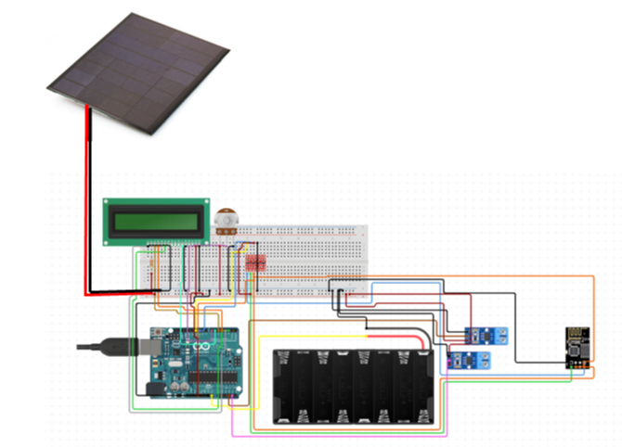
1.3. HARDWARE REQUIRED
SNO | COMPONENTS | REQUIREMENT
1 | Arduino UNO | 1
2 | ESP8266 WIFI Module | 1
3 | Voltage sensor | 1
4 | Current sensor | 1
6 | Solar panel | 1
7 | Potentiometer | 1
8 | LCD display | 1
9 | Battery(12v) | 1

2. Arduino UNO:
Arduino is an open-source electronics platform based on easy-to-use hardware and software.

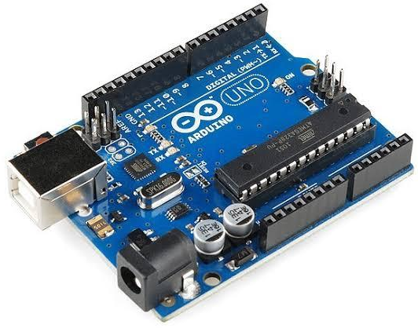

2.1 Pin Description
Pin Category | Pin Name | Details
Power | Vin, 3.3V, 5V, GND | Vin: Input voltage to Arduino when using an external power source.  5V: Regulated power supply used to power microcontroller and other components on the board.  3.3V: 3.3V supply generated by on-board voltage regulator. Maximum current draw is 50mA.  GND: ground pins.
Reset | Reset | Resets the microcontroller.
Analog Pins | A0 – A5 | Used to provide analog input in the range of 0-5V
Input/Output Pins | Digital Pins 0 - 13 | Can be used as input or output pins.
Serial | 0(Rx), 1(Tx) | Used to receive and transmit TTL serial data.
External Interrupts | 2, 3 | To trigger an interrupt.
PWM | 3, 5, 6, 9, 11 | Provides 8-bit PWM output.
SPI | 10 (SS), 11 (MOSI), 12 (MISO) and 13 (SCK) | Used for SPI communication.
Inbuilt LED | 13 | To turn on the inbuilt LED.
TWI | A4 (SDA), A5 (SCA) | Used for TWI communication.
AREF | AREF | To provide reference voltage for input voltage.
2.2 Arduino Uno Technical Specifications
Microcontroller | ATmega328P – 8 bit AVR family microcontroller
Operating Voltage | 5V
Recommended Input Voltage | 7-12V
Input Voltage Limits | 6-20V
Analog Input Pins | 6 (A0 – A5)
Digital I/O Pins | 14 (Out of which 6 provide PWM output)
DC Current on I/O Pins | 40 mA
DC Current on 3.3V Pin | 50 mA
Flash Memory | 32 KB (0.5 KB is used for Bootloader)
SRAM | 2 KB
EEPROM | 1 KB
Frequency (Clock Speed) | 16 MHz
2.3 Other Arduino Boards:
Arduino Nano, Arduino Pro Mini, Arduino Mega, Arduino Due, Arduino Leonardo.
2.4 Overview:
Arduino Uno is a microcontroller board based on an 8-bit ATmega328P microcontroller. Along with ATmega328P, it consists of other components such as crystal oscillator, serial communication, voltage regulator, etc. to support the microcontroller.
Arduino Uno has 14 digital input/output pins (out of which 6 can be used as PWM outputs), 6 analog input pins, a USB connection, A Power barrel jack, an ICSP header and a reset button.
2.5 How to use the Arduino Board:
By using the pin Mode (), digital Read(), and digital Write() methods in Arduino programming, the 14 digital input/output pins can be used as input or output pins.
- Each pin contains an inbuilt pull-up resistor of 20 to 50 kOhms that is unconnected by default, runs at 5 volts, and may deliver or receive a maximum of 40 milliamperes of current.
- Some of these 14 pins, as stated below, serve particular purposes.
- The serial pins 0 (Rx) and 1 (Tx) are: TTL serial data is transmitted and received via the Rx and Tx pins.
- The related ATmega328P USB to TTL serial chip is used to connect them.
- Interrupt Pins 2 and 3 can be set up to initiate an interrupt in response to low values, rising or falling edges, or value changes.
- PWM Pins 3, 5, 6, 9 and 11: These pins use the analog Write() method to output an 8-bit PWM signal.
- SPI communication occurs on SPI Pins 10 (SS), 11 (MOSI), 12 (MISO), and 13 (SCK).
- Built-in LED Pin 13: When this pin is HIGH, the built-in LED is on, and when pin 13 is LOW, the LED is off.
- There are 6 analog input pins in addition to 14 digital pins, each of which offers 10 bits of resolution, or 1024 distinct values.
They can measure between 0 and 5 volts, however by using AREF pins with an analog reference function, this limit can be raised.
- TWI communication with the Wire library also uses analog pins 4 (SDA) and 5 (SCA).
- Other pins on the Arduino Uno are listed below:
- For analog inputs with the analog Reference () function, AREF is used to supply the reference voltage.
- Resetting the microcontroller involves setting the reset pin to low.
2.6 Communication
A computer, another Arduino board, or other microcontrollers can all be reached via Arduino. UART TTL (5V) serial communication is offered by the ATmega328P microcontroller and can be carried out via digital pins 0 (Rx) and 1 (Tx).
This serial communication is routed through USB by an ATmega16U2 on the board, which is seen by computer software as a virtual com port. Because the ATmega16U2 firmware takes use of the integrated USB COM drivers, no additional driver is required. A.inf files are necessary on Windows.
Using the serial monitor included in the Arduino software, simple text can be sent to and received from the Arduino board. When data is transmitted over the USB-to-serial chip and USB connection to the computer (not for serial communication on pins 0 and 1), two RX and TX LEDs on the Arduino board will flash.
Any digital pin on the Uno can support serial communication thanks to a software serial library. Additionally supporting I2C (TWI) and SPI communication is the ATmega328P. To make using the I2C bus easier, the Arduino software comes with the Wire library.
2.7 Arduino Uno to ATmega328 Pin Mapping:
When ATmega328 chip is used in place of Arduino Uno, or vice versa, the image below shows the pin mapping between the two
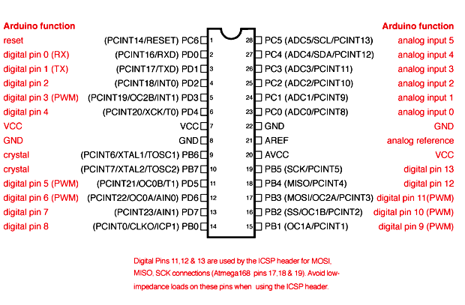
3. LCD:
LCD (Liquid Crystal Display) is a type of flat panel display which uses liquid crystals in its primary form of operation. LCD draws its definition from its name itself. It is combination of two states of matter, the solid and the liquid. LCD uses a liquid crystal to produce a visible image. LCD's technologies allow displays to be much thinner when compared to cathode ray tube (CRT) technology.
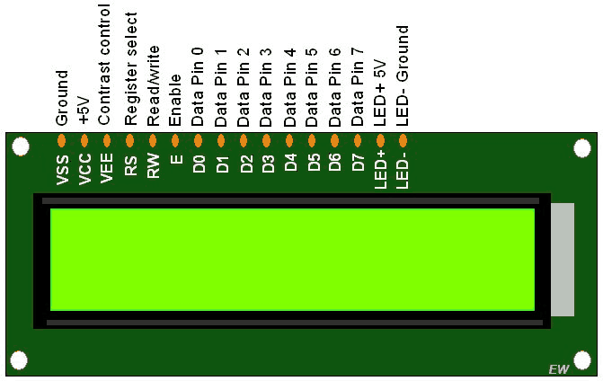
- In an LCD television, polarized light is rotated by liquid crystals that electronically turn on and off the pixels.
- Wide-ranging uses for LCDs include LCD televisions, computer monitors, instrument panels, cockpit displays for airplanes, and indoor and outdoor signs.
- Liquid crystal displays, or LCDs, are utilized in embedded system applications to display different system data and statuses.
- A 16-pin device with two rows that can each hold 16 characters is called an LCD 16x2.
- You can use the LCD 16x2 in either 4-bit or 8-bit mode.
- Additionally, it is possible to make original characters.
- It contains 3 control lines that can be utilized for control in addition to the 8 data lines.
- For more information about LCD 16x2 and how to use it, refer the topic LCD 16x2 module in the sensors and modules section.
3.1 Functions Used:
3.1.1. Liquid Crystal object name
- Name of the liquid crystal object: (rs,rw,en,d0,d1,d2,d3,d4,d5,d6,d7)
- This function defines an object of the class Liquid Crystal with the name object name.
- The Arduino board's rs, rw, and en pins are connected to rs, rw, and en of the LCD.
- The Arduino board's pins d0, d1, d2, d3, d4, d5, d6 and d7 are linked to the LCD's data pins D1, D2, D3, D4, D5, D6 and D7.
- Liquid crystal LCD (13) 12, 11 (10), 9 (8), 7 (6), 5 (4), and 3 are two examples. The LCD is used in 8-bit mode for this.
- Liquid crystal LCD as an example (13, 12, 11, 6, 5, 4, 3). The LCD is used in 4-bit mode for this.
3.1.2 LCD begin (cols,rows)
The LCD's rows and columns are specified by this function, which is also used to initialize the LCD.
Once the object has been defined using the function in point 1, it must be invoked before calling any other functions.
Consider the 16x2 LCD as an example. Begin (16,2). The object of the class Liquid Crystal is known by the abbreviation lcd. The number of rows is 2, and there are 16 columns.
3.1.3 LCD set Cursor (col, row)
The row and column parameters are used to position the LCD's cursor in the desired spot.
The cursor should be in column 0, column 1, column 4, and so on. Col is the column number, the cursor should be in row, where row is the row number (0 for row 1, 1 for row 2).
For instance, LCD Set Cursor (4,1) will position the cursor at the fifth column in the second row. The object of the class Liquid Crystal is known by the abbreviation lcd.
3.1.4 LCD create Char (num, data)

To generate a new custom character for the LCD, utilize this function. The custom character is to be stored at CGRAM location num, which ranges from 0 to 7. Eight bytes in an array called data stand in for the custom character. Only 5x8 pixel custom characters are permitted. A set of eight bytes, one for each row, in an array, are used to specify each custom character. The pixels in that row are determined by the five least significant bits of each byte. A write () function is required to display a unique character on the screen. The write function receives as an argument the CGRAM position number (0 to 7) of the custom character that will be displayed on the LCD.

3.2 Interfacing 16×2 LCD to an Arduino uno:

A key component of many embedded system designs using Arduinos is LCD modules. Therefore, understanding how to interface LCD modules with Arduino is crucial for creating embedded systems. The article's interface between an Arduino and 162 LCD is discussed in this part. The LCD module in use here is JHD162A. A 162 LCD module called JHD162A is based on Hitachi's HD44780 driver. The JHD162A has 16 pins and can be used in either 4-bit or 8-bit mode, depending on the application. The LCD module is being used in 4-bit mode here. I'll demonstrate how to use an Arduino to display a plain text message on an LCD module first, and then I've created a project that you can use.

3.3 16×2 LCD Module Pin Out Diagram:
The JHD162A lcd module has 16 pins and can be operated in 4-bit mode or 8-bit mode. Here we are using the LCD module in 4-bit mode. Before going into the details of the project, let’s have a look at the JHD162A LCD module. The schematic of a JHD162A LCD pin diagram is given below.
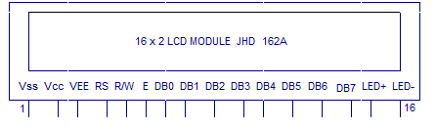
The name and functions of each pin of the 16×2 LCD module is given below.

Pin1(Vss)
Ground pin of the LCD module.
Pin2(Vcc)
Power is supplied to the LCD module through this pin (+5V supply)
Pin3(VEE)
Contrast adjustment pin. This is done by connecting the ends of a 10K potentiometer to +5V and ground and then connecting the slider pin to the VEE pin. The voltage at the VEE pin defines the contrast. The normal setting is between 0.4 and 0.9V.
Pin4(RS)
Register select pin. The JHD162A has two registers namely command register and data register. Logic HIGH at RS pin selects data register and logic LOW at RS pin selects command register. If we make the RS pin HIGH and feed an input to the data lines (DB0 to DB7), this input will be treated as data to display on the LCD screen.
If we make the RS pin LOW and feed an input to the data lines, then this will be treated as a command ( a command to be written to the LCD controller – like positioning cursor or clear screen or scroll).
Pin5(R/W)
Read/Write modes. This pin is used for selecting between read and write modes. Logic HIGH at this pin activates read mode and logic LOW at this pin activates write mode.
Pin6(E)
This pin is meant for enabling the LCD module. A HIGH to LOW signal at this pin will enable the module.
Pin7(DB0) to Pin14(DB7)
These are data pins. The commands and data are fed to the LCD module through these pins.
Pin15(LED+)
Anode of the back light LED. When operated on 5V, a 560 ohm resistor should be connected in series to this pin. In Arduino based projects the back light LED can be powered from the 3.3V source on the Arduino board.
Pin16(LED-)
Cathode of the back light LED.
For knowing more about LCD module JHD162A and its pin functions, read this article: Interfacing 16×2 LCD and 8051 microcontroller. The circuit diagram of interfacing LCD to Arduino for displaying a text message is shown below.

3.4 Circuit diagram:

Arduino to 16×2 LCD Module:

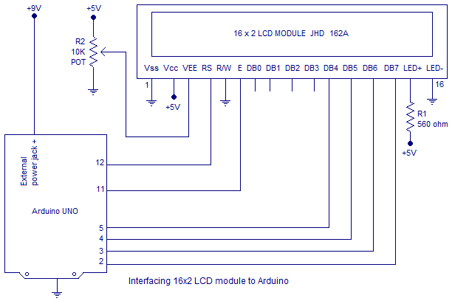

The RS pin of the LCD module is connected to digital pin 12 of the Arduino. R /W pin of the LCD is grounded. Enable pin of the LCD module is connected to digital pin 11 of the Arduino.
In this project, the LCD module and Arduino are interfaced in the 4-bit mode. This means only four of the digital input lines( DB4 to DB7) of the LCD are used. This method is very simple, requires less connections and you can almost utilize the full potential of the LCD module. Digital lines DB4, DB5, DB6 and DB7 are interfaced to digital pins 5, 4, 3 and 2 of the Arduino.
The 10K potentiometer is used for adjusting the contrast of the display. 560 ohm resistor R1 limits the current through the back light LED. The arduino can be powered through the external power jack provided on the board.
+5V required in some other parts of the circuit can be tapped from the 5V source on the arduino
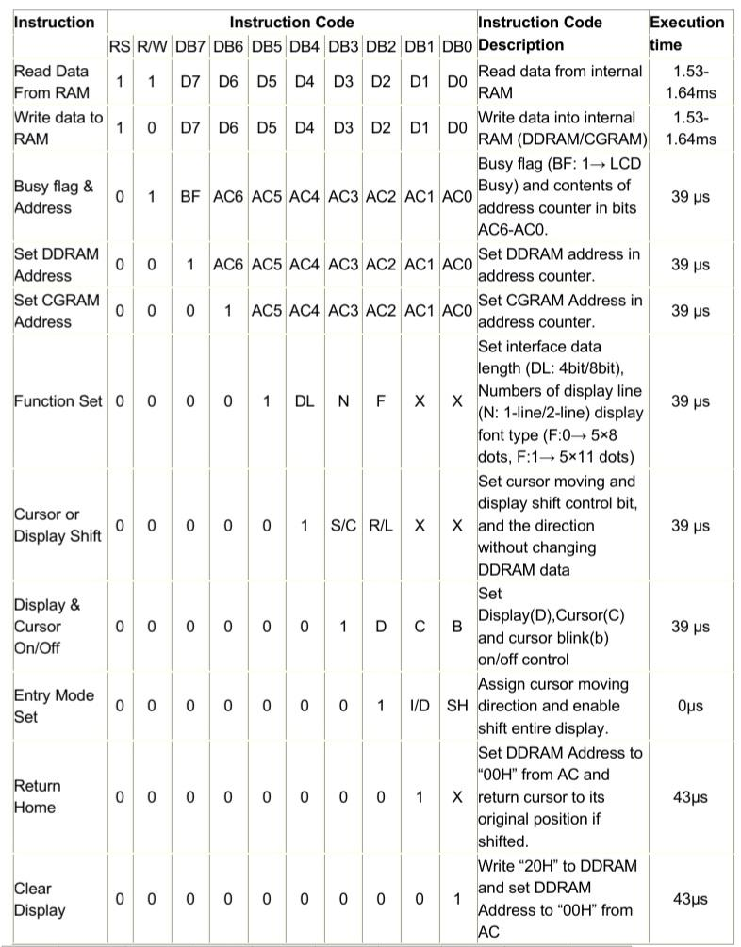
Control and display commands
AC -Address Counter
3.5 Outline
Now the instruction can be divided mainly in four kinds
1) Function set instructions
2) Address set instructions
3) Data transfer instructions with internal RAM
4) Others
3.6 Details of the Instructions
1) Read Data from RAM
RS | R/W | DB7 | DB6 | DB5 | DB4 | DB3 | DB2 | DB1 | DB0
1 | 1 | D7 | D6 | D5 | D4 | D3 | D2 | D1 | D0
Read 8 bit binary data from DDRAM/CGRAM
The previous address set instruction has already determined which RAM to use. The data read first is invalid if the RAM's address set instruction is not executed prior to this instruction because the AC's direction has not been established. As there isn't enough time to transfer RAM data, if the RAM data is read numerous times without a RAM address set instruction before read operation, the second read will always yield the proper RAM data. Cursor shift instructions perform the same function as DDRAM address set instructions while performing DDRAM read operations; they also transport RAM data to the output data registers. Depending on the entry mode, the data address counter is automatically incremented or dropped by 1 after a read operation. It's possible that the display shift procedure after CGRAM read won't go as planned. When writing to RAM, AC is either increased or decreased by 1 just like when reading from RAM. The AC now indicates the following address location, but the read instruction is the only way to access the prior data.
2) Write data to ram
RS | R/W | DB7 | DB6 | DB5 | DB4 | DB3 | DB2 | DB1 | DB0
1 | 0 | D7 | D6 | D5 | D4 | D3 | D2 | D1 | D0
Write binary 8bit data to DDRAM/CGRAM. The selection of CGRAM or DRAM is set by the previous address set instruction; DDRAM address set, CGRAM address set. RAM set instruction can also determine the AC direction to RAM.
After write operation, the address is automatically increased or decreased by 1 according to the entry mode.
3) Read Busy Flag and Address
RS | R/W | DB7 | DB6 | DB5 | DB4 | DB3 | DB2 | DB1 | DB0
0 | 1 | BF | AC6 | AC5 | AC4 | AC3 | AC2 | AC1 | AC0
By making this readout operation, it can be determined if the LCD is performing some internal operation or not. If Busy Flag (BF) is high, some internal operation is going inside the LCD at that particular moment. To perform further operation the data source (e.g. micro controller) must wait for the BF to go low. Here, the address counter value can also be read.
RS | R/W | DB7 | DB6 | DB5 | DB4 | DB3 | DB2 | DB1 | DB0
0 | 0 | 1 | AC6 | AC5 | AC4 | AC3 | AC2 | AC1 | AC0
4) Set DDRAM Address

Set DDRAM address to AC, this instruction makes DDRAM data available from MPU. In 1-line display mode, DDRAM address rangers from “00H” to “4FH”. In 2-line display mode, DDRAM address in the first line ranges from “00H” to “27H”, and DDRAM address in the 2nd line is from “40H” to “67H”.
5) Set CGRAM address
RS | R/W | DB7 | DB6 | DB5 | DB4 | DB3 | DB2 | DB1 | DB0
0 | 0 | 0 | 1 | AC5 | AC4 | AC3 | AC2 | AC1 | AC0
Set CGRAM address to AC. This instruction makes CGRAM data available from MPU.
6) Function Set
RS | R/W | DB7 | DB6 | DB5 | DB4 | DB3 | DB2 | DB1 | DB0
0 | 0 | 0 | 0 | 1 | DL | N | F | X | X
DL: Interface data length control bit
DL=’1’ means 8bit mode of data transfer.
DL=’0’ means 4bit mode of data transfer
When 4 bit mode is activated, the data needs to be transferred in two parts, first higher 4 bits, and then lower 4 bits.
N: display line number control bit
N=’1’ will allows to characters to display in 2-lines
N=’0’ will allows to characters to display in the first line only
F: display font control bit
F=’0’ will use 5×8 dots format display mode
F=’1’ will use 5×11 dots format display mode
7) Cursor or display Shift
RS | R/W | DB7 | DB6 | DB5 | DB4 | DB3 | DB2 | DB1 | DB0
0 | 0 | 0 | 0 | 0 | 1 | S/C | R/L | X | X
Without writing or reading the display data, shifting right/left cursor position or display.
This instruction is made to correct or search or display data. During 2-line display mode, cursor moves to the 2nd line after the 40th digit of the 1st line.
When displayed data is shifted repeatedly, each line shifts individually.
When display shift is performed, the contents of the address counter are not changed.
8) Display On/Off Control
RS | R/W | DB7 | DB6 | DB5 | DB4 | DB3 | DB2 | DB1 | DB0
0 | 0 | 0 | 0 | 0 | 0 | 1 | D | C | B
This instruction controls Display, Cursor and cursor blink.
D: Display On/Off control bit
D=’1’ means entire display is turned on
D=’0’ means the entire display is turned off. But Display data remains in DDRAM.
C: cursor On/Off control bit
C=’1’ turns on the cursor
C=’0’ turns off the cursor. But I/D register retains the data
B: Cursor blink On/Off control bit
B=’1’ makes the cursor blink periodically.
B=’0’ stops the cursor to blink and the cursor looks steady if the Cursor is turned on.
9) Entry Mode Set
RS | R/W | DB7 | DB6 | DB5 | DB4 | DB3 | DB2 | DB1 | DB0
0 | 0 | 0 | 0 | 0 | 0 | 0 | 1 | I/D | SH
This instruction sets the moving direction of the cursor and display.
When I/D= ’1’ cursor moves to the right and the DDRAM address is increased by 1.
When I/D= ’0’ cursor moves to the left and DDRAM address is decreased by 1.
CGRAM operates in the same way in this setting.
10) Return Home
RS | R/W | DB7 | DB6 | DB5 | DB4 | DB3 | DB2 | DB1 | DB0
0 | 0 | 0 | 0 | 0 | 0 | 0 | 0 | 1 | X
This instruction sets the address counter to ‘00H’, and returns the cursor to the first column of the first line. And if the display is shifted previously, this instruction shifts this too. The DDRAM contents don’t change in this instruction.
11) Clear display
RS | R/W | DB7 | DB6 | DB5 | DB4 | DB3 | DB2 | DB1 | DB0
0 | 0 | 0 | 0 | 0 | 0 | 0 | 0 | 0 | 1
Clear all the display data by writing “20H” (ASCII code of ‘space’ character) to all DDRAM addresses, AND set value DDRAM address counter (AC) to “00H”. It returns the cursor to the first column of the first line and sets the entry mode to increment mode (I/D=’1’).
3. 7 8-bit and 4-bit interfacing of LCD
The issue at hand is how to send orders or display data on the LCD. The two types of data transport that LCD displays support are listed below. One uses 4 bit mode, while the other uses 8 bit mode. data transfer Put your data in the 8-bit bus first in 8-bit mode, then your commands in the command bus, and then pulse the enable signal. Put the upper 4 bits in the 4 bit data bus attached to the 4MSB pins of the LCD display first, then put control signals in the control bus, and finally pulse the E pin once to transfer data in 4 bit mode. Put the bottom 4 bits in the data bus after that, then pulse the E pin once more. Here is a diagram simply describing it.
4. ESP8266 Module:
The ESP8266 is a relatively affordable and user-friendly tool for connecting your creations to the internet. The module may function as a station (connect to Wi-Fi) and an access point (create hotspots), allowing it to simply retrieve data and post it to the internet, making the Internet of Things as simple as feasible. Your project could access any information that is available on the internet because it can also retrieve data from the internet via APIs, making it smarter. This module's ability to be programmed using the Arduino IDE, which makes it much more user-friendly, is another intriguing feature. However, this version of the module only has 2 GPIO pins (although you may hack it to use up to 4). As a result, you must use it in conjunction with another microcontroller, such as Arduino. If this is not an option, you can consider the more independent ESP-12 or ESP-32 versions.
The Arduino IDE is the most widely utilized of the several methodologies and IDEs that are compatible with ESP modules. So let's confine our discussion to that down below.
Be careful with your circuits because the ESP8266 module can only operate at 3.3V; at 3.7V or more, the module will be destroyed. The FTDI board, which enables 3.3V programming, is the most effective tool for programming an ESP-01. It is advised to purchase one if you don't already have one, but you can also use an Arduino board in the interim. The ESP-01's powering up issue is a widespread issue that affects everyone. Since the module requires some power while being programmed, you can either use a potential divider or an Arduino 3.3V pin to supply power. Therefore, it's crucial to create a tiny voltage regulator for 3.31v that can deliver at least 500mA. The LM317 is one recommended regulator that might do the task with ease.
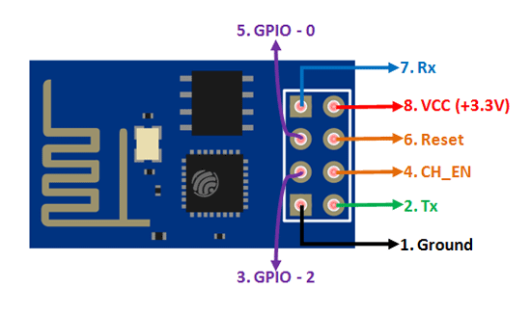
4.1 ESP8266 Pin Configuration
Pin Number | Pin Name | Alternate Name | Normally used for | Alternate purpose
1 | Ground | - | Connected to the ground of the circuit | -
2 | TX | GPIO – 1 | Connected to Rx pin of programmer/uC to upload program | Can act as a General purpose Input/output pin when not used as TX
3 | GPIO-2 | - | General purpose Input/output pin | -
4 | CH_EN | - | Chip Enable – Active high | -
5 | GPIO - 0 | Flash | General purpose Input/output pin | Takes module into serial programming when held low during start up
6 | Reset | - | Resets the module | -
7 | RX | GPIO - 3 | General purpose Input/output pin | Can act as a General purpose Input/output pin when not used as RX
8 | Vcc | - | Connect to +3.3V only
4.2 ESP8266-01 Features
- Low cost, compact and powerful Wi-Fi Module
- Power Supply: +3.3V only
- Current Consumption: 100mA
- I/O Voltage: 3.6V (max)
- I/O source current: 12mA (max)
- Built-in low power 32-bit MCU @ 80MHz
- 512kB Flash Memory
- Can be used as Station or Access Point or both combined
- Supports Deep sleep (<10uA)
- Supports serial communication hence compatible with many development platform like Arduino
- Can be programmed using Arduino IDE or AT-commands or Lua Script
5. Solar panel:
- 12 volt 10-watt polycrystalline solar panel USB charging.
- High conversion speed, high-efficiency output.
- Excellent low light effect.
- High transmittance tempered glass.
- A unique technique to prevent water frozen within the deforming framework.
The 10W 12 Volts 36-cell Solar Panel (41 x 30 cm) for DIY Projects is ready to use without requiring a frame or special modifications. We have chosen to sell these Polycrystalline solar cells because they are Laser cut to the proper size and encapsulated in the special sun and weather-resistant materials which give them unique characteristics.
The 12v 10W mini Solar Panel has Polycrystalline solar cells which are encased and protected by a durable outer poly frame. This 3v 150mA mini Solar Panel for DIY Projects is light weighted, very strong and weather-resistant substrates or injection molded trays custom-designed for the target product. These Small Epoxy Solar Panels are simple to install or add to your existing product and their construction requires no frame or special modifications.
Polycrystalline solar cells have 2 to 3 times the power of amorphous thin-film solar panels.

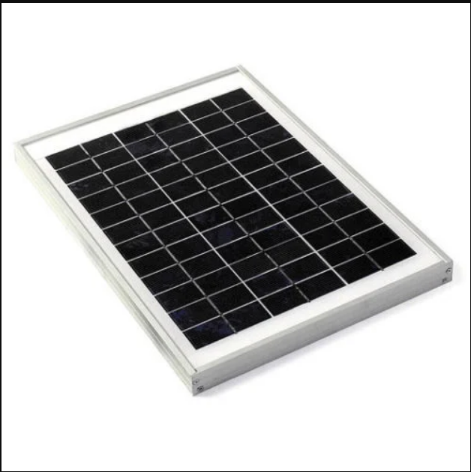
5.1 Features:
- 100% new high quality.
- 12 volt 10-watt polycrystalline solar panel USB charging
- High conversion speed, high-efficiency output.
- Excellent low light effect.
- High transmittance tempered glass.
- A unique technique to prevent water frozen within the deforming framework.
- Small Epoxy Solar Panels are simple to install or add to your existing product.
- Construction requires no frame or special modifications
- Small space required for installation.
- Has 2 to 3 times the power of amorphous thin-film solar panels
- Ready to use, they require no frame or special modifications.
- For connection, just solder or crimp to the copper tape.
6. Battery:
1 x 10W 12 Volts 36-cell Solar Panel (41 x 30 cm). A twelve-volt battery has six single cells in series producing a fully charged output voltage of 12.6 volts. A battery cell consists of two lead plates a positive plate covered with a paste of lead dioxide and a negative made of sponge lead, with an insulating material (separator) in between. This is a rechargeable 12 volt 1.2AH Sealed Lead Acid Battery Our Power-Sonic or Equivalent valve regulated sealed lead acid batteries are maintenance free, easy to handle, rugged and economical. It has a characteristic of high discharge rate, wide operating temperature, long service life and deep discharge recovery. This product has Absorbent Glass Mat (AGM) technology for superior performance. This product is valve regulated and spill proof construction allows safe operation in any position and the power/ volume ratio yields unrivaled energy density. This product is approved for transport by air.

A 12-volt motorcycle battery is made up of a plastic case containing six cells. Each cell is made up of a set of positive and negative plates immersed in a dilute sulfuric acid solution known as electrolyte, and each cell has a voltage of around 2.1 volts when fully charged
Voltage | Amp Hours | Size
 | (20 hour) | Inches
12 | 1.2 | 3.82 x 1.77 x 2.09
12 | 1.9 | 7.01 x 1.34 x 2.36
12 | 2.3 | 7.01 x 1.34 x 2.36

7. CURRENT SENSOR
The current sensor is a device that detects and converts current to get an output voltage, which is directly proportional to the current in the designed path. When current is passing through the circuit, a voltage drops across the path where the current is flowing. Also, a magnetic field is generated near the current-carrying conductor. These above phenomena are used in the current sensor design technique.
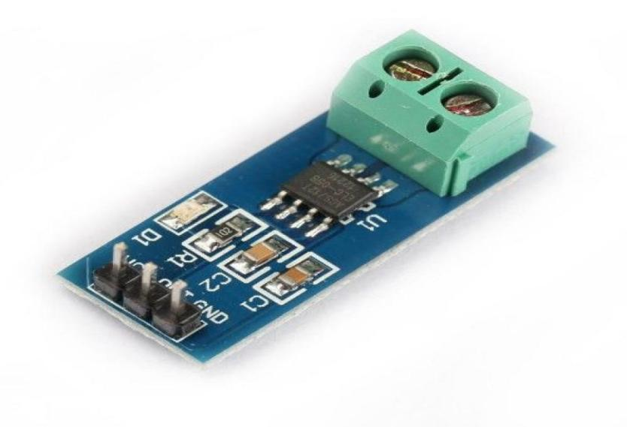
8. VOLTAGE SENSOR
A voltage sensor is a sensor that determines and keeps track of an object's voltage level. Voltage sensors can identify the level of either AC or DC voltage. Voltage serves as the sensor's input, and its outputs can be switches, analog voltage signals, current signals, or aural signals. Sensors are tools that can detect and respond to specific electrical or optical impulses. The use of current sensor and voltage sensor techniques has emerged as a fantastic replacement for traditional current and voltage measuring techniques. We may go into great detail about a voltage sensor in this article. The supply of voltage can be found out about, watched over, and measured by a voltage sensor. It is capable of measuring both AC and DC voltage levels. Voltage itself serves as the voltage sensor's input, and its outputs can be analog voltage signals, switches, auditory signals, analog current levels, frequencies, or even frequency-modulated outputs.
We are aware that a capacitor consists of two conductors (or two plates), with a non-conductor sandwiched in between. The term "dielectric" refers to the non-conducting substance. When an AC voltage is applied between these plates, current will begin to flow as a result of the opposite plate's voltage acting to either attract or repel electrons. Without any hardware connections, the field between the plates will construct an entire AC circuit. A capacitor functions in this manner. We can then talk about how the voltage is divided between two series-connected capacitors. In series circuits, the component with the high impedance typically experiences a high voltage development. Capacitance and impedance (capacitive reactance), in the case of capacitors, are always inversely proportional. To put it another way, some voltage sensors can output sine or pulse trains, while others can generate outputs with amplitude, pulse width, or frequency modulation. The measurement in voltage sensors is based on a voltage divider. Capacitive type voltage sensors and resistive type voltage sensors are the two primary types of voltage sensors available.
9. Internet of Things
The internet of things, or IoT, is a network of connected computing devices, mechanical and digital machines, objects, animals, or people who can exchange data over a network without interacting with other people or computers. The term "thing" refers to any natural or artificial object that can be given an Internet Protocol (IP) address and has the ability to transfer data over a network, including people with implanted heart monitors, farm animals with biochip transponders, cars with built-in tire pressure monitors, and other examples. Organizations across a range of industries are increasingly utilizing IoT to run more smoothly, better understand their consumers to provide better customer service, boost decision-making, and raise the value of the company.
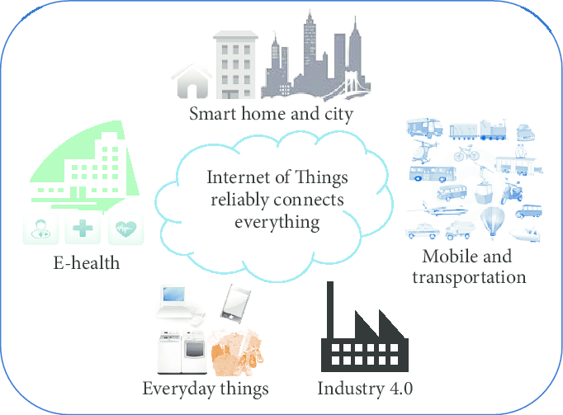
9.1 How IoT works?

The Internet of Things (IoT) ecosystem is made up of web-enabled smart devices that use embedded systems, such as processors, sensors, and communication gear, to gather, send, and act on the data they get from their surroundings. By connecting to an IoT gateway or other edge device, which either sends data to the cloud for analysis or analyzes it locally, IoT devices exchange the sensor data they collect. These gadgets converse with other similar devices on occasion, acting on the data they exchange. Although individuals can engage with the devices to set them up, give them instructions, or retrieve the data, the gadgets accomplish the majority of the job without their help. These web-enabled gadgets' connectivity, networking, and communication protocols mostly depend on the specific IoT applications deployed. IoT can also make use of artificial intelligence (AI) and machine learning to aid in making data collecting processes easier and more dynamic.

10. CONCLUSION
To guarantee that solar panel systems are operating at their best and producing the most energy, monitoring their performance is essential. Remotely monitoring and controlling solar panel systems is now easy and dependable thanks to Internet of Things technologies. The suggested solar panel monitoring system, which combines the Internet of Things, LCD display, changeable component, voltage sensor, current sensor, battery, and solar panel, may offer important information about energy generation, consumption, and storage. By using this technology, users are able to remotely check their solar panel systems' output of voltage and current as well as the battery's level of charge. Utilizing this information will help you save money and use energy more efficiently. The technology may also identify any flaws or problems with the solar panel installation, enabling quick maintenance and repairs. the proposed solar panel monitoring system using IoT offers an efficient and effective way to monitor solar panel systems, ensuring they are functioning optimally, and providing maximum energy output.
REFERENCES
- J. Singh, "Internet of things (IoT) enabled solar panel monitoring system," 2019 IEEE 9th International Conference on Power and Energy Systems (ICPES), Chennai, India, 2019, pp. 127-132.
- Alharbi, A. Almutairi, and A. Alabdulwahhab, "Design and implementation of a solar panel monitoring system using internet of things," 2020 1st International Conference on Renewable Energy and Energy Storage (CREES), Riyadh, Saudi Arabia, 2020, pp. 1-6.
- K. Khairnar and R. Kulkarni, "Solar panel monitoring system using IoT," 2018 3rd IEEE International Conference on Recent Trends in Electronics, Information & Communication Technology (RTEICT), Bangalore, India, 2018, pp. 1251-1254.
- Darwesh, M. Elshaer, and H. El-Bakry, "Design and implementation of solar panel monitoring system based on internet of things," 2020 IEEE 13th International Conference on Compatibility, Power Electronics and Power Engineering (CPE-POWERENG), Blagoevgrad, Bulgaria, 2020, pp. 1-5.
- S. Shah, M. Khanna, and R. Kumar, "Design and implementation of a solar panel monitoring system using IoT," 2019 IEEE International Conference on Computational Intelligence and Communication Networks (CICN), Durgapur, India, 2019, pp. 354-358.
- Gupta and A. Kumar, "Solar panel monitoring system using IoT," 2019 2nd International Conference on Intelligent Computing, Instrumentation and Control Technologies (ICICICT), Kannur, India, 2019, pp. 1350-1354.
- B. A. Akram, N. N. Ismail, and M. F. Abdollah, "Smart solar panel monitoring system using IoT," 2020 International Conference on Computer and Communication Engineering (ICCCE), Penang, Malaysia, 2020, pp. 107-112.
- S. S. Srinivasan and S. Sankaranarayanan, "Solar panel monitoring system using IoT and machine learning," 2018 IEEE International Conference on Advanced Networks and Telecommunications Systems (ANTS), Indore, India, 2018, pp. 1-4.
- J. A. Oon, N. Ismail, and M. F. Abdollah, "A review on solar panel monitoring systems using Internet of Things (IoT)," 2018 International Conference on Innovative Technology, Engineering and Sciences (iCITES), Bali, Indonesia, 2018, pp. 1-5.
- P. C. P. Abraham and P. John, "IoT based smart solar panel monitoring system," 2017 IEEE International Conference on Innovations in Green Energy and Healthcare Technologies (IGEHT), Coimbatore, India, 2017, pp. 1-5.

