A Brief Report On Analytical Chemistry And Technical Aspects of Thermal Analytical Methods
Dr.N.Padmaja
Assistant Professor, Department of Chemistry, Lal Bahadur College, Warangal, Telangana, India.

ABSTRACT:- This article is a brief report on the various processes, methods and importance of analytical chemistry. It explains about the multiple ways in which analytical chemistry plays a key role in our everyday life. The various methods and techniques available are described and detail explanation is provided for one of the most used Technique- Thermal analytical methods.
Keywords: Analytical chemistry, Thermal methods, Thermogram, TGA, DTA, DSC, TMA.

Introduction and about Analytical Chemistry
Analytical chemistry is a one of the important branches of chemistry can be considered as measurement science. Analytical Chemistry includes powerful ideas and methods which are useful in different fields of science and medical field.
An Analytical process is a constructive attempt of the analyst to determine the composition of different chemical substances and to understand the nature of chemical substances.
Analytical Chemistry provides vast information about methods and instruments used in different Analytical processes which separate, identify and quantify different chemical substances of Analytical sample.
Separation process separates different chemical substances, Qualitative analysis identifies the substances and Quntitative analysis determines the amount or concentration of different substances of the given analytical sample. Analytical Chemistry consists of classical, wet chemical methods and modern instrumental methods.

Analytical Process:-

Analytical process includes the following steps ¹.

Definition :- Defining the analytical problems that needs to be answered.
Sampling:- Obtaining a representative sample.
Method:- Choosing an appropriate analytical method.
Separation:- Separating the substance being analyzed (the analyte) from any interfering substance.
Quantitation:- Performing a quantitative measurement.
Evaluation:- Evaluating the results.

In Detail:-
Definition:- The reason for the analysis will educate the analyst to how the succeeding steps of the total
Analytical process to be taken and follow.
Sample:- Sample chosen for analysis will reflect the entire body from which it is collected.
And sampling is the basis for all other steps that follow in the total analysis process. If
it is not done carefully, the entire analysis will be invalidated.
Method:- The best method is the one most suited to the circumstances of analysis. While selecting
method, analyst have to consider accuracy, detection limit, selectivity, speed, cost and
legality.

Accuracy:- The analyte must assess the required level of accuracy and select the suitable method ,
which meet this requirement.
Detection limit:- Detection limit should be like that, the selected method must allow analyst to detect and
determine the desired constituent.
Selectivity :- The best selective method regarding selectivity is that, in the analysis of a sample only few
other substances of the sample should interfere, when they present at much higher
concentrations than that of the analyte.
Speed:- Speed of the method should give best in analysis result in various, different angels all
the times.
Cost:- An analyst always will try to complete analytical process with low cost but it is not possible
for all the times, an analyst to do analysis with low cost and to give best result.

The role of analytical chemistry/ Applications of Analytical chemistry ²:- Analytical chemistry plays a very significant role in multiple fields. Analytical chemistry is having applications in different fields like industries, medical field, pharmaceutical field, in all branches of the science and in our day to day life. To understand this, we consider a few outcomes and applications of analytical chemistry.
- The pathfinder mission is a spectacular example illustrating the application of analytical chemistry to practical problems. The pathfinder example demonstrates us, how qualitative information and quantitative information are crucial in an analyses.
- Everyday millions of body fluids are analyzed to diagnose to treat illnesses.
- Millions of food samples are analyzed everyday to give composition of the sample, concentrations of different chemical substances and presence of toxic substances.
- In steel industries while production, Analysis of steel gives adjustment in the concentrations of elements like Chromium, Nickle and Carbon to achieve desired hardness, corrosion resistance , strength and ductility.
- Analysis of the chemical composition of soil samples from moon and mars.
- Determination of nitrogen oxides, carbon dioxide, lead etc., present in the atmosphere, automobile exhausts and industrial exhausts.
- Measurement of the purity percentages and quality of all kinds of food products.
- Analysis of the composition, components and thermal behavior of drugs.
- Determination of the composition and thermal stabilities of explosives.
- In agriculture, fertilizer composition and amounts of different components are determined using analytical chemistry. This will help in its usage for best yield of crops.
- Body fluids of sports person and Olympic athletes are analyzed to monitor their health status.
- Determination of structure and properties of new molecules and new compounds.
- Analytical chemistry provides limit values for environmental pollution.
- Environmental and Pollution boards function by the information obtained through analysis of samples.

- Air in different living places is analysed and its quality information is given to people.
- Drinking water samples are analysed and quality information is provided to concerned authorities.
- Food ingredients, edibles and beverages are analysed and quality information is furnished to concern bodies. Example – Baby foods and packet foods were analysed to determine if they are edible.
The inter-disciplinary nature of chemical analysis makes it a vital tool in medical, industrial, government and academic laboratories through out the world.
Chemistry is known as central science and its centre position is occupied by Analytical Chemistry due to its key role in multiple fields .

Thermal Methods of Analysis
Introduction:
Thermal methods of analysis or thermoanalytical techniques may be defined as experimental methods for characterizing an element / compound or mixture by measuring changes in physic-chemical property at elevated temperature as a function of increasing temperature.
These techniques provide information regarding physical and chemical phenomenon associated with chemical substances. Some of these phenomenon that could be studied are adsorption crystalline transition and solid state reactions etc.,.
Modern thermal analysis instrument measures temperatures of transitions, weight losses, energies of transitions, dimensional changes, modulus, and viscoelastic propertiesin Analytical sample while thermal process is taking place. Thermal Analytical method may involve heating or cooling at a fixed rate of temperature change or holding the temperature constant at different time span. The graphical results obtained are called Thermo gram/Curve.
These methods are generally applied to solids, gels and liquids to characterize them. Present thermal analytical applications include environmental studies, product reliability, compositional analysis, stability, chemical reactions and dynamic properties of Analytical samples.

Thermal analytical Techniques:-
In these techniques basic components used in instrumentation are sensor, a controlled temperature programmed furnace and a recording devise which is either X-Y recorder or a micro computer.

According to measuring property the below are few Thermal Analytical Methods
Symbol | Name of Method | Property Measured
TGA | Thermogravimetry Analysis | Mass
DTG | Derivative Thermogravimetry | First derivative
DTA | Differential Thermal Analysis | Differential temperature
DSC | Differential Scanning Calorimetry | Enthalpy
TMA | Thermomechanical Analysis | Mechanical properties
DMA | Dynamic Mechanical Analysis | Visco-elastic properties
EGA | Evolved Gas Analysis | Identify and amount of gas/gases evolved
TL | Thermoluminescence | Light emission

Brief discripition of TG, DTA, DSC and TMA:-
Thermogravimetric analysis(TGA):- In this method a substance is heated from lower temperature to higher temperature at a fixed rate of heating. The changes in weight the sample undergoes as it is heated to higher temperature are recorded as a function of increasing temperature.
The graphical representation of weight changes the substances undergoes against temperature is called Thermogram.
The analysis of a thermogram gives us information about behavior of the substance while heating.
Thermogram

Horizontal portions : Stands for no weight loss.
Vertical portions : Stands for weight loss.

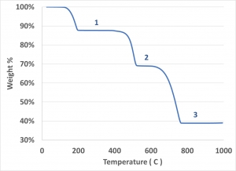

Instrumentation: - The basic components in TGA are:---
- Precision balance to make recordings of weight changes associated with a substance as it is heated.
- Furnace assembly used to heat the sample from lower temperature to higher temperature.
- Recorder – which records the weight changes and the increasing temperature.
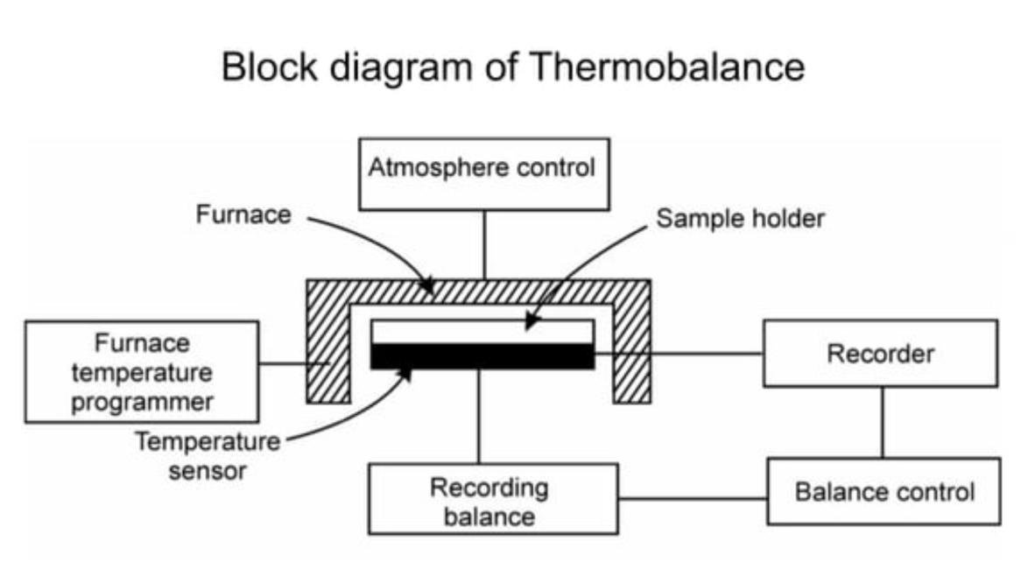

Few applications of TGA³:-
- TGA is helpful in determining the purity and thermal stability of both primary and second standard Analytical samples.
- TGA gives information about drying temperatures and the stability of different, various weighing forms for gravimetric analysis.
- Alloys and mixtures composition is determined.
DTA:- In differential thermal analysis ( DTA) a sample which is to be studied is heated along with a reference compound. Usually, the temperature program involves heating the sample and reference material in such a way that, the temperature of the sample increases linearly with the time.
A reference compound is one which is thermally stable, and simply gets heated without undergoing any change in the temperature range in which the sample is to be studied. Commonly used reference compounds are alumina, quartz etc.,
In the analysis, the temperature of a sample and a thermally inert reference material are measured as a function of furnace temperature. Any transition are change which the sample undergoes will result in liberation or absorption of heat or energy by the sample with a corresponding deviation of its temperature from that of the reference, as both the sample and reference are heated to elevated temperature. The differential temperature between the sample and reference is plotted against, programmed temperature (T). The resulting plot is called DTA curve. Analysis of the curve gives the information about the temperature of transition and whether the transition is exothermic or endothermic.
Instrumentation:- DTA equipment contains furnace sample block, temperature programmer, controller, preamplifier and a recorder. The sample block contains two identical and symmetrically located chambers. Temperature is increased in a linear rate. The differential temperature is measured continuously using a thermocouple and this ∆Т signal is amplified and is recorded. And to the furnace also, thermocouple connected to measure the temperature. And thermocouples is connected to the recorder.
While process, The difference in temperatures between sample and reference (S,R), thermocouple is continuously measured.
This differential signal is amplified by a high gain and low noise preamplifier and is recorded on the Y- axis of the recorder graph . The temperature of the furnace is measured by a separate thermocouple, which is connected to the X-axis of the recorder.

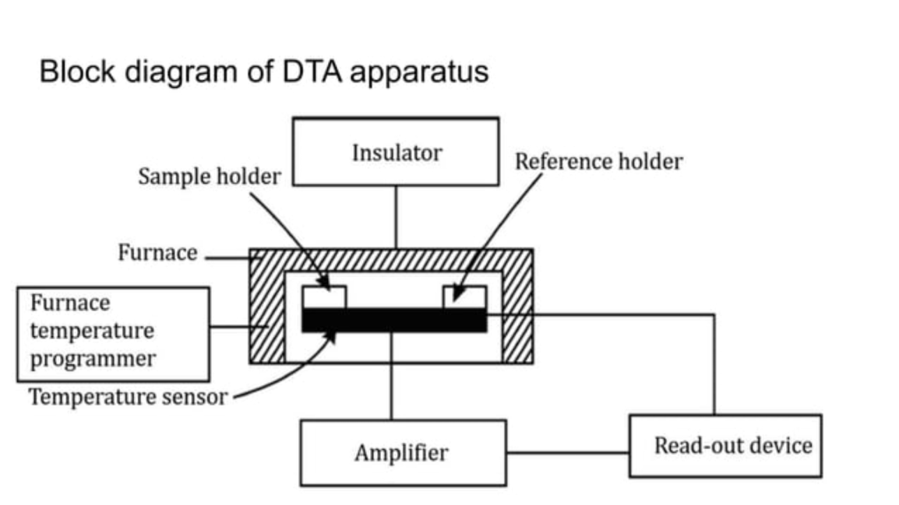

In differential thermal analysis, DTA curve consists of a series of endothermic and exothermic peaks corresponding to the heat changes associated with the samples.
*) Endothermic peak represents Physical change, whereas exothermic stands for chemical reactions those of an
oxidative in nature.
*) Physical changes (absorption of energy) includes vaporization, sublimation , absorption and
gives a downward peak.
*) Chemical reaction (liberation of energy) includes oxidization, polymerization, catalytic reactions
gives an upward peak.

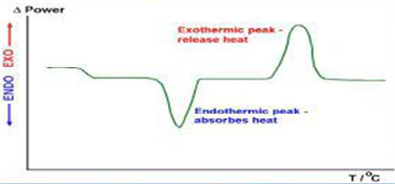

Few applications of DTA ³:-
- DTA is very useful in the qualitative analysis of different analytical samples.
- DTA technique is unique and rapid method for the fingerprinting of various polymeric materials, minerals and clays.
- DTA is very applicable to get the information regarding thermal stability of a wide number of inorganic compounds and metal complexes. The compounds include oxalates, carbonates, metal amine complexes etc.
- DTA largely applicable in the quality control of a number of substances like cement, glass, catalysts, resins and explosives etc.

Differential Scanning Calorimetry:- In this method the sample and reference are heated to elevated temperature. When the sample undergoes an endothermic reaction on heating, its temperature will be less than the reference temperature. Then a sensor will detect this and thermal energy is added to the sample, so that the differential temperature between the sample and reference is zero. And when the sample undergoes an exothermic reaction, temperature of the sample is higher than the reference temperature and now the excess thermal energy from the sample is drawn, so that the differential temperature is zero. Because this energy input is precisely equivalent in magnitude to the heat energy absorbed or evolved in the particular transition, a recording of this balancing energy yields a direct calorimetric measurement of the transition energy.
Thus in DSC, the energy required to establish a zero temperature difference between the sample and the reference is recorded as a function of temperature, when both are heated or cooled at a fixed rate.
Thus DSC curve provides the information about the total energy transferred to or from the analytical sample.

Instrumentation: DSC equipment contains furnace sample block, temperature programmer, controller, preamplifier and a recorder. The sample and reference materials are supplied with separate heaters and maintain at the same temperature. While heating, when sample undergoes any endothermic or exothermic reaction ( the energy absorbed by the sample or released by the sample) the energy is given or are removed from the sample thus maintaining same temperature for sample and reference.

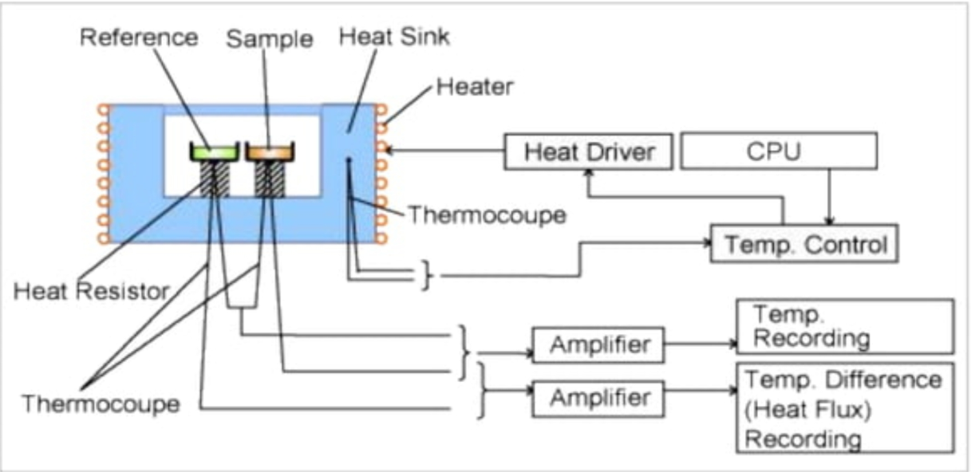

Block Diagram of DSC Apparatus

In differential Scanning calorimetry, DSC curve consists of a series of endothermic and exothermic peaks corresponding to the heat changes associated with the samples. Endothermic peaks stands for physical reactions and exothermic peaks stands for chemical reactions.
The heat capacity at any point is proportional to the displacement from the blank base line (∆T=0).

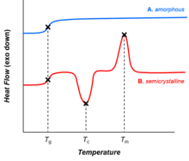

Few applications of DSC technique :-
- In Pharmaceutical chemistry – product purity identification of optical isomers, polymorphism and eutectic formation.
- In the food industry, edible fats and oils have been characterized by these methods.
- DTA is used for the high temperature studies of minerals, refractory materials and ceramics.
- DSC can be used to study the number and temperature range of polymorphs ³.

Thermomechanical Analysis⁴:--
Thermoimechanical Analysis (TMA) measures the dimensional and mechanical properties of the analytical sample like penetration, expansion, contraction and extension of sample materials as a function of temperature. Typical apparatus consists of a probe which is mechanically connected to the core of a linear variable differential transformer (LVDT). The core is coupled to the sample by means of a quartz probe having a thermocouple for measurement of sample temperature. Any movement of the sample is translated into a movement of the transformer core and results in an output that is proportional to the displacement of the probe, and whose sign is indicative of the direction of movement. The temperature range is from that of liquid nitrogen to 85⁰C.

Few applications of TMA technique :-
- TMA is useful in the study of dimensions of samples such as film and fiber while heating process⁵.
- TMA provides worthy information for characterization on the dimensional properties of a wide range of analytical samples⁶.

References:-
- John H. Kennedy University of California, Santa Barbara – Analytical Chemistry : Principles - Second Edition
- R- Skoog, Douglas A; West, Donald M; Holler, F. James, Crouch, Stanley R (2014). Fundamentals of Analytical Chemistry , Eight Edition.
- J Mendham, R C Denney, J D Barnes, M J K Thomas – Vogel’s Text book of Quantitative Chemical Analysis, Sixth Edition
- Willard, Merritt, Dean, Settle - Instrumental Methods of Analysis, Sixth Edition
- (http://www.hitachi-hightech.com>...)
- (Thermomechanical Analysis and Its Applications – ScienceDirect.com)

