POSSIBLE ERRORS AND CORRECTIVE ACTIONS FOR THE AUTOMATION SYSTEM

Govindarajulu Eedara¹, Varri Penushya², Kammari Bhargav², Gudepu Abhilash² and Darga Karthik²
govind305@gmail.com¹, varripenushya9573@gmail.com², 221LA21007@vignan.ac.in³, 221la21005@vignan.ac.in⁴, and 221LA21008@vignan.ac.in⁵
Assistant Professor¹, Student²
Vignan’s Foundation for Science Technology and Research

Abstract:
The possible errors that can affected to an automated CNC tool cell. A parts storage unit, and a load/unload robot. The errors are mainly divided into five types: machine and process, cutting tools, work holding fixture, part storage unit, and load/unload robot. For every type, we have provided list of possible errors and corrective actions is provided. This study also tells about the importance of regular testing and maintenance, including the use of sensors and devices such as tool wear sensors, part position sensors, and coolant systems, to monitor and enhance the performance of the automated cell containing CNC machine tools.
The first phase of this study involves a comprehensive analysis of potential sources of errors in the automation system. These errors encompass hardware malfunctions, software glitches, sensor inaccuracies, communication failures, and human-machine interaction challenges. By identifying these error sources, we establish a foundation for a proactive error management strategy. Once errors are detected, a structured approach to corrective actions is employed. This includes root cause analysis techniques to understand the underlying reasons for errors and their potential recurrence. Corrective actions range from simple adjustments and software updates to more complex hardware replacements or process reengineering, depending on the severity and impact of the error.
In conclusion enhance the system's performance and utilization by adopting a proactive approach to error management and implementing corrective actions, industries can significantly improve system reliability, maintain productivity, and reduce operational risks. Also can be by personnel training and documentation improvements are implemented to reduce human-related errors, as human-machine interaction is a critical aspect of automation system performance.

Keywords—Automated Cell, CNC machine tool, Robotics, Errors, Tool wear, Part position, Part Quality, Coolant System

Introduction
Automation systems have become the backbone of modern industries, driving efficiency, precision, and productivity to new heights. These systems, which encompass a wide range of applications from manufacturing to data analysis, have revolutionized how we produce goods, provide services, and manage complex processes. However, as our reliance on automation grows, so too does the need to address the potential for errors that can disrupt operations, compromise safety, and result in costly downtimes.
The deployment of automation systems, whether in industrial, commercial, or even residential settings, comes with the inherent risk of errors. These errors can stem from various sources, including hardware malfunctions, software bugs, sensor inaccuracies, communication failures, and even human factors in system operation and maintenance. While automation promises increased efficiency and reduced human error, it is not immune to its own set of challenges.
In this era of automation, it is imperative to not only recognize the immense benefits but also acknowledge and understand the possible errors that can arise within these systems. This understanding is fundamental for ensuring the seamless and safe operation of automated processes, especially in critical industries such as manufacturing, healthcare, transportation, and energy production.
This comprehensive exploration aims to delve into the realm of possible errors within automation systems, shedding light on their origins, impacts, and, most importantly, strategies for their detection, prevention, and mitigation. The ultimate objective is to establish a proactive and adaptive framework for managing errors in automation, enabling industries to harness the full potential of these systems while minimizing the risks associated with their operation.
In the subsequent sections, we will delve into the specific facets of possible errors in automation, ranging from technical malfunctions to human interaction challenges. We will also explore the implementation of real-time monitoring, predictive maintenance, and corrective actions as vital components of an effective error management strategy. Additionally, we will investigate the role of redundancy mechanisms, fail-safes, and human factors in enhancing the resilience of automation systems.
By confronting the challenges posed by possible errors head-on and by developing systematic approaches to address them, we aim to contribute to the ongoing evolution of automation technology. The insights presented herein are intended to guide industries and practitioners in their quest to harness the benefits of automation while navigating the intricate landscape of potential errors and their corrective actions.

case study
This chapter includes the importance of regular testing and maintenance of CNC Machine and Its Tool Parts, including the sensors and devices such as tool wear sensors, part position sensors, and coolant systems, and monitor and Improve the performance of the automated CNC Machine Tool cell. by implement these measures can improve the reliability and production of the system, and confirm the consistent production of high-quality parts [2].
Some of the list of Errors that will cause the Automated CNC Machine Cell. The errors divided into Five Types:
Machine and process Errors:
- Incorrect Programming.
- Improper setup of machine tools.
- Machine tool does not follow as the program input.
- Contaminants and Scattered Pieces In the machine tool.
- Damage to the Machine tools which will affect the pre-program.
- Electrical and Electronics Parts Failure.
- Improper Lubrication of machine tools.
- Software Problems of machine tools to.
Cutting Tool Errors:
- Error in Selection of Cutting Tool.
- Cutting Tools are not Sharpen Properly.
- Some Pre-Damages in cutting Tools.
Work Holding Fixtures Errors:
- No Proper Design of Work holding Fixtures.
- the work holding fixture not set properly.
- Damage in the work holding fixture.
- Improper lubrication of work holding fixture.
- Improper lubrication of work holding fixture.
Part Storage Unit Errors:
- No proper storage of parts.
- Damaged parts in the storage.
- Scattered Pieces and contamination in part storage unit.
- No proper maintains of humidity and temperature control in storage unit.
Load and unload robot errors:
- Incorrect programming of load and unload robot hand.
- The robot not setup properly to the Machine.
- Failure of load and unload robot due to Program error.
- Contaminants in the load and unload robot.
- Damage to the load and unload robot.
- Improper lubrication of the load and unload robot
- Electrical and electronics error in the load and unload robot
- Input programmable errors and Software errors.
The above are the List of possible errors that will occur in the five different categories. Now we will discuss about the corrective actions to be taken for the above five categories if any error occurred for the above mentioned errors [3].

Here are the list of Different Possible Corrective Action for the Errors.
Machine and process:
- Check and Re program the Lines of the machine tool.
- Adjust and Setup the Machine Tool Properly.
- Repair or change the machine tool.
- Clean the machine tool regularly.
- Lubricate the machine tool in Perfect Manner.
- Regularly Update the Program lines and input.
Cutting Tool:
- Select the Cutting Tools for the Operation.
- Lubricate and Sharp the Cutting Tool Properly.
- Replace the Damaged one with New one.
- Clean the Cutting tool.
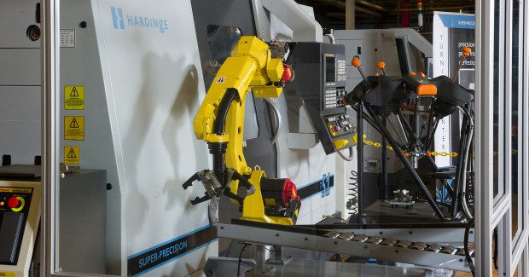
Fig 01: Shows about the Automated CNC Cell
Work Holding fixtures:
- Redesign and replace the work holding fixture with new one.
- Adjust the Work holding fixture according to the tool and the type of operation.
- Repair the work holding fixture according to the tool.
- Regularly clean the work holding fixture.
- Lubricate the work holding fixture.
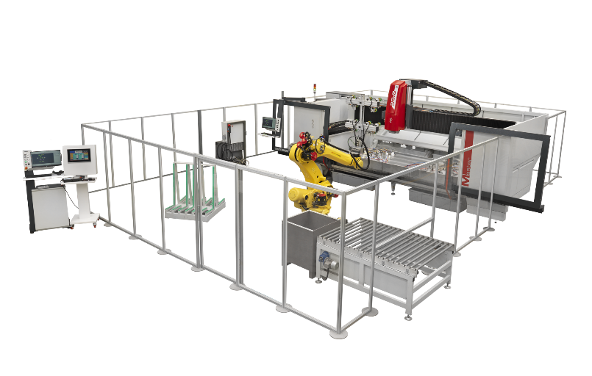
Fig 02: Shows about the Work holding and tool Processing.
Part storage unit:
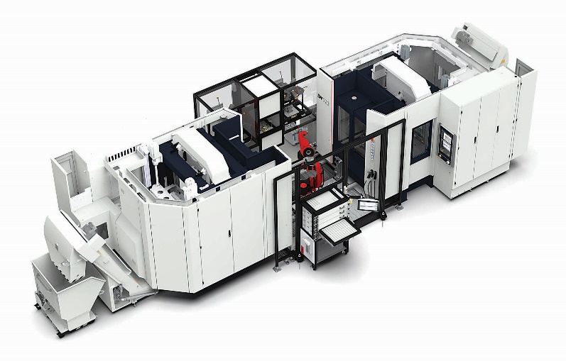
Fig 03: This image shows about the part storage unit.
- Store the parts in the correct order.
- Repair and remove the damaged parts.
- Clean the storage regularly.
- Control the Temperature and Humidity.
Load/Unload Robot:
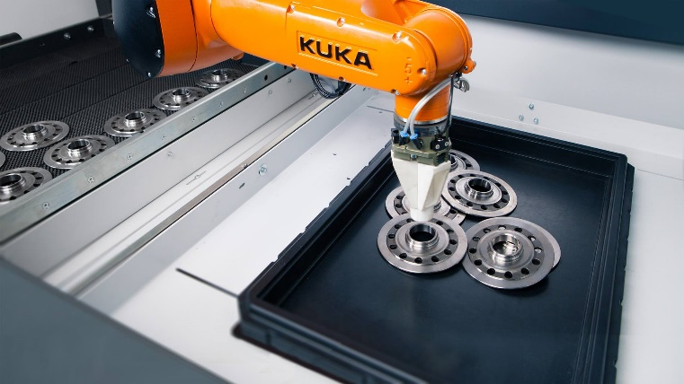
Fig 04: Picture of load and Unload Robot.
- Reprogram the Load and unload robot according to the setup.
- Adjust the Load and unload robot.
- Regularly Clean the Robot.
- Lubricate the Robot Every Required Tine.
- Update the Software Regularly

Testing and Maintenance
Regular testing and maintenance should be done for the cutting tools as much as possible to get the maximum output from the tool.so in this paper we are also going to tell about the parts and the sensors which are to maintained regularly that are used in the CNC Automated Machine Cell [5].

Tool wear sensor: These Sensors are the most common used sensors in the CNC Machine. These are used to find the wear of the Cutting tools. This shows the damaged tools before use. Which can lead to poor quality.
Tool Breakage Sensor: These sensors are used to detect the breakage of the cutting tools. This can help to prevent the spread of the metal fragments. These parts can damage to the machine parts and other parts.
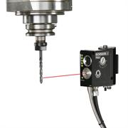
Fig 05: Tool Breakage sensors
Part Position Sensors: These Sensors are used to be shows the position of the parts in the automated cell. This sensor can be used to help to know that the part is correctly loaded or not? And find the damages during running.
Machine Condition Sensors: These Sensors are used to be check the condition of the sensor and the machine tool. By checking the condition, we can prevent the machine damages before. And helps to increase the production.
Coming to the Devices, there are number of devices that can be help to maintain the different parts and cutting tools in the automated cell:
Some of them are:
Tool Sharpening Machine:
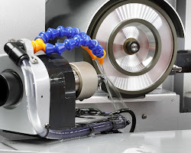
Fig 06: Tool Sharpening Machine in CNC
These Machines are used to be Sharpen the Cutting tools. Which can help to extend the life of the cutting tools [6].
Tool Pre-setting Machine:
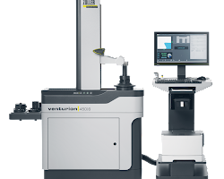
Fig 07: Tool Pre-setting Machine Graphic
These Machines are used to precisely Adjust the cutting tools. this will help in the alignment of Cutting tools properly.
Coolant Systems: These are the mainly used systems in the industries and other manufacturing companies to cool the cutting tools and the machine tools which are later causes the damages of parts [7].
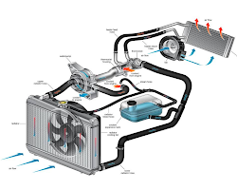
Fig 08: Coolant System
Lubricating Systems: These systems also mostly used systems. It can used to lubricate the Cutting tools and machine parts Which can reduce the Friction between the surfaces and extend the life of the cutting tools.
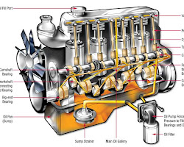
Fig 09: Shows the different parts of lubricant system

By using This Sensor and Devices Which can monitor the cell continuously of different parts and cutting tools in the machine we can achieve more Quality, Quantity and Production in the Automated CNC Machine Tool Cell [8].

Conclusion
These systems have become the backbone of modern manufacturing, driving productivity, reducing human error, and enabling the creation of intricate and high-quality products. However, as we've explored in this discussion on possible errors and corrective actions for CNC systems, even the most advanced technology is not immune to challenges. CNC systems, like any intricate machinery, can face a spectrum of errors that, if left unaddressed, have the potential to disrupt production, compromise the quality of components, and incur substantial costs. These errors may stem from various sources, including mechanical issues, software glitches, tool wear, or human factors such as programming errors and operator oversight.
Throughout this exploration, we've highlighted the importance of proactive error management as a crucial element in maintaining the reliability and effectiveness of CNC systems. By investing in predictive maintenance techniques, real-time monitoring, and data analysis, manufacturers can anticipate and mitigate errors before they cause production disruptions. Implementing redundancy mechanisms, such as backup tooling and machine backups, can further enhance the system's resilience. Moreover, operator training and clear documentation play a pivotal role in reducing human-related errors, ensuring that CNC systems operate at peak efficiency.
By continuously refining and optimizing CNC processes and embracing emerging technologies, manufacturers can not only mitigate errors but also drive innovation and maintain their competitive edge in today's dynamic industrial landscape.

References
- Wang, S.M., Liu, Y.L. and Kang, Y., 2002. An efficient error compensation system for CNC multi-axis machines. International Journal of Machine Tools and Manufacture, 42(11), pp.1235-1245.
- Wang, S.M., Liu, Y.L. and Kang, Y., 2002. An efficient error compensation system for CNC multi-axis machines. International Journal of Machine Tools and Manufacture, 42(11), pp.1235-1245.
- Mei, B., Wang, H. and Zhu, W., 2021. Pose and shape error control in automated machining of fastener holes for composite/metal wing-box assembly. Journal of Manufacturing Processes, 66, pp.101-114.
- Callegari, M., Amodio, D., Ceretti, E. and Giardini, C., 2006. Sheet incremental forming: advantages of robotised cells vs. CNC machines. In Industrial Robotics: Programming, Simulation and Applications. IntechOpen.
- Vichare, P., Nassehi, A., Kumar, S. and Newman, S.T., 2009. A Unified Manufacturing Resource Model for representing CNC machining systems. Robotics and Computer-Integrated Manufacturing, 25(6), pp.999-1007.
- Lyu, D., Liu, Q., Liu, H. and Zhao, W., 2020. Dynamic error of CNC machine tools: a state-of-the-art review. The International Journal of Advanced Manufacturing Technology, 106, pp.1869-1891.
- Zhu, S., Ding, G., Qin, S., Lei, J., Zhuang, L. and Yan, K., 2012. Integrated geometric error modeling, identification and compensation of CNC machine tools. International journal of machine tools and manufacture, 52(1), pp.24-29.
- Czwartosz, R. and Jedrzejewski, J., 2022. Application of machine learning in the precise and cost-effective self-compensation of the thermal errors of CNC machine tools–a review. Journal of Machine Engineering, 22(3).

