Experiential Study on the Impact of Digital Marketing on Consumer Buying Patterns

Kamatchi Iyer*, Rishabha**, Nilima Zade ***
* Universal AI University,Karjat, India
** Indian School of Management and Enterpreuship, Mumbai, India
***Symbiosis International University, Lavale,Pune, India

 |  | ABSTRACT
Keyword :  Experiential  Consumer Behaviour  Social media  Buying pattern  Digital mail |  | When it comes to digital marketing, which is used to advertise products and services, the internet has emerged as the most important channel. This is so that a tone of time, money, and other resources can be saved. The purpose of this study is to gain more knowledge about digital marketing consumer behavior in Maharashtra. To ascertain the significance, understanding, and content of the effectiveness of digital marketing among consumers, a thorough literature review was conducted. By using primary data (survey) and secondary data methodologies, it helps researchers figure out how to build a strong brand awareness of customer behavior.
Corresponding Author:
Email:kamatchi.iyer@universalai.in
__________________________

INTRODUCTION :

Marketing using digital platforms is an effective way to reach consumers in today’s world. The digital marketing helps to achieve the goal that is promotion and advertisement of companies and products through various digital media platforms. Companies can identify appropriate media channel to target consumers using social media marketing techniques. Since many decades mass media and advertise agencies have dominated the field of advertising. This will change as marketing technology advances, allowing businesses and brands more control over their content, brand recognition, and marketing. Influencer marketing, user-generated content, and compensated digital amplification of real material will all be used. More businesses will reclaim their marketing control from middlemen in the coming years. More advertising will be done in-house, directly to social and digital networks, using digital marketing automation technologies. The goal of this study is to determine consumer attitudes toward digital marketing as well as brand awareness.
In the year 1961, Ray Tomlinson founded electronic Direct, also known as Electronic Direct Mail (EDM). Direct mail and retention EDM come in two different varieties, including direct mail. In that it entails conveying a marketing message, direct mail is comparable to email. It could be a special offer announcement. While retention mail is a promotional email that is just meant to persuade the reader to take action (buy something or sign-up for something) ( Keith Garnet 2011). To reach a specific audience, such as clients or consumers, EDM, is a sort of direct marketing that makes use of electronic mail. And one strategy for direct email marketing (EDM) is the promotion of a good or service. EDM can be utilized to improve connections with both current and potential customers. The practice of sending advertisements or company information via email is known as e-mail marketing. This is a marketing plan to draw in new clients or keep existing ones committed to the business (Diyana Ahmed and Dr. Jasni Dolah 2018, Yeung, Julia 2013).
Background Study:
A web-based extension of conventional marketing tools and techniques is commonly referred to as digital marketing. Digital marketing has developed into a phenomenon that combines mass distribution and customization to accomplish marketing goals. User-centered, more quantifiable, omnipresent, and interactive are some of the characteristics of a new digital marketing paradigm that has been pushed by technological convergence and the proliferation of gadgets (Dr. Bharti Shukla, Mr. Himanshu Singh 2021). Online marketing can be done in a variety of ways such as banners, pop-ups and similar ads, e-mail advertising, newspaper and classified ads, search engine advertisement, advertising in chat rooms, blogs, and social networks. The most popular methods of advertising are banners and search engines, and mobile has gained popularity recently (Piñeiro-Otero, T., Martínez-Rolán, X. 2016).
The ability to create new forms of social engagement based on dynamic user exchanges through social media is tremendously beneficial. Social media is rapidly expanding in terms of the quantity, variety, and number of platforms and users. As a result, the new Web winners can be found in a huge digital marketplace, including audio-visual platforms like YouTube, Vimeo, and Sound Cloud. It also includes the image platforms like Flikr, Picasa, Pinterest, or Instagram and general social networking platforms like Facebook, Twitter, Google+, or niche ones like LinkedIn along with the news or bookmark aggregators like Digg or Delicious; blogs; and wikis, among others (Meenaghan, T.2001).
The majority of people don't actively seek for advertising unless they're memorable and shareable. To produce advertisements that pique the interest of the target audience, the marketing and creative teams work together. Sales and brand awareness will increase as a result of a successful commercial. Although advertisements are not what clients need, they are a great way for them to find out about the goods or services they do need. People create advertisements that are more effective and memorable by understanding how advertising affects consumer behavior (Bauer, Christine et al 2014).
A customer's familiarity with a company's goods or services can be described as their level of awareness. Considerations for brand awareness include human behaviour, advertising management, brand management, and strategy development. It is always debatable to understand the real reason behind the purchase whether it is the actual product or the services offered by the company. Outbound and inbound marketing strategies together are the best method to increase brand recognition. One of a company's most significant assets during times of intense industry competition is brand recognition. (Boon-Long, S., Wongsurawat, 2015), (Aveh Peighambari et al (2016).
Brand awareness has no impact on consumers. The primary objective of advertising is to let people know that the goods or services are easily accessible. Similar to how public learn about current events in the news, viewers of different advertisements learn about the products. At this point, customers move from being unaware of the company’s existence to becoming familiar with it in the case of a future purchase (Bauer, C., Lasinger, P. 2013).
Based on the literature review problem statement is formulated and presented as below. Maharashtrians are becoming more acquainted with the internet and are increasingly living in the digital world. As a result, agencies must embrace the future of digital marketing to have a better customer reach and product publicity. As advertising costs have increased, consumers have been overburdened by a large number of traditional advertisements (e.g., leaflets, brochures, etc.) that are difficult to pique their attention. It also has an impact on customer behavior when it comes to brand recognition. For example, customers currently spend a lot of time on the internet doing things like online shopping, product comparison, price comparison, enabling the product related notifications and so on, all of which contribute to online marketing rather than brand awareness. As a result, the higher degree of awareness is must to ensure the success of a product or service.
METHODOLOGY:

This study begins with extensive literature review to determine the challenges and gaps in customer behavior related to digital marketing. This research adopts the exploratory and descriptive research designs to analyze the multiple buying channels and its impact on consumer buying patterns. This research has considered the secondary data, wherein the necessary information has been taken from the current research reports, books, e-books, online papers, online journals. It has also been supported by a survey conducted based on a validated questionnaire. The study's limitations include the data concentration is geographically bounded. Because it considers the data only based on Maharashtra's working and studying consumers. This study can further be extended to the other segments too in future.

RESULTS AND DISCUSSION

This study has been conducted based on the survey taken on working class or the students of Maharashtra. The survey includes the personal background of the respondents and their experience with the digital marketing platform on multiple parameters in detail. The questionnaire is framed based on the understanding of various articles which includes the recent research reports, journals, online publications, and other sources.
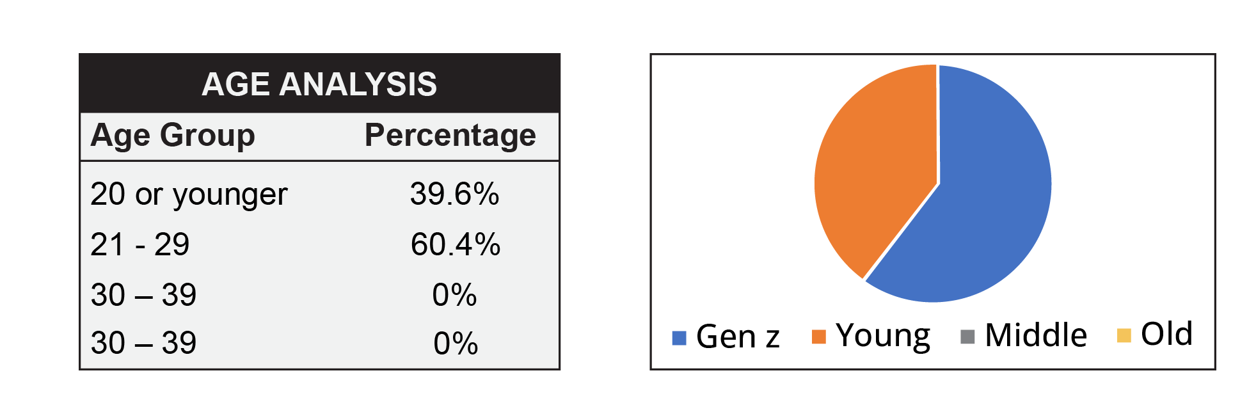

Figure 1. Age Anaysis of internet uses

The Figure 1. makes it abundantly evident that, out of all responses, the maximum group of 21-29 has the biggest percentage (60.4%), while the other distributions (21 or younger has only 39.6%, 30 to 39 has 0%, and 40 or older likewise has 0%). These poll results mostly demonstrate that the adult generation is the most active online. And this is to the benefit of both the marketer and the customer to meet their needs.

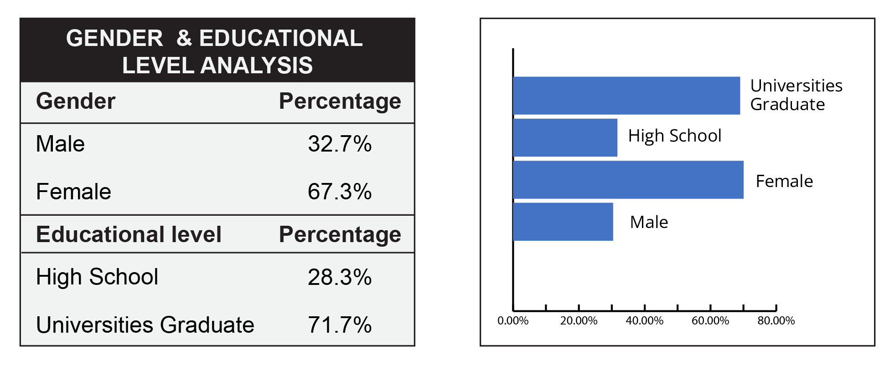
Figure 2. Gender and Educational level analysis

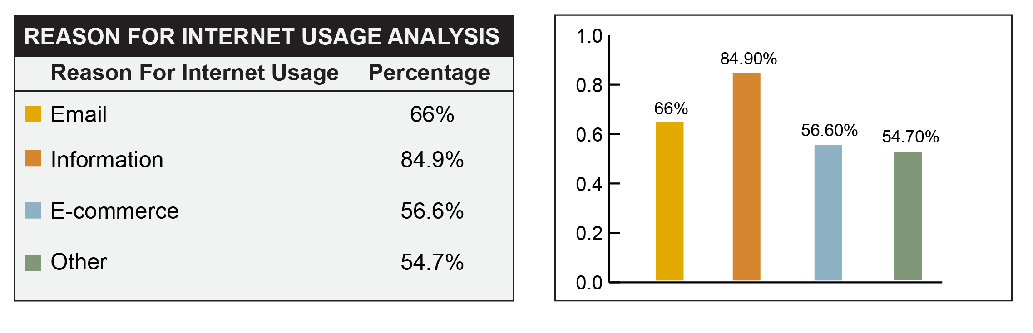
From the preceding Figure 2, it is clear that women made up 67.3% of respondents, while men made up only 32.7%. It demonstrates that most women prefer to talk on the phone more than men do. Knowing which educational level group spends the most time online is indicated in the above figure. 71.7% of the respondents who provided information are university graduates, compared to 28.3% of respondents who only completed high school.

Figure 3. Reason for internet usage analysis

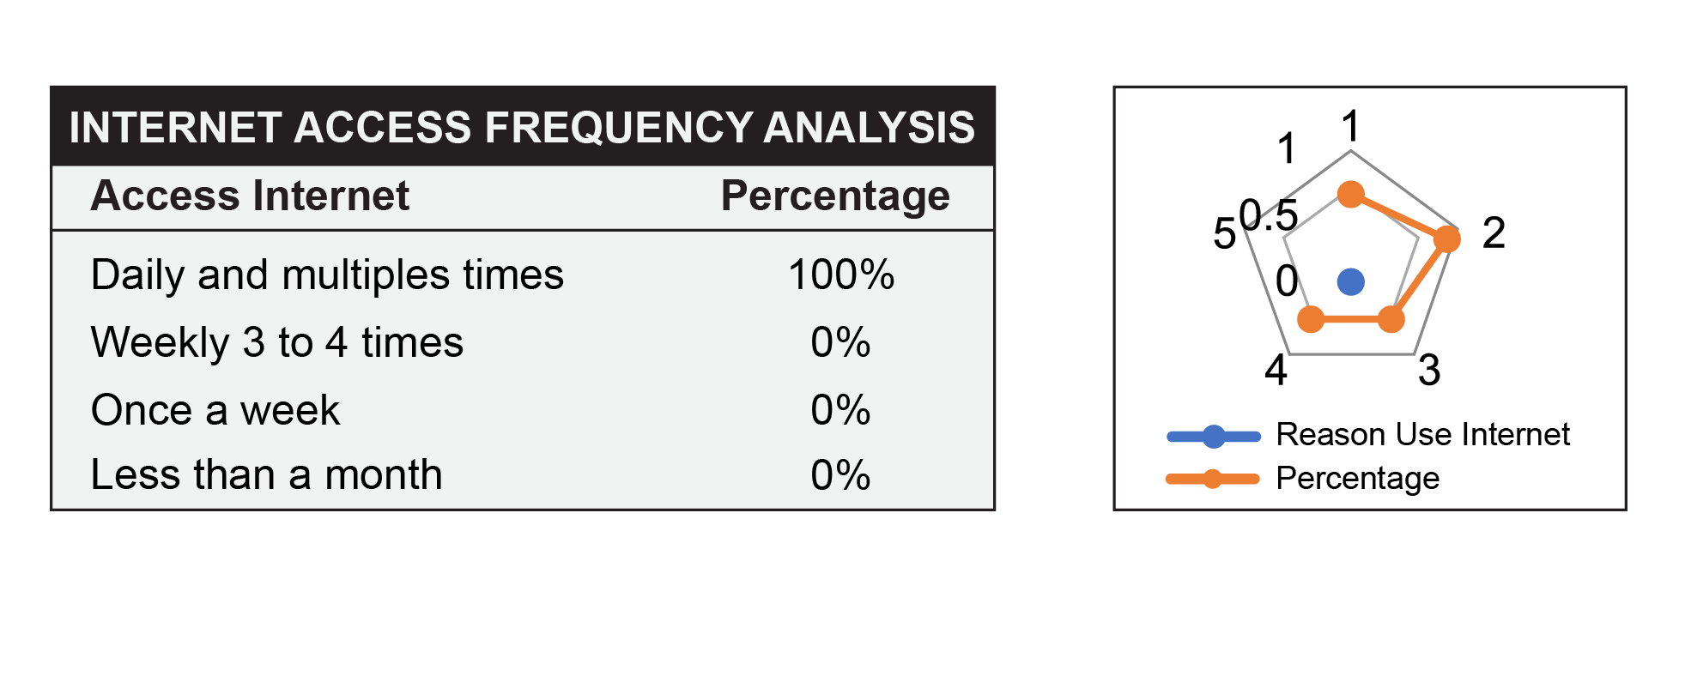
The Figure 3 below demonstrates that 100 percent of respondents frequently use the internet. This makes it easier to comprehend how consumers behave. We can learn more about respondents' online usage patterns from the Figure 3 above. 84.9% of the respondents use the internet to research topics. 54.7% of users use the internet for different purposes. Additionally, 56.6% of people use the internet for e-commerce, while 66% use it for email.

Figure 4. Internet access frequency analysis

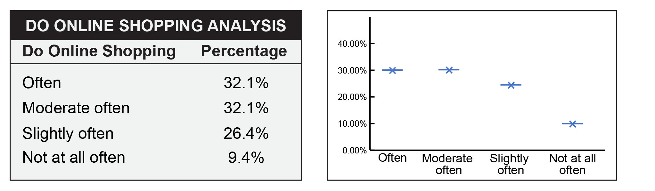
Figure 5. Online shopping analysis
The above Figure 5 shows, that 26.4% of them slightly often do online shopping due to not convenience to feel the actual product/services.

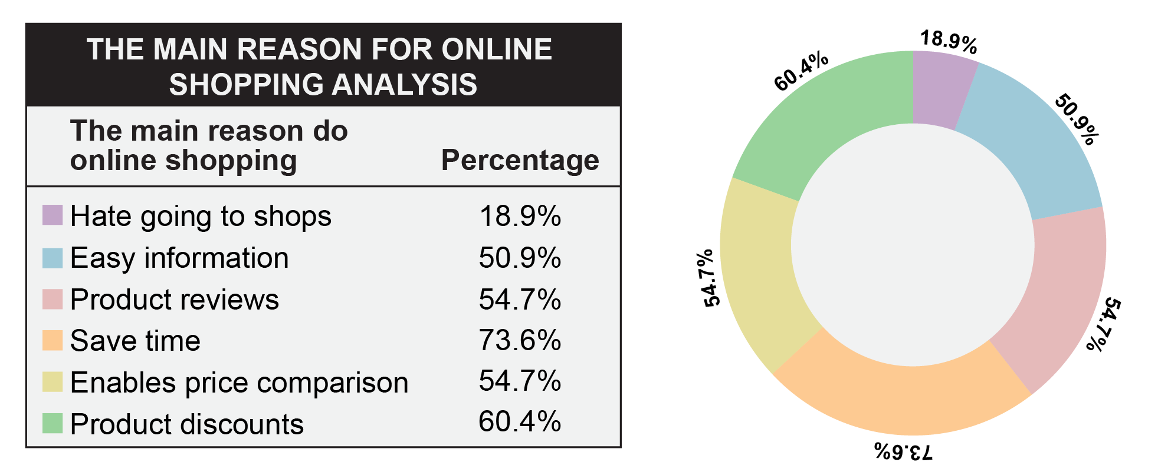
Figure 6. The main reason for online shopping
The aforementioned Figure 6 reveals that 73.6% of people purchase online primarily to save time, whereas 54.7% do so to read product reviews. While 50.9% of those surveyed prefer simple information when they shop online. Additionally, just 54.7% of feedback allows for price comparison, and only 60.4% believe that online purchases make it simple to receive product discounts.
Table 1. Analysis of the online purchares
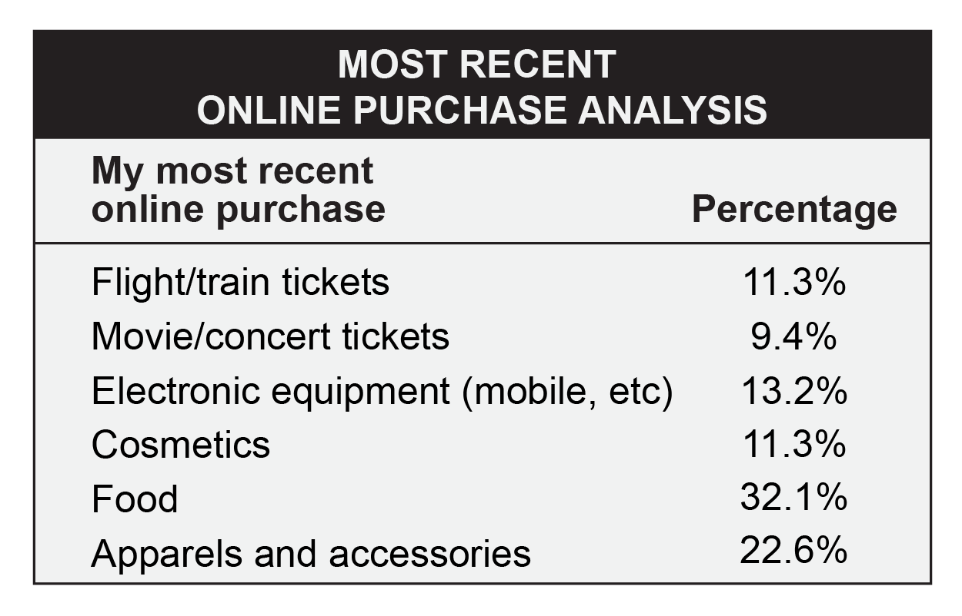
The above Table 1 shows, that 32.1% of recent online purchase was for food, and 22.6% for apparel and accessories. This is because it saves time from going to the shops. From the Figure 7, 47.2% of respondents trust internet advertisements. From the Table 2, 54.7% of respondents ignore online ads due to wasting time while waiting to be finished

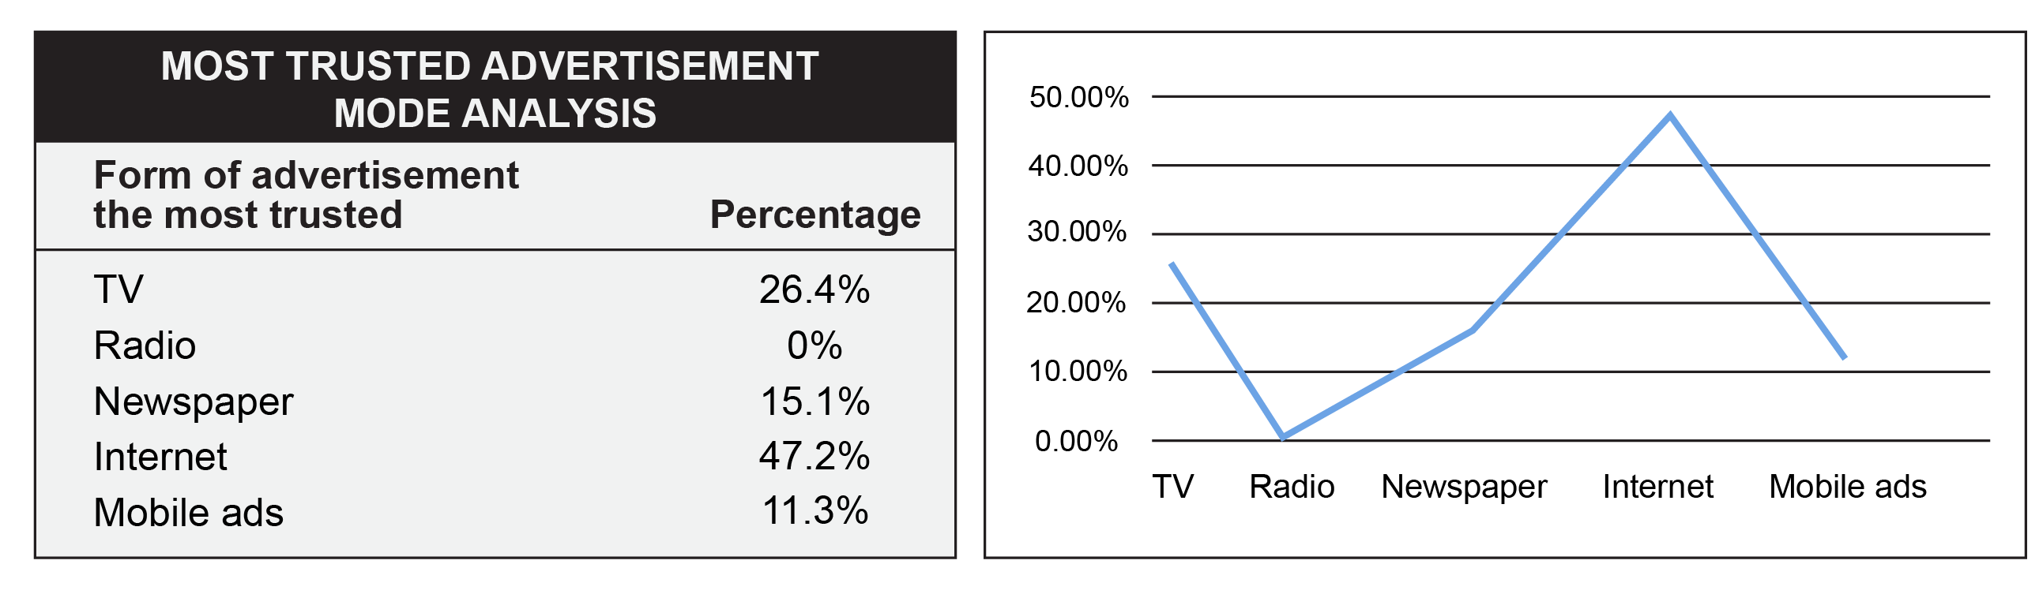
Figure 7. Most trusted advertisement analysis

Table 2. Analysis of the click on internet advertisements
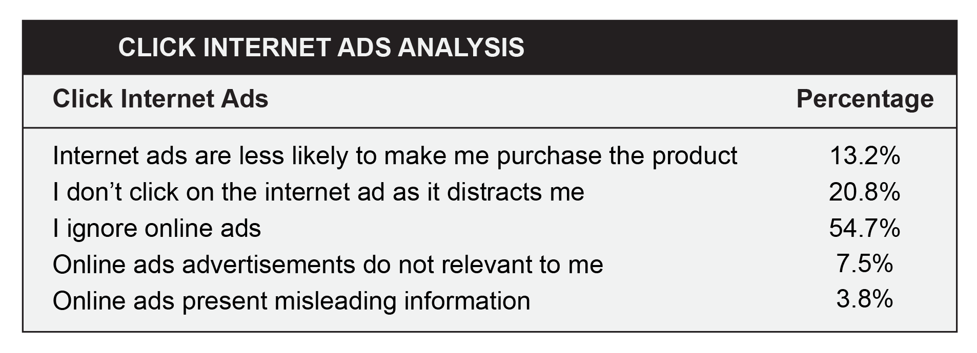

The results of the aforementioned survey show that various consumers have distinct demands and expectations when it comes to digital marketing. It emphasizes the dramatically rising use of online marketing and identifies improved visibility, usage, comfort, results, application of layout and design, and customer satisfaction levels in the current online business environment.

CONCLUSION
This study portrays a gap and an opportunity to investigate and increase the requirement for detecting customer behaviors toward digital marketing. The study will continue to provide respondents more ways to respond to the visual representations, as well as further surveys, interviews, and opportunities to access the digital marketing platform. As the intensity of smartphones usage grows daily, it benefits marketers, designers, and consumers by supporting them to meet their demands and requirements.

REFERENCES (12 pt)
- Keith Garnet (2011), The Business of Design: Balancing Creativity and Profitability, Presenton Architectual Press, New York, First Edition.
- Diyana Ahmed Ghazie, Dr. Jasni Dolah (2018) How digital marketing affects consumer behavior Conference Proceeding: 3rd International Conference On Creative Media, Design & Technology ©2018 IEEE
- Yeung, Julia (2013), Advertising and Consumer Spending in the Digital Age. Honors College Theses. Paper 121. http://digitalcommons.pace.edu/honorscollege_theses/121
- Dr. Bharti Shukla, Mr. Himanshu Singh(2021) , Impact of Social Media on Consumer Buying Behaviour, In book: Consumer behaviour in changing environment (pp.1-6), Publisher: S Sharda global research publications
- Piñeiro-Otero, T., Martínez-Rolán, X. (2016). Understanding Digital Marketing—Basics and Actions. In: Machado, C., Davim, J. (eds) MBA. Management and Industrial Engineering. Springer, Cham. https://doi.org/10.1007/978-3-319-28281-7_2
- Meenaghan, T.(2001), Sponsorship and Advertising: A Comparison of Consumer Perceptions, Psychology & Marketing © 2001 John Wiley & Sons, Inc. Vol. 18(2):191-215.
- Bauer, Christine & Lasinger, Peter (2014). Adaptation Strategies to Increase Advertisement Effectiveness in Digital Media. Management Review Quarterly, 64(2, April), Springer, pp 101-124. DOI: 10.1007/s11301-014-0101-0
- Boon-Long, S., Wongsurawat, W. (2015) Social media marketing evaluation using social network comments as an indicator for identifying consumer purchasing decision effectiveness. J Direct Data Digit Mark Pract 17, 130–149 (2015). https://doi.org/10.1057/dddmp.2015.51

- Kaveh Peighambari, Setayesh Sattari, Arash Kordestani , and Pejvak Oghaz (2016), Consumer Behavior Research: A Synthesis of the Recent Literature, SAGE Open April-June 2016: 1–9 © The Author(s) 2016 DOI: 10.1177/2158244016645638
- Bauer, C., Lasinger, P. (2013), Adaptation strategies to increase advertisement effectiveness in digital media, 2013.

