Transdermal drug delivery system
Pradyumn Tiwri *¹, Vinod Sahu, Shivang Sharma
ITM University Gwalior
Difinition-
Transdermal therapy systems are self-contained, self-discrete dose forms that distribute medication to the systemic circulation at a regulated pace when applied to undamaged skin. a simple patch that you apply to your skin like an adhesive bandage and uses passive medication diffusion over the skin as its delivery method.
History of Transdermal drug delivery system-
- The first transdermal patch was authorized in 1981 to stop motion sickness-related nausea and vomiting.
- Up until 2003, the FDA has authorized more than 13 molecules' worth of transdermal patch products.
- In 2001, the US transdermal market was close to $1.2 billion.
- Two new, recently approved transdermal patch products (a contraceptive patch containing ethinyl estradiol and nor-elgestromin, and an overactive bladder patch containing oxybutynin). It was based on 11 drug molecules: fentanyl, nitroglycerin, estradiol, ethinylestradiol, nor-ethindroneacetate, testosterone, clonidine, nicotine, lidoca.
- More than 30 years ago, transdermal medication delivery systems were initially launched.
- In the 1980s and 1990s, the technique attracted a lot of attention from top pharmaceutical corporations.
- Since the FDA's initial approval of the first transdermal patch in 1981 to treat motion sickness, which causes nausea and vomiting, more than 35 transdermal patch treatments covering 13 compounds have received FDA approval.
- The NDDS may require producing a patch form in place of injections or switching from a three times day dosage to a once daily dosage.
- Over the past 20 years, the transdermal patch has established itself as a technology that has a number of important therapeutic advantages over alternative dosing modalities.
- Transdermal medication administration permits a constant blood-level profile and regulated drug release, which reduces systemic adverse effects and, in certain cases, improves effectiveness as compared to conventional dose forms.
Introduction-
Transdermal drug delivery systems are topically applied medications in the form of patches that release medications for systemic effects at a set and regulated rate. An alternate method of medicine administration is offered by a transdermal drug delivery device, which can have either an active or passive design. Pharmaceuticals may now be given across the skin barrier thanks to these devices. Transdermal patches operate quite simple in principle. A medication is injected within a patch that is worn on the skin for a prolonged length of time at a reasonably high dosage. The medicine directly enters the bloodstream through the skin through a diffusion mechanism. Given that the medication is present in low concentration in the blood and high concentration on the patch, the drug will continue to diffuse into the blood for a considerable amount of time, keeping a consistent concentration in the blood flow.
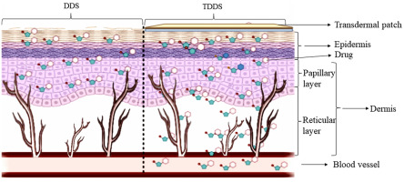
Anatomy of the Skin-
The biggest organ in the body is the skin. The epidermis, dermis, and subcutaneous layer are its three primary layers.
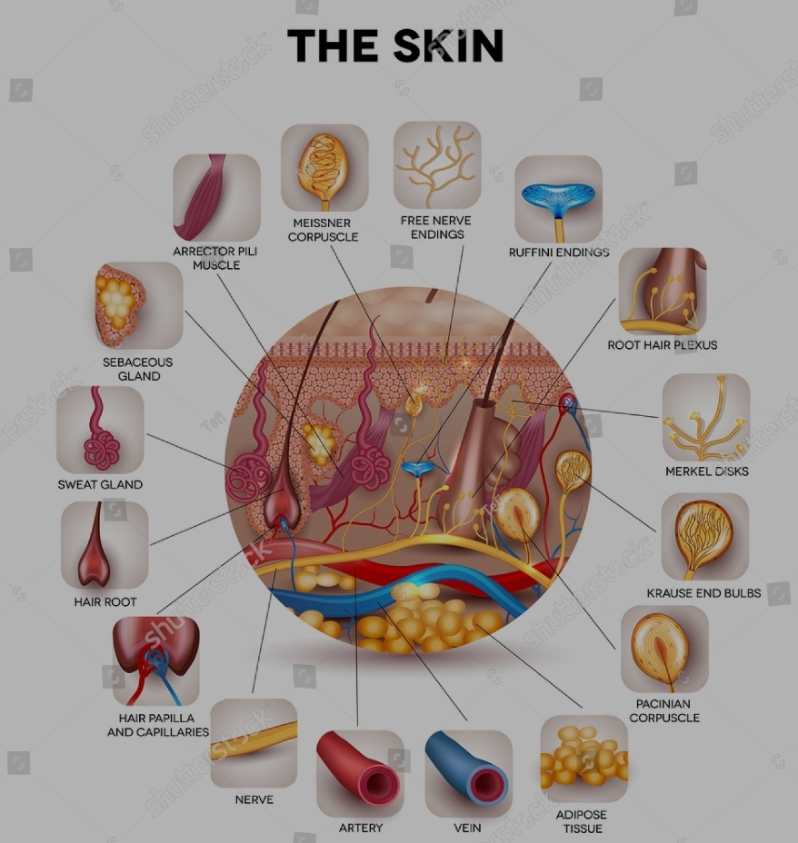

Facts about the skin
The biggest organ in the body is the skin. It envelops the whole body. It acts as a barrier to keep out heat, light, harm, and illness. Moreover, the skin
- Regulates body temperature
- Stores water and fat
- Is a sensory organ
- Prevents water loss
- Prevents entry of bacteria
- Acts as a barrier between the organism and its environment
- Helps to make vitamin D when exposed to the sun
All across your body, your skin assumes various thicknesses, hues, and textures. For instance, your head has the most hair follicles of any other place. However, your feet's soles are devoid of them. In addition, the skin on the palms of your hands and the soles of your feet is significantly thicker than the skin on other parts of your body.
The skin is made up of 3 layers. Each layer has certain functions:
- Epidermis
- Dermis
- Subcutaneous fat layer (hypodermis)
Epidermis-
The epidermis is the thin outer layer of the skin. It consists of 3 types of cells:
- Squamous cells. The outermost layer is continuously shed is called the stratum corneum.
- Basal cells. Basal cells are found just under the squamous cells, at the base of the epidermis.
- Melanocytes. Melanocytes are also found at the base of the epidermis and make melanin. This gives the skin its color.
Dermis-
The dermis is the middle layer of the skin. The dermis contains the following:
- Blood vessels
- Lymph vessels
- Hair follicles
- Sweat glands
- Collagen bundles
- Fibroblasts
- Nerves
- Sebaceous glands
The dermis is held together by a protein called collagen. This layer gives skin flexibility and strength. The dermis also contains pain and touch receptors.
Subcutaneous fat layer (hypodermis)-
The subcutaneous fat layer is the deepest layer of skin. It consists of a network of collagen and fat cells. It helps conserve the body's heat and protects the body from injury by acting as a shock absorber.
Advantages-
- Avoids first pass hepatic metabolism.
- Maintains constant blood levels for longer period of time.
- Decrease the dose of administration.
- Decreases unwanted / side effects.
- Decreases gastro-intestinal side effects.
- Easy to discontinue in case of toxic effects.
- Increased patient compliance.
- Great advantage for patients who are unconscious.
- Provides an ability to modify the properties of biological barriers to improve absorption.
- Relatively large area of application in comparison to buccal / nasal cavity.
Disadvantages-
- Drug must have some desirable physico-chemical properties to penetrate through stratum conium.
- Drugs for daily dose less than 5 mg/day are preferred, if drug dose is more than 10-25 mg/day the TDD will be difficult.
- Local irritation at the site of administration may be caused by drug, adhesive / other excipients in patch.
- Clinical need must be clearly established.
- The barrier function of skin changes form one site to another, from person to person and with age.
- Poor skin permeability limits the number of drug that can be delivered in this route.
- TDD can’t deliver ionic drug.
- TDD can’t achieve high drug levels in Blood / plasma.
- Drugs of large molecular size can’t be formulated as TDD.
- TDD can’t deliver the drugs in pulsatile fashion.
Comparison of three diferent routes of drug administration: oral, intravenous injection and transdermal-
An important tactic used to increase the bioavailability of active pharmaceutical ingredients (APIs) is innovation in drug delivery methods. Due to benefits such a range of dose forms, painless administration, simplicity, self-administration, high safety, and patient compliance, oral delivery systems continue to be the preferred technique for administering API. Despite these benefits, oral administration methods are prone to first pass metabolism and have low drug stability in the gastrointestinal tract. For instance, drugs may degrade as a result of an enzymatic interaction or exposure to the stomach's acidic environment. Additionally, inadequate bioavailability of medications may result from problems with their solubility in the intestinal lining and their permeability across the intestinal membrane, which might function as rate-limiting processes in drug absorption. These shortcomings are frequently seen in the administration of medications made of peptides or proteins. Consequently, intravenous (IV) injection is seen as one of the most promising methods for delivering proteinaceous medications due to its capacity to achieve up to 100% bioavailability, precise dose, and avoidance of hepatic metabolism. It is not surprise, therefore, that the IV route for administration has certain potential drawbacks. For instance, it is an intrusive delivery technique that causes discomfort, has low patient compliance, and requires significant expenses to dispose of sharps waste. The transdermal route has been investigated as an additional possible method for improving the administration of peptide medicines with the goal of perhaps addressing some of these drawbacks. The skin serves as the medication administration location in transdermal drug delivery systems. Through blood arteries in the skin, the medication is absorbed into the systemic circulation and subsequently circulates throughout the body. Patients can benefit from transdermal drug delivery systems because they are less intrusive (some techniques are completely noninvasive), avoid first-pass metabolism, are simple to apply and administer, don't require specialized staff, and may be used less frequently. This method has also been utilized to administer a variety of medications, including both hydrophilic and hydrophobic substances. Pharmaceutical researchers are now interested in developing and investigating transdermal drug delivery methods, particularly in terms of altering or breaking the stratum corneum to improve drug absorption through the skin.
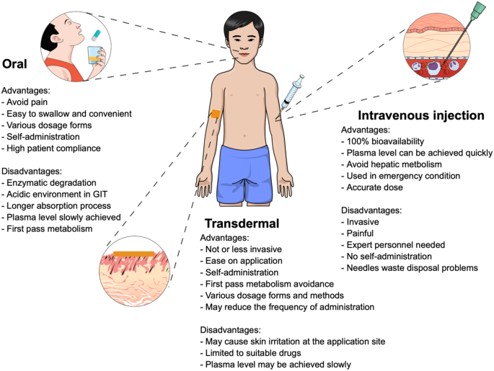

Drug absorption via the skin-
Due to its extensive surface area, the skin is a possible location for drug absorption. Drug-containing dosage forms will release their contents into the skin after being applied to it. The first barrier that must be overcome, the SC, makes the absorption of drugs via the skin exceedingly difficult. The SC is made up structurally of degenerated keratinocytes, which along with the ceramide lipid component create a dense arrangement described as a "brick-and-mortar" configuration. Keratin, an acidic or basic to neutral protein produced by keratinocytes, serves as the SC's "brick," whilst lipids serve as its "mortar." Glycoprotein desmosomes, sometimes referred to as corneodesmosomes, link the keratinocytes to one another. Drugs that are delivered must first penetrate the skin through this molecular architecture in order to be absorbed into the bloodstream. Transepidermal and transappendageal routes may generally be separated between medication absorption from the epidermis via the SC. Transepidermal is the first pathway and the primary absorption route. The transdermal patch's medication can diffuse over the skin's surface and penetrate cells or the gaps between cells thanks to the vast surface area of the SC. Transcellular and intercellular paths can be used to further separate the transepidermal route. Drugs diffuse into SC cells during the absorption process while taking the transcellular route. As a result, since membranes are made of lipid bilayers, medications must cross them. Because of the hydrophobic characteristics of the lipid complex in the cell membranes of the SC, this pathway is mostly used by hydrophobic medicines. The second pathway, known as the intercellular one, requires the medicines to diffuse across the lipid matrix of the SC's intercellular space where keratinocytes are present before reaching the SC. This pathway enables the delivery of hydrophilic substances or tiny molecules to dermal vascular capillaries. The intercellular pathway is the most common way that drugs are absorbed, and it mostly depends on the drug's molecule having the right amounts of lipid and water solubility.
Transappendageal drug delivery through skin sweat glands or hair follicles is the second route by which drugs can enter the body through the skin and be absorbed. This pathway is required for the transportation of polar or ionisable substances and is helpful for the transportation of big macromolecules that have difficulty passing through epidermal cells due to their size and various partitioning characteristics. Although this method has a lower absorption area (0.1% of the total skin surface) than the transepidermal route, its use is still relatively constrained. As a result, scientists have created techniques to improve medication absorption through the skin by changing the SC's structure chemically, physically, or by combining both of these techniques. The development of transdermal products and a number of methods for improving medication absorption via the skin are covered in the sections that follow.
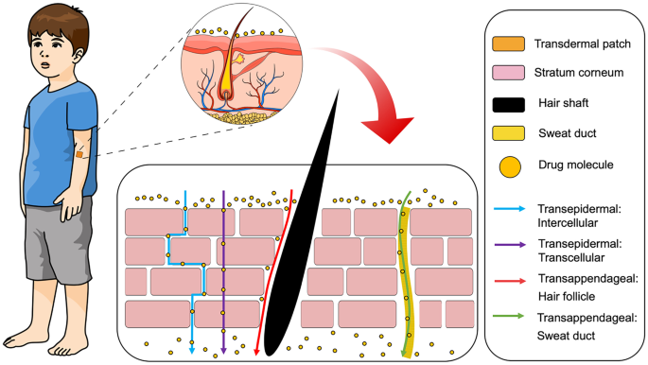
Classifications of TDDS-
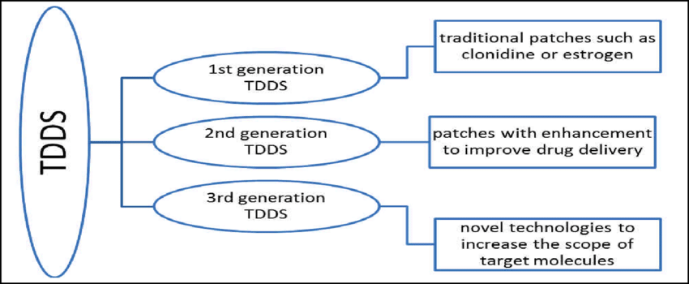
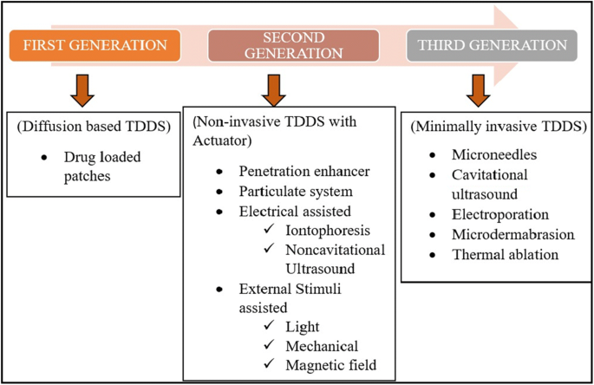

Basic Components of TDDS-
A typical Transdermal drug delivery system consists of the following components.
- Polymer Matrix.
- Drugs.
- Permeation Enhancers.
- Pressure sensitive adhesives (PSA).
- Backings Laminates.
- Release Liner.
- Other Excipients.
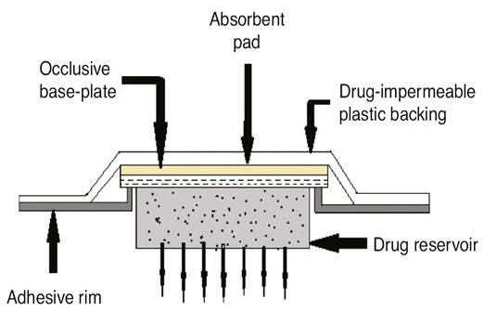

- Olymer Matrix:
- The Polymer controls the release of the drug from the device.
- Possible useful polymers for transdermal devices are:
- a. Natural Polymers:
  - cellulose derivatives,
  - Zein,
  - Gelatin,
  - Shellac,
  - Waxes,
  - Proteins,
- Gums and their derivatives,
  - Natural rubber,
  - Starch etc.
- b. Synthetic Elastomers:
  - polybutadiene,
  - Hydrin rubber,
  - Polysiloxane,
  - Silicone rubber,
  - Nitrile,
  - Acrylonitrile,
  - Butyl rubber,
  - Styrene Butadiene rubber,
  - Neoprene etc.
- c. Synthetic Polymers:
  - polyvinyl alcohol,
  - Polyvinyl chloride,
  - Polyethylene,
  - Polypropylene,
  - Polyacrylate,
  - Polyamide,
  - Polyurea,
  - Polyvinyl pyrrolidone,
  - Polymethyl methacrylate,
  - Epoxy etc.
- Drugs:
- Desirable properties of a drug for transdermal delivery.
- The drug should have a molecular weight of less than 1000 Daltons.
- The drug should have affinity for both lipophilic and hydrophilic phases.
- Extreme partitioning characteristics are not useful for successful drug delivery via the skin.
- The drug should have a low melting point.
- Drug should be potent, have a short half-life and be non-irritating.

- Permeation Enhancers:
- These are compounds that promote skin permeability by altering the skin as a barrier to the flux of a desired penetrant.
- Penetration enhancers are added to a formulation to improve the diffusivity and solubility of drugs through the skin, thereby reducing the skin's barrier resistance.
- These includes water, pyrrolidones, fatty acids and alcohols, alcohol and glycols, essential oils, terpenes and derivatives, sulfoxides like DMSO and their derivatives, urea and surfactant.
- Pressure sensitive adhesives (PSA):
- The fastening of all transdermal devices to the skin can be done by using a PSA.
- The first approach involves the development of new polymers, which include hydrogel hydrophilic polymers, and polyurethanes.
- The second approach is to physically or chemically modify the chemistries of the PSAs in current use (such as silicones, and acrylates).
- Physical modification refers to the formulation of the base adhesives with some unique additives so that there is enhanced drug delivery and improved skin-adhesion properties.
- Chemical modification involves chemically incorporating or grafting functional monomers to the conventional PSA polymers in order to improve drug delivery rates
- Backings Laminates:
- Backings laminates are selected for appearance, flexibility and need for occlusion.
- Examples of backings are polyester film, polyethylene film and polyolefin film, and aluminium vapour coated layer.
- Major areas of concern are the backing additives leaching out and diffusion of drugs or the compositions, through the backing.
- An over emphasis on the chemical resistance often may lead to stiffness and high occlusivity to moisture vapour and air.
- It causes the TDDS to lift and may possibly irritate the skin during long-term use.
- Release Liner:
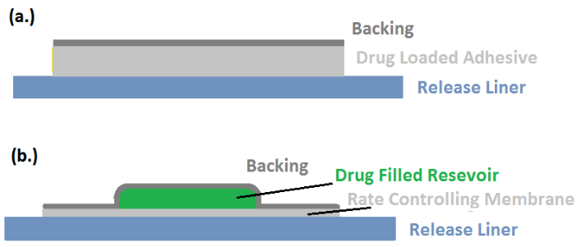
- During storage, the patch is protected by a liner, which is removed and discarded before the patch is applied to the skin.
- Since the liner is in direct contact with the TDDS, the liner must be chemically inert.
- The release liner is composed of a base layer which may be non-occlusive (e.g. paper fabric) or occlusive (e.g. polyethylene, polyvinyl chloride) and a release coating layer made up of silicon or Teflon.
- Other materials used for TDDS liners include, polyester foil and metalized laminate that protects the patch during storage.
- The liner is removed prior to use only.
- Other Excipients:
- Various solvents such as chloroform, methanol, acetone, isopropanol and dichloromethane are used to prepare drug reservoirs.
- In addition, plasticizers such as dibutyl-phthalate, triethyl citrate, polyethylene glycol and propylene glycol are added to provide plasticity to the transdermal patch.

Formulation Approaches of TDDS
TDDS can be formulated by different ways as follows,
  - Polymer membrane permeation controlled TDDS.
  - Polymer matrix diffusion controlled TDDS.
  - Adhesive Dispersion – Type Systems.
  - Microreservoir dissolution controlled TDDS.
- Polymer membrane permeation controlled TDDS:
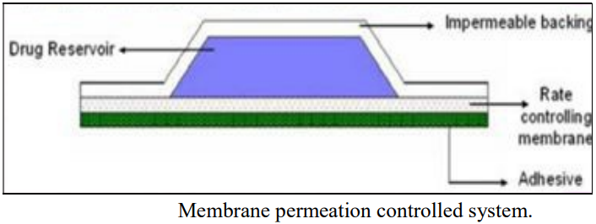
- A polymeric membrane that controls flow rate is positioned between a backing laminate that is drug-impermeable and a drug reservoir.
- The drug is evenly distributed throughout the drug reservoir compartment in a solid polymeric matrix (like polyisobutylene) and suspended in a viscous, non-leachable liquid medium (like silicon fluid) to create a paste-like suspension.
- A polymeric membrane that controls rate can be either microporous or nonporous, such as ethylene-vinyl acetate copolymer.
- Estraderm (used twice weekly to treat postmenopausal syndrome) and Duragesic (used to manage chronic pain for 72 hours) are two examples of this type of patch.
- The intrinsic rate of drug release from this type of drug delivery system is defined by
{dq/dt}=Cr/1/Pm+1/Pa.
Where,
  - Cr = Concentration of drug in the drug reservoir.
  - Pa= Permeation Coefficient of adhesive layer.
  - Pm= Permeation Coefficient of rate controlling membrane.
- Polymer matrix diffusion controlled TDD system:
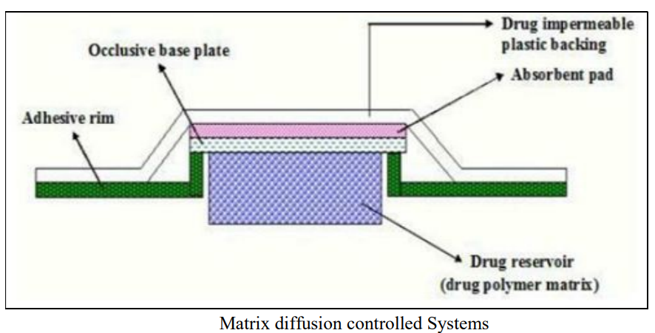
- This method involves uniformly dispersing drug particles in a hydrophilic (or lipophilic) polymer matrix to create the drug reservoir.
- A disc with a specific surface area and controlled thickness is then formed from the resulting polymer matrix.
- The medicated disc is then moulded onto an occlusive base plate in a compartment made of a drug impermeable backing.
- The film is then covered in adhesive polymer around its perimeter.
- Examples include the 0.5g/cm2 daily dose of nitro-glycerine-releasing transdermal therapeutic system for angina pectoris.
- Rate of drug release in this system is given by the equation
dq/dt = {ACpDp/2t}1/2
Where,
  - A= Initial drug loading dose dispersed in polymer matrix
  - Cp = Solubility of drug in Polymer
  - Dp = Diffusivity of drug in Polymer since Cp is equal to Cr.
- Adhesive Dispersion – Type Systems:
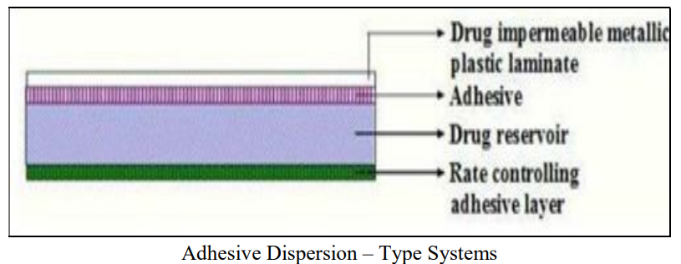
- This is a streamlined version of membrane permeation-controlled systems.
- In this system, the drug and particular excipients are added directly to the adhesive solution.
- The solvent is then removed by drying the thin films that were cast after they were combined and mixed.
- The drug reservoir (film) is then sandwiched between the rate-regulating adhesive polymer membrane and the banking laminate.
- The rate of drug release from this system is given by,
dq/dt = Cr.Ka/r .Da/ha
Where
  - Ka/r = Partition co-efficient for interfacial partitioning of drug from reservoir layer to adhesive layer.
  - ha= Thickness of adhesive layer.
  - Da= Diffusion Coefficient of a derive layer.
- Examples: Isosorbide dinitrate releasing TDDS – 24 hr, Used in Angina Pectoris Verapamil releasing TDDS – 24 hrs, used in Hypertension.
- Microreservoir dissolution controlled TDD system:
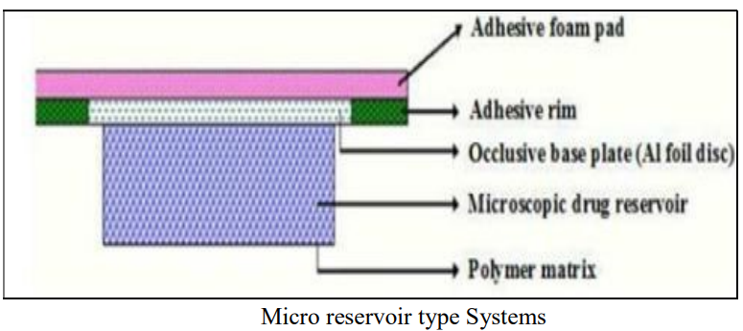
- It's a hybrid system of reservoir and matrix dispersion drug delivery.
- The drug reservoir is formed in this system by first suspending the drug solids in an aqueous solution of a water-miscible drug solubilizer, such as polyethylene glycol, and then homogeneously dispersing the drug suspension with a controlled aqueous soluble lipophilic polymer using high shear mechanical force to form thousands of un-leachable microscopic drug reservoir.

References-
- Raj GM, Raveendran R. Introduction to basics of pharmacology and toxicology. 1st vol. Singapore: Springer Nature Singapore Pte Ltd. 2019.
- Marschütz MK, Bernkop-Schnürch A. Oral peptide drug delivery: polymer-inhibitor conjugates protecting insulin from enzymatic degradation in vitro. Biomaterials. 2000;21:1499–507.
- Dahan A, Miller JM, Amidon GL. Prediction of solubility and permeability class membership: provisional BCS classification of the world’s top oral drugs. AAPS J. 2009;11:740–6.
- Patel A, Cholkar K, Mitra AK. Recent developments in protein and peptide parenteral delivery approaches. Ther Deliv. 2014;5:337–65.
- McDonald TA, Zepeda ML, Tomlinson MJ, Bee WH, Ivens IA. Subcutaneous administration of biotherapeutics: current experience in animal models. Curr Opin Mol Ther. 2010;12:461–70.
- Wen NX, Venkatraman S. Protein delivery options: how well have we succeeded? Ther Deliv. 2015;6:537–9.
- Alkilani AZ, Mccrudden MTC, Donnelly RF. Transdermal drug delivery: innovative pharmaceutical developments based on disruption of the barrier properties of the stratum corneum. Pharmaceutics. 2015;7:438–70.
- X. Wang et al. Differences of first-pass effect in the liver and intestine contribute to the stereoselective pharmacokinetics of rhynchophylline and isorhynchophylline epimers in rats
- S.T. Sanjay et al.Recent advances of controlled drug delivery using microfluidic platforms
- Lee W-R, Shen S-C, Al-Suwayeh SA, Yang H-H, Li Y-C, Fang J-Y. Skin permeation of small-molecule drugs, macromolecules, and nanoparticles mediated by a fractional carbon dioxide laser: the role of hair follicles. Pharm Res. 2013;30:792–802.
- Scheiblhofer S, Strobl A, Hoepflinger V, Thalhamer T, Steiner M, Thalhamer J, et al. Skin vaccination via fractional infrared laser ablation-optimization of laser-parameters and adjuvantation. Vaccine. 2017;35:1802–9.
- Lee HJ, Liu Y, Zhao J, Zhou M, Bouchard RR, Mitcham T, Wallace M, Stafford RJ, Li C, Gupta S. Marites P. Melancon. In vitro and in vivo mapping of drug release after laser ablation thermal therapy with doxorubicin-loaded hollow gold nanoshells using fluorescence and photoacoustic imaging. J Control Release 2013; 172:152–158.
- Liu C, Zhang J, Yue Y, Luo Q, Zhu D. 1064 nm-Nd:YAG lasers with different output modes enhancing transdermal delivery: physical and physiological mechanisms. J Biomed Opt. 2013; 18:061228.

- https://www.simplepharmanotes.com/2022/10/formulation-approaches-of-tdds.html?fbclid=IwAR0K82TbnzF6BOiPpXc4rZyXvufRkHY0GbrqMIj5QzMj0xGaG1IVzhAC7fY
- https://www.simplepharmanotes.com/2022/10/basic-components-of-tdds.html

