In Silico Molecular Docking Analysis For Repurposing Ribavirin Antiviral Drugs Against Tumour Activity
Sangeetha. S*, Alexandar. S, Kumar. M and Vigeshwaran. S
Department of Pharmaceutical Chemistry
Vinayaka Mission’s College of Pharmacy, Vinayaka Mission’s Research Foundation (DU)
Salem
Introduction and Objective

The growing cost of medical care worldwide, particularly in oncology, has incentivized researchers and physicians to repurpose clinically used drugs to alleviate the financial burden of drug development and offer potential new therapeutics. Present works have explain anticancer properties of the FDA-approved drug Ribavirin antiviral molecule used over the past four decades for the treatment of antiviral¹. Eukaryotic translation initiation. Further more ribavirin has shown to be safe and effective to enhance anticancer activity .The extensive work carried out in this study is to examine the interaction of the cancer protein and different antiviral drug ligands to inhibit the cancer protein main protease.the most robust preclinical docking suggest that ribavirin principal target in serveral cancer is eIF4E,modulated via direct binding and competiitive inhibition. The results from this in silico molecular docking study enhance the use of ribavirin for as potential candidate drugs for the treatment of cancer because the drug expressed their highest docking scores.

Methods
Since its advent as an antiviral therapy over 40 years ago, a growing body of work has shown evidence for ribavirin as an anticancer agent. In particular, the elucidation of its antagonism toward the oncogenic eukaryotic translation initiation factor Eukaryotic translation initiation factor -4E (eIF4E)¹ has led to promising preclinical and clinical results in monotherapy and combination therapy for several cancers. Moreover, several clinical trials have examined the safety and efficacy of ribavirin in malignancies and have validated its use as an antineoplastic agent, particularly in combination therapies².

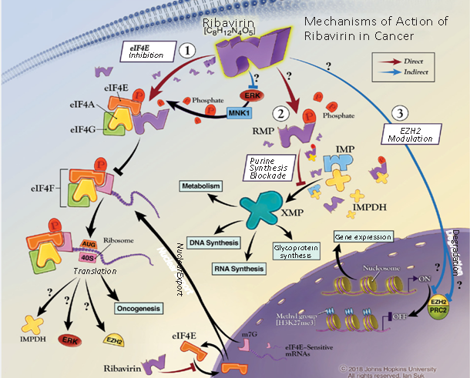

3D Structure of Ribavarin

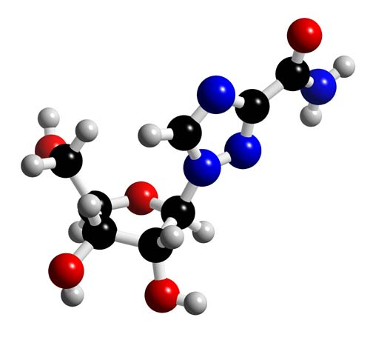
STEP: I
The main virus protease was collected from a Protein Data Bank

Protein Target: 3D Structures of protein were procured from PDB. The protein structures were cleaned (water molecules and other heteroatoms removed), prepared and minimized before docking.

Ligand preparation.
Preparation of ligand is also done because of some reasons,
- A reasonable 3D structure is needed as starting point.
Protonation state and tautomeric form of a particular ligand could influence its hydrogen bonding ability.
STEP: II
Docked with a sequence of selected approved antiviral drugs, and based on the binding energy score, we suggest that these compounds can be tested against virus and used to develop effective antiviral drugs.
Define binding site
After the protein and ligand preparation, next step is to define binding site for docking.
Receptor ligand interaction → Define & Edit binding site [In Define site, there are 3 options: – From Receptor Cavities, From PDB Site Records, and From Current Selection].
Docking: Docking module Schrodinger using Mastero13.2 was used to study interaction between the Protein and ligand molecules.

Result
Protein Preparation
Mastero13.2- Protein Preparation-PDB import structure(eIF4E)- Review structure-entry clearance-Run
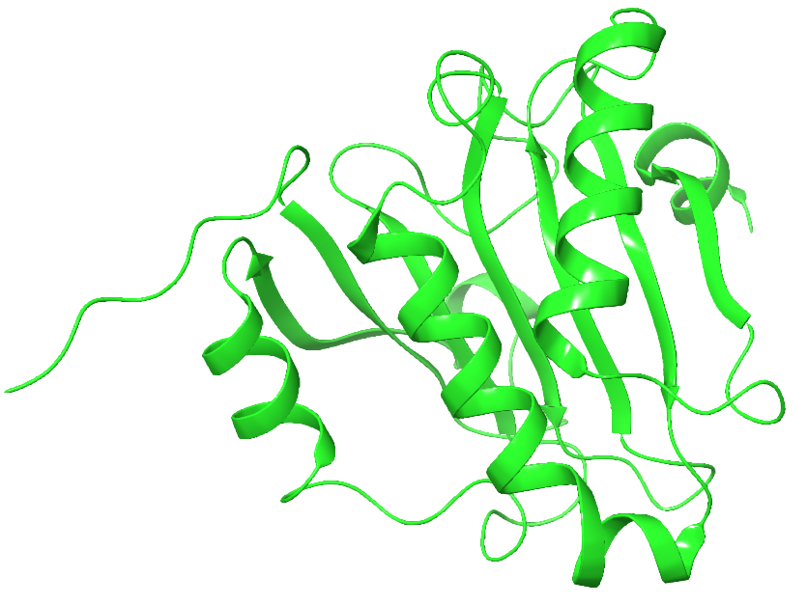

Ligand Preparation
Mastero13.2-File-Import structure in SDF format-Ligprep-workspace format-default setting-Run
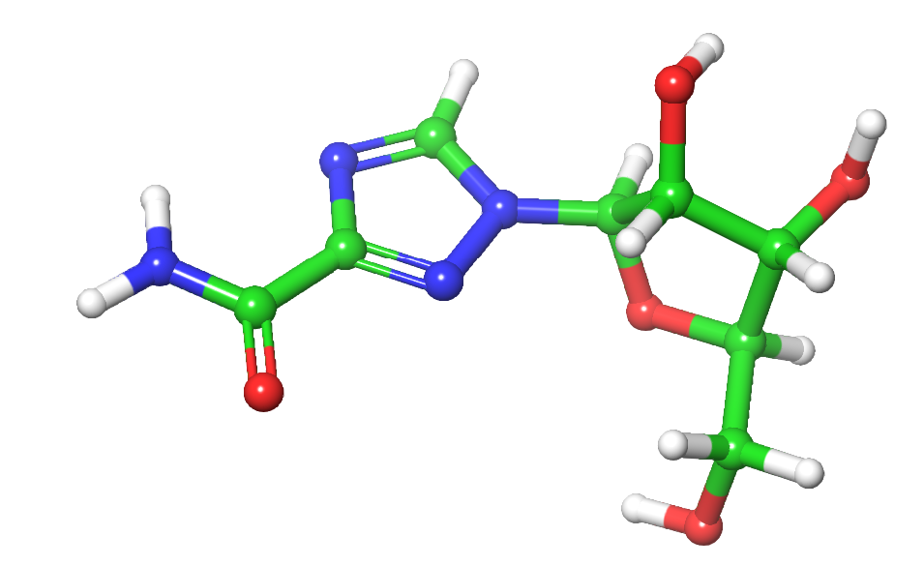

Glide preparation
Mastero13.2- prepared protein- Entry point selection-Glide browser-Receptor Grid generation- select entry point- Default setting – Run
Docking
Maestro 13.2- Ligand docking- Glide prepared protein maestro format- Prepared Ligand- Run
+= 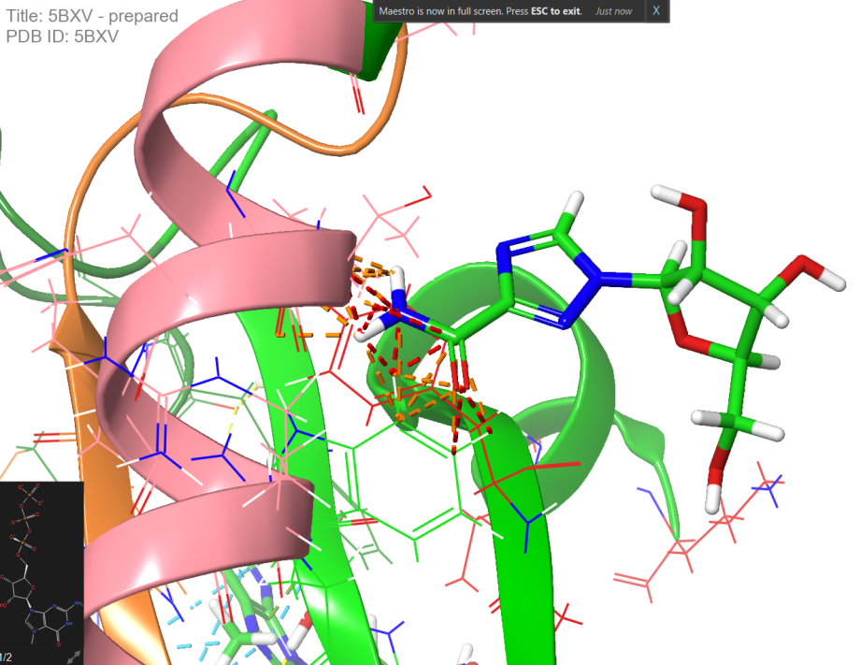
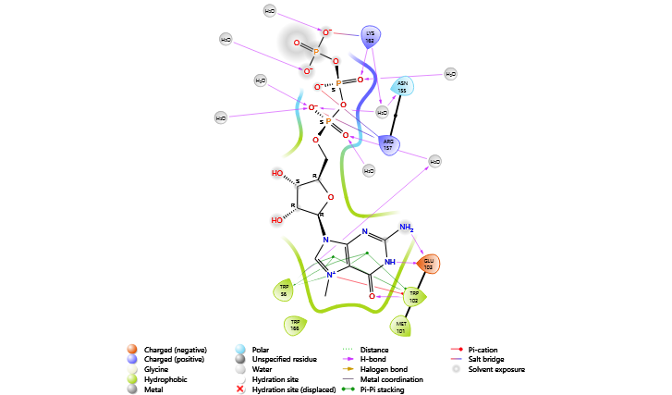
Protein-Ligand intraction with molecular docking of ribavirin

Docking analyis of ribavirin

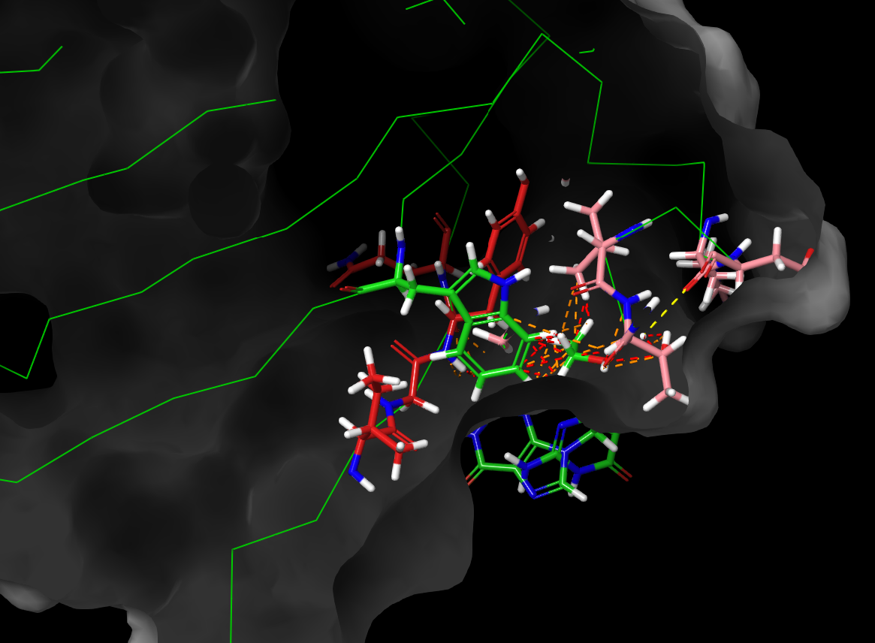
S.no | Ligand | Docking scores | Total no of hydrogen in protein (polar and non polar) | RMSD=Root mean square deviation
1. | Ribavirin | -1258.833 | H-3227(non-polar-1752 )and (polar-927) | 0.600

Conclusions
Eukaryotic translation initiation factor -4E (eIF4E) main protease inhibitor is a key to reduce the spread of the cancer infection and repurposing approved antiviral drugs is a fast approach in finding the safest treatment for the novel anticancer treatment.Further more ribavirin has shown to be safe and effective to enhance anticancer activity .The extensive work carried out in this study is to examine the interaction of the cancer protein and different antiviral drug ligands to inhibit the cancer protein main protease, the most robust preclinical docking suggest that ribavirin principal target in serveral cancer is eIF4E,modulated via direct binding and competiitive inhibition. The results from this in silico molecular docking study enhance the use of ribavirin for as potential candidate drugs for the treatment of cancer because the drug expressed their highest docking scores.
References
- 1. Friesner RA, Banks JL, Murphy RB, Halgren TA, Klicic JJ, Mainz DT, et al. Glide: A New Approach for Rapid, Accurate Docking and Scoring. 1. Method and Assessment of Docking acuracy. J Med Chem. 2004; 47: 1739-1749.
- Jones G, Wilett P, Glein RC, Leach AR, Taylor R. Development and Validation of Genetic Algorithm and an Empirical Binding Free Energy Function. J Mol Biol. 1997; 267: 727-748.

