Biofuels: A sustainable path to renewable energy
Abhijit Sahu*, Sthitapragyan Mishra, Anshu Kamal Shatrusal
Department of Agriculture and Allied Sciences, C.V. Raman Global University, Bidyanagar, Mahura, Bhubaneswar-752054, Odisha, India
*Corresponding author- abhijitnarendrasahu@gmail.com
Abstract
The global pursuit of sustainable and environmentally friendly energy sources has sparked significant interest in the development and utilization of biofuels. This article provides a comprehensive overview of the biofuel landscape, covering various types of biofuels, their production processes, environmental implications, and future prospects. The article begins by clarifying the differences between first-generation and second-generation biofuels, highlighting their respective benefits and challenges. A detailed exploration of biofuel production processes, including fermentation, transesterification, and advanced techniques like pyrolysis and gasification, reveals the diverse methods used to convert biomass into usable energy. The article places emphasis on the environmental and socioeconomic impacts of biofuel production. It examines the life cycle assessment of biofuels, including their potential to mitigate greenhouse gas emissions and the complexities of land and water use. The intricate relationship between biofuel production, food security, and global markets is addressed, providing insights into strategies for maintaining balance. The advancement of biofuel technologies is a central point, highlighting the potential of third-generation biofuels derived from microorganisms and algae. The integration of synthetic biology and genetic engineering in enhancing biofuel production efficiency is explored, offering a glimpse into a future driven by innovation. Policy and regulatory frameworks are discussed as catalysts for biofuel adoption, including renewable fuel standards and accompanying incentives. The article acknowledges challenges such as market competition and infrastructure development while envisioning a future where biofuels find applications in aviation, shipping, and emerging technologies.
Keywords: Biofuels, renewable energy, agriculture

Introduction
The search for sustainable and renewable sources of energy has taken center stage in a world where energy demand continues to rise alongside urgent environmental concerns. Among the various possibilities, biofuels have emerged as a ray of hope, offering a revolutionary solution to both the increasing demand for energy and the imperative to mitigate global warming [16]. This chapter embarks on an engaging exploration of the realm of biofuels, unveiling their significance, diversity, production methods, and the significant implications they hold for our energy future. The overarching energy landscape stands at a crossroads, driven by the necessity to reduce carbon emissions and transition away from finite fossil fuels [3]. In this context, biofuels present a compelling prospect, harnessing the vast potential of biological processes to generate clean and renewable energy. By tapping into nature's inherent power, biofuels have the potential to reshape energy production, consumption, and environmental impact dynamics. As we delve deeper into the chapter, the spotlight shines on an array of biofuel categories, each offering distinct attributes and challenges. From first-generation biofuels derived from conventional crops to the innovative realms of second-generation biofuels utilizing waste biomass, and the promising frontiers of third-generation biofuels cultivated from microorganisms and algae, the diverse sources of biofuels paint a vivid canvas of possibilities [1]. Biofuel production techniques serve as the foundation of this transformation, representing the intricate fusion of biology, chemistry, and engineering. The art of converting sugars, starches, and cellulose into bioethanol, or the alchemical process of transforming vegetable oils into biodiesel, exemplifies the intricate molecular dance characterizing biofuel creation. Additionally, novel methodologies like pyrolysis and gasification offer innovative pathways to unlock energy from organic matter, paving the way for a more sustainable energy landscape. Beyond the laboratory and production facilities, the impacts of biofuels ripple across the global landscape, influencing ecosystems, economies, and societies. Given the primacy of environmental considerations, a thorough examination of the environmental and socioeconomic impacts of biofuel production becomes imperative [2]. As we navigate complexities related to land use, water consumption, and carbon emissions, a holistic perspective emerges, guiding us toward a future where biofuels seamlessly integrate with existing systems. The journey toward biofuel integration is not without challenges [6]. Regulatory frameworks, market dynamics, and the necessity for technological innovation all play pivotal roles in shaping the trajectory of biofuel adoption. Yet, amidst these challenges, a sense of optimism prevails [7]. The potential to reduce greenhouse gas emissions, enhance energy security, and promote rural development underscores the profound promise biofuels hold. In the ensuing pages, we embark on an exploration of the multifaceted world of biofuels, from their inception to their application in transportation, industry, and beyond. With each revelation, a deeper understanding of their impact on our world and the potential to establish a more sustainable energy paradigm comes into focus. As the chapters unfold, we invite you to join us on a journey that promises to empower the future with the vitality of nature. Together, we uncover the untapped potential of biofuels in shaping a cleaner, more resilient, and environmentally conscious world
What is Biofuel?
Biofuel is a type of renewable energy derived from living organisms such as plants, crops, algae, and even residual organic materials. It serves as an environmentally friendly alternative to conventional fuels like gasoline and diesel that are commonly used in vehicles and machinery [4]. What's fascinating about biofuel is that it can be produced from rapidly regrowing sources, unlike fossil fuels that require millions of years to develop. Through specialized processes, these plants and leftover materials can be transformed into practical energy sources, like ethanol or biodiesel, capable of powering vehicles, providing heat, and generating electricity. The remarkable aspect of biofuels lies in their positive impact on the environment. They have the potential to release fewer harmful gases that contribute to the degradation of our planet. Consequently, biofuels offer a cleaner approach to obtaining energy while also showing greater consideration for the well-being of the Earth [7]
.
History of biofuels
The history of biofuels can be traced through the evolution of human civilization over millennia, showcasing the innovative ways in which societies have tapped into nature's energy resources. This narrative unfolds through a series of significant events that have shaped the progression of biofuels from ancient times to the present era [5]. The journey of biofuels reflects humanity's ongoing pursuit of energy solutions that strike a balance between technological advancement and environmental stewardship. From the early use of fires for warmth to the contemporary drive for sustainable alternatives, the trajectory of biofuels tells a story of creativity, adaptation, and a collective commitment to powering our world while preserving its future [24].
Rudolf Diesel, a German inventor born in 1858, is renowned for his creation of the diesel engine. Unlike gasoline engines, Diesel's innovation relied on high-pressure compression to ignite the fuel, resulting in improved efficiency. He patented his engine design in 1892, and it quickly found applications in diverse fields such as transportation and industry [11]. Despite the profound impact of his invention, Diesel's life took a mysterious turn when he disappeared in 1913. His legacy endures through the widespread adoption of the diesel engine, which has revolutionized the way we propel vehicles and operate machiner. Rudolf Diesel
Ancient Utilization (Before 1000 AD)
Long before the emergence of modern energy systems, ancient civilizations demonstrated a fundamental grasp of utilizing biomass for energy purposes. Millennia ago, in regions like Mesopotamia and Egypt, wood and other plant materials were burned to generate heat and light. Animal fats and plant oils, such as olive oil and flaxseed oil, are found used in lamps for illumination. These early practices laid the groundwork for harnessing organic materials to meet energy requirements [11].
Medieval Wisdom and Renaissance Innovations (1000 - 1700 AD)
The medieval era marked a continuation of biomass utilization, with wood remaining a primary energy source for cooking, heating, and metallurgical procedures. Yet, it was during the Renaissance that technological advancements broadened the horizons of bioenergy. Windmills and watermills emerged as mechanisms to convert wind and water power into mechanical energy, enabling tasks like grain milling and water pumping. These inventions constituted the initial strides toward harnessing renewable energy sources on a larger scale [11].
18th Century: The Dawn of the Fossil Fuel Era
The 18th century witnessed the burgeoning adoption of coal as an energy source, notably in steam engines that powered factories and locomotives during the Industrial Revolution. The transformative impact of coal marked a pivotal departure from reliance on biomass to the utilization of fossil fuels. James Watt's enhancements to the steam engine in 1775 ushered in an era of mechanization that reshaped industries and societies [11].
19th Century: Petrochemical Revolution
The 19th century saw the ascendancy of petroleum as a critical energy source. The commercial production of kerosene in the mid-1800s offered an alternative to whale oil for lighting, contributing to the decline of the whaling industry. Furthermore, the development of the internal combustion engine in the late 19th century paved the way for gasoline-powered vehicles, cementing liquid fossil fuels as the foundation of modern transportation [5].
20th Century: Biofuels Alongside Fossil Fuels
While the 20th century witnessed the unprecedented rise of fossil fuels, biofuels persisted. The creation of the diesel engine by Rudolf Diesel in the late 19th century sparked interest in using vegetable oils as fuel. Biodiesel, a renewable substitute for diesel fuel, gained traction during World War II when petroleum shortages necessitated innovative solutions. In the latter part of the century, ethanol production from crops like corn and sugarcane gained prominence, spurred by concerns about the environment and energy security [24].
21st Century: A Sustainability Revival
The 21st century marked a renewed emphasis on biofuels in response to environmental and climate worries. Advanced biofuels, derived from non-food sources such as algae and lignocellulosic materials, garnered attention for their potential to mitigate environmental impacts and address the food-versus-fuel debate. Research endeavors intensified to refine biofuel production processes, optimize feedstock selection, and develop groundbreaking technologies that align with sustainability objectives [24].
First-Generation Biofuels
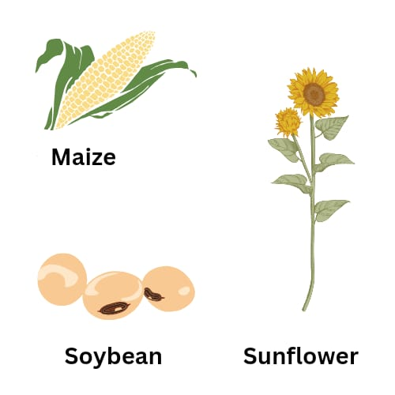
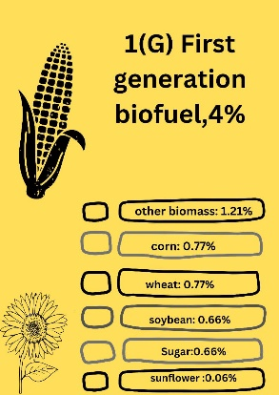
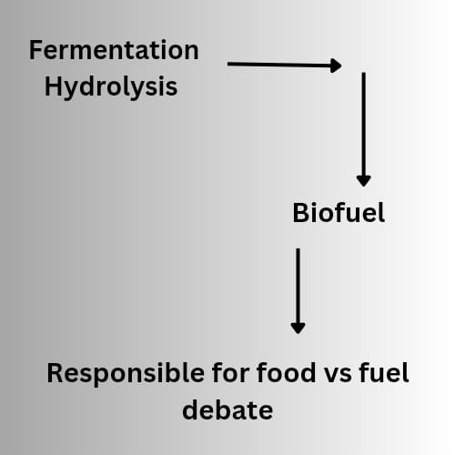

Fig .1: First Generation Biofuel
Biofuels provide a gateway into the early stages of our pursuit of sustainable energy alternatives. Imagine a world where our vehicles and machines are powered not by traditional gasoline or diesel, but by fuels derived from the very plants we cultivate and the oils we use in our diets. This forms the essence of first-generation biofuels – an innovative approach to energy generation that taps into the sugars present in crops like corn and sugarcane to produce ethanol, a fuel not only recognized as a potential engine propellant but also as a crucial component in alcoholic beverages [13]. Likewise, the oils contained within soybeans, canola, and even animal fats can be converted into biodiesel, offering an environmentally friendlier substitute for conventional diesel fuel. While the allure of first-generation biofuels stems from their renewable nature and potential to mitigate the environmental impacts of conventional fuels, they also pose a nuanced challenge in the form of competition [17]. The very crops utilized for biofuel production also hold a pivotal role in our food supply chain. As a result, a delicate balance must be maintained between utilizing these crops to fulfill our energy needs and ensuring a consistent supply of food resources. This balancing act resembles the endeavor of harmonizing the sharing of toys and treats among friends – finding equilibrium between individual desires and communal necessities. As we contemplate the evolution of energy sources, first-generation biofuels offer a valuable lesson in navigating the intricate dance between sustainability and practicality. They unveil the intricate interplay between our appetite for energy and our responsibility to nourish ourselves and our planet [17]. It underscores our unwavering pursuit of innovation and an evolving comprehension of how to harness nature's resources to meet our diverse requirements. (Ethanol, a core element in many alcoholic beverages, is commonly employed as a motor fuel, particularly in V8 supercars) [13]. Oil derived from oil-seed crops like canola, soy, pangamic, and jatropha, as well as animal-based tallow, can be transformed into a fuel known as "biodiesel." Regrettably, starch, sugar, and oil crops are also utilized for human consumption and livestock feed, potentially resulting in feedstock competition, especially during periods of scarcity. This can influence the cost and availability of staple food ingredients. Furthermore, significant hikes in feedstock prices can render biofuel production economically unfavorable compared to existing fossil-based fuels [17].
Second-Generation Biofuels

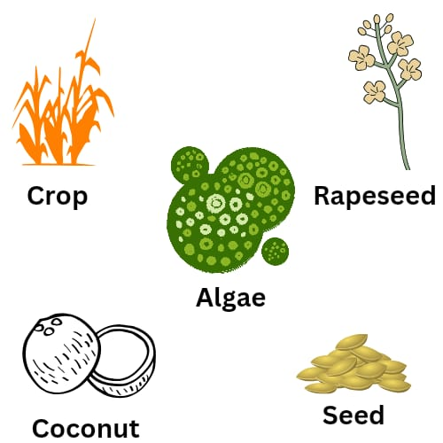
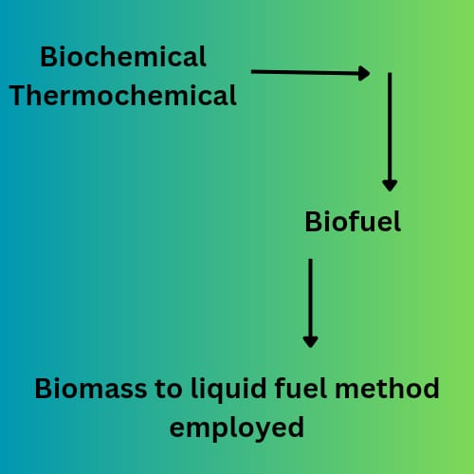
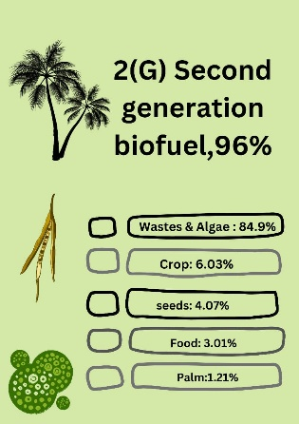

Fig.2 : Second generation Biofuel
Biofuels of the second generation signify the next stride in our journey towards cleaner and more sustainable energy solutions. In contrast to their first-generation counterparts, which stem from crops used for food, second-generation biofuels are derived from lower-value biomass residues – essentially, residual organic materials from recently living or living organisms. This encompasses materials like agricultural waste, leftover plant parts, and even specific types of waste [17]. The innovation lies in the advanced processes employed to convert these materials into viable energy sources. Consider cellulose, for instance – a resilient substance present in plant walls. Through a series of steps, fermentable sugars can be extracted from cellulose, which can then be converted into biofuels like ethanol. Picture it as unlocking a concealed storehouse of energy within plant fibers [13]. Another method involves high temperatures and pressures in a process called pyrolysis. This process breaks down organic matter, generating energy-rich gases, solid char, or even a liquid bio-crude. These outputs can function as energy sources themselves or be refined into a range of valuable fuels and chemicals. Algae, with their impressive capability to employ sunlight and carbon dioxide to produce oils, play a substantial role in second-generation biofuels [13]. These algal oils can be harvested from expansive ponds or specialized enclosed systems and subsequently utilized to create fuels and other beneficial products. It's akin to harnessing the sun's energy to establish a sustainable energy source. The allure of second-generation biofuels lies in their potential to reduce competition between food and fuel. As they are produced from leftovers – materials that might otherwise go to waste – they alleviate the strain on food resources [17]. This renders them a more sustainable and environmentally friendly choice, aligning with our objective of balancing energy requirements with ecological responsibility. Essentially, second-generation biofuels showcase human ingenuity in transforming what was once deemed waste into valuable energy sources. They serve as a testament to our commitment to utilizing nature's resources in ways that minimize our impact on the planet and propel us towards a cleaner and more environmentally conscious energy future [17].
Types of biofuels
- Biodiesel
Biodiesel stands as a remarkable example of innovation in the realm of renewable energy. It represents a specific type of biofuel produced from a diverse range of biological sources, particularly vegetable oils, animal fats, and even recycled cooking oils [15]. What distinguishes biodiesel from traditional fossil fuels like diesel is its sustainable and eco-friendly nature. The production process involves a transformative chemical reaction called transesterification. Here, fats or oils undergo a process where they are chemically altered using alcohol, often methanol or ethanol, in the presence of a catalyst [17]. This process separates the glycerine component from the fats or oils, resulting in biodiesel as the end product. One of biodiesel's striking advantages is its compatibility with existing diesel engines and infrastructure. This means that vehicles and equipment designed for traditional diesel can often use biodiesel without significant modifications [17]. Biodiesel can be blended with regular diesel fuel in varying proportions, with the most common blends being B20 (20% biodiesel and 80% diesel) and B5 (5% biodiesel and 95% diesel). From an environmental standpoint, biodiesel holds several key benefits. Firstly, it tends to emit fewer harmful pollutants and greenhouse gases compared to conventional diesel, contributing to improved air quality and reduced carbon emissions [15]. Additionally, producing biodiesel from waste materials such as used cooking oils can help divert these materials from landfills, supporting waste reduction efforts. It's important to consider the larger picture of biodiesel production [15]. The crops or materials used to create biodiesel must strike a balance between their potential impact on food resources and their suitability for fuel production. The "food vs. fuel" debate underscores the complexity of this issue, emphasizing the need for sustainable practices and responsible feedstock selection. As a versatile and sustainable alternative to conventional diesel, biodiesel embodies the ongoing pursuit of greener energy solutions [17]. It showcases the remarkable ways in which science and technology are harnessed to transform everyday materials into viable sources of energy, underscoring our commitment to reducing our carbon footprint and moving towards a more environmentally conscious future [17].
- Bioethanol
Bioethanol, a captivating exemplar of renewable energy ingenuity, exemplifies the intersection of science, sustainability, and energy transformation. Derived from organic materials such as crops and plant residues (paddy-straw), bioethanol stands as a potent alternative to conventional fossil fuels. What sets it apart is its capacity to reduce greenhouse gas emissions and enhance the environmental profile of energy consumption [17]. The production process of bioethanol involves harnessing the natural sugars within plants, such as sugarcane, corn, and various grains. These sugars are fermented using specialized microorganisms, transforming them into alcohol – specifically, ethanol. This ethanol can then be refined for use as a clean and green fuel source. Bioethanol boasts versatile applicability, finding its way into various sectors of our lives. It can be blended with gasoline to create fuel with reduced emissions, contributing to improved air quality and reduced carbon footprints. Furthermore, bioethanol's compatibility with current gasoline engines makes its integration into our existing transportation infrastructure a feasible endeavor [15]. One of the remarkable dimensions of bioethanol lies in its potential to invigorate rural economies. Since its production hinges on agricultural feedstocks, it provides an avenue for farmers to diversify their crops and revenue streams, fostering economic resilience and sustainability. The road to bioethanol's success isn't devoid of challenges. Striking the right balance between utilizing crops for energy production and ensuring food security remains a critical consideration. The food-versus-fuel debate underscores the complexity of this issue, necessitating a careful approach to feedstock selection. our energy evolution, bioethanol stands as a testament to human innovation [15]. It signifies our aspiration to reshape energy paradigms, transforming everyday plants into potent sources of power. Bioethanol underscores our collective commitment to mitigating climate change, embracing sustainable practices, and steering our planet toward a cleaner, greener future.
- Biogas
Biogas, a remarkable facet of the biofuel landscape, exemplifies the ingenious utilization of organic materials to generate energy. This versatile biofuel is generated through a natural process called anaerobic digestion, where microorganisms break down organic matter in the absence of oxygen. The result is a gas mixture primarily composed of methane and carbon dioxide, both of which hold substantial energy potential [15]. The magic of biogas production unfolds within anaerobic digesters, where diverse organic materials come to life as sources of energy. These materials encompass agricultural residues, food waste, sewage sludge, and more. By harnessing the inherent power of microorganisms, these digesters convert these materials into biogas, offering an energy source that is not only renewable but also significantly lessens the environmental impact of organic waste. The utilization of biogas as a biofuel bears multifaceted benefits. Firstly, it significantly reduces methane emissions that would otherwise be released into the atmosphere during the natural decomposition of organic matter [17]. Methane, a potent greenhouse gas, is captured and converted into energy through biogas production, contributing to mitigating climate change. Secondly, the energy-rich methane in biogas can be harnessed for a variety of purposes, including electricity generation, heating, and even as fuel for vehicles. In sustainable waste management, biogas emerges as a dual-purpose solution. It diverts organic waste from landfills, reducing their environmental burden while simultaneously creating a valuable energy resource. Moreover, biogas facilities often produce nutrient-rich digestate, which can serve as an organic fertilizer to enrich the soil and support agricultural productivity. Challenges persist on the road to widespread biogas adoption. Efficient collection and transportation of feedstock, as well as optimal digester operation, are vital for consistent biogas production. Additionally, upgrading biogas to remove impurities like carbon dioxide and hydrogen sulphide enhances its energy content and quality, making it suitable for various applications [15].
Advanced Biofuels
Renewable energy stands as a guiding light leading us toward a more sustainable and promising future. As we confront challenges like climate change, resource depletion, and environmental degradation, the imperative to transition to renewable energy becomes ever more evident. The benefits are multifaceted and compelling. Firstly, renewable energy offers an abundant and untapped resource pool that harnesses natural processes such as sunlight, wind, and flowing water. Unlike finite fossil fuels, these sources are replenished naturally, ensuring a consistent and long-lasting energy supply [18]. Secondly, the environmental toll of conventional energy sources is staggering. Fossil fuels release harmful pollutants and greenhouse gases, contributing to air pollution and climate change. In contrast, renewable energy systems produce minimal or zero emissions, safeguarding air quality and mitigating global warming. Moreover, the economic rationale is compelling. Investing in renewable energy fosters job creation, innovation, and local economic growth. As technology advances, the costs of renewable energy production continue to decrease, making it an increasingly cost-competitive solution [18]. The versatility of renewable energy extends beyond electricity generation. It has the potential to revolutionize transportation through electric vehicles and biofuels, transforming our dependence on fossil fuels. Importantly, renewable energy enhances energy security by reducing reliance on imported fossil fuels that are subject to geopolitical uncertainties. By tapping into local resources, nations can achieve greater control over their energy supply and reduce vulnerabilities to global energy market fluctuations. Ultimately, the shift toward renewable energy aligns with the principles of sustainable development. It offers a pathway to address environmental challenges while fostering social progress and economic stability. As we embark on this journey, renewable energy emerges as not just a choice, but a necessary step toward a cleaner, more resilient, and harmonious world for current and future generations.
Advanced biofuels represent a significant advancement in our pursuit of cleaner energy solutions. These specialized fuels are distinct in that they are derived from non-traditional sources, such as wood, grass, and specific plant components that are not typically used for food. Their production involves advanced technologies that break down these materials into smaller constituents, which are then converted into biofuels through intricate chemical processes [12]. The notable advantage of advanced biofuels lies in their environmental benefits. They emit fewer pollutants compared to conventional fuels, contributing to improved air quality and reduced environmental impact. Additionally, advanced biofuels diverge from fossil fuels, reducing our reliance on non-renewable resources extracted from the ground. Furthermore, advanced biofuels offer the potential to address waste management concerns by utilizing materials that might otherwise be discarded. This concept aligns with the broader concept of a circular economy, wherein resources are utilized efficiently and sustainably. It's important to acknowledge the complexity associated with the production of advanced biofuels. Their creation demands advanced scientific knowledge and sophisticated technologies. Overcoming these challenges requires concerted research efforts and the collaboration of experts across disciplines. In the narrative of energy evolution, advanced biofuels present a new chapter characterized by their capacity to provide cleaner and more sustainable energy alternatives [18]. They underscore humanity's determination to innovate and develop solutions that align with environmental stewardship, while concurrently addressing our energy requirements. Assuming that they are produced from renewable resources, biofuels have long been hailed as a sustainable replacement for fossil fuels. This renewable resource might occasionally be an organic waste, the disposal of which presents unique environmental difficulties. The inherent problem with biofuels, though, is that they don't always help reduce greenhouse gas (GHG) emissions. In reality, there is a growing body of information showing that the manufacturing of biofuels and the use of such fuels cause environmental issues [12]. Biofuels have often been championed as an eco-friendly replacement for fossil fuels because they come from things that can be replenished, like plants. Sometimes, these plants are even made from stuff we'd otherwise throw away, which helps with a big waste problem. But there's a catch. While biofuels seem like a good way to reduce pollution, it's not that simple. There's growing evidence that making and using biofuels can actually cause more harm to the environment. It's like this even though biofuels come from renewable sources, the process of making and using them can release a lot of greenhouse gases, which are bad for the Earth's atmosphere. So, while we might be using something more "natural," it doesn't always mean we're doing less harm. Understanding both the potential and the problems of biofuels is really important. It helps organizations figure out the best ways to manage their resources and deal with waste. It's not just about using something that seems greener but making sure it's truly better for our planet in the long run. This way, we can work towards a cleaner and healthier world for everyone. A cleaner environment and a healthier population are a few benefits of biofuels, as are zero emissions of harmful gases like carbon monoxide (CO) and sulphur oxide (SO), reduced risk of global warming, and reduced emission of harmless compounds, which lowers the chance of cancer and respiratory issues [18]. Biofuels have a high oxygen concentration for effective burning and are non-toxic, biodegradable, and environmentally beneficial. Biofuels will almost completely cut down greenhouse gas emissions. Governmental incentives to reduce fuel prices and meet the demands of companies, cars, and the agricultural sector will promote the use of biofuels made from crop waste [12].
Biofuel Production
- Feedstock Selection
Feedstock selection stands as a pivotal determinant in shaping the efficiency, sustainability, and overall viability of biofuel production. The careful consideration of feedstock sources plays a crucial role in minimizing potential competition with food crops and mitigating concerns related to land use changes. Researchers and experts are ardently engaged in the process of optimizing feedstock selection to ensure that biofuel production aligns with ecological balance, food security, and environmental preservation [20]. The primary objective in feedstock selection is to strike a harmonious balance between energy production and the utilization of land and resources. This involves identifying and prioritizing feedstock options that offer higher energy yields and can be cultivated on lands not suitable for intensive food crop production. Non-food biomass resources, such as agricultural residues (crop stalks, husks, and stems), dedicated energy crops (miscanthus, switchgrass), algae, and waste materials, hold significant promise as they reduce the likelihood of competition with food supplies [20]. An important aspect of feedstock optimization is considering the life cycle impacts. This entails evaluating the entire lifecycle of the feedstock – from cultivation to processing to end-use – to ascertain its environmental, economic, and social implications. This evaluation includes factors such as greenhouse gas emissions, water use, energy input, and economic feasibility. Researchers utilize life cycle assessment tools to quantify and compare the impacts of different feedstock options, aiding in informed decision-making. Technological advancements in agriculture and biotechnology play a pivotal role in enhancing feedstock options. Genetic modifications and breeding techniques can potentially improve the characteristics of energy crops, making them more resilient to various environmental conditions and increasing their productivity. This can result in higher energy yields without compromising land suitable for food cultivation. Importantly, the concept of feedstock flexibility is gaining attention. This approach advocates for the utilization of multiple feedstocks, depending on regional availability and suitability. This not only mitigates supply risks but also optimizes land use by matching crops with specific ecological conditions [20].
- Conversion Processes
Biofuel production hinges on a spectrum of conversion processes that encompass both biochemical and thermochemical methods. These intricate processes are instrumental in transforming diverse feedstock materials into biofuels suitable for practical use. The cornerstone of these processes lies in their ability to harness nature's intricacies to produce cleaner and more sustainable energy alternatives. Biochemical processes, for instance, involve the marvel of fermentation [20]. This bio-magical transformation employs microorganisms to break down sugars and other organic components present in feedstocks. The result is the production of biofuels like ethanol and biogas. Ethanol, a common biofuel, is produced through the fermentation of sugar-rich crops such as sugarcane or corn. On the other hand, biogas, a mixture of methane and carbon dioxide, emerges from the breakdown of organic matter, often waste materials [20]. Thermochemical processes, however, are like turning up the heat on innovation. These methods deploy heat to trigger a symphony of transformations that lead to the creation of biofuels. Gasification is a fascinating example, involving high temperatures and limited oxygen to convert solid feedstocks into a gas called syngas. This syngas is a versatile concoction that can be further refined into biofuels like synthetic diesel or even used to generate electricity. Pyrolysis, another thermochemical dance, revolves around the concept of heating feedstocks in the absence of oxygen [20]. This results in the breakdown of these materials into liquids, gases, and char. The liquids, often referred to as bio-oil, can be upgraded into various biofuels or serve as raw materials for chemicals and plastics. The collective symphony of these conversion processes underscores the multifaceted nature of biofuel production. Researchers and innovators orchestrate these methods to derive energy from the earth's offerings while adhering to sustainable practices. It's a tale of scientific exploration, environmental responsibility, and energy ingenuity, all converging to compose a harmonious narrative of cleaner and more responsible energy generation [17].
- Technology Advancements
The realm of biofuel technology is an ever-evolving landscape fuelled by ongoing research and relentless innovation. The overarching goal is to enhance the efficiency of conversion processes, streamline production costs, and pioneer novel methods that can revolutionize biofuel production. At the heart of these endeavors lies the pursuit of improved conversion efficiency. Researchers delve into the intricacies of biochemical and thermochemical processes, seeking to optimize every step of the journey from feedstock to biofuel [20]. This includes refining fermentation techniques, exploring catalysts for thermochemical reactions, and leveraging advanced computational models to predict and enhance conversion outcomes. The ultimate aim is to extract more energy from the same amount of feedstock, making the process resource-efficient and environmentally sustainable. A parallel effort centers on reducing production costs. As biofuels strive to be competitive with traditional fuels, finding ways to make their production economically viable is paramount. Researchers investigate cost-effective feedstock options, develop more efficient processing technologies, and identify methods to streamline the entire production chain. By making biofuel production financially feasible, it becomes a more attractive and sustainable energy solution on a larger scale.
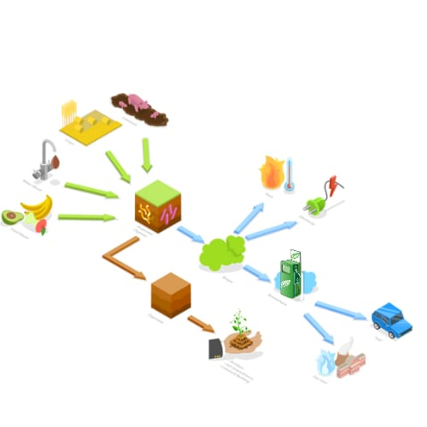
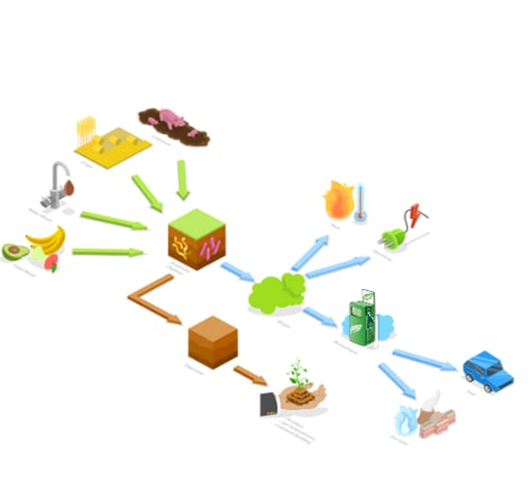
Innovation, however, knows no bounds. The realm of synthetic biology emerges as a game-changer. This cutting-edge field involves the design and engineering of biological organisms, including microorganisms, to perform specific tasks with unparalleled efficiency. In the context of biofuels, synthetic biology offers the tantalizing prospect of creating organisms that are custom-designed to produce biofuels more effectively. This could involve optimizing metabolic pathways, improving tolerance to harsh conditions, and even creating microorganisms that can directly convert sunlight into biofuels. The integration of advanced technologies further amplifies the potential of biofuels. Nanotechnology, for instance, is explored to enhance catalytic reactions and improve fuel quality. Moreover, data analytics and machine learning algorithms enable researchers to predict and optimize biofuel production, minimizing trial and error[20]. In essence, the ongoing quest for biofuel technology advancements embodies a harmonious blend of scientific exploration, engineering prowess, and environmental stewardship. It reflects humanity's commitment to shaping a cleaner and more sustainable energy future, where biofuels take center stage as a cornerstone of the energy revolution.

Fig.4: Biofuel Production
Environmental Impact
- Greenhouse Gas Emissions
Greenhouse gas emissions are a critical aspect of assessing the environmental impact of biofuels. Biofuels hold the promise of reducing carbon dioxide (CO₂) emissions compared to traditional fossil fuels, contributing to the global effort to mitigate climate change. However, the extent of these emission reductions is influenced by a range of complex factors. The reduction in CO₂ emissions hinges on the principle of carbon neutrality. Biofuels are often considered carbon-neutral because the CO₂ released during their combustion is believed to be roughly equivalent to the CO₂ absorbed by the plants during their growth. This creates a cycle where the net emissions are theoretically balanced; however, the reality is more nuanced. The environmental benefits of biofuels are highly dependent on various factors:
- Feedstock Choice and Carbon Sequestration:
The type of plant used as feedstock has a direct impact on emissions reduction. Fast-growing plants like switchgrass and algae have a higher potential to absorb carbon dioxide during their growth, making them more efficient at sequestering carbon. Additionally, perennial crops that require less land preparation and fewer inputs can offer higher emissions reduction benefits.
- Lifecycle Emissions:
Evaluating the entire lifecycle of a biofuel, from cultivation to combustion, provides a clearer understanding of its emissions impact. For instance, cellulosic ethanol derived from agricultural residues or non-food plant material tends to have lower lifecycle emissions compared to conventional corn ethanol, as it avoids competition for agricultural land.
- Direct and Indirect Land Use Changes:
One of the most debated aspects is the potential for indirect land use change (ILUC). If biofuel production leads to deforestation or displacement of agricultural activities, it can release substantial stored carbon and diminish the overall emissions reduction potential. The inclusion of ILUC emissions in calculations significantly affects the net emissions impact of biofuels.
- Energy Inputs in Production:
The energy consumed during the production and conversion of biofuels also impacts their emissions. If the energy required is primarily derived from fossil fuels, it can offset emissions reduction benefits. Employing renewable energy sources for processing and transportation helps improve the overall environmental profile.
- Land Efficiency and Yield:
High-yield feedstocks that require minimal land area for cultivation can maximize emissions reduction. Optimizing agricultural practices to enhance yields while minimizing inputs like fertilizers can contribute to a more sustainable emissions outcome.
- Technological Advancements:
Continuous research and development in biofuel production technologies can lead to more efficient processes with lower emissions. Advanced techniques like carbon capture and storage (CCS) can further enhance the emissions reduction potential [21]. While specific percentage reductions can vary widely based on these factors, research provides some illustrative data: The International Energy Agency (IEA) estimates that the average reduction in lifecycle greenhouse gas emissions for conventional biofuels (like corn ethanol) is around 20-60% compared to fossil fuels. Advanced biofuels, such as algae-based fuels, have the potential to achieve 50-90% or even higher emissions reductions compared to conventional fuels [21]. Biodiesel, produced from feedstocks like waste cooking oil or non-food crops, can achieve emissions reductions ranging from 50-90% compared to fossil diesel [22]. The environmental impact of biofuels on greenhouse gas emissions is a nuanced interplay of feedstock characteristics, production methods, land use changes, and technological advancements. A comprehensive analysis that considers these factors provides a more accurate understanding of the emissions reduction potential of biofuels in the transition towards a more sustainable energy future [22].
- Land Use and Biodiversity
The expansion of biofuel crops has significant implications for land use and biodiversity. While biofuels offer a potential pathway to reduce greenhouse gas emissions, their cultivation can also trigger environmental challenges, particularly in terms of habitat loss and biodiversity impacts.
- Deforestation and Habitat:
The conversion of natural habitats, such as forests, grasslands, and wetlands, into biofuel crop plantations, can lead to habitat destruction. This transformation disrupts the homes of many plants and animals that rely on these areas for their survival. Forests are homes to a wide variety of species, and when they are cut down, these creatures lose their habitats and their sources of food and shelter. Not only that, but deforestation also has another impact – it releases carbon stored in trees into the air, adding to the problem of climate change. The carbon that was once locked up in trees now contributes to the build-up of greenhouse gases in the atmosphere, which traps heat and warms the planet.
Now, to put this into numbers, deforestation is responsible for around 10% of the world's greenhouse gas emissions. In some regions, like tropical rainforests, this number can be even higher. These forests are known as "carbon sinks" because they absorb more carbon dioxide than they release. However, when they are cleared for biofuel crops or other purposes, they stop absorbing carbon and even release stored carbon, contributing to climate change. Additionally, every year, millions of hectares of forests are lost to activities like logging, agriculture, and biofuel expansion. This loss of forests not only affects the climate but also has a cascading effect on biodiversity. It's estimated that deforestation leads to the extinction of around 50,000 species each year. These numbers highlight the urgent need to find ways to produce biofuels without causing further deforestation and habitat loss. Balancing the benefits of biofuels with the preservation of ecosystems and species diversity is a crucial challenge that requires careful consideration and sustainable practices.
- Biodiversity Impacts:
Biodiversity impacts are a significant concern when it comes to growing biofuel crops. Imagine if you only had one type of food to eat every day – you'd get bored, and it wouldn't be very healthy. Well, the same idea applies to nature. When we plant only one type of crop over a big area, it's called a monoculture. This can cause problems because nature loves variety. Monocultures lack the diversity that natural ecosystems have. In real forests and grasslands, there are many different plants and animals living together, like in a big family. But when we plant just one crop, it's like having only one type of guest at a party. This lack of diversity can lead to trouble. It makes the land weaker against pests and diseases because there's no backup plan – no other types of plants to help out. When we lose the natural plants that used to grow in an area to make way for biofuel crops, we disrupt the balance of nature. This can be bad news for insects, birds, and other animals that rely on those plants for food and shelter. For example, if flowers that bees usually visit disappear, the bees might struggle to find food. When pollinators like bees have trouble finding food, it can affect the plants that rely on them for pollination. This disruption can ripple through the ecosystem, affecting other animals that depend on those plants for food. So, to sum it up, planting just one type of crop for biofuels can hurt the natural diversity of an area. It's like having a party with only one kind of food – not as fun and not as good for nature's health either. It's important to find ways to grow biofuel crops without losing the variety of plants and animals that make ecosystems strong and resilient.
Sustainable Land Management Practices are Crucial
- Agroforestry:
Agroforestry is an innovative agricultural practice that brings together the best of both worlds – trees and crops – to create a harmonious and biodiverse landscape. Imagine a farm where trees and shrubs grow alongside the crops, like a natural partnership. This approach isn't just about farming; it's about creating an entire ecosystem that benefits both nature and people. Agroforestry lies in its numerous advantages. First and foremost, it's a biodiversity booster. Planting different types of vegetation side by side invites a variety of insects, birds, and animals, creating a mini-ecosystem [23]. It's like setting up a bustling community where everyone has a role to play. But that's not all – trees in agroforestry serve as homes for wildlife. Birds find shelter in their branches, insects make homes in their bark, and small mammals find refuge in their shade. It's like building a tiny city within a natural paradise. Agroforestry doesn't stop at the surface; it goes deeper into the ground [25]. The roots of trees and plants work together to improve soil health. Trees prevent soil erosion, acting as nature's protective shield against the forces of nature. As their leaves fall and decay, they enrich the soil with nutrients, creating a fertile foundation for crops to thrive. And here's the exciting part: agroforestry isn't just about growing food; it's also about growing a sustainable future [23]. By combining biofuel crops with trees, agroforestry pioneers a greener approach to biofuel production. The trees provide shelter and shade to the biofuel crops, making them more resilient to changing weather conditions. It's like nature's insurance policy for our energy needs. But perhaps the most remarkable aspect of agroforestry is its commitment to preserving biodiversity [23]. By respecting the natural world and finding innovative ways to work with it, agroforestry shows that progress and conservation can go hand in hand. It's a testament to our ability to find solutions that benefit both ourselves and the environment we depend on. In a world where balance is key, agroforestry shines as a beacon of sustainable coexistence [26].
- Marginal Lands:
Cultivating biofuel crops on marginal lands is a clever strategy that holds great promise for sustainable biofuel production. These lands, which may account for around 20-30% of the world's total land area, often face challenges like poor soil quality, limited water availability, or topographical limitations that make them less suitable for traditional agriculture [26]. One of the key benefits of cultivating biofuel crops on marginal lands is that it avoids competition with food crops. This is crucial because as the global demand for both food and energy increases, we need to ensure that we're not sacrificing one for the other. By growing bioenergy crops on lands that wouldn't support food crops effectively, we strike a balance between our energy needs and food security [23]. Marginal lands are often located in areas with fragile ecosystems or low biodiversity. When we choose these lands for bioenergy production, we minimize the potential impact on primary ecosystems, preserving biodiversity and protecting vital habitats. This approach is especially important when considering the potential land use changes that can result from large-scale biofuel production. Another perk of using marginal lands is their efficient land use. Since these lands might not yield substantial agricultural outputs with traditional crops, they're often underutilized [26]. By converting them into bioenergy production areas, we're maximizing the potential benefits of these lands without intensifying the competition for space between food and fuel crops. It's estimated that approximately 10-15% of the world's arable land is considered marginal or non-arable due to various limitations. In some regions, this percentage can be even higher. For instance, arid and semi-arid regions account for a significant portion of marginal lands. By making use of these lands for bioenergy crops, we're making efficient use of resources that might otherwise remain unproductive. This approach can contribute to sustainable biofuel production and reduce the environmental footprint associated with energy production.
- Restoration:
If biofuel cultivation has already led to habitat loss, restoration efforts can help restore ecosystems and enhance biodiversity. It's like giving nature a second chance to heal and thrive. When biofuel crops have taken away precious habitats, restoration steps in to repair the damage and bring back the balance. planting trees where they used to stand tall. Reforestation is like bringing back the green cover that was lost [25]. Trees not only provide homes for animals and help clean the air, but they also store carbon, which is great for fighting climate change. This is like giving nature a makeover. If we've altered a place too much, we can work to make it look and function more like it used to. It's like putting pieces of a puzzle back together. we protect the lands that are still wild and untouched, we're conserving what's left of nature. It's like preserving a piece of art that tells the story of our planet. These restoration actions do more than just mend what's broken – they enhance biodiversity. By giving back habitats to animals and plants, we1're helping them thrive. It's like creating a safe haven where every species can play its role in the grand tapestry of life. Restoration reminds us that even when we make mistakes, we can make amends and work towards a healthier planet [23].
- Lifecycle Analysis:
Lifecycle analysis is like taking a journey through the entire life of biofuels, from the moment they're just ideas to when they're used to power our world. It's an incredible tool that helps us see the bigger picture – the impact of biofuels on the environment from every angle [25]. Imagine you're making a cake. You don't just focus on the taste; you also think about the ingredients, the baking process, and how you'll clean up afterward. Similarly, lifecycle analysis looks at all stages of biofuel production and use [23]. It starts with the seeds in the ground. How are the crops grown? What resources are needed – water, fertilizer, land? This phase sets the foundation for everything that follows. Next, the raw materials are transformed into biofuels. How much energy does this process use? Are any harmful chemicals released? We're like detectives, investigating every step to see how it affects the environment. Once the biofuels are ready, they have to travel to where they're needed. How far do they go? How are they transported – by truck, ship, or plane? The energy used in transportation matters too. Finally, the biofuels are burned to create energy. How efficiently does this process convert the fuel into power? What emissions are released into the air? By putting all this data together, we get a holistic view of the environmental impact. We can see if biofuels are helping to reduce greenhouse gases or if they're causing other problems along the way. It's like seeing the whole story instead of just one chapter [26]. Lifecycle analysis is crucial because it prevents us from focusing on just one part of the process. It reminds us that the choices we make at every stage – from planting seeds to using fuel – have consequences. It empowers us to make informed decisions about the fuels we use, making sure that our journey toward cleaner energy is truly sustainable [23].
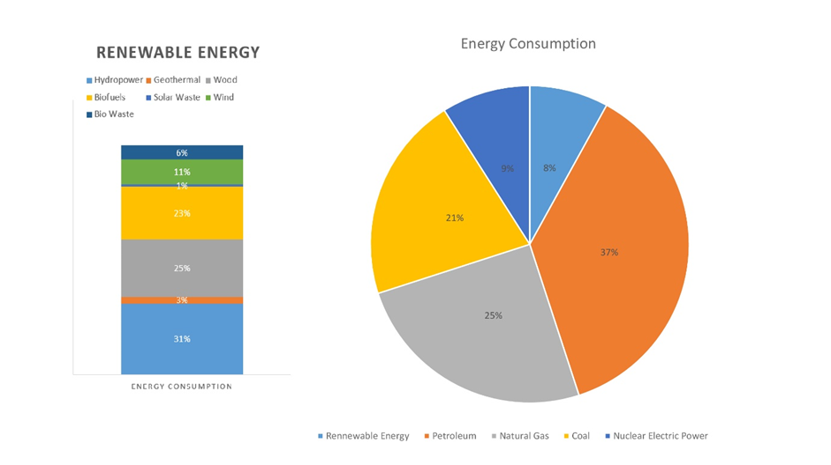
Consumption of renewable energy
The consumption of renewable energy has become a driving force in the global transition towards cleaner and more sustainable energy sources. This transition is like a shift from
Fig.3: Different forms consumption of renewable energy
conventional vehicles to electric ones, propelling us toward a greener future.
Wind Power
Wind power is a dynamic player in the renewable energy landscape, harnessing the power of the wind to generate electricity. Globally, wind energy capacity has exceeded 700 gigawatts, contributing significantly to electricity generation. In some regions, wind power has reached impressive levels, such as Denmark, where wind energy contributed to over 50% of the country's electricity consumption [13].
Solar Energy
The sun, a constant source of energy, is harnessed through solar PV systems. Solar capacity has experienced remarkable growth, with over 600 gigawatts installed worldwide. Some countries, like Germany and China, have become leaders in solar energy adoption [13]. In fact, solar power has reached such levels of efficiency and affordability that it's becoming a household energy solution.
Hydropower
Hydropower, generated from the flow of water, has a significant global presence. It accounts for the largest share of renewable energy consumption. Countries like Brazil, Canada, and China heavily rely on hydropower for their electricity needs [17]. This highlights the adaptability of renewable sources to suit various geographical and climatic conditions.
Bioenergy
Biomass and bioenergy also play a substantial role in renewable energy consumption. Biomass, derived from organic materials like agricultural residues, wood, and even waste, can be converted into energy. Globally, bioenergy contributes to around 10% of the total primary energy supply [17].
Geothermal Energy
Geothermal energy, tapping into the Earth's natural heat, is utilized for electricity generation and direct-use applications like heating and cooling [17]. While its share in global energy consumption is smaller compared to other renewables, it remains an important contributor in regions with suitable geothermal resources.
In the grand narrative of energy consumption, renewables have emerged as protagonists, challenging the dominance of fossil fuels. The steady increase in renewable energy adoption reflects a collective commitment to mitigate climate change and foster a more sustainable future. As we continue to harness the power of wind, sun, water, and other renewable resources, the story of our energy consumption is being rewritten with a greener, cleaner, and more resilient plot [13].
Role of Biofuel in Agriculture
The role of biofuels in agriculture is multifaceted and impactful, intertwining the realms of energy production, environmental sustainability, and agricultural practices. Biofuels serve as a bridge between the energy sector's demand for cleaner alternatives and the agricultural sector's responsibility to cultivate food while minimizing environmental impacts.
- Circular Economy and Waste Utilization
Biofuels, nestled within the realm of agriculture, play a pivotal role in fostering a circular economy – a concept that aims to maximize resource efficiency and minimize waste [25]. This role is akin to orchestrating a grand symphony where every note contributes to a harmonious whole, creating a cycle of sustainability. At the heart of this orchestration lies the transformative power of biofuels. These fuels are not just sources of energy; they are agents of change that can turn agricultural residues, crop waste, and byproducts into valuable resources [10]. This transformation is akin to converting overlooked ingredients into a culinary masterpiece – where the ordinary becomes extraordinary. The aftermath of a harvest – fields strewn with corn stalks, or sugarcane fields with remnants left behind. These remnants, traditionally considered waste, possess untapped potential. Biofuels enter the stage as alchemists, utilizing cutting-edge technologies to convert these remnants into bioenergy [25]. Corn stalks become a source of ethanol, and sugarcane bagasse metamorphoses into biofuel. This transformation not only breathes new life into discarded materials but also turns them into valuable sources of energy. The significance of this transformation reverberates across various dimensions. Firstly, it curtails waste, aligning with the ethos of a circular economy. Instead of leaving residues to decay or cluttering landfills, biofuels give them a renewed purpose. This practice resonates with the ideology of "reduce, reuse, recycle," embodying the essence of sustainability. Secondly, this process epitomizes resource efficiency [10]. In a world grappling with finite resources, biofuels provide a solution that maximizes the utility of agricultural outputs. Like a chef utilizing every part of an ingredient to create a sumptuous feast, biofuels harness the latent energy in agricultural residues, turning them into a valuable energy source. The role of biofuels in waste utilization extends beyond energy production [26]. The co-products generated during biofuel production, such as distillers' grains or biodiesel byproducts, find a new purpose as livestock feed. This convergence of energy production and agriculture closes loops, reducing the strain on traditional feed sources and forming a harmonious relationship between energy and food production. The transformative potential of biofuels also resonates on a larger scale. Picture a world where biofuel production becomes an integral part of agricultural practices. This symbiotic relationship not only addresses energy demands but also elevates the ethos of sustainability in agriculture [23]. As a result, agriculture transcends its traditional boundaries, contributing not only to nourishment but also to powering economies through renewable energy. In this symphony of circular economy and waste utilization, biofuels play a resonant note of innovation, resourcefulness, and environmental stewardship. They embody the art of transformation, turning remnants into riches, and waste into wealth [10]. As biofuels take center stage, they shine as beacons of sustainable progress, where every element, every residue, and every note finds purpose, enhancing the rhythm of our circular world.
- Diversification of Agricultural Landscape
The cultivation of dedicated energy crops for biofuel production brings about a profound transformation in the agricultural landscape, akin to infusing a canvas with an array of vibrant colors. Just as nature thrives on diversity, this deliberate introduction of energy crops enriches the agricultural tapestry, enhancing its ability to weather external challenges. An ecosystem, where each species plays a unique role in maintaining equilibrium [23]. Much like the delicate balance of a forest, the introduction of energy crops introduces a new dimension to the agricultural stage. These crops, nurtured for their biofuel potential, add layers of resilience that mirror the way various species in a diverse ecosystem support one another. The garden is filled with a variety of blooms, each contributing its charm to the overall scene. Similarly, these energy crops diversify the agricultural landscape, creating a living mosaic of growth and adaptation. As we stand witness to this transformation, we recognize that this diverse cast of crops fortifies the farming system against the unpredictability of changing climate patterns [17]. Contemplate the soil beneath this diverse growth, where intricate roots intertwine like the threads of a tapestry. Just as a tightly woven fabric holds its form, the root systems of different crops interlock, preventing soil erosion and promoting vitality. The Earth, underpinned by this diverse network of roots, becomes more resilient and capable of sustaining life [23]. The impact of this diversification extends beyond the soil – it reverberates through the entire ecosystem. Picture a symphony, where a multitude of instruments collaborates to create a harmonious melody. Similarly, these crops work in harmony, bolstering the health of the agricultural system. This unity among crops and the creatures they sustain paints a picture of balance, where nature's harmony unfolds without the need for excessive interventions. As we immerse ourselves in the evolving agricultural landscape, we recognize that it's not just about energy crops or biofuel production [10]. It's about fostering a resilient ecosystem that embraces change and thrives through diversity. With every energy crop planted, a new chapter unfolds, one that celebrates the intricate dance between agriculture and the natural world. This transformation isn't just about biofuels; it's about cultivating a future where our land flourishes, our ecosystem prospers, and our world harmonizes with the rhythms of nature [23].
- Co-Products for Livestock
The co-products generated during biofuel production, such as distillers' grains and biodiesel co-products, find a purpose in livestock feed. This convergence of energy and agriculture helps close resource loops and reduces the pressure on traditional feed sources. It's like optimizing resources to benefit both energy production and animal agriculture.
- Sustainable Land Management
The expansion of biofuel crops can lead to land use concerns, but it also presents an opportunity for sustainable land management practices. For instance, the cultivation of bioenergy feedstocks on marginal lands that are unsuitable for traditional agriculture can help avoid competition with food crops and minimize the impact on primary ecosystems [23].
- Carbon Sequestration
Certain biofuel feedstocks, like perennial grasses and trees, have the ability to sequester carbon from the atmosphere. As these plants grow, they capture and store carbon dioxide, contributing to greenhouse gas mitigation. This not only aligns with climate change goals but also enhances the sustainability of biofuel production [17]. The role of biofuels in achieving carbon neutrality is a compelling journey toward balancing our carbon books. Biofuels, derived from renewable sources like plants and agricultural residues, play a pivotal role in curbing the carbon emissions that contribute to climate change [27]. Imagine them as eco-friendly puzzle pieces that fit perfectly into the larger picture of a sustainable future. Think of biofuels as a key that unlocks a door to carbon neutrality. When biofuels are burned for energy, they release carbon dioxide into the air, just like conventional fossil fuels do. The lies in the fact that the plants used to create biofuels initially absorbed that same amount of carbon dioxide while growing. This creates a cycle – when biofuels are burned, they release carbon dioxide, but when new plants grow to replace the ones used for biofuel production, they absorb an equivalent amount of carbon dioxide, effectively canceling out the emissions . Now envision a world where we rely on biofuels as an integral part of our energy mix. As we consume biofuels, we simultaneously encourage the growth of new plants to replace the ones used, perpetuating a cycle of carbon neutrality [24]. It's like giving back to nature what we borrowed, creating a harmonious exchange that keeps our carbon footprint in check. Consider a scale where the carbon emissions we release are balanced by the carbon absorption of new plant growth. This equilibrium tips the scale toward a carbon-neutral state, where our net contribution to atmospheric carbon dioxide remains close to zero. This intricate dance between human activity and nature's resilience redefines our relationship with energy and the environment. The path to carbon neutrality through biofuels is a testament to our capacity for innovation and adaptation. It's a commitment to harnessing the power of nature to combat climate change, all while meeting our energy needs. As we embrace biofuels, we step onto a bridge that connects sustainability and progress, fostering a world where the energy we consume becomes an ally in the fight for a balanced, carbon-neutral future.
Policy of Biofuels
- Recently, biofuels have attracted attention on a worldwide scale, and it is critical to stay up with the speed of advancements in this area. In India, biofuels are strategically significant and align well with government plans [19]. India continues to rely largely on imported crude oil to meet its domestic energy needs. However, changes in the price of crude oil on the global market might have a big impact on emerging nations.
- The ongoing and significant lack of indigenous feedstock for biofuel production has had a negative influence on India's biofuel program, which has to be rectified. In 2007, a draught of the national biofuels policy was discovered, and by 2009, it had been published [9].
The 2018 National Policy on Biofuels has the following goals: The program aims to move towards the loose goal of reaching a 20% blending of fossil-based fuels with biofuels by 2030.
- The goal of the strategy is to guarantee the appropriate and ongoing supply of domestic feedstock for the manufacture of biofuels, while also improving farmer income, lowering imports, creating jobs, and turning waste into money [19].
- This policy demonstrates the Center's efforts to advance the environmental agenda while bolstering the nation's energy infrastructure [19].
Important Elements of the 2018 National Biofuels Policy The following stand out as key elements of the 2018 National Policy on Biofuels:
The policy divides biofuels into the following categories:
- Basic biofuels include biodiesel and First Generation (1G) bioethanol.
- Municipal Solid Waste (MSW), Second Generation (2G) ethanol, and drop-in fuels are examples of advanced biofuels [19].
- Bio-CNG, a kind of third-generation biofuel
- The goal of the strategy is to guarantee the appropriate and ongoing supply of domestic feedstock for the manufacture of biofuels, while also improving farmer income, lowering imports, creating jobs, and turning waste into money ( RJ Zomer et al.,2017) [19].
- This policy demonstrates the Center's efforts to advance the environmental agenda while bolstering the nation's energy infrastructure
- By allowing the use of sugarcane juice, sugar-containing materials like sugar beetroot, starch-containing materials like cassava, and damaged food grains like broken rice and rotten potatoes that are unfit for human consumption, the policy broadens the range of raw materials that can be used to produce ethanol [19].
- The Policy permits the use of extra food grains to make ethanol that may be blended with fuel. This is done to make sure that during the era of surplus production, the farmers receive the proper price for their crops
- In addition to increased tax incentives and a higher purchase price than 1G biofuels, the Policy suggests a Rs. 5000 crore finance program to close the viability gap for 2G ethanol biorefineries over a six-year period [13 ]
- The Policy encourages the establishment of supply chain mechanisms for the manufacture of biodiesel from non-edible oilseeds, spent cooking oil, and short-gestation crops
- In order to maximize efficiency, the Policy outlines all of the departments' and ministries' obligations with regard to biofuels
Benefits of the 2018 National Biofuels Policy
The 2018 National Biofuels Policy provides the following advantages:
- It lessens the nation's reliance on imports.
- It works to make the environment cleaner: As a result of the conversion of agricultural waste or residue into bioethanol, there is a decrease in the burning of crops [9].
- Cooking oil reuse poses serious health risks, but it might serve as a source of biodiesel [9].
- It also helps with the management of municipal solid waste (MSW). Technologies are available that can turn MSW trash and plastic into biofuels. Such garbage has the potential to reduce fuel use by around 20% per tonne [19].
- The process of making biofuels will help with employment generation.
- The conversion of extra grains and agricultural biomass can assist to stabilize prices and give farmers a second source of income [19].
Expected advantages:
- Reduce Import Dependency: At current exchange rates, one crore E10 lights save Rs. 28 crore in foreign exchange. Around 150 billion liters of ethanol are anticipated to be supplied during the 2017–18 ethanol supply year, saving around Rs. 4000 billion in foreign exchange [9].
- Environmental Cleaner: E-10 can prevent around 20,000 tonnes of CO2 emissions every crore of lights. There will be a 30 lakh tonne decrease in CO2 emissions for the ethanol supply year 2017–18. There will be a further decrease in greenhouse gas emissions by minimizing crop burning and turning agricultural wastes into biofuels [9].
- Health advantages: Reusing cooking oil for food preparation for an extended period of time, especially when deep-frying, poses a health risk and increases the risk of several diseases. It is possible to use wasted cooking oil as a feedstock for biodiesel, which will stop it from being diverted to the food business [19].
- Management of MSW: In India, 62 MMT of municipal solid waste is produced each year, according to estimates. Technologies are available that can turn garbage (including plastic) and MSW into drop-in fuels. Such garbage has the potential to reduce fuel use by 20% or more per tonne [17].
- Rural areas will need about Rs. 800 crore in capital expenditure to build one 100klpd bio refinery, according to estimates. Twelve 2G bio refineries are now being built by Oil Marketing Companies with an estimated cost of Rs. 10,000 crores. The expansion of 2G bio refineries around the nation will encourage infrastructure spending in rural regions ( Leu & Boussiba 2014) [17].
- One 100klpd 2G bio refinery may generate 1200 employment in supply chain management, plant operations, and village-level businesses ( Leu & Boussiba 2014) [17]
- Farmers will now have an additional source of income thanks to the adoption of 2G technology, which will allow them to turn agricultural waste and residue into ethanol and, if a market is created, sell it for a profit. Additionally, during the era of surplus production, farmers run the danger of not receiving a fair price for their crops. In order to stabilise prices, excess grains and agricultural biomass can be converted [13].

National Biofuels Policy Amendment (2022)
- The "National Policy on Biofuels" was released by the Indian Ministry of Petroleum and Natural Gas in 2018 and further updated in June 2022 [28]. The goal of the policy is to increase domestic biofuel generation while lowering petroleum product imports [19].
- The following changes were made to the 2018 National Policy on Biofuels as a result of the amendment: - Move forward the target date for achieving 20% bioethanol blending in petrol from 2030 to 2025–2026 [19].
- Expand the list of feed stocks that can be used to make biofuels [19].
- The plan replaces India's National Biofuel Policy from 2009. India developed a "Roadmap for Ethanol Blending in India 2020-25" based on the updated National Policy on Biofuels [19].
Conclusion
The role of biofuels in agriculture emerges as a transformative force, bridging the gap between energy production, environmental sustainability, and agricultural practices. As agents of change, biofuels orchestrate a harmonious symphony within the circular economy, converting agricultural residues and waste into valuable resources. This shift exemplifies the ethos of sustainability, embodying the principles of reduce, reuse, and recycle, while curbing waste and maximizing resource efficiency. Moreover, the cultivation of dedicated energy crops diversifies the agricultural landscape, infusing it with resilience akin to a vibrant ecosystem. This intentional diversification mirrors the balance found in nature, fortifying agricultural systems to confront the challenges of a changing climate. The harmonious collaboration among energy crops parallels the orchestration of a melody, highlighting the interdependence and unity that contribute to a thriving ecosystem. Biofuels' transformative role extends to livestock co-products, where they optimize resources, reducing pressure on traditional feed sources while bridging energy and agriculture. Additionally, sustainable a}nd management practices associated with biofuel crop expansion provide opportunities to minimize environmental impact while maximizing energy production on marginal lands. Furthermore, the potential of certain biofuel feedstocks, such as perennial grasses and trees, to sequester carbon underscores their contribution to greenhouse gas mitigation and carbon neutrality. This journey towards balancing carbon books through biofuels aligns with climate change goals, offering a sustainable solution that embraces the natural world's intricate dance. In a world embracing the renewable revolution, biofuels illuminate a path toward a future where energy and agriculture coexist harmoniously, complementing each other's vitality. As we continue to harness the potential of biofuels, we embark on a journey toward a more sustainable, resilient, and greener world, where innovation, resourcefulness, and environmental stewardship shape the narrative of our circular planet. The story of biofuels in agriculture is not merely a tale of energy production; it's a testament to the harmony we can achieve when we view our world through the lens of sustainability. With each chapter unfolding, biofuels etch their mark on a canvas of transformation, guiding us towards a future where energy and agriculture flourish hand in hand, weaving a narrative that celebrates the unity of human progress and the rhythms of our interconnected planet.
Reference
- Achinas, S., & Euverink, G. J. W. (2016). Consolidated briefing of biochemical ethanol production from lignocellulosic biomass. Electronic Journal of Biotechnology, 23, 44-53.
- Agarwal, A., Rana, M., & Park, J. H. (2018). Advancement in technologies for the depolymerization of lignin. Fuel Processing Technology, 181, 115-132.
- Agyeman, J. (2013). Introducing just sustainabilities: Policy, planning, and practice, 574.
- Arshad, M., Zia, M. A., Shah, F. A., & Ahmad, M. (2018). An overview of biofuel. Perspectives on Water Usage for Biofuels Production: Aquatic Contamination and Climate Change, 1-37.
- Ayadi, M., Sarma, S. J., Pachapur, V. L., Brar, S. K., & Cheikh, R. B. (2016). History and global policy of biofuels. Green Fuels Technology: Biofuels, 1-14.
- Bauer, F., Persson, T., Hulteberg, C., & Tamm, D. (2013). Biogas upgrading–technology overview, comparison and perspectives for the future. Biofuels, Bioproducts and Biorefining, 7(5), 499-511.
- Grisolia, G., Fino, D., & Lucia, U. (2020). Thermodynamic optimisation of the biofuel production based on mutualism. Energy Reports, 6, 1561-1571.
- Hufnagel, J., Reckling, M., & Ewert, F. (2020). Diverse approaches to crop diversification in agricultural research. A review. Agronomy for Sustainable Development, 40, 1-17.
- IEA (2023). National Policy on Biofuels (2022 Amendment). Retrieved from https://www.iea.org/policies/17006-national-policy-on-biofuels-2022-amendment
- Kamble, C. B., Raju, R., Vishnu, R., Rajkanth, R., & Pariatamby, A. (2021). A circular economy model for waste management in India. Waste Management & Research, 39(11), 1427-1436.
- Kotay, S. M., & Das, D. (2008). Biohydrogen as a renewable energy resource—prospects and potentials. International Journal of Hydrogen Energy, 33(1), 258-263.
- Kothari, R., Vashishtha, A., Singh, H. M., Pathak, V. V., Tyagi, V. V., Yadav, B. C., Ashokkumar, V. & Singh, D. P. (2020). Assessment of Indian bioenergy policy for sustainable environment and its impact for rural India: Strategic implementation and challenges. Environmental technology & innovation, 20, 101078.
- Leu, S., & Boussiba, S. (2014). Advances in the production of high-value products by microalgae. Industrial Biotechnology, 10(3), 169-183.
- Liska, A. J., Yang, H., Milner, M., Goddard, S., Blanco-Canqui, H., Pelton, M. P., Fang, X.X., Zhu, H. & Suyker, A. E. (2014). Biofuels from crop residue can reduce soil carbon and increase CO 2 emissions. Nature Climate Change, 4(5), 398-401.
- Lucia, U. (2017). The wasted primary resource value: an indicator for the thermodynamics of sustainability for municipalities policy. International Journal of Thermodynamics, 20(3), 166-172.
- Majid, M. A. (2020). Renewable energy for sustainable development in India: current status, future prospects, challenges, employment, and investment opportunities. Energy, Sustainability and Society, 10(1), 1-36.
- Malode, S. J., Prabhu, K. K., Mascarenhas, R. J., Shetti, N. P., & Aminabhavi, T. M. (2021). Recent advances and viability in biofuel production. Energy Conversion and Management: X, 10, 100070.
- Murphy, C. W., & Kendall, A. (2015). Life cycle analysis of biochemical cellulosic ethanol under multiple scenarios. Gcb Bioenergy, 7(5), 1019-1033.
- National Policy on Biofuels-2018 (2018) Ministry of Petroleum & Natural Gas. Government of India. Press Inf. Bur. Retrieved from https://pib.gov.in/Pressreleaseshare.aspx?PRID=1532265
- Nguyen, D. D., Chang, S. W., Cha, J. H., Jeong, S. Y., Yoon, Y. S., Lee, S. J., Tran, M.C. & Ngo, H. H. (2017). Dry semi-continuous anaerobic digestion of food waste in the mesophilic and thermophilic modes: New aspects of sustainable management and energy recovery in South Korea. Energy Conversion and Management, 135, 445-452.
- O’Hara, I. (2023). Explainer: The Evolution of Biofuels. Retrieved from https://theconversation.com/explainer-the-evolution-of-biofuels-3180
- Polburee, P., Yongmanitchai, W., Lertwattanasakul, N., Ohashi, T., Fujiyama, K., & Limtong, S. (2015). Characterization of oleaginous yeasts accumulating high levels of lipid when cultivated in glycerol and their potential for lipid production from biodiesel-derived crude glycerol. Fungal biology, 119(12), 1194-1204.
- Saini, R., Hegde, K., Brar, S. K., & Vezina, P. (2020). Advanced biofuel production and road to commercialization: An insight into bioconversion potential of Rhodosporidium sp. Biomass and bioenergy, 132, 105439.
- Shah, R. (2021). The Evolution of Biofuels. Retrieved from https://www.petro-online.com/article/biofuel-industry-news/22/koehler-instrument-company/the-evolution-of-biofuels/2923
- Sharma, S., Basu, S., Shetti, N. P., & Aminabhavi, T. M. (2020). Waste-to-energy nexus for circular economy and environmental protection: Recent trends in hydrogen energy. Science of the Total Environment, 713, 136633.
- Sharma, S., Kundu, A., Basu, S., Shetti, N. P., & Aminabhavi, T. M. (2020). Sustainable environmental management and related biofuel technologies. Journal of Environmental Management, 273, 111096.
- Zomer, R. J., Bossio, D. A., Sommer, R., & Verchot, L. V. (2017). Global sequestration potential of increased organic carbon in cropland soils. Scientific Reports, 7(1), 15554.

