INDIGENOUS BREEDS OF POULTRY
Shivani Das
College of Veterinary Science & Animal Husbandry
Odisha University of Agriculture & Technology
Bhubaneshwar, Odisha, India
Email- shivanidas093120@gmail.com

I. Introduction

Indigenous/ native breeds of chickens are playing an important role in rural economies in most of the developing and underdeveloped countries.The play a major role for the rural poor and marginal section of the people with respect to that subsidiary income and also provide them with nutritious chicken egg and meat for their own consumption. In the tropics, small land holders keep chickens for their socio religious functions. This refers to the commitment of an individual or community to a particular spiritual being, deity or season and traditional/ religious festivals are evaluated by the quality of the offering that satisfy special morphological features of chicken demanded by the receivers.

Though local chickens are slow growers and poor layers with small sized eggs, they are ideal mothers and good sitters. They are also excellent foragers, hardy and possess natural immunity against common diseases.One of the most important positive traits of native chicken is their hardiness which enable them to resist the harsh environmental conditions and poor husbandry practices without much loss in production.

In India, some of the important breeds which have been documented are Aseel, Ankaleshwar, Busra, Daothigir, Denki, Ghagus, Haringhatta black, Kadaknath, etc.

II. Aseel

Aseel is an Indian breed of game chicken. It is distributed in much of India, particularly in the states of Tamil Nadu, Andhra Pradesh, Chhattisgarh and Odisha. They were originally kept for cock fighting but nowadays they are kept for ornamental purposes. It is not advisable to keep many roosters together because they will fight until death. They are friendly, very tame and trusting towards humans.

Aseel chickens are known for their distinctive appearance with a muscular build, short and powerful legs and a small head with a large comb. They come in a variety of colors including black, white and red and can have either smooth or feathered legs. Both roosters and hens are very beautiful.

Aseel chickens are a slow growing breed but they are known for their flavorful meat. They have a high muscle to bone ratio. They lay smaller eggs with a rich and flavorful yolk.

Aseel chickens are used as a base for crossbreeding with other breeds. They have also been used in traditional cultural events, religious ceremonies, etc.

Aseel chicken has a rich history. Their origin dates back to the Indus valley civilization. They were highly priced for their fighting abilities and were considered as a symbol of power and wealth.

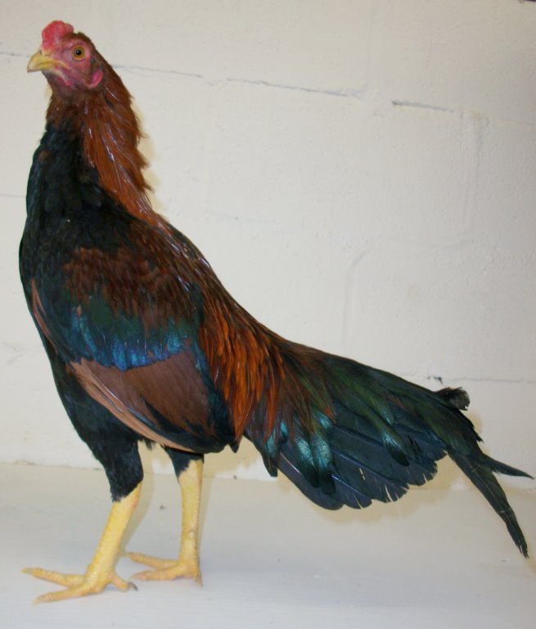
Figure 1: Aseel

III. Ankaleshwar

Ankleshwar birds are found in Bharuch and Narmada district of Gujarat, mainly in Ankleshwar, Jambusar, Bharuch, Valia areas. In their breeding tract, they are also called desi/ gowrani/ gamthi. Ankleshwar chicken is quite hard and adapted to its environment. The chicken is associated with the culture of the tribe (Vanvasi) which rear them. Ankleshwar birds are maintained in the backyard system and provide a good source of animal protein for the tribals. They are kept for meat and egg production.

Plumage colour ranges widely from a combination of white and light grey to brown and golden. The plumage pattern is generally stripped with golden yellow feathers having black tips. Yellow plumage is more common in cocks and black golden is more common in hens. The comb is red and is of rose type. The beak is small and yellow in colour.

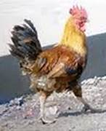
Figure 2: Ankleshwar

IV. Busra

Busra birds are layer type small to medium size and found in some parts of Maharashtra and Gujarat. This is the only breed of backyard poultry in Maharashtra and the tribal peoples economy is basically dependent on it. These birds are reared for home consumption as well as for sale purpose. They are kept in the free range system. Flock size varies from 2 to 25 (average).

Busra birds are small in size and have variation in body colour. Plumage colour is mostly white mixed with black feathers on neck, back, tail and reddish brown feathers on shoulders and wings. Comb is red and single.

Weight of cock is near about 0.85 to 1.25 kg and of hen is from 0.8 to 1.2 kg. Age at first egg ranges from 5 to 7 months and a hen lays about 12 to 13 eggs in about two weeks of time.

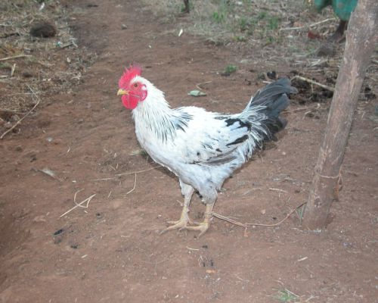
Figure 3: Busra

V. Daothigir

Daothigir breed of chicken is found in Bodoland region of Assam. Breeding tract comprises mainly of Kokrajhar district and some parts of Dhubri, Bongaigaon, Barpeta and on the North Bank of the Brahmaputra. These birds are reared mainly for meeting the domestic needs of meat and eggs. These also serve as a cash reserve for the farmers.

Flock size in the Daothigir breed ranges from 10 to 60 with an average of about 23. Birds are kept in the open system. They collect their feed from forest areas and eat whatever is available in the form of grains, seed, vegetation, insects, etc. In the evening, they return back to the owner’s house.

Birds are small sized but are heavy and have long legs. Plumage colour is mostly black interspersed with white feathers. White with black or brown with white are also not uncommon. Plumage pattern is stripped or spotted. Neck and back have golden yellow or brown feathers. Tail is short and almost in level with the back.

Average weight of cock is 1.79 kg and that of hen is 1.63 kg. Age at first egg ranges from 5.8 months to 6 months. Annual egg production ranges from 60 to 70 eggs. Egg shell colour is light brown.

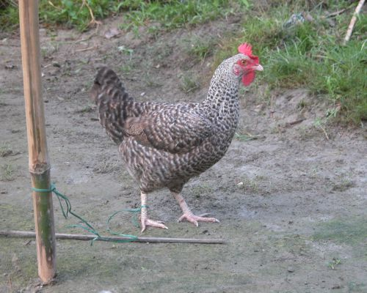
Figure 4: Daothigir

VI. Ghagus

Ghagus is an important chicken breed found in Karnataka.Birds mostly distributed in Kolar and adjourning parts of Bangalore district of Karnataka, Chittoor and Anantapur district of Andhra Pradesh. It is a native chicken breed of India. It is a medium sized bird with good mothering ability or broodiness. Male birds have shiny, bluish black tail, feathers and breast and reddish brown coloured plumage.The brown coloured feathers are found in the neck. Female birds have mostly brown coloured plumage mixed with dark to light brown coloured feathers. Pea comb is observed predominantly but single comb is also noticed in some birds.

Ghagus birds are smaller in size as compared to Aseel, Danki and Kalasthi but egg production is more than these breeds. The average egg production in a year is 45 to 60 eggs in a laying cycle. There are about 3 laying cycles. The adult cocks and hens weigh on an average about 2.16 kg & 1.43 kg respectively. Their age at first egg ranges from 5 to 8 months. They are reared in free range, backyard and semi-intensive systems in rural tribal areas.

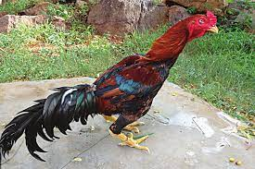
Figure 5: Ghagus

VII. Haringhata Black

Haringhata black chicken is the native breed of West Bengal state of India. It is jet black in colour with red comb and wattles while the shanks are white in colour. It can be used for starting backyard poultry farming. They are used for both egg & meat purpose. They mainly act as game birds. The body weight of male bird generally ranges from 1 to 2 kg. The female bird starts to lay eggs after 4 months. They lay about 100 to 120 eggs annually.The meat and egg satisfy most of the nutrient requirements and are rich in minerals and vitamins. Power of tolerance, survivability from predators and adaptability is superb.

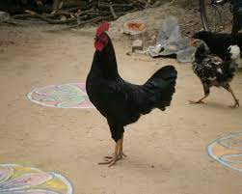
Figure 6: Haringhata Black

VIII. Kadaknath

Kadaknath, also called as Kali Masi (fowl with black flesh) is an Indian Native breed of chicken. The birds originated from Dhar and Jhabua areas of western Madhya Pradesh; these birds are mostly bred by rural people & Bhil tribals. Kadaknath birds are in demand due to its meat quality, texture and taste. It is said to have some medicinal properties.

Males and females are black in colour with golden head and neck. The entire bird including plumage, skin, shank and internal organ is black. The eggs of kadaknath are very expensive because they are an excellent source of protein, iron and are low in fat.

Male bird weighs from 1.8 to 2 kg and the female bird weighs from 1.2 kg to 1.4 kg. Age at first egg is high (185 days) and the egg production potential of this breed is somewhat less, about 50 to 55 eggs in 40 weeks. The annual egg production is in the range of 120 to 140 eggs.

Nowadays, People are preferring kadaknath chicken to lose weight because it has low fat. These birds bear great medicinal value in Homeopathy and are useful in treating nervous disorders. It also helps to increase blood cells and haemoglobin concentration in blood, curing many pulmonary problems. Kadaknath chicken is set to be good for women's health. Kadaknath chicken eggs are used to treat headaches, asthma & nephritis. The main advantage of these bird’s meat is that it has more protein, less fat and low cholesterol, when compared to similar kinds of other poultry breeds.

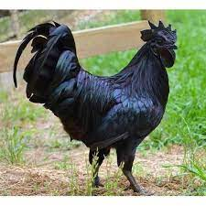
Figure 7: Kadaknath

IX. Kalasthi

Kalasthi is an indigenous breed distributed in Chittoor and adjoining parts of Nellore and Cuddapah district of Andhra Pradesh. They are known as desi. Kalasthi birds are mainly kept for meat purposes and cocks are used for fighting. Utility of these birds for egg production is not much due to the very small number of eggs being laid, about 30 to 40 eggs per year.

The birds are reared in the backyard system. Average flock size ranges from 3 to 53. They spend their nights on trees. Fighting cocks are kept individually under a basket.

The plumage colour is bluish black & brown. Cocks have shining bluish black feathers. Neck is long and is covered with golden feathers. Wattles are small & red in colour. Comb is red & is of pea or mixed type.
Average weight of cocks & hens is 2.48 kg & 1.85 kg respectively. Hens start laying eggs at the age of about 5 to 9 months. Annual egg production is 34 eggs.

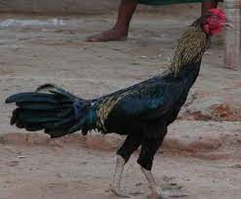
Figure 8: Kalasthi

X. Punjab Brown

A multi-purpose breed, yielding good quality meat and reared in backyard system and shelter is provided only at night, mostly made up of mud & sometimes of wood. These are found in rural areas of Gurdaspur in Punjab & Ambala in Hariyana.

Plumage colour is brown. Males usually have black spots or stripes on the neck, wings & tail. Comb is large, single and red in colour. Wattles are large-sized in males and small-sized in females.

Average weight of cocks and hens is 2.15 kg and 1.6 kg respectively. Age at first egg is 5 to 7 months and annual egg production is 60 to 80 eggs. They are used both for meat as well as egg production in Punjab.

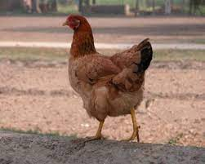
Figure 9: Punjab Brown

XI. Conclusion

India is full of non-descriptive breeds of poultry. The documentation of the breeds are going on, but much is still left. There is a need to do much research on non-descriptive breeds. Preservation should be done and we have to find out the adaptability and other good qualities of indigenous breeds and genetically upgrade them with crossbreeding, which can enhance their utility and benefit the rural, tribal, marginal and landless families of India.

REFERENCES

[1]https://nbagr.icar.gov.in/wp-content/uploads/2020/02/Ghagus-Chicken.pdf

[2]https://www.pashudhanpraharee.com/importance-of-native-breeds-of-poultry-for-rural-economy-in-india/

[3]https://r.search.yahoo.com/_ylt=Awr1TaVL0cdk9j0c51S7HAx.;_ylu=Y29sbwNzZzMEcG9zAzEEdnRpZAMEc2VjA3Nj/RV=2/RE=1690845643/RO=10/RU=http%3a%2f%2fsapplpp.org%2farchive%2fgoodpractices%2ffolder-for-related-files%2fSAGP03-GPNote.pdf%23%3a~%3atext%3dThe%2520NDDB-FAOSouth%2520Asia%2520Pro-Poor%2520Livestock%2520Policy%2520Programme%2528SA%2520PPLPP%2529%2cas%2520international%2520policies%2520and%2520programs%2520affecting%2520their%2520livelihoods%2527./RK=2/RS=YJZ79GORQhEV5sIZkG9r6Ya1cFk-

[4]https://r.search.yahoo.com/_ylt=Awr1Qad60cdkEzwckD.7HAx.;_ylu=Y29sbwNzZzMEcG9zAzEEdnRpZAMEc2VjA3Ny/RV=2/RE=1690845691/RO=10/RU=https%3a%2f%2fnbagr.icar.gov.in%2fen%2fregistered-chicken%2f/RK=2/RS=txJAfihLg_iVQvXJwOpCrjFV3JE-

[5]https://r.search.yahoo.com/_ylt=Awrx_xTU0cdkB4UbQsu7HAx.;_ylu=Y29sbwNzZzMEcG9zAzEEdnRpZAMEc2VjA3Nj/RV=2/RE=1690845781/RO=10/RU=https%3a%2f%2fwww.ncbi.nlm.nih.gov%2fpmc%2farticles%2fPMC4838803%2f%23%3a~%3atext%3dIndigenous%252Fnative%2520breeds%2520of%2520chickens%2520are%2520playing%2520an%2520important%2cchicken%2520egg%2520and%2520meat%2520for%2520their%2520own%2520consumption./RK=2/RS=laCqpWaqFnyxi0LRnLCVuKoM96Q-

[6]https://r.search.yahoo.com/_ylt=AwrKB1gj0sdkFC4cxny7HAx.;_ylu=Y29sbwNzZzMEcG9zAzEEdnRpZAMEc2VjA3Nj/RV=2/RE=1690845859/RO=10/RU=https%3a%2f%2faliah.ac.in%2fupload%2fmedia%2f07-04-20_1586256727.pdf%23%3a~%3atext%3dThe%2520most%2520popular%2520varieties%2520are%2520peela%2520%2528golden%2520red%2529%252C%2cwhite%2520silver%2529%252C%2520Teekar%2520%2528brown%2529%2520and%2520Reza%2520%2528light%2520red%2529./RK=2/RS=oXl.2_LMlHr5XfYlrx51JMvdCHQ-

[7]https://r.search.yahoo.com/_ylt=Awr1Qade0sdkuSMcpF.7HAx.;_ylu=Y29sbwNzZzMEcG9zAzQEdnRpZAMEc2VjA3Ny/RV=2/RE=1690845918/RO=10/RU=https%3a%2f%2fdownloads.hindawi.com%2fjournals%2fscientifica%2f2016%2f2604685.pdf/RK=2/RS=1LqhDPTBxvA.6N3GDWkkMN4chNk-

[8]https://r.search.yahoo.com/_ylt=AwrKB1iP0sdkgjwcM4C7HAx.;_ylu=Y29sbwNzZzMEcG9zAzIEdnRpZAMEc2VjA3Ny/RV=2/RE=1690845968/RO=10/RU=https%3a%2f%2fwww.agrifarming.in%2fkadaknath-chicken-breed-information/RK=2/RS=CzsolXhHWnDiGNNgf3wnSMTnLew-

[9]https://r.search.yahoo.com/_ylt=Awrx_R660sdk73Ycnlm7HAx.;_ylu=Y29sbwNzZzMEcG9zAzIEdnRpZAMEc2VjA3Ny/RV=2/RE=1690846010/RO=10/RU=https%3a%2f%2fnbagr.icar.gov.in%2fen%2fregistered-chicken%2f/RK=2/RS=XF81vFOad1gmpuwiiJm0eZNfWFc-

