Selection of Parting agent and coping with oxidizing materials for creating nuclear targets
Amar Das^{1,2}, Nabendu Kumar Deb^{1,3}, Kushal Kalita¹
¹Department of Physics, Gauhati University, Jalukbari, Guwahati, 781014, Assam
²Suren Das College Hajo, 781102
Kamrup College Nalbari 781306
Email: amarbhdas@gmail.com
Abstract
In heavy ion nuclear reaction experiments; self-supporting, thin and pure targets of uniform thickness are required for the studies like measurement of fusion excitation function, barrier distribution and recoil range distributions using different heavy ion projectile. But it is not always possible due to its inconsistencies and instabilities. Obtaining such target foil (especially for high Z materials) becomes a very tedious job, due to certain experimental limitations. To avoid these, target materials are evaporated on a thin lower Z backing material. Fabrication of targets of materials which get readily oxidized also poses lot of challenges in experiments. To avoid oxidation, appropriate capping along with backing is provided. To avoid contamination in the target, environmental condition and the proper selection of parting agent is also important. The enriched targets of stable isotopes ^{61,62}Ni, ¹¹⁶Sn, ^{154,144}Sm and ^{142,148}Nd have been fabricated by adapting physical vapour deposition technique at IUAC, New Delhi using a high vacuum evaporation chamber facility. Role of encapsulation in minimizing the oxidation and the contamination level from parting agents in the targets is reported in this work. The thicknesses of the targets are verified using profilometer, α-energy loss technique. The purity and the uniformity of the fabricated targets are further confirmed after verification using RBS technique.
Keywords: Physical vapour deposition, Nuclear reaction studies, Oxidised target fabrication, Thin film, The RBS, Alpha energy loss thickness measurement
1. Introduction
For the nuclear reactions to occur, a good quality projectile beam and the homogeneous target with uniform thickness, smooth surface, good tensile strength, good adhesion between the thin film and the substrate, low enmesh of gas and less contamination, as per the requirement of experiments, are needed [1,2], which poses a serious challenge during its fabrication. In order to study heavy-ion induced nuclear reaction with ^{61,62}Ni and ¹¹⁶Sn elements using mass analyzer, where the reaction products are separated from the beam-like particles and disperses the nuclei of interest at its focal point with good mass resolution, thin self-supporting targets with areal density ranging from few μg/cm² to a few mg/cm², are preferable. The energy loss of projectile beam and of the trapping of reaction products within the target will then be minimized due to its small thickness which ultimately gives better experimental resolution and hence clear spectrum can be obtained. In order to measure fusion excitation function (EF) precisely and to determine barrier distribution, small energy steps are necessary. And the energy lost by the incident beam must be lesser than the energy steps. Also in order to study about the role of various entrance channel parameters viz., mass-asymmetry of the system, coulomb factor (Z_{p}Z_{t}), target deformation etc. [3] on the incomplete fusion dynamics [4], a series of experiments were to be done to perform EFs and Forward Recoil Range Distribution measurements using the alpha and non-alpha clusters ion beam with enriched ^{144,154}Sm and ^{142,148}Nd targets. Accordingly, thermal evaporation techniques are the most effective methods to obtain thin self-supporting targets [5]. But sometimes, due to certain experimental complications involved in the deposition, obtaining a very thin self-supporting target foil (especially for high Z materials) becomes a very tedious job. Thus to avoid these difficulties, target materials are evaporated on a thin lower Z backing material (e.g. carbon) foil (≈ 30 μg/cm²) through which the energy loss and energy straggling effects will be minimized before reaching the target material. As carbon does not react with most of the metals, it qualifies to be the first choice as the backing material. But Sm and Nd are both highly oxidizing elements due to which the elements need to be sandwiched between two non-oxidising thin layers of low Z material. Apart from backing, the other layer will cover the opposite side of the target known as the capping which will be of very thin layer. Here the backing for both Sm and Nd is chosen to be Al material (≈ 1 mg/cm²) and the capping will be of C material (≈ 5 μg/cm²) for Sm and Al material (≈ 5 μg/cm²) for Nd elements. Both these low Z elements are inert towards Sm and Nd.

There are various procedures and backing composition of Ni, Sn, Sm target fabrications that are already available in the literature. Cheltsov [6] obtained highly enriched Ni isotope using centrifugal enrichment process. The fabrication of self-supporting Ni target using rolling technique and evaporation technique (a deposition method based on the vibrational motion of micro-particles in the electrostatic field) are respectively reported in refs. [7,8] and refs. [9,10]. K.O. Zell [11] prepared Sn target on Bi – backing by rolling and on Cu – backing using evaporation technique. Abhilash et al. [7] prepared self-supporting Sn target using rolling techniques. A. Singh et al. fabricated Au – backed Sn targets using rolling technique and evaporation technique [12]. Abhilash et al. [7] and P. Sharma et al. [13] prepared thin carbon backed ¹²²Sn targets using the resistive heating method with parting agent NaCl and BaCl₂ respectively. P. K. Giri et al. [14] and S. Ali et al. [15] fabricated ¹²⁴Sn on Al – backing and ¹¹²Sn target on Pb – backing respectively. Here, in this paper, preparation of a carbon backed thin target of enriched ^{61,62}Ni, ¹¹⁶Sn (≈ 100 – 150 μg/cm²) isotopes, with KCl (potassium chloride) as parting agent, using a physical vapor deposition technique (ultra-high vacuum thermal evaporation) has been reported along with the essential steps and also the precautionary measures to be considered for successful fabrication.

Preparation and storage of lanthanide targets are quite challenging task as they are chemically very active. Kavita et al. [16] have prepared such lanthanide targets, viz., thin ¹⁶⁰Gd targets using thermal evaporation technique. Banerjee et al. [1] also fabricated lanthanides (¹⁷⁵Lu, ¹⁶⁹Tm) targets. Sm is moderately hard silvery metal that promptly oxidizes in air to form Sm₂O₃. Lipski et al. [17] fabricated self supporting Sm target (1 – 2 mg/cm²) by reduction of metal oxides using rolling technique. Nickel et al. [18] prepared 100 – 250 mg/cm² of Sm oxide targets with thick C and Ti backing to prevent oxidation using electron-gun technique. But such thick backing will be inefficient in our case. Guozi et al. [19] prepared Sm targets (0.1 – 15 mg/cm²) on Al-, Au- and C-backings (0.2 mm) by centrifugal precipitation method. But fabrication of thin Sm and Nd targets have not been yet achieved using the thermal evaporation technique.

For this purpose, 100 mg of each 99.39% enriched ⁶¹Ni, 98.45% enriched ⁶²Ni, 99.6% enriched ¹¹⁶Sn, 93.7% enriched ¹⁴⁴Sm, 98.9% enriched ¹⁵⁴Sm, 93.7% enriched ¹⁴²Nd and 98.9% enriched ¹⁴⁸Nd were imported. Both ⁶¹Ni and ⁶²Ni were in the form of powder with the latter being magnetic in nature which readily sticks even to the forceps, bottles etc. ¹¹⁶Sn, ^{144,154}Sm and ^{142,148}Nd were in the form of thin metal flakes. Owing to this limited availability of the isotope material, many trials were done using the natural elements, before going for the direct isotope deposition, to calibrate and optimize the various parameters required for their fabrication process. To begin with, fabrications of self-supporting thin films were tried using natural elements. The fabrication of targets with the natural elements was successful, but it was inconsistent and unstable. This led us to go for evaporation of the material on some appropriate backing which is chosen to be carbon for non-oxidising elements and Aluminium for oxidizing elements. The diffusion pump based coating unit, with a vacuum of the order of 10⁻⁶ mbar, was used for the deposition of carbon and aluminium foils whereas the turbo-pump based coating unit, with a vacuum of around 10⁻⁹ mbar, was used for the deposition of isotopes. At times the target broke down due to some unknown reasons. In order to obtain consistent and intact or stable targets, some trials are done using deposited carbon-slides and were found that the parting agent, or carbon, or the material deposited over carbon in the slides start degrading whenever it is kept idle for more than one or two days. This precautionary aspect of degradation is very important for any target fabrication process [20]. The following sections will give the description of the experimental setup, fabrication processes, characterization techniques and conclusions.

2. Experimental Details
2.1 Thermal Evaporation setup.
Thermal deposition (TD) technique is one of the important and effective methods for the thin film fabrication involving heavy ion beams. TD is a coating technique in which the material to be deposited is transferred from the source to substrate on an atomic level under vacuum. During evaporation the material is bombarded by a high energy beam of electrons/ions which dislodge the atoms from its surface. The vaporized atoms are then transported in straight line to the substrate. The metal atoms that react with gas while being transported will not be the case in vacuum. The deposition then takes place due to which coating build up on the surface of the substrate. Schematics of the diffusion pump based coating unit (DPU) or high vacuum (HV) chamber and the turbopump based coating unit (TPU) or ultra-high vacuum (UHV) chamber, in the target laboratory of IUAC can be seen in Fig. 1 where TD will be implemented. DPU is connected with a diffusion pump. It is equipped with single pocket 2 kW electron gun (e-gun) and resistive heating arrangement. Liquid nitrogen (LN2) trap is fitted between the chamber gate valve and the diffusion pump. LN2 condense oil molecules of diffusion pump from moving towards the chamber. This gives better vacuum pressure. TPU, on the other hand, is connected with a turbo molecular pump and a pump used as the backing, i.e., scroll pump. This chamber is equipped with electron beam bombardment assembly consisting of 6 kW multi-pockets e-gun.

To maintain the chambers at room temperature, chilled water is circulated throughout it. A thickness monitor, made of piezoelectric crystal (quartz crystal of model Edwards FTM 5 crystal with 6 MHz as its unloaded frequency), is kept inside both the chambers which will monitor the deposition of thin films with time [21].
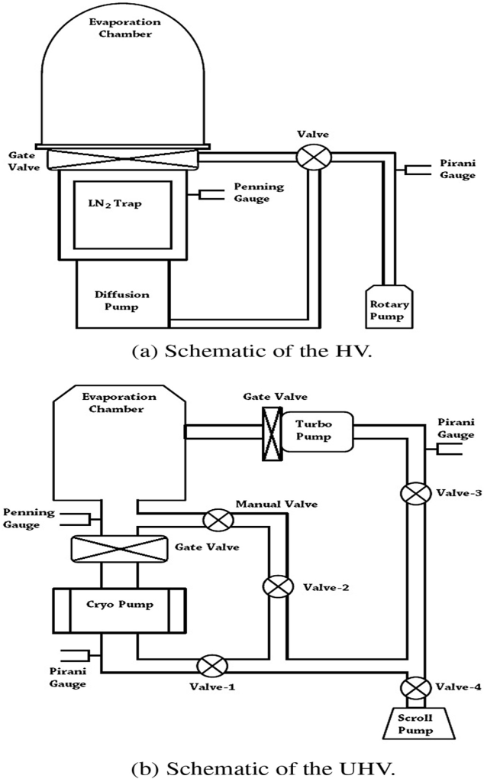
Figure 1 Schematic diagram of DPU and TPU
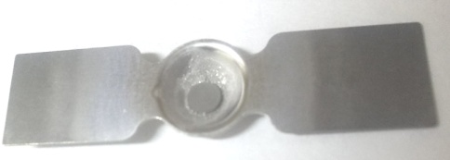
Figure 2 Metal boat used for source evaporation

2.2 Fabrication of self-supporting natural element.
Using natural Ni (in the form of wire), natural Sn (in the form of metal shots) several attempts were made to prepare the thin self-supporting targets. Clean glass slides were taken and on one face of them, few drops of colourless and dense soap solution - Teepol (composition of Myristyl trimethyl ammonium bromide and hydrogen peroxide) were rubbed uniformly throughout the surface. Teepol will act as a parting agent in this case as it is readily soluble in water. These teepol coated glass slides are then kept (with teepol surface facing the source) on the dice which is clamped in the clean DPU chamber at a distance of 10 cm from the source. The thickness monitor is also focussed at 10 cm from the source. The source is kept on the metal boat (the metal of the boat is selected in such a way that it should not react with the source) as shown in Fig. 2. The vacuum of the order of 10⁻⁶ mbar is then obtained in the chamber and then the deposition was started using thermal evaporation with resistive heating technique till the desired thickness of ≈ 100 μg/cm² is obtained. The deposition rate was kept around 0.1 nm/sec. After about 4 hours, the chamber is vented gradually, it is then opened. The glass slides are taken out and floated in warm distilled water (the floating process is very well described by T. Banerjee et al. [1]). During floating, the deposited face of the slide is exposed over the vapour of the warm water. This loosens the deposited layer thereby making it easier for its separation from the slide when it is forced very slowly inside the water from one end at approximately 45⁰ with the water surface. The film then floats on the water (Fig.3). With the target holder having 1 cm diameter hole, the film is then grabbed and slowly picked up from the water surface. The natural element target fabrication, therefore, was successful. But then these targets were found to be inconsistent and some of them even broke down. Thus to avoid the loss of the limited amount of isotopes, preparation of self-supporting targets were not attempted. This led us to go for carbon backed target preparation.

In case of both Sm and Nd elements being oxidising in nature, it is hard to fabricate their self-supporting target. So these targets were fabricated on Al backings of thickness ~ 1 mg/cm². These Al – backing foils were prepared by rolling machine in the same way as discussed in Ref. [12] and their thickness was determined by the weighing method as well as an alpha transmission method [20]. The first few testing of target fabrication using natural Sm and Nd revealed a critical issue. The issue was, after the deposition of the required thickness of material over the Al backed foil, both Sm and Nd material got oxidised very quickly the moment these were taken out from the evaporation chamber by breaking the vacuum after the evaporation. Thus to minimise such oxidation the concept of sandwiched targets was taken by capping the target with a thin layer of carbon. It is important to make sure about the fabrication probability with natural material before attempting the isotope fabrication. This would not only save the cost but it will also give the high rate of successful isotopic target fabrication with the required target thickness for experimental nuclear physics and other experimental purposes.
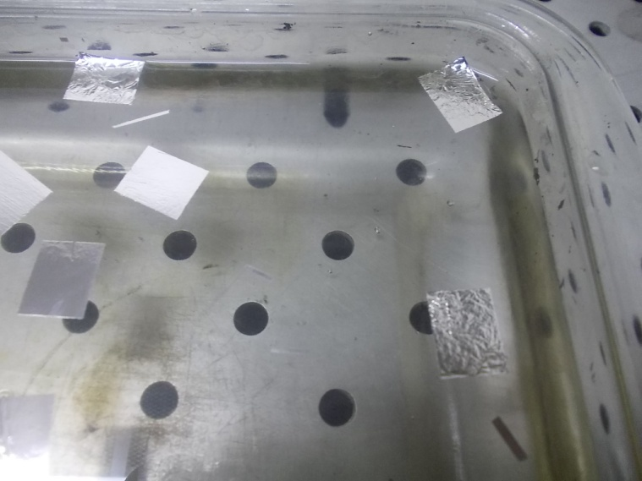
Figure 3 Floating Films

2.3 Fabrication of carbon backing
To prepare carbon-backed target, the first step is to prepare carbon foil. But before going for carbon (C) deposition, a parting agent deposition is required. A parting agent selection is very important as it helps in separating the target film from the substrates after deposition. The parting agent should not contribute in contamination or degradation of the isotopic film. Braski [2] found that alkali halides are more effective as a parting agent than others by using carbon replicas for comparing surface structure and separating ability of different parting agents like alkali halides, Victawet, detergents, plastics. For the present work, potassium chloride (KCl) is considered as parting agent. In case of other metal halides, the degradation of NaCl film in the moist air reduces its solubility in water [7], CsI being unstable cannot be used here [1] and BaCl₂ leads to more contamination with carbon film compared to KCl [22]. For the case of isotopes considered here, the difference of K mass and the mass of these isotopes is enough to separate its energy spectrum which will ease the analysis work after the experiments, provided if K is responsible for the contamination on the metal unlike that of Refs. [7] and [13].

The DPU chamber is thoroughly cleaned with propanol. A thin pellet of KCl powder is prepared using hydraulic press and then taken along with carbon source, viz., graphite and are enclosed in the DPU chamber simultaneously. KCl is kept on rectangular Molybdenum boat of width 1 cm (Fig. 4) and C is kept on the Copper crucible. Using thermal evaporation, KCl of 120 nm thickness was deposited on the clean glass slides (as substrate) which are kept on the dice clamped at 18 cm from the source. The deposition rate was done slowly with the rate of around 0.1 nm/sec at 188 A current and 1 V voltage. After about 15 minutes, C of thickness ≈ 30 μg/cm² (as measured using crystal monitor) was deposited over KCl on the slides (kept at 17 cm away from the C source) by e-gun without disturbing the vacuum with the rate of 0.1 nm/sec at 220 V voltage and 120 nA current. The current was increased gently from 0 to 55 mA for outgassing process. At 55 mA the deposition commenced following which the current was increased gradually till 120 mA to minimize the internal stress. E-gun is used for C because its melting point is very high (3550⁰ C). After cooling the chamber, it is vented following which the C slides were taken out and then annealed in a tubular furnace at a KCl annealing temperature of 250 ⁰C for 1 hour in the Argon gas environment to relieve the internal stress, which may get developed during film growth due to various reasons like lattice misfits, chemical interaction with the substrate, the adhesive force acting between the evaporated materials and the substrate or the thermal expansion of the films and the substrate [23]. The ramp rate, i.e., the rate of temperature increase, is kept at 10 ⁰C per minute till it reaches the desired temperature of 250 ⁰C, which is optimized using trial and error. The dwell time, i.e., the duration for which the desired temperature is kept fixed, is 1 hour. After that, the temperature is allowed to fall down gradually to the room temperature to avoid any sort of quenching effect taking place within the deposited material.

After annealing, one of the slides is floated to check the quality of parting agent which readily dissolves and separates the glass slide from the C layer, using the same technique as mentioned in the previous section, in the warm distilled water. Floating was found to be successful. Therefore the remaining carbon slides were considered for the further material deposition.

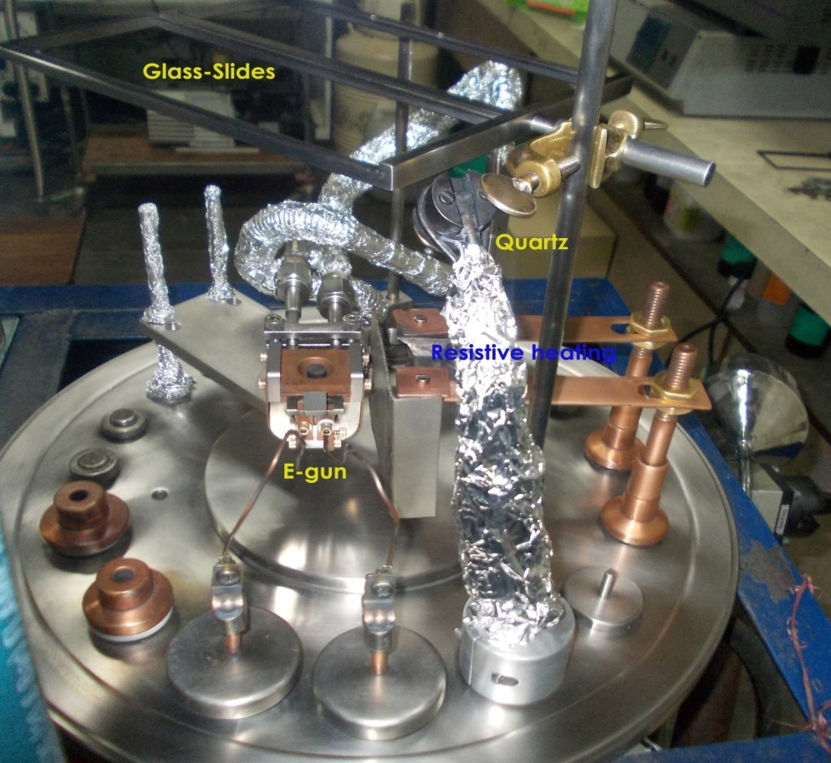
Figure 4 Internal setup of DPU

2.4 Fabrication of thin natural elements on carbon backing.
2.4.1 Fabrication of Ni, Sn elements
In the clean TPU chamber, the carbon deposited slides were kept (with carbon surface facing the source) on the dice, clamped at a distance of 10 cm from the source. Keeping the other parameters same as was done in case of preparing self-supporting targets mentioned above, with the exception that in this case the vacuum is of the order of 10⁻⁹ mbar, deposition of natural element was done using the same procedure. The chamber is then opened after completing the deposition and the glass slides are taken out. Floating was done and the layer is obtained. The required amount of target is then grabbed with the target holder from the water surface. The carbon-backed natural target fabrication, therefore, was successful.

At times some of the targets broke down after fabrication and even the floating in some of the glass slides were found to be very difficult. Some of the targets in the target holder also broke down. Hence, to find out the reason, several such similar trials of metal deposition was done with three different categories of carbon slides; (i) freshly prepared carbon slides kept for few days before being annealed, (ii) freshly prepared carbon slides are immediately annealed and then kept for few days, and (iii) freshly prepared carbon slides and immediately annealed are immediately taken for metal evaporation. It was found that in the third case, the floating was most successful and the target remained intact for the longer duration. This led us to the conclusion that whenever we keep any material deposited glass slides for few days, there will be degradation in the deposited layer, or in the parting agent which makes even the floating difficult, as the layer sticks to the glass slides.

2.4.2 Fabrication of oxidised Sm, Nd elements
The Al layer prepared by rolling were then placed carefully over the stainless steel frame and kept just above the boat containing Sm material at a distance of 9 cm. The Sm was then deposited over the target holder containing Al layer by thermal evaporation method. The current was increased very slowly. The optimized value of current and voltage were in the range of 120 – 135mA and 1 V respectively. Further, to deposit a layer of C capping (~5 μg/cm²) over Sm by electron-gun method, the substrate holder was manually moved at a distance of 14 cm just above the C pellet without breaking the vacuum which will prevent oxidation. In this method, 27 mg of enriched material was used which successfully produced a set of nine Sm targets each. Similar parameters were optimised even for Nd materials and the results were also the successful one producing as many as ten targets with the same amount of enriched natural element.

2.5 Fabrication of thin isotope
2.5.1 Fabrication of ^{61,62}Ni, ¹¹⁶Sn isotope on carbon backing
Both ⁶¹Ni and ⁶²Ni powders were compressed into pellet form of approximately 3 mm in diameter by the hydraulic press. These pellets are then used for the deposition process. This was done to avoid the sucking of powdered particles by the pump when the chamber will be kept under vacuum.

Using TPU thermal evaporation, both ^{61,62}Ni were deposited one after another on the fresh annealed C slides, kept at 15 cm from the source, at the rate 0.1 nm/sec at 350 A current. These parameters were set during the trial deposition of natural Ni which produced the desired result. ^{61,62}Ni are then evaporated till the deposition thickness reading in the crystal monitor was around 100 μg/cm². After evaporation, the chamber was left for few hours for cooling followed by venting and then the deposited material is taken out. The floating was successfully done, and targets of required thickness were obtained. The same procedure was repeated for ¹¹⁶Sn in the next round of evaporation with freshly prepared C slides kept at the same distance as in the last case. The deposition rate was kept around 0.1 nm/sec at 250 A current and 1 V voltage. The current was increased slowly from 0 to 180 A where the evaporation started. From 180 A, the current is then slowly increased till 250 A and is kept constant after which the deposition was steady. ¹¹⁶Sn is then evaporated till the deposition thickness reading in the crystal monitor was ~ 150 μg/cm². After evaporation, the deposited material is taken out of the chamber. The targets of the required thickness are then obtained after floating (Fig 5 (a)-(e)).
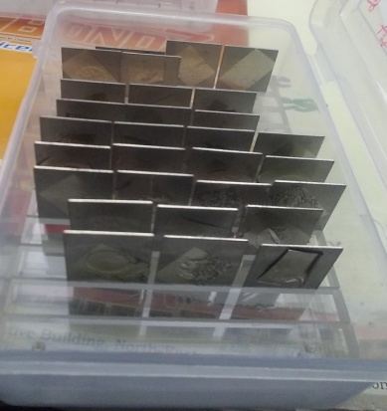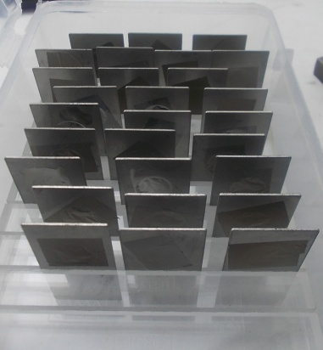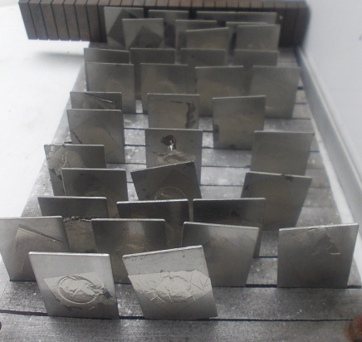
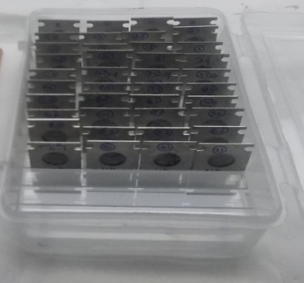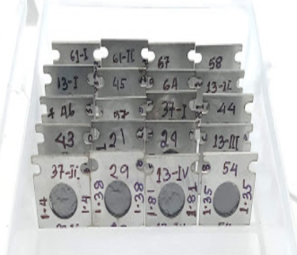
Figure: 5 Targets obtained for (a) ⁶¹Ni, (b) ⁶²Ni, (c) ¹¹⁶Sn, (d) Sm and (e) Nd elements (in serial order from upper left to right and then below from left to right).

2.5.1 Fabrication of ^{144,154}Sm, ^{142,148}Nd isotope on Aluminium backing
All the elements of Sm and Nd isotopes were in the form of metallic flakes. One after another each isotope was taken along with graphite (for Sm) and aluminium (for Nd) for capping in the TPU. Thermal evaporation of the isotope was performed using the parameter optimised while evaporating corresponding natural elements. Following the deposition, without breaking the vacuum, carbon/aluminium was evaporated slightly for capping. After the required deposition, the targets were successfully taken out (Fig. 5 (a) – (e)).
3. Results and discussions
The target thickness is being measured using various techniques and then they are characterized to check its purity, which is necessary as impurities are liable to be introduced during handling and evaporation or floating process. This can ensure the quality checks of the target which is very much essential in nuclear reaction studies.
3.1 Alpha particle energy loss technique
Alpha (α) – particle energy loss technique is a method in which alpha radiation from the radioactive source is allowed to transmit through the foil [24]. This will then reduce the energy of the radiation from which the thickness of the targets can be estimated. In this case, a strong 50 μCi radioactive ²⁴¹Am source is used which radiates 5.486 MeV α – particles which will lose its energy through the foil. This energy of alpha passing through the film is then recorded in the U126 Canberra Model Silicon Solid-Surface Barrier Detector kept on the opposite side of the target film in vacuum. For the carbon backed targets, we measured the thickness of the carbon film first, which was extracted from one of the carbon deposited glass slides before going for target deposition. Similarly, the measurement was obtained from the carbon-backed ^{61,62}Ni, ¹¹⁶Sn target separately with respect to that of background. Following which, the calculation was corrected with that of the energy loss due to carbon foil. The energy loss of α-particle in the ^{61,62}Ni, ¹¹⁶Sn targets and the carbon foils were extracted from the SRIM code [25]. Using this information, the thicknesses were calculated and found to be ~ 30.05 ± 0.9 μg/cm² for carbon, ~ 110.98 ± 3.1 μg/cm² for ⁶¹Ni, ~ 106.89 ± 1.5 μg/cm² for ⁶²Ni and ~ 150.9 ± 3.1 µg/cm² for ¹¹⁶Sn. An uncertainty is due to source-target-detector geometry. The thickness measurement could not be done for Sm and Nd isotope as they were capped with a layer which may not contribute for effective measurements. Thus profilometer measurement technique was adopted for such isotopes which are described below.
3.2 Profilometer measurement technique
While going for the target material deposition, the substrate holder containing carbon slides was also equipped with one fresh glass slide. It was kept on top of the carbon slides in such a way that it lies in line with the source and in between two carbon slides, which are kept at small separation from each other. This is done so that some of the material to be deposited sneaks through the carbon slides' separation during evaporation and gets deposited on this fresh slide.
The thin strip of deposited material on the slide is then used for determination of its thickness using an instrument - Profilometer. It is a measuring device which measures the surfaces' profile, in order to quantify its roughness. The lateral movement of the profilometer stylus across the strip in the slide measures the surface height with the position. This surface height determined is the thickness value considered for the sample. Using this measurement technique at the target development laboratory, IUAC, New Delhi, the thicknesses of the fabricated targets of ^{144,154}Sm and ^{142,148}Nd were found to be in the range of 200-700 μg/cm².

3.3 Rutherford Back-Scattering (RBS) characterizations

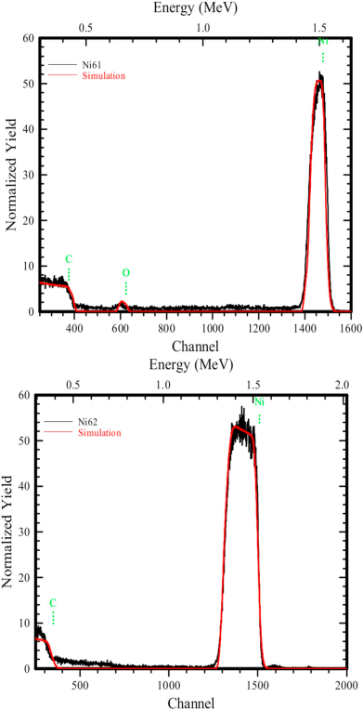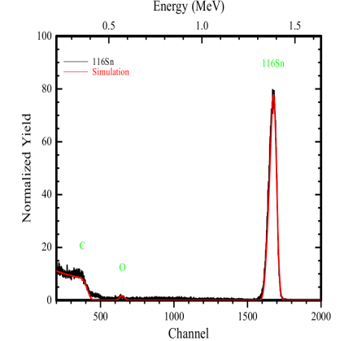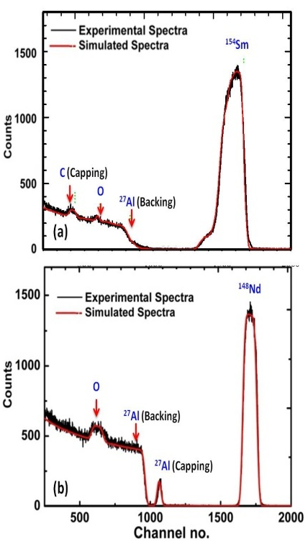
Figure 6 RBS results for (a) ⁶¹Ni, ⁶²Ni, (b) ¹¹⁶Sn, (c) Sm and Nd targets

RBS is the only technique which analyzes the test target film quantitatively without the application of any standard reference target. It is an elastic collision between the projectile of high kinetic energy and the fixed target nuclei. 2 MeV α-particle projectile from 1.7 MV 5SDH-2 tandem accelerator at IUAC, hits the target normally, which is then backscattered enabling us to determine the atomic mass and the elemental concentration versus depth below the surface. This backscattered particle is then determined using the Silicon surface barrier detector (SSBD) kept at around 165⁰. Energy spectra and yield obtained from SSBD is then analyzed using RUMP simulation software [26]. In the spectrum obtained (Fig. 6 (a) – (c)) for both ^{61,62}Ni targets, three peaks of carbon (C), oxygen (O) and nickel (Ni) can be seen. For ¹¹⁶Sn case also three peaks of carbon (C), oxygen (O) and tin (Sn) can be seen, C is because of backing element, O indicates the oxidizing of the target which is very minimal in this case making it negligible amount as impurity content. Even the spectra of ¹⁵⁴Sm (as a representative case) confirms the presence of Sm, C (capping), O (very minimal) and Al (backing) and ¹⁴²Nd (as a representative case) confirms the presence of Nd, Al (capping and backing) and O. No other significant high or low Z contaminants can be seen in the spectra. The compound nucleus that will form due to C and O content in the target will be negligible and only Ni, Sn, Sm or Nd will contribute to the formation of the bulk of the compound nucleus in the respective cases leading to the desired spectrum. Hence the target developed is free from any substantial impurities in this work.

4. Conclusions
With the amount of available enriched isotopic material (~100 mg) being limited, we used nearly 50 mg of the isotopes of ^{61,62}Ni, ¹¹⁶Sn and could produce as much as 25 thin and uniform carbon-backed targets each. Although many self-supporting targets are successfully prepared with natural elements, however, due to lack of consistency in results, the isotopes were prepared with carbon backing, using thermal evaporation or resistive heating method which is found to be more stable and consistent. Moreover, to obtain isotopically enriched ^{144,154}Sm and ^{142,148}Nd targets, 100 mg of the materials each were taken and about 40 thin and uniform Aluminium backed and Carbon (for Sm) and Aluminium (for Nd) capped targets each were produced. After fabrication of the targets, their thicknesses were verified with the help of different techniques, viz., alpha energy loss technique, profilometer technique. The thicknesses of ⁶¹Ni, ⁶²Ni and ¹¹⁶Sn are found out to be ~ 110.98 ± 3.1 μg/cm², ~ 106.89 ± 1.5 μg/cm² and ~ 150.9 ± 3.1 µg/cm² respectively which were successfully prepared with carbon backing of thickness ≈ 30 μg/cm². The thicknesses of ^{144,154}Sm and ^{142,148}Nd targets were in the range of 200 – 700 μg/cm². The uniformity and the purity of the targets fabricated are then measured using RBS techniques. From RBS measurement, it was confirmed that any impurities are absent in the substantial amount within the target material thus making these targets available for the experiments to be performed henceforth. These targets are then kept properly in the desiccators in the Argon environment to be used for the upcoming experiments.
5. Acknowledgement
One of the authors (N. K. Deb) gratefully acknowledges the Council of Scientific and Industrial Research (CSIR), New Delhi for the award of the junior research fellowship in order to carry out this work. Also, authors are thankful to Dr. D. Kanjilal, IUAC for extending FESEM facility, procured under Geochronology project [MoES/P.O.(Seismic)8(09) Geochron/2012], Dr. Sunil Ojha, IUAC, for the help and support extended towards RBS characterizations; Health Physics Department, IUAC for providing the strong radioactive source.
6. References
[1] T. Banerjee, et al., Vacuum 144 (2017) 190–198.
[2] D. Braski, Nucl. Instrum. Methods 102 (3) (1972) 553–566.
[3] P. K. Giri et al., Ind. Jour. of Pure and Appl. Phys. 57 (9) (2019) 675-678.
[4] D. Singh et al., Phys. Rev. C, 97 (2018) 064610.
[5] V. Singh et al., Nucl. Instr. Methods Phys. Res. Sect. A 635 (1) (2011) 20-23.
[6] A. Cheltsov, et al., J. Radioanal. Nucl. Chem. 299 (2) (2014) 981–987
[7] S. Abhilash, et al., J. Radioanal. Nucl. Chem. 305 (3) (2015) 749–753.
[8] J. Gehlot, et al., DAE Symp. Nucl. Phys 58, (2013), 930–931.
[9] B. Lommel, et al., Nucl. Instrum. Methods Phys. Res. Sect. A 655 (1) (2011) 44–46.
[10] I. Sugai, Nucl. Instrum. Methods Phys. Res. Sect. A 397 (1) (1997) 81–90
[11] K. Zell, Newsletter vol. 9, no. 1 (1982) 6, International Nuclear Target Development Society
[12] A. Singh, et al., DAE Proc. of the Int. Symp. on Nucl. Phys. 54 (2009) 706 – 707
[13] P. Sharma, et al., Proc. of the DAE Symp. on Nucl. Phys. 59 (2014) 912 – 913.
[14] P. Giri et al., Proc. of the DAE Symp. on Nucl. Phys. 60 (2015) 984 – 985.
[15] S. Ali, et al., Proc of the DAE Symp. on Nucl. Phys. 62 (2017) 1132 – 1133
[16] Kavita, et al., Vacuum 145 (2017) 11 – 13.
[17] A.R. Lipski, INTDS Newslett. 23 (1996) 24.
[18] F. Nickel, et al., Nucl. Instrum. Meth. Phys. Res. 167 (1979) 175 – 177.
[19] Guoji, et al., Nucl. Instrum. Meth. Phys. Res. 236 (1985) 555 – 557.
[20] N. Deb et al., Vacuum 163 (2019) 148 – 157.
[21] K. Behrndt, R. Love, Vacuum 12 (1) (1962) 1–9.
[22] M. M. Hosamani, et al., Journal of Instrum (JINST) 14 (2019) P01007
[23] L. Freund, S. Suresh, Thin Film Materials: Stress, Defect Formation and Surface Evolution, Cambridge University Press, Cambridge, England (2004).
[24] L. Yaffe, Annual review of Nuclear Science 12 (1) (1962) 153–188
[25] J.F. Ziegler, M.D. Ziegler, J.P. Biersack, SRIM: the Stopping and Range of Ions in Matter, Cadence Design Systems, 2008
[26] L. Doolittle, Nucl. Instrum. Methods Phys. Res., Sect. B 9 (1985) 344

