WATER RESOURCE MANAGEMENT
Dr Ragini Dubey, Dr Pravita Gupta, Dr Vivek Kumar Tripathi, Rashmi Dubey and Vanshika Tewari
- Subject Matter Specialist (Homescience) Krishi Vigyan Kendra pg college Ghazipur
- Guest Faculty Department of Food & Nutrition Chandra Shekhar Azad University of Agriculture and Technology
- Professor and Head Department of Horticulture Chandra Shekhar Azad University of Agriculture and Technology
- Research Scholar Department of FRM Chandra Shekhar Azad University of Agriculture and Technology
Introduction
People from different backgrounds seldom have the same idea about what water resources management implies. To those living in an arid country, it means drought relief, irrigation, food, jobs, law, and politics. Generally there is an emphasis on groundwater. Rivers are normally dry, or experience flash floods after torrential rains (wadis or ephemeral streams). To those people living in humid areas, the emphasis is more on surface water. They are particularly concerned with waterworks, flood protection, navigation, hydropower, treatment plants, etc. Also, people from different professional backgrounds tend to view water resources management differently. To the water engineer, water resources management is related to dams, reservoirs, flood protection, diversions, canals, water treatment, and land reclamation. To the ecologist, water resources management is often connected with the deterioration of ecosystems, land degradation, pollution, and destruction of wetlands. To the lawyer, the main issues in water resources management are the ownership of water, the system of water rights (ownership or license to use), the priority of use, the water legislation, and international water law. To the economist, water resources management is connected with water use efficiency, cost recovery, the creation of water markets, tradable water rights and privatization of water supply. To politicians, water resources management means solving conflicts over water and attaining national objectives such as: economic growth, poverty alleviation, employment generation, and food security.
In fact, water resources management includes all these points of view. Water resources management is multi-disciplinary, multi-sector, and multi-objective. Management is only effective if all interested parties (both formal and informal) are—in one way or another—involved in the process of planning, decision making and implementation. Unless all stakeholders feel committed, water projects or policies are likely to fail.
Water resources management refers to a whole range of different activities: monitoring, modeling, exploration, assessment, design of measures and strategies, implementation of policy, operation and maintenance, and evaluation. It also covers supportive activities such as institutional reform. Water resources management includes local, national and international activities, directed at either the short or the long term. As such, water resources management is rather a diffuse field. It includes the whole set of scientific, technical, institutional, managerial, legal, and operational activities required to plan, develop, operate, and manage water resources. If you tell someone about a certain water management problem and ask how he or she would solve this problem, you will probably get one of two answers. One: look at the causes of the problem, who is involved; look also at the effects of the problem others; think of some alternative solutions; analyze the effectiveness, costs, and benefits of each of the solutions and implement the best solution. Two: invite all interested parties, the stakeholders, ask them what they think about the problem, let them suggest solutions and look for compromises on which all parties can agree. The first approach puts emphasis on the scientific analysis of the problem, while the second approach puts emphasis on the process that should lead to a solution. Water resources management is actually both.
Water resources management includes management at two distinct levels. Management at the first level refers to the actual tasks and central objectives of the water manager. This includes all activities directly aimed at the sustainable use of water, the provision of clean drinking water to all, the allocation of water to different sectors of society, the provision of safety against flooding, etc. Management at the second level refers to the management of the management organization and process itself. It is supportive to the actual tasks of the water manager. Management at the first level is also called external management, while management at the second level is referred to as internal management.
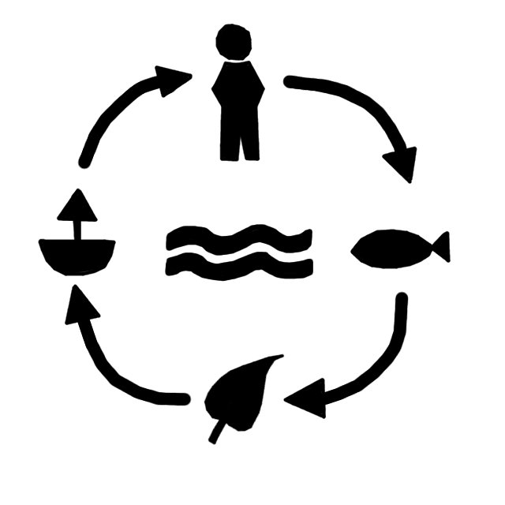
Water Management in Ancient Civilizations
Water resources management is probably as old as the human race. Historical writings and archeological research have taught us that many old civilizations could only flourish as a result of advanced methods of managing their water resources. Examples can be given for the three contemporary civilizations of the Indus, Mesopotamia and Egypt, for the Greeks and the Romans, but also for the ancient civilizations in the Americas. Let us give just two examples, one for the civilization of the Indus Valley and one for the pre-Inca civilization of the Tiahuanaco in South America.
The Indus Valley Civilization was one of the world’s first great urban civilizations. It flourished in the vast river plains and adjacent regions in what is now Pakistan and western India. Around 2600 BC, the earliest cities together formed an extensive urban culture. This culture continued to dominate the region for at least 700 years. Excavations during the twentieth century have revealed well-planned cities and towns built on massive mud brick platforms to protect the inhabitants against seasonal floods. Waterways connected the empire, and flat-bottomed barges, almost identical to thosestill used today, plied the rivers between the cities. In the ancient city Mohenjo-daro (in Sindh, southern Pakistan), rainwater was harvested in tanks and brought to the wells of each house through gutters. The drainage system was both elaborate and efficient: carefully graded brick-lined drains flowed down the center of the streets to the Indus. The drains were covered, but at intervals there were inspection holes so that they could be unblocked when necessary. Tributary drains flowed from each house, first into a cesspit where solid matter was deposited. When the pit was half full, the water drained off into the main sewer. The richer houses had their own bathroom, but the city also had a large bathhouse, which has been well restored.
Another example of early water management can be seen from the Tiahuanaco civilization, which dates back to about 1600 BC. This civilization, on the southern shore of Lake Titicaca, at an altitude of about 4000 m above sea level, developed through five periods, and was at the peak of its splendor around AD 700. At that time Tiahuanaco was the largest city in the world, with more than 100 000 inhabitants. There was an extensive system of roads, aqueducts and agricultural terraces. In order to increase agricultural yields, the Tiahuanaco people constructed a network of little canals. The theory, at the end of the twentieth century, is that these canals influenced the local climate in such a way that the strong daily temperature variation at this altitude was tempered, thus improving the conditions for agriculture. Experiments are being carried out in order to discover whether this technique can be introduced again.
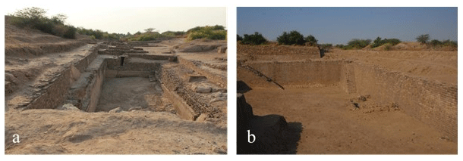
Recent Developments
There has never been one worldwide-applied recipe for how to manage water. Climate conditions and cultures have always varied to such a great extent that we cannot expect that such a recipe will ever be developed. Nevertheless, for thousands of years there was something like a common attitude towards water. Water was primarily regarded as a natural resource to be exploited for the benefit of man. And in these areas of the world where floods regularly threatened human life, water was at the same time seen as an enemy to be defeated. Water resources management basically meant planning, building and maintaining infrastructure for supplying water to the places where people could use it and for defending people against flooding. At the time scale of the human race, it is only very recently that this common attitude has changed. This change has a lot to do with the consequences of the industrial revolution and the explosive growth of the world population.
The increasing pressure on water resources and the growing competition between divergent interests, particularly during the second half of the twentieth century, has led to the recognition that water is a “scarce resource” and can be “overexploited.” Steadily, people started to replace the term “water resources development” by the more general term “water resources management.” Recognizing that water is an intricate part of nature and that water is actually more than just a “resource,” it would be even better to speak simply about “water management.” However, whatever terminology we use, at the turn of the century the issue of water stands high on many political agendas. Today some visionaries even say that, where energy appeared to be the most critical issue in the twentieth century, water will be the most critical resource in the twenty-first century.
Looking back, one could say that global attention to water issues started with the International Hydrological Decade 1965–1974, under the auspices of UNESCO. The purpose was to advance hydrological knowledge through promoting international cooperation and training specialists and technicians. One of the products at the end of the decade was a study on the world water balance carried out by the USSR Committee for the IHD. The work was based on new material received from various countries as a result of the implementation of the IHD program. In the same period, two other major studies by Baumgartner and Reichel, and L’vovich, on the global water balance, were published. For global water studies in the twenty-first century, people still rely heavily on these previous three studies. Although L’vovich and Korzun pay some attention to the socioeconomic aspects of water demand, the emphasis in all these studies lies on the hydrological aspects of water availability.
A milestone in the early period was the establishment of the “Helsinki Rules” on the use of international rivers in 1966. These rules, adopted by the International Law Association, were a first step towards a common notion on the equitable use of transboundary river basins. The fourth article of these rules stated that each basin state is entitled, within its territory, to a reasonable and equitable share in the beneficial uses of the waters of an international drainage basin. The fifth article added that what is a reasonable and equitable share is to be determined in the light of all relevant factors in each particular case.
An important event raising global political awareness of the environment, was the United Nations Conference on the Human Environment in Stockholm, Sweden, in 1972. At this conference, the foundation was laid of the United Nations Environment Programme (UNEP). In the Stockholm Action Plan, nations agreed that when major water resource activities are contemplated that may have a significant environmental effect on another country, the other country should be notified well in advance. It was also agreed that countries should ensure the best use of water and avoid its pollution.
The first global conference specifically dedicated to water, was the United Nations Water Conference in 1977, in Mar del Plata, Argentina. The Mar del Plata Action Plan stimulated a number of activities, including the International Drinking Water Supply and Sanitation Decade (1981–1990). This decade, proclaimed by the UN General Assembly at the end of 1980, had, as its primary goal, the achievement of full access to water supply and sanitation for all inhabitants of developing countries. Although this goal was far from achieved by the end of the decade, it was successful in creating awareness of the importance of clean water and sanitation, and in developing workable strategies for further improvements.
During the 1960s and 1970s, it became clear that the old paradigm of growth needed revision. In the beginning of the 1980s, this led to the introduction of the concept of sustainable development. The famous Brundtland Commission defined this as development that meets the needs of the present generation without compromising the ability of future generations to meet their own needs (WCED, 1987). In the water field, people started to speak about the need for “sustainable water resources management.” This is a type of management that guarantees all humans are provided with their basic water needs, but also that ecosystems continue to be provided with a proper amount of water to maintain their function. In the same period that the notion of sustainabilitybecame widespread, people began to recognize that the traditional reductionistic approach towards environmental problems was no longer fruitful. Instead, people started to advocate an holistic or integrated approach, in which the recognition that seemingly separate problems often form a coherent system of interconnected parts, is the starting point of the search for solutions. In the water field, people started to recognize that problems of water shortages and problems of water pollution cannot be dealt with separately. People started to look at surface water and groundwater as one system. Soon people even argued that land and water have so many interactions that water management should be combined with land and soil management.
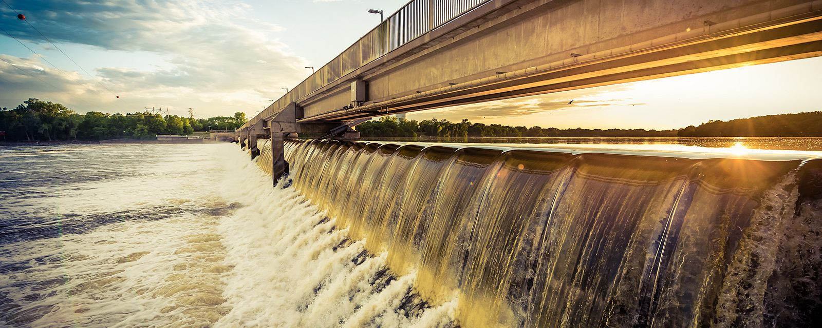
In the midst of these discussions, the International Conference on Water and the Environment took place in Dublin, 1992. It was during this preparatory meeting for the UN Conference on Environment and Development (UNCED) in Rio de Janeiro, that the concepts of sustainable and integrated water resources management were widely discussed and adopted by the international community. At this meeting, the Dublin principles on water management were established.
The Dublin principles
Principle No. 1
Fresh water is a finite and vulnerable resource, essential to sustain life, development and the environment. Since water sustains life, effective management of water resources demands a holistic approach, linking social and economic development with protection of natural ecosystems. Effective management links land and water uses across the whole of a catchment area or groundwater aquifer.
Principle No. 2
Water development and management should be based on a participatory approach, involving users, planners and policymakers at all levels. The participatory approach involves raising awareness of the importance of water among policymakers and the general public. It means that decisions are taken at the lowest appropriate level, with full public consultation and involvement of users in the planning and implementation of water projects.
Principle No. 3
Women play a central part in the provision, management and safeguarding of water. This pivotal role of women as providers and users of water and guardians of the living environment has seldom been reflected in institutional arrangements for the development and management of water resources. Acceptance and implementation of this principle requires positive policies to address women’s specific needs and to equip and empower women to participate at all levels in water resources programs, including decision making and implementation, in ways defined by them.
Principle No. 4
Water has an economic value in all its competing uses and should be recognized as an economic good. Within this principle, it is vital to recognize first the basic right of all human beings to have access to clean water and sanitation at an affordable price.
The acceptance of the Dublin principles by 114 countries, 14 UN organizations and 38 NGOs, can be seen as the official launch of integrated water resources management, worldwide. Although it had been discussed for many years in certain circles, Dublin was, for many countries, the starting point to revise their water policy, and for many agencies to start looking over the walls that divide them. The first and the second principle are essential components of integrated water resources management. The third principle, about the involvement of women, is in fact an addition to the second principle. Women are often responsible for water management at local level, both for household supply and agriculture, but are notoriously absent in consultation or planning of interventions, and as a result absent in the operation and maintenance of systems. This is a very unfavorable situation that needs to be given due attention, and changed.
The fourth Dublin principle caused the largest debate. The reason why several people opposed it was because they interpreted it as if everybody should pay the economic price of water. That was a misunderstanding, however. Considering water as an economic good, means that decisions on the allocation or use of water should be taken on the basis of economic rationality. That does not necessarily imply that an economic price needs to be paid by the user. Part or all of the costs can be borne by others or by the government, e.g., through subsidies. Whether water services should be priced is primarily a question of cost-recovery and demand management, not of economic valuation.
In 1993, the World Bank published an influential policy paper on water resources management, which emphasized the importance of integrated water resources management, economic pricing, cost recovery, decentralization, privatization, management of international river basins and incorporation of environmental criteria in planning and management.
Twentieth century developments include the establishment in 1996, of the Global Water Partnership and the World Water Council. The Global Water Partnership aims to support integrated water resources management programs by collaboration with governments and existing networks and by forging new collaborative arrangements. The World Water Council has the aim to promote awareness of critical water issues. In March 1997, the “First World Water Forum” was held in Marrakesh, Morocco. The “Second World Water Forum” was held in March 2000, in The Hague, the Netherlands. At this second meeting, the so-called “World WaterVision” was presented.
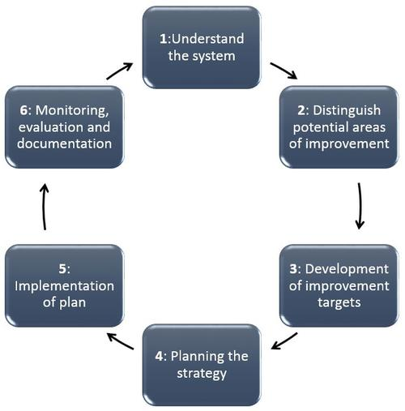
Water Resources Management at the Beginning of the Twenty-first Century
In the international debate, there is a growing consensus with regard to priorities in water resources allocation. The supply of water for basic human needs should have first priority. Second priorities are the requirements to maintain essential life support ecosystems. All other needs—for industry, agriculture or other societal purposes— should be prioritized according to socioeconomic criteria, whereby water is considered an economic good. Here, it is important to note that although cost-recovery and economic trade-off are over-riding principles, cross-subsidies within sub-sectors to benefit the poor, are considered necessary where equity or social wellbeing are at risk.
Another common notion is the need for adequate participatory approaches to planning and management, and mechanisms for accountability and democratic control. This is closely related to the principle of decision making at the lowest appropriate level (subsidiarity), which also implies that some decisions (for instance on the sharing of international waters) should be taken at the highest level. Clearly in that case, mechanisms of democratic control and stakeholder participation should operate at the highest level of government.
Globally and with regard to the sharing of international waters, an important issue is food security. Since agriculture is the largest consumer of water, it is important that nations start to realize that food self-sufficiency is not always possible or sometimes highly uneconomic. Present thinking moves into the direction of food security, whereby food is grown in those parts of the world where it is most economic and where the conditions are most favorable, while countries produce sufficient income to allow them to import the food. Clearly, where countries become dependent on food imports, adequate and reliable market arrangements should be in place. Poor countries need to have opportunities to develop activities that bring in foreign exchange.
In recent years, as a result of an increasing pressure on water, the scope and complexity of water resources management has broadened. The problems associated with rapideconomic development, population growth, urbanization and industrialization have clearly demonstrated the inadequacy of traditional water management at sector level. Until the early 1990s, different aspects and interests of water resources were generally managed separately, and often independently, in different institutions, e.g., water quality, groundwater, water supply and sanitation, irrigation, hydropower, etc. Modern water resources management aims at dealing with conflicting interests in a multi-sector, coordinated, interdisciplinary, participatory, transparent, and flexible manner. The term for this approach is “integrated water resources management.” There are several definitions for integrated water resources management, but it is generally agreed that it has the following components:
• it addresses all the natural aspects of water (e.g. quantitative, qualitative and ecological aspects) and also considers the linkages between the various aspects; • it puts water management in a broader context of socioeconomic development policy and environmental management;
• it takes full account of all the sector interests related to the functions and values of the water system, in a participatory process with the stakeholders;
• it considers the spatial and temporal variation of resources and demands;
• it considers the full spectrum of relevant policy objectives and constraints
• it takes into account the different institutional levels involved in water resources management.
Although integrated and sustainable water management are close to each other and often mentioned in the same sentence, there is a subtle difference between the two. Sustainable water resources management requires an integrated approach, but following an integrated approach does not guarantee sustainability. Integrated management particularly refers to a type of approach: holistic, participatory (see also Integrated Water Resources Management, EOLSS on-line, 2002). Sustainable management adds to that a certain normative constraint to the outcome of the process. Where integrated management does not pre-include a certain statement about the main objective of development, sustainable management does include such a statement (see also Water and Sustainable Development, EOLSS on-line, 2002).
There is growing recognition, particularly in regions that depend on surface water, that the river basin is the most appropriate unit for water resources management. A river basin can be defined as a geographical unit within which water flows naturally towards a common outlet. The term river basin is generally used for the entire basin that drains into a sea, an ocean, or an inland lake. However, the concept can also be applied at a smaller scale. In such cases, people often speak about sub-basins or catchment, subcatchment or watershed areas. The management of water resources within such geographical boundaries is called river basin management. Many river basins include the territory of more than one nation. International river basins encompass nearly 50% of the global land area, so a large part of the world’s population depends on water resources shared by neighboring countries. This has led to a growing number of transboundary water conflicts, but also to increased cooperation between neighboring countries
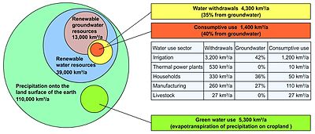
What are the challenges of water resource management?
Nature takes care of water resources through replenishing them by precipitation, surface run-off and ground water levels. The biggest challenge when it comes to WRM are humans. Freshwater resources like river, lakes are polluted by human activity. If sustainable water management is not implemented there may be war in future for fresh water. Water is an integral part of life and without which life is not possible on the earth. Acute water shortages because of drought which is attributed to climate change have hit most parts of the world. Many rivers are drying up, polluted and encroached. Now more than ever, the challenge is whether future generations will have enough freshwater for living? As humans we used freshwater for drinking, sanitation, watering, livestock, irrigation just to mention but a few. Humanity does have choices to make which is their role to play in WRM. People must make lifestyle and economic trade-offs to actively participate in finding sustainable solutions to water resource management. So, for example high demanding water crops of no big nutritional value might have to compromise on irrigation which means they might not grow well or generally for their consumers they must compromise and consume less. Efforts to conserve water by reducing surface evaporation through transporting it in canals or pipelines but with consequences on local groundwater, surface aquifers, flora and fauna. What seems to be a solution for humans comes with a dire problem for nature and the challenge is that nature will always be at the peril of human activity and behavior complicating lives for future generations to come. It starts with inherent choices to how we manage our water consumption and WRM extends to spheres of corporate wants of industries and political agendas.
Management of Water Resources
Destilation
- Canals, tanks, yeris, etc. must be destilled regularly during the summer months.
- People should be encouraged to revive the ancient practice of protecting trees around tanks. Major rivers were sanctified and groves were established around villages and on the river banks.
Afforestation
Afforestation of barren, hilly slopes on a warfooting should be carried out. Trees withstand drought better than crops. They check dust, replenish streams, provide shade to cattle and man and give fodder for cattle. They provide innumerable uses for man. Denuding the land of trees without compensatory afforestation is a suicidal and short-sighted approach to solving immediate needs.
Ponds and Tanks
- Creation of small reservoirs and percolation tanks to hold run-off water must be implemented and maintained well.
- Agronomic practices like off-season tillage (prior to pre-monsoon showers) conserve soil moisture. Moisture penetration to a depth of 90 cm. is achieved if the land is ploughed to a depth of 30 cm. Other practices like early sowing of seeds, moderate use of fertilisers, weeding, pest and disease control and timely harvesting increase the yield inspite of limited moisture in the soil.
- Terrace cultivation of hilly slopes prevents water run-off.
- Contour ploughing and planting of grasses and trees check run-off water and increase the soil's capacity to retain moisture.
- Green manuring (incorporation of fresh green leaves into the soil) and crop-rotation (cultivating different crops in rotation depending upon the soil and climate, e.g. cereals followed by legumes) conserve soil moisture.
- Mulching the soil with organic residue conserves soil moisture.
- The use of sprinkler irrigation for closely-spaced crops like millet, pulses, groundnuts, etc., conserves 30 to 40% of the surface water.
- Drip irrigation is most suited for closely-spaced row crops like vegetables, cotton, sugarcane. The efficiency of this system is around 25 to 30% in conserving soil moisture. The cheapest and easiest form of drip irrigation is to drill one to three holes in a mud pot and bury it partially in the soil next to the plant. The water in the pot drips slowly, ensuring that the soil is continuously moist and the plant gets a constant supply of water.
- Harvesting rain water and storing it in small ponds ensures water supply during summer.
- Deep trenches can be dug adjacent to bunds to collect run off water and soil.
- All these practices are useful only if utilised properly.
References
https://www.eolss.net/sample-chapters/c07/e2-16-00-00.pdf
https://vikaspedia.in/energy/environment/know-your-environment/water/water-resources-management
https://globalroadtechnology.com/water-resource-management-importance-challenges-techniques/

