Synthesis and Characterization of Tin Oxide (SnO) nanoparticles

Introduction:

Nanoparticles of metals and metal oxides are employed in a variety of applications, including catalysis, medicine, electronics, and others due to their unique chemical, thermal, optical, magnetic, and other characteristics compared to their bulk analogues. The use of supercritical fluids (SCF) has been proposed for a wide variety of synthesis processes, including the reverse micelle, fast expansion, and hydrothermal synthesis [1-3]. The hydrothermal procedure offers the most promising opportunities for the production of metal and metal oxide nanoparticles among these approaches [4-6]. SnO is a crucial semiconductor material due to its high electrical and thermal conductivity. SnO nanostructures have been shown to be an efficient photocatalyst, able to convert organic contaminants into less harmful small molecules. We provide herein a one-pot hydrothermal approach for the manufacture of SnO nanoparticles.
This chapter presents the synthesis of SnO nanoparticles. The synthesized SnO nanoparticles were characterized with various experimental methods such as X-ray Diffraction, TEM, SEM, FT-IR, EDAX and UV-Vis spectroscopy etc.

Synthesis of SnO Nanoparticles:
SnO nanoparticles were synthesised using a standard hydrothermal technique. The starting elements for the synthesis were SnCl₂.2H₂O and Dilute HCl. In a typical process, stock solutions of 0.1 M (2.3 g) SnCl₂.2H₂O are produced in 50 ml of 1.0 M HCl while stirring. To this stock solution, 250ml of SnCl₂ (0.1 M) solution produced in an adequate quantity of urea was added under continuous stirring to keep the pH of the reactants at 9.
The solution was placed in an autoclave lined with Teflon and heated to 150 degrees Celsius while under autogenous pressure for 1 hour. It was finally allowed to cool to room temperature on its own. The white solid product was rinsed with distilled water, filtered, and then dried in air at 60O C in a laboratory oven (figure 1) once the reaction was complete.
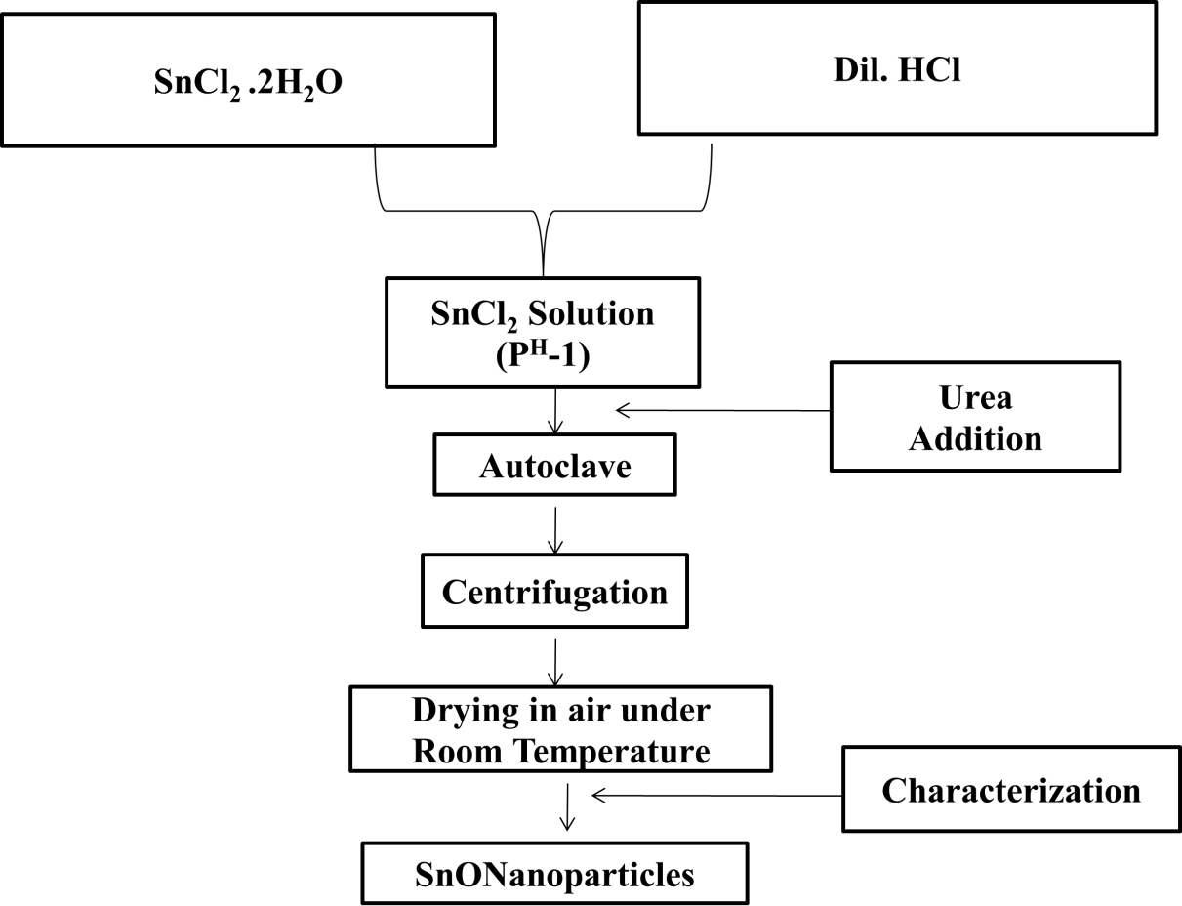

Figure 1: Flowchart for the synthesis of SnO Nanoparticles.

Characterization of SnO nanoparticles
X-ray Diffraction of SnO nanoparticles
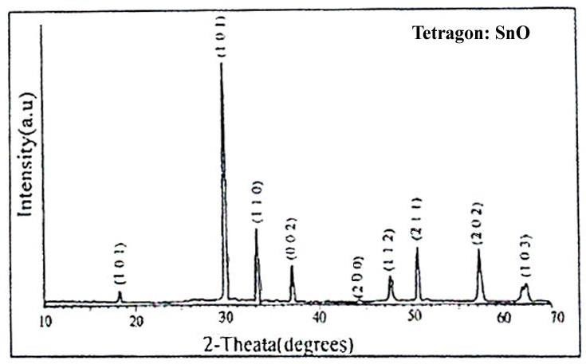
Figure 2: XRD pattern of SnO Nanoparticles

The recorded X-ray diffraction pattern of SnO powder sample synthesized by hydrothermal technique is shown in figure 2. The calculated from the X-Rd data of SnO nano particles are found to be having diameter ~ 50 nm in size [7-8] with crystalline in nature. The XRD pattern reveals the formation of SnO nanoparticles with polycrystalline phase demonstrating rutile structure with crystal planes in (0 0 1), (1 0
1), (1 1 0), (0 0 2), (2 0 0), (1 1 2), (2 1 1), (2 0 2) and (1 0 3) planes at 18.2, 29.8, 33.2, 37.1, 44.3, 47.8, 50.7, 57.3, and 62.5 theta values for SnO, and these values line up pretty well with the data from JCPDD No.36-1451.

TEM Micrograph of SnO Nanoparticles:

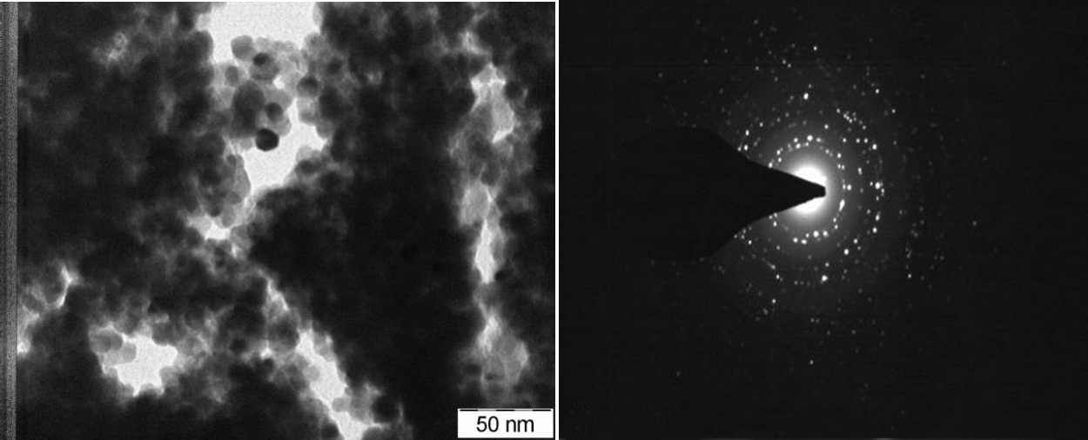

Figure 3: TEM of SnO nano partricles

Fig 3 represents the TEM image of SnO nanoparticles. TEM images of SnO nanoparticles are clear tetragonal structures having diameter ~ 50 nm, [7-10] which clearly indicates that the SnO nanoparticles are highly crystalline in nature.

SEM Micrograph of SnO Nanoparticles:

Figure 4 shows a scanning electron micrograph of SnO nanoparticles. Mesoporous particles with a molecular size of 50 nm are observed. Better clarity on the passivation of SnO nanoparticles' growing aspect can be seen in SEM micrographs at 1 nm. The formed shape of the composite was visible in the images, as were homogeneous particles with a diameter of 100 nm. Furthermore, the closest look reveals that the particles synthesised using the hydrothermal process are mostly free of aggregation.
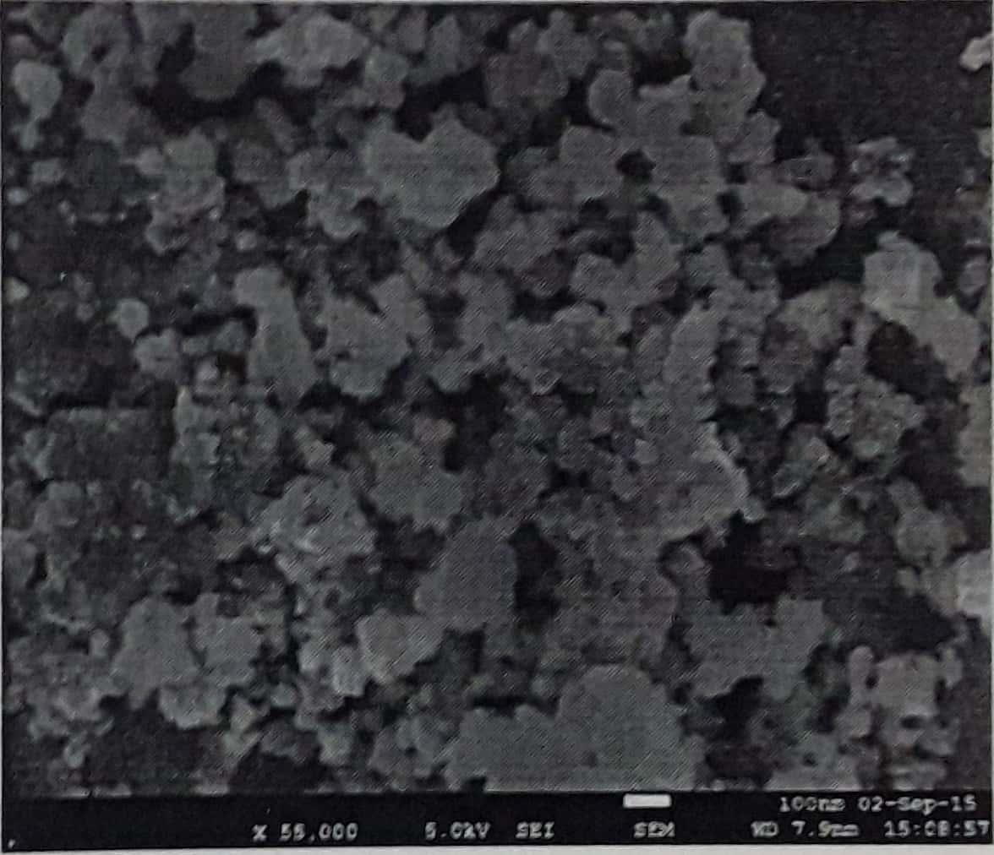

Figure 4: SEM image of SnO nanoparticles.

FT-IR Spectrum of SnO Nanopartilces:

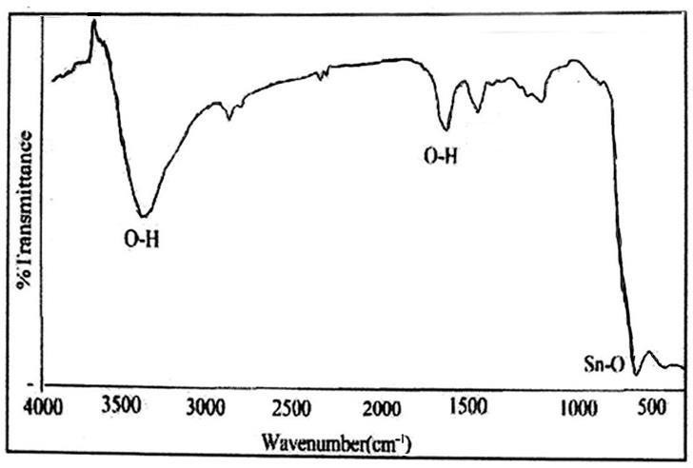
Figure 5: FTIR spectra of SnO nanoparticlas.

The FT-IR range of the SnO nanoparticles, the solid vibrational peakes at 3456 cm-1 and 1618 cm-1 are credited primarily to the O-H extending vibration of surface hydroxyl gathering or adsorbed water on the SnO nanoparticles. Pinnacle saw at 1409 cm-1 is appointed to N - O, this might be from urea utilized in the examination. At lower wave number region exhibits a very strong vibration at 515cm-1 is all Sn-O vibration, [7-8] which clear evidence of nanoparticle of SnO as shown in fig. 5.

EDAX of SnO Nanoparticles:
Table: 1 EDAX of SnO

Element | Weight % | Atomic %
O K | 31.29 | 45.29
Sn L | 68.71 | 54.71
Total | 100.00 | 100.00

Figure 7 EDAX graph of SnO nanoparticles and also obtained data from EDAX of SnO nanoparticles have shown in Table 1. Energy Dispersive X- ray Spectroscopy analysis was carried out for SnO nano particles. The atomic weight percentage of the oxygen was found to be 45.29% and Tin was found to be 54.71% [8]

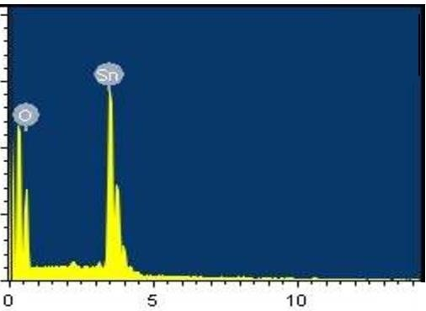
Figure 6: EDAX of SnO nanoparticles.

UV-visible spectroscopy:

The frequency at pinnacle of the absorbance range was estimated. With the frequency, band hole (in electron Volts) was determined utilizing the principle

𝐸 =
ℎ𝑐

𝜆

Where h is plank’s constant, E = 4.136 × 10−15 eV

The Speed of light in vacuum, c = 3×108m/s λ is wave1ength in meters up on substitution

𝐸 =
4.136 × 10⁻¹⁵ × 3 × 10⁸
𝜆 =
1.241 × 10⁻⁶
𝜆 𝑒𝑉

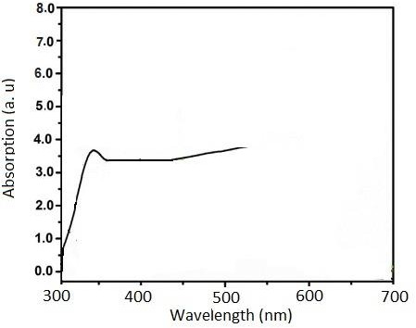

Figure 7: UV-visible spectroscopy of SnO nanoparticles.

Fig. 7 demonstrates the UV – Vis spectra of SnO nanoparticles. The absorbance spectrum was observed Energy band gap is 3.85 eV at 322 nm wavelength [11].

References:
[1]. Koster L. J. A., Mihailetchi V. D., Xie H. and Blom P. W. M., Appl Phys Lett, 2005, 87, 20.
[2]. Nikolay Radychev, Irina Lokteva, Florian Witt, Joanna Kolny- Olesiak, Holger Borchert, and Jürgen Parisi, J. Phys. Chem. C, 2011, 115(29), 14111.
[3]. V. Dyakonov, Thin Solid Films 451-52, 493-497(2004).
[4]. Jung, J. and Perrut, M. Journal of Supercritical Fluids, 2001,20, 179.
[5]. Zhang, Y. and Erkey, C. Journal of Supercritical Fluids, 2006, 38, 252.
[6]. Reverchon, E., Adami, R. and Caputo, G. Journal of Supercritical Fluids, 2006, 37, 298.
[7]. Tazikeh, S., Akbari, A., Talebi, A., & Talebi, E. (2014). Synthesis and characterization of tin oxide nanoparticles via the Co-precipitation method. Materials Science-Poland, 32(1),
98–101. doi:10.2478/s13536-013-0164-y.
[8]. Krishnakumar, T., Jayaprakash, R., Pinna, N., Phani, A. R., Passacantando, M., & Santucci, S. (2009). Structural, optical and electrical characterization of antimony-substituted tin oxide nanoparticles. Journal of Physics and Chemistry of Solids, 70(6), 993–999. doi:10.1016/j.jpcs.2009.05.013.
[9]. Xie Y, He Y, Irwin LP, Jin T, Shi X (2011) Antibacterial activity and mechanism of action of zinc oxide nanoparticles against Campylobacter jejuni. Appl Environ Microbiol 77:2325– 2331.
[10]. Akbar A, Anal AK (2014) Zinc oxide nanoparticles loaded active packaging, a challenge study against Salmonella typhimurium and Staphylococcus aureus in ready-to-eat poultry meat. Food Control 38:88–95.
[11]. Inbathamizh L, Mekalai Ponnu T, Jancy Mary E. Journal of Pharmacy Research, 2013, 6, 32.

