Design a Unified LPG Gas Cylinder
Delivery System

Mohammad Asif
Design and Innovation
Jamia Millia Islamia, Okhla
Delhi, 110025, India
ux.asif@gmail.com
Deepshikha
Design and Innovation
Jamia Millia Islamia, Okhla
Delhi, 110025, India
emaildeepshikhajha@gmail.com

ABSTRACT
The purpose of this study is to offer a solution to the problems consumers face when ordering and getting petrol cylinders, especially in urban locations. A user-centred design strategy was used in the research which included the development of personas, empathy maps, user journey maps, information architecture, low-fidelity prototype and usability testing. The target audience's unique needs and pain points were identified by the personas which were based on consumer segmentation. 100 participants between the age group 16-52 years participated in online questionnaire based study and contextual interviews with 15 participants of age group 22-38 years were conducted for user research phase. It was found that users most commonly use websites for gas booking apart from message, call and WhatsApp. Some users are unaware of or unable to locate the delivery tracking option, rescheduling options on the website is not easy for users to find, status of delivery cannot be tracked and other usability issues on the exiting websites were identified. The findings demonstrate the need for a user-centred design process while creating a petrol cylinder delivery application that meets the expectations of Indian consumers. The application needs to be simple to use, easily accessible, and able to supply petrol cylinders on time. The design and implementation of a mobile application for the distribution of petrol cylinders in India was the core of the study. Heuristic evaluation and usability tests were conducted via a focus group study with 15 participants for 4 tasks on the new application designed. The success rate was recorded to be 80%-93% for the 4 tasks and participants found the process easy to understand and navigate. This paper offers a thorough manual for creating a mobile app for petrol cylinder distribution tailored to the Indian market. The results of this study can be utilised as a guide for further research and implementation of mobile software for the delivery of gas cylinders in India based on internet based connections and networks.

Keywords— User-centric, Service, Usability, Heuristic, Application

INTRODUCTION

The three largest businesses Indian Oil Corporation (Indane Gas), Bharat Petroleum Corporation Limited (Bharat Gas), and Hindustan Petroleum Corporation Limited (HP Gas) provide liquefied petroleum gas (LPG), which is the most popular fuel for cooking in India. For the purpose of ensuring that the cylinders are easily accessible to customers, these businesses have a wide network of distributors and retailers throughout the nation. Booking for LPG cylinders was previously done manually, such as by going to the distributor or calling to place an order. But as technology advances, consumers now find the process to be much more convenient. Currently, customers have access to a variety of channels for booking LPG cylinders, including mobile applications, SMS, and interactive voice response systems (IVRS) [2].
Mobile applications [4,7,8]- All three of India's major LPG providers provide mobile applications that let customers make online LPG cylinder reservations. These apps make it easier for customers to reserve and track LPG cylinders by offering features like refill tracking, booking history, and online payment alternatives. These apps may be downloaded from various app stores and are offered for both Android and iOS smartphones. Before utilising the service, users of the apps must register by providing their LPG ID, mobile number, and other information. With mobile apps, the LPG cylinder reservation process is now simpler and less complicated. Customers may now conveniently order LPG cylinders from the convenience of their homes and keep track of refills using an app. Additionally, the apps offer feedback, rating, and customer service features that make it simpler for users to communicate with the LPG companies.
IVRS: Another means of ordering LPG cylinders in India is through the Interactive Voice Response System (IVRS). Customers can book their LPG cylinder by calling a specific number and following the instructions. This strategy can benefit customers who lack access to mobile phones or the internet. Because IVRS is accessible in a number of languages, it is convenient for users to access it from anywhere in India.
SMS: Additionally, customers can use SMS to reserve LPG cylinders. In order to use this approach, the user must send an SMS including their LPG ID and other information to a predetermined number. After processing the request, the LPG provider gives the customer the cylinder. Customers without mobile phones or the internet can benefit from this strategy. Overall, LPG cylinder delivery services in India have advanced significantly over time, and customers now have a wide range of options when it comes to making cylinder reservations. The 11 process has become more convenient and effective with the use of technology, saving customers time and effort. The Indian government has also launched a number of measures to improve consumer access to and affordability of LPG cylinder delivery services. The Pradhan Mantri Ujjwala Yojana (PMUY), which seeks to offer LPG connections to households below the poverty line, is one such project. In conclusion, LPG cylinder delivery services in India have advanced significantly from the manual cylinder reservation processes. Consumers now find the process more convenient and effective because of the use of technology, and the government has also taken steps to make the service more widely available and reasonably priced.
The aim is to develop a comprehensive understanding of the existing gas cylinder distribution system in India, identify customer needs and expectations, and design and develop a user-friendly and secure mobile application for gas cylinder delivery that addresses the identified challenges and meets customer requirements.

GOOGLE PLAY STORE REVIEW FOR INDANE GAS BOOKING APP

Users' experiences with the Indane gas booking app have been inconsistent [7]. While some users have found the app to be practical and user-friendly, others have encountered problems and difficulties that have made their experience unpleasant. The app's sluggish and jerky functionality, which can make it challenging to browse and use, is one of the main problems customers encounter. Additionally, some users have reported issues with the app's booking and payment features, saying that some transactions fail to complete while others are processed incorrectly. The lack of customer assistance offered by the app is another issue that users frequently report. Users may have trouble locating the tools or support they need to solve their difficulties when they run into problems or need assistance with their bookings. Users who are not tech-savvy or who have never used mobile apps before may find this to be especially frustrating. Despite these difficulties, a lot of users have also had good response about the Indane petrol booking app. The ability to track orders and get information on deliveries has been valued by several users as a simple and trustworthy way to manage their petrol reservations. Users may easily and swiftly pay for their petrol bookings thanks to the app's connectivity with various digital payment systems.

CONTEXTUAL USER STUDY INSIGHTS

The study was conducted with 100 respondents living in metropolitan cities. Between the age group of 18-52 years. The majority of gas cylinder bookings are made by people aged 16-35. Website is the most commonly used method for booking gas cylinders. Gas cylinder delivery is generally on time and without delay. Some users are unaware of or are unable to locate the delivery tracking option. Rescheduling options on the website may not be easy for users to find. Some users have experienced delays in gas cylinder delivery. Users are interested in receiving information about the status of their gas cylinder delivery. Users are not keen on paying extra for faster delivery. Prepayment for gas cylinders is only used by a small portion of users.
Generally, the younger members of a family are responsible for receiving gas cylinder deliveries. The average family size is between 3-6 people. Most households order a gas cylinder once a month, but some may order twice a month at most. When a new cylinder isn't delivered after the current one has run out, people often have to rely on help from friends or neighbours as there is no support from the gas agencies. Initially, customers had to call the agency and provide their customer number to book a cylinder. However, automated phone calls were later introduced, which simplified the booking process to just two steps. Earlier, phone bookings didn't provide delivery time details or tracking information, causing a lot of anticipation among customers. However, later on, website and SMS bookings were introduced to provide more convenience. Although SMS bookings were effective, they didn't generate much confidence among customers about their booking. The website has all the features required for gas cylinder bookings, but it may be difficult for some people to use effectively. The delivery tracking system is not very useful as it doesn't provide real-time updates. Same-day or 2-4 hour delivery options should be provided for urgent requirements. While the option to select delivery time is available, it cannot be changed once the order is placed. The portal doesn't have an SOP for missed deliveries, and customers have to inform the delivery boy personally. The app appears government-related and may not be user-friendly or efficient. The app doesn't have all the features listed on the website, and customers may prefer to use the website for booking and other LPG-related activities. Customers would be more likely to use the app if it has better visual appeal and functionality.

HIGH-FIDELITY SCREENS DEVELOPED ON FIGMA

An easy-to-use onboarding process increases user engagement and lowers irritation and abandonment. It's crucial to put user-friendly and effective design first. Following screens were developed- Homepage, News Page and Track order page, Complaints Screen, New Connection Screen for Domestic Connections, New Connection Screen for Commercial Connection, Booking Screen, Profile, Notification, History and wallet screen. Designs were developed based on trends [1-12], usability studies [3,5,6] and user study insights.

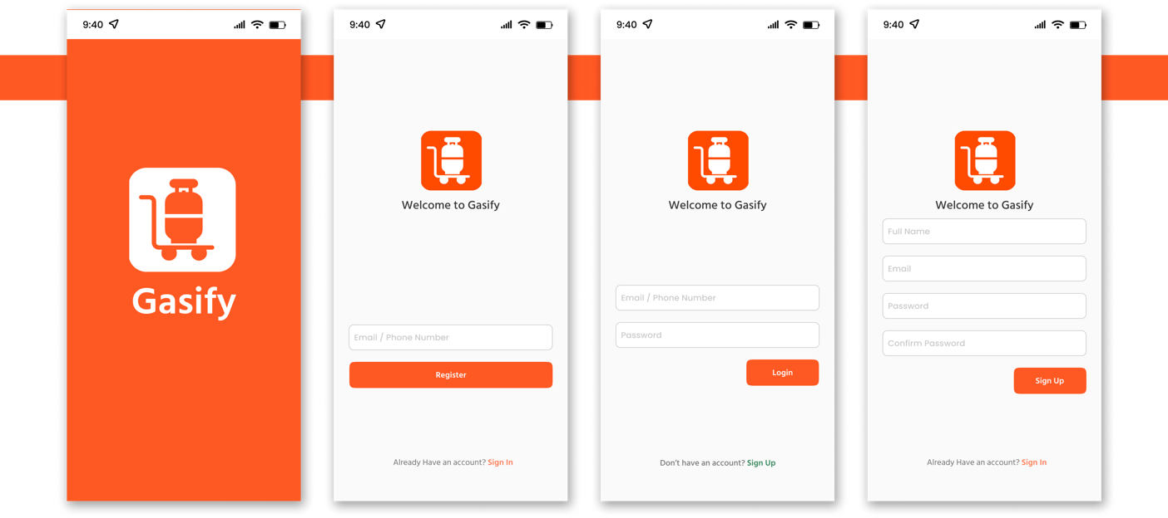
Figure 1: Onboarding Screen

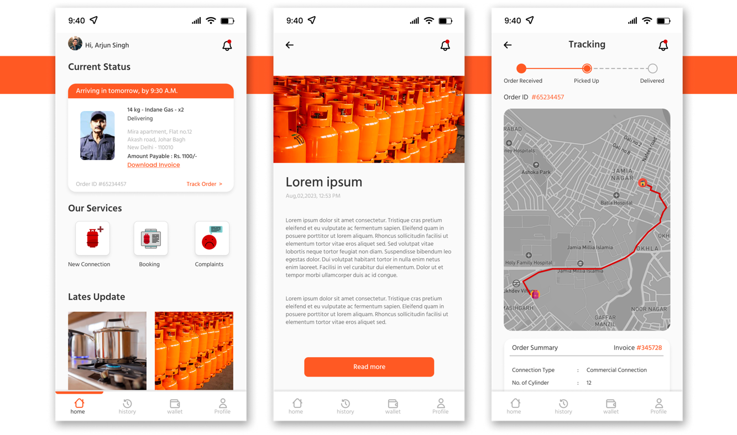
Figure 2: Home Page, news page and Track order page

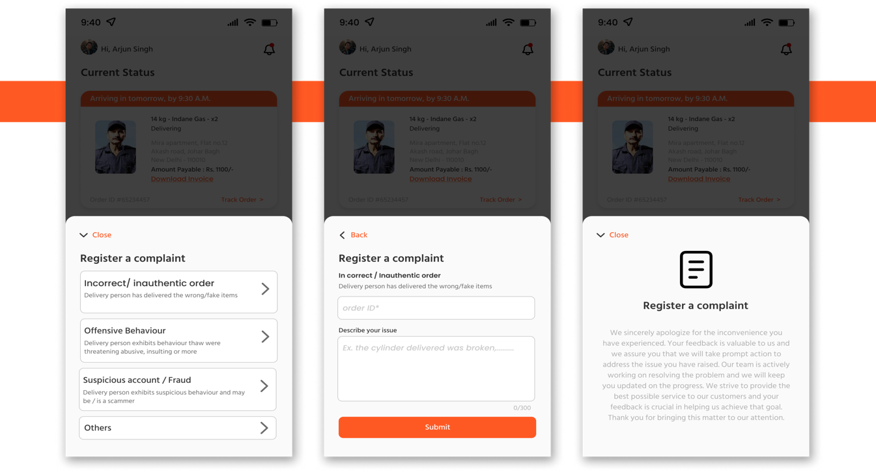
Figure 3: Complaints Screen

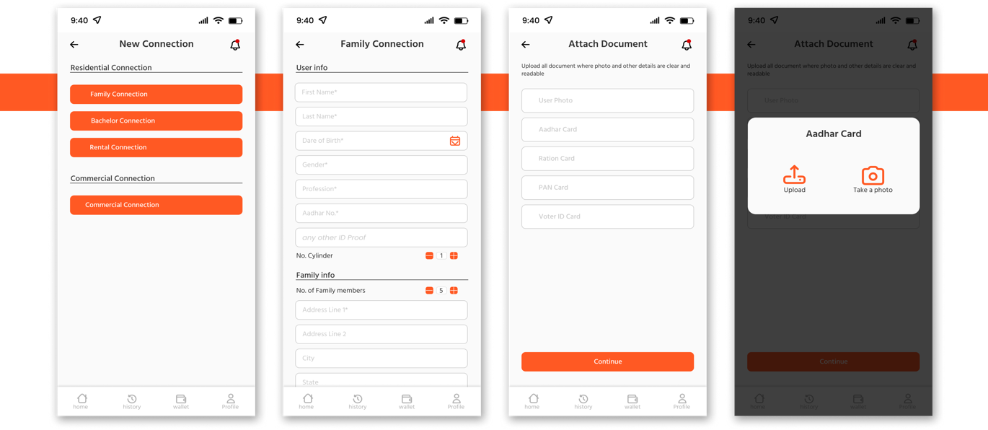
Figure 4: New Connection Screen for Domestic Connection

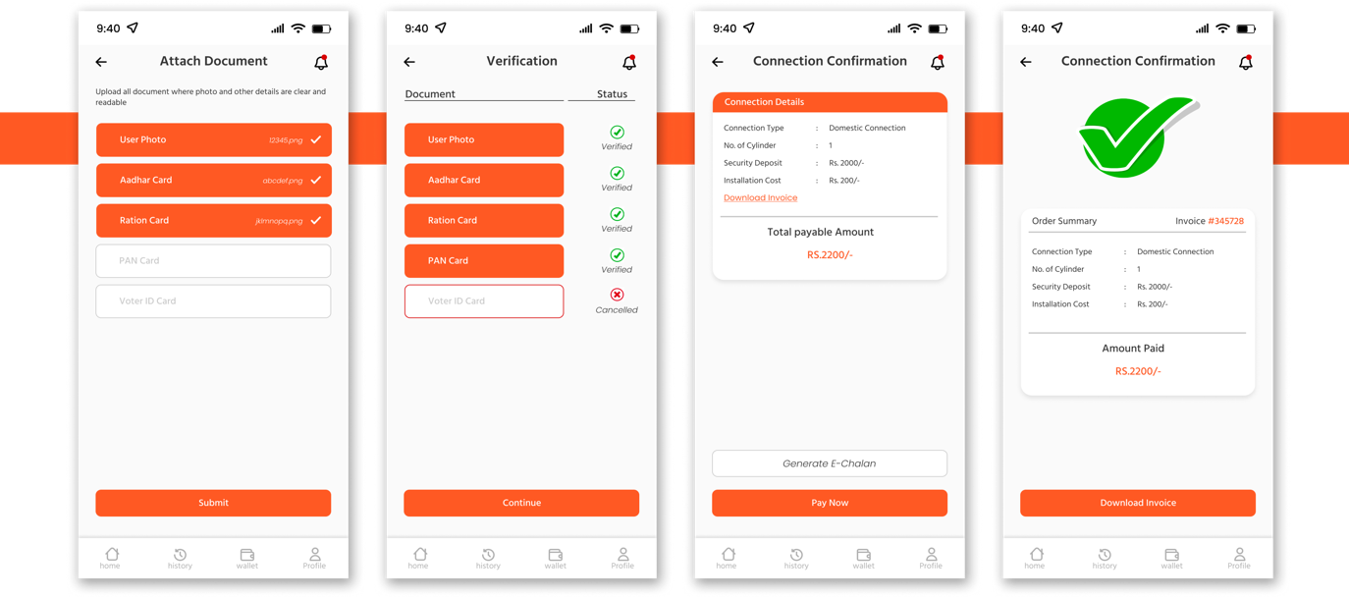
Figure 5: New Connection Screen for Domestic Connection
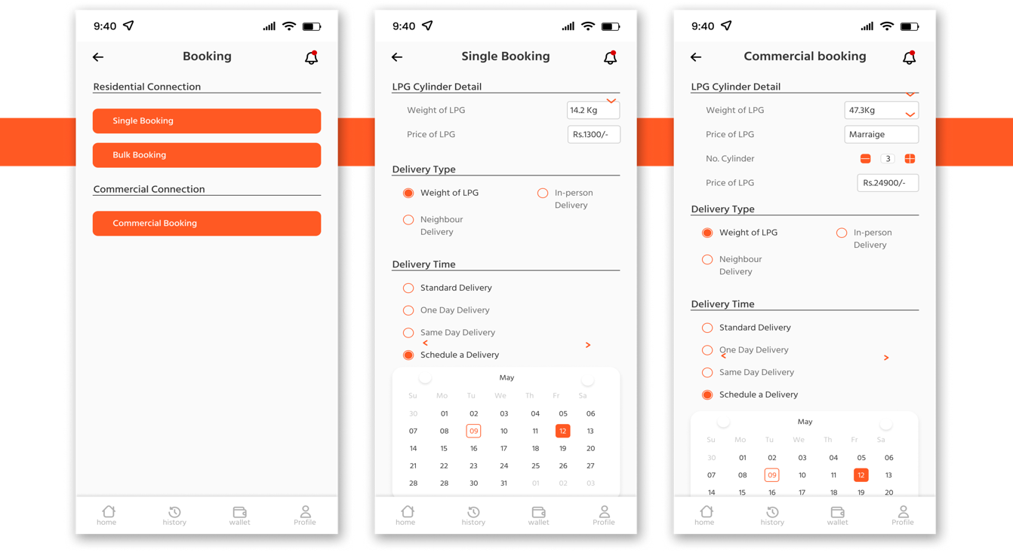
Figure 6: Booking Screen

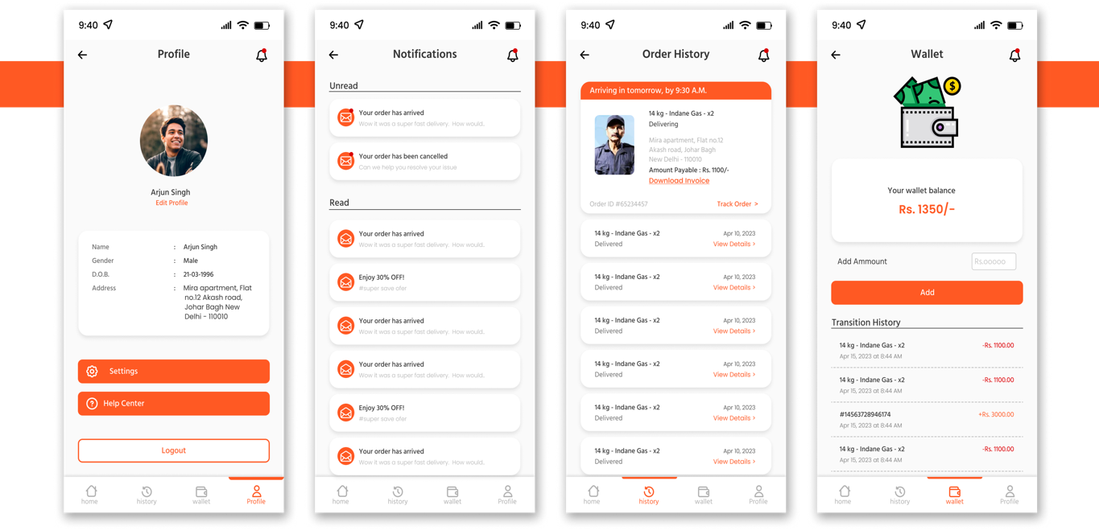
Figure 7: Profile, Notification, History and Wallet Screen

USABILITY TESTING

The goal of Usability Testing [3,5-6] • To evaluate the ease of use of the mobile application by potential users • To identify areas of improvement in the user interface and user experience • To determine the overall satisfaction of users with the app and their likelihood of using it in the future • To gather feedback and suggestions from users on how to improve the app's functionality and features. Tasks that were done by the users • Task 1- Registering as a new customer: The users were asked to register themselves on the app by providing their personal details, such as name, contact number, address, and other relevant information. • Task 2- Booking a gas cylinder: The users were asked to place an order for a gas cylinder through the app • Task 3- Raising a complaint: The users were asked to raise a complaint if they face any issues with the app or the services provided by the gas agency. They will be required to describe the problem and provide relevant details • Task 4- Tracking the delivery status: The users were asked to track the status of their gas cylinder delivery through the app. They will be required to check the estimated time of delivery and the current location of the delivery person.

Participant Selection Criteria – The criteria for selecting participants for this usability testing study included selecting those who had already been spoken to during the contextual study phase. Based on their availability and willingness to participate during the testing phase, the volunteers were chosen. These participants were chosen for the usability testing stage because they had first-hand knowledge of the LPG cylinder booking process and had offered insightful commentary during the contextual study. It was simpler to evaluate the success of the usability changes made to the app and to get more thorough feedback on its features by employing the same participants.

Figure 8: Task Completion Rate chart

HEURISTIC EVALUATION OF SCREENS

Norman-Nielsen's heuristics are a set of general principles developed by usability expert Jakob Nielsen for evaluating the usability of user interfaces. They are a set of 10 heuristics that provide a framework for assessing the effectiveness, efficiency, and satisfaction of the user experience. These heuristics are general rules of thumb rather than specific usability guidelines, and they cover a broad range of usability issues that can arise in different contexts (Figure 9-18).
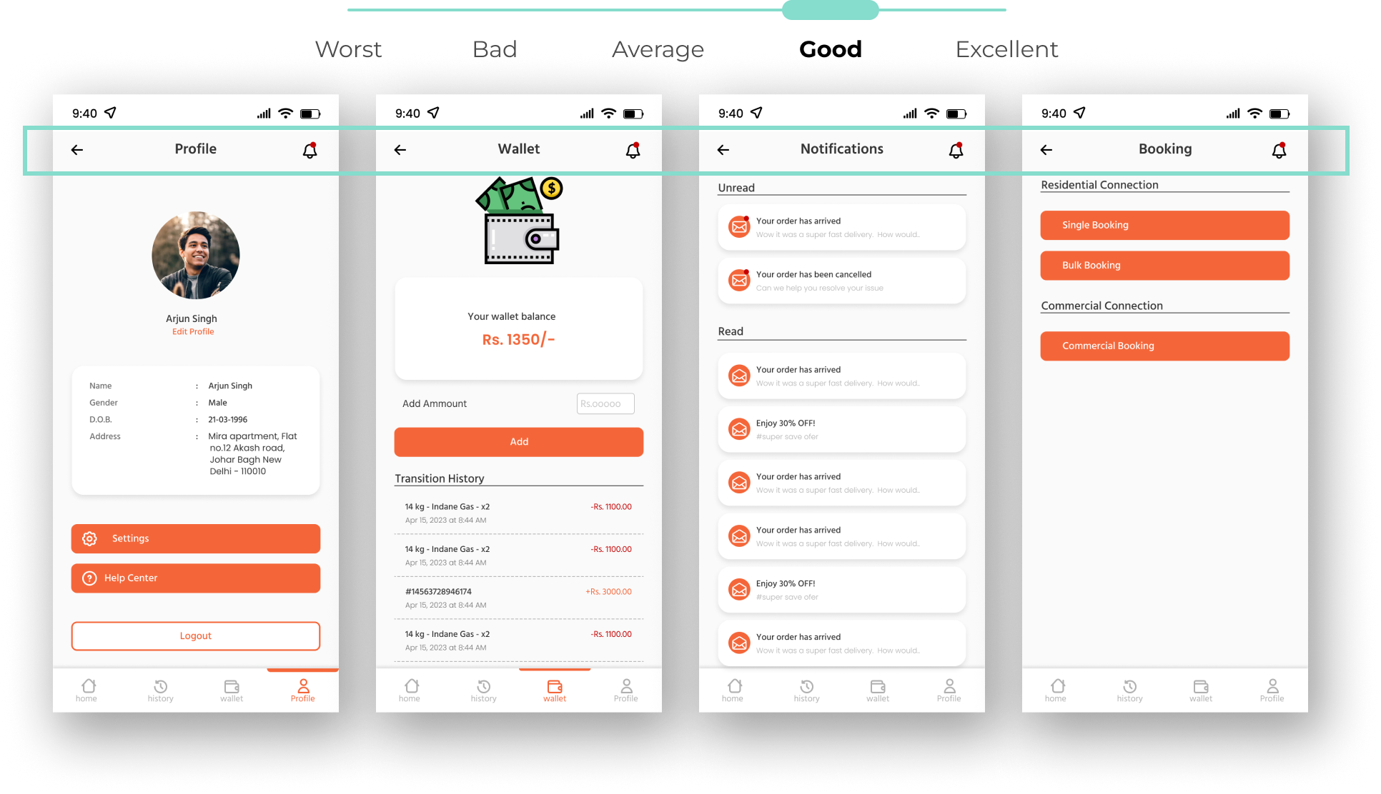
Figure 9: Visibility of System Status- The purpose of each screen is always indicated at the top of the user interface to help users understand where they are and what they can expect to find.

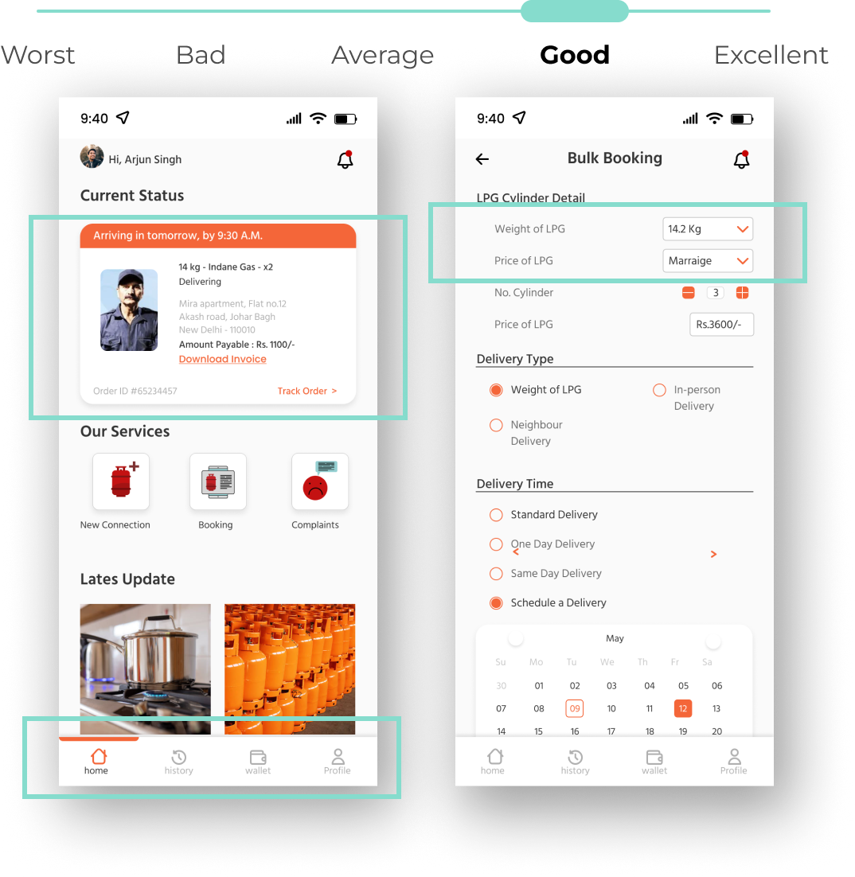
Figure 10: Recognise rather than recall - Recognize rather than recall - The landing page of the app provides users with necessary information about the delivery status and the latest updates related to LPG cylinders. The navigation bar is designed to help users easily remember and access the app's features. This approach reduces the cognitive load on users and enhances the overall user experience.to them.

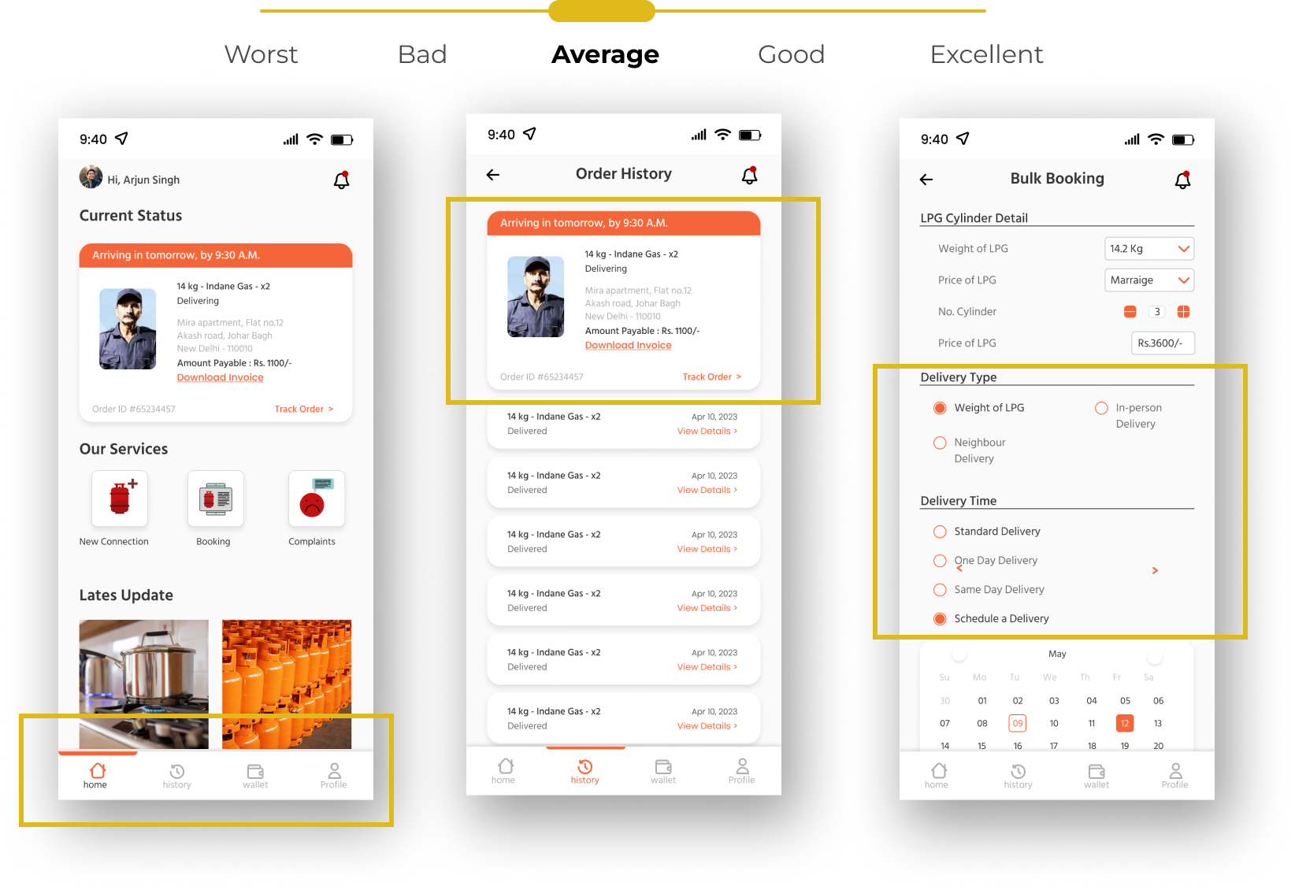
Figure 11: User Control and Freedom - The Navigation bar offers easy control to navigate to any part of the app for the user. Users can select their preferred delivery time for their LPG cylinders. However, there is no option to reschedule a delivery once it has been confirmed.
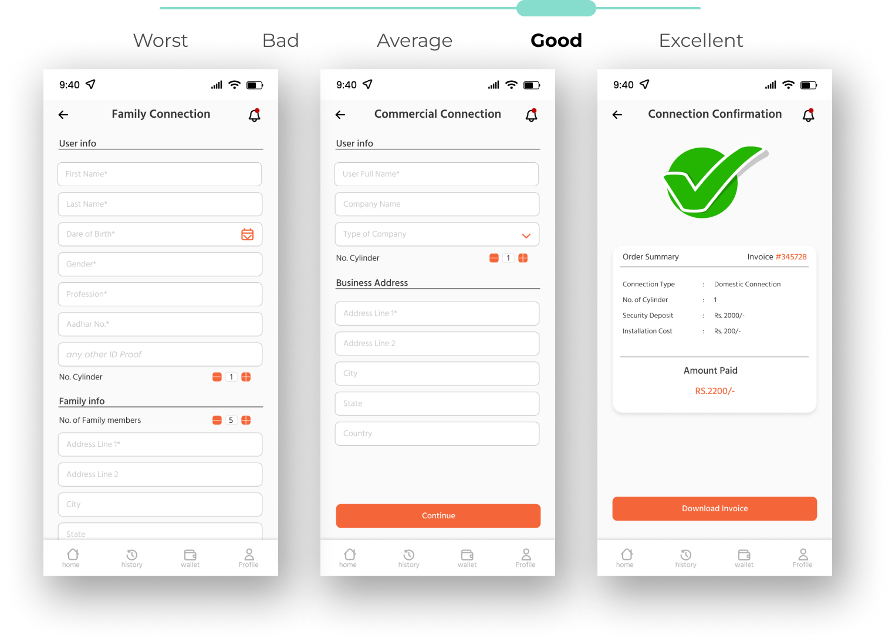
Figure 12: Match between the system and the real world - The interface is designed to resemble real-world scenarios, such as filling out forms for new connections. The order summary in the app is designed to look like a receipt generated in real-world situations.

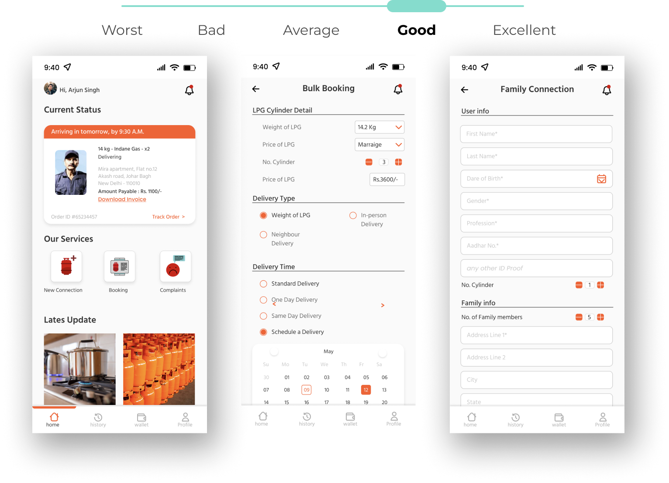
Figure 13: Aesthetic and Minimalist Design - The app's design language is minimalistic, providing a clear understanding of its purpose while also maintaining aesthetic value. This approach ensures that users can easily navigate the app without being overwhelmed by unnecessary visual elements.

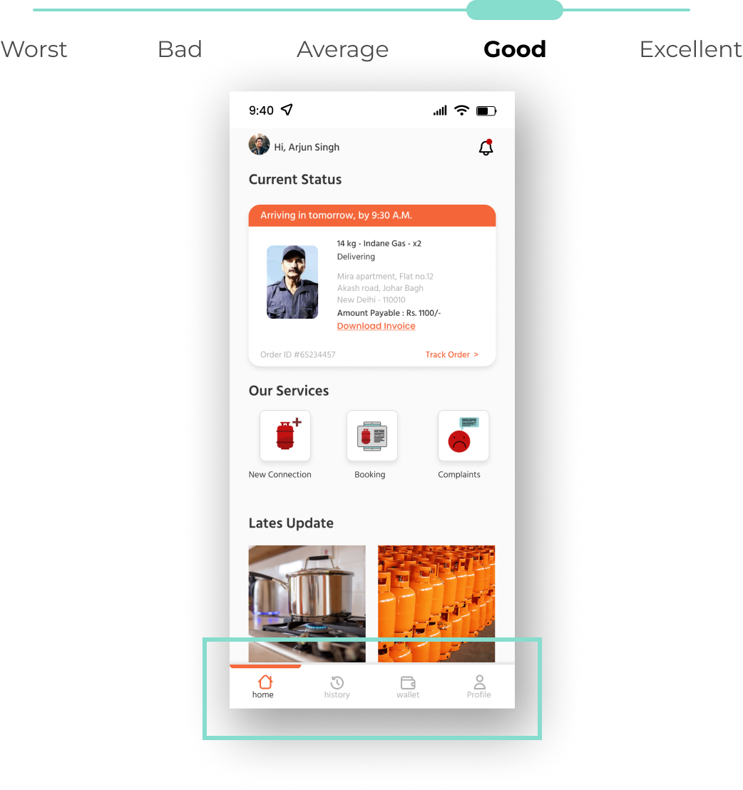
Figure 14: Flexibility and Efficiency of Use - The Navigation bar provides the user with ultimate flexibility in using the app. Major actions can be done by just opening the app, as they are present on the landing page. The app's usability is highly efficient, allowing users to access key features quickly and easily.

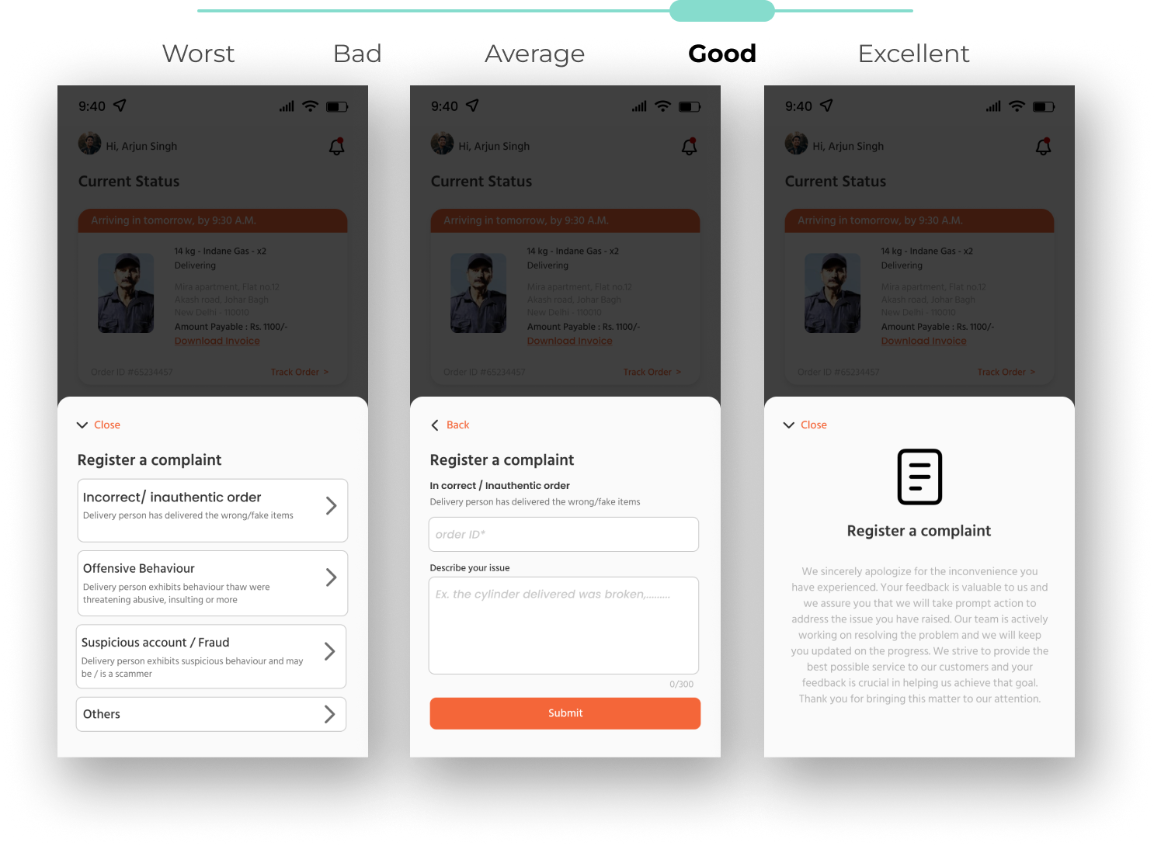
Figure 15: Help user recognise, diagnose and recover from errors- The provision of a complaint-raising option for both individual deliveries and overall experiences assists users throughout their LPG cylinder booking journey.

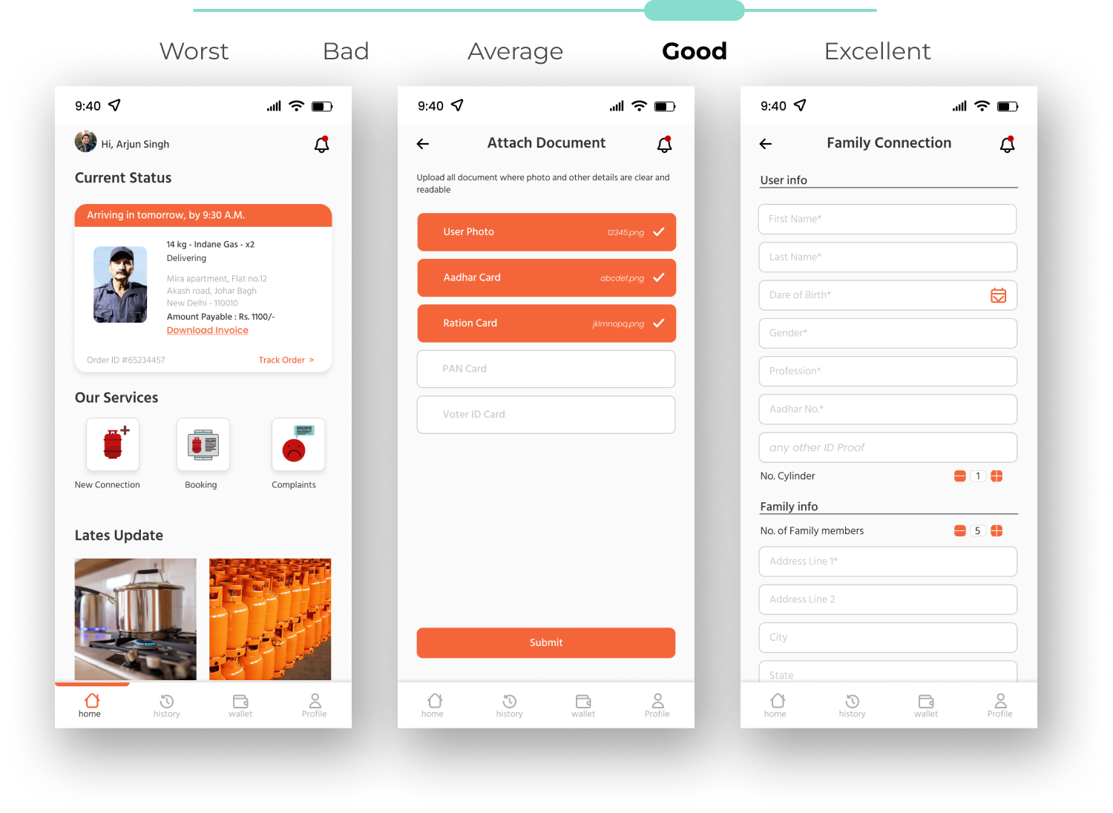
Figure 16: Consistency and Standard - The design theme maintains consistency by using familiar icons and avoiding unfamiliar ones, which could lead to confusion. Standardization is also ensured in the design.

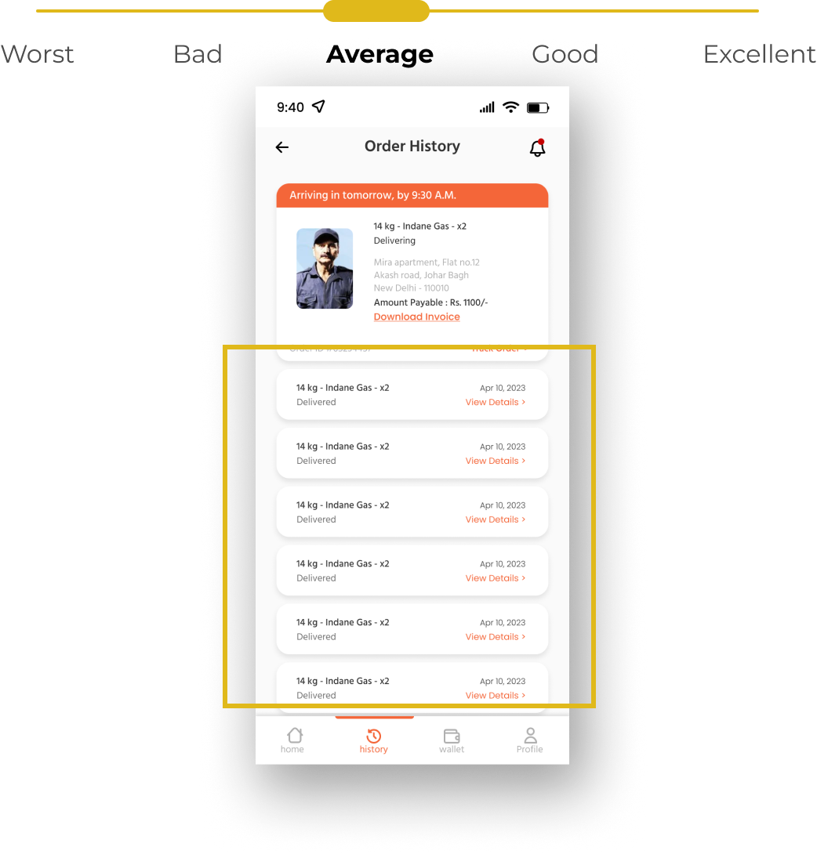
Figure 17: Help and Documentation - The order history simply maintains a record and doesn't offer any additional functionality.
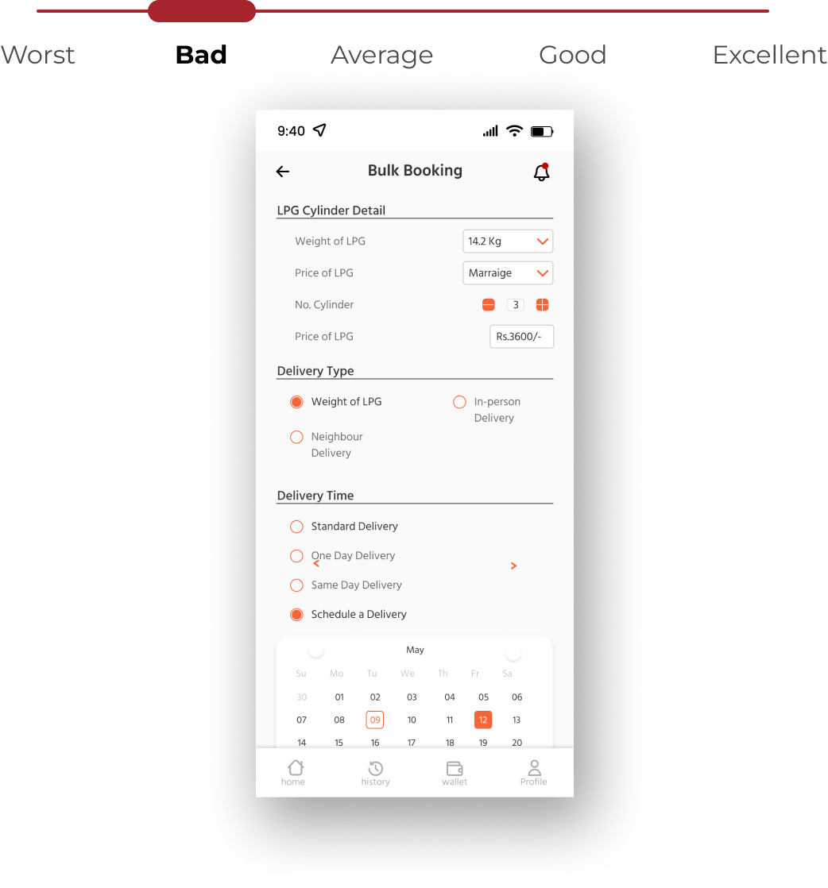
Figure 18: Error Prevention - There is no mechanism or feature in place within the app to prevent any errors from occurring while placing an order. This lack of error prevention could potentially result in a less efficient and frustrating user experience.

SUMMARY

The purpose of the app is to offer clients a simple and convenient way to book LPG cylinders. A set of volunteers who had previously been interviewed about their LPG cylinder booking experiences were used to test the app. Four tasks—creating an account as a new client, ordering a gas cylinder, filing a complaint, and monitoring the delivery status—were part of the usability testing. To assess the effectiveness of the app, the completion rates of each task were tracked. With an overall success percentage of 86.5%, the usability testing outcomes were generally favourable. There were, however, certain places that may use iteration. Participants pointed out that several aspects of labelling and navigation may be enhanced. For instance, some participants had trouble finding the section for complaints. Some participants also suggested that to improve the overall experience, more features could be added. For instance, to encourage frequent users to use the app, they suggested a rewards programme. The participant comments were quite helpful in pinpointing areas that needed improvement. The app's design was improved with the help of this data to make it more user-friendly. For instance, the navigation system was altered by the developers to make it simpler for consumers to locate the complaint section. To improve the users' overall experience, they additionally incorporated a rewards programme. The app may function well with the network connectedness of present times rather than relying on conventional methods of booking gas cylinders. The system offers hassle free and methodical approach towards booking process and delivery status notification. It may function well with the IOT services connected to other networks.

REFERENCES

[1] Smith, J. (2019) Mobile Apps: The Future of Online Business. Journal of Business and Management, 10(2), 45-57.
[2] Ahmad, M. and Khan, S. (2020) Gas Cylinder Delivery Mobile App: A Case Study. Journal of Information Technology Management, 31(3), 35-46.
[3] Braun, M. (2016) User Experience Design for Mobile Apps. Journal of Usability Studies, 11(2), 65-75.
[4] Kumar, A. and Aggarwal, N. (2018) Design and Development of a Gas Cylinder Booking App for Indian Households. International Journal of Innovative Technology and Exploring Engineering, 7(5), 246-250.
[5] Bastien, JMC. 2010. Usability testing: a review of some methodological and technical aspects of the method. International Journal of Medical Informatics Volume 79, Issue 4, April 2010, Pages e18-e23. https://doi.org/10.1016/j.ijmedinf.2008.12.004
[6] Moran, K. 2019. Usability Testing 101. Retrived August 2023 from https://www.nngroup.com/articles/usability-testing-101/
[7] BankBazaar. (n.d.). Gas Booking - LPG Gas Cylinder Booking Online [Website]. Retrieved April 5, 2023, from https://www.bankbazaar.com/gas-booking.html
[8] ORF Online. (2019, August 28). Household LPG Access in India. Observer Research Foundation. https://www.orfonline.org/expert-speak/household-lpg-access-inindia/#:~: text=According%20to%20the%20fifth%20National,use%20LPG%20or%20natural %20gas.
[9] Upwork. (n.d.). 9 Mobile UX Design Examples We Love. Upwork. Retrieved April 5, 2023, from https://www.upwork.com/resources/mobile-ux-design-examples
[10] UXCam. (n.d.). Mobile UX: Best Practices, Design, and Testing. Retrieved April 30, 2023, from https://uxcam.com/blog/mobile-ux/
[11] CivicPlus. (2021, February 12). Trends in Local Government Web Design. CivicPlus. https://www.civicplus.com/blog/ce/hot-trends-in-local-government-web-design
[12] Fireart Studio. (2020, December 28). Mobile App Design Trends 2020: Comprehensive Collection. Fireart Studio. https://fireart.studio/blog/mobile-app-design-trends-2020- comprehensive-collection/

