shwetha-paper
by User user

Submission date: 23-Jun-2023 01:39AM (UTC-0500)
Submission ID: 2121286188
File name: Research_paper.docx (1.18M)
Word count: 1800
Character count: 10131

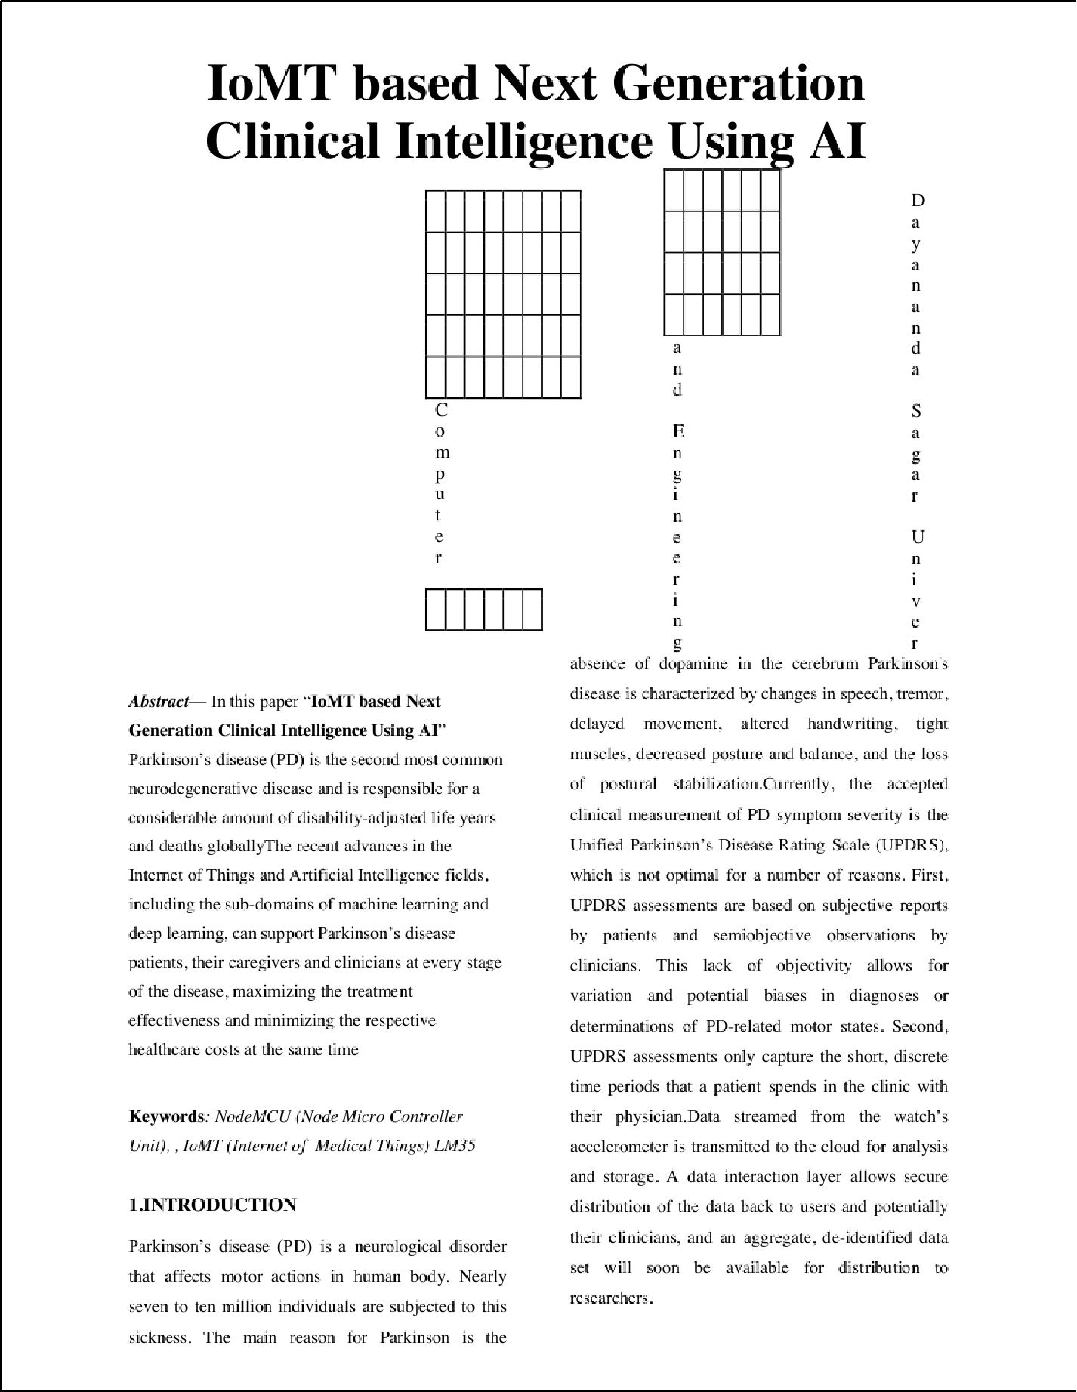

7
5
3
6
3
3
4
5
5

4
4
6 3

4
3

8
3

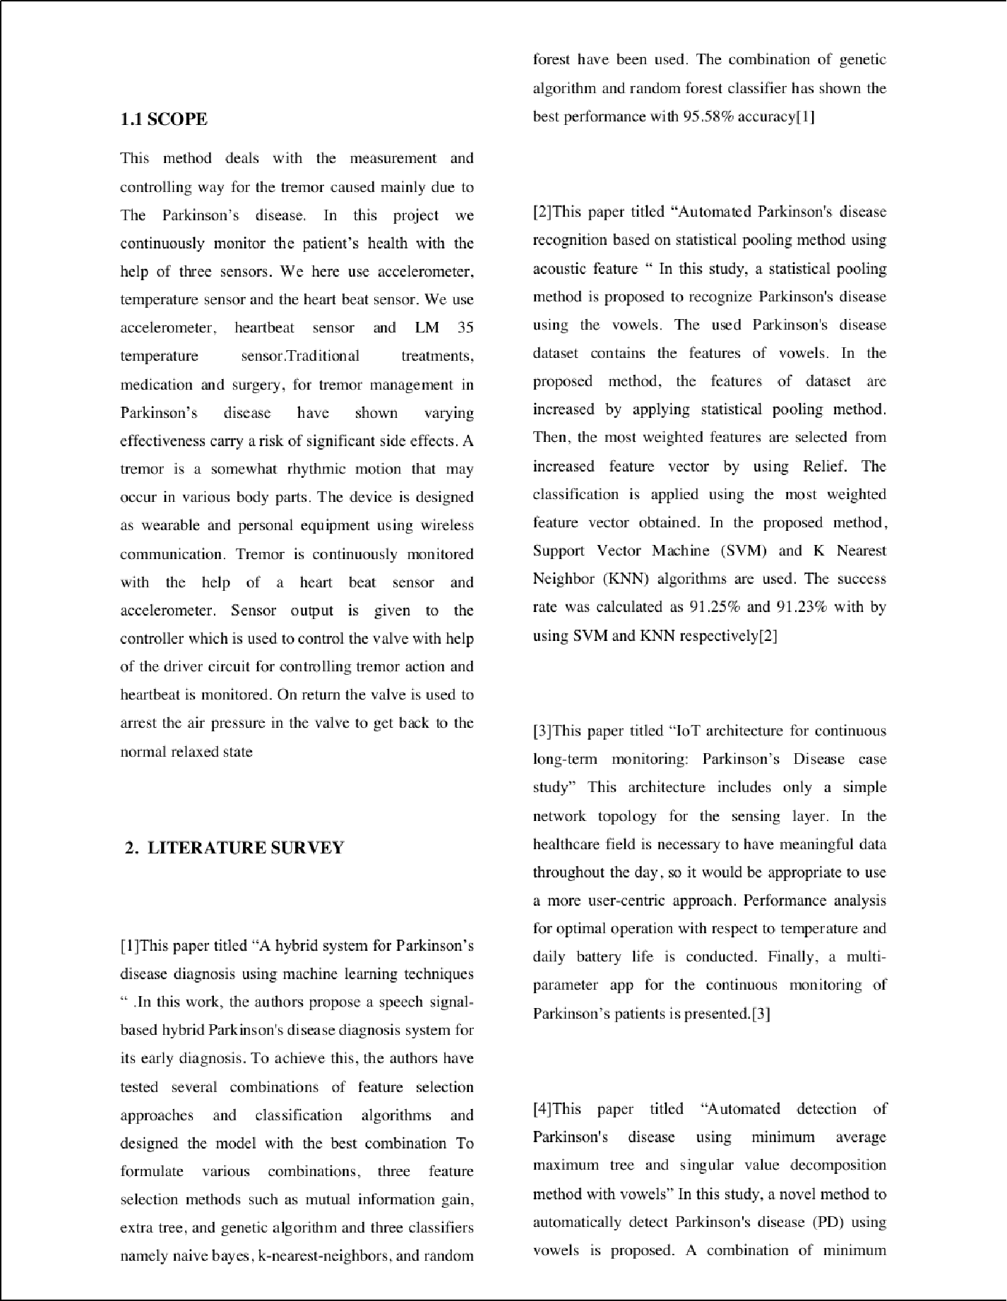
2

1

2

1

2

2

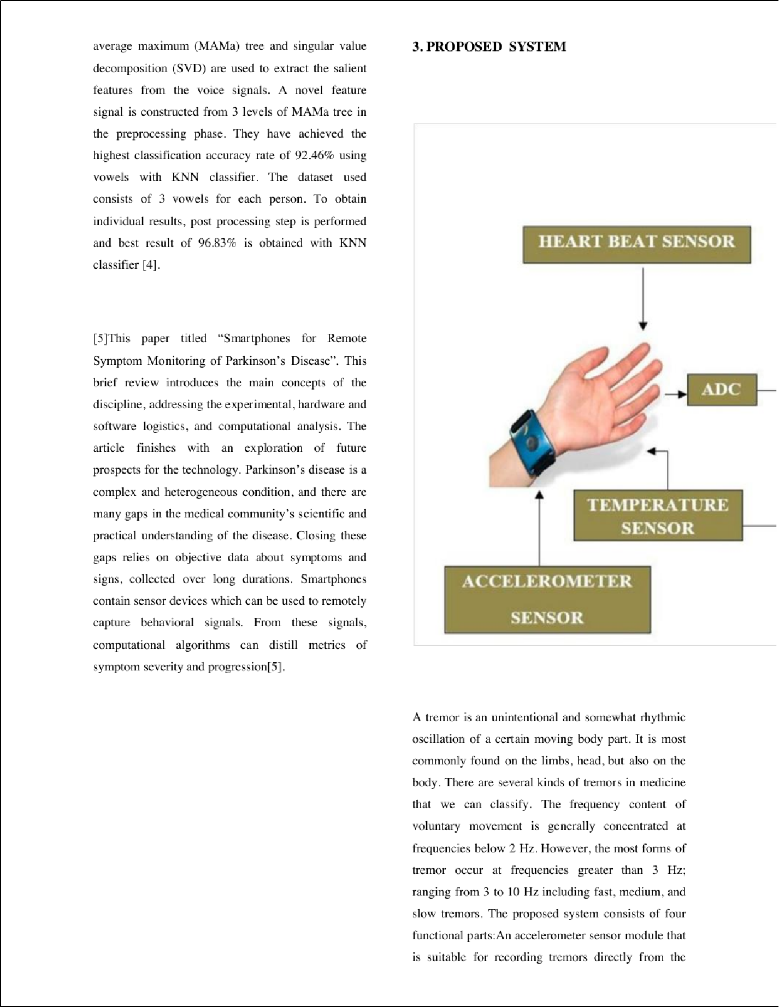

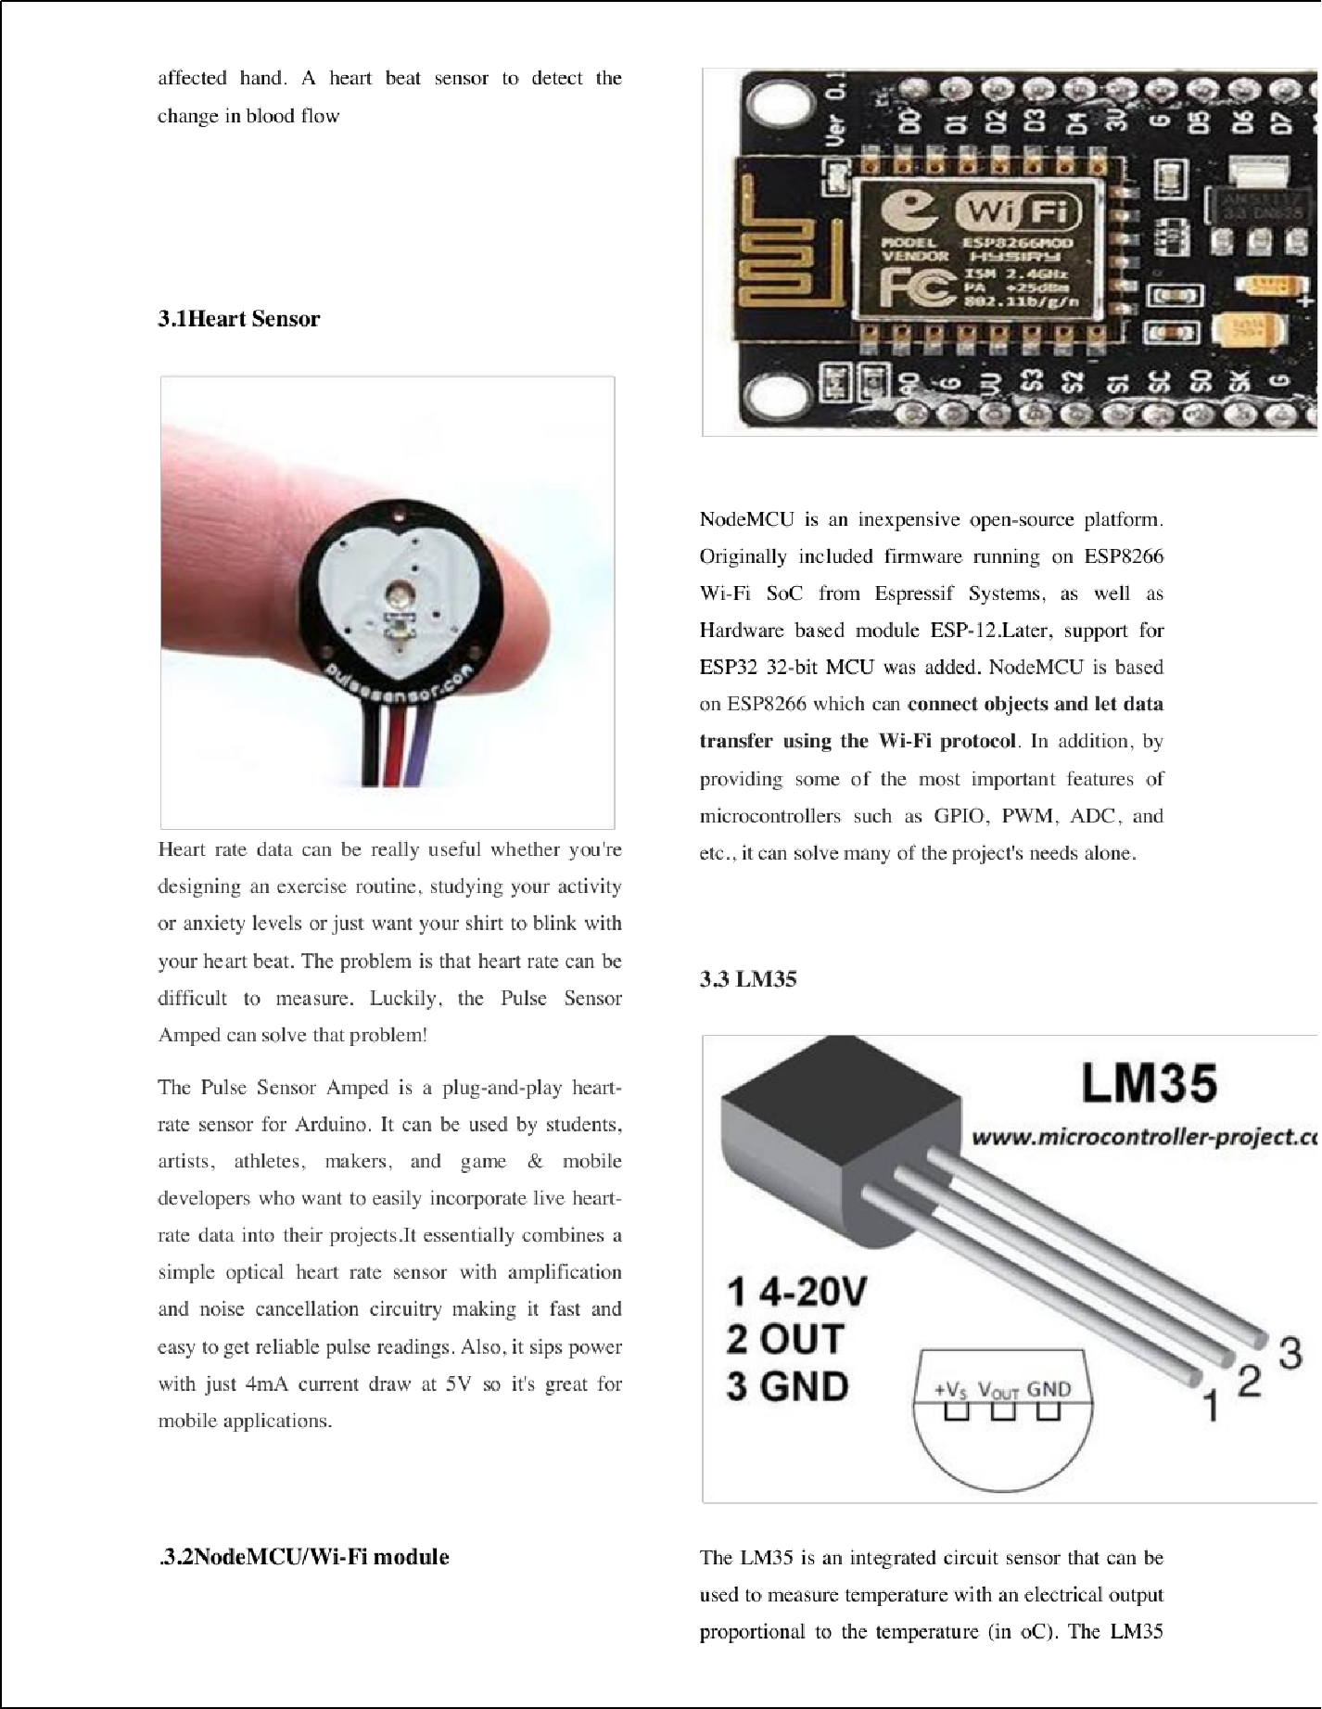

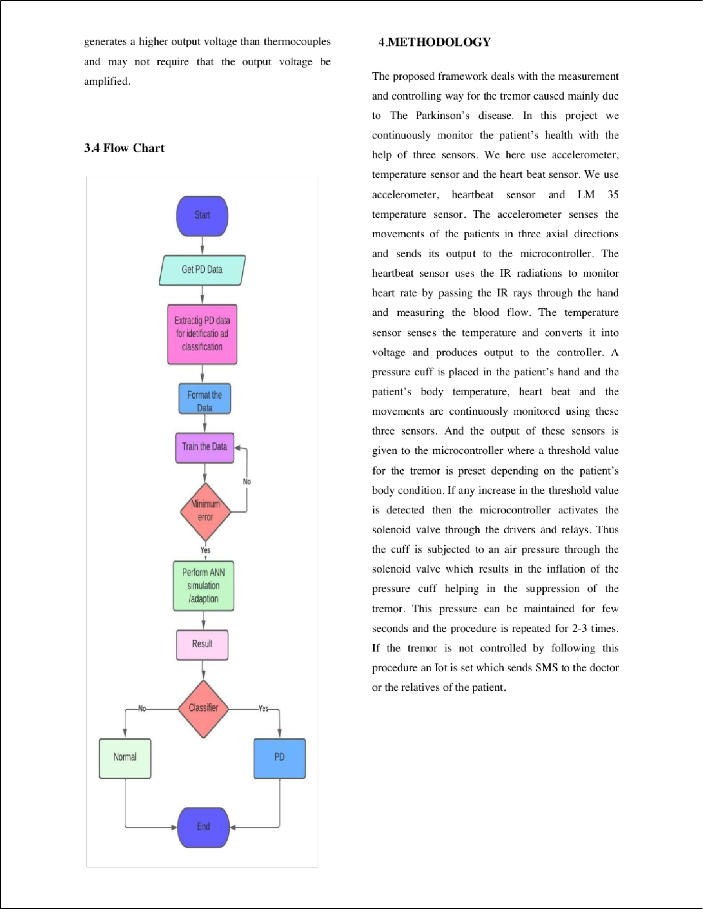

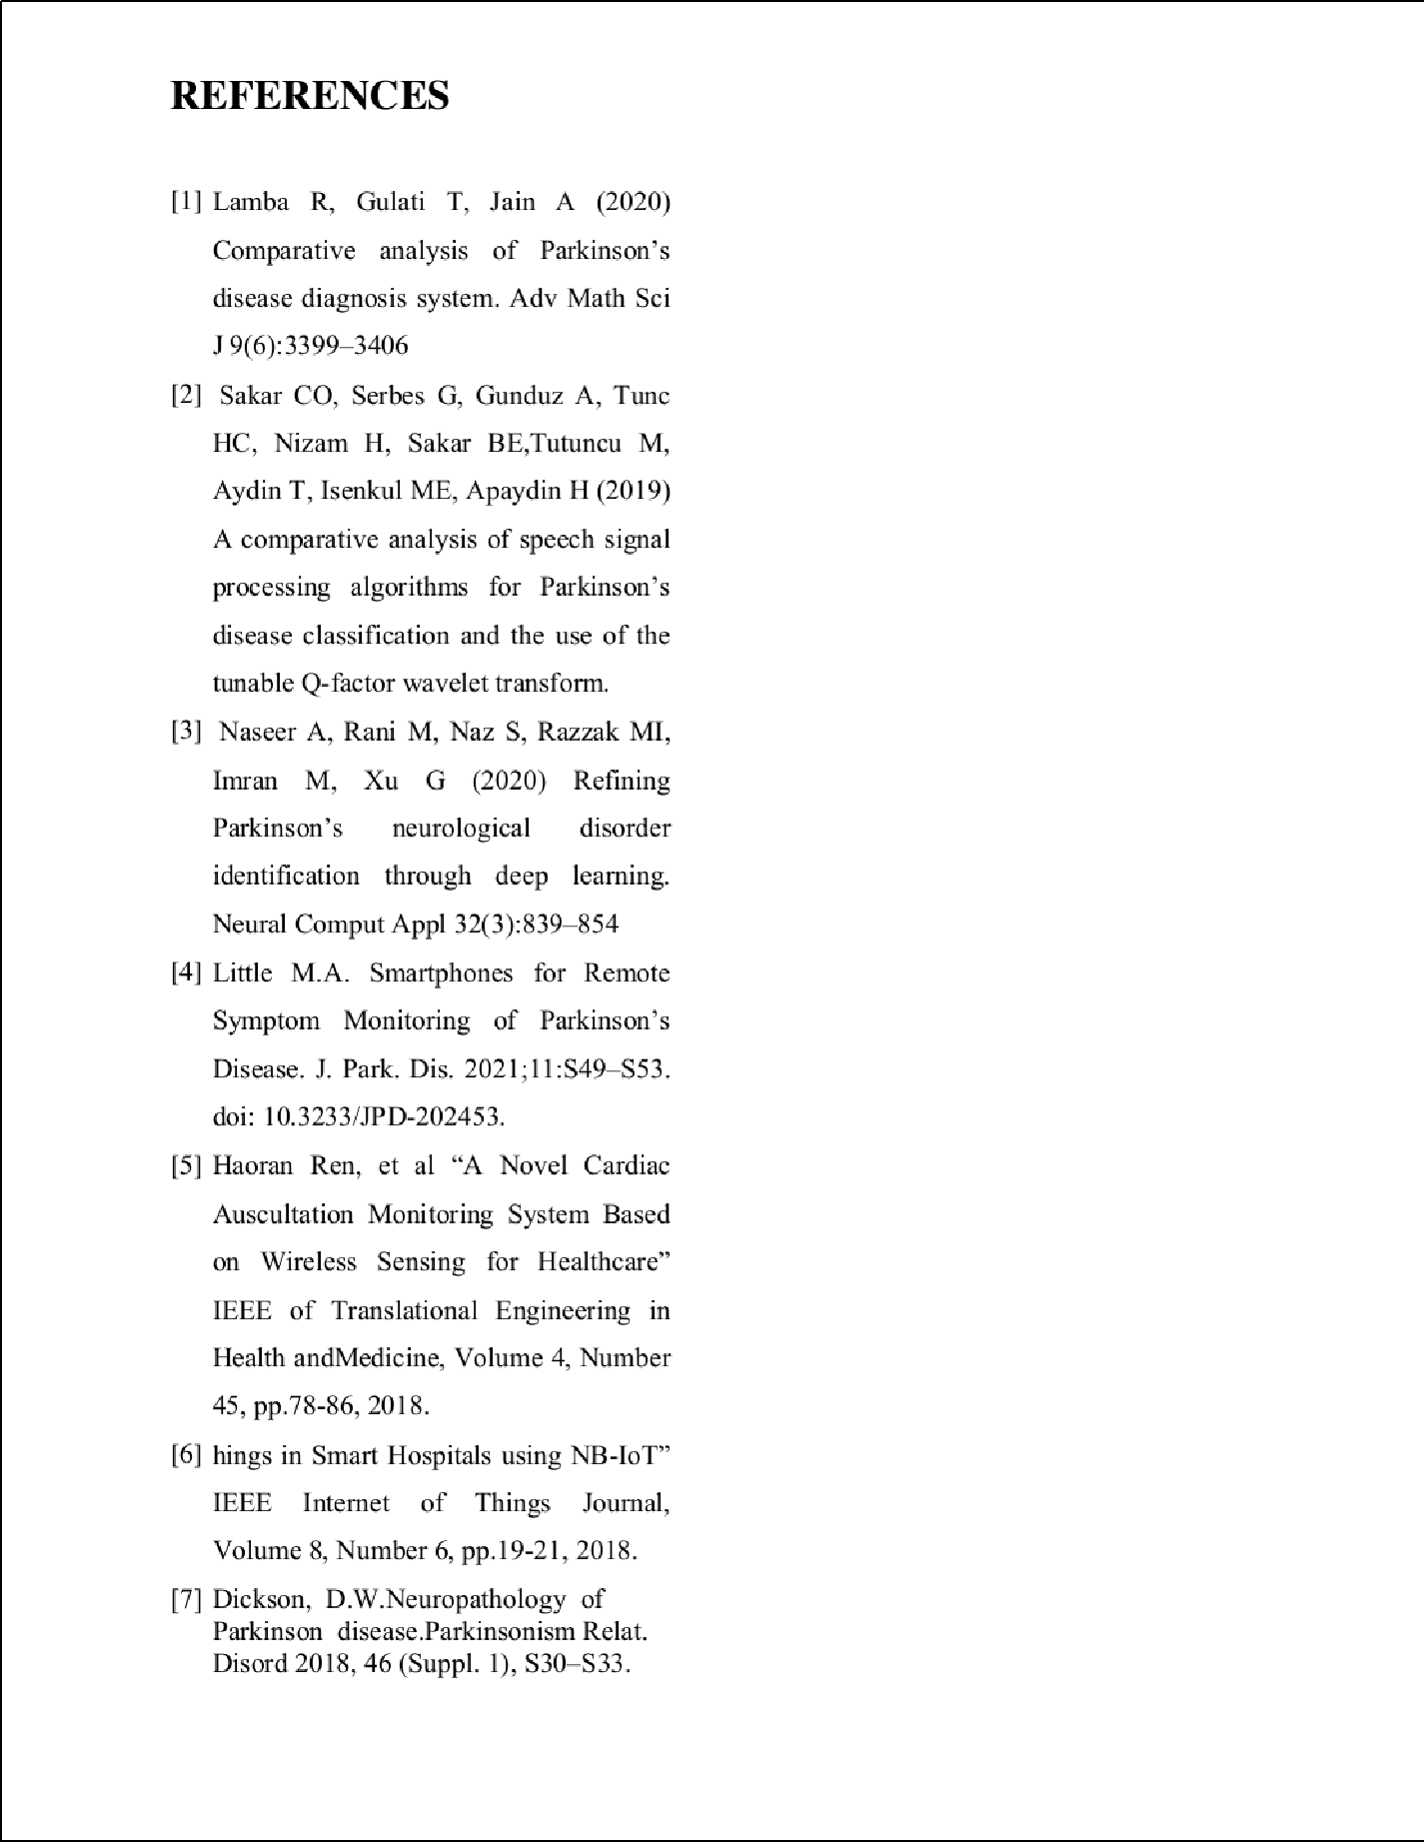

shwetha-paper
ORIGINALITY REPORT
25

%
SIMILARITY INDEX

23%
INTERNET SOURCES

18%
PUBLICATIONS

2%
STUDENT PAPERS

PRIMARY SOURCES
ijirset.com
Internet Source %
1
9
7

link.springer.com
Internet Source %
2
4

mhealth.amegroups.com
Internet Source %
3
2%

4 Shahar Cohen, Lauren R. Bataille, Adria K. Martig. "Enabling breakthroughs in Parkinson’s disease with wearable technologies and big data analytics", mHealth, 2016
Publication
1

www.mdpi.com
Internet Source %
5
1%

6 Konstantina-Maria Giannakopoulou, Ioanna Roussaki, Konstantinos Demestichas. "Internet of Things Technologies and Machine Learning Methods for Parkinson’s Disease Diagnosis, Monitoring and Management: A Systematic Review", Sensors, 2022
Publication

www.nature.com
7
1
Internet Source %
1

research.library.mun.ca
Internet Source %
8

Exclude quotes On Exclude bibliography On
Exclude matches Oﬀ

