Stump Appendicitis; it’s rare, but still there: A Case Report
Rajesh Chaudhary¹, Ramesh Baharti², Arvind Bhatia³, Ankit Shukla⁴, Munish Kumar⁵, Maninder Rana⁶
Authors:
Rajesh Chaudhary¹, Ramesh Baharti², Arvind Bhatia³, Ankit Shukla⁴, Munish Kumar⁵, Maninder Rana⁶
Affiliations:
1. MS, Assistant Professor, Department of Surgery, Pandit Jawahar Lal Nehru Government Medical College Chamba, HP, India.
2. MS, Professor, Department Of Surgery, Pandit Jawahar Lal Nehru Government Medical College Chamba, HP, India.
3. MS, Senior Resident, Department Of Surgery, Pandit Jawahar Lal Nehru Government Medical College Chamba, HP, India.
4. DNB, Senior Resident, Department Of Surgical Gastroenterology, Jawahar Lal Nehru Institute of Post Graduate Medical Education & Research, Puducherry, India.
5. MD, Assistant Professor, Department of Pharmacology, Pandit Jawahar Lal Nehru Government Medical College Chamba, HP, India.
6. MD, Assistant Professor, Department of Pharmacology, Pandit Jawahar Lal Nehru Government Medical College Chamba, HP, India.

Corresponding Author Details
Dr. Rajesh Chaudhary,
MS, Assistant Professor,
Department Of Surgery,
Pt.JLNGMC Chamba, HP, India
Email ID: topgun.chaudhary@gmail.com
ORCID ID: https://orcid.org/0000-ooo3-0699-466X
Abstract
Acute appendicitis is the most common surgical emergency worldwide so, emergency appendectomy is the most performed emergency surgery throughout the world. Intestinal obstruction, intraabdominal collection, faecal fistula formation and incisional hernias are the complications of appendectomy. Stump appendicitis is one of the rarest complications of appendectomy. World over, only 132 cases have been reported so far. Since the patients have undergone appendectomy, Stump appendicitis is last of any physician’s initial diagnoses, leading to mismanagement of such patients. The diagnosis is usually based on the clinical examination which is like those in acute appendicitis but since there is the history of appendectomy, usually another diagnosis is considered first. Ultrasound of the abdomen can pick up Stump appendicitis, but still undiagnosed cases will require the CECT of abdomen for diagnosis. This difficulty and delay in diagnoses may lead to serious complications like perforation of the Caecum and generalised peritonitis. Completion Appendectomy, whether open or laparoscopic, is the treatment of choice. We present the case of a 31-year-old female patient who presented to ED with a RIF pain after 8 months of emergency Appendectomy. She had a history of similar complaints in the past and was previously treated for UTI, 3 months ago. This time she again presented with the signs and symptoms of acute appendicitis and subsequently was diagnosed as stump appendicitis on USG Abdomen. Completion Appendectomy was done. To manage stump appendicitis high index of suspicion, good clinical acumen and surgical expertise is required. Although the patients can be managed conservatively with antibiotics, Completion Appendectomy is the treatment of choice.
Keywords
Acute Appendicitis, Stump Appendicitis, Acute abdomen, recurrent appendicitis, appendicular remnant
Introduction
Acute appendicitis is the most common cause of Acute abdomen worldwide consequently, Appendectomy is the most performed surgery worldwide. The inflammation occurring in the appendicular remnant is known as Stump Appendicitis (SA).[1] It is a complication of appendectomy that can present weeks to years after appendectomy. Most of the times such kind of patients are usually neglected or misdiagnosed, since the appendix has already been removed.[2] Thus, SA becomes least of a priority and a diagnosis of exclusion. These patients thus may land up in serious trouble because of gangrene and perforation of the appendicular stump resulting in acute generalised peritonitis.[3] It was first reported in 1945 by Rose, since then only 132 cases have been reported worldwide. [4] The signs and symptoms of the patient are no different than acute appendicitis, but since there is a history of appendectomy and, there are a myriad of other conditions, SA is the last on the list of differential diagnoses by any emergency physician. The patient reported here in this case report was similarly misdiagnosed and had a prolonged morbidity before being diagnosed as SA. Open completion appendectomy was done since, Completion appendectomy, either conventional or laparoscopic, is the treatment of choice.[5]
Case report
We present the case of a 31 yrs. old female who presented to the Emergency Department (ED) with Acute Abdomen. She had a history of similar pain in the past. She was investigated and diagnosed to be suffering from acute appendicitis for which emergency appendectomy was done 8 months ago. On examination she had pulse rate of 102 per minute. There was tenderness and rebound tenderness in the right iliac fossa beneath the healthy appendectomy scar. She did not complain of dysmenorrhoea, dysuria, or haematuria. She was treated for urinary tract infection at a similar visit to ED 3 months ago. Her Total leucocyte count was 9200 per mm³, with absolute neutrophil count of 80 %. Her other haematological parameters and biochemical analysis was within normal limits. Her ultrasound of abdomen showed a blind ending tubular structure with the transverse diameter of 6.5mm for a length of 1.3 cm, arising from the caecum. (Fig.1) Probe tenderness was present in right iliac fossa. All these features were suggestive of Stump Appendicitis. On opening the abdomen through the previous incision scar, there were multiple adhesions in the right iliac fossa. Omentum was present in the right iliac fossa. Careful dissection was done. Base of the appendix was identified and dissected out revealing an inflamed appendiceal stump of about 1 cm. (Fig.2) Right ovary and fallopian tube were grossly normal. Completion appendectomy was done, and specimen sent for histopathological examination which confirmed the diagnosis of stump appendicitis. The patient was discharged home on third post operative day and is doing well after 6 months of follow up.
Discussion
Emergency appendectomy is the most performed surgery worldwide. [1-3] The common post operative complications after appendectomy are wound infection, intestinal obstruction, intraabdominal abscesses, faecal fistula formation and prolonged ileus. One of the rarest complications is Stump Appendicitis developing in the remnant appendiceal tissue. The incidence of stump appendicitis is about 0.15% which is much less than 7% lifetime risk of Acute Appendicitis. [3] However, a recent review by Burbano et al suggested that it is high, ranging between 0.22-1.37%. [4] These patients present with typical symptoms and signs of Acute Appendicitis clinically, but since they already have undergone appendectomy, they are seldom considered as suffering from stump appendicitis. The other reason could be, that these patients are underreported, may be due to surgeons fearing retribution or due to lack of confidence in their surgical abilities. [1-3] That’s why only 132 cases have been reported worldwide since 1945, when first case was reported by Rose.[4] It is thought that since it is difficult to properly identify and tie the base of appendix during laparoscopic appendectomy, it should have higher incidence of stump appendicitis, but contrary to this belief, the incidence of stump appendicitis is more after open appendectomy. This could be related to the initial difficult appendectomy. Most of the times these patients are misdiagnosed as pelvic inflammatory disease, ureteric colic or urinary tract infections leading to delay in management and this may lead to serious complications like intraabdominal abscess formation [6], caecal gangrene or sometimes peritonitis. [3,7] Our case presented after 8 months of appendectomy, however patients presenting within 9 weeks to 50 years have been reported. [1] These patients usually present to the emergency department on number of occasions and are treated for other conditions like PID or UTI but to diagnose stump appendicitis requires confidence and good clinical judgement on the part of the surgeon or else, their treatment is delayed. Typically, the diagnosis of Acute Appendicitis has been clinical, based upon the Alvarado Score but the Ultrasound of the abdomen has been said to improve the diagnostic accuracy although the accuracy of ultrasound in diagnosing acute appendicitis has been found to vary widely. Graded compression is believed to increase the diagnostic accuracy of the ultrasound, but Contrast Enhanced Computerised Tomographic (CECT) scan of the abdomen is the investigation of choice. [8] Point-of-Care ultrasound abdomen done by the physician in the Emergency Department has been advocated as a useful tool to assist in the diagnosis of Stump Appendicitis.[2] The length of the remnant appendix has been reported to vary but a stump of more than 5mm has been found to be associated with the development of acute appendicitis. [9] A study by Kanona et al has found that complexity of the case during initial presentation, anatomic variations of the appendix, surgical technique and the operative experience of the surgeon may play a role in the development of stump appendicitis.[1]. Although the conservative management has been advocated but a completion appendectomy, either open or laparoscopic the treatment of choice. [1,4,5]
Conclusion
Stump Appendicitis is a rare but known complication of emergency appendectomy. A high index of suspicion and a good surgical technique are required to diagnose and treat the patient or else the patient may suffer serious consequences. Completion appendectomy is the treatment of choice.
.
Declarations
Reporting Checklist: The authors have completed the CARE reporting checklist and is being submitted as an additional file.

Ethical Approval: This is a case report and the patient identity is totally concealed; hence, the ethical approval is not required.

Consent: Written informed consent was obtained from the patient for publication of this case report and any accompanying images. A copy of the written consent is available for review by the editor-in-chief of this journal.

Availability of data and material: not applicable

Competing Interest: The authors declare that they have no competing interest.

Financial disclosures: None
AUTHOR’S CONTRIBUTIONS
Rajesh Chaudhary: Contributed substantially to the Conception, design, Acquisition of data, Analysis and interpretation of data, drafting the article, Critical revision of the article and final approval of the version to be published.
Munish Kumar : Contributed substantially to the Conception and design, Acquisition of data, Critical revision of the article and final approval of the version to be published
Ankit Shukla: Contributed substantially to the Conception and design, Acquisition of data, Critical revision of the article and final approval of the version to be published.
Maninder Rana: Contributed substantially to the Conception and design, Acquisition of data, Critical revision of the article and final approval of the version to be published.
Ramesh Bharti: Contributed substantially to the Conception and design, Acquisition of data, Critical revision of the article and final approval of the version to be published.
Arvind Bhatia: Contributed substantially to the Conception and design, Acquisition of data, Critical revision of the article and final approval of the version to be published.
Acknowledgements: Nil

REFERENCES
- Kanona H, Al Samaraee A, Nice C, Bhattacharya V (2012) Stump appendicitis: a review. Int J Surg 10:425–428
- Monsomboon A, Bret P. Nelson BP, Andrus P, Tsung JW (2019) Point‑of‑care ultrasound diagnosis of stump appendicitis in the emergency department. Ultrasound J 11:12 https://doi.org/10.1186/s13089-019-0128-5
- Dikicier E, Altintoprak F, Ozdemir K, Gundogdu K, Uzunoglu MY, Cakmak G, Onuray F, Capoglu R (2018) Stump appendicitis: a retrospective review of 3130 consecutive appendectomy cases. World Journal of Emergency Surgery 13:22 https://doi.org/10.1186/s13017-018-0182-5
- Burbano D, García AF, Chica Yantén J, Salazar C, Toro JS, Bravo JC. Stump appendicitis, a case report and a review of the literature. Is it as uncommon as it is thought? Int J Surg Case Rep. 2020; 68:88-91. doi: 10.1016/j.ijscr.2020.02.016. Epub 2020 Feb 11. PMID: 32126353; PMCID: PMC7052431.
- Buttrick SS, Choi JJ, Divino CM (2012) Stump appendicitis after open and
laparoscopic appendectomies. Am Surg 78:143–144
- Kumar A, Sharma A, Khullar R, Soni V, Baijal M, Chowbey PK. Stump appendicitis: a rare clinical entity. J Minim Access Surg. 2013;9(4):173–6.
- Manoglu B, Niflioglu GG, Uysal E. A rare case: appendectomy after connected stump appendicitis perforation of the cecum. J Clin Anal Med. 2015;6(4):539–41.
- Verma A, Chaudhary R, Bharti R, Sharma K, Sharma R, & Sharma V. (2020). Ultrasonogram in Acute Appendicitis, A Surgeon’s Perspective: Original Article. Journal of Advances in Medicine and Medical Research, 32(6), 118–125. https://doi.org/10.9734/jammr/2020/v32i630442
- Durgun AV, Baca B, Ersoy Y, Kapan M. Stump appendicitis and generalized peritonitis due to incomplete appendectomy. Tech Coloproctol. 2003; 7:102–4.

FIGURES
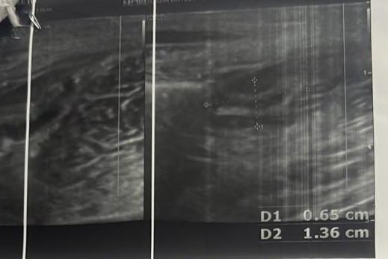

Figure 1: USG film showing a non-peristaltic, non-compressible, blind ending tubular structure in continuity with the Caecum, with a transverse diameter of 6.5 mm diagnostic of Stump Appendicitis.

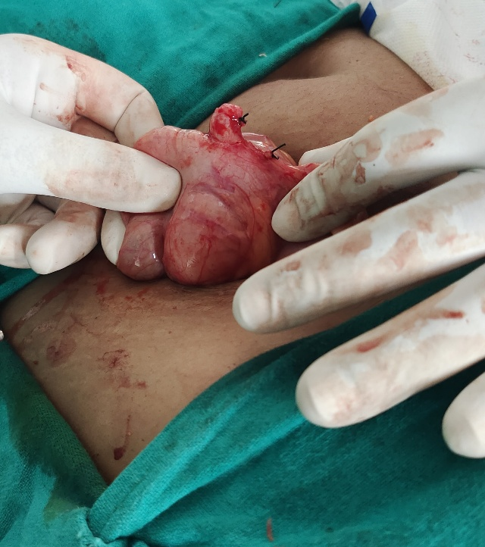

Figure 2: Showing inflamed appendicular stump at Completion Appendectomy

