“BIODEGRADATION OF RICE STRAW USING THERMOPHILIC CONSORTIUM FOR METHANE PRODUCTION BY BIOCHEMICAL DIGESTION”
Shashikala K J ¹, Srinidhi R Kulkarni ² and Dr. C. M Kalleshappa ³.
- Assistant Professor, Department of Chemical Engineering, BIET, Davangere-04.
- Assistant Professor, Department of Chemical Engineering, BIET, Davangere-04.
- Professor, Department of Chemical Engineering, BIET, Davangere-04.

ABSTRACT
From the debris of agricultural stubble in a paddy, wheat or grains fields. From biochemical digestion process having potential to form biogas production. The aim of this study was to investigate the potential of thermophilic strain on rice straw digestion was carried out in batch reactor under pH 7–8 and temperature 55ºC for 24 days. The biogas digester feedstock prepared with carbon to nitrogen ratio maintained as 20:1 with 8% solid content and dry biomass have 66.2% volatile solids.
The research paper divided into two parts that includes elemental analysis and proximate analysis of paddy straw performed using CHNS analyzer. It is found that C/N ratio is around 60:1 in paddy straw, while hydrogen: carbon ratio as cellulose feed stock lies between 1:7. Proximate analysis reveals that volatile solid contents 66.20% wt. In the last part of the paper the biogas production discussed and observed that average methane and carbon-dioxide composition in biogas is 53.35% and 46.58%, respectively. Biogas yield obtained as 0.484 m3 kg–1 of volatile solid.
Keywords— Biochemical conversion, elemental and proximate analysis, methane, paddy straw.

INTRODUCTION
Rice straw is produced as a by-product of rice production at harvest. Rice straw is removed with the rice grains during harvest and it ends up being piled or spread out in the field depending if it is harvested manually or using machines. With developments in the technologies for its collection and utilization, rice straw is increasingly removed from the fields to be used for better purposes such as for mushroom and energy production and for cattle feed.
Collecting rice straw is still a major challenge in the rice straw supply chain. Upon being gathered from the field, bundles of rice straw need to be compressed into bales to make them compact to reduce the transportation cost. With the introduction of combine harvesters that tend to leave the rice straw in the field, collecting rice straw has become even harder and costlier.
Because of harder and costlier hence the people start’s seasonal burning of crop residues called “stubble burning” especially paddy straw, by farmers of Punjab and Haryana contribute significantly to the national capital’s air pollution woes, with severe consequences for public health. In the wake of air pollution crisis in Delhi NCR, both central and state governments have come up with a number of awareness activities and subsidies to encourage farmers to stop stubble burning and adopt alternative straw management strategies. Understanding that the farmers, devoid of cost-effective alternatives, end up burning the straw hence, we have developing a processing technology to convert agro- like paddy straw into biogas – thus generating revenues to incentivise farmers to not burn the straw.

AIM AND OBJECTIVES

- To generate Biogas from Rice Straw.
- To Study composition of Rice straw (CHNS Analysis).
- To Study optimization of parameters for anaerobic digester.
- To Study the characteristics and compositions of Biogas.

METHODOLOGY

Biomass paddy straw is collected for biogas preparation from local area of Davanagere. The feedstock such as paddy straw cut into small pieces of 1 cm for the better yield of biogas and later they were grinded (1 mm size) in order to increase the surface area so that maximum area of the biomass becomes accessible to fermentative microbes in the digester.The biogas digester feedstock prepared with C/N ratio maintained as 20:1 with 8% solid content. The dry biomass taken 40 g with 66.2% volatile solids
The paddy straw biomass is used in ground form (< 0.25–5.5 mm) and soaked overnight in water, 1:10 ratio. The thermophilic consortium is isolated from soil samples, collected from dump yard and stored at 4ºC in refrigerator.
The optimum temperature range is 50–55ºC. It constitutes hydrolytic, acidogenic, acetogenic and methanogenic bacteria to carry out the anaerobic digestion process efficiently.
CHNS analysis is used to elemental analysis based of carbon, hydrogen, nitrogen and sulphur content of raw rice straw. Total Solids (TS) and total Volatile Solids (VS) for the rice straw were determined using standard techniques.
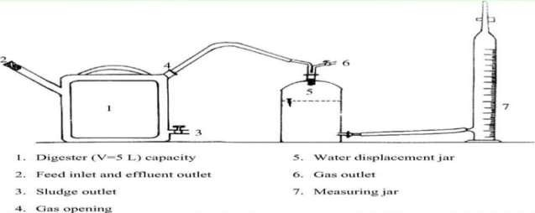
The day to day methane production for each anaerobic digester is recorded using the water displacement method and the corresponding cumulative methane volume is calculated. Methane is analysed using a gas chromatograph in presence of nitrogen as carrier. Soaking of feedstock for 24 h, is done prior to plant setup, this act as a pre- treatment step.

Fig: 3.1 LABORATORY SETUP

ANAEROBIC DIGESTION:
Anaerobic process, plants produce conditions that encourage the natural breakdown of organic matter by bacteria in the absence of air.

The process generates three main products:
- Biogas - a mixture of carbon dioxide (CO₂) and methane (CH₄), which can be used to generate heat and/or electricity.
- Fibre - can be used as a nutrient-rich soil conditioner, and
- Liquor - can be used as liquid fertiliser.
The process takes place in a digester; a warmed, sealed airless container. The digestion tank is warmed and mixed thoroughly to create the ideal conditions for biogas conversion.
In an anaerobic digestion plant, there are two types of process:

Mesophilic digestion - Mesophilic digestion is the most commonly used process for anaerobic digestion, in particular sludge treatment. Decomposition of the volatile suspended solids (VSS) is around 40% over a retention time of 15 to 40 days at a temperature of 30 to 40ºC, which requires larger digestion tanks. It is usually more robust than the thermophilic process, but the biogas production tends to be less, and additional sanitization is usually required.

Thermophilic digestion - Thermophilic digestion is less common and not as mature a technology as mesophilic digestion. The digester is heated to 55ºC and held for a period of 12 to 14 days. Thermophilic digestion systems provide higher biogas production, faster throughput and an improved pathogen and virus ‘kill’, but the technology is more expensive, more energy is needed and it is necessary to have more sophisticated control & instrumentation. Anaerobic digestion is divided in to four phases: Hydrolysis, acidogenesis (acid- producing), acetogenesis (acetic acid – producing), and metahnogenesis (methane – producing).

WATER DISPLACEMENT METHOD
The day to day methane production for each anaerobic digester is recorded using the water displacement method. The volume of water displaced in the container is equal to that of the volume of the gas. One end of the gassing gadget is connected to the biogas plant and other end connected to invert measuring cylinder which contained water. The amount of gas is calculated is equal to the mL of the water displaced. The biogas is allowed to collect in the inverted measuring cylinder by displacing water.

GAS CHROMOTOGRAPHY
Methane is analysed using gas chromatograph equipped with a thermal conductivity detector (TCD). This detector senses changes in the thermal conductivity of the column effluent and compares it to a reference flow of carrier gas, here nitrogen is used as carrier

ELEMENTAL ANALYSIS
Elemental analysis is a process where a sample of some material (e.g., soil or drinking water, bodily fluids, (minerals and chemical compound’s) is analysed for its elemental and sometimes isotopic composition Elemental analysis can be qualitative (determining what elements are present), and it can be quantitative (determining how much of each are present).
Elemental analysis falls within the ambit of analytic chemistry. CHNS analysis provide a rapid determination of carbon, hydrogen, nitrogen and Sulphur in organic matter (rice straw) and other types of materials. They are capable of handling a wide variety of sample types including solids, liquids, volatile and viscous samples, in the fields of pharmaceuticals, polymers, chemicals, environment, food and energy.

PROXIMATE ANALYSIS
Standard test methods (ASTM E1756-08, and E872-82) were used to analyze the proximate analysis to calculate the Moisture content, Total Solids (TS), Volatile Solids (VS), and Ash content in each biomass.

RESULTS AND DIOSCUSSION

Elemental analysis based on carbon, hydrogen, nitrogen and Sulphur content was carried out of rice straw in daily basis and the average values of the collected sample of the rice straw are shown in Table.2
Table 4.1: CHNS analysis of rice straw (wt % basis)

Sample of rice straw  (250gm) | Carbon (%) | Nitrogen (%) | Hydrogen (%) | Sulphur (%)
Sample 1 | 34.9 | 0.49 | 4.8 | 0.035
Sample 2 | 35.4 | 0.53 | 4.9 | 0.035
Sample 3 | 35.4 | 0.52 | 4.9 | 0.04
Average | 35.26 | 0.51 | 4.9 | 0.04

Proximate analysis, collected biomasses were undergone for proximate analysis to measure the contents such as volatile solids or organic matter which will be utilized during anaerobic digestion process for biogas production.
Standard methods (ASTM) were used for proximate analysis to calculate the Moisture content, Total Solids (TS), Volatile Solids (VS), and Ash content in each biomass as illustrate in the Table.
Table 4.2: Proximate analysis of various samples collected for biogas production in %
Sample Paddy straw (250 gm) | Moisture content % | Fixed carbon% | Volatile solids% | Ash content %
Sample 1 | 6.69 | 13.29 | 66.20 | 13.8
Sample 2 | 6.68 | 13.28 | 66.20 | 13.7
Sample 3 | 6.70 | 13.30 | 66.23 | 13.6
Average | 6.70 | 13.30 | 66.20 | 13.8

PRODUCTION OF BIOGASS

Illustrates the biogas production over a period of four weeks. It can clearly be seen that biogas production was the most dominating in the initial period of incubation.
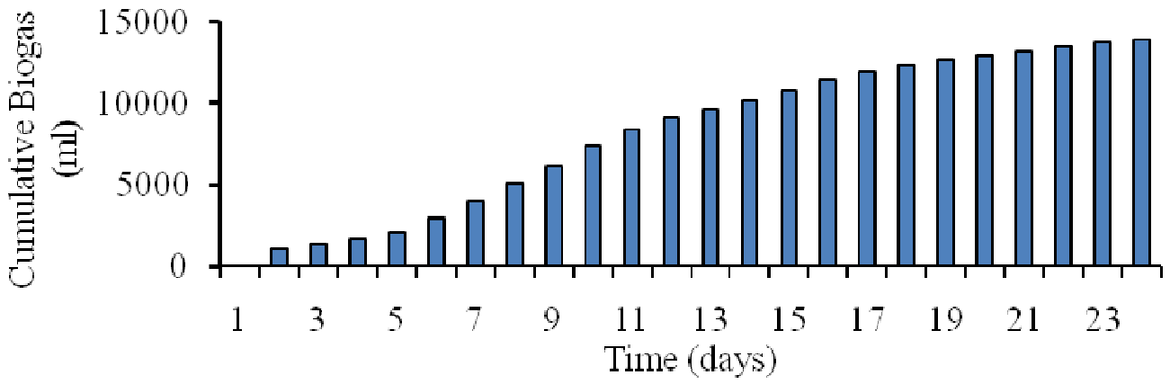
Fig. 4.1. Cumulative biogas production of all paddy straw used for biogas production.
To begin starting period of incubation show similar patterns and gradually increased from week 1 to 2. However, the rate of biogas production remained significantly higher from 0 to 10775 ml over this time frame.
From first week to second week of the experiment, the increase in biogas production at a steady rate, finishing the period at 10150–10775 ml. With the exception of a slight fall in week 3, production of biogas reached a peak in the final week of around 14000 ml.
Biogas production also increased at a steady rate, in the last three to four days finishing the overall rise 600 ml. The biodegradable contents suitable for thermophilic strain used excessively in first two weeks and on later stage inhibitor molecules formation takes place.
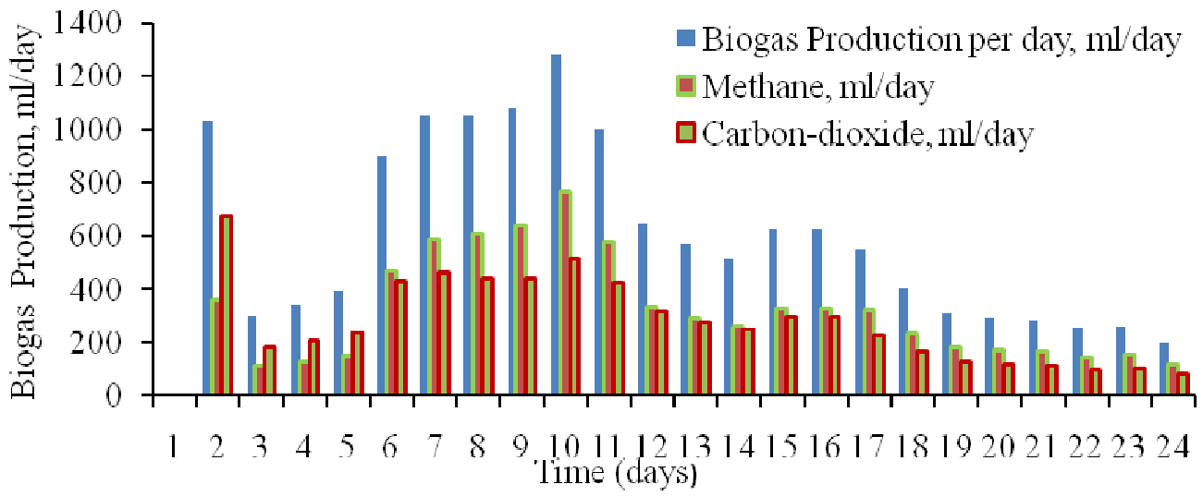
Fig. 4.2 Production of biogas, methane and carbon dioxide during anaerobic digestion from rice straw
In the early phase of digestion process CO2 production is higher than CH4 quantity. Cumulative CO2 contents increased sharply reached a peak value of 1301.92 ml, that 58% higher than production of CH4 in the same period. During this phase the thermophilic consortium lies in lag phase due to lower biochemical reaction temperature, but as reaction proceed the desirable components concentration dominates rest of digestion process.

The optimum amount of methane production occurs on 8th and 9th day of digestion. Percentage of CH4 and CO2 in biogas varies with the temperature, raw material and biochemical reaction controlled by microorganisms.

CONCLUSION

CHNS analysis indicates that paddy straw have high content of carbon approximately 35.26% and virtue of higher moisture contents that leads to shoot up volatile matter content.
After the day one of incubation the lag phase starts and dominates up to five days. During lag phase regime total biogas collection was 2060 ml/day and CH4 to CO2 production ratio 1:2. From 6th day of incubation to 11th day exponential production of biogas, CH4 and CO2, but in this region the CH4 production take over CO2. 12–16th day of incubation exhibits the behaviour of stationary growth, then proceed to death phase due reduction in biomass.
The maximum biogas production takes place on the tenth day of incubation and methane production on the same day was 766.72 ml/day. In anaerobic digestion of paddy straw using thermophilic strain, the total displacement 13940 ml observed. Out of that, CH4 yield 7436.86 ml and CO2 6493.74 ml and ratio between methane and carbon dioxide composition observed in biogas was 1.149:1 respectively, and temperature range of 50ºC to 54ºC to check the tolerance and performance in respect to biogas production with thermophilic consortia. The biogas yield obtained as 0.484 m3 kg–1 of volatile solid.

REFERENCE

- Jameson Filer, Hujhuang H. Ding and Sheng Chang,School of Engineering, University of Guelph, Published: 1 May 2019.
- A Haryanto, B P Sugara, M Telaumbanua and A R B Rosadi, IOP Conf Series; Earth and Environmental science, The university of Lampung, IOP Publishing doi:10.1088/1755-1315/147/1/012032.
- H Zhang P Zhang, j-Ye, y. Wu,W.Fang, X.Gou and G.Zeng, Int.Biodeterioe,2016,113,9.
- A.A. Adamu and E. O. Aluyour, Global journal of Engineering researcher VOL 12,2013:63-68., Published; 16/july/2013.
- Keanoi, napon, Hussaro, kanokom and teekasap sombat, American journal of environmental science, Published:2013,9(6) 529.
- Tahseen Sayara and Antoni Sanchez, department of environment and sustainability Agriculture Faculty of Agricultural Sciences and Technology, Palestine Technical University-Kadoorie, Tulkarm, Palestine, Published 2019, nov 1.
- Mariana Ferdes, , Mirela Nicoleta Dincă , Georgiana Moiceanu , Bianca S, tefania Zăbavă and Gigel Paraschiv ; Department of Biotechnical Systems, Politehnica University of Bucharest, 060042 Bucharest, Romania; Department Management and Entrepreneurship, Politehnica University of Bucharest,060042 Bucharest, Romania;
- C. J. Creevey, W. J. Kelly, G. Henderson and S. Leahy, Microbial. Biotechnology, Published:2014, 467.
- E. Rouches, I. Herpoël-Gimbert, J. P. Steyer and H. Carrere,Renew. Sustain. Energy Rev, Published: 2016, 59, 179.
- Shiwei Wang, Fang Ma ,Weiwei Ma, Ping Wang, Guang Zhao and Xiaofei Lu State Key Laboratory of Urban Water Resource and Environment, Harbin Institute of Technology, Harbin 150090, China; Published:12/jan/2019.
- Darwin, J. Cheng , Z. M. Liu, J. Gontupil and O. S. Kwon, Int. J. Agric. Biol. Eng., 2014, 7(6), 7
- Phutela Urmila Gupta and Sahni Nidhi, African Journal of Microbiology Research, 2013, 7(21), 2689.
- E. Rouches, I. Herpoël-Gimbert, J. P. Steyer and H. Carrere, Energy Rev., 2016,
- S. Achinas, V. Achinas and G. J. Euverink, Engineering, Published 2017.
- Gomez C D C 2013 Biogas as an energy option: an overview The Biogas Handbook: Science, Production and Applications, ed A Wellinger et al. (Cambridge: Woodhead Publishing Limited) pp 1–16.

