"Breaking Barriers and Building Bridges: A Comprehensive Study on Women's Empowerment through Self-Help Groups in Jharkhand, India"

Author
Abhishek Kumar Pandey (Research Scholar)
Dr. Manali Upadhyay (Asst. Professor)
Rabindranath Tagore University, Bhopal

Mobile No: 9334342868
Email ID: pandeyabhishek2625@gmail.com

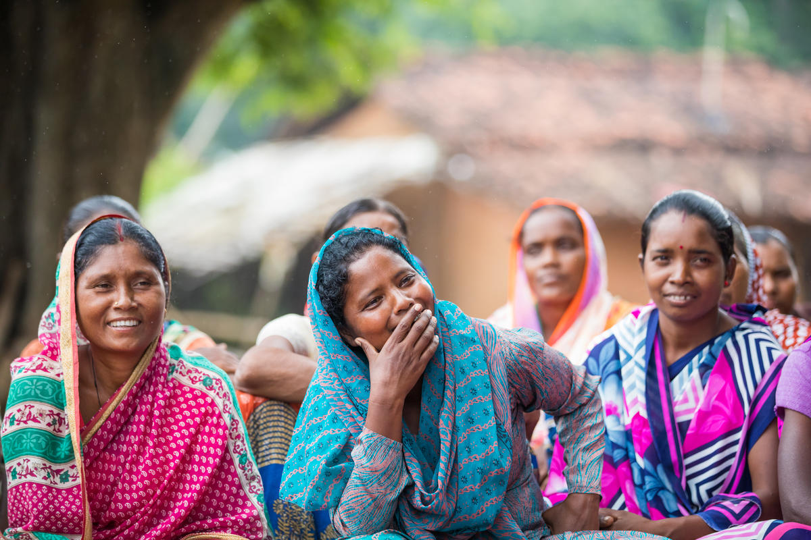
Self-help group members in discussion with foundation staff and Professional Assistance for Development Action (PRADAN) staff during a meeting in Sondari Pakartoli village, Torpa, Jharkhand, India on August 28, 2018.
Photo credit: ©Gates Archive/Mansi Midha

A Study on Women's Empowerment Through Self-Help Groups with Special Reference to the District of Jharkhand

Abstract
In recent years, a remarkable shift has been observed in society as women continue to assert their presence and strive for empowerment. This research paper focuses on exploring the transformative impact of Self-Help Groups (SHGs) on women's status within Jharkhand, India. The main objective is to analyze how participation in SHGs empowers women and affects their societal standing.
The study delves into both the positive and negative changes experienced by women involved in SHGs, in comparison to those not associated with such groups. Furthermore, the research aims to understand the attitudes of men towards the changing status of women in this context.
The findings of this study highlight significant and positive effects of SHG participation on women's empowerment within the society. SHGs serve as effective platforms for women to share information, raise awareness about their rights, and foster a supportive network.
The concept behind SHGs centers around the principles of "by the women, of the women, and for the women,"making it a powerful tool for poverty eradication, financial support, and women's empowerment in India. Through this research, we gain valuable insights into how SHGs play a vital role in elevating the status of women and promoting gender equality.
Keywords : Women, empowerment, gender
INTRODUCTION

In today’s world, lots of girls are unit privy to the state. To decide lady the weaker sex may be a libel; it's a man's injustice to girls. If strength is supposed ethical power, then girls are infinitely man's superior - nationalist leader. “We want girls the least bit levels, together with the highest, to alter the dynamic reshape the oral communication, to create positive women’s voices area unit detected and heeded, not unnoticed and unheeded.” — Sheryl Sandberg.
The relationship between women's authorization and social development has been a significant theme in studies of any nation's development. The United Nation Claims that there ought to be an Associate in the Nursing accomplishment of equality between girls and men as partners and beneficiaries of development, human rights, humanitarian action, peace, and security. As we tend to see that nowadays girls contains half the country's population, despite this they didn't have the management over financial gain. attributable to gender discrimination, most women are below the low- financial gain activities. because of this, the Republic of India has no exception in poorness and state that have become the main drawback of any under- developed country.
According to the report, there is a unit 42.16 % of individuals in the Jharkhand area unit poor, which is the highest within the country state (51.91%). In rural areas, there is a unit of nearly 49% of the population World Health Organization lives below the poverty level, whereas 47.99% of the individuals in the Jharkhand area unit are malnourished. Jharkhand is the second poorest state in the country within the third poorness Index 2021. In Jharkhand state was bigger than the national rate which was 59.2 percent. whereas the per centum of females in Jharkhand was 15.5 percent. this can be a result of the low growth of recent and productive employment.
In the Ninth 5 Year Plan, the Government of the Republic of India had launched several schemes for authorization of ladies and socially disadvantages teams like regular Castes, regular Tribes, and alternative Backward categories and Minorities as agents of socio-economic changes and development. However, there's the foremost effective theme with less monetary expenditure was the construct of Self- facilitate cluster. it's a good tool that may take away poorness and improve agricultural development.
On the thirteenth July 1848 initial time, the Women's Right Movement had started wherever a tea launches this revolution. This movement started with a little cluster of individuals questioning why human lives were below the belt constricted. Some changes don’t happen impromptu, it’s taken a few years. For these changes, girls themselves need to build changes. presently these changes come in terribly democratic ways in which like through conferences, oral presentations, and non-violent resistance. they need to work on this deliberately and build some changes in this world.
Self Help Groups offer government plans to individuals especially girls to attain property development goals i.e., no poverty, nobody sleeping while not food, achieving gender equality, and especially empowering girls together with economic process and cutting back difference. There are several analyses are done to grasp the effectiveness of those teams and to grasp that the participation in the SHGs area unit is ever-changing the participation things. The good thing about SHG-BLP (Self facilitate teams - Bank Linkage Program) is that helps girls in meeting monetary wants in rural areas, that strengthens girls’ capability in creating their authorization.

What is Self-Help Group?
A Self-Help Group (SHG) is a voluntary association of individuals sharing similar socio-economic backgrounds, who come together to improve their living conditions collectively. These groups are self-governed and peer-controlled, aiming to address various challenges faced by communities, especially in rural villages. These challenges often include poverty, illiteracy, limited skills, and lack of access to formal credit, which necessitate collaborative efforts for effective solutions.
Economic empowerment through SHGs plays a pivotal role in fostering women's confidence and agency, enabling them to actively participate in decision-making processes both within their households and at the community level. By joining SHGs, women gain the necessary support and resources to enhance their financial independence and contribute significantly to their families and society.
In essence, SHGs empower individuals to uplift themselves and their communities, creating a positive impact on various aspects of life, and promoting sustainable development at the grassroots level.

HOW DO SELF-HELP GROUPS HELP WOMEN IN MAKING THEM EMPOWERMENT?
Self-Help Groups (SHGs) have emerged as powerful financial intermediary committees comprising 12 to 25 local women aged between 18 and 50. In the state of Jharkhand, there are approximately 2,67,772 SHGs, with the majority being Women Self Help Groups. Women have made significant contributions to the economy, yet many are unaware of their true potential. However, today's women are actively involved in entrepreneurial activities, showcasing their capabilities.
The Emergence and Promotion of SHGs: The SHG movement began in the early 1990s, following Reserve Bank of India guidelines encouraging nationalized commercial banks to lend to informal SHG groups. NABARD actively promotes this initiative. SHGs are community-based groups comprising women from similar social and economic backgrounds. They regularly save small sums of money to achieve financial stability and can access loans from their collective savings during emergencies, important life events, or asset purchases. RBI regulations mandate banks to provide monetary services, including collateral-free loans to SHGs at low-interest rates.
SHGs as Anti-Poverty Instruments: Non-governmental organizations often establish SHGs with broader anti-poverty objectives. These groups are instrumental in empowering women and fostering leadership skills among the marginalized. According to a 2006 report by NABARD, there are approximately 22 million SHGs in India, representing about 33 million members who have taken loans from banks under the linkage program. This number does not account for SHGs that have not yet utilized this opportunity.
Empowerment and Attitude Shifts: Empowerment requires a fundamental change in attitude towards socialization. It entails granting individuals the freedom to make decisions. SHGs typically comprise 10-20 members from poor households with similar aims and objectives. These groups include both male and female participants, serving as an excellent platform for impoverished individuals to improve their socio-economic conditions.
Importance of Training and Gender Equality: Training plays a crucial role in transforming individuals into capable entrepreneurs who not only survive but also contribute to the economy. India has been investing in SHGs since the 1980s to improve gender equality and empower women.
The National Rural Livelihoods Mission: The National Rural Livelihoods Mission aims to mobilize 70 million households into SHGs. These groups typically undergo a six-month period during which women contribute their savings for intragroup lending. Subsequently, they can access larger loans from banks or other institutions, complemented by life skill training, business training, financial education, and more.
Positive Impact on Women's Empowerment: Systematic reviews demonstrate the significant positive effects of self-help group programs on women's empowerment. Participation in SHGs enhances women's ability to exert control over resources, participate in decision-making, and make crucial decisions about reproductive health within households. Training components have shown considerable impacts on women's economic and reproductive empowerment.
The SHG Movement as a Powerful Tool: The Self Help Groups movement has become a potent weapon for empowering females and fostering entrepreneurship in rural India. It has played a crucial role in challenging and improving the gender construct within villages. Women in rural areas now have the means to generate income, with SHG membership empowering them to build confidence, access financial resources, and gain social support for setting up businesses. SHGs typically consist of 8-10 women who meet weekly to collect money, connect with banks, and provide loans at very low-interest rates. Improved financial access and support have enabled women to uplift their family incomes.

Statement of Problems
In India, two things create a barrier in developing economies, they are Poverty and Unemployment. In India, for the rural sector financial institutions have not been able to reach them. As we can see in all developed countries women also play a crucial role in developing their economies and decreasing poverty and unemployment in severe regions. In this SHGs help in providing loans to the poor with very low interest. Finance become a major problem and SHGs also believe that finance became a major problem. Women suffer from most of Rome things i.e., illiteracy, lack of awareness, poor healthcare, gender inequality, and unemployment and this is true in rural areas and for weaker sections i.e., scheduled tribes and scheduled caste. Currently, with awareness, no women are also contributing to a great extent towards developing the economy.

REVIEW OF LITERATURE
- Soumitro Chakravarty and A.N. Jha’s (2011) this paper analysis women’s empowerment through Self Help Groups which is the case study of Jharkhand. The authors talked about the impact on the women empowerment process in Jharkhand. They talked about the working process, achievements, and operational difficulties of Self - Help Groups. Self Help Group is a method that helps poor people to come together to solve their problems. The SHG method is used by governments, NGOs, and other institutions.
- Soumitro Chakravarty, Umesh Prasad, Anant Kumar, Amar Nath Jha (2014) This research paper delves into the topic of women's empowerment through Self-Help Groups (SHGs), with a specific focus on the utilization of Information and Communication Technology (ICT). The case study centers on the state of Jharkhand, with a particular emphasis on the Ranchi District. The authors aim to analyze the potential, role, scope, and limitations of ICT in enhancing the functions and impact of SHGs in India, contributing to the overall empowerment of women.
- Priyanka Sahu, T.K. Venkatachalapathy (2018) this paper examines the role of the Self Help Groups through micro-credit schemes run for the empowerment of women in rural areas of Khunti district of Jharkhand State. The authors had done the personal meeting and interviews with one hundred and eighteen poor tribal women. The main of this study is to examine the socio-economic background, changes in an employment activity, income, borrowings, and habits of saving money before and after a microcredit loan.
- Raghuram Palli, Atanu Deb, Preetha Bhadra’s (2020) this study shows women’s empowerment through Self Help Groups with looming light from the tribal villages of Jharkhand. The study shows the main objectives, the study on socio-economic, political, entrepreneurial aspects of empowerment with some measure suggestions against the problems and constraints of the Self Help Groups. On the other side, Self Help Groups highlight the potential of women through a group approach, suggesting they help themselves in their capacity.

OBJECTIVE OF THE STUDY
- To analyze the level of awareness for women of Self-Help Groups in rural areas of Jharkhand.
- To analyze the rate of employment which is generated through Self-Help Groups in rural areas of Jharkhand.
- To study the economic condition of women members of Self-Help Groups.
- To analyze the attitude of society towards the women who are members of Self-Help Groups.

SCOPE OF THE STUDY
The scope of the study is to find out generating the employment for women, their income generation, women empowerment, economic development of the rural areas, etc. through Self-Help Groups in the rural district of Jharkhand and also know how much women are aware of Self-Help Groups among districts of Jharkhand.

RESEARCH METHODOLOGY
The data have been collected from secondary sources i.e., reports, journals, magazines, newspapers, and the internet. Data regarding the organization’s history of activities of the organization are collected from secondary sources i.e. - various textbooks, journals, magazines, records, reports, publications, and statistical tools. Reliability of data is ascertained where consistency of result could differ depending upon the situational circumstances of the measuring instruments used.

FINDINGS
Some of the major findings of this study found that many of the female respondents have joined the Self-Help Groups because they act as a source of income for the family, and being members of SHGs they can easily get a loan whenever they are in need with cheaper rates. With this study, we also find that there are some increases in their income after joining SGFs. With this, we also include that there was a significant increase in the rate of employment of women after joining the Self Help Groups. Women feel empowered not only economically but also socially.

Conclusion
Self Help Groups improved the lives of women respondents not only economically but also socially for backward respondents. They became financially independent after joining the Self Help Groups. With the help of Self-Help Groups, it’s become possible for making women to empowerment. Self Help Groups are successful in rural areas, especially among women.

References
- https://www.drishtiias.com/state-pcs-current-affairs/jharkhand-second- poorest-state-in-the-country-in-the-multidimensional-poverty-index-2021
- https://www.livemint.com/news/india/unemployment-in-jharkhand-increased-12-1-pct- points-rose-to-59-2-in-may-2020-cmie-11590970447392.html
- https://nationalwomenshistoryalliance.org/history-of-the-womens-rights- movement/
- https://academic.oup.com/cdj/advance- article/doi/10.1093/cdj/bsab036/6374653
- https://en.wikipedia.org/wiki/Self-help_group_(finance)
- https://www.drishtiias.com/to-the-points/Paper2/self-help-groups-shgs
- https://en.wikipedia.org/wiki/Reserve_Bank_of_India
- https://womensgroupevidence.org/empowering-women-through-self-help-groups-evidence-effectiveness-questions-scale
- https://theleaflet.in/self-help-groups-women-become-the-change-they-want-to-see-in-the-world/
- Chakravarty, S. and Jha, A.N., 2011. Women empowerment through SHGs— A case study of Jharkhand state in India. Journal of Social & Psychological Sciences, 4(1), pp.3-15.
- Chakravarty S, Prasad U, Kumar A, Jha AN. Women empowerment through self-help groups: The role of information& communication technology–A case study of Jharkhand state in India. Int J Appl Eng Res. 2014;9(24):28631-43.
- Palli, R., Deb, A. and Bhadra, P., 2020. WOMEN EMPOWERMENT THROUGH SHGS: LOOMING LIGHTS FROM THE TRIBAL VILLAGES OF JHARKHAND. Editorial Board, 9(4), p.186.
- Sahu, Priyanka, and T. K. Venkatachalapathy. "Women Empowerment Through Micro-Credit: A Case Study of Rural Khunti District of Jharkhand, India." Jharkhand Journal of Development and Management Studies, XISS, Ranchi 16, no. 2 (2018): 7687-7704.
- https://sjcc.edu.in/sjccresearch/pdf/ugc_poornima17.pdf

