**Hall effects on flow of a Prandtl fluid through aporous mediuminaplanarchannelwithperistalsis**

### Introduction

Many researchers considered the fluid to behave like a Newtonian fluid forphysiological peristalsis including the flow of blood in arterioles.But such a modelcannot be suitable for blood flow unless the non – Newtonian nature of the fluid isincluded in it.Peristaltic transport of non-Newtonian fluids in a tube was first studiedby Raju and Devanathan (1972), by considering the blood as a power-law fluid.Fewinteresting studiesdealing with the peristaltic flows of non-Newtonian fluids aregivenin(BohmeandFriedrich,1983;Siddiquietal.,1991;SubbaReddyetal.,2011).Recently, Akbar et al. (2012) have discussed the peristalticflow of a Prandtl fluidinan asymmetric channel.Peristaltic flow of a Prandtl fluid in a symmetric channelundertheeffectofamagneticfieldwasinvestigated byJyothietal.(2012).

The basic perception regarding MHD is the magnetic field which induces the currentsin conductive moving fluids which in results generates the forces on the fluid and alsovaries the magnetic field itself. It is well known that when any conductor comes into amagnetic field which in results creates a voltage, which is perpendicular to the currentand field, this effect is known as Hall Effect. Hayat et al. (2007) have investigated theHall effects on peristaltic flow of a Maxwell fluid in a porous medium. Effects of Halland ion-slip currents on peristaltic transport of a couple stress fluid was analyzed byAbo-Eldahab et al. (2010). Gad (2014) has studied the effects of Hall current onperistaltic transport with compliant walls. Eldabe (2015) have studied the Hall Effecton peristaltic flow ofthird order fluid in a porous medium with heat and mass transfer.Effect of hall and ion slip on peristaltic blood flow of Eyring Powell fluid in a non-uniform porous channel was studied by Bhatti et al. (2016).Shalini and Rajasekharhave investigated theeffect of hall on peristaltic flow of a Newtonian fluid through aporousmediumina two-dimensionalchannel.

In view of these, we studied the effect of Hall on the peristaltic transport of a Prandtlfluidthrough a porous medium in a two-dimensional channel underthe assumptionsof long wavelength and low Reynolds number.Series solutions of axial velocity andpressuregradientaregivenbyusingregularperturbationtechniquewhen

Prandtlnumberissmall.Theeffectsofvariousemergingparametersonthepressure gradient, pumping characteristics are studied in detail with the help ofgraphs.

### Mathematicalformulation

We consider the peristaltic transport of a conducting Prandtl fluid through aporous medium in a two dimensional channel of width 2*a* . The walls of the channelare flexible. A uniform magnetic field *B0*is applied in the transverse direction to theflow. The fluid is taken to be of small electrical conductivity, so that the magneticReynolds number is small and the induced magnetic field is neglected in comparisonwith the applied magnetic field. The flow is induced by periodic peristaltic wave oflengthandamplitude*b*withconstantspeed*c*alongthechannelwalls.ThephysicalmodelofthechannelisshowninFig.2.1

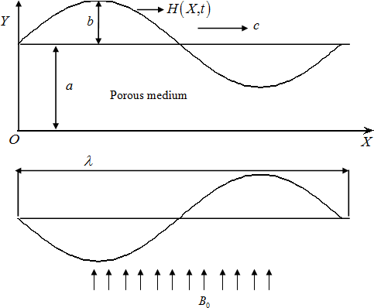

**Fig2.1.**Thephysicalmodel

Theequationofthe wallisgivenby

*Y**H*(*X*,*t*)*a**b*sin2(*X**ct*)

●

(2.2.1)

where*t*isthetime,isthewavelengthand*(X,Y)*aretheCartesianco-ordinatesinlaboratoryframeofreference.

Weintroducea waveframeof reference*x*, *y*movingwith velocity*c*inwhich the motion becomes independent of time when the channel length is an integralmultipleofthewavelengthandthepressuredifferenceattheendsofthechannelisa

constant(Shapiroetal.,1969).Thetransformationfromthefixedframeofreference

*X*,*Y*tothewaveframeofreference*x*,*y*

isgivenby

*x**X*-*ct*,*y**Y*,*u**U*-*c*,*v**V*

and

*p*(*x*)

*P*(*X*,*t*),

(2.2.2)

where*u*,*v* and*U*,*V*arethevelocitycomponents, *p*and*P*are pressures inthe wave andfixedframes ofreference,respectively.

TheConstituteequationsforPrandtlfluidisgivenby(Pateland Timaol,2010) (2.2.3)

in which A and C are material constants of Prandtl fluid model.

The equations governing the flow in wave frame of reference are given by

 (2.2.4)

 (2.2.5)

 (2.2.6)

whereisthe density,*m*istheHallparameter,istheviscosityof thefluidandisthe

electricalconductivity.

Thedimensionalboundaryconditionsare

*u**c*

at *y**H*

(2.2.7)

*u*0

*y*

at *y*0

(2.2.8)

Introducingthefollowingnon-dimensionalvariables

 , 



$=$

whereis the constant viscosity, in the Eqs. (2.4) – (2.6), we get

 (2.2.9)



(2.2.10)



(2.2.11)

where is the Darcy number, is the Hartmann number,  is the

Reynolds number and  is the wave number.

Under the assumptions of long wave length and low Reynolds number

, the Equations (2.2.10) - (2.2.11) become

 (2.2.12)

 (2.2.13)

here ,  and .

The corresponding boundary conditions in wave frame of reference are given by

 at , (2.2.14)

 at . (2.2.15)

Equations (2.2.12), (2.2.13) indicate thatis independent of. Therefore Eq. (2.2.12)

can be rewritten as

 (2.2.16)

The volume flow rate in a wave frame of reference is given by

. (2.2.17)

The instantaneous flux  in the laboratory frame is

. (2.2.18)

The time average flux over one period  of the peristaltic wave is

. (2.2.19)

### SolutionoftheProblem

TheEq.(2.2.16)isnon-linearanditsclosedformsolutionisnotpossible.Hence,welinearizethisequationintermsof1.Soweexpand*u*,*p*and*q*as

*u**u*

0*u*1

*O*(2)

*p**p**p*

*O*(2)

0 1

*q**q*

*q*

*O*(2)

(2.3.1)

0 1

Substituting(2.3.1)intheEquation(2.2.16)andintheboundaryconditions(2.2.14)-(2.2.15)andequatingthecoefficientsoflikepowersoftozeroand

neglectingthetermsof

2andhigherorder,wegetthefollowingequations:

* + 1. **Systemoforderzero(**0**)**

 (2.3.2)

here .  (2.3.3)

with the corresponding boundary conditions are

 at , (2.3.4)

 at . (2.3.5)

* + 1. **System of orderone(****)**

    (2.3.6)

with the corresponding boundary conditions are

 at , (2.3.7)

 at . (2.3.8)

**2.3.3. Solution of order zero ()**

Solving Eq. (2.3.2) together with the boundary conditions (2.3.4) and (2.3.5), we get

 (2.3.9)

Here .

The volume flow rate  in the moving coordinate system is given by

 (2.3.10)

From Eq. (2.3.9), we have

 (2.3.11)

**2.3.4 Solution of order one ()**

Solving the Equation (2.3.6) by using the Equation (2.3.9) and the boundary

conditions (2.3.7) and (2.3.8) to get



(2.3.12)

where

and the volume flow rate  is given by

(2.3.13)

where .

From Eq. (2.3.12), we have

 (2.3.14)

Substituting Equations (2.3.11) and (2.3.14) into the second Equation of (2.3.1) and

using the relation and neglecting terms greater than, we get

 (2.3.15)

The dimensionless pressure rise per one wavelength in the wave frame is defined as

 (2.3.16)

Note that, as  our results coincide with results of Subba Narasimhudu

(2017).

### ResultsandDiscussions

Fig.2. 2 shows the variation of axial pressure gradient  with Prandtl fluid

parameterfor ,, , , and . It is

observed that, the axial pressure gradient increases on increasing .

The variation of axial pressure gradient  with Prandtl fluid parameter for

, ,, ,  and  is shown in Fig.2.3. It is

noted that, the axial pressure gradient increases with an increase in.

Fig.2.4 depicts the variation of axial pressure gradient  with for ,

,, ,  and . It is found that, the axial pressure

gradient decreases with increasing.

The variation of axial pressure gradient  with Hartmann number for ,

,,, and  is depicted in Fig.2.5. It is

observed that, the axial pressure gradient increases with an increase in.

Fig.2. 6 illustrates the variation of axial pressure gradient  with Darcy number

for , ,,, and . It is found that,

the axial pressure gradient decreases with increasing .

The variation of axial pressure gradient  with for , , 

, and  is shown in Fig.2.7. It is observed that, the axial

pressure gradient increases by increasing.

Fig.2.8 shows the variation of pressure rise  with time averaged flux  for

different values of with ,, ,  and . It is

observed that, the time averaged flux  increases with increasing  in the pumping

region, while it decreases with increasing  in both the free-pumping

and co-pumping regions. Further, it is observed that, the

pumping is more for Prandtl fluid than that of Newtonian fluid.

The variation of pressure rise  with time averaged flux  for different values of

with,, ,  and is depicted in Fig. 2.9. It

is noticed that, the time averaged flux  increases with increasing  in

the pumping region, while it decreases with increasing  in both the free-pumping

and co-pumping regions.

Fig.2.10 depicts the variation of pressure rise  with time averaged flux  for

different values of  with,, ,  and . It is

found that, the time averaged flux  decreases with increasing  in the pumping

region and increases in both the free-pumping and co-pumping regions with

increasing.

The variation of the pressure rise  with  for different values of with

,, and  is depicted in Fig.2.11. It is observed that,

in the pumping region, the  increases with increasing, while it decreases in both

the free-pumping and co-pumping regions with increasing .

Fig.2.12 illustrates the variation of pressure rise  with time averaged flux  for

different values of with,, , and . It is

noted that, the time averaged flux decreases with increasing  in the pumping

region, while it decreases with increasing  in both the free pumping and the co-

pumping regions.

The variation of pressure rise  with time averaged flux  for different values of

with,, , and  is shown in Fig. 2.13. It is

noted that, the time averaged flux  increases with increasing  in both the

pumping and free-pumping regions, while it decreases with increasing  in the co-

pumping region for chosen .

### Conclusions

In this chapter, we studied the effect of Hall on peristaltic flow of a Prandtl fluid

through a porous medium in a tow-dimensional channel under the assumptions of

long wavelength and low Reynolds number. Series solutions of axial velocity and

Pressure gradient are given by using regular perturbation technique when

Prandtl number is small. It is observed that, the axial pressure gradient

increases with increasing or, whereas it decreases with increasing

or. In the pumping region, time averaged flux  increases with

increasingor  whereas decreases with increasing increasing or .

Also, it is observed that, the pumping is more for Prandtl fluid than that of

Newtonian fluid.

*dpdx*

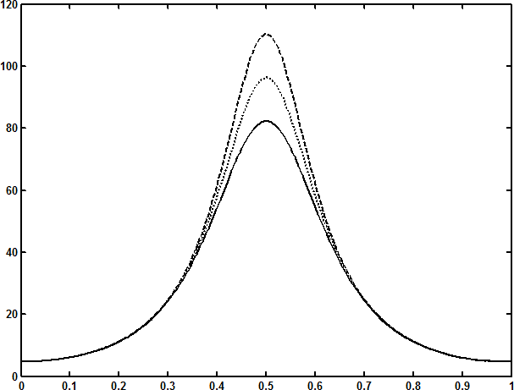

0.02,0.01,0

*x*

**Fig.2.2**The variationofthe axialpressure gradient*dp*

*dx*

withfor1.2,*m*0.2,

*Da*0.1,

*M*1,0.5

and*Q*1.

*dpdx*

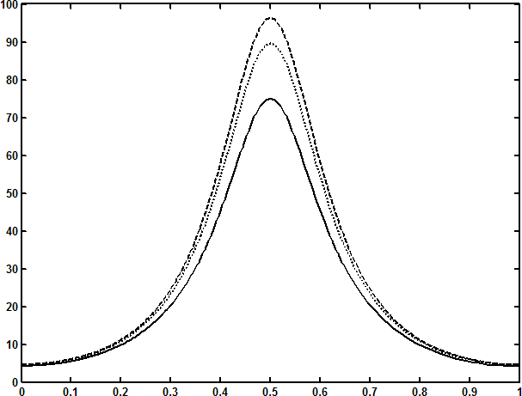

1.2,1,0.5

###### x

**Fig.2.3**The variationofthe axialpressure gradient*dp*

*dx*

withfor*m*0.2,*M*1,

0.01,*Da*0.1,

0.5

and*Q*1.

*dpdx*

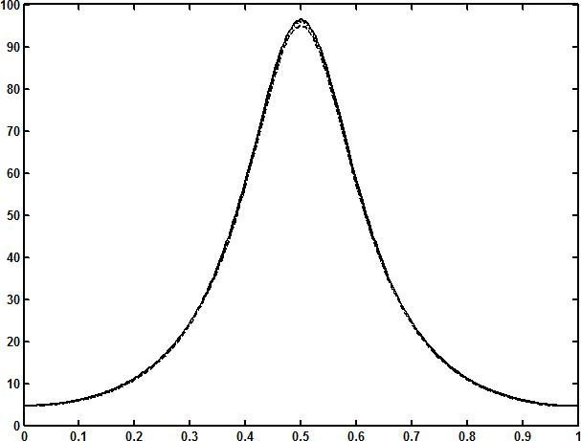

*m*0,0.4,0.8

###### x

**Fig.2.4**Thevariationoftheaxialpressuregradient*dp*

*dx*

with*m*for1.2,*M*1,

0.01,

*Da*0.1,

0.5

and*Q*1.

*dpdx*

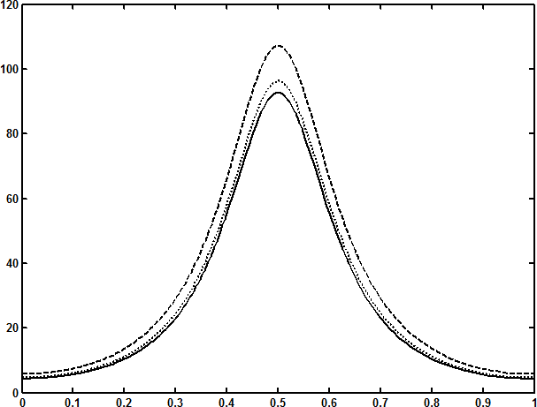

*M*2,1,0

###### x

**Fig.2.5**Thevariationoftheaxialpressuregradient*dp*

*dx*

with*M*for1.2,*m*0.2

0.01,*Da*0.1,0.5and*Q*1.

*dpdx*

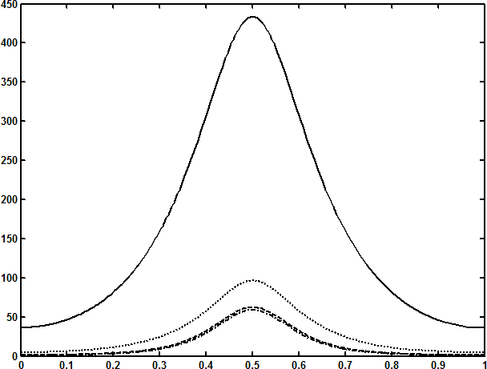

*Da*0.01,0.1,1,10

###### x

**Fig.2.6**Thevariationoftheaxialpressuregradient*dp*

*dx*

with*Da*for1.2

*m*0.2,

0.01,*M*1,0.6

and*Q*1.

*dpdx*

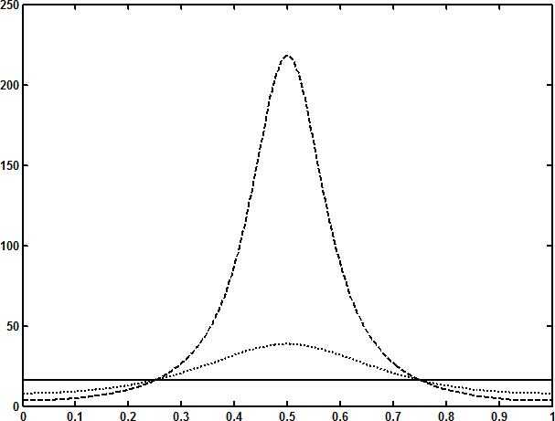

0.6,0.03,0

###### x

**Fig.2.7**Thevariationoftheaxialpressuregradient*dp*

*dx*

withfor1.2,*m*0.2

0.01,*Da*0.1,*M*1and*Q*1.

*p*

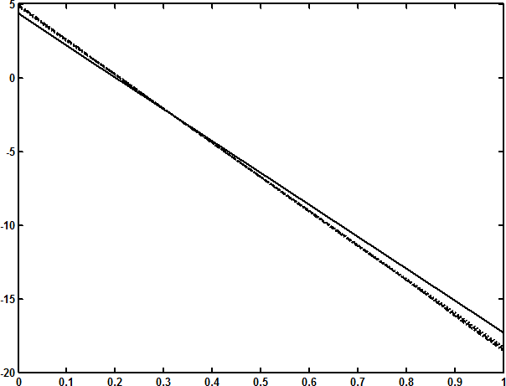

0.02,0.01,0;1.2

0,1

**Fig.2.8**Thevariationofthepressurerise

*Q*

*p*with*Q*fordifferentvaluesof

with1.2,*m*0.2,

*Da*0.1,

*M*1and0.5.

*p*

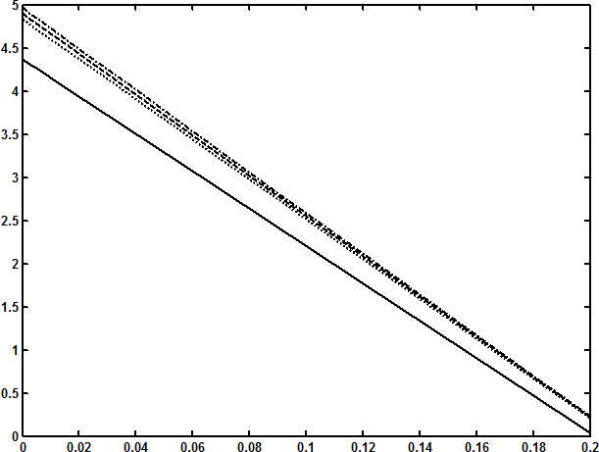

0.02,0.01,0;1.2

0,1

*Q*

**Fig.2.8(a).**ExpansionofFig.2.8.

*p*

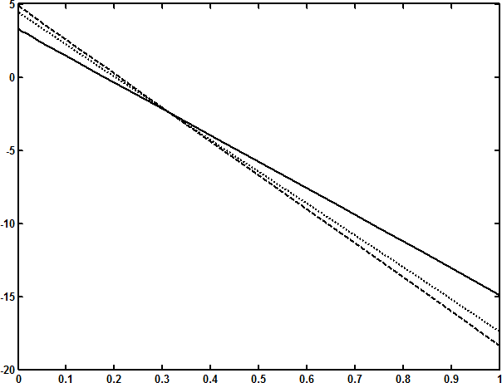

1.2,1,0.5

**Fig.2.9**Thevariationofthepressurerise

*Q*

*p*with*Q*fordifferentvaluesof

with0.01,*m*0.2,

*Da*0.1,

*M*1and0.5.

*p*

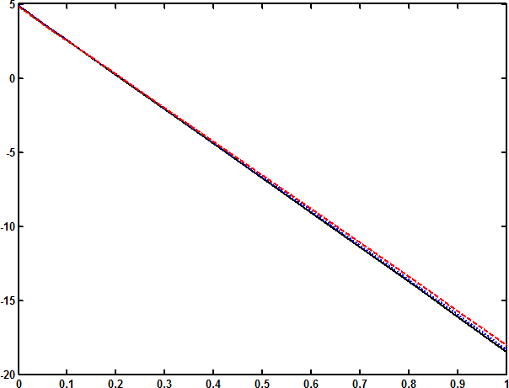

*m*0,0.4,0.8

#### Q

**Fig.2.10**Thevariationofthepressurerise

*p*with*Q*fordifferentvaluesof*m*

with0.01,1.2,

*Da*0.1,

*M*1and0.5.

*p*

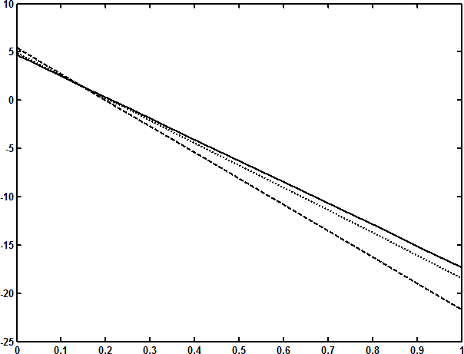

*M*0,1,2

#### Q

**Fig.2.11**Thevariationofthepressurerise

*p*with*Q*fordifferentvaluesof*M*

with0.01,*m*0.2,*Da*0.1,1.2and0.5.

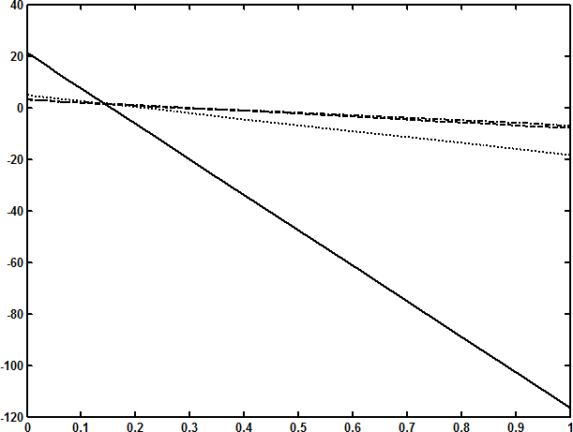

*Da*0.01,0.1,1,10

*p*

#### Q

**Fig.2.12**Thevariationofthepressurerise

*p*with*Q*fordifferentvaluesof

*Da*with 0.01,*m*0.2,*M*1,1.2and0.5.

*p*

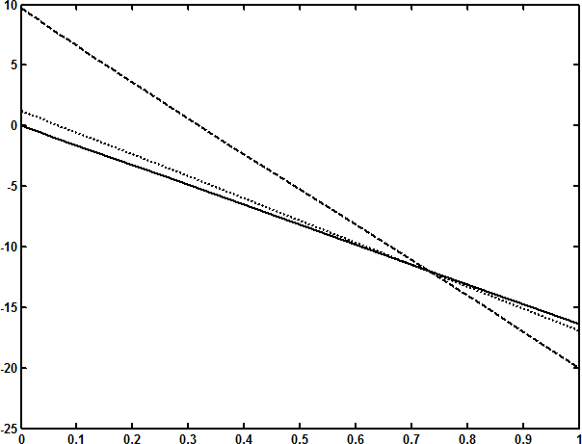

 0.6,0.3,0

**Fig.2.13**Thevariationofthepressurerise

*Q*

*p*with*Q*fordifferentvaluesofwith

0.01,*m*0.2,

*Da*0.1,

*M*1and1.2.

References:

Bhatti, M.M., Ali Abbas, M. and Rashidi,M.M., “Effect of hall and ion slip on peristaltic blood flow of Eyring Powell fluid in a non-uniform porous channel”,World Journal of Modelling and Simulation, Vol. 12 (2016) No. 4, pp. 268-279.

[4] Bohme, G., and Friedrich, R. “Peristaltic flow of viscoelastic liquids”, J.Fluid Mech., 128 (1983), pp 109-122.

[5] Eldabe,N.T.M., Ahmed,Y., Ghaly,A.Y., Sallam,S.N., Elagamy,K., and Younis,Y.M, “Hall effect on peristaltic flow of third order fluid in a porous medium with heat and mass transfer”, Journal of Applied Mathematics and Physics, 2015, 3, 1138-1150.

[6] Gad, N.S., “Effects of Hall current on peristaltic transport with compliant walls”, Appl. Math. Comput. 235 (2014), pp 546–554.

[7] Hayat, T., Ali, N and Asghar, S, “Hall effects on peristaltic flow of a Maxwell fluid in a porous medium”, Phys. Letters A, 363(2007), pp 397-403.

[8] Jyothi ,S., SubbaReddy, M.V and Ramakrishna Prasad,A, “Peristaltic flow of a Prandtl fluid in a symmetric channel under the effect of a magnetic field”, Advances in Applied Science Research, 3 (4)(2012), pp 2108-2119.

[9] Patel,M., and Timol, M.G, “The stress strain relationship for viscous-inelastic non-Newtonian fluids”, Int. J. Appl. Math. Mech., 6(12)(2010), pp 79-93.

[10] Radhakrishnamacharya ,G., and Srinivasulu, Ch., “Influence of wall properties on peristaltic transport with heat transfer”, C. R. Mecanique, 335 (2007), pp 369 –373.

[11] Raju, K.K.. and Devanathan, R., “Peristaltic motion of a non-Newtonian fluid part –I”, Rheol. Acta., 11(1972), pp 170-178.

[12] Shalini, K., and Rajasekhar, K., “Peristaltic flow of a Newtonian fluid through a porous medium in a two-dimensional channel with Hall effects”, International Journal of Scientific & Engineering Research Volume 10, Issue 5, May-2019,pp 872-877

[13] Shapiro, A.H., Jaffrin, M.Y and Weinberg, S.L., “Peristaltic pumping with long wavelengths at low Reynolds number”, J. Fluid Mech. **37**(1969),pp 799-825.

[14] Siddiqui, A.M., Provost, A. and Schwarz, W.H. “Peristaltic pumping of a second-order fluid in a planar channel”, Rheol. Acta, 30(1991), pp 249-262.

[15] Srinivas,S. and M.Kothandapani, “The influence of heat and mass transfer on MHD peristaltic flow through a porous space with compliant walls”, Appl. Math. Comput., 213(2009), pp 197.

[16] Subba Narasimhudu, K. “Effects of hall on peristaltic flows of conducting fluids ”, Ph D., Thesis, Rayalaseema University, (2017). Reddy, M. V., Jayarami Reddy, B. and Prasanth Reddy,

[17] Subbareddy .D, “Peristaltic pumping of Williamson fluid in a horizontal channel under the effect of magnetic field”, International Journal of Fluid Mechanics, Vol. 3(1)(2011), pp 89-109.