PRODRUG ENHANCEMENT OF REMDESIVIR ANALOGUES

D. Bharathi*, L. Karpagavalli, K. Nandhan, A. Mohan, S. Priyadharshini, S. Sathasri
Jaya College of Pharmacy, Thiruninravur, Chennai-602024, Tamil Nadu, India,
Corresponding author:
Mrs. D. Bharathi. M. Pharm.., (Ph.D)
Bharathi.madhavan3@gmail.com

Introduction

Prodrugs are the drugs that undergo biotransformation before exhibiting their pharmacological activity. There are many prodrugs which are available in the market for many diseases and recently corona virus has created huge disaster and the development of remdesivir as a prodrug was driven by several consideration and the rationale behind developing remdesivir as a prodrug was to enhance the bioavailability, chemical stability, targeted delivery, metabolism and activation, formulation and administration. The main goal was to enhance the therapeutic properties, improve it is efficacy, facilitate its clinical use.

Keywords: Prodrugs, Biotransformation, Remdesivir, Bioavailability, Therapeutic properties

CHEMISTRY OF REMDESIVIR

The chemical structure of remdesivir consists of a modified nucleoside; specifically, a nucleotide analogue of adenosine it contains a ribose sugar moiety, which is a five-carbon sugar, attached to an adenine base. The modification in remdesivir involves the replacement of the ribose sugar with a modified sugar known as a 1’-cyano-substituted adenosine analogue.

NOMENCLATURE :
-------------------------------------------------------------------------------------------------------
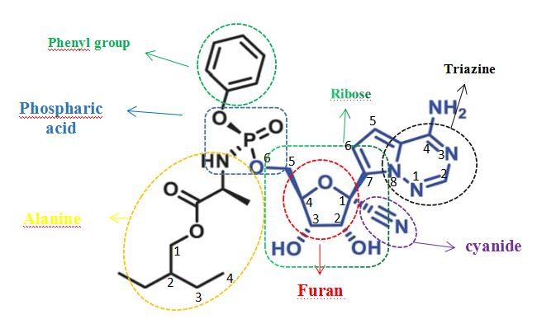
Figure 1: Chemistry of remdesivir

-------------------------------------------------------------------------------------------------------

IUPAC NAME: (2S)-2-{(2R,3S,4R,5R)-[5-(4-Aminopyrrolo[2,1-f] [1,2,4] triazin-7-yl)-5-cyano-3,4-dihydroxy-tetrahydro-furan-2-ylmethoxy] phenoxy-(S)-phosphorylamino} propionic acid 2-ethyl-butyl ester

MOLECULAR FORMULA: C₂₇H₃₅N₆O₈P
MOLECULAR WEIGHT: 602.59g/mol
WATER SOLUBILITY: Very slightly soluble
APPEARANCE: White crystalline powder
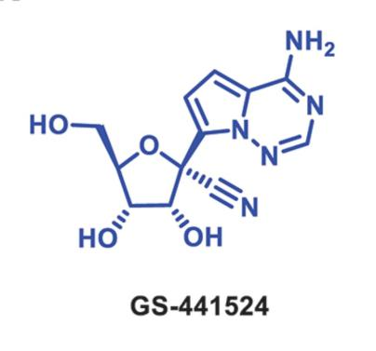
The remdesivir is anti-coronaviral agent are active form of GS-441524. The functional groups carboxylic ester, a nitrile, a pyrrolotriazine & C-nucleoside & aromatic amine, a phosphoramide ester. The nucleobase attached with carbon (C) 1’cyanide (CN) groups it ensures enough optimal anti-ebola activity & selectively inhibit the host RNA polymerase enzyme [1].

SAR OF REMDESIVIR:
European medicine agency has authorized treatment of life threating coronavirus by the using remdesivir. The interesting antiviral agent remdesivir play the crucial role in altering the different substitution to produce the different kind of activity. The structural activity relationship of remdesivir [2] is shown below in figure 2.

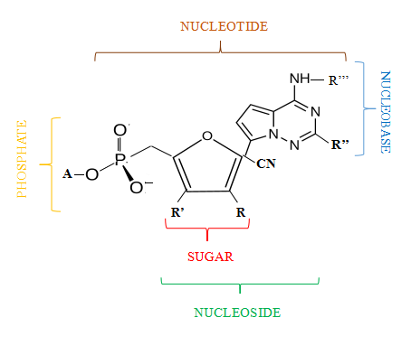

Figure 2: Basic nuclease of remdesivir

In 1901-levene and Jacobs has used “nucleoside” word. The nucleoside are structurally similar to nucleotide. The collective groups of sugar moiety and nucleo base and phosphate groups are called as nucleoside.

NUCLEOSIDES:
The nucleosides are naturally occurring in the living cells by biochemical process involved in metabolites like hydrolysis of RNA, DNA components. The alteration of nucleoside structure to get a lot of wonderful nucleoside analogue derivatives are development and discovered to invent moiety’s which play a crucial role of nucleoside. The structural modification of nucleotide mainly involves in the three areas – a. Nucleobase, b. side chain, c. sugar moiety

Modification of sugar:
The broad functional activity produced by the modified sugar contained nucleoside base in synthetic compounds is used in treatment of several diseases in human. Example-there is some interesting nucleoside analogue help to treat cancer and viral chemotherapeutic effect’s [3, 4].
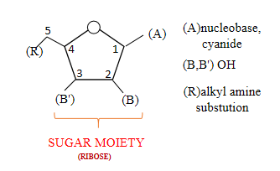

Figure 3: Modification of sugar

- The substituted methyl group (CH₃) on C₁ ribosyl nucleus between the glycoside bridges instablized the molecule and alter the anti-viral activity.

- Glycoside bridge stabilize by PH, C1- substitution and also is of Nucleobase depended.

- The substitution of pyrrolotriazine ring on C₁ position stabilized the glycoside bridge.

- The replace of H ion in C₁ position leads to cleavage bridge, loss of activity, loss of electronic stearic effect.

- The C₁ Position alteration deals with scientist report, as O-C-N, O-C-C bond not affect the rigidity of Glycoside Bridge.

- The ribosyl nucleus in C₁ position substituted with CN group provides better anti-viral activity such as hepatic c virus, influenza virus, EBOLA virus, SARSCoV-2, yellow fever [3].

- The cyanide group substitution shows as wide spectrum activity.

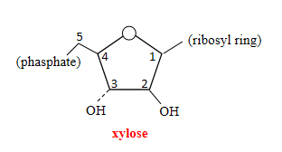
- The altering of stereogenic configuration in ribosyl molecule is converted to xylose state and arabinose molecule which influence the antiviral activity.
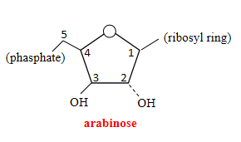
Figure 4: Stereogenic configuration

- The monophosphated substitution on 5th position help to promote the phosphorylation process upon the metabolic process.

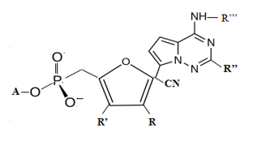

Figure 5: Monophosphated moiety

- When further substitution of alkylated alanine group, phenyl, phenoxy groups to monophosphated at 5th position enhance lipophilicity of drug. Help to fast penetrate through the cell membrane.
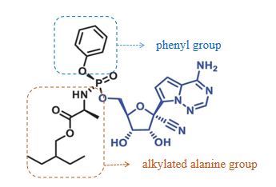
Figure 6: Enhancement of lipophilicity

- 5th position substitution on amino group influence and mimic the triphosphate bonding.
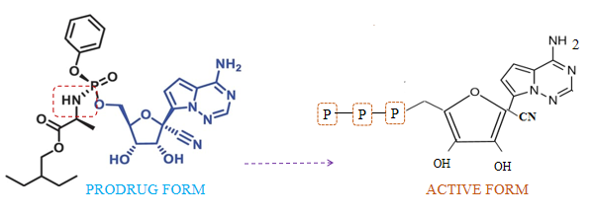
Figure 7: Activation of pro moiety

Modification of Nucleobase:
Substitution of C1 with pyrrolotriazine ring, which is an isosteric ring of pyrazolopyrimidine which produce the antiviral activity.
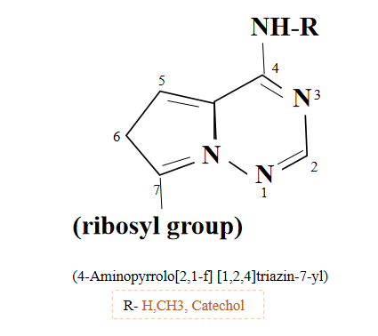
Figure 8: Nucleobase

- The 4th position amino group are linked to catechol ring. The catechol ring substitution result in better antiviral action. The catechol derivative kills the encephalomyocarditis virus (EMCV) [4].
Figure 9: catechol ring

- C₂ position substitution with hydrazine group or Benzyl thio group alters the antiviral activity [5].

Enhancement of bioavailability:
The prodrug of remdesivir is present in the form of lyophilized powder and solution form. These dosage forms are recommended only intravenously as the drug administration have 100% bioavailability, when compared to other route of drug delivery because oral route of administration have very high hydrolysis mediated first pass clearance in GI tract and also limited absorption, low therapeutic window and poor bioavailability. Intramuscular administration route is better than oral route because the accumulated drug is slowly released for long period of time which prevents repeated drug administration but maintains low therapeutic range. Thus, prodrug of RDV is efficiently absorbed as slow iv infusion [7].

Factor influence the administration:
The comparative study involved in the bioavailability of remdesivir and the parent compound (GS-441524). The single dose given by buccal, intravenous route using rabbits exhibited better bioavailability by IV route only since oral route undergoes quicker degradation by liver metabolizing enzymes. The two groups of rabbits were treated with lyophilized pro drug of remdesivir and GS-441524 by IV and buccal route. The study revealed that damaged or broken remdesivir may be detected only for the GS-441524 compound metabolites after buccal administration compared to IV route. Intravenous route exhibited 10% higher bioavailability than buccal route. The remdesivir complexation with SBECD (sulfobutylether -β cyclodextrin) ie., solubilizing agent cannot protect remdesivir from the action of esterase of oral mucosa. In a preliminary study for development of buccal route formulation of remdesivir, it was found that the process was not easy. The developed formulation enabled fast absorption through the mucosal layer and protects the drug from the enzymes of oral cavity [8].

Targeted delivery:
The single stand RNA virus of RSV from the pneumoviridae family and in recent year study has proof of targeting in viral protein. The discovery of C-nucleoside of parent (GS-441524) compound to targeting the respiratory syncytial virus (RSV) in replicating enzyme of RNA depended RNA polymerase was identified a phenotypic screening method and also Nucleoside (ALS-8176) targeting to RdRp, in which the function complex to large 250 kDa protein with RSV other protein. The RNA depended RNA polymerases (RdRp) play the sensitive function of copying the viral RNA, and like another viral RdRp. The different kind nucleoside analogue is inhibited in viral RNA species and increase the efficacy to bind the RNA polymerase enzyme by screening to obtain the prodrug of adenosine nucleoside analogue [6,7,8].

Metabolism and activation:
The intracellular metabolism of RDV prodrug cleavage by carboxyl ester hydrolysis and phenylic group substitution ejection and hint mediated phosphorus nitrogen bond break down to release the metabolite of monophosphate and the comparison of parent (GS-441524) moiety intracellular metabolism is very slow to formation of monophosphate intermediate by the presence of nucleoside kinase. The monophosphate intermediate further involve into nucleotide kinase to get a 1-NTP (activated triphosphated metabolite) selectively bind to RdRp enzyme to disrupt the viral replication, when compared with prodrug RDV and parent compound to provide faster and better metabolism, activation [7].

EXAMPLE OF REMDESIVIR PRODRUG:

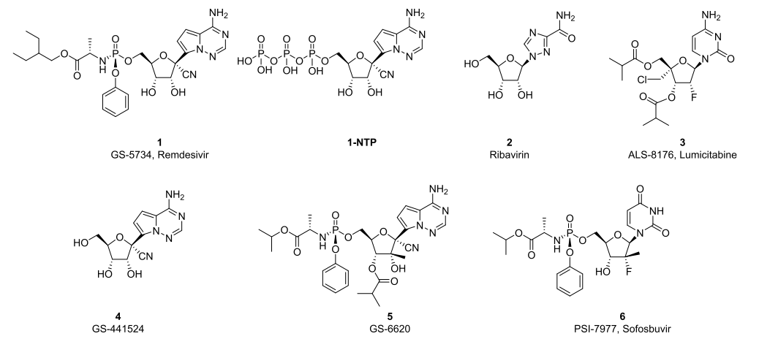

Figure 10: Examples of pro moiety
The establishment of triphosphate metabolite influences the antiviral activity. The study involved in antiviral activity of ribonucleoside analogue by using the biochemical assay to extract out the RdRp protein in RSV infected cell, [9] established that 1-nucleoside triphosphate are more potent to complex with RdRp protein in RSV ribonucleoside phosphate than Hepatitis C virus i.e., it is five times potent to bind and produce antiviral activity [10].

ESTER PRODRUGS:
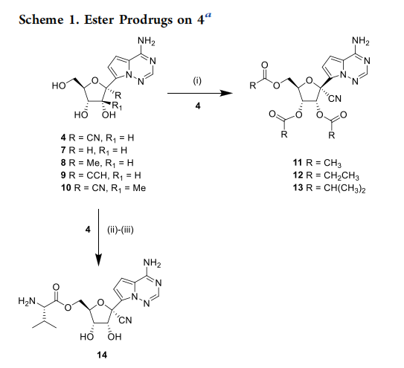
------------------------------------------------------------------------------------------------------ Figure 11: Modification ester prodrugs

The parent (GS-441524) compound are substituted with R-methyl (CH₃) and R1-hydrogen (H)8, R-ethynyl(CCH) and R1-hydrogen(H)9,and R-cyanide(CN) and R1-methyl(CH3)10 nucleobase activity are decreased in anti-viral (RSV) respectively to RSV ribo-nucleoside phosphate complexation and similarly anti HCV are decreased which were observed in the compound 8 and 9 and the compound 10 are 15 time more potency to bind with the triphosphate or complex with HCV RdRp protein compared with 1-NTP [11].

The ester form of prodrug 12 have a low logD value and low cell permeability are detected in Caco-2 assay. It is compound 12 have a low oral bioavailability under the clinical study in animals like cynomolgus monkey, rat. But the orally high bioavailability is noted under the dog clinical study, because of dog haven the larger pore size contained paracellular pathway use to reach in blood stream [12] and ribose nucleus contained hydroxyl group which mask to produce the increased oral bioavailability. For eg: when the ester of prodrug in R-methyl, ethyl, iso propyl substitution compound 12,13 produce the enhanced oral bioavailability in cynomolgus monkey 33% increased. Also, ester of prodrug 14 similarly promote the oral bioavailability [13].
when the tri iso butyryl are substituted with compound 4 to get the ester of prodrug as responsible for produce the high lyophilic in nature and increase potency about two-fold and high log d value and no efflux which improve the greater CaCo-2 permeability [14].

The 57% oral bioavailability are prone on the recent study in rat by using the compound 13 of deutro analogue. The compound 13 does not have limited permeability condition. The compound 4 in cell culture undergoes drug metabolism which are involved in intracellular anabolism of C-nucleoside analogue and are limited rate of monophosphate formation. The limiting step of monophosphate are reduced by using cellular assay i.e., the compound 5, 6 undergo rapid anabolism step and straight to deliver the higher concentration of monophosphate into the cell [15,16,17]. The structural alteration involved in the compound 4 in 5-position contained monophosphate moiety are responsible for increase the potency and same time improve the inhibition of RSV in cell culture.

PHOSPHATE PRODRUGS:
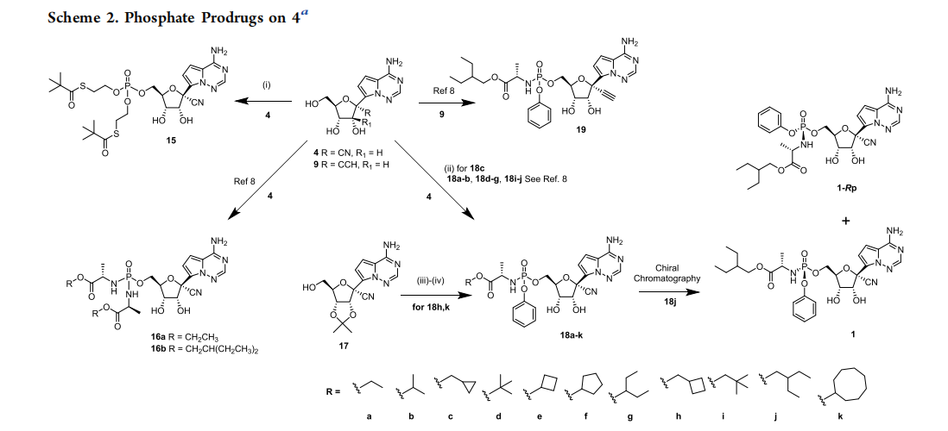

Figure 11: Phosphate prodrugs

The phosphate prodrug which are isolated and involved in screening assay with the phosphoradimate ester [18] thio ester prodrug compound 16 a-b, 18a-k, are synthesised by using phosphorane reagent.

The compound 18c-monoamidate are prepared by using Mgcl₂ reagent and used as a catalyst to compound 4- nucleoside [19].

The compound 17 are involved in the reduction reaction by removal of acetamide to develop the monoamidite. The yield of 18K was 62% [20].

The chiral chromatography is used to separate the diastereomeric monoamidate mixture of compound 18j nucleoside compound. The different substitutions produce potency which is seen in 5’phosphate prodrug. The prodrug mainly helps to bypass the first phosphorylation which are involved from conversion of compound 4 to its intermediate 5’-monophosphate in cell at the same time increase the 1-NTP.

In earlier study dithioester phosphate prodrug compound 15 enhanced activity compared with compound 4 example: hepatitis C virus in human hepato cell myeloma huh-7 cell in compound 15 have a low selectivity and small improvement occur in RSV- inhibition.

The proagent-thioester are converted into episulfide form from the metabolic reaction by the cleavage of thioester. The ester form may cause the selectivity decreased. The phosphamidate based prodrug are phosphamide ester 16 (a-b), monoalanine phosphamide ester 18(a-k) [21].

Monoalanine phosphamide ester have established in the form of prodrug which have proven that different substitution occurs in the compound 4. Compound 18b are prepared by diastereomeric isopropyl monoamidate ester in the form of sp isomer. The sp isomer is lesser potency compared with compound 4 eg: tenofovir alafenamide. Sp diastereomer forms are greater potency than compound 4. Similarly, isopropylmonoamidate have a high polarity in nature as a result limited cell membrane permeability [22].
Compound 18j-2-methylbutyl esters are lipophilic in nature and increase the cell permeability and also inhibition due to steric hinderance from α carbon on the parent nucleobase that have 20-fold more potent inhibition with the RSV -RdRp enzyme comparatively than compound 4. Ethynyl nucleobase compound 19 are greater than 30-fold improved antiviral activity. The chiral compound 18j to form 1-Rp are 35-fold more potent than parent compound 4.

With the interesting different kind of prodrug by structural modification show different level of potency, bioavailability, efficacy, effective, stability. In the RdRp inhibition study involved in RSV – in vitro study of proagent for efficacy to inhibit the viral infecting organism in respiratory cell line and also similar structured HCV, SARS Cog, Covid 19, RSV infective organism are response to proagent ie., ester of prodrug, phosphamidate prodrug, C - Nucleoside based prodrugs.

LIMITATION OF REMDESIVIR:

The limited aqueous solubility is an important thing of drug delivery and bio availability. The drug that has more solubility has increased bio availability. The limited solubility can overcome by prodrug development. The solubilizing agent used as cyclo dextrin and sulphoglutayl ether sodium (SBECD) result in the accumulation of the drug that leads to renal impairment. ALT (alanine amino transferase) elevated greater than five times upper limit of normal function. Due to this reason remdesivir is not recommended, if taken it leads to hepatic inflammation, increase the bilirubin (jaundice) and alkaline phosphatase. The RDV should not be administered oral route because by metabolism it results in hydrolysis of prodrug as a result poor absorption in GI track. The hospitalized covid 19 adult patient recovery time is very short. However, the impact on rate of mortality and prevention of severe illness is still uncertain. The Intravenous route for inpatient is very limited whereas out patient in pandemic COVID 19 was in high demand.

REFERENCE:

- Eastman, Roth, Kyle R. Richard T. Jacob S. Brimacombe, Anton Simeonov, Min Shen, Samarjit Patnaik and Matthew D. Hall. Remdesivir: A Review of Its Discovery and Development Leading to Emergency Use Authorization for Treatment of COVID-19.ACS Cent. Sci. 2020, 6, 672−683

- Richard L. Mackman. Phosphoramidate Prodrugs Continue to Deliver, The Journey of Remdesivir (GS-5734) from RSV to SARS-CoV‑2. ACS Med. Chem. Lett. 2022, 13, 338−347.

- Jianxin Wei, Muhammad Kamran Siddiqui, Atiq Ur Rehman, Muhammad Nasir, Murat Cancan, Muhammad Tayyab Younas and Muhammad Farhan Hanif. On Topological Indices of Remdesivir Compound Used in Treatment of Corona Virus (COVID 19). Polycyclic Aromatic Compounds. 2021.1to 17.

- Mahran· Ibrahim M. Elfky ·Wael M. Ibrahim·Mohamed N.Amr Sonousi· Hanan A. Ibrahim. Abdo A. Elshemey. Novel adenosine derivatives against SARS‑CoV‑2 RNA‑dependent RNA polymerase: an in-silico perspective. Springer. (2021) 73:1754–1764

- Larson G, Prigaro B, Ding Y, Girardet J-L, Smith KL, Wu JZ, et al. Parallel synthesis of 5-cyano-6-aryl-2-thiouracil derivatives as inhibitors for hepatitis C viral NS5B RNA-dependent RNA polymerase. Bioorg. Chem. 2006; 34(1):26–38.

- Eastman, A. Shen, M. Patnaik, R.T. Roth, J.S. Brimacombe, K.R.Simeonov, S. , M.D. Remdesivir: A Review of Its Discovery and Development Leading to emergency Use Authorization for Treatment of COVID-19. ACS Cent. Sci. 2020, 6, 672–683.

- Subrata Deb, Rebecca Bejusca, Anthony Allen Reeves, Robert Hopeflfl. ADME and Pharmacokinetic Properties of Remdesivir: Its Drug Interaction potential Pharmaceuticals 2021, 14, 655.

- D´avid Sirok, J´ anos St´ahl , G´abor Hirka ,Lajos Szente, Tibor Renkecz , Istv´an Pusk´ as,Tam´ as Sohajda , Eva Fenyvesi. Comparative bioavailability study following a single dose intravenous and buccal administration of remdesivir in rabbits. International Journal of Pharmaceutics 620 (2022) 121739

- Jordan, R.; Lo, M. K.; Ray, A. S.; Warren, T. K.; Mackman, R. L.; Soloveva, V. Therapeutic efficacy of the small molecule GS-5734 against Ebola virus in rhesus monkeys. Nature 2016, 531, 381−385.

- Cho, A.; Suanders, O. L.; Butler, T.; Zhang, L.; Xu, J.; Vela, J. E.; Feng, J. Y.; Ray, A. S.; Kim, C. U. Synthesis and antiviral activity of a series of 1′-substituted 4-aza-7,9-dideazaadenosine C-nucleosides. Bioorg. Med. Chem. Lett. 2012, 22, 2705−2707.

- Eldrup, A. B.; MacCoss, M.; Allerson, C. R.; Bennett, C. F.; Bera, S.; Bhat, B.; Structure-activity relationship of purine ribonucleosides for inhibition of hepatitis C virus RNA-dependent RNA polymerase. J. Med. Chem.
2004, 47, 2283−2295

- He, Y.-L.; Eastmond, R.; Murby, S.; Warhurst, G.; Gifford, L.; Walker, D.; Ayrton, J.; Rowland, M. Species differences in size discrimination in the paracellular pathway reflected by oral bioavailability of poly(ethylene glycol) and D-peptides. J. Pharm. Sci.
1998, 87, 626−633.

- Hong, J.; Dyatkina, N.; Prhavc, M.; Wang, G.; Deval, J.; Taylor,J.; Fung, A.;. Discovery of 4′-chloromethyl-2′-deoxy-3′,5′-di-O-isobutyryl-2′-fluorocytidine (ALS-8176), a first-in-class RSV polymerase inhibitor for treatment of human respiratory syncytial virus infection. J. Med. Chem. 2015, 58, 1862−1878.

- Yin, W.; Wang, Q.; Wang, Q.; Shen, D.; Zhang, Y.; Tian,G.; Aisa, H. A.; Hu, T.;. Structural basis for repurpose and design of nucleoside drugs for treating COVID-19. bioRxiv 2020, No. 11.01.363812.

- Cho, A.; Metobo, S.; Aktoudianakis, V.; Lew, W.; Ye, H.; Clarke, M.; Zhang, L.;. Discovery of the first C-nucleoside HCV polymerase inhibitor (GS-6620) with demonstrated antiviral response in HCV infected patients. J. Med. Chem. 2014, 57, 1812−1825.

- Sofia, M. J.; Bao, D.; Ross, B. S.; Wang, P.; Zhang, H.-R.; Bansal, S.; Espiritu, C.; Discovery of a β-d-2′-deoxy-2′-α-fluoro-2′-β-C-methyluridine nucleotide prodrug (PSI-7977) for the treatment of hepatitis C virus. J. Med. Chem. 2010, 53, 7202−7218.

- Cho, A.; Butler, T.; Zhang, L.; Xu, J.; Suanders, O. L.; Vela, J. E.; Feng, J. Y.;. Synthesis and antiviral activity of a series of 1′-substituted 4-aza-7,9-dideazaadenosine C-nucleosides. Bioorg. Med. Chem. Lett. 2012, 22, 2705−2707.

- Siegel, D.; Hui, H. C.; Doerffler, E.; Soloveva, V.; Knox, J.; Perry, J.; Perron, M.;. Discovery and synthesis of a phosphoramidate prodrug of a pyrrolo[2,1-f][triazin-4-amino] adenine C-nucleoside (GS-5734) for the treatment of Ebola and emerging viruses. J. Med. Chem. 2017, 60, 1648−1661.

- Lefebvre, I.; Pompon, A.; Gosselin, G.; Aubertin, A.-M.; Kirn, A.; Périgaud, C.;. Synthesis, decomposition pathways and “In Vitro” evaluation of bioreversible phosphotriesters of Azt. Nucleosides, Nucleotides Nucleic Acids 1995, 14, 763−766.

- Axt, S. D.; Badalov, P. R.; Brak, K.; Campagna, S.; Chtchemelinine, A.. Methods for the Preparation of Ribosides. WO2016069825A1, Gilead Sciences, May 6, 2016.

- Murakami, E.; Tolstykh, T.; Bao, H.; Bansal, S.; Lam, A. M.; Otto, M. J.; Sofia, M. J.; Niu, C.;. Mechanism of activation of PSI-7851 and its diastereoisomer PSI-7977. J. Biol. Chem. 2010, 285, 34337−34347.

- Richard L. Mackman, Hon C. Hui, Michel Perron, Eisuke Murakami, Christopher Palmiotti, et al., Prodrugs of a 1′-CN-4-Aza-7,9-dideazaadenosine C-Nucleoside Leading to the Discovery of Remdesivir (GS-5734) as a Potent Inhibitor of Respiratory Syncytial Virus with Efficacy in the African Green Monkey Model of RSV,s: J. Med. Chem. 2021, 64, 5001−5017.

