Detection Techniques in Monitoring of Stored Grain Insects

Dr. Pyla Jyothi
Assistant Director, National Institute of Plant Health Management, Hyderabad

Insect infestations in grain cause quantity and quality losses and lower crop values. Insects not only consume grain but also contaminate it with their metabolic by-products and body parts (FAO, 2018).

All types of food commodities like cereals, pulses, spices, oil seeds and other stored food products are prone to insect pest attack during storage. Following are the major pests of cereals, pulses, oil seeds, oil cakes, meals and dry fruits and nuts.

Common Insect Pests of Stored products
Scientific name | Common name
Cereals
Trogoderma granarium | Khapra Beetle
Sitophilus oryzae | Rice weevil
Rhyzopertha dominica | Lesser grain borer
Tribolium castaneum | Red flour beetle
Oryzaephilus surinamensis | Saw-toothed grain beetle
Cryptolestes spp. | Rusty grain beetles
Sitotroga cerealella | Angoumois grain moth
Ephestia cautella | Tropical warehouse moth
Corcyra cephalonica | Rice Moth
Plodia interpunctella | Indian Meal Moth
Pulses
Sitophilus oryzae | Rice weevil
Callosobruchus maculatus | Cowpea beetle
Callosobruchus analis | Cowpea beetle
Callosobruchus chinensis | Adzuki bean weevil
Oil seeds, oil cakes, meals
Caryedon serratus | Groundnut bruchid
Oryzaephilus surinamensis | Saw-toothed grain beetle
Trogoderma granarium | Khapra Beetle
Corcyra cephalonica | Rice Moth
Plodia interpunctella | Indian Meal Moth
Ephestia cautella | Tropical warehouse moth
Dry fruits and tree nuts
Oryzaephilus surinamensis | Saw-toothed grain beetle
Lasioderma serricorne | Cigarette beetle
Tribolium spp. | Flour beetle
Trogoderma granarium | Khapra Beetle
Plodia interpunctella | Indian Meal Moth
Ephestia cautella | Tropical warehouse moth
Stegobium paniceum | Drugstore beetle
Spices
Lasioderma serricorne | Cigarette beetle
Stegobium paniceum | Drugstore beetle
Tribolium spp. | Flour beetle

The stored grain pests become small in size, average adult size being 3-5 mm and are cryptic and therefore, they go unnoticed when present in low numbers. They are highly prolific in that several generations occur in a year.

Importance of pest detection
Detection of insect infestation in stored products plays an important role to ensure quality and prolonged shelf life of the grains. Inspecting for insect-damaged kernels is labour intensive and many infested kernels may be undetected where an immature insect has not emerged from the kernel. Grain inspectors at milling facilities need to know the quantity of hidden insect infestation so that loads with excessive infestations can be cleaned or diverted for other uses. Detection methods alert about presence of infestation in the storage premises or grain consignment and helps in decision making (Quitco and Quindoza, 1986). Detection methods are useful in locating infestation, for early diagnosis of low-level infestations and to ascertain the success of fumigation or other control measures undertaken. Early detection also helps to avoid scheduled or calendar fumigations and spray treatments and thus, reduce pesticide use or contaminants (Ramzan et al. 1986; Merga and Haji, 2019).

The standards of quality for grains have been established in the majority of countries to satisfy customers, among whom the awareness for clean grain and its products are increasing. With consumers demanding that food be of the highest possible quality, the contaminants such as insects, rodent droppings, and ergot (a toxic fungal body) in post-harvest grains must be minimized. There is an increasing trend among grain buyers towards zero-tolerance to these contaminants. Countries such as Canada have a legally defined zero tolerance for stored-grain insects (Canada Grain Act, 1975). Any delay in detection may cause pest outbreak or heavy population build-up, initiating severe contamination besides quantitative loss. Detection of stored grain insects using appropriate techniques is considered as the main step in pest management. Quality maintenance and contaminant reduction to meet the International Standard Organization (ISO) and hazard analysis critical control points (HACCP) are important for marketing the produce.

Detection methods
Accurate information about insect infestation can only be obtained by thorough and regular inspection and sampling procedures. This is imperative in formulating sound management decisions involving the adoption of any remedial action against these bio-deteriorating agents or the disposal of grain with due cognizance to the condition of both the commodity and the storage facility. Regular inspection will help in maintaining a good storage environment which is favourable to good grain quality by monitoring any significant build-up in pest populations, grain temperature, moisture migration, and grain residues. Exact and reliable detection and monitoring of stored grain insects in grain bulks is an essential part of commercial trading and research for pest management.

Several methods have been developed to detect hidden insects in whole kernels. Infestation of grains may be detected by staining of kernels to identify entrance holes for eggs, floatation, trapping, radiographic techniques, acoustic techniques, uric-acid measurement, nuclear magnetic resonance imaging and immunoassays. The major techniques commonly practiced to detect the infestation caused by insects are as follows -

Visual Inspection – Normal visual inspection of storage facilities and stored grain is subjective in nature, and therefore any results can only be recorded in a descriptive way. Based on visual inspection, many observations can be made on the grain or stored products to find out whether the sample is infested or not. The presence of exit holes, eggs on grain surface, webbing or silken strands present, pupal cases sticking to shells and gunny bags can be observed visually.

Symptoms caused by various stored grain pests
Symptoms | Commodity | Causal agent
Exit Holes | Cereals | Rhyzopertha dominica,  Sitophilus spp.
 | Paddy | Sitotroga cereallela
 | Pulses (whole) | Callosobruchus spp. , Other  Bruchids
 | Groundnut in Shell | Caryedon serratus
 | Whole spices | Stegobium paniceum
 | Cassava | Lasioderma serricorne
Eggs on grain surface | Pulses | Bruchid infestation,  Callosobruchus spp.
Webbing and silken strands present | Cereals (whole and  milled), oilseeds, oilcakes/meals | Corcyra cephalonica, Ephestia cautella, Plodia interpunctella
Pupal cases sticking to  shells and gunny bags | Peanut in shell | Caryedon serratus
Exuviae or moulted cuticle  /skin casts | Cereals | Trogoderma granarium

Sampling and Sieving Method – These are the ancient and most popular and widely practiced methods. The aim of drawing random samples of the commodity is to determine the mean value and the variability of the level of infestation or contamination (% discoloured kernels) in any given situation (Murdock et al. 2003). The method simply involves drawing grain samples 0.5-1.0 kg using trier or spear sampler from the consignment and bag stacks. The accuracy depends on the number of samples drawn and quantity of each sample and insect population density in the grain (Jones et al. 2011).

"Hand held sieves" are particularly useful in assessing the dust content and live insects from small samples. Different-sized mesh openings can be used for different particle size, or a combination of appropriate sizes can be used for mixed commodities varying in particle size.

"Sack sieves" have also been developed to sample an entire sack; the time taken can be between 5-15 minutes. The recovery of insects is dependent on insect species, time of sieving, slope of the oscillating sieve mesh and mesh size. However, one demerit of sampling and sieving methods is that they do not indicate the level of hidden (internal) infestation.

Specific gravity method
In hidden infestation, the larva inside the grain feeds on the endosperm and creates a cavity and thus reduces the density of the grain. When a mixture of uninfested and infested grains is immersed in a salt solution of appropriate density for about 10 minute the uninfested grains sink to the bottom, while the infested grains float. The specific gravity method is suitable for the detection of internal infestation in whole grains. It is quick and requires very simple laboratory facilities but does not indicate the species or the specific life stage present inside the grains. Grains infested with egg and early larval stages do not float and therefore, cannot be detected. Hence, it underestimates the actual infestation level. This method is reported to be not suitable for hulled seeds such as barley, oats and rice and for large seeded grains like corn.

Insect Fragment count
In this method, insect fragments such as insect heads, cast skins and head capsules arising from live and dead insects are isolated from processed foods directly and from whole grains after grading /sorting and then counted. It is an accepted method in India (BIS, 1971).

Whole grains are ground to a particle size of 1.5 mm so as to expose the internal infesters. After digesting the grain materials, the insect parts or fragments are trapped in a system consisting of an oil phase (mineral oil) and an aqueous phase (water). The oil globules extract and concentrate the light insect fragments. The trapped insect fragments in the oil phase are then removed by filtration and collected on a filter paper for microscopic examination.

X-ray technique (X-ray radiography) – Soft X- ray is the only non-destructive direct method that can detect insect infestation in grain kernels. Hidden Infestation caused by Bruchids and rice weevil is significantly detected. Both living and dead insects can be detected by this method. However, the X-ray technique is not sensitive for egg and early larval instars. In this technique an expensive machine to generate the X-rays, films for exposure/automatic computer enabled software system and an expert to interpret the radiographs are the key requirement. The exposure and voltage vary according to commodity and the degree of penetration and contrast required. Grains having higher moisture need a higher voltage for the penetration of X-rays. X-ray technique has also been used for detection of mango stone weevil Sternochetus mangiferae in mango fruits.
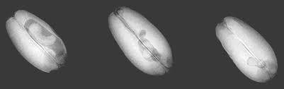

ray image of large, medium, and small larvae in wheat grains (left to right)

NMR AND NIR technique - The NIR spectroscopy has evolved as a fast, reliable, accurate and economical technique available for compositional analysis of grains. This technique can be used for both qualitative and quantitative analysis. The NIR is based on the absorption of electromagnetic wavelengths in the range 700–2500 nm. The concentrations of constituents such as water, protein, fat, and carbohydrate can be determined using classical absorption spectroscopy. Near-infrared spectroscopy (NIRS) can rapidly and automatically detect the presence of hidden insect larvae or external adult insects. NIRS can differentiate insect species based on their absorbance characteristics because the cuticle of each insect species may have a unique chemical composition. This unique chemical composition causes molecules to vibrate at unique frequencies and absorb NIR energy corresponding to these frequencies and overtones of these fundamental frequencies.

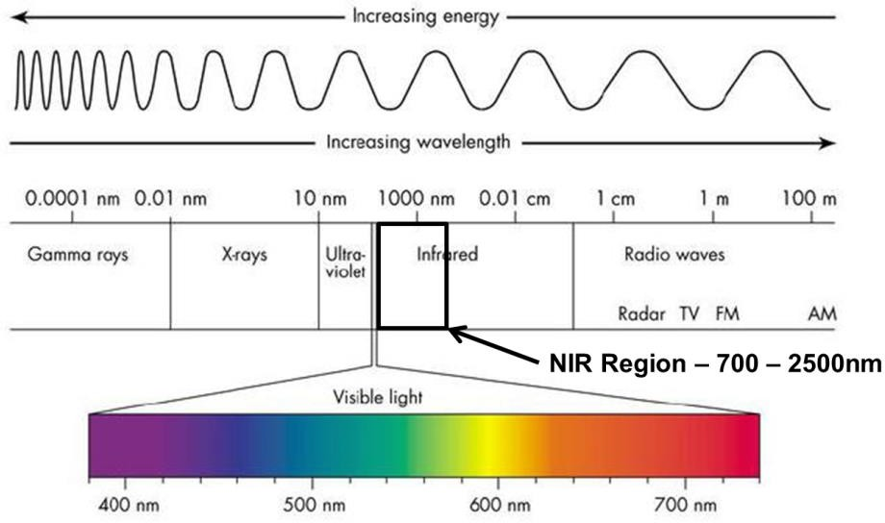

ELISA test – Enzyme linked immunosorbant assay (ELISA) is also one of the detection method which can be used to detect insect pest contamination in grains. This is a simple but highly sensitive method of detecting minute quantities of specific insect protein in grain and milled grain. Myosin a muscle protein is present in all life stages, except eggs of insects. The muscle protein myosin is easily extractable from infested grains. Myosin is not found in food grains and processed food. In this method, the mass of insect material (myosin content) present is correlated to the number of insects in the infested grains.

In the first instance, antibodies to insect myosin are developed. Insect protein extracted from sample is allowed to bind with the antibodies, which have been conjugated to an enzyme in ELISA plate. The development of colour, which is proportionate to the quantity of myosin, is measured in colorimetric ELISA reader at 414 nm. The assay is generally linear and can detect one weevil / 50 g grain. To carry out the test, it needs a moderately equipped laboratory and normally the test takes 2 h for 20 samples approximately.

Uric Acid Analysis - Measurement of the uric acid contents in infested grains will give an indication of the past insect infestations which may have been concealed during processing. The method is only useful when population densities were high, in which case they were visibly obvious anyway. The quantity of uric acid excreted by insects varies between species and life stages. Uric acid can be determined by colorimetric, flurometric, GLC, TLC, HPLC and enzymatic methods.

Analysis of CO₂ production – Insect produces CO₂ during the respiration. The amount of CO₂ produced in grains due to respiration of insects in 24 h has been considered to detect the presence of internal infestation in grains. The expected CO₂ level in un-infested dry grain of <14% moisture content is less than 0.25%. In a 24 h incubation period at 35⁰C, if the intergranular air contains beyond 0.3% CO_{2,} it indicates that the grain is infested. The CO₂ concentration is determined by instrumental methods using a gas chromatograph with TCD detector, interference refracto-meter or infra-red gas analyser.

Demerit of this method is that, it is time consuming, less sensitive at low level infestation and is not applicable for grains with moisture content exceeding 14%. At higher moisture levels, grain alone evolves more CO_{2.} If the grain is infested only with eggs or early larval stages, detection is not possible because of their low respiratory activity.

Staining techniques

Egg-plug staining – Weevils (Sitophilus spp.) attacking cereals will deposit their eggs inside the grain and plug the holes by their mucilaginous saliva. The egg-plugs can be identified after staining the grains with suitable chemicals. The egg-plugs are stained cherry red by a 0.5% acid fuchsin solution or plurple colour by 1% gentian violet solution.

Soaking grains for a minute in 20 ppm aqueous solution of berberin sulphate, selectively stains eggs. The stained grains fluoresces greenish yellow, when observed under UV light of 366 nm wavelength. The intensity of infestation can be estimated by the number of egg-plugs observed (Obeng-Ofori, 2012).

Ninhydrin method –It is very useful method for the detection of hidden infestation. When the insect body fluid (haemolymph) comes in contact with a paper impregnated with ninhydrin (triketohydrindene hydrate), an orange dye, purple colour spots appear due to the reaction of free amino and keto acids in haemolymph with the dye.

The indicator paper is impregnated with 0.3% ninhydrin in acetone. The grain sample is allowed to be crushed on the paper to facilitate contact of insect haemolymph with the dye in the paper. Following the reaction, the purple colour spots develop in less than one hour at 20-25⁰C. The

numbers of marked spots are counted and the infestation level is expressed as the number of hidden insects/kg of grain. This method does not require any skilled technician.

In situ detection and monitoring methods – The various methods applicable for detecting and monitoring insect infestation in grain stored in silos and elevators and food processing industries are as follows –

  - Acoustic method - Insects produce mechanical vibrations during their movement in stored grains. They also produce sound during feeding inside the grain (larvae) and outside the grains (adults and larvae)( Njoroge et al. 2014). Insects developing inside food grains are also known to emit ultrasonic signals. These mechanical vibrations, feeding noises and ultrasonic signals can be detected by using appropriate sensors (Fintrac, 2016).

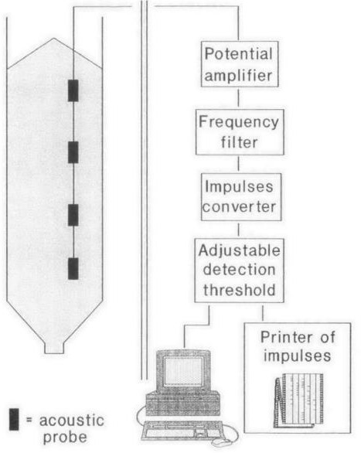
Larvae of Sitophilus spp. and Rhyzopertha dominica in cereals and bruchids in legumes make sounds by their feeding activity. In addition to feeding activity, adult of lesser grain borer make noise by their grain boring activity and adult females of rice weevil probe the grains for inserting their eggs inside the grains.

Acoustic probe trap

The frequency of the sound produced in a definite period is considered for the level of pest activity in the grain. In this method, grain sample is taken in a sound proof box having an acoustic vibration sensor, which is connected to an amplifier and the noise produced from the feeding activity is transmitted for recording.

Recent Advances -Now acoustic detection of insects has concentrated on methods of analysing the sound spectrum of insect noises and developing computer based analysis programmes that will identify the insect species through their sound spectrum.

  - Physical traps – Insects will move around and fly in stored grains or storage premises in response to volatiles emitted by grains/food commodities, pheromones secreted by the adults and they also wander at random due to their innate behaviour of dispersal. This dispersal activity of insects has been exploited to detect and monitor the insects using appropriate devices known as insect traps. Traps help to avoid repeated sampling, which is labour intensive and time consuming (Mutungi et al. 2014). Following traps can be used for the early detection of stored grain pests -

- Pitfall traps – Pitfall trap consists of a plastic jar with a mesh screen over the top. The traps can be fixed inside the grains lot on the surface layer of bulk storage. Insects such as saw toothed beetle crawling across the grain slip through the mesh into the trap and unable to escape.
- Probe traps - Probe trap consists of a plastic cylinder perforated with approximately 2.8 mm holes that are angled down into the body of the traps where a funnel directs the captured insects into a collecting tube. The probe trap is vertically inserted into the body of the traps where a funnel directs the captured insects into a collecting tube. The probe trap need to be inserted vertically into the grain mass and left for a week or more. Insects in the deep layer of the grains crawl into the holes and fall into the collecting tube. They remain trapped inside, till the trap is pulled out of the grain and inspected. The probe traps are sensitive to Rusty grain beetle, red flour beetle and saw toothed beetle.

Recent advances – Normally the traps are left inside the grain for a week or more and then taken out to examine the trapped insects to assess the infestation level. In the improved system which is known as Electric Grain Probe Insect counter (EGPIC), an infrared beam sensor has been installed in the probe, which identifies and records the insects, as they drop into the trap. The sensor output signals are continuously recorded in a computer and the data analysed.

- Pitfall cone traps – Pitfall cone (PC) trap is the combination of pitfall and probe trap, to trap the insects which are active at surface level as well as in the deep layers of the grain bulk.

Thus, the trapping methods are applicable only for the insect stages that are active and mobile.

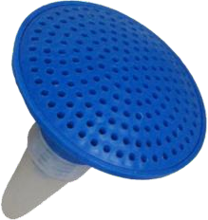 | 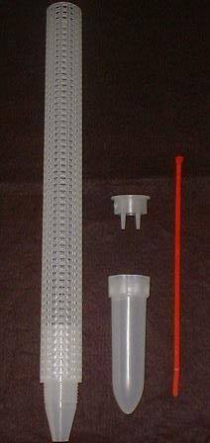 | 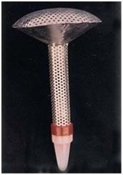
Pitfall trap | Probe trap | Pitfall cone trap

- Multiple funnel trap – Multiple funnel trap consists a series of funnels fitted vertically one above the other without any food bait. It is useful to detecting/trapping beetle and moth pests showing flight activity. Lesser grain borer, red flour beetle and rusty grain beetle in cereal warehouses and moth pests in flour mill can be trapped efficiently (Adams et al. 1978).
- Sticky traps – Adhesive and sticky traps have the surface, treated with sticky substances like petroleum jelly and polybutane gel. Sticky traps can be used for detecting and trapping flying insects including lesser grain borer, Rice moth, Angoumois meal moth, almond moth, Indian meal moth etc (Mboya et al. 2013).

Sticky traps in conjunction of food bait/attractants are highly efficient in locating and monitoring insect infestation in warehouses and other traditional storages.

- Attractant traps – Stored grain pests (adults) are attracted by light of wavelength between 280 and 600 nm. Long wavelengths UV light (365 nm) and green light (500-560 nm) is particularly attractive. A light trap consist a suitable light source and a container or sticky surface to catch and retain insects.
- Traps using food lures – Insect pests are attracted by volatile, deriving from stored commodities. This behavioural response has been taken advantage of, for detecting and monitoring insect pests, particularly beetles. The food attractant traps are useful and low cost material in detecting and monitoring both larvae and adults and are cheaper as locally available (Baoua et al. 2012).
- Triple layer plastic bags: Omondi et al. (2011) and Vales et al. 2014 reported that the seeds stored in triple layer plastic bags retained the germination percentage up to 85 per cent when stored for a period of 9 months compared to traditionally used storage gunny bags where the germination percentage was reduced to 76%e14% within three months. Similarly, Waongo et al. (2019) reported that germination rates of sorghum grains stored in polypropylene bags decreased significantly although no changes observed compared with the initial germination in grains stored in PICS bags. This might be the fact that triple layer bags acts as a hermetic storage which works on the principle of creating air tight conditions in which oxygen levels are depleted from the initially trapped air through insect, fungal and seed respiration and maintain the seed quality parameters by reducing their growth and development (Quezada et al. 2006; Murdock et al. 2012).

- Management using entomopathogens: The indiscriminate usage of pesticides created many hazards such as the development of resistance, residues on food crops, and contamination of the environment (Dhanapal et al. 2021; Dhanapal et al. 2022). The effectiveness of several strains was tested by using aqueous conidial suspensions with different concentrations either by immersing the adults or immature stages of insects in these suspensions or by spraying the inner surfaces of grain containers before introduction of grains and insects ((Dhanapal et al. 2021; Dhanapal et al. 2022). This paves the way for the entry of biological control concepts that utilize predators (Dhanapal et al. 2019a; Dhanapal et al. 2019b; Murugasridevi et al. 2022), parasitoids, and entomopathogens (Dhanapal et al. 2019; Dhanapal et al. 2020a; Dhanapal et al. 2020b; Velavan et al. 2022). The overall results, based on the relevant literature, indicate that the tested strains of EF have shown variable degree of effectiveness according to insect species, virulence of EF strains and the method of treatment or application (Ajaykumar et al. 2023). Although many of these strains have caused a moderate to high level of mortality to the target insects, there is a requirement for formulation of the applied strains to enhance their efficacy. Few investigators have tested the efficacy of isolated strains of EF against certain species of stored-grain insects using certain types of formulations in order to achieve a constant and higher control efficacy.

The two types of food lures are used in the traps

Broken grains – the broken grains of one or mixed type are used in cloth, jute or plastic bags. These baited bags are distributed around grain stacks and on the floor in warehouses. After a period of 1-2 weeks, the bags can be retrieved and insects trapped need to be counted. The bait bags need replacement once in 2 weeks, as they lose their attractiveness in due course. An important advantage of these baited bags is that they attract multiple species and the attracted insects remain inside bags for a considerable period. Rolled barley, wheat, corn and coffee beans have already been tested as food baits. It is also proved that brown rice alone and a mixture of wheat, peanuts and locust beans are the most attractive food baits (Kumar and Kalita, 2017).

Oil & distillates - Cereal (wheat germ oil), sesame oil, vegetable oils and distillates of locust bean deployed as a lures in the traps. Oat and corn oils has ability to attract the adults of S. oryzae and rice, soybean, wheat germ and corn oil are attractive to the adults of red flour beetle. Sesame oil and pumpkin seed are found more attractive in case of Khapra beetle larvae. These attractants are only fatty acids, which can be incorporated with pheromone traps and in physical traps for improved detection and monitoring.

- Corrugated paper traps – Traps that contain corrugated cardboard are particularly effective at attracting wandering moth larvae. Corrugated paper acts as a refuge or hiding site for many of the crawling beetle pests and for the late larvae of Ephestia spp. which are about to pupate. The refuge seeking behaviour has been exploited in refuge traps. The trap efficiency gets boosted, when grain oils and /or pheromones were used as lures in these traps.

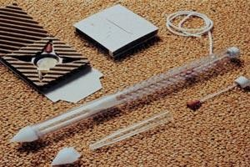
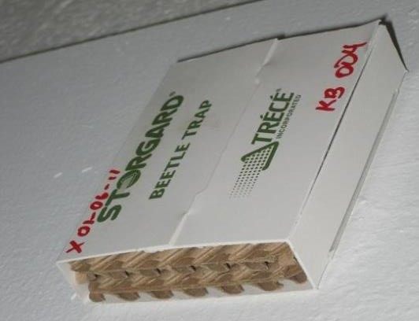
Corrugated paper traps

- Pheromone traps - Pheromones are chemical substances secreted by insects as a part of their communication process. Mainly two types of pheromones are known to secrete by the insects
–

Sex pheromones
  - Aggregation pheromones

All the moth pests and some of the beetles such as Stegobium paniceum and Trogoderma spp. release sex pheromones. However, most of the beetle pests, the males release aggregation pheromones, which attracts both males and females of the same species.

Commercial traps baited with pheromones include (Z, E)-7, 11-hexadecadien-1-ol acetate (or HAD) for Sitotroga cerealella, (Z, E) - 9, 12-tetradecadien-1-ol-acetate (or TDA) for the pyralids like Ephestia spp. and Plodia interrpunctella, dominicalure for Rhyzopertha dominica, 1, 8 dimethyldecanal for Tribolium spp., serricornin for Lasioderma serricorne and stegobinone for Stegobium paniceum. The traps are used at an optimum height of 2-3 meters for every 14 metre for monitoring moth pests. The required trap density varies according to the pests to be detected and monitored.

The use of traps and subsequent interpretation of insect captures for monitoring and population estimation are the most efficient and cost effective tools available so far. Data generated using traps and interpretation provides the best pest management decision support.

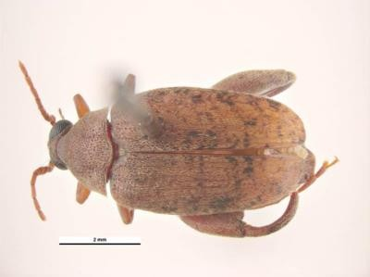
Important Stored Grain Insect Pests

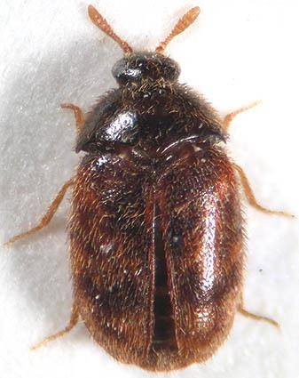 | 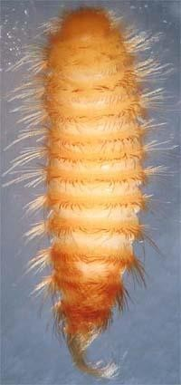 | 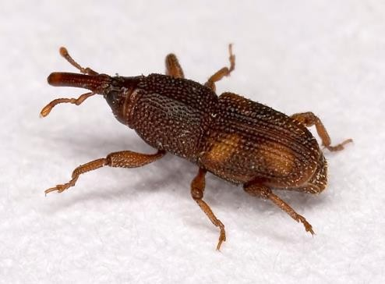
Trogoderma granarium –  Khapra Beetle | Khapra Beetle- Larva | Sitophilus oryzae – Rice Weevil
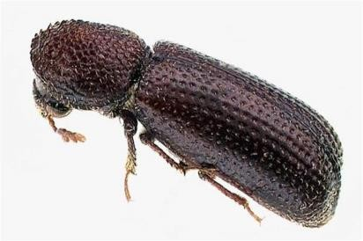 | 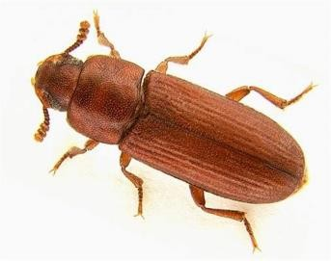 | 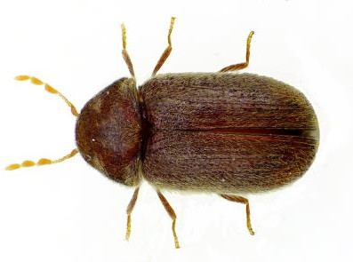
Rhyzopertha dominica –  Lesser Grain Borer | Tribolium castaneum –  Red flour beetle | Stegobium paniceum –Drug Store  Beetle
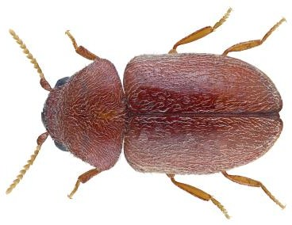 |  | 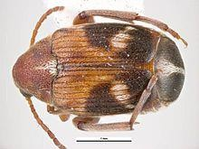
Lasioderma serricorne –  Cigarette beetle | Caryedon serratus –  Peanut Bruchid | Callosobruchus maculatus – Pulse  Beetle

REFERENCES

Adams, J.M., Schulten, G.G.M., 1978. Chapter VI.Standard measurement techniques.
Ajaykumar, R., Murali Krishnasamy, S., Dhanapal, R., Ramkumar, G., Megaladevi, P., Manjubala, M., Chandrasekaran, P., Pradeeshkumar, T., Navinkumar, C. and Harishankar, K., 2023. Mitigation of abiotic and biotic stress using plant growth regulators in rice. Agronomy, 13(9), p.2226.
Baoua, I.B., Margam, V., Amadou, L., Murdock, L.L., 2012. Performance of triple bagging hermetic technology for postharvest storage of cowpea grain in Niger. J. Stored Prod. Res. 51, 81e85. https://doi.org/10.1016/j.jspr.2012.07.003.
between X-ray and MRI in the pDhanapal R, Kumar DVSR, Lakshmipathy R, Sandhya Rani C, Manoj Kumar R (2020a) Exploration of indigenous strains of the green muscardine fungus from soils and their pathogenicity against the tobacco caterpillar, Spodoptera litura (Fabricius) (Lepidoptera: Noctuidae). Egyptian Journal of Biological Pest Control 30:34. https://doi.org/10.1186/s41938-020-00239-8
Dhanapal R, Kumar DVSR, Lakshmipathy R, Sandhya Rani C, Manoj Kumar R (2020b) Isolation of indigenous strains of the white halo fungus as a biological control agent against 3rd instar larvae of tobacco caterpillar, Spodoptera litura (Fabricius) (Lepidoptera: Noctuidae). Egyptian Journal of Biological Pest Control 30:89. https://doi.org/10.1186/s41938-020-00286-1
Dhanapal R, Kumar DVSR, Lakshmipathy R, Sandhya Rani C, Manoj Kumar R (2019) Pathogenicity testing of indigenous isolates of the entomopathogenic fungus, Lecanicillium lecanii against tobacco caterpillar, Spodoptera litura. Journal of Experimental Zoology India. 22(2):753–756
Dhanapal, R., Babu, S. R., Kumar, A. (2019b). Predatory potential of lady bird beetle, Coccinella septempuntata (Linnaeus) on wheat aphid, Macrosiphum miscanthi (Takahashi). Journal of Experimental Zoology India, 22(2): 567-571.
Dhanapal, R., Kumar, A., Babu, S. R. (2019a). Coccinellid species complex in different crops at Varanasi region. Journal of Experimental Zoology India, 22(2): 521-525.
Dhanapal, R., Singh, R.N., Raghuraman, M., Mohan, M., Subaharan, K. (2021). Evaluation of predatory potential and prey stage preference of mirid bug, Nesidiocoris tenuis on tomato pinworm, Tuta absoluta. Biologia 76, 2965–2971. https://doi.org/10.1007/s11756-021-00786-x
Dhanapal, R., Sravika, A., Sekar, S., Ramesh Babu, S., & Gajalakshmi, M. (2022). Improving Insect Control Using Genetically Modified Entomopathogens. In New and Future Development in Biopesticide Research: Biotechnological Exploration, Springer Nature Singapore, pp. 223-242.
Dhole, R.R., Singh, R.N., Dhanapal, R., Singla, S., Ramkumar, G., Muthuusamy, R., Salmen, S.H., Alharbi, S.A., Narayanan, M. and Karuppusamy, I. (2023). Impact assessment of natural variations in different weather factors on the incidence of whitefly, Bemisia tabaci Genn. and yellow vein mosaic disease in Abelmoschus esculentus (L.) Moench. Environmental Research, 231, p.116209.
FAO, 2018. Save food: global initiative on food loss and waste reduction. http:// www.fao.org/save-food/en/.
Fintrac, 2016. Smallholder grain storage in sub-Saharan Africa: a case study on hermetic storage technology commercialization in Kenya. Fintrac Topic Papers 3, 1e8.
in wheat by near-infrared reﬂectance spectroscopy. Journal of the Science of Food and
infrared reﬂectance spectroscopy. Cereal Chemistry, 80(3), 346–349.
infrared reﬂectance spectroscopy. Cereal Chemistry, 80(3), 346–349.
Jones, M., Alexander, C., Lowenberg-DeBoer, J., 2011. Proﬁtability of Hermetic Pur- due Improved Cowpea Storage (PICS) Bags for African Common Bean Producers Working Paper No. 11e13. Dept. of Agricultural Economics, Purdue University West Lafayette: West Lafayette, USA.
Kim, S. S., Phyu, M. R., Kim, J. M., & Lee, S. H. (2003). Authentication of rice using near
Kim, S. S., Phyu, M. R., Kim, J. M., & Lee, S. H. (2003). Authentication of rice using near
Kim, S. S., Phyu, M. R., Kim, J. M., & Lee, S. H. (2003). Authentication of rice using nearinfrared reﬂectance spectroscopy. Cereal Chemistry, 80(3), 346–349.
Kumar, D., Kalita, P., 2017. Reducing postharvest losses during storage of grain crops to strengthen food security in developing countries. Foods 6 (1), 8. https:// doi.org/10.3390/foods6010008.
Mboya, R.M., 2013. An investigation of the extent of infestation of stored maize by insect pests in Rungwe district, Tanzania. Food Security 5, 525e531. https://link. springer.com/article/10.1007%2Fs12571-013-0279-3.
Merga, B., Haji, J., 2019. Economic importance of chickpea: production, value, and world trade. Cogent Food and Agricult. https://doi.org/10.1080/ 23311932.2019.1615718, 5-1615718.
Murdock, L L, Seck, D, Ntoukam, G, Kitch, L, Shade, R.E., 2003. Preservation of cowpe grain in sub-Saharan Africa-Bean/Cowpea CRSP contributions. Field Crop. Res. 82, 169e178. https://doi.org/10.1016/S0378-4290(03)00036-4.
Murdock, L.L., Margam, V., Baoua, I., Balfe, S., Shade, R.E., 2012. Death by desicca- tion: effects of hermetic storage on cowpea bruchids. J. Stored Prod. Res. 49, 166e170. https://doi.org/10.1016/j.jspr.2012.01.002.
Murugasridevi, K., Dhanapal, R., Sekar, S., Tamilselvan, R. and Aravind, J. (2022). Biointensive Integrated Pest Management (BIPM) Approaches in Orchards. In Handbook of Research on Principles and Practices for Orchards Management, IGI Global. pp. 249-276.
Mutungi, C.M., Affognon, H., Njoroge, A.W., Baributsa, D., Murdock, L.L., 2014. Storage of mung bean (Vigna radiata [L.]Wilczek) and pigeonpea grains (Cajanus cajan [L.] Millsp) in hermetic triple-layer bags stops losses cause by Calloso- bruchus maculatus (F.)(Coleoptera: Bruchidae). J. Stored Prod. Res. 58, 39e47. https://doi.org/10.1016/j.jspr.2014.03.004.
Njoroge, A.W., Affognon, H.D., Mutungi, C.M., Manono, J., Lamuka, P.O., Murdock, L.L., 2014. Triple bag hermetic storage delivers a lethal punch to Prostephanus truncatus (Horn) (Coleoptera: Bostrichidae) in stored maize. J. Stored Prod. Res. 58, 12e19. https://doi.org/10.1016/j.jspr.2014.02.005.
Nutrition Research, 49, 163–232.
Obeng-Ofori, D., 2011. Protecting grain from insect pest infestations in Africa: producer perceptions and practices. Stewart Post-Harvest Rev. 7 (3), 1e15. https://doi.org/10.2212/spr.2011.3.10.
Omondi, B.A., Jiang, N., Den Berg, J.V., Schulthess, F., 2011. The ﬂight activity of Prostephanus truncatus (Horn) (Coleoptera: Bostrichidae) and Teretrius nigres- cens Lewis (Coleoptera: Histeridae) in Kenya. J. Stored Prod. Res. 47 (1), 13e19. https://doi.org/10.1016/j.jspr.2010.08.002.
p. 46. Unpublished Terminal Report.
Proceedings of the international conference on information technology and multimedia at
Quezada, M.Y., Moreno, J., Varqueze, M.E., Mondoza, M., Mendeze-Albores, A., Moreno-Martineze, E., 2006. Hermetic storage system preventing the prolifer- ation of Prostephanus truncatus (Horn) and storage fungi in maize with different moisture contents. Postharvest Biol. Technol. 39, 321e326. https://doi.org/ 10.1016/j.postharvbio.2005.10.004.
Quitco, R.T., Quindoza, N.M., 1986. Assessment of Paddy Loss in Storage. NAPHIRE,
Rajendran, S. (2005). Detection of insect infestation in stored foods. Advances in Food &
Rajendran, S. (2005). Detection of insect infestation in stored foods. Advances in Food &Nutrition Research, 49, 163–232.Ridgway, C., & Chambers, J. (1996).
Ramkumar, G., Muthusamy, R., Narayanan, M., Dhanapal, R., Karthik, C., Shivakumar, M.S., Malathi, G. and Kariyanna, B., 2022. Pretreatment of mosquito larvae with ultraviolet-B and nitropolycyclic aromatic hydrocarbons induces increased sensitivity to permethrin toxicity. Heliyon, 8(10).
Ramzan, M., Chahal, B.S., Judge, B.K., 1986. Studies on the preference of pulse beetle, Callosobruchus maculatus F. to some commonly used pulses. Bull. Grain Technol. 24 (3), 211e214.
Ridgway, C., & Chambers, J. (1996). Detection of external and internal insect infestation
S. Neethirajan, C. Karunakaran, D.S. Jayas, N.D.G. White. Detection techniques for stored-product insects in grain. Volume 18, Issue 2, February 2007, Pages 157-162. Elsevier.
UNITEN (ICIMU ‘05), Malaysia
Vales, M.I., RangaRao, G.V., Sudini, H., Patil, S.B., Murdock, L.L., 2014. Effective and economic storage of pigeonpea seed in triple layer plastic bags. J. Stored Prod. Res. 58, 29e38. https://doi.org/10.1016/j.jspr.2014.01.004
Velavan, V., Dhanapal, R., Ramkumar, G., Karthi, S., Senthil-Nathan, S., Ndomba, O. A., & Kweka, E. J. (2022). Characterization and Evaluation of Metarhizium spp.(Metsch.) Sorokin Isolates for Their Temperature Tolerance. Journal of Fungi, 8(1), 68.
Yacob, Y., Ahmad, H., Saad, P., Aliana, R., Raof, A., & Ismail, S. (2005). A comparison
Yacob, Y., Ahmad, H., Saad, P., Aliana, R., Raof, A., & Ismail, S. (2005). A comparison between X-ray and MRI in the postharvest non-destructive detection method. Proceedings of the international conference on information technology and multimedia at UNITEN (ICIMU ‘05), Malaysia

