BIOLOGICAL EFFECTS OF IONIZING RADIATION
G Thangam¹, S Iyyappan^{2*} and S Mathu Kumar³
¹Department of Science & Hummanities, Rohini College of Engineering & Technology, Palkulam, Tamilnadu, India.
^{2,3}Department of Mechanical Engineering, Ponjesly College of Engineering, Nagercoil, Tamilnadu, India.
Abstract:
Ionizing radiation emerges as a form of energy discharged by atoms through electromagnetic waves or particles. This particular radiation finds utility across diverse domains like medicine, industry, agriculture, and research. Despite its intrinsic harm and potential toxicity to organisms, regulated amounts find application in medical imaging and radiotherapy. Prolonged exposure to low levels of ionizing radiation amplifies the risk of enduring effects, notably cancer. Moreover, extremely elevated radiation doses can induce pronounced consequences such as radiation burns and swift fatality due to acute radiation syndrome. Within this chapter, an outline is presented detailing the potential biological repercussions at the cellular level stemming from radiation exposure.
Keywords: Radiation, DNA, Chromosome.
- Introduction
  - Exposure of radiation to people:
Individuals might encounter ionizing radiation while at home or in public spaces, as well as during their time at work or within medical facilities. Exposure to radiation can occur through external means or internal processes. Internal exposure can occur by the inhalation or absorption of radionuclides into the bloodstream. On the other hand, external exposure can result from the deposition of radioactive substances on the skin or clothing.
The radionuclide can be eliminated from the body through washing. The occurrence of ionizing radiation exposure might originate from external factors, such as medical radiation exposure from x-rays. This exposure can be halted by shielding the radiation source. The radiation harms the cells and tissues of the human body, and the impact of this radiation on the body is referred to as the biological effects of radiation.
  - The Cell
The cell, the fundamental unit of living organisms, consists of two main constituents: the nucleus and the cytoplasm as shown in figure 1.The cytoplasm, under the direction of the nucleus, plays a central role in carrying out various metabolic processes.
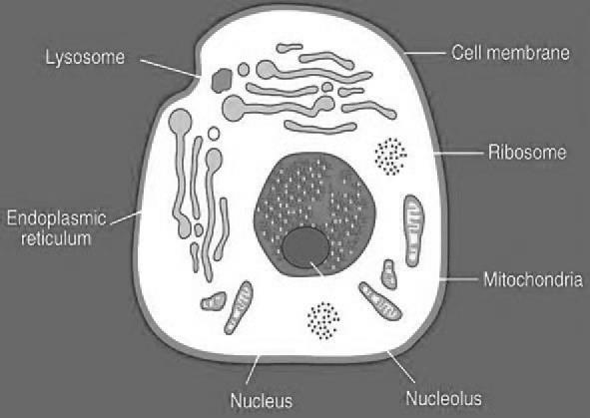
Within the nucleus, there reside chromosomes that exhibit a thread-like configuration featuring dual arms connected by a centromere. These chromosomes are comprised of genes, the fundamental carriers of hereditary information across all living organisms. Genes themselves are composed of molecules of deoxyribonucleic acid (DNA).
Figure 1. Structure of Human Cell
The distinctive nature of a chromosome is defined by its gene sequence. Within the cell's cytoplasm, four crucial organelles—ribosomes, endoplasmic reticula, mitochondria, and lysosomes-undertake essential metabolic functions. Comprising protein and ribonucleic acid (RNA), ribosomes play a pivotal role in orchestrating the synthesis of proteins in living organisms.
- Classifications of Biological effects
The biological effects of radiation can be classified into two types. They are
- Direct damage:
If the ionizing radiation directly leads to molecular disruption then it is direct damage,
- Indirect damage:
Indirect damage occurs when free radicals are produced, which then attack other parts of the cell.
2.1. Direct damage:
2.1.1. DNA molecule:
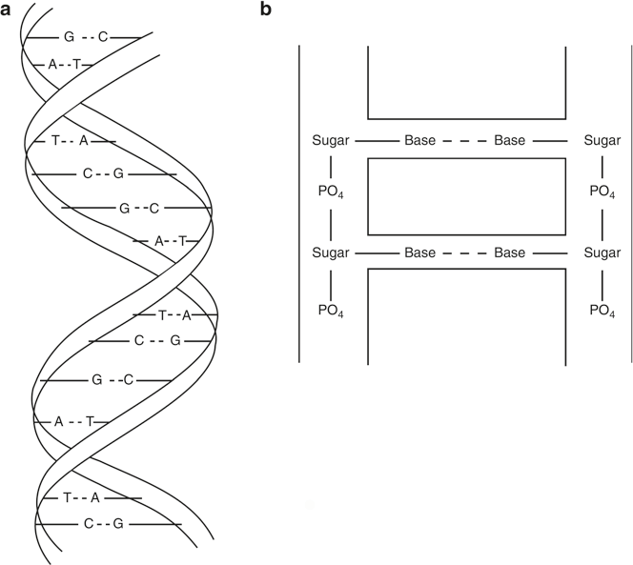
The DNA molecule exhibits a double-helical arrangement consisting of two strands. These strands are composed of sugar molecules linked by phosphate bonds. These strands are ladder-like rungs comprised of four bases: thymine (T), adenine (A), guanine (G), and cytosine (C). These bases form connections with the sugar molecules on both sides of the strands and are held together by hydrogen bonds as in figure 2.
Figure 2. Structure of DNA
2.1.2. Effect of radiation on DNA
Figure 3a illustrates the standard DNA molecule. Radiation can induce damage to this molecule through the subsequent mechanisms:
- Cleavage of hydrogen bond (in figure 3b)
- Missing of base (in figure 3c)
- Breakage of single strand (in figure 3d)
- Breakage of double strand (in figure 3e)
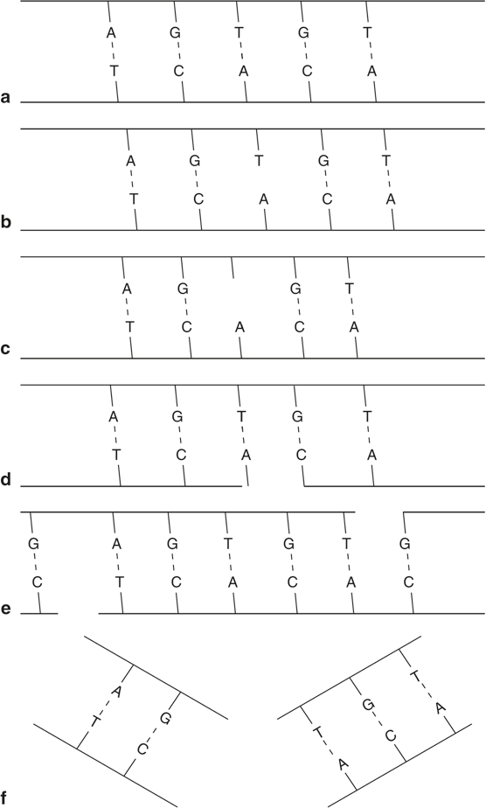

Figure 3. a) Normal DNA, b) Cleavage of hydrogen bond, c) Missing of base, d) Single strand Breakage and e)Double strand Breakage
2.1.3. Chromosome
Mutations in DNA molecules can impact chromosomes, leading to structural alterations known as aberrations. These aberrations are categorized into two main types.
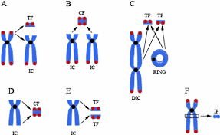
Figure 4. Aberrations of chromosomes
- Chromatid aberrations
Only one chromatid within this context experiences the effect, and the broken sections of chromatids will undergo rejoining.
- Chromosome aberration
In this scenario, the broken chromatid undergoes duplication, resulting in daughter cells containing impaired chromosomes. Subsequently, four distinct processes come into play as in Table 1.
Table 1. Process of chromosomes aberrations
Name of the Process | Explanations
Deletion | Fragment of chromosome is broken and it is deleted
Inversion | Broken fragment reattaches in the reverse order.
Translocation | Broken fragment from one chromosome attaches with the fragment of different chromosome.
Reciprocal translocation | Two broken fragments from two chromosomes reattach with the wrong chromosome

2.2. Indirect damage
In this the radiation hits the water molecules, major constituents of cells thus producing free radicals. This will react with the DNA molecules to cause molecular damage.

- Conclusion
In conclusion, the biological effects of radiation on cells are complex and multifaceted, reflecting the intricate interplay between radiation and cellular components. Ionizing radiation, with its ability to directly or indirectly interact with cellular molecules, can induce DNA damage, leading to mutations and potential cancer development. The cellular response to radiation, including DNA repair mechanisms and apoptosis, showcases the cell's remarkable ability to mitigate damage. Understanding these effects is vital for both medical and technological advancements. It guides the safe use of radiation-based therapies in medicine while promoting the responsible implementation of radiation-emitting technologies in various applications.
References
- Wang, H., Jiang, H., Van De Gucht, M., & De Ridder, M. (2019). Hypoxic Radioresistance: Can ROS Be the Key to Overcome It? Cancers, 11(1), 112. doi:10.3390/cancers11010112.
- B.H. Brown, R.H. Smallwood, D.C. Barber, P.V. Lawford, D.R. Hose, “Medical Physics and Biomedical Engineering”, Institute of physics publishing, Bristol and Philadelphia, 1999.
- Gopal B. Saha. “Physics and Radiobiology of Nuclear Medicine” Fourth Edition, Springer, 2006.
- Steve Webb, The Physics of Medical Imaging, Taylor & Francis, Newyork, Second Edition, 2012.

