ANTI-ARTHRITIC OF ZINC OXIDE NANOPARTICLES MEDIATED FROM PUNICA GRANATUM LEAVES

Ms. A. Jananisri *
I-M.Sc. chemistry,
PG & Research Department of Chemistry
Bishop Heber College (Autonomous),
Trichy, Tamilnadu, India.
Email ID: jananisri144@gmail.com

Ms. V. S. Sangeetha
Assistant Professor
Department of Chemistry
Dhanalakshmi Srinivasan College of Arts and Science for Women (Autonomous)
Perambalur, Tamilnadu, India.
Email ID: sangeethavasanth23@gmail.com

Abstract:
Rheumatoid arthritis (RA) is a major global public health challenge, and novel therapies are required to combat it. Zinc oxide nanoparticles have been employed as delivery vehicles of anti-inflammatory drugs for RA therapy, and it has been recently realized that ZnONPs have anti-inflammatory action on their own. However, their conventional synthesis processes might result in cytotoxicity and environmental hazards. Instead, the use of natural products as a reducing and stabilizing agent in the biosynthesis of zinc oxide nanoparticles has arisen as an option to decrease the cytotoxic and environmental concerns associated with the chemical synthesis of ZnONPs. In this study, we challenged the efficacy of Punica Granatum leaves aqueous extract as a reducing and/or capping agent for the biosynthesis of ZnONPs. Punica Granatum -mediated biosynthesized zinc oxide nanoparticles were characterized via UV-vis spectroscopy, dynamic light scattering, and scanning electron microscopy. In addition, their anti-arthritic potential was evaluated in an adjuvant-induced arthritis (AIA) model. The synthesized G-AgNPs were nearly spherical, with a particle size of 337.6 ± 12.1 nm and a negative surface charge (−18.9 ± 1.8 mV). Finally, histological examination revealed comparatively lower inflammatory cells infiltration in ankle joint tissue upon treatment with PG-ZnONPs. Collectively, biosynthesized PG-ZnONPs might represent a plausible therapeutic option for the management of RA.
Keywords: Zinc oxide Nanoparticles, Synthesis, Characterisation, Anti-arthritic Activity

- INTRODUCTION
One type of autoimmune illness is Rheumatoid arthritis which is caused by inflammation illnesses and results in inflammation in the joints, synovial expansion, and destruction of cartilage in the majority of instances. Prolonged treatment with allopathic medications generates harmful side effects, hence an alternate natural therapy has been explored. In 2007, the Arthritis Foundation predicted that three-quarters of the population would be affected by arthritis, and census information shows that by 2030, this percentage is expected to have risen to 40%. People with rheumatoid arthritis are twice as probable to develop lung disease, cardiovascular disease, and respiratory infections, which account for 10-20% of overall deaths. Inflammation was classified as a pathogenic transformation in rheumatoid arthritis. The deterioration of renal function is directly related to the development of pain in the joint.
The therapeutic management of rheumatoid arthritis is an integrated approach with the goal of lowering discomfort, reducing inflammation, and improving joint function. However, advances in understanding the disease's etiology have encouraged the development of novel accessible treatments with enhanced results. In practice, the goal of prolonged therapy is to reduce inflammation. Natural treatments have been gaining popularity in treatment of rheumatoid arthritis around the world. Nanotechnology is the world's fastest industrial sector, with a frantic search for innovative nanomaterials and technologies for manufacturing.
There are many techniques for producing micron-sized particles including chemical, physical, and biological methods. The chemical method of synthesis may create an enormous volume of nanoparticles in a short time, but it requires capping agents to stabilize the size of the nanoparticles. The nanoparticle production and stabilization process need hazardous chemicals that produce waste that is harmful to the environment. The growing interest in biological methods that eliminate harmful chemicals as byproducts is a result of the demand for environmentally safe synthetic processes for nanoparticle production. Consequently, there is a rising need for "green nanotechnology." currently, numerous biological methods utilizing bacteria, fungi, and plants have been investigated and documented for the fabrication of extracellular and intracellular nanoparticles. Plants serve as a better biosynthesis platform for nanoparticles since they provide natural capping agents and are free of hazardous chemicals. Additionally, using plant extracts lowers the price of microbe isolation and culture media.
zinc oxide nanoparticles are widely used in pharmaceuticals, photonics, chemical sensing, electronic devices, biosensors, and catalysis due to their unique optical, chemical and catalytic properties. The use of zinc oxide nanoparticles in biological applications, such as antibacterial effects, has tremendous potential. Antibacterial properties of zinc oxide nanoparticles make them suitable for usage in a variety of household items, including fabrics, home appliances, food storage containers, and medical devices. Zinc oxide has little toxicity and is a powerful antibacterial agent. The field of medicine uses zinc oxide and zinc oxide nanoparticles most frequently in tropical ointments to guard against infection in burns and open wounds. Due to their appealing physiochemical features, zinc oxide nanoparticles have a significant impact on biology and medicine. Since ancient times, zinc oxide-based substances have been utilised for the prevention and treatment of a variety of illnesses, most notably infections. These products are known to have potent inhibitory and bactericidal effects as well as a broad spectrum of antimicrobial activity. According to reports, zinc oxide nanoparticles have anti-viral, anti-inflammatory, anti-angiogenesis, and antifungal properties.
The leave of Punica Granatum have long been used traditionally to treat joint pain. Though, it has not been pharmacologically assessed for rheumatoid arthritis. The current study explores the anti-arthritic activity of zinc oxide nanoparticles mediated by Punica Granatum extracts. The medicinal plant extracts are used as reducing, stabilizing, and capping reagents for the synthesis of zinc oxide nanoparticles.

- MATERIALS AND METHODS
Collection of plant material and preparation of extract
The Rapinat Herbarium at St. Joseph College in Trichy authenticated the plant Punica Granatum, which had been collected from the Lalgudi geographical area of the Trichy District. The plant parts have been collected, meticulously washed with distilled water, and then dried at the ambient temperature. The dried part of the chosen plant materials was chopped into small pieces, pounded with a manual hammer, and then processed through a disc grinder in order to produce a fine powder. The powder was subsequently separated and kept in a container for future investigation in an unheated, shaded area. Punica Granatum dried powders were combined in a 1:1 ratio and infused into 100 milliliters of ethanol solvent for 48 hours. After two days the extract is filtered and stored in the brown bottle for further analysis.

Green Synthesis and Characterization of Zinc oxide Nanoparticles
In the bulk synthesis 100ml of 0.001M of Zinc acetate solution is initially taken in the 500ml beaker and kept on the magnetic stirrer with stirring. To this initially 50ml of Punica Granatum extract is added in drop wise and set the temperature 40oC then allowed to react for 1 hour on stirrer with continuous stirring and the pH of the medium maintained at 10. Likewise every one hour time interval 50ml of Punica Granatum extract is added. After complete addition of 400ml of extract the whole reaction mixture is allowed to stirring on magnetic stirrer for 5 hours. Once the reaction is over the whole reaction mixture is stored in reaction chamber for 48 hours. Then, visibly can understand that the Zinc oxide nanoparticles were settled in the bottom of the beaker and the unreacted zinc acetate solution and extract was move to the liquid layer. Finally, the Zinc oxide nanoparticles were collected by centrifuging at 6000rpm and collected particles were again washed with double distilled water followed by the methanol to remove the unreacted additive and precursor. In the obtained particles (precipitate) Zinc oxide is in the form of hydroxide and to make it into oxide the precipitate is further calcinated at 200oC at muffle furnace. The crystalline nature, morphology, size and elemental composition of synthesized PG-ZnONPs are determined by using FT-IR and UV-visible spectra, as well as XRD, SEM, and EDAX.

EVALUATION OF ANTI-ARTHRITIC ACTIVITY:
The main cause of certain types of rheumatoid arthritis is the production of autoantibodies (toxins). The body produces auto antigens as a result of membrane lysis and the denaturant of in-vivo proteins. Protein denatures and membrane lysis % inhibition is used to gauge in-vitro anti-arthritis efficacy. To investigate the in-vitro anti-arthritis effect, two approaches—the protein denature model and the membrane stabilization model for human red blood cells (HRBCs)—were used.
INHIBITION OF PROTEIN DENATURATION
The process of protein denaturation inhibition has been investigated by standard Method.100 milliliters of synthesised CP-AgNPs were combined with 500 ml of 1% bovine serum albumin. After that it is kept for 10 minutes at room temperature, the entire mixture was heated for 20 minutes at 51°C. After cooling at room temperature, the absorbance of the mixture is measured at 660 nm. The positive control was taken to be diclofenac sodium. Using the following formula, the rate of inhibition for protein denaturation was calculated:
Percentage inhibition= [Ac-At/Ac] x 100.
Where, At is absorbance of test sample, Ac is absorbance of control.

- RESULT AND DISCUSSION

Characterization of Punica Granatum mediated Zinc oxide Nanoparticles (PG-ZnONPs):
UV-Visible observation of PG-ZnONPs:
UV-Visible spectroscopy measure the surface plasmon resonance of the nanoparticles in solutions. From the literature it is evidenced that, the Zinc oxide nanoparticles shows the plasmon resonance between 250-380nm. The obtained PG- ZnONPs revealed the absorption maximum at 355nm which confirms the Zinc oxide plasmon resonance and are close agreement with the previous studies. The UV-Visible spectrum of PG- ZnONPs are shown in figure-1.

Figure: UV spectrum of Punica Granatum mediated Zinc oxide oxide nanoparticles (PG- ZnONPs)

FT-IR of PG-ZnONPs
The synthesized PG-ZnONPs showed the few absorption peak on FT-IR analysis and the observed frequencies are 3112cm⁻¹, 2499 cm⁻¹, 2349 cm⁻¹ , 1558 cm⁻¹, 1444 cm⁻¹, 1018 cm⁻¹, 952 cm⁻¹ and 843cm⁻¹ which are due to O-H stretching of intra molecular bonding of alcohol, C-H stretching of aldehyde, C=C stretching of unsaturated ketone, C-H bending of aldehyde, O-H bending of alcohol, C=C bending of alkene and C-X stretching. Similarly the bands at 693 cm⁻¹and 621 cm⁻¹ responsible for M-O stretching of metal-oxygen bonds. The combined spectral results of FT-IR reveals that, after forming the nanoparticles the O-H, and C=C frequencies are gets suppressed and the range below 700 cm⁻¹ (M-O bond) the peaks were elongated which confirms the Zn-O metal bonds in the Punica Granatum mediated Zinc oxide oxide nanoparticles.
Figure-2: FT IR spectrum of PG-ZnONPs
XRD of PG-ZnONPs
XRD spectral analysis provides the structural and crystalline nature of the synthesized PG-ZnONPs. XRD peaks of obtained PG-ZnONPs showed the 2ϴ values of 32.23⁰, 36.71⁰, 34.88⁰, 47.98⁰, 57.04⁰, 63.27⁰, and 68.39⁰ which are well agreement with the plane of (110), (202), (111), (020), and (113). The reported XRD peak data with the plane are matches closely with the standard Zinc oxide oxide diffraction card JCPDS file number of 36-1451. The average crystalline size of the PG-ZnONPs is found to be 72.10nm. ³⁸
Figure-3: XRD pattern of synthesized PG-ZnONPs

SEM images of PG-ZnONPs
The structural and the morphological characterizations of biogenic synthesized PG-ZnONPs nanoparticles were examined with the Scanning Electron Microscope. The accelerating voltage used in the analysis is 15.00kV. The magnifications images of synthesized PG-ZnONPs are shown in the figure. It is found that the obtained Zinc oxide nanomaterials are in polydispered form. The shapes of PG-ZnONPs were found to be rod and few elongated hexagonal morphologies with the accumulations.
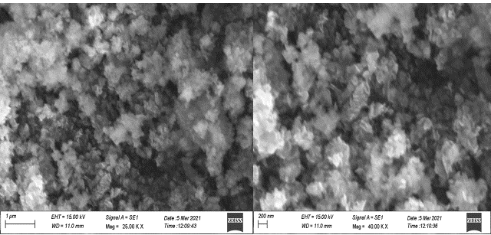
Figure- 4: SEM images of synthesized PG-ZnONPs
EDX of PG-ZnONPs
In qualitatively and quantitatively the elemental composition of the synthesized PG-ZnONPs are screened by the EDX. The resulted EDX images are shown in the figure and can identified that the prominently the Zinc oxide peak is reported with the weight percentage of 77.46% followed by oxygen at 22.54%. The obtained narrow and the strong diffraction peaks of the PG-ZnONPs revealed the high crystalline nature of that. Along with the existed Zinc oxide and oxygen peaks some of the impurities peaks also found in the results and are due to the plant pytoconstituents present in the aqueous extract (involved in the M-O complexation).
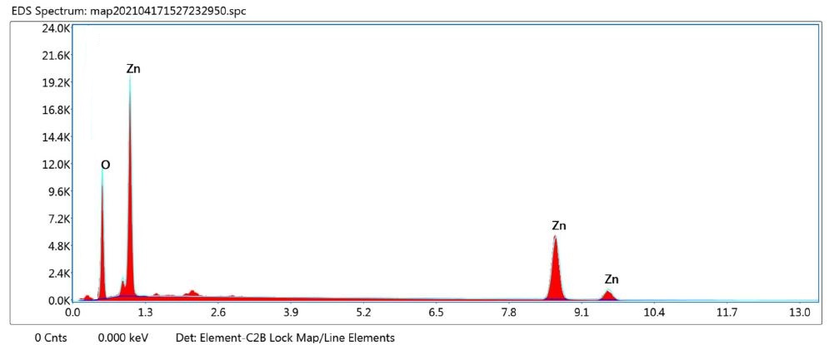
Figure- 5: EDX of synthesized PG-ZnONPs
Inhibition of protein denaturation:

Denaturation of tissue proteins may be the cause behind the production of auto-antigens in certain arthritic diseases. So, it may be said that tissue protein denaturation is a marker for inflammatory and arthritic diseases. Agents that can prevent protein denaturation, therefore, would be possible candidate for anti-inflammatory drug development. With this idea in mind, the in vitro test was done as a preliminary screen to check presence of anti-arthritic activity. In the present study, the protein denaturation bioassay was selected for in vitro assessment of anti- arthritic of zinc oxide nano particles from the Punica Granatum with a wide range of dose concentrations. The present findings exhibited a concentration dependent inhibition of protein (albumin) denaturation by zinc oxide nano particles throughout the concentration range of 20-100 μg/ml. Diclofenac sodium (at the concentration range of 20-100 μg/ml) was used as the standard drug. The increased absorbance in the extracts and the standard drug with respect to control indicates the protein stabilizing activity (denaturation is inhibited) with increased dose. The highest activity of AgNPs from the Punica Granatum ZnONPs was found to be near to standard diclofenac sodium 69.37%, in the concentration of 100μg/ml respectively. From the present study it can be concluded that AgNPs showed marked in vitro anti-inflammatory effect against the denaturation of protein.

Table 1: In vitro anti-arthritic activity of synthesized zinc oxide Nano particles and standard

S.No | Concentrations  (µg/ml) | Protein denaturation (%)
 |  | PG-ZnONPs | Diclofenac sodium
1 | 20 | 47.72 | 49.06
2 | 40 | 56.03 | 57.37
3 | 60 | 60.34 | 63.82
4 | 80 | 63.79 | 69.72
5 | 100 | 69.37 | 73.31
6 | IC 50 | 22.98 | 18.40

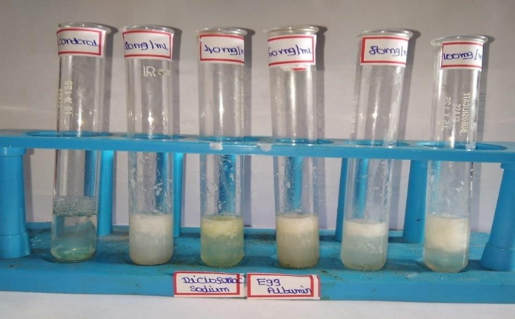
Figure-6: Anti-arthritic activity of standard diclofenac sodium by egg albumin assay method

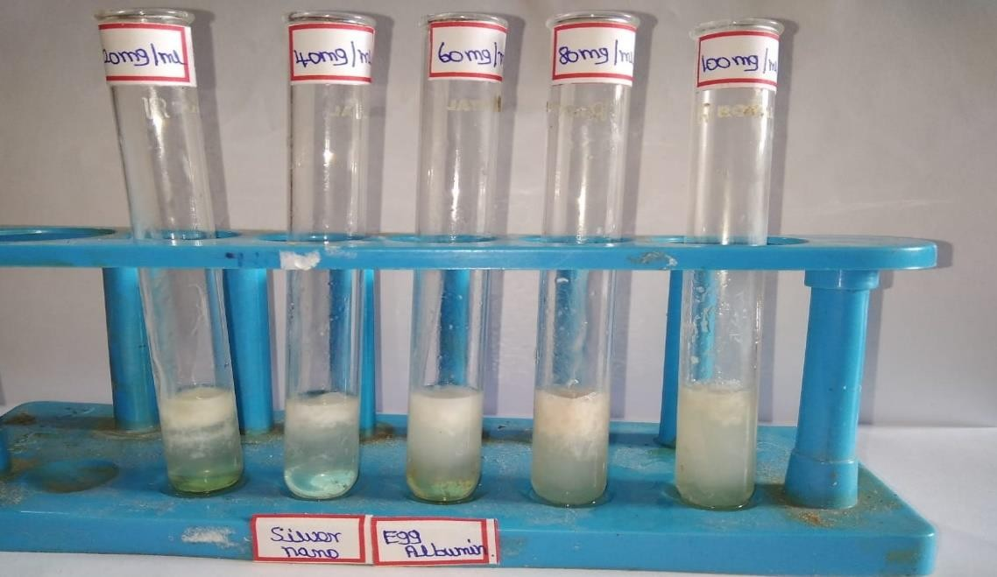
Figure-7: Anti- arthritic activity of PG-ZnONPs by egg albumin assay

- CONCLUSION

The current study showed that the zinc oxide nano particle synthesized from Punica Granatum possesses anti-arthritic activities. The synthesised zinc oxide nanoparticles are capped by the phytochemicals of Punica Granatum extract showed significant anti- arthritic activity in conclusion combining the benefits of phytomedicine with nanomedicine can result in the formation of more efficient zinc oxide nanoparticles. This finding suggested that the synthesis of AgNPs using Punica Granatum extract could be a good source for developing green nano-medicine for the management of arthritis.
V. REFERENCE
- S. Faisal, H. Jan, S. A. Shah et al., “Green synthesis of zinc oxide (ZnO) nanoparticles using aqueous fruit extracts ofMyristica fragrans: their characterizations and biological and environmental applications,” ACS Omega, vol. 6, no. 14, pp. 9709–9722, 2021.
- L. Al-Naamani, S. Dobretsov, and J. Dutta, “Chitosan-zinc oxide nanoparticle composite coating for active food packaging applications,” Innovative Food Science & Emerging Technologies, vol. 38, pp. 231–237, 2016.
- B. R. Sankapal, H. B. Gajare, S. S. Karade, R. R. Salunkhe, and D. P. Dubal, “Zinc oxide encapsulated carbon nanotube thin films for energy storage applications,” Electrochimica Acta, vol. 192, pp. 377–384, 2016.
- R. Kumar, O. al-Dossary, G. Kumar, and A. Umar, “Zinc oxide nanostructures for NO₂ gas–sensor applications: a review,” Nano-Micro Letters, vol. 7, no. 2, pp. 97–120, 2015.
- P. K. Mishra, H. Mishra, A. Ekielski, S. Talegaonkar, and B. Vaidya, “Zinc oxide nanoparticles: a promising nanomaterial for biomedical applications,” Drug Discovery Today, vol. 22, no. 12, pp. 1825–1834, 2017.
- M. D. Newman, M. Stotland, and J. I. Ellis, “The safety of nanosized particles in titanium dioxide- and zinc oxide-based sunscreens,” Journal of the American Academy of Dermatology, vol. 61, no. 4, pp. 685–692, 2009.
- M. Abedini, F. Shariatmadari, M. A. Karimi Torshizi, and H. Ahmadi, “Effects of zinc oxide nanoparticles on the egg quality, immune response, zinc retention, and blood parameters of laying hens in the late phase of production,” Journal of Animal Physiology and Animal Nutrition, vol. 102, no. 3, pp. 736–745, 2018.
- H. Agarwal, S. Venkat Kumar, and S. Rajeshkumar, “A review on green synthesis of zinc oxide nanoparticles - An eco-friendly approach,” Resource-Efficient Technologies, vol. 3, no. 4, pp. 406–413, 2017.
- M. Heinlaan, A. Ivask, I. Blinova, H. C. Dubourguier, and A. Kahru, “Toxicity of nanosized and bulk ZnO, CuO and TiO₂ to bacteria _Vibrio fischeri and crustaceans Daphnia magna and Thamnocephalus platyurus_,” Chemosphere, vol. 71, no. 7, pp. 1308–1316, 2008.
- H. Jan, M. Shah, H. Usman et al., “Biogenic synthesis and characterization of antimicrobial and anti-parasitic zinc oxide (ZnO) nanoparticles using aqueous extracts of the Himalayan columbine (Aquilegia pubiflora),” Frontiers in Materials, vol. 7, p. 249, 2020.
- F. Thema, E. Manikandan, M. S. Dhlamini, and M. Maaza, “Green synthesis of ZnO nanoparticles via Agathosma betulina natural extract,” Materials Letters, vol. 161, pp. 124–127, 2015.
- N. Matinise, X. G. Fuku, K. Kaviyarasu, N. Mayedwa, and M. Maaza, “ZnO nanoparticles via Moringa oleifera green synthesis: Physical properties & mechanism of formation,” Applied Surface Science, vol. 406, pp. 339–347, 2017.
- S. Vijayakumar, B. Vaseeharan, B. Malaikozhundan, and M. Shobiya, “Laurus nobilis leaf extract mediated green synthesis of ZnO nanoparticles: Characterization and biomedical applications,” Biomedicine & Pharmacotherapy, vol. 84, pp. 1213–1222, 2016.
- G. Sangeetha, S. Rajeshwari, and R. Venckatesh, “Green synthesis of zinc oxide nanoparticles by aloe barbadensis miller leaf extract: Structure and optical properties,” Materials Research Bulletin, vol. 46, no. 12, pp. 2560–2566, 2011.
- J. Huang, Q. Li, D. Sun et al., “Biosynthesis of silver and gold nanoparticles by novel sundried Cinnamomum camphora leaf,” Nanotechnology, vol. 18, no. 10, article 105104, 2007.
- U. Vijayalakshmi, M. Chellappa, U. Anjaneyulu, G. Manivasagam, and S. Sethu, “Influence of coating parameter and sintering atmosphere on the corrosion resistance behavior of electrophoretically deposited composite coatings,” Materials and Manufacturing Processes, vol. 31, no. 1, pp. 95–106, 2016.
- S. A. Khan, F. Noreen, S. Kanwal, A. Iqbal, and G. Hussain, “Green synthesis of ZnO and Cu-doped ZnO nanoparticles from leaf extracts of Abutilon indicum, Clerodendrum infortunatum, Clerodendrum inerme and investigation of their biological and photocatalytic activities,” Materials Science and Engineering: C, vol. 82, pp. 46–59, 2018.
- D. Suresh, P. C. Nethravathi, Udayabhanu, H. Rajanaika, H. Nagabhushana, and S. C. Sharma, “Green synthesis of multifunctional zinc oxide (ZnO) nanoparticles using Cassia fistula plant extract and their photodegradative, antioxidant and antibacterial activities,” Materials Science in Semiconductor Processing, vol. 31, pp. 446–454, 2015.
- R. H. Fang, A. V. Kroll, W. Gao, and L. Zhang, “Cell membrane coating nanotechnology,” Advanced Materials, vol. 30, no. 23, article 1706759, 2018.
- K. Vimala, S. Sundarraj, M. Paulpandi, S. Vengatesan, and S. Kannan, “Green synthesized doxorubicin loaded zinc oxide nanoparticles regulates the Bax and Bcl-2 expression in breast and colon carcinoma,” Process Biochemistry, vol. 49, no. 1, pp. 160–172, 2014.
- D. Raoufi, “Synthesis and microstructural properties of ZnO nanoparticles prepared by precipitation method,” Renewable Energy, vol. 50, pp. 932–937, 2013.
- P. Uthirakumar and C.-H. Hong, “Effect of annealing temperature and pH on morphology and optical property of highly dispersible ZnO nanoparticles,” Materials Characterization, vol. 60, no. 11, pp. 1305–1310, 2009.
- A. Diallo, B. D. Ngom, E. Park, and M. Maaza, “Green synthesis of ZnO nanoparticles by Aspalathus linearis: Structural & optical properties,” Journal of Alloys and Compounds, vol. 646, pp. 425–430, 2015.
- G. Dayana Jeyaleela, J. Rosaline Vimala, S. Margrat Sheela, A. Agila, M. Stella Bharathy, M. Divya. Biofabrication of Zinc Oxide Nanoparticles using the Isolated Flavonoid from Combretum ovalifolium and its Anti-oxidative Ability and Catalytic Degradation of Methylene Blue Dye, Oriental Journal of Chemistry 36(4) (2020), 655-664.
- A. Ali, S. Ambreen, R. Javed, S. Tabassum, I. ul Haq, and M. Zia, “ZnO nanostructure fabrication in different solvents transforms physio- chemical, biological and photodegradable properties,” Materials Science and Engineering: C, vol. 74, pp. 137–145, 2017.
- M. Nazıroğlu, S. Muhamad, and L. Pecze, “Nanoparticles as potential clinical therapeutic agents in Alzheimer’s disease: focus on selenium nanoparticles,” Expert Review of Clinical Pharmacology, vol. 10, no. 7, pp. 773–782, 2017.
- H. G. Breunig, M. Weinigel, and K. König, “In vivo imaging of ZnO nanoparticles from sunscreen on human skin with a mobile multiphoton tomograph,” Bionanoscience, vol. 5, no. 1, pp. 42–47, 2015.
- A. C. Janaki, E. Sailatha, and S. Gunasekaran, “Synthesis, characteristics and antimicrobial activity of ZnO nanoparticles,” Spectrochimica Acta Part A: Molecular and Biomolecular Spectroscopy, vol. 144, pp. 17–22, 2015.
- M. Alaraby, B. Annangi, A. Hernández, A. Creus, and R. Marcos, “A comprehensive study of the harmful effects of ZnO nanoparticles using Drosophila melanogaster as an in vivo model,” Journal of Hazardous Materials, vol. 296, pp. 166–174, 2015.
- P. Chen, H. Wang, M. He, B. Chen, B. Yang, and B. Hu, “Size-dependent cytotoxicity study of ZnO nanoparticles in HepG2 cells,” Ecotoxicology and Environmental Safety, vol. 171, pp. 337–346, 2019.
- A. F. Ismail, M. M. Ali, and L. F. Ismail, “Photodynamic therapy mediated antiproliferative activity of some metal-doped ZnO nanoparticles in human liver adenocarcinoma HepG2 cells under UV irradiation,” Journal of Photochemistry and Photobiology B: Biology, vol. 138, pp. 99–108, 2014.
- P. B. Ezhuthupurakkal, S. Ariraman, S. Arumugam et al., “Anticancer potential of ZnO nanoparticle-ferulic acid conjugate on Huh-7 and HepG2 cells and diethyl nitrosamine induced hepatocellular cancer on Wistar albino rat,” Nanomedicine: Nanotechnology, Biology and Medicine, vol. 14, no. 2, pp. 415–428, 2018.
- A. Iswarya, B. Vaseeharan, M. Anjugam et al., “Multipurpose efficacy of ZnO nanoparticles coated by the crustacean immune molecule β-1, 3-glucan binding protein: toxicity on HepG2 liver cancer cells and bacterial pathogens,” Colloids and Surfaces B: Biointerfaces, vol. 158, pp. 257–269, 2017.
- E. H. Ismail, A. Saqer, E. Assirey, A. Naqvi, and R. Okasha, “Successful green synthesis of gold nanoparticles using a Corchorus olitorius extract and their antiproliferative effect in cancer cells,” International Journal of Molecular Sciences, vol. 19, no. 9, p. 2612, 2018.
- D. Nayak, S. Pradhan, S. Ashe, P. R. Rauta, and B. Nayak, “Biologically synthesised silver nanoparticles from three diverse family of plant extracts and their anticancer activity against epidermoid A431 carcinoma,” Journal of Colloid and Interface Science, vol. 457, pp. 329–338, 2015.

