Piezoelectric-driven Graphene-based Self-Chargeable Supercapacitor for Wearable Devices
Ashmita Saha
Department of Electronics and Communication Engineering
Guru Nanak Institute of Technology
157/F, Nilgunj Road, Panihati, Sodepur, Kolkata, India
Kolkata, India
Email: ashmita03saha@gmail.com

Abhijeet Sarkar
Department of Electronics and Communication Engineering
Guru Nanak Institute of Technology
157/F, Nilgunj Road, Panihati, Sodepur, Kolkata, India
Kolkata, India
Email: abhijeet.sarkar7191@gmail.com

Dr. Soumik Podder
Department of Electronics and Communication Engineering
Guru Nanak Institute of Technology
157/F, Nilgunj Road, Panihati, Sodepur, Kolkata, India
Kolkata, India
Email: nanotechsoumik@gmail.com

ABSTRACT

Piezoelectric devices can convert mechanical energy to electrical energy. Any random mechanical stress or pressure put on a piezoelectric device leads to the generation of a potential difference. This kind of electrical energy can help in powering small low-powered devices like Radio Frequency Identification (RFID) tags, small sized sensors in Internet of Things devices, wearable devices etc. Traditionally, devices such as these and other handheld and personal devices are powered by Lithium-ion cells. These kind of heavy Li-ion batteries are expensive to manufacture, have negative environmental consequences, have long charging times and self-discharge over time. Supercapacitors are a promising next-generation energy storage device, which have very high power density, fast charge and discharge rates and long lifespan. Supercapacitors have a long lifespan of 1 million charge cycles compared to Li-ion batteries which have a lifecycle of 500-1000 charge cycles only. Hence, supercapacitors have become a promising power storage solution which can be used in next-gen low powered wearable devices. Wearable devices have received a lot of attention in recent days due to its flexibility, portability, ease of use and usage in medical monitoring devices. So, combining piezoelectric generators and supercapacitors, we can make an efficient and reliable power source for low power devices.

Keywords: Piezoelectric effect, supercapacitors, charging, power, wearable electronics

- INTRODUCTION

Low powered wearable electronic devices have garnered a lot of attention because of their versatile advantages such as being lightweight, flexibility and ease of being carried around. This has led to the emergence of various devices such as wearable healthcare monitoring devices, touchscreen displays, smart skin, smart tongue etc. which are transforming the modern lifestyle. However, traditionally, these devices are equipped with heavy Lithium Ion batteries which need to be charged often and take up quite some time to completely charge. It makes the device non-functional for a specific period of time, which may be life threatening in some cases where the device is used for health monitoring purposes. Also, places where electricity is not available, the device would be of no use. So, keeping these issues in mind, there is a need for reliable and efficient energy producing and energy storage device.

For generation of the required electricity, a crucial technology is the usage of piezoelectricity. Piezoelectric devices are able to convert mechanical energy into electricalchemical energy. Mechanical pressure on a piezoelectric device changes the orientation and distance between bonds in the molecule of the piezoelectric material. This, in turn, leads to the generation of potential difference across the material and electrical energy is generated. We will discuss about piezoelectricity in detail in the coming sections.

Now comes the question of storage of this electric current. The overall power output of piezoelectric devices are less compared to other sources of electricity. So, to store this low powered current, we would require such a device which has a high charge and discharge rate. The charging rates of regular use batteries such as Lead acid, Nickel Cadmium or Lithium ion is very lowand charging them with piezoelectricity won’t be a feasible option. So, to counter this problem, we would need an energy storage device which has a comparatively high rate of charging. This can be done using a Supercapacitor. A supercapacitor is a semiconductor device, similar to a capacitor, but contains electrolyte instead of a dielectric medium. It can be charged completely in a matter of a few seconds to a few minutes. It also has a massive lifecycle of around 1 million charge cycles as opposed to 500-1000 of a lithium ion battery. The only downside of a supercapacitor is that it has a low energy density due to the combination of low operating voltage and small specific capacitance. Researchers are continuously exploring different materials and structures which will increase the energy storage capacity of the supercapacitor. We will discuss about structure, working and all other aspects of supercapacitors in the coming sections.

- PIEZOELECTRIC EFFECT

The Piezoelectric Effect is a property found in some materials that enables them to convert mechanical energy into electrical energy. These materials can produce an electric current when mechanical stress or pressure is applied to it. It is reversible process i.e. when these materials are subjected to electric fields, they change their shape and gets deformed. The term piezoelectric is derived from the Greek words “Piezein” which means “to press or squeeze” and “electron” meaning “electrostatic charges in amber”.
A. Properties of Piezoelectric materials

The piezoelectric materials have specific properties which make them useful for broad range of applications. To optimize their performance and to make them efficient, we need to understand their properties.
- Piezoelectric Coefficients
These are parameters which define the strength of piezoelectric effect in a particular material and orientations. The value of piezoelectric coefficients change with the change in crystallographic direction of the materials.

- Anisotropy
Piezoelectric material are anisotropic which allows them to experience varying sensitivity and response in the direction of applied pressure or electric field.
- Long-term stability
Piezoelectric materials exhibit piezoelectric effect for a long time which makes it very useful for application in systems that require reliable and efficient power supply in the long run.

- Polarization
Piezoelectric materials possess electric dipole moment which always exists. This is due to the irregular arrangement of the positive and negative charges. This polarization is very important for maintaining the direct piezoelectric effect.

- Broad frequency range
Piezoelectric materials can operate in a wide range of frequencies. This property makes it useful for devices working with varied frequencies such as SONAR, ultrasonic imaging etc.

B. Mechanism and Working

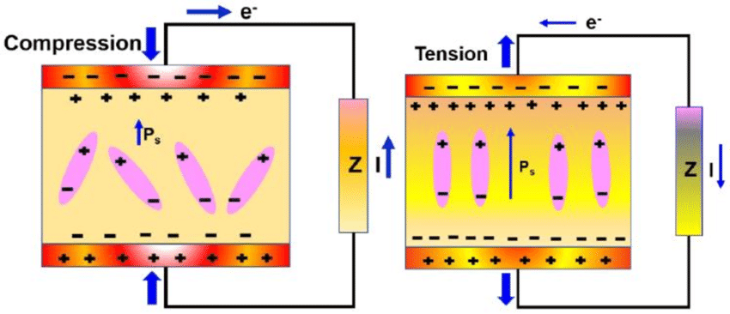
Figure1: Effects of pressure and electric current on a piezoelectric material

The existence of electric dipole moments within solids is directly related to the piezoelectric phenomenon. These dipole moments can either be directly carried by chemical groups, as is the case in compounds like cane sugar, or they can be generated in ions at crystal lattice locations with an asymmetric charge distribution. Summing up the dipole moments per unit volume of the crystallographic unit cell yields the polarisation or dipole density (measured in C•m/m3) for crystals. The polarisation (P) becomes a vector field since each dipole is represented as a vector. Nearby dipoles have a tendency to align, forming regions called Weiss domains. Although these domains usually have random orientations, they can be aligned through a process called poling (distinct from magnetic poling). Poling involves applying a strong electric field across the material, typically at elevated temperatures. It's important to note that not all piezoelectric materials can be successfully poled.
When mechanical stress is applied, the polarisation (P) changes, which has a significant impact on the piezoelectric effect. This alteration may result from a restructuring of the environments that induce dipoles or from a reorientation of molecular dipole moments brought on by the external stress. Because of this, piezoelectricity can show up as a change in the strength and/or direction of polarisation, with it depending on: 1. the orientation of P inside the crystal; 2. the crystal symmetry; and 3. the amount and direction of the applied mechanical stress. The variation in surface charge density on the crystal faces brought on by this change in polarisation alters the electric field extending between these faces due to the variation in dipole density. For instance, a 1 cm3 cube of quartz subjected to a correctly applied force of 2 kN can generate a voltage of 12500 V. Piezoelectric materials also show the opposite effect, called the converse piezoelectric effect, where the application of an electrical field creates mechanical deformation in the crystal.
C. Types of Piezoelectric Materials
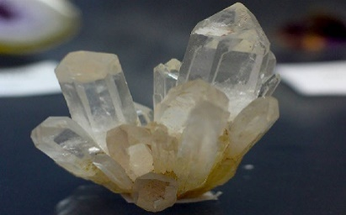
Many different kinds of materials exhibit piezoelectricity. Such as:-
- Crystalline materials
- Quartz
- Rochelle Salt
- Topaz
Figure 2: Quartz Crystal
- Ceramics
- Lead zirconate titanate (Pb[ZrxTi1−x]O3 with 0 ≤ x ≤ 1) commonly called PZT
- Zinc Oxide (ZnO)
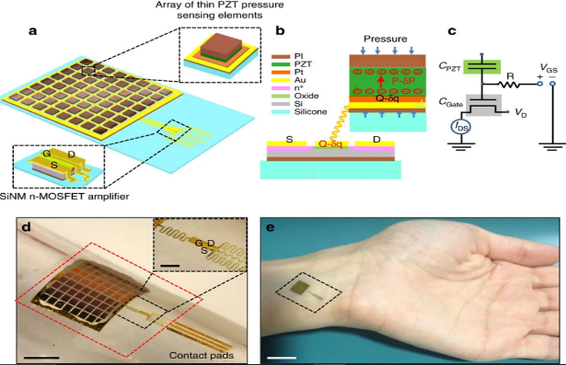
- Potassium niobate (KNbO₃)

- III–V and II–VI semiconductors
- GaN
- InN
- AlN

- Polymers such as PVDF

Figure 3: PZT used in wearable pressure sensor
D. Applications

- Power Source: Researchers in DARPA are working on what they call “Energy harvesting”, where they plan to power devices needed during war with piezoelectric generators equipped in soldier’s boots.

- Frequency Standard: Quartz clocks use a crystal oscillator made of quartz which uses piezoelectricity to create regularly timed electrical pulses.

- Surgery: Piezo-surgery aims at cutting a specific tissue without affecting the surrounding soft tissue. This is done by causing micro-vibrations in the piezoelectric materials.

- Antenna: Cambridge university researchers are working on piezoelectric materials, found that at a specific frequency, these materials act as efficient radiators.

- Other potential applications

- Tyre Company “Goodyear” has been planning on developing a tyre which would generate electricity as the car moves. This would be done by using piezoelectric generators inside the tyres.

- There have been numerous attempts made to generate electricity from the kinetic energy of walking pedestrians. This would require piezoelectric tile placement in footpaths and sidewalks.
- SUPERCAPACITOR

In this age of increasing rate of new technological innovations and higher demand for smaller, more portable and more functionally efficient electronic devices. This in turn puts pressure on power supplies to be more small and light-weight, run for long periods of time (i.e. have lots of energy), and also meet the demands of multiple high current loads (i.e. have a high power capacity). But all these demands cannot be fulfilled by one portable power supply.

For many years, batteries remained the preferred storage device for portable electronic devices, mainly because of their ability to store energy (high energy density). But batteries take a long time to discharge and then recharge, so it limits their ability to deliver power. It is nearly impossible to overcome this power deficiency. Even newer battery technologies such as the lithium ion batteries are still not suitable for high power applications. Over-engineering the batteries are still not the right solution for the increasing the power efficiency, in turn it will typically result in increased size, weight, cost, and can also reduce the energy and life of the battery. This power deficit has increased with the explosion of Internet of Things (IoT). These applications are usually wireless still they need smaller portable devices, with many features and functions. The necessarily small batteries are not efficient for the high demand of power in these IoT devices. So to overcome all this, supercapacitors are believed to be a critically enabling technology for the IoT and other devices which need high energy and power as they provide a unique combination of high energy and high power, in a thin, flat and very small package.

A supercapacitor is an electronic charge storing device developed in the 1970s-1980s, which has the capability to store electrical charge using the method of electrochemical and electrostatic processes. They have the unique capability to hold electrical charges of incredibly large amounts and they have high energy density. They are usually referred to as Electrical Double-Layer Capacitors (EDLC) or ultracapacitors and with time they are becoming quite popular in the field of electric energy storage. They are known for their unique ability to charge and discharge quickly which makes them a feasible alternative to traditional batteries. We know that there are normal capacitors like Ceramic capacitors, Electrolytic capacitors and few more, which can store electric energy very quickly and also, discharge quickly but they are not in the same par as the supercapacitors.

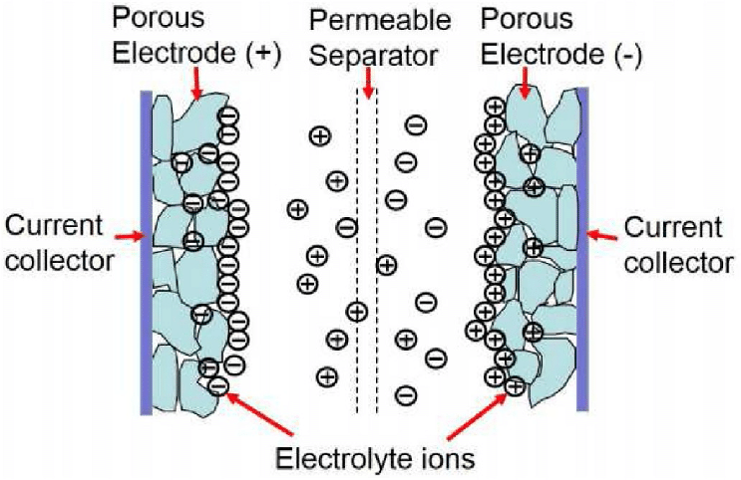
Figure 4: Schematic diagram of Supercapacitor

Based on their principle of storing electrical charge, supercapacitors can be divided into three different types which are different from traditional dielectric, they are as follows:

- Electrostatic double-layer capacitor-These capacitors' building blocks consist of two electrodes, a separator, and an electrolyte. An electrolyte is a solution of positive and negative ions in water. The separator divides the two electrodes into two parts. The carbon electrodes or their derivatives utilized in these capacitors have an electrostatic double-layer capacitance that is noticeably higher. Their charge separation is between 0.3 to 0.8 nm, which is less than that of typical capacitors.

- Pseudo-capacitor- Electrochemical pseudo-capacitors are another name for pseudo-capacitors. These capacitors use conducting polymer electrodes or metal oxide electrodes with substantial metal oxide electrochemical pseudocapacitance. These components store electrical energy by transferring electron charges between an electrode and an electrolyte.

- Hybrid capacitor- The double-layer capacitor and pseudo-capacitor techniques are used to create the hybrid capacitors. Different electrodes with various properties are utilised in these components. Electrodes that are placed side by side demonstrate electrochemical capacitance on one electrode and electrostatic capacitance on the other.
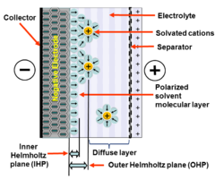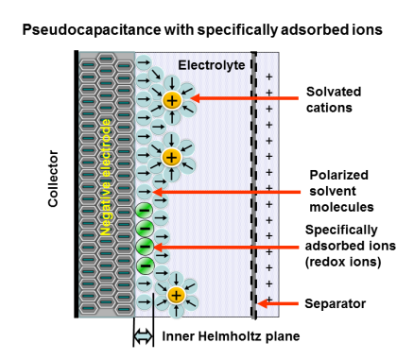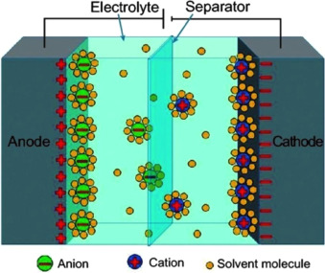
(c)
(b)
(a)

Figure 5: Schematic diagram of (a) Electrostatic double-layer capacitor, (b) Pseudo capacitor, (c) Hybrid capacitor
(a)

Now, the double-layer capacitor is electrostatic in nature and use electrostatic charge storage, whereas the pseudocapacitor is electrochemical in nature and uses electrochemical method, and the hybrid capacitor is a mixture of both of the previous mentioned methods. Hence, the supercapacitors function as the combination of traditional capacitors and batteries. They combine the storage properties of batteries with the power discharge characteristics of capacitors. With the proper utilization of these methods, we can successfully produce capacitors with capacitance as high as 15000 F.

To attain its high degree of energy density, supercapacitors use electrodes made of activated carbon with a very large surface area and a layer of electrolyte that is only a few molecules thick. Supercapacitors have a very high energy density because the amount of energy that can be stored in a capacitor is proportional to the surface area of the electrode and inversely proportional to the gap between the electrode and the electrolyte. They can therefore store very large electrical charges.

Because the energy is kept as a static charge, there is a high power density. A supercapacitor may be charged or drained much more quickly (milliseconds to seconds) than a battery since there is no chemical reaction necessary. Again, unlike a battery, a supercapacitor has a nearly infinite number of charge-discharge cycles since there are no chemical processes taking place.
The self-capacitance of our entire planet earth, which has an approximate value of about 710 F, is considered to be only a small fraction of the capacitance of a supercapacitor, which is 15 million times larger. The maximum charge voltage of a supercapacitor is typically between 2.5 and 2.7 volts, in contrast to the high maximum functioning charge voltage of a regular electrostatic capacitor.

- Characteristics
- Charge/Discharge Time: Milliseconds to seconds.
- Operating Temperature: -40℃ to +85℃
- Operating Voltage: Aqueous electrolytes~1V; Organic electrolytes 2-3V.
- Capacitance: 1mF to >10,000F
- Operating life: 5,000 to 50,000 hours (a function of temperature and voltage).
- Power Density: 0.01 to 10 kW/kg
- Energy Density 0.05 to 10 Wh/kg
- Pulse Load: 0.1 to 100 A
- Pollution Potential: No heavy metals.
- It has extremely low internal resistance and heating levels.
- Convenient detection, with direct readout of remaining charge.
- Simple charging and discharging, no need for rechargeable batteries, high safety factor, long-term use and maintenance free.

B. Working principle
(a)
- The capacitors use electrostatics or static electricity to store energy. Ions that are both positively and negatively charged are present in the electrolytic solution between the two plates of the supercapacitor. When a voltage is placed across the plates, one of the plates develops a positive charge and the other one develops a negative charge.
- As a result, the positively charged plate attracts the positively charged ions in the electrolytic solution, while the negatively charged metal plate attracts the negatively charged ions. A thin coating of ions is formed on the inner surface of both the plates. Hence, an electrostatic double-layer is formed which is like a two capacitors in series.
- Each of the two resulting capacitors has a high capacitance value because the space between their charge layers is relatively small.
- The electrodes cannot attract the ions when a load is connected across the supercapacitor and the ions start distributing through the electrolyte solution and go to the mixed state. This process is the discharging of supercapacitor.

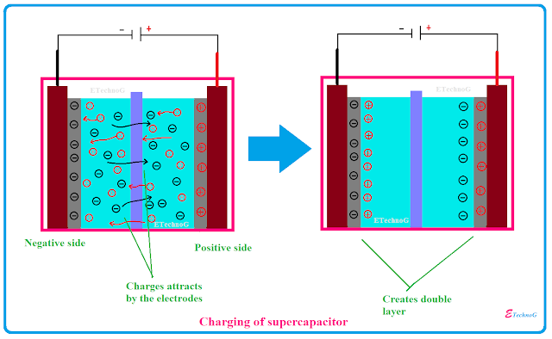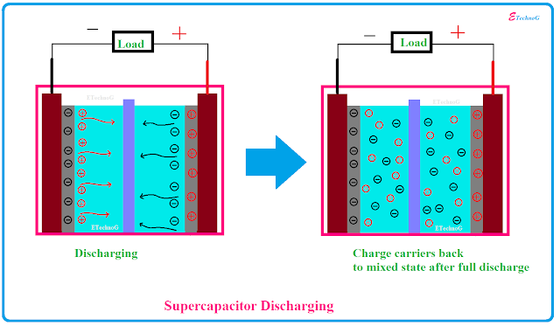
(b)
(a)

Figure 6: (a) Charging of Supercapacitor (b) Discharging of Supercapacitor

C. Advantages
(a)

The supercapacitor has many advantages like-
- It offers higher energy and power density compared to other capacitors.
- It has very high charging and discharging rates.
- It is cost efficient.
- It offers high capacitance.
- It offers fast charging ability.
- It offers higher reliability of performance.
- It improves safety, no corrosive electrolyte and low toxicity of materials.
- It can be installed in a short area as it is very small in size.
- It provides peak power and backup power.
- It improves load balancing when used in parallel with a battery.

D. Disadvantages
(a)

The disadvantages of supercapacitors are-
- They discharge themselves more frequently which is significantly higher than a battery.
- Series connections are necessary to attain greater voltages as low voltages exist within individual cells.
- It cannot be utilized in circuits with AC or higher frequencies.
- They have the highest dielectric absorption among any type of capacitors.
- Very low internal resistance causes extremely rapid discharge when shorted.
- Price of supercapacitors is higher than Li-ion batteries for the same capacity.
- It is very difficult to make very high voltage supercapacitors at the present time.

E. Applications
(a)

Supercapacitors are used in-
- Electric cars
- Wind turbines
- Photographic flash
- Static memories
- Regenerative breaking in the automotive industry
- Flywheel in machines
- MP3 players
- Industrial electric motors
- Tools- Supercapacitor-based cordless electric screwdrivers have a runtime that is half that of models with comparable battery capacity, but they can be fully charged in under 90 seconds.
- Voltage stabilizers- By serving as dampers, supercapacitors can control voltage variations for power lines.
- Power buffer for grid.
- Power buffer for low-power equipment.
- Micro grids
- Energy harvesting- For systems that capture energy, supercapacitors make good temporary energy storage options.
- Incorporation into batters- A combination rechargeable lead-acid battery and supercapacitor make up the UltraBattery.
- Medical field- To shock the heart back into sinus rhythm, defibrillators use supercapacitors, which have a 500 Joule energy output.

- PIEZOELECTRIC-DRIVEN SELF-CHARGING SUPERCAPACITOR

A Self-Charging Piezoelectric Supercapacitor power cell (SCPSC) can be fabricated by using polyvinyl difluoride (PVDF)-ZnO as the piezoelectric material as well as the separator, Polyvinyl Alcohol – Phosphoric Acid (PVA-H₃PO₄) as the electrolyte gel and electrochemically active Manganese Oxide (MnO) as the positive and negative electrodes. Due to the low cost, environmental friendliness and high specific capacitance (∼1400 F.g⁻¹) of MnO, it is chosen as the electrode material.
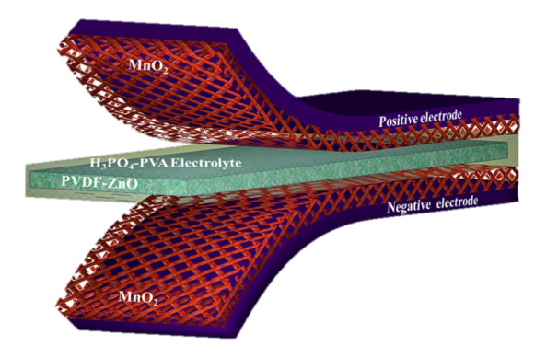
Figure 7: Schematic diagram of the fabricated SCSPC.

The working mechanism of the SCSPC is based on piezoelectric potential-driven electrochemical oxidation and reduction reaction (faradaic reaction). At the beginning, the device is at the discharge state, in which there is no electrochemical reaction due to the electrochemical equilibrium between the electrolyte and electrodes (active material). At this stage, there is no external deformation applied to the device. When a compressive stress is applied on the device, the PVDF layer undergoes polarization due to piezoelectric effect. Due to this polarization of ions, a potential difference is generated across the PVDF-ZnO layer. This potential difference drives the ions in the electrolyte(PVA-H₃PO₄) towards the electrodes which leads to an ionic imbalance at the electrolyte and the positive and negative electrode sides. Hence, to obtain chemical equilibrium, oxidation and reduction reactions occur at the surfaces of the electrodes. The reaction can be expressed as follows-
MnO₂ + H⁺ + e⁻⟺ MnOOH
The liberated electrons are transported to the negative electrode to maintain the charge neutrality as well as the continuity of the charging process. When the mechanical force is applied continually, the charging cycle gets repeated which leads to the conversion of mechanical energy into electrical energy.
With the help of Nernst Equation, we can show explain the relation between electrode potentials and the H⁺ ion concentrations. When external stress is applied, H⁺ ions migrate from the positive to the negative electrode. Consequently, the concentration of H⁺ ions on the oxidative electrode decreases and simultaneouslyincreases on the reductive electrode. The negative electrode is at a higher potential than the positive electrode, and hence the device starts self-charging due to the gradient of H⁺ ions.
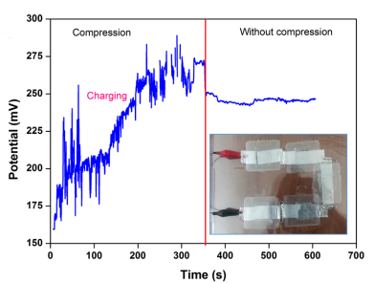
Figure 8: Self-charging performance of serially connected SCSPC
A. Schematic Diagram of the Working Mechanism
(a)
(b)

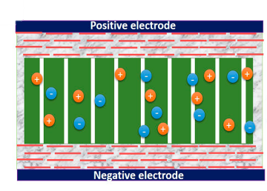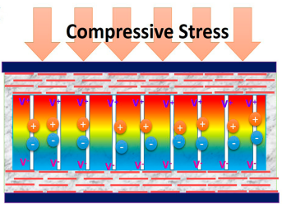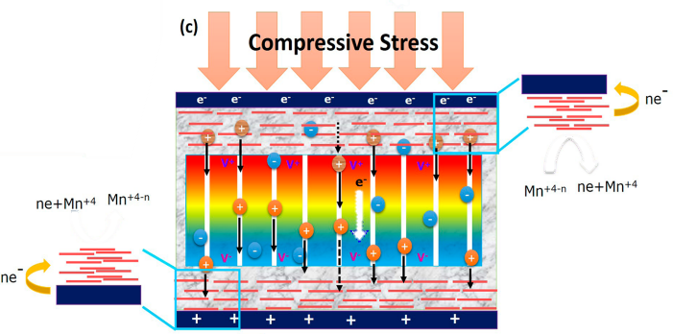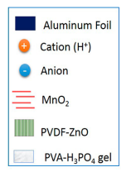B. Results and Conclusion
Figure 9: Working mechanism of the SCSPC driven by mechanical deformation. (a) Fabricated SCSPC at the discharge condition. (b) Mechanical deformation is applied on the top of the device; it creates a piezoelectric field (potential) in the PVDFZnO separator film. (c) Under the piezoelectric field, the H⁺ ions will migrate through the PVDFZnO separator in the electrolyte to the negative electrode, leading to the corresponding charging reactions
A piezoelectric-driven self-charging supercapacitor power cell can be successfully fabricated that consists of a PVDF-ZnO separator (piezoelectric generator) and MnO2 nanowires used as the positive and negative electrodes, which are used to simultaneously harvest and store the energy produced.
The SCSPC based on aluminum foil can generate around 110 mV for 300 seconds while the cloth-based one can generate around 45 mV for 300 seconds on being subjected to external stress.
The creation of next-generation self-powered sustainable power sources for wearable and flexible electronic devices is made possible by the SCSPCs, a new and promising area in supercapacitor research.

- GRAPHENE BASED SUPERCAPACITOR

Graphene is a very thin layer of pure carbon that is linked and packed closely together in a hexagonal honeycomb structure. It possesses a wide range of interesting qualities, like being the thinnest substance ever discovered by humans at just one atom's thickness and being extraordinarily powerful (i.e., nearly 200 times stronger than steel). Additionally, graphene has a remarkable ability to absorb light while also being a great conductor of heat and electricity. Carbon is abundant in nature and is a component of all living things, thus it is even environmentally benign and sustainable. It is a versatile substance that may be combined with other substances, such as metals and gases, to create a variety of materials with superior qualities.

Due to its property of high relative surface area, graphene is frequently recommended as a replacement for the activated carbon found in supercapacitors because it is even more substantial than that of activated carbon. A capacitor's surface area is one of the factors that prevent it from having a high capacitance since a larger surface area allows for better electrostatic charge storage. Additionally, supercapacitors made of graphene will be light-weight in nature and have greater elasticity and mechanical characteristics.

A graphene-based supercapacitor can charge and discharge in seconds and sustain all of this across tens of thousands of charging cycles, allowing it to store almost as much energy as a lithium-ion battery. One approach to accomplishing this is to use a highly porous variety of graphene with a sizable internal surface area, which is created by pressing and drying graphene powder into a coin-shaped cell.The efficiency of supercapacitors is the most important factor to bear in mind. In the past, scientists were able to create supercapacitors that have the capability to store 150 Farads per gram, but many have suggested that the theoretical upper limit for graphene-based supercapacitor is 550 Farad per gram. This is particularly even more impressive when compared against current technology: a commercially available capacitor can store 1 Farad of electrostatic energy at 100 volts and would be about 220 millimeters of height and weigh about 2 kilograms. Though in terms of dimensions relative to energy store values, current supercapacitor technology is same as that of a graphene-based supercapacitor.

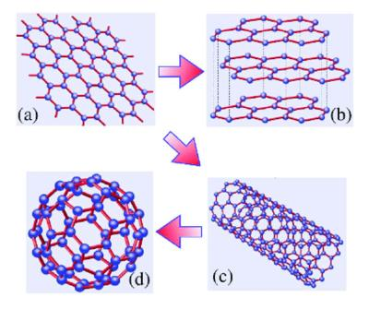
Figure 10: Schematic diagram of graphene

A.Supercapacitor electrode materials based on graphene:
Graphene can be put together to form a variety of structures, including -
- free-standing particles or dots
- one dimensional fibers or yarns
- two-dimensional films
- three-dimensional foams and composites

According to their macro structural complexity, recent investigations have focused on graphene-based electrode materials, i.e.,
- zero-dimensional (0-D) (example- free standing graphene dots and particles),
- one-dimensional (1-D) (example- fibre-type and yarn-type structures),
- two-dimensional (2-D) (example- graphene-based films and graphenes),
- three-dimensional (3-D) (example- graphene composites and graphene foams).

Figure 11: Schematic drawing of a parallel plate graphene supercapacitor formed by two large area graphene electrodes and electrolyte medium in between.

A.1.Graphene dots and particles as Supercapacitor electrodes:

Making graphene dots and particles involves chemically converting graphite into graphene oxide (GO), which is then reduced in a controlled manner using a reduction agent like hydrazine hydrate. The reduced Graphene Oxide (rGO), which is subsequently treated in water or an aqueous environment, becomes hydrophobic by the subsequent reduction and the resulting graphene particles quickly collect. The amphiphilic nature of graphene oxide (GO), in contrast, has hydrophilic edges that are negatively charged and a hydrophobic basal plane.Due to this distinctive quality, graphene oxide (GO) only interacts with specific surfactants, which are able to regulate the amphiphilicity of graphene oxide (GO) and regulate the production of rGO.

Because of their enormous surface area and superior electrical conductivity, graphene powder-based supercapacitor electrodes often exhibit a high power density, but they also transfer charge very quickly. A moderate capacitance value of 200 F/g normally serves as their upper limit. This means that the device's energy density and overall performance are still inadequate. In electrostatic double-layer capacitors (EDLCs), carbon-based materials like graphene serve as the primary electrode materials. Creating hybrid electrodes that include metal oxides, metal hydroxides, or conductive polymers with graphene network is one method for efficiently coordinating the EDLC and pseudocapacitance. In contrast to pseudocapacitance electrodes, which are comprised of metal oxides, hydroxides, or conductive polymers, hybrid electrodes, which are constructed of graphene, will serve as a conductive channel in which charge transfer occurs. As a result, the overall conductivity will improve.

Though the process of chemical reduction for producing graphene is an effective and affordable way to make graphene on an extremely huge scale, the substances that are obtained typically show a moderate conductivity for electricity and usually do not have micro pores, and these are crucial for electrochemical energy storage.

A.2. 1-D Graphene-based Supercapacitor electrodes:

Due to the combined benefits of low volume, excellent flexibility, and weave-ability, graphene-based fibers and yarns have a significant potential for practical use. These fibers and yarns may find use in the forthcoming generations of supercapacitors for wearable, portable, and electrical vehicle applications. There are numerous yarn and fiber shapes that can be created from carbon-based materials such as carbon fibers, CNTs, graphene, and mesoporous carbon. Additionally, they can be mixed with specific electrical active materials such conducting polymers, metal oxides, and hydroxides that exhibit faradaic pseudocapacitance.

A.3. 2-D Graphene film-based Supercapacitor electrodes:

Due to its distinct structural and distinctive features, graphene is regarded as one of the most intriguing materials for the next-generation flexible thin-film supercapacitors-

Having a vast surface area allows the two-dimensional structure to serve as an extended electrolyte transport platform.

Because graphene sheets have high levels of conductivity and a low diffusion resistance, there is a gain in power and energy density.

Graphene sheets can be effectively built into free-standing films that have high mechanical stability thanks to their exceptional mechanical properties.

Due to its advantageous traits, including as light weight, structural flexibility, tuneable thickness, and electrical properties—which are the main requirements for flexible supercapacitors—graphene papers have drawn a lot of attention among the graphene-based 2-D films.

A.4. 3-D Graphene film-based Supercapacitor electrodes:

The diminution of graphene accumulation, which is otherwise constrained by ion access to the overall 2-D structure, can be favored by graphene-based nanocomposite films that include nanoparticles into 2-D graphene sheets. The development of 3D networked graphene-based macrostructures, such as aerogels, graphene foams, and sponges, was undertaken to address these and other significant difficulties. These 3-D-based materials, which have huge surface areas, fast ion or electron transfer channels, and micro, meso, and macro-interconnected pores, are widely desired for boosting power and energy density and enhancing the overall performance of supercapacitance.

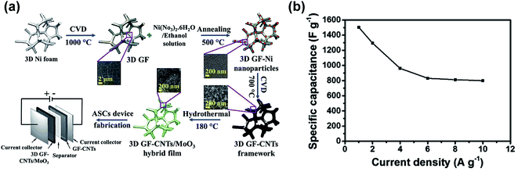
Figure 12: (a) schematic diagram illustrating all steps involved in the synthesis of 3D GF/CNTs/MoO3 hybrid film-based electrode and the asymmetric supercapacitor device and (b) specific capacitance vs. current density obtained with this supercapacitor.

In electrochemical energy storage devices like supercapacitors, graphene-based materials in diverse forms of 0-D, 1-D, 2-D, and 3-D have shown to be ideal choices for electrode materials. Significant progress has been made in the previous few years in the areas of structural design, material production, evaluation of performance, and electrochemical process comprehension. The quality and production volume of the electrode materials must be raised for wide-scale practical application. The chemical disintegration of graphite into graphene oxide (GO) and subsequent reduction of GO to rGO are the most efficient and affordable methods for creating graphene-based products.
The slurry casting approach, in which the efficient material powders were mixed with polymer binder and conductive additives to connect electrode material with current collectors, was typically utilized to construct supercapacitors with free-standing graphene particles. However, the volumetric and gravimetric capacitance of electrodes are both decreased by these polymers and the conductive additions, which normally contribute little to the overall capacitance.

B. Fabrication of graphene based piezo-electrolyte, electrodes and supercapacitor

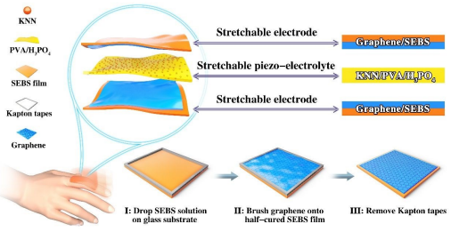
Figure 3: Schematic illustration of the as-fabricated stretchable Self-charging SC consisting of stretchable graphene/SEBS electrodes and stretchable KNN/PVA/H3PO4 piezo-electrolyte, and the fabrication process of the stretchable graphene/SEBS electrodes

The elastic SEBS substrates (approximately 500 m) were coated with graphene powders to create stretchable graphene electrodes. First, 200 mg-ml-1 of commercial SEBS particles were dissolved in toluene with constant stirring at 90 °C. (Nanotechnology Co., Ltd.) were then brushed onto the SEBS surface directly with a gentle press before the SEBS film was fully cured, resulting in a half-insertion of graphene sheets into the SEBS film. The resulting SEBS solution was then dropped onto a cleaned glass substrate that was pre-patterned with tapes for producing stretchable films. Stretchable graphene/SEBS film was produced when the SEBS film had finally been cured.

The stretchy KNN/PVA/H3PO4, piezo-electrolyte film was made by first dissolving 10 g of PVA (M= 89,000-98,000, 99+% hydrolyzed, Sigma-Aldrich) in 100 mL of deionized water for 3 hours at 95 °C. Then, 5 g of self-made KNN piezoelectric particles and 10 g of concentrated HPO4 (99+% crystallised, Aladdin) were added. To create a uniform grey solution, the mixture was agitated for an additional two hours in the same environment. The solution was cast onto the patterned glass substrate once it had cooled. The resulting film was separated from the glass substrate and a stretchy KNN/PVA/H3PO4 after drying for at least 24 hours. Film made of piezoelectrolytes was made. Before the electrochemical tests, the stretchable KNN/PVA/H PO, piezo-electrolyte film was poled under a DC field of 10 kV mm in air atmosphere at ambient temperature for 24 h.

Two strectable graphene/SEBS films were used to provide the working electrodes for the stretchable SCSC devices, and a stretchable KNN/PVA/H3PO4 piezo-electrolyte film served as both the piezoelectric separator and the electrolyte. The stretchy graphene/SEBS electrodes and the KNN/PVA/H3PO4 piezo-electrolyte were initially cut to the same size of around 20 mm 30 mm before being assembled into the stretchable SCSC. After that, the two graphene/SEBS electrodes were sandwiched with the KNN/PVA/H3PO4 piezo-electrolyte. Transparent adhesive tapes were utilised to seal the elastic SCSC device used for palm patting, while elastomeric SEBS film was employed to seal the device used for repetitive stretching.
C. Conclusion

To summarize everything, we successfully fabricated a stretchable and self-chargeable supercapacitor driven by piezoelectricity by simply using a stretchable piezo-electric film between two stretchable electrodes. The stretchy supercapacitor shows great efficiency of energy collection, conversion, and self-charging under continuous palm pressure and repetitive stretching due to the high elastoplasticity and piezoelectricity of graphene.The system also has the ability to power LED lights and electronic calculators continuously, highlighting the intriguing uses for integrating and powering stretchy electronics. Additionally, it paves the door for the creation of extremely flexible and self-charging energy devices employing comparable electrodes and piezo-film on a global scale

REFERENCES
- Tressler, J.F., Alkoy, S. & Newnham, R.E. Piezoelectric Sensors and Sensor Materials. Journal of Electroceramics 2, 257–272 (1998). https://doi.org/10.1023/A:1009926623551
- G. M. Sessler; Piezoelectricity in polyvinylidenefluoride. J Acoust Soc Am 1 December 1981; 70 (6): 1596–1608. https://doi.org/10.1121/1.387225
- Aabid, A.; Raheman, M.A.; Ibrahim, Y.E.; Anjum, A.; Hrairi, M.; Parveez, B.; Parveen, N.; Mohammed Zayan, J. A Systematic Review of Piezoelectric Materials and Energy Harvesters for Industrial Applications. Sensors 2021, 21, 4145. https://doi.org/10.3390/s21124145
- Kumar, N.; Kim, S.-B.; Lee, S.-Y.; Park, S.-J. Recent Advanced Supercapacitor: A Review of Storage Mechanisms, Electrode Materials, Modification, and Perspectives. Nanomaterials 2022, 12, 3708. https://doi.org/10.3390/nano12203708
- Halper M.; Ellenbogen J.; Supercapacitors-A Brief Overview, MITRE Nanosystems group 2006
- Sun, J., Luo, B. and Li, H. (2022), A Review on the Conventional Capacitors, Supercapacitors, and Emerging Hybrid Ion Capacitors: Past, Present, and Future. Adv. Energy Sustainability Res., 3: 2100191. https://doi.org/10.1002/aesr.202100191
- Ananthakumar Ramadoss, Balasubramaniam Saravanakumar, Seung Woo Lee, Young-Soo Kim, Sang Jae Kim, and Zhong Lin Wang, Piezoelectric-Driven Self-Charging Supercapacitor Power Cell, ACS Nano 2015 9 (4), 4337-4345
- Xiong C, Wang T, Zhao Z, Ni Y. Recent progress in the development of smart supercapacitors. SmartMat. 2023;4:e1158.doi:10.1002/smm2.1158
- Yao Lu, et al., Progress in Natural Science: Materials International, https://doi.org/10.1016/j.pnsc.2020.01.0
- Krishnamoorthy K, Pazhamalai P, Manoharan S, Liyakath Ali NUH, Kim S‐J. Recent trends, challenges, and perspectives in piezoelectric‐driven self‐chargeable electrochemical supercapacitors. Carbon Energy. 2022;4:833‐855. doi:10.1002/cey2.202
- Zhou, D., Wang, N., Yang, T., Wang, L., Cao, X., & Wang, Z. (2020). Piezoelectric Nanogenerator Promotes Highly Stretchable and Self-chargeable Supercapacitors. Materials Horizons. doi:10.1039/d0mh00610f
- Rajan Lakra, Rahul Kumar, Parasanta Kumar Sahoo, Dhirendranath Thatoi, Ankur Soam, A mini-review: Graphene based composites for supercapacitor application,Inorganic Chemistry Communications, Volume 133,2021, 108929, ISSN 1387-7003, https://doi.org/10.1016/j.inoche.2021.108929.

