Nanotechnology in Food Science
Author Name: Dr. Sheetal Sonawdekar, Jidnesh Amar Bhandari*.
Affiliation Name: D Y Patil University School of Biotechnology and Bioinformatics-Navi Mumbai, India
Email: jid.bha.bt21@dypatil.edu
ABSTRACT
Recent progress in the field of nanotechnology has had a significant influence on various scientific and industrial fields, encompassing the realm of nutrition. This section offers an overview of the potential applications of nanoscale materials within the food industry, with the objective of delivering to consumers a nourishment that is devoid of impurities and secure, while simultaneously enhancing the nutritional properties of the food to meet consumer preferences. Various categories of packaging, including upgraded, dynamic, intelligent, and biodegradable options, are examined. Furthermore, issues pertaining to safety and challenges are duly considered.
Keywords: Nanotechnology, improved packaging, active packaging, smart packaging, bio-based packaging.

- INTRODUCTION

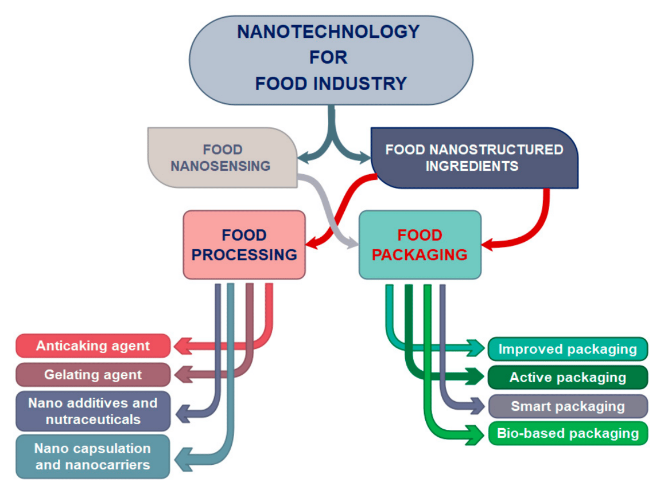
Over the past few decades, nanotechnology has emerged as a highly sought-after tool in the food industry. Nanotechnology has sparked a new industrial revolution, enabling the creation and widespread adoption of structures, substances, and systems with innovative or enhanced properties across a wide array of sectors, including agriculture, nutrition, and healthcare. Advances in nanotechnology have led to substantial reductions in food packaging losses. This technology operates at the nanoscale, dealing with particles and macromolecules ranging from 1 to 100 nanometers in size (Kuswandi, 2016). Nanotechnology holds the promise of ushering in numerous captivating changes that can enhance well-being, prosperity, and overall quality of life, while also mitigating the environmental impact. Compared to conventional packaging materials, nanomaterials and edible coatings enriched with nanoparticles offer superior preservation and maintenance of food product quality. Nano-packaging can be engineered to release antimicrobials, antioxidants, enzymes, flavors, and nutraceuticals to extend shelf life. Notably, nanomaterials substantially elevate food quality and safety, as well as the health benefits derived from food consumption. By incorporating nanoparticles into films, nanofilms can be produced to enhance the permeability of specific gases, with the aim of reducing the levels of detrimental gases such as carbon dioxide (CO2) or oxygen (O2), which can negatively impact food shelf life. These materials can also function as barriers to prevent microbial spoilage. The adoption of biomaterials in packaging can lead to a reduced usage of packaging materials and address the issue of excessive waste. Additionally, these materials have been found to remain stable under high temperatures and pressures. Nanotechnology plays a pivotal role in the food industry through food nano sensing and the integration of nanostructured components. In the realm of food nano sensing, advancements enhance food quality and safety, while nanostructured food components find a multitude of applications, encompassing food processing and packaging. Within the food processing industry, nanostructures and nanostructured materials serve various purposes, including acting as food additives and carriers for intelligent nutrient delivery, thereby enhancing the nutritional value of food. They also function as anti-caking agents to improve food consistency and prevent clumping, gelating agents to enhance food texture, and nanocapsules and nanocarriers to safeguard the aroma, flavor, and other components in food (Primozic et al., 2021). In the sphere of food nano-packaging, a range of categories are considered, including
Fig. 1. Application of nanotechnology in different fields of food industry [Primozic et al.,2021].
enhanced packaging, active packaging, smart packaging, and bio-based packaging. This paper provides an overview of the role of (bio)nanotechnology in the field of food science, with a particular focus on the application of (bio)nanomaterials in packaging. It also delves into potential adverse consequences associated with the utilization of nanotechnology in the food industry.

- Nanotechnology in Food Processing

The incorporation of nanostructures into food ingredients holds the promise of delivering improved uniformity, flavor, and consistency. Nanotechnology prolongs the shelf life of numerous food items and reduces food wastage caused by microbial contamination. Nanosensors can be employed to detect the presence of contaminants, mycotoxins, and microorganisms in food. Various delivery systems, comprising synthetic and naturally derived polymer-based encapsulation, have been devised to enhance the bioavailability and preservation of active food constituents. Furthermore, the influence of nanotechnology on the augmentation of food products concerning (i) food texture, (ii) food aesthetics, (iii) food taste, (iv) food nutritional content, and (v) food longevity can be employed to gauge the significance of nanotechnology in food processing. Remarkably, nanotechnology not only impacts the aforementioned aspects but also profoundly transforms food products, bestowing upon them entirely novel attributes.

- Texture, Taste, and Appearance of food: Nanotechnology provides a multitude of solutions for enhancing food quality and taste. Nanoencapsulation methods, which involve enclosing bioactive compounds within a matrix to preserve their properties, are frequently employed to enhance taste release and retention and achieve culinary balance. Nanoemulsions are commonly utilized for delivering lipid-soluble bioactive substances and can be engineered to improve water dispersibility and bioavailability. Nanoparticles, owing to their subcellular dimensions, offer a viable means of enhancing the bioavailability of nutraceutical components compared to larger particles, as they often exhibit prolonged release of encapsulated substances. Several metallic oxides, including silicon dioxide (SiO2) and titanium dioxide (TiO2), have traditionally served as colorants or flow agents in culinary products. Silicon dioxide (SiO2) is among the most widely used nanomaterials in food for conveying flavors or aromas in food items. For instance, TiO2 is employed as a coloring agent in the powdered sugar coating on doughnuts.

- Nutritional Value: The majority of bioactive compounds, encompassing lipids, proteins, carbohydrates, and vitamins, are susceptible to the highly acidic environment and enzymatic activity within the stomach. Their low water solubility poses challenges for absorption in their natural, non-encapsulated state. However, encapsulation not only shields these bioactive substances from such harsh conditions but also facilitates their incorporation into food products. Researchers are currently developing small, ingestible capsules crafted from nanoparticles with the aim of enhancing the dispersion of medications, vitamins, and delicate micronutrients within daily diets. Such edible capsules fall within the category of nutraceutical foods, which can offer benefits to the general populace. Numerous techniques, including nanocomposite formation, nanoemulsification, and nanostructuring, have been employed to more effectively disperse nutrients such as proteins and antioxidants, providing targeted nutritional and health advantages. Lipid-based nanoencapsulation methods enhance the solubility and bioavailability of antioxidants, as well as their stability in both in vitro and in vivo contexts. Furthermore, these methods bolster the ability of antioxidants to avoid unfavorable interactions with other dietary components, thereby augmenting their overall effectiveness.
- Preservation or shelf life: Nanoencapsulation of bioactive ingredients in functional foods serves to prolong their shelf life. This process effectively hinders or retards the degradation of these bioactive components, thereby preventing their eventual inactivation. This preservation continues until the product reaches its intended destination. Moreover, edible nano-coatings applied to various food elements can serve as barriers against moisture and gas exchange, providing flavors, colors, antioxidants, enzymes, and anti-browning agents. These coatings also contribute to the extension of the shelf life of prepared meals, even after the packaging has been opened (Maddela et al., 2023). It is often possible to decelerate chemical degradation processes by altering the properties of the interfacial layer surrounding the functional elements. For instance, when curcumin, which is the most potent yet least stable bioactive constituent of turmeric (Curcuma longa), underwent encapsulation, it exhibited stability even under pasteurization conditions and varying ionic strengths, all while retaining its antioxidant activity (A N A Sari et al., 2020).

- Nanotechnology in Food Packaging

Ensuring the safety of food involves a crucial aspect known as food packaging, which encompasses the act of enclosing edibles to safeguard them against interference or contamination stemming from physical, chemical, and biological factors. The primary objectives of food packaging are preventing contamination and spoilage, optimizing reactivity by promoting enzyme functionality, and reducing the loss of weight. To fabricate superior food packaging, functional nanomaterials equipped with enhancements in their physico-chemical attributes, including improved mechanical strength, resilience, flexibility, as well as moisture and temperature resistance, can be harnessed. This kind of packaging, possessing these special attributes, is referred to as "Enhanced Packaging." Nanomaterials endowed with active characteristics, such as those boasting antimicrobial, antioxidant, and UV shielding properties, are termed "Active Packaging." Moreover, nanosensors, equipped with intelligent capabilities for the detection of gases, small organic molecules, active states, and product identification, fall under the category of "Smart Packaging." To enhance the eco-friendly aspects of packaging materials by incorporating bio-based properties like biodegradability, biocompatibility, waste reduction, and environmental friendliness, Bionanomaterials can be employed. This environmentally-conscious packaging is known as "Bio-based Packaging."

- Improved Food Packaging: The primary goal of advanced food packaging is to enhance the mechanical and physical attributes of the packaging, including its ability to block gases, withstand varying temperatures and humidity levels, boost its mechanical strength, and improve flexibility. This is achieved by introducing functional nanoparticles into polymer materials. These nanoparticles elevate the packaging's barrier properties, resulting in a reduction in the permeability of oxygen and carbon dioxide by as much as 80-90%. When compared to materials lacking the inclusion of montmorillonite clay nanoparticles, the oxygen-blocking capabilities of the nanocomposite films saw a significant increase, with improvements of 59% and 90% when just 3% (w/w) of clay was added. The benefits of employing nanomaterials for food packaging as opposed to traditional packaging materials are manifold. The most commonly utilized nanotechnology method for enhancing food packaging properties is nano-coating, which can also be derived from edible materials.

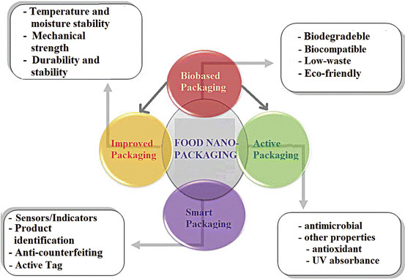
Fig. 2 Food nano packaging, classification, functions, and features [Kuswandi,2016].

Edible materials can also serve as the source for these coatings. The application of edible nano-coatings is uncomplicated and can be achieved through rubbing, spraying, or immersion methods. These coatings typically incorporate environmentally friendly elements and don't require removal from the food before consumption. Presently, these nano-coating films provide nanostructures that allow for the inclusion of organic compounds with antibacterial and antioxidant properties, enhancing the beneficial impact on the freshness of perishable goods. Food packaging materials based on clay nanocomposites are durable, lightweight, heat-tolerant, and contribute to an extended shelf life.

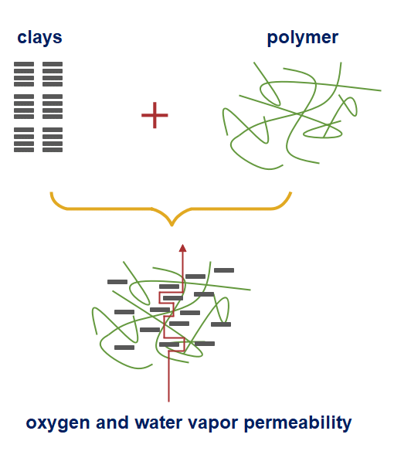
Fig. 3 Diagrammatic representation of nonlinear and prolonged pathway of oxygen, and water vapor permeability formed due to incorporation of clay into a polymer matrix film [Primozic et al.,2021].

- Active Packaging: To combat food wastage and elevate food safety, there is a need to innovate and develop fresh materials and technologies. Crafting active materials for active packaging, with the aim of extending product shelf life, stands out as a promising avenue for curbing food spoilage and the associated reduction in food waste. Conventional materials used in food packaging comprise non-biodegradable substances like polyethylene (PE), polypropylene (PP), and polyethylene terephthalate (PET), which effectively block the penetration of O2 and H2O molecules. In the realm of new active food packaging, a diverse array of scavengers, absorbers, emitters, and coatings are incorporated. While these agents can be employed in standard non-biodegradable packaging, there is a growing trend to amalgamate them with biodegradable components.

- Antimicrobial Active Packaging: The utilization of antimicrobial active packaging is instrumental in preserving food and extending its shelf life by inhibiting the proliferation of microorganisms. This can be achieved by incorporating an active substance into the packaging material or applying a coating. The effectiveness of antimicrobial agents varies depending on the specific pathogenic bacteria, owing to their distinct physiological characteristics. Key criteria for selecting the appropriate antimicrobial agent encompass microbial attributes such as cell wall composition (Gram negative or Gram positive), oxygen requirements (aerobic or anaerobic), growth stage (spores and/or vegetative cells), resistance to acidity or osmosis, and optimal growth temperatures (mesophilic, thermophilic, etc.). Antimicrobial nanomaterials, including silver (Ag), titanium dioxide (TiO2), zinc oxide (ZnO), magnesium oxide (MgO), and others, exhibit remarkable antibacterial activity, rendering them highly suitable for antimicrobial active packaging systems. In the realm of food packaging, titanium dioxide (TiO2) nanoparticles are frequently employed due to their non-toxic nature for humans and their authorization as food additives and materials safe for food contact.

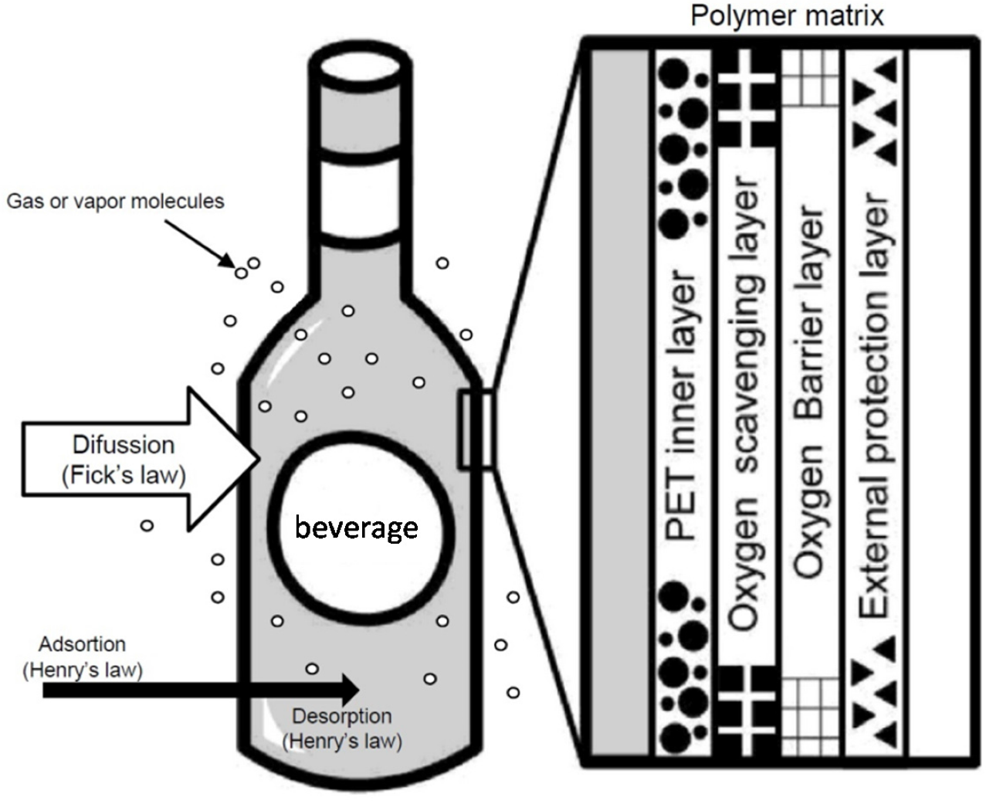
- Oxygen Scavenging Films: Numerous food items experience degradation, either through direct or indirect means, due to the presence of oxygen (O2) (Kuswandi, 2016). To illustrate, direct oxidation processes are responsible for the spoilage of vegetable oils, causing them to become rancid, and for fruits to undergo browning (Kuswandi, 2016). Therefore, the inclusion of oxygen scavengers within food packaging serves to maintain exceedingly low oxygen levels, conferring several benefits in various contexts, as it can effectively extend the shelf life of the food products.

Fig. 4 Illustration of oxygen scavenging films [Ramos et al.,2015].

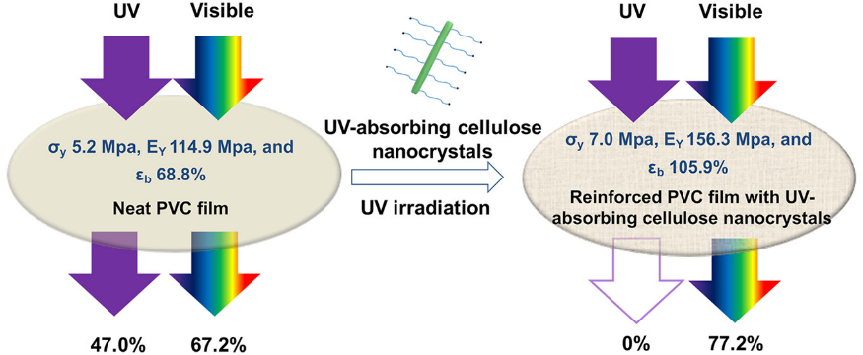
- UV Absorbing Films: In the contemporary world, UV-absorbing films hold significant potential for application within the beverage industry, facilitating the preservation of the product's intended quality. Currently, experiments are underway within PET bottles, subjecting them to UV radiation to assess potential product quality degradation in the absence of these films. Should the plastic exhibit accelerated degradation, the incorporation of UV-absorbing films proves advantageous. Additionally, these films can augment the transparency of food and beverage packaging, thereby introducing UV films as a solution to counteract degradation while simultaneously improving the visibility of the food product.

Fig. 5 Illustration of UV absorbing films [Zhang et al.,2018].
- Smart Packaging: Nanoparticles offer the potential to enhance food packaging with intelligent capabilities, allowing for the monitoring of chemical, biochemical, or even microbiological changes occurring within the food product and its immediate environment. This aids in the development of smart packaging solutions. Nano sensors play a crucial role in identifying food spoilage, as they can detect specific bacteria and particular gases. These nano sensors are designed to respond to alterations in both internal and external parameters within the food product and its surrounding environment. In the context of smart packaging, nanosensors find applications in various aspects of food analysis, including the detection of toxins, chemicals, and foodborne pathogens, as well as the identification of flavor and color changes. For instance, in the event of gas production due to food spoilage, the packaging undergoes a color change, serving as an indicator that alerts consumers to the unsuitability of the product. Recent advancements in polymer nanoparticles for intelligent food packaging encompass traceability, oxygen indicators, indicators of spoilage, and product identification.
Top of Form

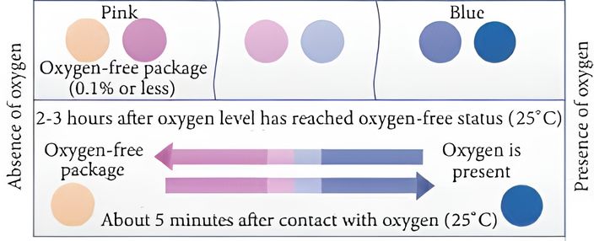
- Oxygen indicators: In the process of food preservation, oxygen serves as a catalyst for the proliferation of aerobic microorganisms. To prevent the ingress of oxygen into the space above the food, different packaging methods like nitrogen or vacuum packaging are employed. An oxygen leakage indicator is depicted in the diagram below. The oxygen indicator shown distinctly communicates that the presence of oxygen in the upper part of the packaging material will cause a color shift to blue. Titanium dioxide nanoparticles find application in these oxygen indicators.
Fig. 6 Illustration of color changing ability of oxygen indicators [A N A Sari et al.,2021].

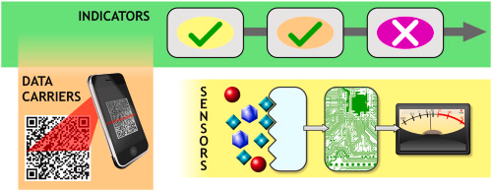
- Traceability or Active Tags: Packaging incorporates active radiofrequency identification (RFID) tags to ensure the traceability of the required food product. These tags are electronic data-driven devices that autonomously track and recognize items by transmitting information from a tag attached to the object through radio frequency (Kuswandi, 2016). Furthermore, sensor-enabled packaging now has the capability to integrate cost-effective radiofrequency identification tags, thanks to advancements in nanotechnology. The RFID tags endowed with nanotechnology functionalities are considerably more compact, pliable, and can be printed on thin labels. This renders the tags more adaptable and substantially reduces production costs. They possess greater capacity, faster data transmission rates, support multiple information exchanges, and allow for the simultaneous reading of multiple tags.
Fig. 7 Illustration of active tags [Azeredo et al.,2021].

- Bio Based Packaging: Biobased packaging pertains to the use of eco-friendly packaging materials aimed at restricting the movement of moisture and/or the interchange of gases within food products. This serves the dual purpose of bolstering safety and preserving the nutritional and sensory attributes of the contents. These packaging materials are widely regarded as more eco-conscious when compared to conventional packaging films. Bio-derived packaging harnesses sustainable resources in lieu of fossil fuels for crafting the materials, and the subsequent disposal process can recuperate energy through incineration. Starch-based, chitosan-based, and cellulose-based nanomaterials stand as some of the microscopic materials employed in the realm of biobased packaging. These inclusions invariably yield positive repercussions for human well-being, the environment, and society as a whole. These benefits could be further fortified by implementing ingenious functions through dependable technology and enduring natural resources.

- Strach based nanoparticles: An assortment of eco-friendly substances can be created as initial materials utilizing starch. Seeds, as well as the underground storage organs like tubers and roots of vegetation, hold starch within. The predominant global source of starch production is derived from corn. Nanoparticles founded on starch can be employed alongside biodegradable plastics like PHA, PLA, PBS, and so on. The incorporation of starch into plastics amplifies their mechanical strength, improves their processing characteristics, bolsters their resistance to moisture, and acts as a barrier against the interchange of gases between the food and its surrounding environment.

- SAFETY ISSUES

Beyond the numerous advantages that nanotechnology offers to the food industry, there exist safety concerns regarding nanomaterials that necessitate careful consideration. The apprehension revolves around the potential for nanoparticles stemming from packaging materials to infiltrate food items and impact consumer well-being. This stems from safety issues tied to nanomaterials. Even when a substance is categorized as GRAS (generally recognized as safe), additional research is imperative to gauge the potential risks presented by their nano counterparts due to the stark disparity in physicochemical properties between the nanoscale and macro scale (Singh et al,2017). To ensure the quality of products, comply with health and safety standards, and adhere to environmental regulations, regulatory agencies must establish specific criteria for commercial products. Furthermore, these standards are essential to ensure the secure implementation of nano-packaging, with a concentrated effort on enhancing our understanding of their potential toxicological impacts, migration tendencies, and exposure levels for both workers and consumers. A special emphasis should be placed on comprehending how the chosen nanomaterials may affect human health following prolonged exposure. Adhering to all the requisite regulations, the successful integration of nanomaterials into food packaging holds the potential to significantly enhance the global food supply concerning health, safety, flavor, nutrition, and ecological sustainability.
- CHALLENGES

Before harnessing nanotechnology to innovate novel food products and processes, a series of hurdles must be confronted in the food industry. The primary obstacle lies in the development of efficient and safe food distribution systems. A critical concern centers on the movement of nanoparticles from packaging materials into food items, as well as their seepage into edibles, a matter of paramount importance for meal safety. It is imperative to remain cognizant of the potential hazards, toxicological complications, and environmental considerations entwined with nanoparticles. It is common knowledge that nanoparticles have the capability to infiltrate diverse tissues and organs by surmounting the biological barrier. Prior to manufacturing, packaging, and consuming food products infused with nanotechnology, it is essential to undertake a comprehensive risk assessment program, establish regulatory frameworks, address biosecurity concerns, and heed public apprehensions.
- FUTURE SCOPE

Thanks to the utilization of nanotechnology, remarkable progress has been achieved in the realms of food science, technology, and research. Employing nanotechnology for the identification of contaminants, illnesses, and pesticides presents an avenue for upholding food quality via the means of monitoring, tracking, and tracing. The utilization of nanosensors renders it straightforward and expeditious to detect foodborne pathogens, including viruses, bacteria, and mycotoxins, offering a swift, resource-efficient, and precise method. The potential ascendency of nanotechnology in the entire arena of food production appears promising, provided that specific legislations and regulations addressing the multifarious safety concerns linked to this technology are formulated. In the forthcoming decade, it is foreseen that the food packaging sector will take the lead in ushering in emerging trends in nanotechnology, with blockchain technology anticipated to assume a predominant role.

CONCLUSION

Undoubtedly, nanotechnology offers a vast expanse of opportunity for inventive progress in the realm of food processing and packaging, a prospect poised to benefit both consumers and the industry. Through the integration of nanoparticles into food or packaging components, the application of nanotechnology within the food sector is geared towards augmenting food quality and safety. Smart packaging, equipped with nanosensors, has the potential to inform consumers about the state of the enclosed food. Embedded within food packaging, these nanosensors can forewarn consumers when a product is no longer suitable for consumption, averting spoilage or delivering precise nutritional data. The packaging materials of the future will be adept at fulfilling the demands of preserving perishable foods. Nano-structured materials stand as a barrier against the intrusion of bacteria and other microorganisms, mitigating threats to food safety. In the event of food degradation, rendering it unfit for consumption, the nanosensors embedded in the packaging can promptly alert the consumer. Furthermore, the utilization of nanomaterials in food preservation has yielded positive outcomes, offering protection against moisture, lipids, gases, undesirable flavors, and aromas. Prioritizing the transparent assessment of safety concerns and environmental impacts becomes imperative when addressing the integration of nanotechnology in food systems. Consequently, mandatory assessments of nanofoods are indispensable before they are introduced to the market.

REFERENCES
[1] Rajesh Singh, Shradha Dutt, Priyanka Sharma, Ashok K. Sundramoorthy, Aman Dubey, Anoop Singh, Sandeep Arya, “Future of Nanotechnology in Food Industry Challenges in Processing, Packaging, and Food Safety”.
[2] Bhupinder S Sekhon, “Food nanotechnology- an overview”.
[3] A. Wallace Hayes, Saura C. Sahu, “Nanotechnology in the Food Industry: A Short Review”.
[4] Mateja Primozic, Zeljko Knez, Maja Leitgeb. “(Bio) Nanotechnology in Food Science - Food Packaging”.
[5] Trepti Singh, Shruti Shukla, Pradeep Kumar, Verinder Wahla, Vivek K. Bajpai, Irfan A. Rather, “Application of Nanotechnology in Food Science: Perception and Overview”.
[6] Bambang Kuswandi, “Nanotechnology in Food Packaging”.
[7] Zahra H. Mohammad, Faizan Ahmad, Salam A. Ibrahim, Sadaf Zaidi, “Application of nanotechnology in different aspects of the food industry”.
[8] Alweera Ashfaq, Nazia Khursheed, Samra Fatima, Zayeema Anjum, Kaiser Younis, “Application of nanotechnology in Food packaging: Pros and Cons”.
[9] A N A Sari et al., “Innovation of oxygen indicators for packaging leak detector: A review”.
[10] Ravindra V. Gadhave, Abhijit Das, Prakash A. Mahanwar, Pradeep T. Gadekar, “Starch Based Bio Plastics: The Future of Sustainable Packaging”.
[11] Naga Raju Maddela, Lizziane Kreti Winkelstroter, “Microbiology for Cleaner Production and Environmental Sustainability”.
[12] Marina Ramos, Arantzazu Valdes, Ana Cristina Mellinas, Maria Carmen Garrigos, “ New Trends in Beverage Packaging Systems: A Review”.
[13] Zhen Zhang, Gilles Sebe, Xiaosong Wang, Kam C. Tam, “ UV Absorbing Cellulose Nanocrystals as Functional Reinforcing Fillers in Poly (vinyl chloride) Films”.
[14] A N A Sari, E Warsiki, I A Kartika, “ Innovation of oxygen indicator for packaging leak indicator : A review”.
[15] Henriette M. C. Azeredo, Daniel Souza Correa, “Smart choices: Mechanisms of intelligent food packaging”.

