EMERGING ERA OF MICRONEEDLE TECHNOLOGY FOR TRANSDERMAL DRUG DELIVERY SYSTEM
Akshay R Supe¹*, Abhishek Nemmaniwar², Gargi Dhaneshwar³, Riya Singh⁴, Neetu A. Khatri⁵
M. Pharm Student^{1,2,3,4}, Assistant Professor⁵
Dr. D.Y. Patil College of Pharmacy, Akurdi, Pune-411044

INTRODUCTION:
The skin is an important organ that protects the body from harmful effects including massive water damage and synthetic chemical attacks. The primary skin barrier, the stratum corneum, which is a component of the epidermis, is made up of 15-20 corneocyte layers.3-5 Transdermal medication delivery offers an important alternative to oral and hypodermic injections.
There are three layers to human skin: the hypodermis, dermis, and epidermis. It might solve the problem of drug degradation and liver or gastrointestinal absorption. It is non-invasive, painless, and self-administered.
Microarray patch technology was developed to deliver high molecular-weight drugs without the use of injections. In order to increase patient compliance, it can give delayed drug release. The surface structure of microneedles (MNs) allowed for the delivery of the medicine in the form of a bandage. MNs are composed of numerous unique micro projections that vary in size, shape, and support from a base. Their heights range from 25 to 2,000 mm. As per a 1976 patent, ALZA was the first business to create MNs. As seen in Figure 1, MNs allow for non-invasive access to the patient's dermis and allow for the direct absorption of medications into the systemic circulation. This study will concentrate on MN technologies that have lately made considerable strides towards breaking through the subcutaneous barrier and enabling enhanced transdermal medication delivery. We'll focus on the latest recent developments in MN design.
It will highlight When MN inventions go from academic research to commercial applications, challenges to effective MN encroachment and some crucial safety considerations will be taken into account. The industry has begun to see the entry of some commercial MN products that aid in the transdermal delivery of medications and vaccines. The novel coronavirus disease COVID-19 (Coronavirus disease 2019) illness has been classified as a global pandemic by the World Health Organisation (WHO). For the treatment of this condition, researchers recently produced the recombinant coronavirus vaccine (PittCoVacc).
Researchers have looked at microneedles (MNs) for transdermal medication administration and for overcoming the drawbacks of the existing methods. A micron-sized needle is used in a microneedle device. The problems with transdermal patches and hypodermic needles prompted the creation of the microneedle drug delivery system, which is seen as a hybrid of the two.
The fundamental problem with transdermal technology is that many drugs cannot exert their therapeutic effects because they cannot penetrate the skin quickly enough. The stratum corneum can be penetrated by hydrophilic, high-molecular-weight compounds thanks to the advanced method known as microneedles. More drug molecules can permeate the skin when drugs are administered using a microneedle device because the drug molecules can pass through the stratum corneum layer.
The distinguishing features of this approach include its speedier onset of action, improved patient compliance, self-administration, enhanced permeability, and efficacy. additionally, to If microneedle tips are left inside the skin, problems may arise since they are much smaller and thinner than the thickness of human hair and can shatter. These limitations are rather infrequent and can be overcome by carefully choosing the microneedle material. The main objective of this technology is to disrupt the stratum corneum by generating larger transport pathways of micron size, which are larger than molecular dimensions and smaller than holes made by hypodermic needles, allowing large molecules to pass through and increasing permeability. Traditional methods include chemical and lipid procedures, as well as electric ones like iontophoresis and electroporation.
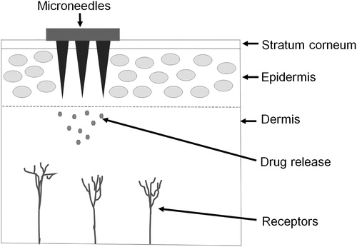
Figure 1: Microneedle
Table-I: Comparison between topical cream, transdermal patch, hypodermic needle, and microneedle drug delivery systems
 | Topical cream | Transdermal patch | Hypodermic needle | Microneedle
Description | Emulsion/ emulgel/ cream/ ointments | Adhesive patch to be placed on the skin | Fine, hollow tube having a sharp tip with small opening at the end | Micron size needles are aligned on the surface of a small patch
Onset of action | Slow | Slow | Faster | Faster
Pain | Painless | Painless | Painful | Painless
Bioavailability | Poor | Insufficient | Sufficient | Sufficient
Patient compliance | Less | Better | Less | Better
Self-administration | Possible | Possible | Not possible | Possible
Mechanism of drug delivery | Permeation through skin pores. | Drug has to cross stratum corneum barrier, thus poor diffusion of large molecules | Drug placed directly in the dermis | Bypass stratum corneum and drug placed directly into epidermis or dermis hence enhanced permeability
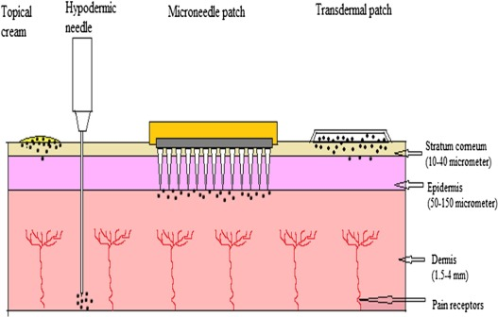
Figure 2: Comparison of topical cream, hypodermic needle, microneedle patch and transdermal patch

MECHANISM OF DELIVERY
The diffusion mechanism is used to administer the medicine via the topical route. The skin is momentarily damaged during the medication delivery process using microneedles. In order to administer enough medicine to produce the necessary therapeutic response, a microneedle device is created by arranging hundreds of microneedles in arrays on a tiny patch (similar to that of a typical transdermal patch available on the market). By cutting through the stratum corneum, it avoids the barrier layer. The medicine is immediately injected into the epidermis or upper dermis layer, where it enters the systemic circulation and, upon reaching the site of action, produces a therapeutic reaction. In Fig. No. 02 ^{[2]}, the mechanism of drug administration using microneedles is shown.

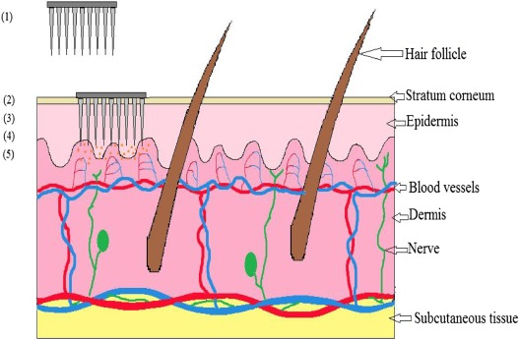
Figure 3: Mechanism of drug delivery by microneedle device: (1) Microneedle device with drug solution; (2) Device inserted into the skin; (3) Temporary mechanical
disruption of the skin; (4) Releasing the drug in the epidermis; (5) Transport of drug to the site of action
METHODOLOGY FOR TRANSDERMAL DRUG DELIVERY:
A variety of methods employed for transdermal drug delivery through hollow or solid MNs are poke and patch system in
Poke and Patch
When a patch is applied on the top of these MNs, needles form micropores into the skin upon removal of it.
Coat and Poke
The MNs perforate the skin, and afterward, the drug containing coating is released through hydration.
Dip and Scrape
The MNs or microblade are first dipped in a drug solution and then scraped over the skin leaving behind the drug within the microprojections generated by the MNs.
Poke and Flow
This approach is used for hollow MNs. The MNs are made up of polymers in which the drug is encapsulated. The incorporated drug is released for a more extended period^{[1]}
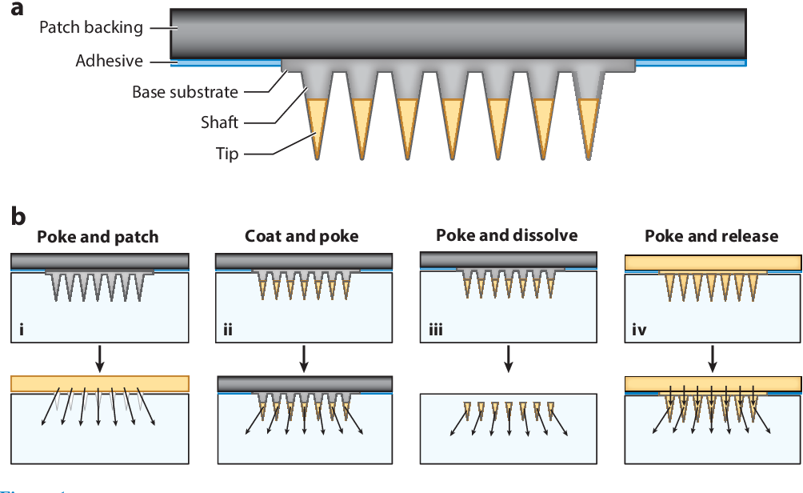
Figure 4: Microneedle patch (MNP) designs and operations. (a) Microneedles comprise a shaft and tip that often encapsulates or is coated with drug. The microneedle array is mounted on a base substrate that is attached to a patch backing to facilitate handling and skin adhesion. (b) Drug delivery approaches for MNP use. MNPs can (i) be used as a pretreatment, after which a drug formulation is placed on the skin surface for slow drug release through residual pores in the skin (poke and patch); (ii) be coated with drug in a water-soluble matrix that is released in the skin (coat and poke); (iii) encapsulate drug in water-soluble microneedles that dissolve in the skin (poke and dissolve); or (iv) encapsulate drug in the patch backing and, in some cases, the microneedles that slowly release drug through the non-water-soluble microneedle matrix (poke and release).
Types of microneedles:
Most patches share a few similar characteristics, even though the microneedle design varies depending on the distribution mechanism, kind of microneedle, and action of the medications to be delivered. A typical microneedle has a tapered sharp tip and measures 150–1500 mm in length, 50–250 mm in breadth, and 1–25 mm in tip thickness. Standard materials for microneedles include metal, silicon, polymer, glass, and ceramic. The medication is often injected into or applied to the microneedle tip, which is attached to the substrate base below to create an array. For convenience, the patch backing—which includes a skin adhesive to enhance contact with the skin—is bonded to the microneedle array. There are normally four varieties of microneedles. Metal and silicon, which offer powerful mechanical qualities and don't contain any pharmaceuticals, are the main materials used to make solid microneedles. Thus, it is vital to continue applying the medication to the area after putting the microneedles. In contrast, the medicine is administered concurrently with the application when coated microneedles are used on the skin's surface. The medicine may be included into the biodegradable matrix when dissolving microneedles, in which case there will not be any sharp debris left over following microneedle application. Because the medication is contained in all locations, including the microneedle's tip and the backing of the patch, hydrogel microneedles provide gradual drug delivery. Since the properties of microneedles vary depending on the kind, a design that is appropriate for the microneedles should be chosen based on the medication dose, time until the drug starts to take effect, length of time it takes to deliver, efficiency of distribution, packing, and sharp waste.
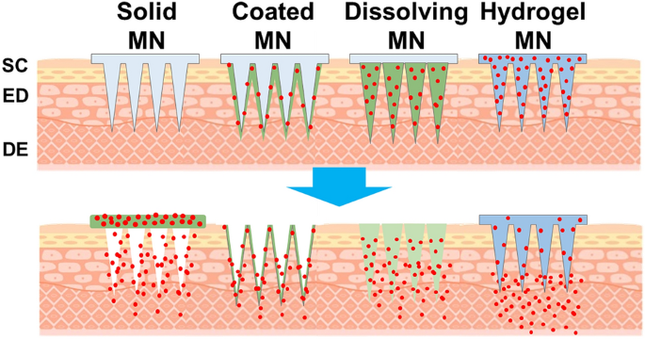

Figure 5: Schematic illustration of the types of microneedles and their drug delivery methods.
SOLID MICRONEEDLE
Hydrogel microneedles administer drugs gradually because the drug is present everywhere, including the tip of the microneedle and the backing of the patch. A design that is suitable for the microneedles should be chosen based on the medication dose, time until the drug begins to take effect, length of time it takes to deliver, efficiency of distribution, packing, and sharp waste since the qualities of microneedles vary depending on the type. Drugs can be delivered over and extended time by including reagents that keep the pores open for a longer duration.^{[4]}
COATED MICRONEEDLES
When a solid microneedle is coated with a water-soluble matrix, the medication is delivered to the skin more quickly following microneedle insertion (Fig. 4b). In order for the coating to remain adherent throughout storage and skin insertion, it must develop a film on the microneedle's surface. To achieve this, the coating recipe must have sufficient viscosity. Where the coating composition to be applied must be considered. In most cases, it is more economical to just inject the drugs at the microneedle's tip, where the skin is actually pierced. In the case of dip coating, the drug-coated region can be controlled by varying the depth at which the microneedle is dipped into the coating formulation. The surface tension of the coating formulation can be altered to control how far the microneedle spreads and, thus, the amount of medication that is coated. Rapid onset of the medication's pharmacological activity is brought on by the medication's quick skin disintegration in coated microneedles. A thicker coating is produced by repeating the formulation coating procedure, but due to dose limitations, this approach is not suitable for drug administration.
DISSOLVING MIRCONEEDLES
The actual microneedles themselves can be created from substances that are biodegradable or water-soluble, contain the medications, and have the required mechanical strength to pierce . Because it dissolves or disintegrates right away as it comes into contact with skin fluid, a dissolving microneedle can be put into the skin without creating sharps waste. Solvent casting with a water-soluble biodegradable polymer is the primary technique for creating dissolving microneedles. Methyl cellulose and carboxymethyl cellulose (CMC) are two popular cellulose-based biodegradable polymers.Additionally, the microneedles include saccharides that aid in the formulation's ability to dissolve and stabilise biomolecules, such as trehalose and sucrose. The formulation of the drug-containing tip must be appropriate for the medication, possess mechanical strength, and have a viscosity that is sufficiently low to completely and bubble-free fill the microscale mould space. The non-drug base substrate may be more viscous than the drug-containing tip, have worse mechanical qualities, or be constructed of non-water soluble materials. Recent studies have looked at techniques to quickly remove the tips from the base substrate without requiring the tips to entirely dissolve in the skin, hence reducing the amount of time that microneedle patches need to be worn. Li et al. described a microneedle patch that can swiftly disengage from the skin after implantation by using shearing force. The mechanical strength of the gadget can be changed by catching a droplet on the microneedle. Additionally, the base substrate, which was constructed of a material that could froth, was taken off the microneedle tip in less than two minutes.produced insertion-responsive microneedles that instantly separate from one another after being applied to the skin. The tip and base of the microneedle could be mechanically separated quickly thanks to the construction of a tiny single wall on the side of the device. Because this method is not optimal for providing large doses, like dissolving and coated microneedles, research is being done to enhance the amount of medication that can be included in these microneedles.
HYDROGEL MICRONEEDLES
While the patch is worn against the skin, the medication is released gradually and is contained in all regions of the hydrogel microneedle tip, base substrate, and patch backing (Fig. 4d). The hydrogel that makes up the majority of the microneedle patches prevents them from dissolving when they come into touch with skin fluids. Diffusion enables a sizeable portion of the hydrogel's medicine to penetrate the skin. Since the drug can be applied throughout the entire microneedle patch, this method can give large quantities of medication; nevertheless, the patch-wearing period is prolonged due to the sluggish drug delivery rate. ^{[4]}
MICRONEEDLE FABRICATION MATERIAL AND ITS PROPERTIES
Silicon
The first microneedle was produced in the 1990s using silicon. Silicon is an anisotropic material with a crystalline structure. The crystal lattice, which displays a range of elastic moduli (50 to 180 GPa), determines its properties. Because of its versatility, needles can be made in a wide range of sizes and shapes. It has appealing physical qualities that make it a versatile material. Silicon substrates may be manufactured accurately and in batches. Because of its high cost and labor-intensive, complicated manufacture process, silicon cannot be used in microneedles. In addition, because silicon is fragile, some pieces may break and remain in the skin, leading to some biocompatibility problems.
Metal
The two main metals used are titanium and stainless steel. Palladium, nickel, and palladium-cobalt alloys are also used. They have strong mechanical properties and are biocompatible. Because they are strong enough to prevent fracturing, metals are a better material than silicon for creating microneedles. The first metal used in the production of microneedles was stainless steel. Titanium is a fantastic alternative to stainless steel.
Ceramic
Chemical resistance is the primary reason that alumina (Al2O3) is employed. The highly energising ionic and covalent interactions between Al and O atoms lead it to form a stable oxide. Calcium sulphate dihydrate [Gypsum (CaSO4 0.2H2O)] and calcium phosphate dihydrate [Brushite (CaHPO4.2H2O)] are two more forms of ceramics that are employed. Ormocer®, a biologically altered ceramic, has been utilised recently. It is a cross-linked copolymer in three dimensions. Different organic units can be used during polymerization to create a polymer with various characteristics. They are mostly made with a micro-molding process. A micro-mold is used to cast ceramic slurry into. Processes utilising micro-molding are less expensive and may be scaled up.
Silica glass
Glass can be used to make a variety of forms on a very small scale. Despite being biologically inert, silica glass is naturally fragile. Glass made of silica and boron trioxide is called borosilicate, and it is more elastic. Because they are often created manually, they are less time-efficient. Glass MNs are currently only used for research purposes; they have no practical use in industry.
Carbohydrate
Maltose is one of the most often utilised sugars. In addition to other sugars, you can also use polysaccharides such galactose, mannitol, trehalose, sucrose, and xylitol. Carbohydrate slurries are moulded using silicon or metal moulds. The drug-loaded carbohydrate mixture is cast into the moulds to produce the microneedles. The time-dependent breakdown of carbohydrates regulates the medication release into the skin. Carbohydrates are cheap and healthy for human health, but they are difficult to produce since they break down at high temperatures.
Polymer
A widespread variation of polymers comprising poly (methyl methacrylate) (PMMA), polylactic acid (PLA), poly (lactic-co-glycolic acid) (PLGA) , polyglycolic acid (PGA), poly (carbonate), cyclic-olefin copolymer, poly (vinylpyrrolidone) (PVP), poly (vinyl alcohol) (PVA), polystyrene (PS), poly (methyl vinyl ether-co-maleic anhydride), SU-8 photoresist are reported for microneedles preparation. Typically, these polymers are employed to make microneedle arrays, which dissolve or deteriorate and produce hydrogels. These polymers can be used to make microneedles that are less strong than other materials but stronger than glass and ceramics.
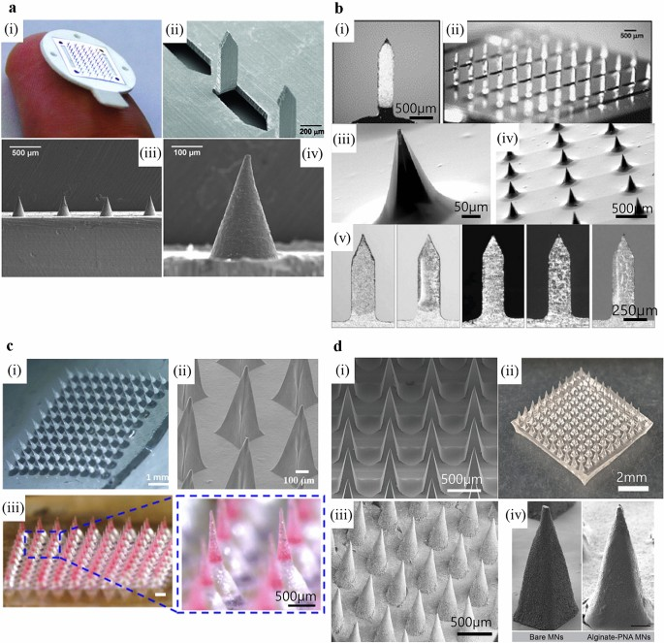
Figure 6: a. Solid microneedles composed of stainless steel (i and ii) and titanium (iii and iv). b. Coated microneedles composed of stainless steel (i and ii) , silicon (iii and iv), and titanium (v). c Dissolving microneedles composed of CMC (i), HPMC (ii), and PLGA (iii) .d Hydrogel microneedles composed of HA (i and ii) , PVA (iii) , and alginate (iv).
Fabrication Methods:
Different materials are used to produce MNs. The method of the fabrication depends upon the types of material used.
Etching
It is one of the techniques used to create MNs. The reaction between the substrate and the etchant is involved. Depending on the etchant employed, this technique can be classified as either dry etching or wet etching. In wet etching, the substrate is etched using a liquid etchant to create the desired shape. Despite its low selectivity and the abundant availability of materials, wet etching is nevertheless often used in fabrication. On the other hand, dry etching uses gas as an etchant. Dry etching is expensive and labor-intensive, but it generates images with excellent resolution and a deeper etching depth. The MNs primarily employed in this method were silicon and metal. 28,73 Silicon hollow MNs for transdermal hemodynamic dysfunction therapy were produced using the reactive ion etching method.
Laser cutting
It is an effective method for producing consistent MNs. Cutting tools are used to form MNs. This process is only successful on materials that are a specific degree of toughness or hardness due to the poor accuracy of the cutting machine. The majority of metal and silicon MNs employ this method. The polydimethylsiloxane (PDMS) MNs were created with the aid of moulds and laser cutters.
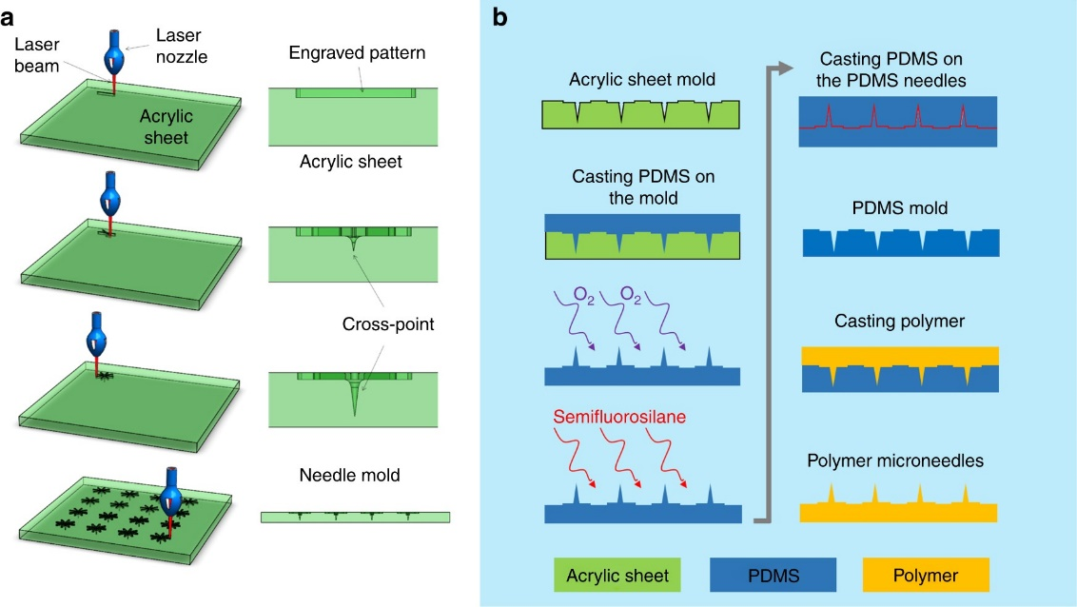
Fabrication of microneedle mold. (a) CO2 laser cutter was used to fabricate microneedle acrylic mold using the proposed cross-over lines (COL) technique, (b) the acrylic mold was used to fabricate polydimethylsiloxane (PDMS) microneedles mold, which can be used to fabricate a variability of polymer-based microneedles.
Photolithography
Using radiation from X-rays or visible ultraviolet (UV) lamps, a design pattern is transferred from a photomask to a substrate covered in photosensitive material. As a result, the substrate develops a 3D structure. The 3D structure is made using many techniques, including altering the UV intensity and using a free or switchable laser source. This technique is useful for producing polymeric hollow MNs utilising photolithography methods. Micromolding. MNs are produced utilising micro- or nanoscale moulds in this method. The shapes are cast from liquid or molten materials. After solidification, the MNs are removed from the shells. It is a simple, time-saving technology for mass production that is more cost-effective than alternative technologies. This strategy makes more sense when dealing with sugar and polymeric MNs. The researchers created the polymeric MN array by micromolding it. outlines the common materials and fabrication techniques.
Table 2: Materials and methods used for Microneedle fabrication
Material | Technique
Silicon | Wet etching, dry etching, 3D Laser Cutting
Metal | Laser Cutting, Laser ablation, micromolding, metal electropolating
Ceramic | Ceramic micromolding and sintering lithography
Carbohydrates | Micromolding
Polymers | Micromolding, Drawing Lithography, Photolithography

EVALUATION OF MNS:
Techniques of Visual Characterization the geometry of the MNs may have an impact on their insertion or penetration behaviour. Geometry and measurements of tip radius, height, and length were evaluated using optical or electrical microscopy as well as eye inspection. The creation of 3D images using confocal laser microscopy and scanning electron microscopy (SEM) aids in quality control. SEM provides data on surface composition and topography. Visual examination, fluorescence microscopy, and confocal laser scanning microscopy were used to identify and view 78 chemicals included in the MNs with the help of fluorescently-labeled molecules.
Mechanical Properties
MNs must have enough mechanical strength, toughness, and hardness to pierce skin without breaking it. Insertion forces are measured via electrical measurements, force/displacement tests, dye markings, and other mechanical testing. To determine insertion depth, many techniques including histological staining, cryosectioning, optical microscopy, and confocal microscopy are used. 80 In vitro permeation research to gauge how quickly medications penetrate the skin, utilise the Franz diffusion cell instrument. Pig ear skin mounted between the donor and receptor compartments is typically used in the test.
In Vivo Studies
On the basis of hairless rat animal models, numerous rebuilt skin models are employed for in vivo experiments. One of the characteristics monitored by the Delfin VapoMeter is trans epidermal water loss.
In Vitro/In Vivo Correlation Studies
A Franz diffusion cell was mounted with hairless pig skin for the in vitro in vivo correlation study. In the in vitro experiment, the drug penetration profile was examined, and the pH and temperature of the dissolving media were maintained at a level that reproduced in vivo circumstances. All study variables and conditions conducted in vitro were consequently linked to those conducted in vivo.
Skin Irritation Studies
Transdermal administration might result in mild to severe erythema at the application site. The Draize method was used to determine how irritably sensitive the skin was. The dermatological changes were seen both before and after the patch was administered at the site of action.
RECENT ADVANCEMENTS OF MN-BASED TECHNIQUES FOR DRUG AND VACCINE DELIVERY
The applications of MNs, in conjunction with physical methods, were studied to improve drug distribution and better regulate drug delivery through the skin.
Sonophoresis in Combination with MNs -

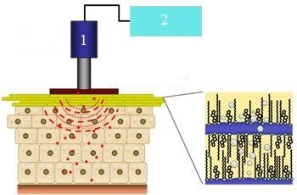
- Ultrasonic Transducer
- Power Supply

Figure 7: Sonophoresis
The process of employing ultrasound to transfer medicinal substances via the skin is known as sonophoresis. This method uses ultrasound (3 W/cm2; 20 kHz to 10 MHz; 20 kHz to 10 MHz) to improve medicine permeability (formation and oscillation of gas bubbles) by altering the lipid content of the top layer of skin and causing cavitation. The ultrasonic frequency can be changed to influence how deeply medications penetrate the skin. This physical enhancer is used in transcutaneous immunisation and gene delivery. 85 MNs and ultrasound are both used to deliver the high-molecular-weight protein known as bovine serum albumin.
The permeability was increased to 1 mm/s by combining a 1.5 mm MN patch with a 15 W ultrasonic frequency. This is more than 10 times the permeability predicted by passive diffusion.
Iontophoresis in Combination with MNs -
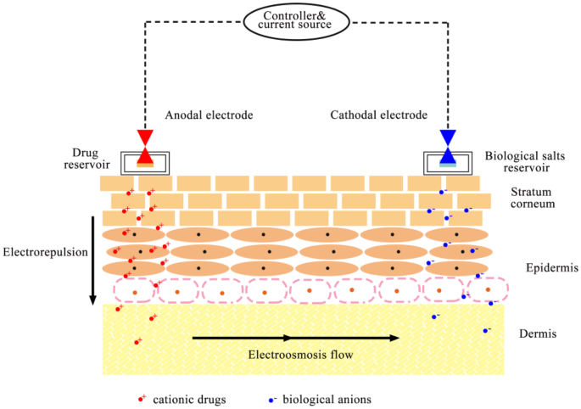
Figure 8: Iontophoresis
By facilitating the passage of ions through a membrane when an externally provided minor electrical potential difference is supplied (0.5 mA/cm2 or less), it is possible to improve skin penetration and rate of release of various drugs with low absorption capacity. Iontophoresis and MN work well together because they control drug distribution by controlling current. By allowing users to change their dose as needed, electronic approaches can help patients comply with treatment regimens more frequently. In a study, MN and iontophoresis were used to deliver the high molecular weight substances D2O and fluorescein isothiocyanate (FITC)-dextrans. The results showed that this increased the skin permeability of the molecules.
Electroporation in Combination with MNs -

Figure 9: Electroporation
Electroporation induces localised disruption by forming microscopic water pores in the lipid bilayer of the skin for a limited period of time. Using this technique, the molecular permeability of drugs with a variety of lipophilicity and molecular weights, including those with a molecular weight larger than 7 kDa, can be accelerated. The electroporation method can be utilised to treat malignancies more successfully when combined with chemotherapy. FITC/dextran, a macromolecular drug, was administered via an MN electrode array. The dispersion of macromolecular drugs was found to be enhanced by electroporation and MNs.
Micropumps in Combination with MNs-

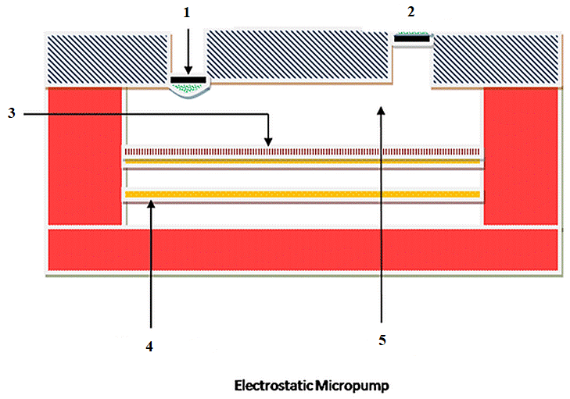
- Inlet Liquid
- Outlet Liquid
- SeparatingMembrane
- Working Electrode
- Pumping Compartment
Figure10: Micropumps
Medication delivery is effective when micropumps are used in conjunction with MNs. Pumps monitor the concentration of the drug solution flow rate in compliance with delivery requirements. Based on the quantity of metabolites, these pumps can control fluid evacuation. Researchers showed MN integration with an on-chip microelectromechanical system displacement micropump for continuous fluid distribution. Continuous pumping for a longer time has been accomplished.
Pocketed and Grooved MNs-

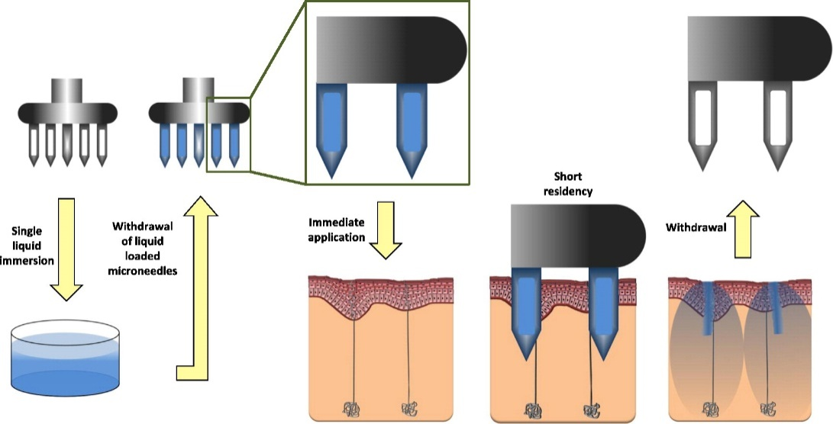

Figure11: Graphical Abstract of Pocketed and Grooved Microneedles
MNs can sink to a certain depth and accumulate higher drug loads while switching surfaces. To test their drug-carrying capacity, we construct polymeric MNs with a wide base, pointed tips, and embedded shafts with grooves. Greater antigen-loading capacity in MNs was associated with a considerably larger antibody response as compared to smooth MNs. 91 The researcher developed a modified groove-embedded MN array to deliver ovalbumin through skin. MNs with more and deeper grooves elicited a higher antibody response as a result of the loading of more antigens in the grooves.Therefore, MNs with grooves provide a better tool for intradermal immunisation.
MNs Combination of Vibratory Actuation
For MNs to enter the skin, the injection force must be carefully managed and kept below the fracture force. Vibration reduces the insertion force by injuring tissue through fluid cavitation and thermal damage brought on by frictional interaction. This relationship supports the use of metals or polymers to fabricate MNs with low Young's moduli. According to a study, the mosquito's probing behaviour can be explained by the vibration frequency and the applied force. The added stresses improved stability and made it possible for greater compressive strengths. The result showed reliable MN delivery with vibration assistance.
Applications of microneedle drug delivery:
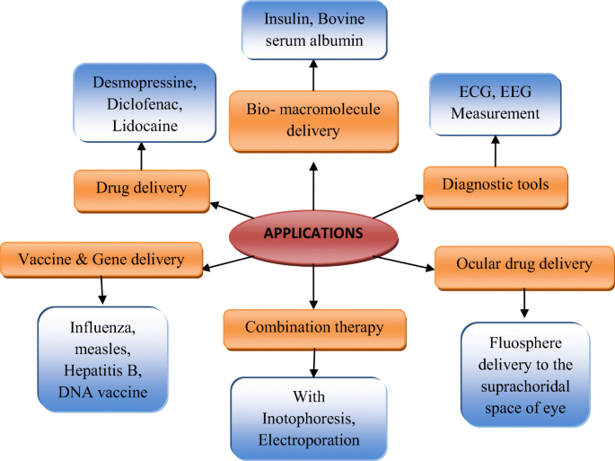
Figure12: Microneedle Applications
- 1. The effectiveness of a transdermal application is determined by a molecule's ability to penetrate the skin. Many substances, especially peptides and vaccines, have had issues during manufacture and use as a result of their high molecular weight.
- 2. MNs have successfully administered such drugs intradermally, and in some cases, it has been discovered that they are more effective at delivering smaller dosages for the same therapeutic benefit than the currently used conventional delivery systems. As an illustration, when MN was used instead of a typical intramuscular injection, a similar change in hemagglutinin inhibitory antibody titer was seen with less than half the medication dosage.
3. The acceptance of the seasonal influenza vaccination administered by Minnesota by numerous regulatory bodies is proof of the effectiveness of the MN systems. MN have been investigated for the treatment of a number of skin disorders, including psoriasis, dermatitis, and viral warts.
4. MN has also demonstrated its effectiveness in the treatment of skin cancer.
5. MN have been investigated for use in ocular medication delivery in addition to intradermal delivery.
6. MN has demonstrated the ability to successfully cure eye conditions such glaucoma, macular degeneration, uveitis, and retinal vascular occlusion. The majority of microneedles on the market today are intended primarily for cosmetic use. Skin health is improved by dermarolling, and acne is treated with dissolving microneedles.
Merits and Demerits of MNs
Merits :
- The administration of large molecules is possible.
- Non-invasive and painless application.
- Avoid the first-pass metabolism.
- Enhanced drug efficacy results in dose reduction.
- Ease of administration.
- Controlled drug delivery.
- Faster healing at the injection site achieved.
- Good tolerability without irritation.
- The cost of production and distribution reduced.
- Targeted drug delivery achieved at a specific area of skin.
Demerits:
- Dosage accuracy may be less.
- Administration of only a small dose of a drug ispossible.
- Possibility of skin irritation.
- Upon removal of the patch, the needle may break and
- remain intact in the skin.
- External environment may affect delivery, for example,
- hydration of the skin.
- Compressed dermal tissues can block hollow MNs
REFERENCE:
- Gupta, Jitendra, Reena Gupta, and Vanshita. "Microneedle technology: an insight into recent advancements and future trends in drug and vaccine delivery." Assay and drug development technologies 19, no. 2 (2021): 97-114.
- Waghule, Tejashree, Gautam Singhvi, Sunil Kumar Dubey, Murali Monohar Pandey, Gaurav Gupta, Mahaveer Singh, and Kamal Dua. "Microneedles: A smart approach and increasing potential for transdermal drug delivery system." Biomedicine & pharmacotherapy 109 (2019): 1249-1258.
- Nagarkar, Rigved, Mahima Singh, Hiep X. Nguyen, and SriramakamalJonnalagadda. "A review of recent advances in microneedle technology for transdermal drug delivery." Journal of Drug Delivery Science and Technology 59 (2020): 101923.

Jung, Jae Hwan, and Sung GiuJin. "Microneedle for transdermal drug delivery: current trends and fabrication." Journal of pharmaceutical investigation (2021): 1-15.
- Chen, Bo Zhi, Ze Qiang Zhao, Mohammad-Ali Shahbazi, and Xin Dong Guo. "Microneedle-based technology for cell therapy: current status and future directions." Nanoscale Horizons 7, no. 7 (2022): 715-728.
- Prausnitz MR. Engineering Microneedle Patches for Vaccination and Drug Delivery to Skin. Annu Rev Chem Biomol Eng. 2017 Jun 7;8: 177-200.
- Nejad, H., Sadeqi, A., Kiaee, G. et al. Low-cost and cleanroom-free fabrication of microneedles. Microsyst Nanoeng 4, 17073 (2018)
- Ji Y.J., Kim K.S., Kim K.H., Byun J.Y., Yeom G.Y. A Brief Review of Plasma Enhanced Atomic Layer Deposition of Si3N4. Appl. Sci. Converg. Technol. 2019;28:142–147. doi: 10.5757/ASCT.2019.28.5.142
- Madou M.J. Fundamentals of Microfabrication: The Science of Miniaturization. 2nd ed. CRC Press; Boca Raton, FL, USA: 2017
- Virji M., Stefaniak A. Comprehensive Materials Processing. Volume 8. Elsevier; Amsterdam, The Netherlands: 2014. A Review of Engineered Nanomaterial Manufacturing Processes and Associated Exposure; pp. 103–125.
- Kim J.H., Chang W.S., Kim D., Yang J.R., Han J.T., Lee G.W., Kim J.T., Seol S.K. 3D Printing of Reduced Graphene Oxide Nanowires. Adv. Mater. 2015;27:157–161. doi: 10.1002/adma.201404380.
- Falo L.D., Jr., Erdos G., Ozdoganlar O.B. Microneedle Arrays for Cancer Therapy Applications. 14/934,927. Patent. 2016 May 19.
- Pal P., Swarnalatha V., Rao A.V.N., Pandey A.K., Tanaka H., Sato K. High Speed Silicon Wet Anisotropic Etching for Applications in Bulk Micromachining: A Review. Micro Nano Syst. Lett. 2021;9:4.
- Prausnitz MR. Microneedles for transdermal drug delivery. Adv Drug Del Rev. 2004; 56:581–587.
- Sivamani RK, Liepmann D, Malbach HI. Microneedles and transdermal applications. Expert Opin Drug Deliv. 2007;4:19–25.
- Vandervoort J, Ludwig A. Microneedles for transdermal drug delivery: a minireview. Front Biosci. 2008;13:1711–1715.
- Chen YT, Hsu CC, Tsai CH, Kang SW. Fabrication of microneedles. J Mar Sci Technol. 2010;18:243–248.
- Davis SP, Martanto W, Allen MG, Prausnitz MR. Hollow metal microneedles for insulin delivery to diabetic rats. IEEE Trans Biomed Eng. 2005;52:909–915.

