STATISTICAL PROCESS CONTROL TOOLS & APPLICATIONS

ABSTRACT:
The Statistical process control methodology has been successfully used in a variety of industrial and non-industrial domains. SPC charts are mostly utilised in manufacturing for process optimisation and control. It is a useful technique for solving issues related to process consistency and capability enhancement by reducing variability. SPC is a collection of tools used to monitor and assess the degree of quality of output produced by an organisation as well as to manage operations. The QC tools were initially emphasised by Dr. Kaoru Ishikawa. The initial set of seven QC tools included a control charts, check sheet, cause-and-effect diagram, Pareto chart, histogram, stratification and scatter diagram. This study provides an overview of these QC tools that plays an important role in obtaining, monitoring and analysing data for identifying and resolving process issues, which helps organisations attain high quality performance.
KEYWORDS: Statistical process control, QC tools, Control chart, Check sheet, Fishbone diagram, Histogram, Pareto chart, Stratification, Scatter diagram

INTRODUCTION:
A statistical method of quality control known as statistical process control (SPC) is used to monitor and manage a process so that it performs to its fullest ability. It establishes a process's stability and predictability. It can be used in any process where it is possible to measure whether the output of the product complies with specifications [1]. Statistical process control is an effective problem-solving tool for achieving consistency in processes and enhancing capability by lowering variability. It is the systematic use of statistical methods to monitor and control the process to make sure that it runs as efficiently as possible and produces a conforming product [2]. A key goal of statistical process control is to quickly identify assignable causes of process shifts so that the process can be investigated and corrective action can be taken before a large number of nonconforming units are produced [3]. SPC is a methodology that has been widely applied in many kinds of industrial and non-industrial fields. SPC charts are primarily used in manufacturing for process control and improvement. The success or failure of an SPC operation is not determined by the size or resources of the company, but rather by appropriate planning and immediate problem-solving actions taken by employees [4]. SPC is a collection of tools used to manage operations as well as assess and track the level of quality of an organization's outputs. SPC is necessary because there is and always will be variation in the qualities of materials, products, services, and people. The degree of variation in any purchased materials, services, processes, and products can be measured, understood, and controlled using SPC techniques. If necessary, this variation can be compared to previously established specifications.
Dr Kaoru Ishikawa, a professor of engineering at Tokyo University and the founder of quality circles, originally emphasised the seven QC tools. He published a book in 1968 named Gemba no QC Shuho to educate Japanese workers on quality control methods and procedures. It was intended to be used for "self-study and employee training" in QC reading groups, or by foremen in the Japanese workplace. The seven fundamental quality control tools were initially introduced in this book. The Asian Productivity Organisation released Dr. Ishikawa's book, Guide to Quality Control, in English translation in 1971. Despite its extensive usage, this book is still useful while using the seven fundamental tools. The initial set of seven tools included a cause-and-effect diagram, a check sheet, control charts, a histogram, a Pareto chart, a scatter diagram, and stratification. Some lists substitute a flowchart or run chart for stratification. The seven quality control tools, the seven old tools, or the seven basic tools are some of their alternate names [5,6].

BASIC QUALITY CONTROL TOOLS:
CONTROL CHARTS:
Control charts are also known as Shewhart chart. A control chart is a graphical method of monitoring a process and for generating a statistical based signal when a process change takes place. It is one of the primary techniques of statistical process control. In the control chart, a quality characteristic's average measurements in process samples are plotted against time. The chart has an upper control limit (UCL), a lower control limit (LCL) and a centre line (CL). The control limits are selected so that almost all of the sample points will fall between them if the process is under control. The centre line of the graph denotes the average value of the quality characteristic corresponding to the in-control state.

TYPES OF CONTROL CHART:
Control charts can be divided into two categories in general. They are variable and attribute control chart.
VARIABLE CHART:
A quality characteristic is typically referred to as a variable if it can be measured and expressed as a number on a continuous scale of measurement. It is practical to describe the quality characteristic in such circumstances using a measure of central tendency and a measure of variability. Variable control charts refer to control charts for both central tendency and variability [2]. The chart is used to increase process quality, determine capability of process, decide when to make adjustments and when to leave the process alone, as well as to look into the root causes of marginal or unacceptable quality. Additionally, it is used to decide on a product's or service's specifications as well as the suitability of recently produced goods or services [9]. Variable control charts are frequently used because they allow for more effective control and give more details about how the processes are performing.
The most popular ones are individual measurements control chart (x), mean control chart (x bar), ranges control chart (R), and standard deviation control chart (s) [7].
The process average or mean quality level is frequently controlled using the control chart for mean, known as the X-bar Chart. To monitor process variability, a control chart for the standard deviation, known as the S control chart, or a control chart for the range, known as the R control chart, can be used [8].
ATTRIBUTE CHART:
Many quality attributes are not assessed on a continuous scale or even a quantitative one. In these situations, we can determine whether each product unit is conforming or nonconforming based on whether or not it possesses specific characteristics, or we can count the number of nonconformities present on a product unit. Attributes control charts are control charts for such quality characteristics [2]. Attributes charts are typically less informative than variables charts because a numerical measurement contains more information than simply classifying a unit as conforming or nonconforming. Attribute charts, on the other hand, have important applications. They are especially helpful in-service industries and in non-manufacturing quality improvement efforts because so many of the quality attributes present in these settings are difficult to quantify on a numerical scale. The most frequently used Attribute control chart are P chart, C chart and U chart [3].
The proportion of nonconforming or defective product produced by a manufacturing process is represented by the control chart for fraction nonconforming, also known as the P chart. The control chart for nonconformities, also known as a C chart, is more practical because it focuses on the number of faults or nonconformities observed rather than the proportion of nonconforming. The U chart, which measures nonconformities per unit, is employed when the average number of nonconformities per unit offers a more useful basis for process control [8].
APPLICATION OF CONTROL CHART:
Use a control chart,
- When monitoring ongoing operations, identifying and fixing issues as they arise.
- When estimating the range of anticipated results from a process.
- When assessing the stability of a process in statistical control.
- When examining trends in process variation resulting from unique causes versus common causes.
- When deciding whether to focus your quality improvement effort on preventing specific problems or making fundamental improvements to the process.

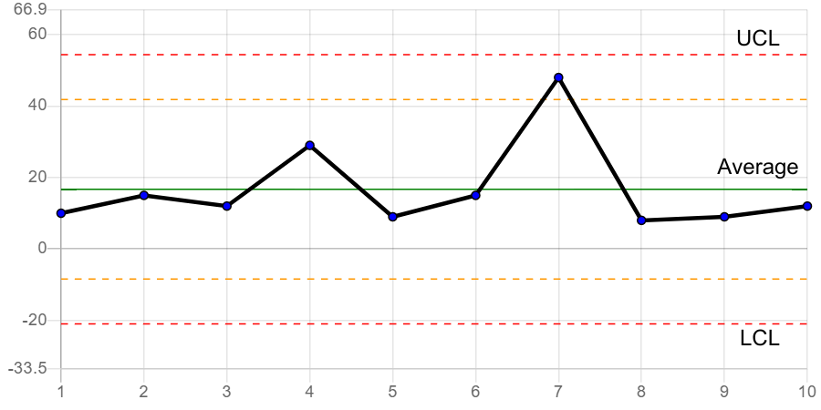
Figure 1 – Control chart

CHECK SHEET:
A systematic, prepared form for gathering and analysing data is a check sheet. This is a versatile tool that may be used for many different tasks [6]. It is frequently important to gather historical or real-time operational data regarding the process under investigation in the early stages of process improvement [2]. Forms called check sheets are employed to compile data in a methodical manner. They offer a "place to start" for the user and a framework for gathering the data. Additionally, they help the user organise the data for subsequent use. Creating histograms, Pareto charts, control charts, etc. can be done using the information acquired on a check sheet. Check sheets have several advantages, but their ease of use and comprehension and ability to create a clear image of the situation are their main advantages.
TYPES OF CHECK SHEET:
The three major categories are defect-location check sheets, tally check sheets, and defect-cause check sheets.
DEFECT-LOCATION CHECK SHEETS:
The sketch, drawing, or photo of the finished product is typically included on the defect-location check sheet. The diagram is labelled with the existence and type of issues or flaws [1]. This check sheet is also known as concentration diagram, defect map, defect concentration check sheet, location diagram [6].
TALLY CHECK SHEETS:
The tally check sheet is used for measuring the instances of various kinds of flaws. It is possible to lower the overall number of flaws by taking the proper action by understanding the most common types of defects.
DEFECT-CAUSE CHECK SHEETS:
The prior check sheets are used to identify specific faults, such as their general location or root cause. A defect-cause check sheet is utilised, though, when further details on a defect's cause are needed. To identify the causes of low quality, a defect-cause check sheet was used [1].
APPLICATION OF CHECK SHEETS:
Use check sheet,
- when information may be repeatedly observed and gathered by the same individual or at the same place.
- When gathering information on the frequency or trends of incidents, faults, or flaws, as well as their causes or locations.
- When gathering information about a production process. [6]

FISHBONE DIAGRAM:
The Fishbone diagram, also known as the Ishikawa diagram, is a tool for determining the underlying factors that contribute to quality issues. It was given this name in honour of Kaoru Ishikawa, a Japanese quality control statistician who introduced this chart in the 1960s [10]. A tool for analysis that offers a systematic way to look at effects and the reasons that lead to or influence those effects is the fishbone diagram. The Fishbone diagram can be referred to as a cause-and-effect diagram due to its objective [11]. A cause-and-effect diagram is used to show the various types of product nonconformities and how they relate to one another. It is helpful in directing management, production engineers, and operators' attention to quality issues. The level of technological understanding of the process typically increases with the creation of a good cause-and-effect diagram [2]. This cause analysis tool is one of the seven basic quality tools. The fishbone diagram identifies a number of potential sources for an impact or problem. A brainstorming session can be organised using it. Ideas are categorised instantly into practical groups [6]. Some advantages of creating a Fishbone diagram include encouraging group participation and utilising group knowledge of the process, identifying areas where data should be collected for further research, and helping to identify the underlying causes of a problem or quality characteristic using a structured approach [12]. The diagram's layout closely resembles the skeleton of a fish. The representation can be made plain by using bevel line segments that slant towards a horizontal axis to suggest the distribution of the various causes and sub-causes that give rise to them. However, it can also be enhanced with qualitative and quantitative evaluations, names and coding for the risks that characterise the causes and sub-causes, elements that demonstrate their succession, as well as other distinct approaches to risk management. The diagram can also be used to assess the risks of the effect's causes and sub-causes, as well as its overall risk [13].
TYPES OF FISHBONE DIAGRAM:
The major types include cause enumeration diagram, CEDAC (cause-and-effect diagram with the addition of cards), desired-result fishbone, process fishbone, time-delay fishbone, reverse fishbone diagram.
APPLICATION OF FISHBONE DIAGRAM:
- Finding potential sources of a problem.
- when a team's thinking has a tendency to get stagnant [6].

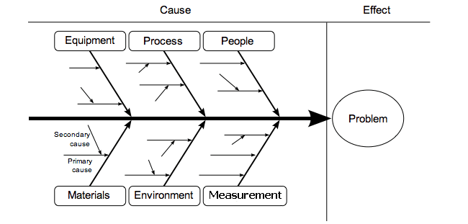
Figure 2 – Cause and effect diagram [16]

PARETO CHART:
Pareto chart is also known as Pareto analysis or Pareto diagram. Pareto analysis is a statistical decision-making technique used to select a small number of tasks that have a significant overall impact. It is one of the most popular easy-to-use methods. When attempting to determine which actions or elements within an organisation will have the greatest impact, the Pareto analysis methodology is used. It lists the information/factors in decreasing order of frequency of occurrence, starting with the highest frequency and ending with the lowest frequency. A Pareto cart is frequently used to illustrate the findings of a Pareto analysis. The chart shows the different factors being taken into account in ranked order. 100 percent is calculated as the sum of all frequencies. The "80-20 rule," which was developed by Italian economist Vilfredo Pareto, states that the "useful many" occupy only the remaining 20% of cumulative occurrences while the "vital few" occupy a significant portion (80%) [14]. Bar graphs are used in Pareto charts. The bars are ordered with the longest on the left and the shortest to the right. The lengths of the bars signify frequency or cost respectively. The chart effectively illustrates which circumstances are more important in this way [6]. Pareto charts have numerous applications. They not only offer a way to study and enhance quality, but also a way to study and enhance efficiency, material waste, energy conservation, safety concerns, cost savings, etc. A Pareto chart can be useful in almost any area that a team wants to research [1]. Due to its ability to organise and inspire ideas, Pareto analysis is a creative technique to examine the root causes of issues. However, it may be constrained by its rejection of potentially significant problems that may be minor at first but will worsen with time. It should be used in conjunction with other analytical methods, such as fault tree analysis and failure mode and consequences analysis, for instance [15].
APPLICATION OF PARETO CHART:
Use a pareto chart,
- When examining information concerning the prevalence of issues or their root causes in a process.
- When there are numerous issues or reasons and you want to concentrate on the biggest.
- When examining broad causes through analysing their particular elements.
- When discussing your data with others [6].

Figure 3 – Pareto chart

HISTOGRAM:
The term "histogram" refers to a visual representation of the frequency distribution of observed values of a variable. It is a type of bar chart that aids users in displaying the distribution of data and the degree of variation within a process while also visualizing attribute and variable data of a product or process [17]. The variability of a product or process is visually represented by the histogram, a type of bar chart. It displays the mean, mode, and average central tendency measures. By placing the specifications on the histogram, it is possible to demonstrate whether the product specifications are being met. A histogram can also be used to examine and identify the variable's underlying distribution [1].
APPLICATION OF HISTOGRAM:
Use a histogram,
- When the data are numerical.
- When establishing if the output of a process is roughly normally distributed, in particular, you want to be able to see how the data are dispersed.
- Determining whether a method can satisfy the needs of the customer.
- Examining the appearance of the product of a supplier's procedure.
- Determining if a process has changed from one period to another.
- Identifying whether the results of two or more processes vary.
- You want to let others know about the rapid and simple sharing of data.
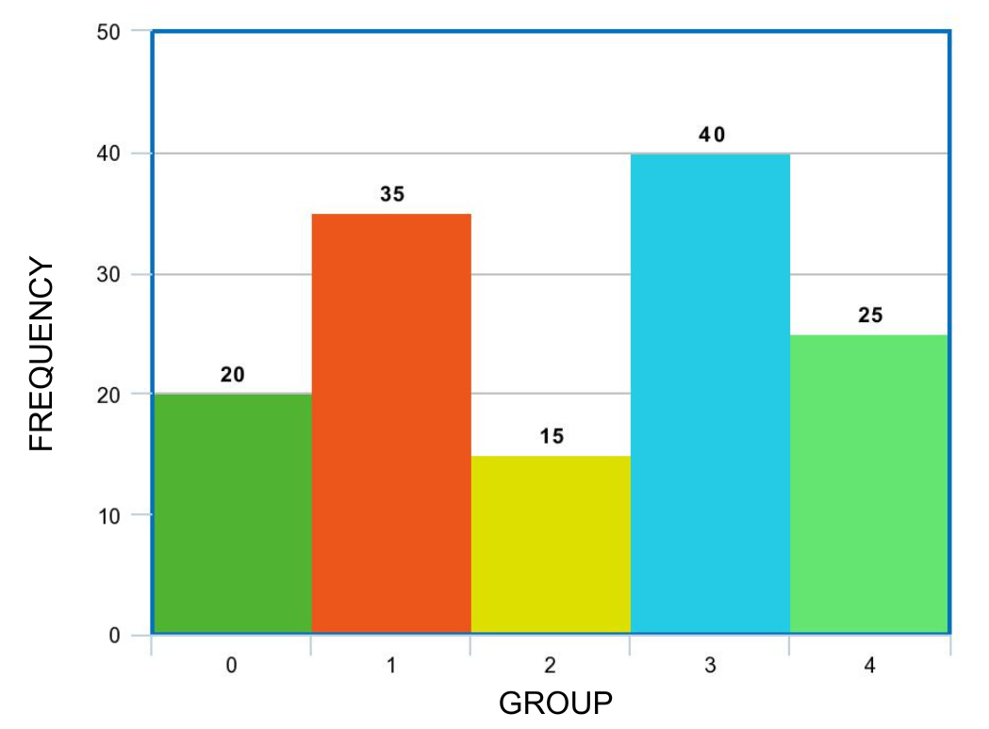
Figure 4 - Histogram
STARTIFICATION:
Stratification is a strategy used in conjunction with other data analysis tools. The significance of the data can be obscured when it has been combined with data from several sources or categories. The data is divided using this method, allowing patterns to be seen. One of the first seven QC tools was stratification.
APPLICATION OF STARIFICATION:
- Used Prior to gathering data.
- When information is derived from multiple sources or circumstances, such as shifts, days of the week, suppliers, or population groups it is used.
- Used when isolating many sources or circumstances may be necessary for data analysis [6].

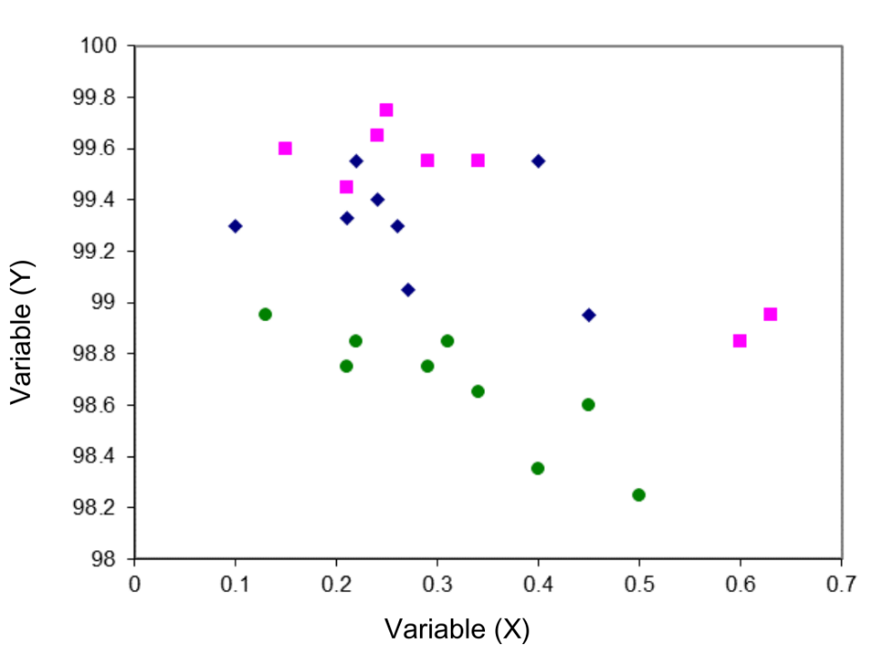
Figure 4 – Stratification

SCATTER DIAGRAM:
A scatter diagram, which compares two variables, is a graph of point plots. The distribution of the points reveals the existence or absence of a cause-and-effect connection between two variables. Pairs of data for the two variables under investigation must be provided in order to use a scatter diagram. In order to clearly show the existence or absence of a cause-and-effect link and provide insight into the strength of that relationship, scatter diagrams are particularly helpful. A scatter plot does not automatically suggest that the observed association is statistically significant. For statistical correlation, further investigation is needed in the form of probability charting or the determination of the correlation coefficient. Additionally, it should be remembered that the interpretation of a scatter diagram is limited to the range of values that were really observed. Scatter diagram is also called scatter plot, X-Y graph [1].
APPLICATION OF SCATTER DIAGRAM:
Use scatter diagram,
- In the case of paired numerical data.
- When each value of your independent variable's dependent variable could have numerous values.
- Consider when attempting to establish a connection between the two variables.
- When attempting to pinpoint probable issues' underlying sources.
- After listing potential causes and effects, utilise a fishbone diagram to verify whether a specific cause and effect are actually connected.
- When establishing whether two seemingly similar phenomena have the same cause.
- Before creating a control chart, check for autocorrelation [6].

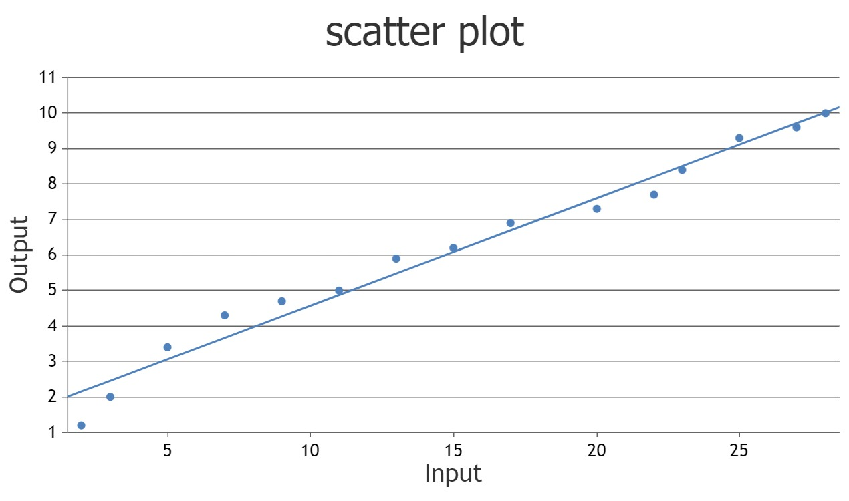
Figure 5 – Scatter diagram
CONCLUSION:
Statistical quality control is primarily concerned with ensuring that various procedures and functional arrangements are in place to provide for successful and effective statistical processes to minimise the probability of errors or issues in procedures or systems or in source material. Quality control tools are simple to use and comprehend. They are primarily helpful for resolving issues with quality control. It also aids in the ongoing improvement of manufacturing process. By using these tools product rejection and product rework is reduced.

REFERENCES:
[1] Omachonu, V.K., & Ross, J.E. (2004). Principles of Total Quality (3rd ed.). CRC Press. https://doi.org/10.1201/b12446
[2] Montgomery DC, Wiley J. Introduction to Statistical Quality Control. 7th Edition. New York: John Wiley & Sons; 2009
[3] Montgomery DC, Wiley J. Introduction to Statistical Quality Control. Sixth Edition. New York: John Wiley & Sons; 2009
[4] S. Subbulakshmi, A. Kachimohideen et al. An Essential Role of Statistical Process Control in Industries. International Journal of Statistics and Systems. 12, (2), 2017, 355-362.
[5] Oakland, J.S. (2002). Statistical Process Control (5th ed.). Routledge. https://doi.org/10.4324/9780080474458
[6] Tague N. R. (2005). The quality toolbox (2nd ed.). ASQ Quality Press.
[7] Sengoz, N.Gonul. (2018). Control Charts to Enhance Quality. 10.5772/intechopen.73237.
[8] Naiknaware Tushar, Gaikwad Sakshi et al. Using measurement system analysis and statistical process control for monitoring and reducing variation in the process. International Journal of Current Research. 14, (10);22485-22488.
[9] Besterfield DH. Total Quality Management. 3rd ed. Upper Saddle River N.J: Prentice Hall; 2003.
[10] Juran, J. M. (1999). Juran's Quality Handbook (5th Edition). McGraw-Hill.
[11] Watson, G. (2004). The Legacy of Ishikawa. Quality Progress 37(4); 54-47.
[12] Basic Tools for Process Improvement. (1995, May 3). Retrived December 20, 2009, from Balanced Scorecard Institute: http://www.balancedscorecard.org/Portals/0/PDF/c-ediag.pdf
[13] Ciocoiu, C. N. (2008). Managementul riscului. Teorii, practici, metodologii. Bucharest: ASE.
[14] Talib, Faisal & Rahman, Zillur & Qureshi, Mohamed Rafik. (2010). Pareto analysis of total quality management factors critical to success for service industries. International Journal for Quality Research. 4; 155-168.
[15] https://en.wikipedia.org/wiki/Pareto_analysis
[16] Fishbone tool of investigation in pharmaceuticals - Pharmaguideline.
[17] Neyestani, Behnam. (2017). Seven Basic Tools of Quality Control: The Appropriate Techniques for Solving Quality Problems in the Organizations. 10.5281/zenodo.400832.

