IOT BASED PATIENT MONITORING SYSTEM

Dr Radhika Rani
Assistant Professor & HOD
Computer Science & Internet of Things Department
Loyola Academy, Secunderabad
radhikarani79@gmail.com
Sk Abdul Khadar
Assistant Professor
Computer Science & Internet of Things Department
Loyola Academy, Secunderabad
abdulkhadar.shaik08@gmail.com

Abstract

Utilizing the Internet of Things (IoT) for patient monitoring involves the continuous tracking of various health metrics. Real-time health data is transmitted to the cloud through internet connectivity, creating a patient monitoring system deeply rooted in IoT technology. This data can be accessed by users from any location worldwide, simply by sending a request to a remote internet location. Contrasting this with an SMS-based patient monitoring system, there are notable distinctions. In an IoT-based system, multiple individuals have the capability to access and review a patient's health information. This accessibility necessitates visiting a website or using a specific URL. This concept represents one of the latest innovations in electronic projects with medical applications. Furthermore, IoT offers the advantage of displaying this data on various devices, including tablets, laptops, Android smartphones, desktop computers, and more. A functional internet connection is the only requirement for accessing this data. Various cloud service providers can be employed for viewing this data online.

Keywords – Internet of Things, Patient Monitoring, Data, Health

- INTRODUCTION

The Internet of Things (IoT) comprises a network of various physical entities, including electronics, working together to collect data from the surrounding environment and transmit it via the internet. This synergy between software and embedded sensors finds applications across numerous industries, including smart cities, environmental monitoring, healthcare, and more.

In our specific healthcare system, we have developed a range of modules aimed at facilitating remote patient diagnosis through telemonitoring.To gather patient data, we have deployed a set of medical sensors, which collect information and relay it to a Raspberry Pi for patient diagnosis, regardless of their location anywhere in the world through internet connectivity. For convenience, we can store this data in a cloud-based medical history repository, ensuring easy accessibility.

Our architectural design is versatile, catering to patient monitoring in both hospital settings and the comfort of one's home. This system could also be suitable for implementation in village health centers, reflecting the impact of technological advancements and industry transformations.The Internet of Things (IoT) has garnered significant attention owing to its evolution into IoT 4.0, with widespread applications across various sectors such as security systems, businesses, agriculture, and healthcare.

Several studies have explored the development of IoT-based smart homes, including home security systems. An earlier study suggested using components like the Arduino Uno, ESP wifi module, and reed sensor, albeit limited to door security, with users receiving smartphone notifications when the door opened.

An alternative approach raises concerns about an increased risk of potential criminalization. A separate study employed an Internet of Things (IoT)-based smart security and home automation system featuring a Passive Infrared (PIR) sensor positioned at the entrance of a building. When human movement is detected, the sensor triggers input to a microcontroller, which then notifies the homeowner through voice calls. These systems offer immediate response capabilities, such as activating lights and alarms when the homeowner presses a pre-programmed keypad button.The IoT-based smart home system, based on the Blynk Framework, comprises three distinct and isolated subsystems: temperature monitoring, GPS tracking, and relay modules. Additionally, it incorporates PIR and ultrasonic sensors for monitoring water levels in connected tanks through Nodemcu via Wi-Fi.

In contrast, Ethernet-based smart home designs focus on safeguarding residences and monitoring variables like temperature, humidity, gas leaks, and fire using sensors integrated with the Arduino Mega microcontroller and Ethernet shield. A message notification system is established to alert the homeowner to any unusual or unexpected activity. However, Ethernet systems are constrained to local networks.

An integrated approach combines the AT89C52 microprocessor, RFID technology, and Multimedia Messaging Service (MMS) to develop a wireless monitoring and access control system. Access is granted only to individuals with valid RFID tags. If a phone number is identified, the microcontroller sends an interrupt signal to the MMS section, which then sends AT commands to the Quested M33 cellular device to capture images of individuals and transmit them via MMS over the GSM network. The homeowner can then respond by granting or denying access and may request additional photographs from the website for making informed decisions. The microcontroller controls the stepper motor using AT commands to read messages from the cellular network, allowing the homeowner to open the gate or activate the alarm.

The design and implementation of GSM-based security systems for smart homes incorporate web cameras to detect motion and promptly notify users via email when such activity occurs. In situations involving fires or escalating temperatures, these GSM-based systems can transmit SMS messages, with the time taken for SMS delivery contingent on the specific cellular network coverage. When the phone maintains a connection to network coverage, SMS messages are typically dispatched within a window of 25 to 30 seconds.

This current research endeavor aims to establish comprehensive home safety and monitoring systems by employing a diverse range of sensors and layered security measures, building upon prior research findings. Consequently, these systems are capable of early intruder detection, rain sensing, temperature and humidity monitoring, and providing periodic smartphone alerts when the stove is in use. Additionally, users have the capability to remotely control various system outputs.

- BLOCK DIAGRAM
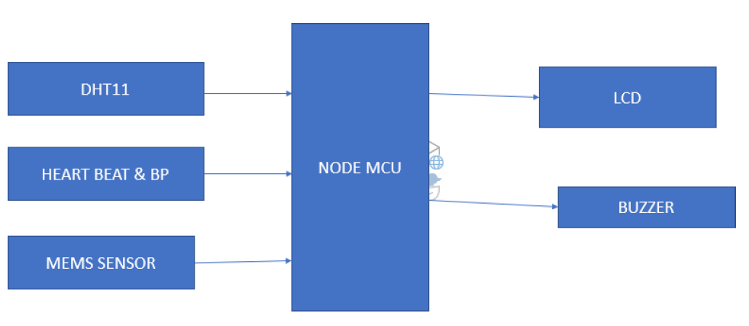
Figure 1: Block Diagram

- EMBEDDED IOT SYSTEMS

An embedded system is a specialized computer system designed to perform a specific, targeted task. Examples of embedded systems encompass various devices such as air conditioners, VCD players, DVD players, printers, fax machines, mobile phones, and more. Each of these appliances incorporates essential components, including a processor, specialized hardware, embedded software, and hardware components operated by the processor to fulfill the specific requirements of the application. The term "firmware" refers to the embedded software.

In contrast to desktop or laptop computers, which are multifunctional and versatile, embedded systems have fixed functionality. They are inherently limited in their ability to be programmed for diverse tasks and are dedicated to performing a narrowly defined function.Embedded systems face severe constraints, particularly in terms of memory and resources. They often lack secondary storage options like CD-ROMs and floppy discs. Embedded systems operate under stringent time constraints, with specific tasks required to be completed within predetermined time frames.

In some cases, embedded systems are classified as real-time systems, where missing a deadline could lead to catastrophic consequences such as loss of life or property damage.Efficient power consumption is critical for embedded systems, as many of them rely on battery power. Therefore, they must minimize energy consumption to extend battery life.Certain embedded systems are designed to operate in extreme environmental conditions, including high temperatures and humidity levels, further highlighting the specialized nature of these systems.

The circuit diagram based on embedded systems is shown in figure 2 which includes power supply, sensors for different healthparameters monitoring and LED / LCD display to display these values.

The figure 3 and figure 4 shows the circuit hardware with pulse rate monitoring sensor, temperature sensor, heart rate monitoringsensor and display to display these values.

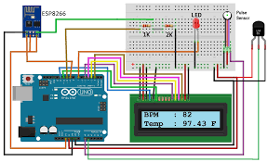
Figure 2: Circuit Diagram

- Result

The figure 3 and figure 4 shows the circuit hardware with pulse rate monitoring sensor, temperature sensor, heart rate monitoring sensor and display to display these values.

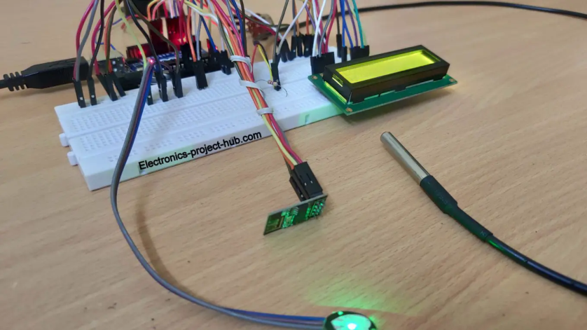

Figure 3: Sensors in the Circuit

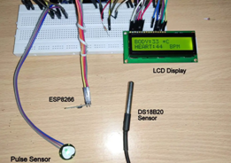

Figure 4: Parts of Design

Figure 4 shows display of health parameters on LED Display .

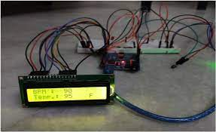

Figure 5: Display of health parameters

- CONCLUSION

We have established that our system relies solely on two fundamental pillars: Internet of Things (IoT) and cloud computing. Cloud computing serves as the storage solution for our data, providing the capability to access it from anywhere and ensuring its permanent retention. One notable advantage of utilizing cloud computing is the ability to keep patients informed and updated. In emergency situations, medical professionals and caregivers can promptly engage with patients, take necessary actions, and administer appropriate treatments based on the patient's health parameters. Furthermore, doctors and caregivers can establish remote communication with patients, as the technology can automatically generate graphical representations illustrating how the patient's condition has evolved in response to emergency SMS notifications.

Our technology is well-suited for village healthcare centers and remote rural areas where access to medical facilities is limited. It simplifies the diagnostic process for doctors and streamlines examinations, particularly when dealing with patients experiencing high body temperatures. Moreover, this approach ensures the privacy of patients when they are outside the hospital and in the comfort of their homes. The efficacy of this patient health monitoring system has been convincingly demonstrated.

REFERENCES

[1] "Low Cost And Portable Patient Monitoring System For E-Health Services In Bangladesh" Mithun Chandra Paul,SumanSarkar,Md. MahfujurRahman,SayedMohsin
Reza IitJahangirnagar University1342
[2] "Patient Health Management System Using E-Health Monitoring Architecture" Srijani Mukherjee, Koustabh Dolui.2014
[3] M. V. M. Figueredo, J. S. Dias, "Mobile Telemedicine System For Home Care And Patient Monitoring". Proceedings Of The 26th Annual International Conference Of
The IeeeEmbs San Francisco, Ca, Usa,September 1-5,2004.
[4] Pei-Cheng Hii, Wan-Young Chung, "A Comprehensive Ubiquitous Healthcare Solution On an Android Mobile Device", Sensors 2011,
[5] "Apnea Medassist: Real-Time Sleep Apnea Monitor Using Single-Lead Ecg" MajdiBsoul, Member, Ieee, HlaingMinn, Senior Member, Ieee,
[6] "Android Based Body Area Network For The Evaluation Of Medical Parame- Ters",Ieee,2012
[7] "Communication And Security In Health Monitoring Systems" - A Review Hos- SeinFotouhi, Aida C Ausevic, Kristina Lundqvist, Mats Bjorkman
[8] Health Gare : "A Real-Time Wearable System For Monitoring And Analysing Physiological Signal" .Nuria Oliver 1 Fernando.2008

