Application of Polymeric Nanoparticles in Nanomedicine

Swati S. Nagare
Department of Chemistry,
Kamla Nehru Mahavidyalaya, Nagpur, Maharashtra, 440024, India
swati21feb@gmail.com

W. B. Gurnule
Department of Chemistry Kamla Nehru Mahavidyalaya,
Nagpur- 440024, Maharashtra, India
wbgurnule@gmail.com

Mamta S. Wagh
Department of Chemistry Kamla Nehru Mahavidyalaya,
Nagpur- 440024, Maharashtra, India

Rashmi R. Dubey
Department of Chemistry,
Kamla Nehru Mahavidyalaya,
Nagpur- 440024, Maharashtra, India

Uma S. Purohit
Department of Chemistry,
Kamla Nehru Mahavidyalaya,
Nagpur- 440024, Maharashtra, India

Swati G. Burade
Department of Chemistry,
Kamla Nehru Mahavidylaya,
Nagpur-440024, Maharashtra, India

ABSTRACT

Polymer-based nanomaterials include chitosan, polylactic acid (PLA), polyglutamic acid (PGA), poly (lactic-glycolic acid) (PLGA), etc.Various nanoparticle preparation methods such as physical vapour deposition, chemical vapour deposition, reactive precipitation,sol-gel,microemulsion,Sono chemical processing and supercritical chemical processing have been developed and reported in the literature. Polymeric nanoparticles (NPs) are one of the most studied organic strategies for nanomedicine. Intense interest lies in the potential of polymeric NPs to revolutionize modern medicine. To determine the ideal nano system for more effective and distinctly targeted delivery of therapeutic applications, particle size, morphology, material choice and processing techniques are all research areas of interest. Utilizations of polymeric NPs include drug delivery techniques such as conjugation and entrapment of drugs, prod rugs, stimuli-responsive systems, imaging modalities, and the agnostic. Cancer, neurodegenerative disorders and cardiovascular diseases are fields impacted by NP technologies that push scientific boundaries to the leading edge of transformative advances for nanomedicine.
Keywords: Nanoparticles, Polymer, Nanomedicine, Morphology and Particle

I INTRODUCTION

Nanomedicine is the medical application of nanotechnology. Nanomedicine ranges from the medical applications of nonmaterial’s and biological devices, to nanoelectronics biosensors, and even possible future applications of molecular nanotechnology such as biological machines. Current problems for nanomedicine involve understanding the issues related to toxicity and environmental impact of nanoscale materials. Polymeric nanoparticles (NPs) are particles within the size range from 1 to 1000 nm and can be loaded with active compounds entrapped within or surface-adsorbed onto the polymeric core. Polymers used to form nanoparticles can be both synthetic and natural polymers. These nanocarriers have been demonstrated for a variety of applications such as drug delivery, imaging, and detection of apoptosis. Many cationic polymers have been studied both in vitro and in vivo for gene delivery. The various biodegradable polymers commonly used in the fabrication of polymeric nanoparticles include poly(lactide) (PLA), poly(lactide-co-glycoside) (PLGA) copolymers, poly (ɛ-caprolactone) (PCL), and poly (amino acids) and also some natural polymers like alginate, chitosan, gelatin, and albumin The two main types of polymeric nanoparticles are nano capsules (reservoir system) and nanospheres (matrix system) with different drug-loading materials. Nanoparticles (NPs) as drug delivery systems or direct anti-tumour systems facilitate unique approaches for many diseases.

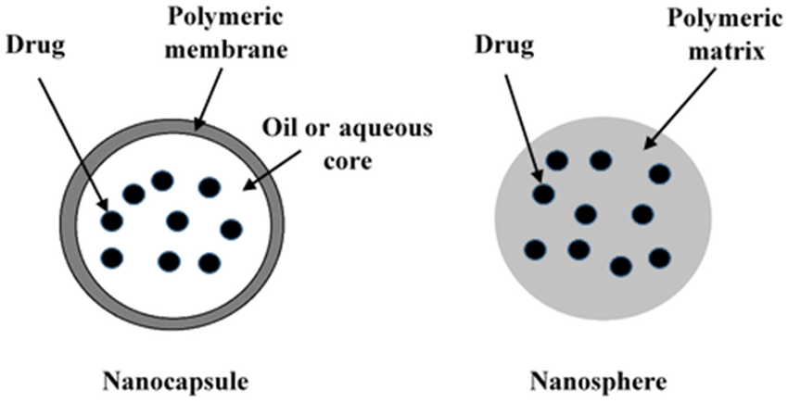
Figure 1 Type of Nanoparticles

II. Types of Nanoparticles

Regarding their chemical compounds, NPs can be divided into three main groups: organic nanoparticles (liposomes and polymers), inorganic nanoparticles (metals, metal oxide, ceramic, and quantum dots), and carbon-based nanoparticles [10] (Figure 1). In general, NPs retain the chemical properties of their bulk materials, which can be useful when choosing a specific NP for a biomedical application. The NPs used in nanomedicine include the following.

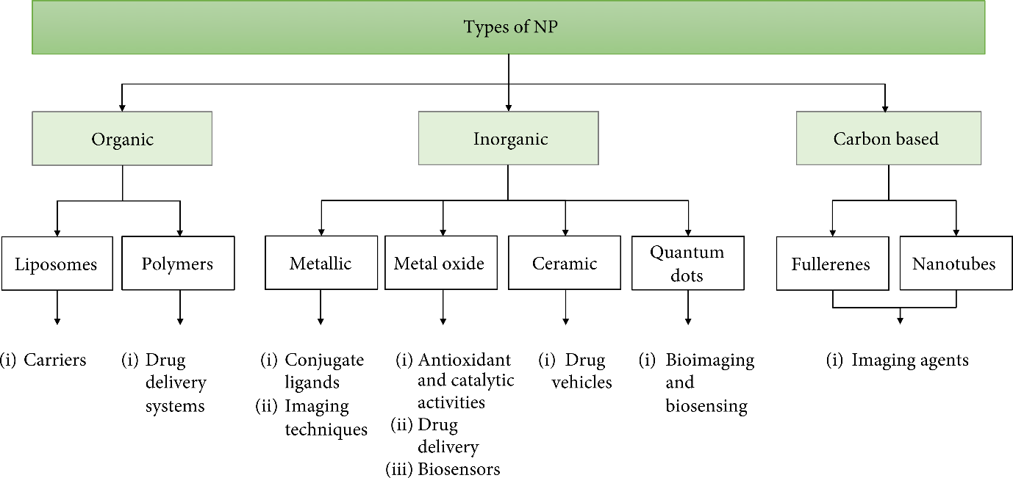

Figure 2. Generalized diagram of the types of nanoparticles and their main biomedical applications.

III. PREPARATION OF POLYMERIC NANOPARTICLES

Polymeric nanoparticles have been synthesized by several methods depending on the requirements of their application and the physicochemical characteristics of the drug [20]. The choice of the most suitable method plays a vital role in order to obtain PNPs with the desired properties for a particular application.
Several preparation methods have been developed and these can be divided into two groups, namely, those based on the polymerization of monomers and those taking advantage of preformed polymers (Fig. 1) [17]. These methods can be further classified into two categories: two-step procedures involving the preparation of an emulsification system followed by formation of nanoparticles in the second step of the process and one-step procedures where emulsification is not required for the formation of nanoparticles.

For the polymerization methods, the monomers are polymerized to form the encapsulating polymer. This process can be carried out in two ways, either using emulsion polymerization techniques or interfacial polymerization [10], [11]. Some drawbacks have been reported which have limited the use of polymerization methods for the synthesis of PNPs [10], [11]. Not only are most PNPs formed from slowly biodegradable or no biodegradable monomers, but also non-biocompatible by products may be generated with these methods. Toxic residues such as monomers and initiators may persist which require extensive purification work to result in a pharmaceutically acceptable product. Another challenge is the requirement for free-radical polymerization or UV light to trigger polymerization, which prevents the addition of proteins or peptides during polymerization [21]. Considering the limitations of polymerization techniques, attention is focused on describing the methods involving preformed polymers, as many of the problems involved in the former method can be avoided.

IV. METHODOLOGY

Polymers have been discovered to be a useful substance for the development of numerous and diverse molecular patterns. These molecular designs can be merged into a unique nanoparticle and are utilized to create many medical applications. Several approaches for the creation of polymeric nanoparticles have been developed over the last two decades. Based on their data, the PNP design approach can be classified, which comprises the polymerization reaction or the production of the nanoparticle from the macromolecule, as well as the ionic gelation method [9]. Nano capsules or nanospheres are formed as a result of the nanoparticle preparation. Figure 1 depicts the distinction between a nanosphere and a Nano capsule. The medications contained within the cavity are known as nano capsules.

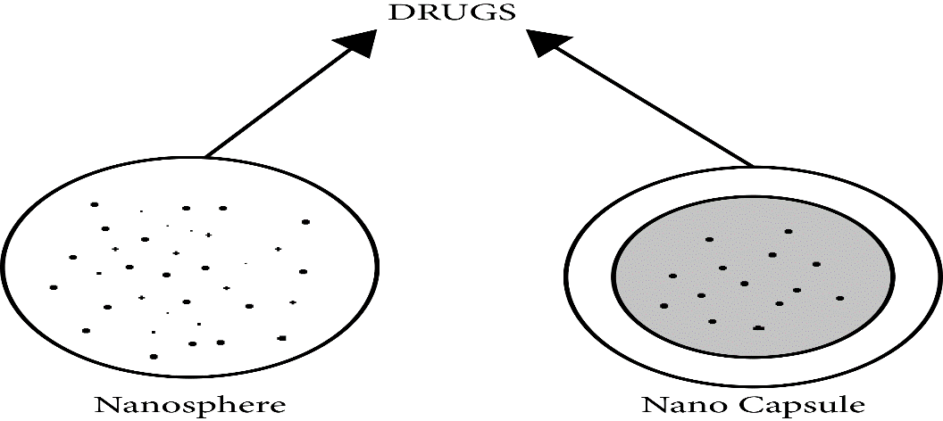

Figure 3 Distinguish between Nanosphere and Nanocapsule

A. Method Used In Polymeric Nanoparticle Preparation

There are different methods used in the polymeric nanoparticle preparation, and they are expressed in Figure (a) which shows the dispersion of the performed polymer, and Figure (b) shows the polymerization of monomers. At first, the preparation of the nanoparticle from the dispersion of the performed polymer is presented, and then the nanoparticle preparation from the polymerization of monomers is expressed.

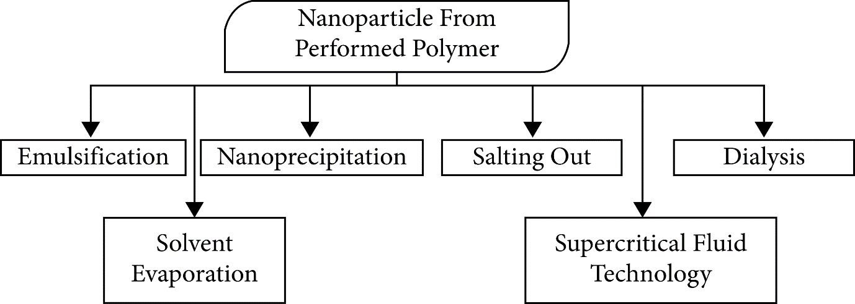

Figure 4 Different Methods Used in Polymeric nanoparticles.

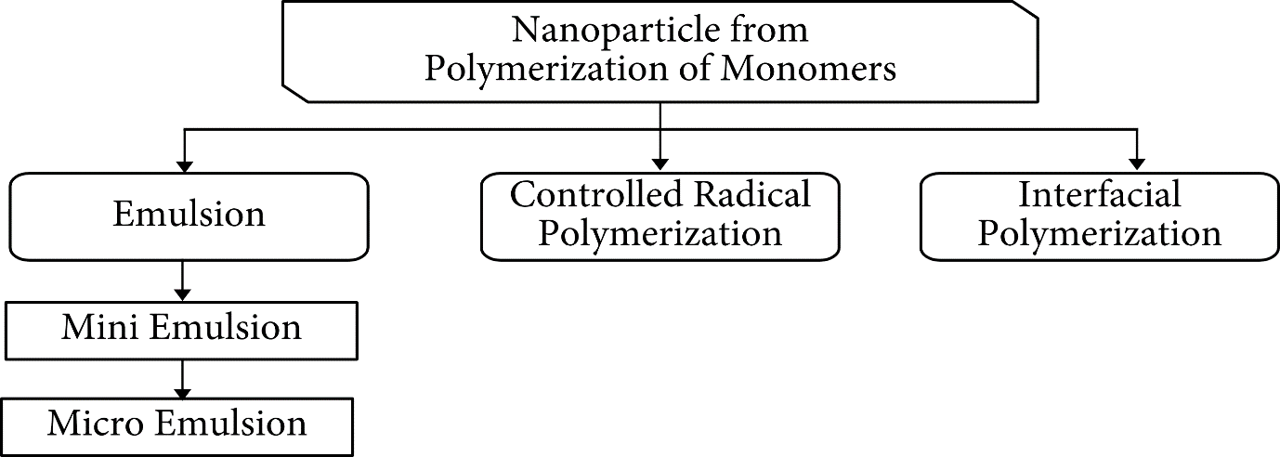

Figure 4 Different Methods of polymerization of monomers.

B. Preparation of the Nanoparticle via Monomer Polymerization

The emulsion polymerization method is the quickest and most easily ascendable way of creating polymeric nanoparticles. The following approach is separated into two groups based on the organic or aqueous phase. In the continuous organic phase, the dispersion of the monomer into an emulsion is involved; this is also known as the inverse micro emulsion or no solvent monomers [13]. To avoid aggregation at the start of the polymerization process, protective or surface-active soluble polymers were utilized to create the nanoparticle. This process is believed to have a low environmental impact due to its requirements, which include an organic hazardous solvent, monomers, mediators, and surfactants.

Figure 3 depicts the emulsification process. The polymerization process could begin via a variety of mechanisms. When the monomer molecule dissolves in the continuous phase, it collides with the initiator molecule. Ions or radicals could be the initiator molecule. The high-energy radiation system, which comprises g-radiation, UV rays, and intense visible light, transforms the monomer molecule into originating radicals [15]. An anionic polymerization mechanism occurs when monomeric ions or monomeric radicals clash with other monomeric molecules, causing the chain to form. Stage separation and the formation of solid particles might occur before or after the polymerization reaction is completed.

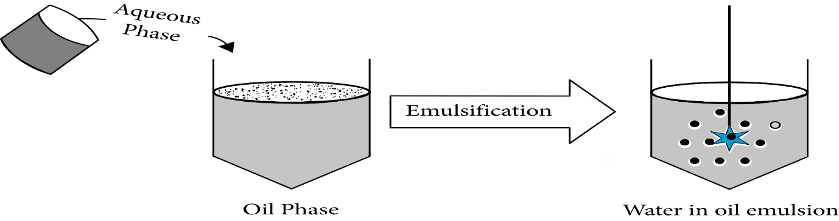

Figure 5 Emulsion Polymerization Method

C. Polymerization of mini emulsions

The number of studies published on Mini emulsion-based polymerization and the production of a wide range of useful polymer materials has increased significantly in recent years. Mini emulsion polymerization formulations commonly contain stabilizers, water, monomer blends, surfactants, and initiators. The monomer combination, water, stabilizer, and originator are the common parameters of Mini emulsion polymerization; these were chosen based on the formulization. Polymerization emulsion is distinguished from polymerization Mini emulsion by the use of a molecule with a low molecular mass as a stabilizer [16] as well as the use of a high-shear device. The Mini emulsion process generated a lot of interfacial tension, and in order to achieve the steady-state condition, a lot of shears is required, and the Mini emulsion is crucially stabilized.

D. Characterization of polymeric nanoparticles

Polymeric NPs may differ in physical properties, such as composition and concentration, as well as in size, shape, surface properties, crystallinity, or in dispersion state. These properties are usually assessed by several methods, aiming for the full characterization of the NPs. Electron microscopy, dynamic light scattering (DLS) or photon correlation spectroscopy (PCS), Near-infrared spectroscopy, electrophoresis, and chromatography are a few of the most commonly used. Polymeric NPs characterization is very important, in terms of its applicability, but also to ascertain issues concerning nanotoxicology and exposure assessment in workplaces, which are important to assess their health and safety hazards, as well as to control manufacturing processes.

E. Morphology

Scanning and transmission electron microscopy (SEM and TEM) have been widely used to obtain information regarding the shape and size of polymeric NPs. These are usually combined with cryofracture techniques to perform the NPs morphology analysis. TEM widely used and is capable of distinguishing between nano capsules and nanospheres, in addition to being able to determine the thickness of the nano capsule wall. Nanospheres have a spherical shape, with a solid polymeric structure, whereas nano capsules are formed by a thin (about 5 nm) polymeric envelope around the oily core. Another technique that has been used to characterize the surface morphology of polymeric NPs is atomic force microscopy (AFM) . It provides information with high resolution in three dimensions, and in a nanometric scale, while it is also able to resolve surface details at an atomic level . By applying this technique, a complex topography on the surface of the nanoparticles has been observed, while by analysing sections of samples, the presence of small cavities and pores has also been revealed.

F. Particle size distribution

In general, polymeric NPs obtained from different methods may have mean diameters between 100 and 300 nm. The polydispersity should be as low as possible (ideally, nearly zero), and the size distribution unimodal. Particles with diameters around 60 to 70 nm or even less than 50 nm can also be obtained. The nanoparticle size can be measured by using different techniques, the most commonly used being the dynamic (DLS) and static (SLS) light scattering, but TEM, SEM and AFM are also oftenly used. Size measurements may vary depending on the method used, for example, electron microscopy provides an image of the particle isolated from the surroundings, while DLS allows the determination of the hydrodynamic radius of suspended particles. Moreover, DLS is an important complement to TEM, because it can measure larger sizes, providing information on the aggregation state of a nanoparticle in solution by determining changes in particle size distribution. Many factors can influence the size of polymeric NPs, such as the quali-quantitative composition, a example is the case of nano capsules, in which during their production a factor that influences the particle diameter is the nature of the oil used as the core, due to differences in viscosity, hydrophobicity or interfacial tension between the different liquid phases. Another factor that can influence the average diameter of the nanoparticles is the amount of drug that may lead to larger particles with wider size distribution.

TECHNIQUES | VALUES
UV-VISIBLE | 520 nm
NMR | 2.0-4.0
IR | 220
SEM | Surface area of nanoparticle
TEM | Inner structure of particle size (80 to 100 nm)

Table 1 Principal techniques for evaluation of the physicochemical characteristics of PNPs

V. Applications

Recent advances in the study of polymers across a variety of fields can enable specified functions of polymeric nanostructures to be matched for adaptable applications. This succinct review focuses on the various preparation techniques for polymeric nanoparticles created in recent decades and their applications in a variety of scientific fields, such as therapeutic, optoelectronic, catalytic, and magnetic applications, as well as some difficult problems relating to the commercialization of new polymer-based therapeutics. It also makes remarks on the cutting-edge usage and applications of polymer nanoparticles in a range of scientific disciplines during the next few decades.

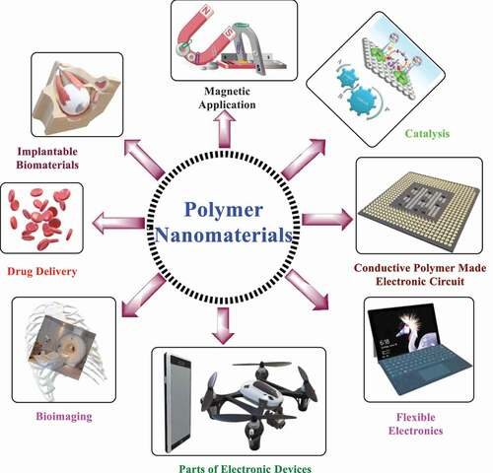

Figure 6. Application of Polymer Nanoparticles in various Fields.

VI. CONLUSION

The use of polymers in NP-based formulations has been extremely advantageous in biomedical applications. With a wide range of materials to choose from polymer NPs offer a significant advantage in fine tuning NP physiochemical properties for a range of drugs delivery applications.The nanoparticles are formed by emmulsion polymerization technique. These nanoparticles are characterized by UV,NMR,SEM,IR and TEM Spectrometric Methods. The study of nanoparticles is neccesary to continue the development of efficient nanocarriers,showing no risk for the enviornment or human health in their potential application.The physiochemical behaviour of polymeric NPs is the subject of numerous researchers,however one of the main difficulties encountered in their characterization is their nanosize.

REFERENCES

[1]. Soppimath K.S., Aminabhavi T.M., Kulkarni A.R., Rudzinski W.E. Biodegradable polymeric nanoparticles as drug delivery devices. J. Control

[2]. Cano A., Ettcheto M., Chang J.H., Barroso E., Espina M., Kuhne B.A., Barenys M., Auladell C., Folch J., Souto E.B., et al. Dual-drug loaded nanoparticles of Epigallocate.

[3]. Cano A., Sánchez-López E., Ettcheto M., López-Machado A., Espina M., Souto E.B., Galindo R., Camins A., García M.L., Turowski P. Current advances in the development of novel polymeric nanoparticles for the treatment of neurodegenerative diseases.

[4]. Owens III D.E., Peppas N.A. Opsonization, bio distribution, and pharmacokinetics of polymeric nanoparticles. Int. J. Pharm. 200

[5]. Schaffazick S.R., Pohlmann A.R., Dalla-Costa T., Guterres S.l.S. Freeze-drying polymeric colloidal suspensions: Nano capsules, nanospheres and nanodispersion. A comparative study. Eur. J. Pharm. Biopharm. 2003;56:501–505. doi: 10.1016/S0939-6411(03)00139

[6]. Crucho C.I.C., Barros M.T. Polymeric nanoparticles: A study on the preparation variables and characterization methods. Mater. Sci. Eng. C Mater. Biol. Appl. 2017;80:771–784. doi: 10.1016/j.msec.2017.06.004.

[7]. Guterres S.S., Alves M.P., Pohlmann A.R. Polymeric nanoparticles, nanospheres and nano capsules, for cutaneous applications. Drug Target Insights. 2007;2:117739280700200002. doi: 10.1177/117739280700200002.

[8]. Christoforidis J.B., Chang S., Jiang A., Wang J., Cebulla C.M. Intravitreal devices for the treatment of vitreous inflammation. Mediat. Inflamm. 2012; 2012 doi: 10.1155/2012/126463.

[9]. Szczęch M., Szczepanowicz K. Polymeric Core-Shell Nanoparticles Prepared by Spontaneous Emulsification Solvent Evaporation and Functionalized by the Layer-by-Layer Method. Nanomaterials. 2020;10:496. doi: 10.3390/nano10030496.
[10]. Escalona-Rayo O., Fuentes-Vázquez P., Jardon-Xicotencatl S., García-Tovar C.G., Mendoza-Elvira S., Quintanar-Guerrero D. Rapamycin-loaded polysorbate 80-coated PLGA nanoparticles: Optimization of formulation variables and in vitro anti-glioma assessment. J. Drug Deliv. Sci. Technol. 2019;52:488–499. doi: 10.1016/j.jddst.2019.05.026.

[11]. Traeger A., Voelker S., Shkodra-Pula B., Kretzer C., Schubert S., Gottschaldt M., Schubert U.S., Werz O. Improved bioactivity of the natural product 5-lipoxygenase inhibitor hyperforin by encapsulation into polymeric nanoparticles. Mol. Pharm. 2020;17:810–816. doi: 10.1021/acs.molpharmaceut.9b01051.

[12]. Qiu F., Meng T., Chen Q., Zhou K., Shao Y., Matlock G., Ma X., Wu W., Du Y., Wang X. Fenofibrate-loaded biodegradable nanoparticles for the treatment of experimental diabetic retinopathy and neovascular age-related macular degeneration. Mol. Pharm. 2019;16:1958–1970. doi: 10.1021/acs.molpharmaceut.8b01319.

[13]. Saqib M., Ali Bhatti A.S., Ahmad N.M., Ahmed N., Shahnaz G., Lebaz N., Elaissari A. Amphotericin B Loaded Polymeric Nanoparticles for Treatment of Leishmania Infections. Nanomaterials. 2020;10:1152. doi: 10.3390/nano10061152.

[14]. Torres-Flores G., Nazende G.T., Emre T.A. Preparation of fenofibrate loaded eudragit l100 nanoparticles by nanoprecipitation method. Mater. Today Proc. 2019;13:428–435. doi: 10.1016/j.matpr.2019.03.176.

[15]. Günday C., Anand S., Gencer H.B., Munafò S., Moroni L., Fusco A., Donnarumma G., Ricci C., Hatir P.C., Türeli N.G. Ciprofloxacin-loaded polymeric nanoparticles incorporated electrospun fibers for drug delivery in tissue engineering applications. Drug Deliv. Transl. Res. 2020;10:706–720. doi: 10.1007/s13346-020-00736-1.

[16]. Gao M., Long X., Du J., Teng M., Zhang W., Wang Y., Wang X., Wang Z., Zhang P., Li J. Enhanced curcumin solubility and antibacterial activity by encapsulation in PLGA oily core nano capsules. Food Funct. 2020;11:448–455. doi: 10.1039/C9FO00901A.

[17]. Dourado D. Pharmaceutical Nanotechnology: A Therapeutic Revolution. Int. J. Pharm. Sci. Dev. Res. 2020;6:009–011.

[18]. Bechnak L., Khalil C., El Kurdi R., Khnayzer R.S., Patra D. Curcumin encapsulated colloidal amphiphilic block co-polymeric Nano capsules: Colloidal nano capsules enhance photodynamic and anticancer activities of curcumin. Photochem. Photobiol. Sci. 2020 doi: 10.1039/D0PP00032A.

[19]. Moncalvo F., Martinez Espinoza M.I., Cellesi F. Nanosized delivery systems for therapeutic proteins: Clinically validated technologies and advanced development strategies. Front. Bioeng. Biotechnol. 2020;8:89. doi: 10.3389/fbioe.2020.00089.

[20]. Avramović N., Mandić B., Savić-Radojević A., Simić T. Polymeric Nanocarriers of Drug Delivery Systems in Cancer Therapy. Pharmaceutics. 2020;12:298. doi: 10.3390/pharmaceutics12040298.

[21]. Lammari N., Louaer O., Meniai A.H., Elaissari A. Encapsulation of Essential Oils via Nanoprecipitation Process: Overview, Progress, Challenges and Prospects. Pharmaceutics. 2020;12:431. doi: 10.3390/pharmaceutics12050431.

[22]. Jummes B., Sganzerla W.G., da Rosa C.G., Noronha C.M., Nunes M.R., Bertoldi F.C., Barreto P.L.M. Antioxidant and antimicrobial poly-ε-caprolactone nanoparticles loaded with Cymbopogon martinii essential oil. Biocatal. Agric. Biotechnol. 2020;23:101499. doi: 10.1016/j.bcab.2020.101499.

[23]. Pina-Barrera A.M., Álvarez-Román R., Báez-González J.G., Amaya-Guerra C.A., Rivas-Morales C., Gallardo-Rivera C.T., Galindo-Rodríguez S.A. Application of a multisystem coating based on polymeric nano capsules containing essential oil of Thymus vulgaris L. to increase the shelf life of table grapes (Vitis vinifera L.) Ieee Trans. Nano bioscience. 2019;18:549–557. doi: 10.1109/TNB.2019.2941931.

[24]. Froiio F., Ginot L., Paolino D., Lebaz N., Bentaher A., Fessi H., Elaissari A. Essential oils-loaded polymer particles: Preparation, characterization and antimicrobial property. Polymers. 2019;11:1017. doi: 10.3390/polym11061017.

[25]. Silva-Flores P.G., Pérez-López L.A., Rivas-Galindo V.M., Paniagua-Vega D., Galindo-Rodríguez S.A., Álvarez-Román R. Simultaneous GC-FID quantification of main components of Rosmarinus officinalis L. and Lavandula dentata essential oils in polymeric nano capsules for antioxidant application. J. Anal. Methods Chem. 2019;2019 doi: 10.1155/2019/2837406.

[26]. Jawahar N., Meyyanathan S. Polymeric nanoparticles for drug delivery and targeting: A comprehensive review. Int. J. Health Allied Sci. 2012;1:217. doi: 10.4103/2278-344X.107832.

[27]. Reis C.P., Neufeld R.J., Ribeiro A.J., Veiga F., Nanoencapsulation I. Methods for preparation of drug-loaded polymeric nanoparticles. Nanomed. Nanotechnol. Biol. Med. 2006;2:8–21. doi: 10.1016/j.nano.2005.12.003.

[28]. Amgoth C., Phan C., Banavoth M., Rompivalasa S., Tang G. Role of Novel Drug Delivery Vehicles in Nano biomedicine. Intech Open; London, UK: 2019. Polymer Properties: Functionalization and Surface Modified Nanoparticles.

[29]. Bennet D., Kim S. Application of Nanotechnology in Drug Delivery. Vol. 8 Intech Open; London, UK: 2014. Polymer nanoparticles for smart drug delivery.

[30]. Hernández-Giottonini K.Y., Rodríguez-Córdova R.J., Gutiérrez-Valenzuela C.A., Penury-Miranda O., Zavala-Rivera P., Guerrero-Germán P., Lucero-Acuña A. PLGA nanoparticle preparations by emulsification and nanoprecipitation techniques: Effects of formulation parameters. Rsc Adv. 2020;10:4218–4231. doi: 10.1039/C9RA10857B.

[31]. Kamaly N., Yameen B., Wu J., Farokhzad O.C. Degradable controlled-release polymers and polymeric nanoparticles: Mechanisms of controlling drug release. Chem. Rev. 2016;116:2602–2663. doi: 10.1021/acs.chemrev.5b00346.

[32]. Desgouilles S., Vauthier C., Bazile D., Vacus J., Grossiord J.-L., Veillard M., Couvreur P. The design of nanoparticles obtained by solvent evaporation: A comprehensive study. Langmuir. 2003;19:9504–9510. doi: 10.1021/la034999q.

[33]. Vieira R., Souto S.B., Sanchez-Lopez E., Machado A.L., Severino P., Jose S., Santini A., Fortuna A., Garcia M.L., Silva A.M., et al. Sugar-Lowering Drugs for Type 2Diabetes Mellitus and Metabolic Syndrome-Review of Classical and New Compounds: Part-I. Pharmaceuticals. 2019;12:152. doi: 10.3390/ph12040152.

