Four-Element MIMO antenna design for capacity enhancement in 5G Smartphones
Ms. Sarabjeet Kaur Dr. Niraj Agrawal Md. Sazid Dr. Pavan Kumar Shukla
ECE, NIET ECE, NIET ECE, NIET ECE, NIET
Greater Noida Greater Noida Greater Noida Greater Noida
India India India India

- Introduction
People have been obtaining a progressively quick information transfer rate as a result of the immense prosperity of current communication networks. As a result, new wireless communication systems must have a substantially higher channel capacity, which greatly encourages the development of 5G communications. The introduction of 5G connectivity is imminent. It is commonly known that one of the key technologies for 5G operation, multiple input multiple output (MIMO) systems relying on multiple antennas, can increase channel capacity and improve communication reliability. In comparison to 4G communications, 5G communications must enable a higher data transfer rate, a shorter time delay, and a larger channel capacity.
In comparison to single-antenna systems, MIMO diversity strategies greatly increase a system's reliability and transmission capacity without the increase of the power and the bandwidth [1]. MIMO communication systems needs mutual coupling in order to work. The installation of many antennas in the transmitter and/or receiver with small dimensions is usually the primary constraint for antenna designers. When multiple antennas are packed closely together in portable MIMO systems, there is inevitably strong mutual coupling between the antenna elements, which decreases the performance of diversity. High mutual coupling between antenna elements while attaining a compact size is an essential challenge which has to be resolved in the construction of a MIMO antenna.
Although UWB systems have several benefits, signal fading in multipath situations is a problem. Combining UWB with multiple-input multiple-output (MIMO) methods resolve this problem Using MIMO As compared to MIMO implemented in narrowband systems like UMTS [4] and WLAN [5] has been investigated in [3], which arrived to the opinion that it significantly increases channel capacity in ultra-wideband (UWB) systems.
Several techniques have been proposed forth to reduce mutual coupling between the radiating components in UWB MIMO systems. In [1]–[6] by using various defective ground structures (DGS) or by introducing stubs and slots between the two radiating elements, MIMO antennas have been explored to enhance isolation. Asymmetric coplanar strips (ACS) fed in with an I-shaped slot creating in the radiator and by connecting a rectangular patch to the back, while in, the isolation is increased by using an electromagnetic band gap structure in the shape of a mushroom between two antennas. Another issue with MIMO devices operating in the UWB band is electromagnetic interference (EMI). A practical solution to this issue is to construct UWB antenna with band-notched features. As a result, numerous techniques for reducing interference are included in the literature, such as by etching two split ring resonator slots in the antenna element, inserting a short stub, an arc-shaped slot, etc.

Table 1 Comparison of the proposed MIMO antenna with other reported antennas.
Reference | Size S11 (mm×mm) | S11  (GHz) | Isolation  (dB) | Gain | Efficiency
[1] | 35×40 = 1400 | 3.1-10.6 | -16 | within 3.1 | -
[2] | 27×28 = 756 | 3-10.6 | -16 | stable (variation < 3 dBi) | more than 82%
[3] | 32×32 = 1024 | 3.1-10.6 | -15 | 1.7 to 4.2 dB | above 60%
[4] | 26×40 = 1040 | 3.1-10.6 | -15 | 0.9 to 6.5 dBi | above 80%
[5] | 30×40 = 1200 | 3-10.6 | -16 | - | 70 to 77.5%
[6] | 26×26 = 676 | 3.1-10.6 | -15 | almost constant (variation < 0.85 dBi) | -
Proposed | 39.6mm×34mm | 2.9-20 | -22 | Upto 7 dB | 75-80 %

However, comparable to the described design, multiple MIMO antennas, both with and without the aforementioned band-notching properties are shown in Table 1, are significantly larger and have smaller isolation. Because of its compact dimensions and low mutual coupling, the newly designed antenna provides an effective choice for many portable wireless applications. This study proposes a small dual band-notched tapered-fed MIMO/diversity.

- ANTENNA DESIGN
The proposed MIMO antenna here contains four identical radiating elements and a common ground plane. The intended antenna's overall dimensions are only 39.6mm×34mm or about 0.396λ₀×0.34λ₀ where λ₀ is the needed first resonance frequency's 3.0 GHz free-space wavelength. However, the fundamental requirement for the UWB antenna is to achieve a lower cut-off frequency, namely 3.1 GHz, while maintaining the design's compactness. The selection of the antenna structure and its size to satisfy the operating frequency requirements is the first step in the preliminary design of the antenna. A monopole structure has been selected for a compact UWB antenna design, and the following equation may be utilized for calculating the monopole's fundamental lower resonant frequency.
The current distribution on the antenna surface is illustrated in Fig. 1 at the notched frequency of 3 GHz, with and without the strips when port 1 is excited and port 2 is terminated. Fig.1 (a)-(d) illustrates the effectiveness of ground plane as a decoupling structure. It is clearly seen in Fig.1(a) without L strips that when port 1 is excited and port 2 is terminated, the coupling current exists on whole ground plane towards port 1 and port 2 as well. Fig.1(b) shows the current distribution with I-slits when port 1 is excited and port 2 is terminated, the surface current mainly occurs on the ground plane towards port 1 i.e. decreases power flow from port 1 to port 2 but some portion of the current is still coupled to port 2 which is turn causes poor isolation. Further, modification of I-strip to inverted L-strip [see Fig.1(c)] greatly increased (S12 and S21 are more than -20 dB throughout the entire operating band) the isolation between port 1 and port 2 illustrates that the strong surface current occurs at feeding strip and radiating element at port 1.

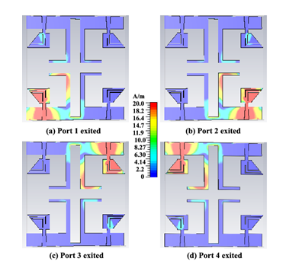
Figure 1: Current distributions of the proposed design
To further improve the isolation between the four antennas, it is improved by etching a rectangular slot that results in a novel inverted L-shaped ground plane. MIMO antenna is manufactured on the FR4 dielectric substrate using the MITS-Eleven Lab PCB machine. Fig 1 demonstrates the four antennas that were constructed as Antenna A, Antenna B, Antenna C, and Antenna D. Different radiator forms were used as the final antenna developed. For excellent UWB performance, (Antenna A) recommends a tapered fed line with an inverted L-shaped ground plane (as shown in fig. 1) on one side of the substrate and a polygon-shaped radiator on the other side.

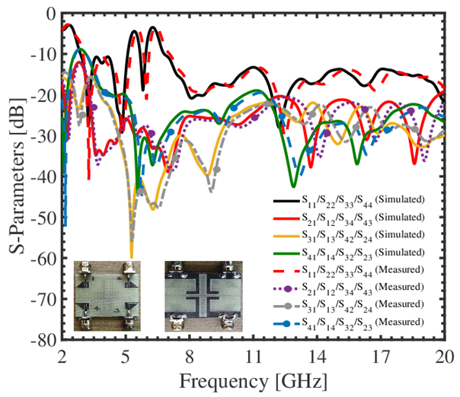
Figure. 2 Simulated and measured S-parameters
Fig. 2 shows an analysis of simulated S11 and frequency for several radiator designs. For the purpose of to decrease interference in the WLAN band, Antenna B's UWB performance was also modified. With the goal to suppress the WLAN band (5.09-5.8 GHz) in the UWB band, a simple L-shaped slit is etched into the radiator's upper portion as shown in Fig. 1. The bottom portion of the radiator gets etched with an L-shaped slit (see Antenna C) to decrease interference at higher IEEE INSAT/Super-Extended C-band frequencies (6.3-7.27 GHz). The simulated S11 is illustrated in Figure 2 for every contour that was applied to construct the final design.

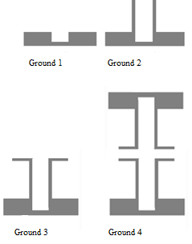
Figure 3: Evolution of the ground plane
The evolution geometry of the ground plane for the recommended MIMO antenna is demonstrated in Fig. 3. Since all of the antenna elements are the same, the S11 and S12 can be matched to the S22 and S21. In addition, there is very little isolation between the antennas. The resonance has been shifted to 3.7 GHz the ground plane (Ground 2), despite the fact that the mutual coupling for Ground 2 in the frequency band below 4 GHz is extremely low, by installing two vertical rectangular strips. In addition, using inverted L-shaped strips in the ground plane leads to a lower resonance frequency of 3.2 GHz with a lowest cut-off frequency of 2.9 GHz, as seen in Ground 3. The mutual coupling is greatly reduced throughout the range (2.9–20 GHz) by these inverted L-shaped strips
- MIMO PERFORMANCE
The envelope correlation coefficient (ECC), diversity gain (DG), mean effective gain (MEG), and total active reflection coefficient (TARC) are used to evaluate the proposed antenna's MIMO functionality. The envelope correlation coefficient (ECC), which may be determined using S-parameters, can be utilised for investigating the mutual coupling between next to antenna elements along with the level of correlation between each antenna element.

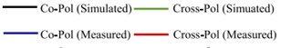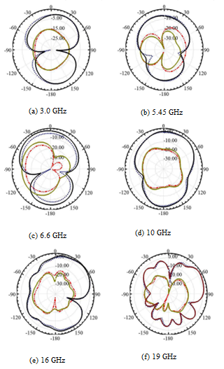
Fig 4 The proposed MIMO antenna's radiation patterns at (a) 3.0 GHz, (b) 5.45 GHz, (c) 6.6 GHz, (d) 10 GHz, (e) 16 GHz, and (f) 19 GHz.
In modern wireless communication systems, MIMO (Multiple-Input Multiple-Output) antenna performance is essential. Several wireless communication technologies, including Wi-Fi (802.11n/ac/ax), LTE, and 5G, use MIMO technology to boost data speeds, improve system capacity, and increase link dependability. Several significant factors influence how well a MIMO antenna system operates, such as: Improvements in diversity, channel capacity, spatial multiplexing efficiency, beamforming and spatial processing, interference reducing, and channel conditions are every aspect that affect spatial multiplexing.
In order to achieve the projected efficiency increases, these aspects must be taken into account all through the design and deployment of MIMO antenna systems. A modern wireless communication system includes MIMO technology as an essential element since it provides it achievable to enhance data rates improve coverage and improve trustworthiness.

- REFERENCES
[1] S. Zhang, Z. Ying, J. Xiong, and S. He, “Ultrawideband MIMO/Diversity antennas with a tree-like structure to enhance wideband isolation,” IEEE Antenna and Wireless Propagation Letters, vol. 8, pp. 1279–1282, 2009.
[2] G. Srivastava and A. Mohan, “Compact dual-polarized UWB diversity antenna,” Microvave and Optical Technology Letters, vol. 57, no. 12, pp. 2951–2955, December 2015.
[3] J. Ren, W. Hu, Y. Yin, and R. Fan, “Compact printed MIMO antenna for UWB applications,” IEEE Antenna and Wireless Propagation Letters, vol. 13, pp. 1517–1520, 2014.
[4] L. Liu, S. W. Cheung, and T. I. Yuk, “Compact MIMO antenna for portable devices in UWB applications,” IEEE Transactions on Antennas and Propagation, no. 8, pp. 4257–4264, August 2013.
[5] J.-Y. Deng, L.-X. Guo, and X.-L. Liu, “An ultrawideband MIMO antenna with a high isolation,” IEEE Antenna and Wireless Propagation Letters, vol. 15, pp. 182–185, 2016.
[6] J.-Y. Zhang, F. Zhang, W.-P. Tian, and Y.-L. Luo, “Acs-fed UWB-MIMO antenna with shared radiator,” Electronics letters, vol. 51, no. 7, pp. 13011302, 2015.

