IMPORTANCE OF PLANKTON IN AQUATIC ECOSYSTEM
Suresh Kumar, Dr. Bharati Veerwal
Department of Zoology, Maharana Pratap Govt. P.G. College, Chittorgarh (Raj.)
Email- sureshkumarberwal@gmail.com
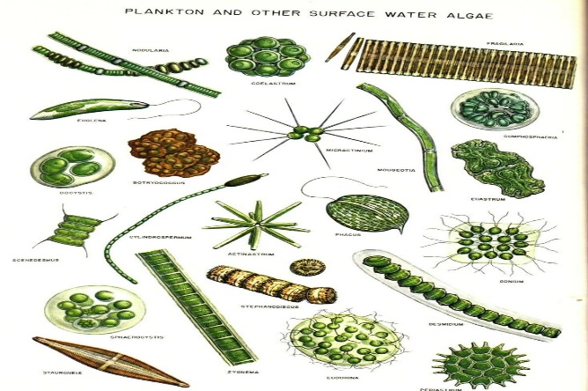
The word 'plankton' is arised from the Greek word 'planktos' which means 'drifting' and is also refered as 'floaters'. Plankton communities evolve in terms of tolerance, abundance, diversity, and dominance in the natural environment in reaction to changes in their environment, which they respond to quickly. Plankton may have a body size of more than 200 micrometers or fewer than 2 micrometers. The category includes many different species of organisms in seawater and freshwater ecosystems. There are two broad group of planktons i.e., Phytoplankton planktonic plants which are producers (capable of photosynthesis) and zooplankton-planktonic animals which are consumers.
Phytoplankton-Being are the earliest organisms to produce energy from light sources like the Sun. Phytoplankton are the primary creators of their environment. Through photosynthesis, they convert acquired light energy into carbohydrates. Approximately 3% of the light shining on the ocean is absorbed by phytoplankton. In contrast, only 15% of the sunlight is absorbed by terrestrial plants.

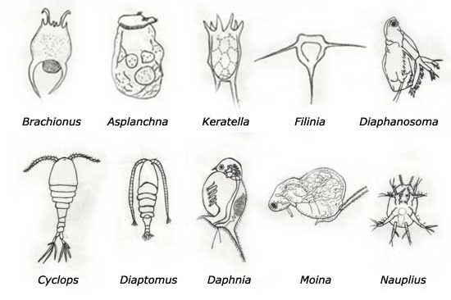
Fig1- Phytoplankton, Weblinkhttps://tinyurl.com/54rbhy2b Zooplankton-Zooplankton are heterotrophic organisms that consume phytoplankton. Since they receive their energy from eating the major providers of energy in their environment, they are secondary consumers. Like phytoplankton, zooplankton utilise a portion of the energy from their food supply for maintenance and save the remainder for consumption by other animals. It could also be a larger animal that grazes on plankton or another zooplanktonic organism. (Marine biodiversity, https://shorturl.at/jsxY1). Aquatic zooplankton is one of the bio-indicator used for assessment in ecological health monitoring of water bodies by most of the research workers (Ismail and Adnan, 2016; Rahkola-Sorsa, 2008; Santos Wisniewski et al., 2006).
Fig2- Zooplankton, Weblink-https://tinyurl.com/pc527zpj

Plankton and the Ecosystem: -

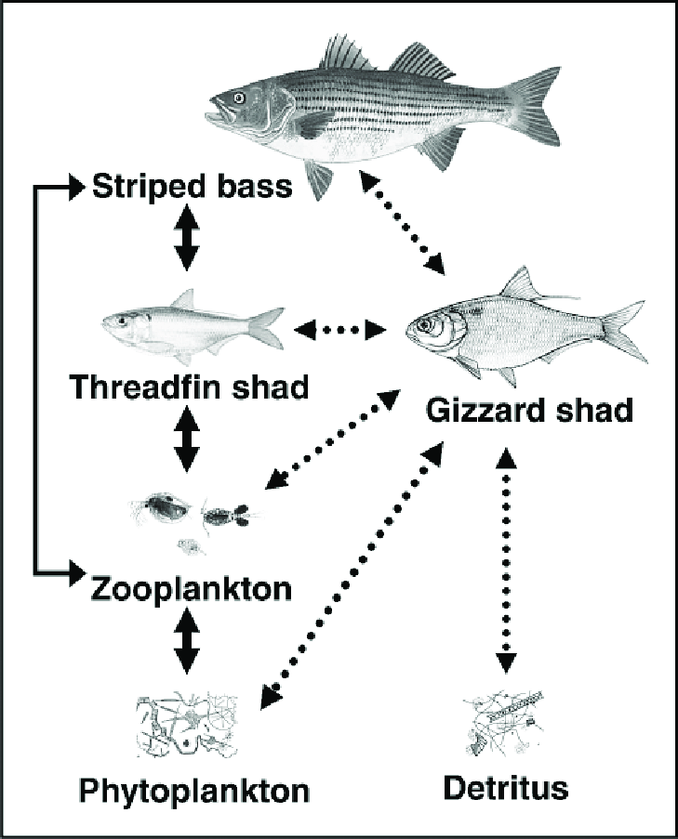
An ecosystem is a complex network of interactions between the biotic and abiotic elements of a specific environment. The biotic component is made up of living things like birds, animals, plants, and microorganisms, whereas the abiotic component is made up of things like land, air, and water. An aquatic ecosystem is defined as a water-based habitat in which organisms interact with physical and chemical parameters in the environment. Aquatic organisms are living things whose basic needs such as nutrition, shelter, reproduction, and others are dependent on the existence of water. Aquatic ecosystems are essential components of the Earth’s biosphere (Hader et al., 2003).
Fig3- Aquatic food chain
Weblink- https://shorturl.at/dfmn
Phytoplankton absorb at least the same amount of atmospheric carbon dioxide as terrestrial ecosystems; they produce more than 50% of the biomass on our planet. (Zepp et al., 2007). Aquatic ecosystem can be divided into two categories: marine ecosystems and freshwater ecosystems (Jim Jansen, https://shorturl.at/sQUX4). The foundation of complex food webs in freshwater and marine ecosystems is made up of primary producers, who also supply energy to primary and secondary consumers. As a result, primary producers play a crucial role in the production of marine mammals, fish, and crustaceans, which are staples of the human staple diet (Hader(a), 2003; Hader(b), 2003; Sinha et al., 2002).
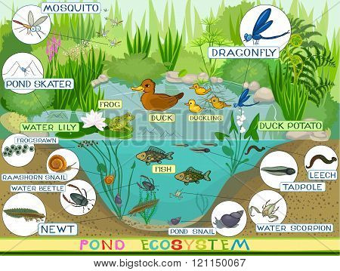
Freshwater ecosystems are the least common, occurring on only 1.8 percent of Earth’s surface. These diverse systems, that consist of lakes, rivers, streams, and springs, are habitat to a wide variety of organisms, such as fish, amphibians, reptiles, birds, and mammals, as well as microorganism, mollusks, and also algae, plants, and phytoplankton are abundant form the basis of the freshwater food web. As a resource, freshwater is used for drinking, agriculture, industry, sanitation, recreation, and transportation.
Fig4- Freshwater ecosystems, Weblink-https://shorturl.at/djK26
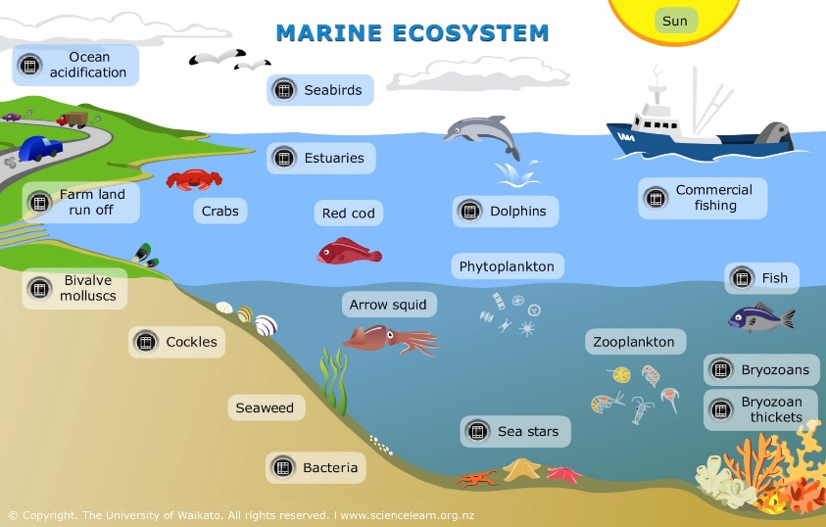
Marine ecosystems are the most common, comprising seventy-five percent of Earth’s surface and can be divided into three categories: shallow ocean, deep ocean water, and deep ocean bottom. Coral reef ecosystems in shallow ocean waters are extremely biodiverse. 40% of all photosynthesis on Earth takes place carried out by phytoplankton, a group of tiny photosynthetic organisms suspended in ocean waters (Biomes chapter. https://shorturl.at/rRV01)
Fig5- Marine ecosystem, Weblink https://shorturl.at/beky2
Due to their wide range of sizes, plankton serve as an important source of food for both animals and other plankton. Even whale sharks, which are among the biggest marine species, mostly eat plankton. Most of plankton is consumed by filter feeders, which filter water through their teeth to feed and then eat the leftovers. Many different animals, including fish, mammals, and squid, are filter feeders. The availability of plankton in the pelagic zone of the water column, which forms the base of the food chain, is essential to maintaining the equilibrium of energy in aquatic ecosystems.
As Health Indicators of Ecosystem: -
The pioneer in the aquatic food chain is phytoplankton. Any aquatic body's biological production can be utilized as a measure of its trophic state and potential for fishery resources. (Jhingan, 1992). Since phytoplankton play a significant role as primary producers and can have an impact on higher trophic levels by supplying as a source of nutrition for zooplankton, which in turn provides food for other organisms in aquatic ecosystem. Aquatic ecosystem health is determined by phytoplankton and zooplankton. In most of the studies that were reported, the abiotic elements of the aquatic environment were closely connected with the diversity and abundance of phytoplankton and zooplankton. Some species were found to be less common because of pollution, but other species were shown to be tolerant of the harsh abiotic conditions present in contaminated bodies, potentially serving as biological indicators in studies to monitor water quality (Jakhar, 2013; Narasimha, 2013; Emmanuel and Onyema, 2007). The physicochemical factors are related with their productions. The phytoplankton is the base of most of the lake food webs and fish production is linked to phytoplankton. Among other factors, their growth and diversity can be controlled by seasonal temperature fluctuations and rising water temperatures (Schabhuttl, 2013).
Reference: -
- Biomeschapter.https://bio.libretexts.org/Bookshelves/Ecology/Environmental_Science_(Ha_and_Schleiger)/02%3A_Ecology/2.05%3A_Biomes/2.5.03%3A_Aquatic_Biomes.
- Emmanuel, B. E. and Onyema, I. C. (2007). The plankton and fishes of a tropical in Creek in Southwestern Nigeria. Turk. J. Fish. Aquat. Sci., 7: 105-113.
- Hader(a), D. P. (2003). Effects of solar ultraviolet radiation on aquatic primary ¨ producers in Handbook of Photochemistry and Photobiology: Photobiology, vol. 4, ed. H. S. Nalwa, American Scientific Publishers, California, USA, pp. 329–352.
- Hader(b), D. P. (2003). UV-B impact on the life of aquatic plants in ¨ Modern Trends in Applied Aquatic Ecology, ed. R. S. Ambasht and N. K. Ambasht, Kluwer Acadameic/Plenum Publishers, New York, pp. 149–172.
- Hader, D. P., Kumar, H. D., Smith, R. C., Worrest R. C. (2003). Aquatic ¨ ecosystems: effects of solar ultraviolet radiation and interactions with other climatic change factors, Photochem. Photobiol. Sci., 2: 39–50.
- Ismail A. H. and Adnan A. A. M. (2016). Zooplankton composition and abundance as indicators of eutrophication in two small man-made lakes. Trop. Life Sciu. Res., 27 (supp1): 31-38. doi: 10.21315/tlsr2016.27.3.5
- Jakhar, P. (2013). Role of phytoplankton and zooplankton as health indicators of aquatic ecosystem: A review. International Journal of Innovation Research Study, 2(12): 489–500.
- Jhingran, V. G. (1992). Fish and Fisheries of India. Hindustan Publishing Corporation, New Delhi, India.
- Jim Jansen, (2019). https://sciencing.com/role-plankton-ecosystem-6461310.html.
- Marine biodiversity. https://daguronachon.wordpress.com/2012/12/30/role-of-plankton-in-an-ecosystem/.
- Narasimha, R. K., and Benarjee, G. (2013). Physico-chemical factors influenced plankton biodiversity and fish abundance-a case study of Nagaram tank of Warangal, Andhra Pradesh. International Journal of Life Sciences Biotechnology and Pharma Research, 2(2): 248-260.
- Rahkola-Sorsa, M. (2008). University of Joensuu, The structure of zooplankton community in large boreal lakes and assessment of zooplankton methodology. Ph.D. diss.,
- Santos-Wisniewski M., Rocha O., Guntzel A., Matsumura-Tundisi T. (2006). Aspects of the life cycle of Chydorus pubescens Sars, 1901 (Cladocera, Chydoridae) Acta Limnologica Brasiliensia, 18(3): 305–310.
- Schabhüttl, S., Hingsamer, P., Weigelhofer, G., Hein, T., Weigert, A. and Striebel, S. (2013). Temperature and species richness effects in phytoplankton communities. Oecologia, 171(2): 527–536.
- Sinha, R. P. and Hader, D. P. (2002). UV-induced DNA damage and repair: ¨ A review, Photochem. Photobiol. Sci., 1, 225–236.
- Zepp, R. G., Erickson, D. J., Paul, N. D. and Sulzberger, B. (2007). Interactive effects of solar UV radiation and climate change on biogeochemical cycling, Photochem. Photobiol. Sci., 6, DOI: 10.1039/b700021a.

