Basic Extraction and Fractionation Procedures for Experimental Purposes of Medicinal plants
Ria Bhar¹*, Amit Gamit²

¹Department of Biotechnology, School of Life Science and Biotechnology, Adamas University, Kolkata, India.
²ICAR-IVRI, ERS, Kolkata-700037

*Corresponding Author
Address for Correspondence:
E-mail addresses: bhar.riya89@gmail.com (R.Bhar)

Abstract:
The preparation of medicinal plants for experimentation is the first and most crucial stage in creating high-quality research outcomes. Before proceeding with the intended biological tests, it is necessary to extract and assess the quality and quantity of bioactive components. The primary purpose of this study was to evaluate the various procedures used in our routine research to produce and screen medicinal plants. Although extracts, bioactive fractions, or compounds derived from medicinal plants are used for a variety of purposes, independent of the biological testing for which they are intended, the techniques employed to produce them are often the same. The important steps in obtaining great bioactive compounds are the selection of an appropriate solvent, extraction techniques, phytochemical screening procedures, fractionation techniques, and identification techniques. The research design totally dictates the types of these treatments as well as the specific course taken. Polar solvents (like water and alcohols), intermediate polar solvents (like acetone and dichloromethane), and nonpolar solvents (like n-hexane, ether, and chloroform) are frequently used in the extraction of medicinal plants. Maceration, digestion, decoction, infusion, percolation, Soxhlet extraction, superficial extraction, ultrasound-assisted extraction, and microwave-assisted extraction are all extraction techniques. Phytochemical substances can be fractionated and purified using several chromatographic techniques such as paper chromatography, thin-layer chromatography, gas chromatography, and high-performance liquid chromatography. Finally, other methods, including nuclear magnetic resonance spectroscopy, infrared spectroscopy, ultraviolet spectroscopy, and mass spectroscopy, are used to identify the molecules. The different approaches mentioned above could be sorted into groups and explained in light of the expected biological tests in order to guide young researchers and aid in their increased concentration.
Keywords: Crude extract, Fractionation, Distillation, Separating funnel, Evaporation,
Introduction:
Medicinal plants can be prepared for experimentation or extracted and processed for direct use as herbal or conventional medicine. Preparing a medicinal plant for experimental purposes includes timely and proper plant collection, expert authentication, appropriate drying, and grinding. The bioactive element is subsequently removed, separated, and isolated as needed. Medicinal plants can be prepared for experimentation or extracted and processed for direct use as herbal or conventional medicine. Preparing a medicinal plant for experimental purposes includes timely and proper plant collection, expert authentication, appropriate drying, and grinding. The bioactive element is subsequently removed, separated, and isolated as needed. Herbal medicines may also be an effective alternative to conventional medication in cases of significant side effects and drug resistance. Extraction of medicinal plants entails isolating active plant components or secondary metabolites such as alkaloids, flavonoids, terpenes, saponins, steroids, and glycosides from inert or inactive components using the appropriate solvent and extraction techniques. Plant products high in phenolic and flavonoid compounds have been found to have antioxidant properties and are thus used to treat age-related disorders such as Alzheimer's disease, Parkinsonism, anxiety, and depression (25). The type of plant material, solvent employed, pH, temperature, and solvent to sample ratio all play a part in determining the best extraction procedure. It also depends on how the finished products will be used. The goal of this research was to compare different extraction solvents, methods, fractionation, and purification techniques, as well as phytochemical screening and identification of bioactive compounds in medicinal plants.

Isolation of plant materials by extraction:
Using a mechanical grinder, coarse powder was created from the dried barks. 20 grams of dry powder were extracted using a magnetic starring machine in 200 ml of organic solvents at 50–60°C, including acetone and methanol. For 48 hours, the extractions went on as usual. The extracts were removed from the solvents using a rotary evaporator, and the resulting crude extracts were kept in sterile amber-colored vials kept at 4°C in a refrigerator until further investigation.
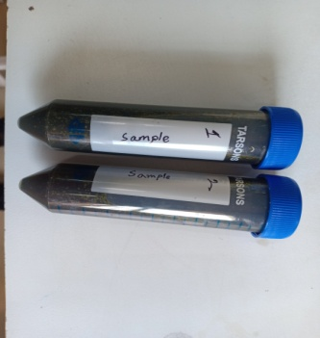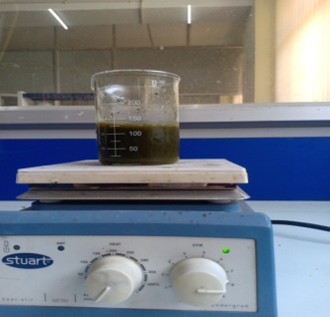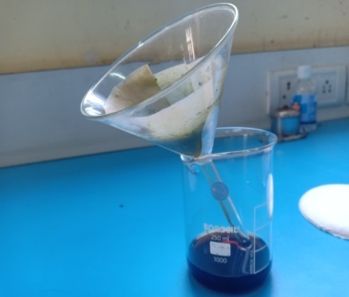
Figure 1: Plant dry Extract Figure 2: Mixed by magnetic Figure 3: Filtration
starring machine
Separation by Fractional Distillation:
The distillation separation method can be used to extract a combination of solids in a liquid. The liquid is heated to create vapours, which are then condensed to create the liquid once more. The liquid that comes from vapour condensation is known as the distillate. Two miscible liquids, like ethanol and water, can be mixed to form a solution. Immiscible liquids do not combine well. Take the contrast between oil and water. A binary mixture of liquids is any two liquids that are miscible with one another in all possible ratios. With enough of a difference in boiling points (B.P.), this method is used to separate the components of a mixture of two miscible liquids that may be heated without decomposing. When heated, a volatile liquid evaporates, but it can be recovered by condensing its vapours when cooled (https://www.geeksforgeeks.org/separation-by-fractional-distillation/).

Fractional Distillation:
To separate miscible liquids that are naturally volatile, fractional distillation is performed. These liquids' boiling points are reasonably near. To mimic the separation, fractionating column equipment is employed. Since the vapor is partially condensed and then returned as a liquid, it is sometimes referred to as rectification. It consists essentially of vaporizing a liquid combination to produce a mixture of elements, which is then followed by the extraction of the desired constituent in its purest form.
Fractionating Column:
The apparatus utilized in this technique differs from that used in basic distillation by a fractionating column that is inserted between the distillation flask and the condenser. A simple fractionating column is a tube filled with glass beads. As a result of the beads, the vapour can repeatedly cool and condense.
The partial condensation of the vapour takes place in a fractionating column during the distillation of the liquid mixture.
vapour from the still that is moving up the column interacts with condensing vapour that is returning to the still. As a result, the more volatile component becomes more enriched in the vapour (1, 9).

Separating Funnel:
A separating funnel is used in the process of separating two immiscible liquids. It is a one-of-a-kind funnel with a stop-cock in the stem that regulates whether liquid flows into or out of it. The separating funnel's ability to separate two immiscible liquids is determined by the various densities of the composing liquids. The lighter liquid stays on top, while the heavier liquid sinks to the bottom.
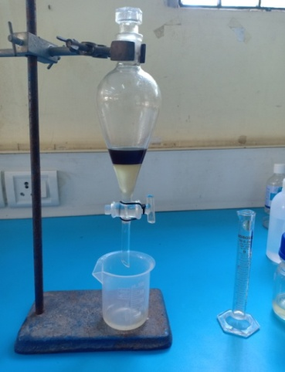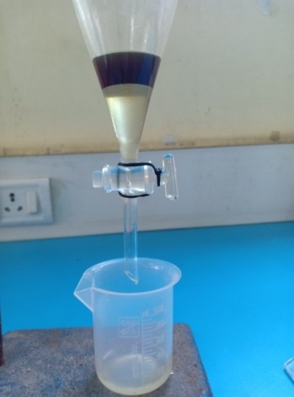
Figure 4: Separating funnel Figure 5: Separated between two immiscible liquid phases.
The components of a combination are separated between two immiscible liquid phases using a separating funnel. Aqueous phase makes up one phase, and an organic solvent makes up the other. The different densities of the liquids provide the basis for this separation. The lower layer is made up of the denser liquid, whereas the top layer is made up of the denser liquid.
The liquid with the lower density floats to the top when the combination is poured into a separating funnel, and when the tap is opened, the liquid with the higher density begins to flow into the container through the separating funnel. Then, just as the liquid with the lower density begins to pour through, the tap is shut. The two immiscible liquids can then be separated by draining the liquid with the lower density that is still in the separating funnel into a new container (1, 5, 9).
Application:
The following mixes can be separated using fractional distillation:
- Acetone and water
- Chloroform and benzene
- Separation of gases of air
Applications of Separating Funnel:
- Removing kerosene and water from a combination.
- separating a gasoline and water combination.
- nut or mustard oil derived from water.
- Chloroform, benzene, mercury, and carbon disulfide from water
Table 1: Difference between Simple Distillation and Fractional Distillation:
Simple Distillation | Fractional Distillation
To separate mixtures of miscible liquids with sufficiently substantial differences between their boiling points, simple distillation is utilized. | When there is little variation between the boiling points, fractional distillation is used.
It comprises of a condenser, two flasks, and a simple equipment. | It is made up of more complicated machinery with a fractionating column.
Example: To purify seawater | Example: Crude oil refining
Separation by Evaporation:
The process of removing a solid from water that has been dissolved in it is known as evaporation. The application is based on the fact that liquids evaporate faster than solids. During evaporation, the solid substance is eliminated and left as a residue. It is a method of vaporization where the liquid transforms into the gaseous phase and leaves behind surface residue. Up until the point of equilibrium, evaporation continues. A liquid will, however, continue to vaporize in an enclosed environment until air saturation is reached. Practically speaking, just a small portion of all molecules have the thermal energy needed to vaporize (https://www.geeksforgeeks.org/separation-by-fractional-distillation/).
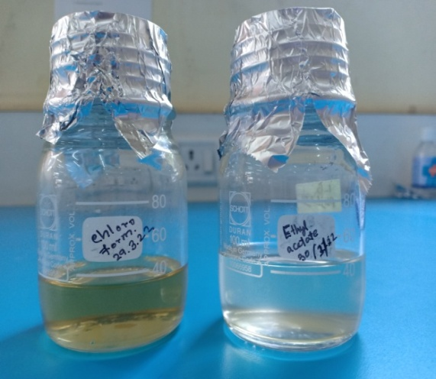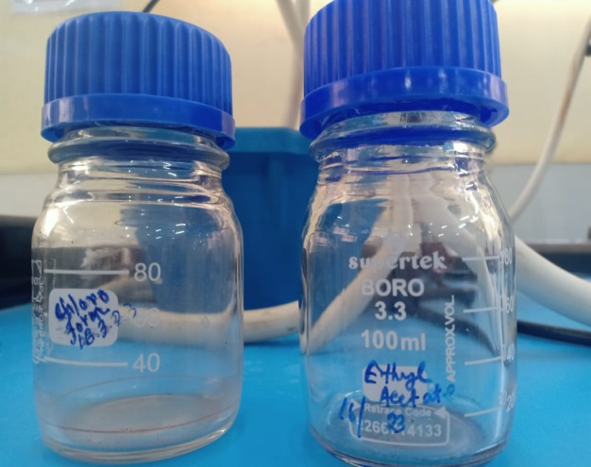
Figure 6: Mixture of a solid dissolves Figure 7: Only solid remains
in a liquid

Conclusion:
Many studies on medicinal plants have been conducted, either to look into and support a claim of biological activity or to replicate its historic medical use based on ethnomedical survey. Successfully extracted, fractionated, and isolated chemicals from numerous therapeutic plants. Additionally, the produced compounds were examined for biological or pharmacological action, and they were typically found to be active. The accuracy, with which solvents are chosen, methods are chosen and executed, phytochemical screening, fractionation, and identification procedures are used, however, determines the rate of success and the reliability of these findings. Finally, proper comprehension and use of these tactics is required. The research process will be sped up and the final product will be improved if these strategies are improved and adjusted on a regular basis.
Acknowledgments: This work was supported by a grant of the Adamas university seed grand letter no. AU/R&D/SEED/28/03-2020-21.
Reference:
1. Ingle KP, Deshmukh AG, Padole DA, Dudhare MS, Moharil MP, Khelurkar VC. Phytochemicals: Extraction methods, identification, and detection of bioactive compounds from plant extracts J Pharmacogn Phytochem. 2017;6:32–6.

2. Azwanida NN. A review on the extraction methods use in medicinal plants, principle, strength, and limitation Med Aromat Plants. 2015;4:196.

3. Pandey A, Tripathi S. Concept of standardization, extraction, and pre-phytochemical screening strategies for herbal drug J Pharmacogn Phytochem. 2014;2:115–9.

4. Doughari JHVenketeshwer R. Phytochemicals: Extraction methods, basic structures, and mode of action as potential chemotherapeutic agents, phytochemicals––a global perspective of their role in nutrition and health A Global Perspective of Their Role in Nutrition and Health.2012.

5. Sasidharan S, Chen Y, Saravanan D, Sundram KM, Yoga Latha L. Extraction, isolation and characterization of bioactive compounds from plants’ extracts Afr J Tradit Complement Altern Med. 2011;8:1–10.

6. Rungsung W, Ratha KK, Dutta S, Dixit AK, Hazra J. Secondary metabolites of plants in drugs discovery World J Pharm Res. 2015;4:604–13.

7. Sofowora A. The present status of knowledge of the plants used in traditional medicine in western Africa: A medical approach and a chemical evaluation J Ethnopharmacol. 1980;2:109–18.

8. Rimando AM, Olofsdotter M, Dayan FE, Duke SO. Searching for rice allelochemicals: An example of bioassay-guided isolation Agron J. 2001;93: 16–20.

9. Das K, Tiwari RK, Shrivastava DK. Techniques for evaluation of medicinal plant products as antimicrobial agents: Current methods and future trends J Med Plants Res. 2010; 4: 104–11.

10. Altemimi A, Lakhssassi N, Baharlouei A, Watson DG, Lightfoot DA. Phytochemicals: Extraction, isolation, and identification of bioactive compounds from plant extracts Plants. 2017;6 :42.

11. Majekodunmi SO. Review of extraction of medicinal plants for pharmaceutical research MRJMMS. 2015; 3: 521–7.

12. Tiwari P, Kumar B, Kaur M, Kaur G, Kaur H. Phytochemical screening and extraction: A review Int Pharm Sci. 2011;v 1:98–106.

13. Cowan MM. Plant products as antimicrobial agents Clin Microbiol Rev. 1999; 12: 564–82.

14. Bhan M. Ionic liquids as green solvents in herbal extraction Int J Adv Res Dev. 2017; 2: 10–2.

