SERICULTURE
SAMPAD BHUYAN, BARSHA PRIYADARSHINI, PRIYANKA PRIYADARSHNI, AKANKHYA MOHAPATRA
Corresponding author: priyankapriyadarshini63@gmail.com
PG STUDENT OF C.V. RAMAN GLOBAL UNIVERSITY, BBSR, INDIA 752054

ABSTRACT: Sericulture, the art of silk farming that embraces a prominent place in human history, dating back thousands of years. This practice involves the cultivation of silkworms and the extraction of their precious silk threads, which have been respected for their elegant properties and luxurious cultural significance.
The history of sericulture includes ancient civilizations in China, India, and other regions, where it became a sign of wealth, trade, and cultural exchange. After so many years the knowledge of silk production spread across different parts of the world, expansion connections between diverse societies.
The process of sericulture begins with the careful rearing of silkworms, primarily the species Bombyx mori, in a controlled environment. These insatiable eaters feed exclusively on mulberry leaves, on molting stages before cocooning themselves with a continuous silk thread. After maturation, skilled silk farmers harvest the cocoons and carefully extract the silk fibers, the length can be 900 meters from a single cocoon. The threads are then reeled, combined, and spun into thicker strands, which results in magnificent silk fabric known for its softness and sheen. Sericulture holds substantial economic value outside its historical and cultural significance. Millions of people worldwide rely on silk farming for their livelihood. The silk industry has also applications in medicine, cosmetics, and high-tech sectors. Despite the availability of synthetic alternatives, sericulture continues to be practiced in numerous countries, preserving its rich cultural heritage and economic importance.
KEYWORDS
History, Silk, cocoon, industrial value, economical value, employment, current scenario
INTRODUCTION:
What is sericulture?
It is an agro-based industry. By certain species of insects the yarn comes out of cocoons and it includes rearing of silkworm. To feed the silkworms cultivation of certain food plant includes which is a major activities of sericulture. Unwinding the silk filament by reeling the cocoons for benefit includes . In sericulture industry Bombyx mori is the widely used species that studied intensively.
What is silk?
Silk is marked as a luxurious item and man is always curious for these products. In textile industry silk is marked as queen . Silk in society resembles luxury , class , elegance and comfort. Silk is made up of protein which is secreted by a caterpillar which is known as silkworm. Only on selective food plants silkworm feed on and make a protective shit known as cocoons .
Why sericulture?
In tribal areas Tasar is the employment generation which is the special benefit of sericulture.
1.High employment potential
60-100 lakh person are indulged in various sericulture activities in the country. About 57% of the gross value of silk fabrics flows back to the cocoon growers with share of income.
cocoon grower- 56.8%
The reeler 6.8%
The twister 9.1%
The weaver 10.7%
16.6% to the trade Thus, large chunk of income goes back to the villages from the cities.

2.Low gestation and high returns
Mulberry plants need only six months to grow for beginning of silk worm. Once mulberry planted will go on supporting silkworm rearing after year for 15-20 years.
3.woman friendly occupation
In downstream activities of sericulture woman constitute over 60% of employment. This is possible due to sericulture activities starting from mulberry garden , leaf harvesting and silkworm rearing is more effectively taken up by the woman.
4. With low land areas sericulture can be possible. One acre of mulberry garden can support five family.
Throughout history, sericulture has been a bridge connecting cultures and civilizations, as the trade and knowledge of silk production spread from Asia to Europe and the rest of the world. Today, despite advancements in technology and the availability of synthetic fibers, sericulture continues to be practiced in many countries, preserving its cultural heritage and economic significance

History of sericulture
Although Confucian texts place the invention of silk manufacture around 2700 BCE, archaeological evidence suggests that the fabric was first cultivated beginning as early as the Yangshao period (5000-3000 BCE). The first known instance of sericulture can be found on a piece of porcelain made between 5400 and 5500 years ago in Nancun, Hebei, and was designed to resemble a silkworm.Based on comprehensive examination of ancient silk fibre unearthed on Indus Civilization sites dating back to 2450-2000 BCE, it is also considered that silk was used throughout a vast area of South Asia. It eventually made its way to ancient Khotan via a series of contacts on the Silk Road around the first half of the first century CE. The tradition was India by the year 140 CE. Byzantine textile, which began in the Mediterranean in the sixth century AD as a result of silkworm eggs smuggled into the Byzantine Empire, experienced a long-term monopoly within the Byzantine Empire. While on the Second Crusade, Roger II of Sicily (1095-1154) invaded Corinth and Thebes, two important Byzantine silk producing locations, in 1147. He stole the weavers’ tools and set up his own silkworks in Palermo and Calabria, eventually spreading the trade to Western Europe.

Indus valley civilization
Recent archaeological discoveries at Harappa and Chanhudaro indicate the existence of sericulture in South Asia between 2450 BC and 2000 BC, which most likely utilised wild silk strands produced by native silkworm species. Antheraea and Philosamia, two species utilised to produce Indus silks (eri silk), were used in a variety of applications. Antheraea assamensis and A. paphia textile were commonly used. Harvard University researchers evaluated the silk fibre unearthed in the two Indus valley cities of Harappa and Chanhudaro and published their findings in the journal Archaeometry. The fibres which were treated using Chinese-style degumming and reeling procedures, were dated between 2450 and 2000 BCE. SEM micrographs of the fibres indicated that a portion of the fibres were spun followed the The silk moth was permitted to explode free from its cocoon, similar to the way the great leader Mahatma Gandhi proposed ahimsa silk. Silk weaving has also been attested in Nevasa since 1500 BC, and a guild of silk weavers is referenced in the fourth-century BC Arthashastra. Gupta inscriptions also mention this guild. During the Gupta ages, India was a notable silk exporter, with the majority of the silk being spread throughout the Indian Ocean commerce. The Byzantine Empire desired the Silk Route not only for the obtaining of silk, but also for the advancement of silk weaving throughout Western Asia and Europe. The Romans imported all of their silk from India, but the Persians monopolised the Indian silk trade.
Cultivation first appeared in India in 140 AD. It later spread to Europe, the Mediterranean, and other Asian countries.Tippu Sultan, often known as the Tiger of Mysore, is widely regarded as the originator of the the south Indian state of silk industry. In 1785, he brought individuals to Bengal to acquire knowledge of sericulture and establish it in his Mysore Kingdom. He desired for “Mysore to be the foremost silk-producing nation.”
According to a history concerning the 27th century BC, silk was discovered by accident. On the basis of folklore, Empress Leizu was drinking tea although a silk worm’s cocoon mistakenly fell into her cup.In its attempt to observe released the cocoon’s thread was beginning unravel. The Empress consequently regarded weaving the thread. The Yellow Emperor challenged his wife to discover concerning the life of a silk worm, and as a result, she learned about sericulture—the practise of raising silk worms. The silk industry began as a result of her entourage receiving instruction as well.
For a very long time, the Chinese kept the availability of silk a secret in the rest of the world. The routes known as the Silk Roads or Silk Routes that connecting the region known as the Mediterranean, North Africa, and Europe were not established across Asia until the latter second of the first thousand BC. In the beginning, cultures like India and Japan immediately embraced the eastern silk exclusive after discovering the trade of sericulture.

Process involved in sericulture
Sericulture is a high-skilled manufacturing that combines agricultural and industrial processes. Sericulture, as an agricultural organisation method, has tremendous economic implications for the rural community. It has the potential to become a job-creating industry, particularly in towns and villages.Sericulture is a type related to agriculture that has been practised in India for ages. The labor-intensive sector is one of India’s primary strengths, drawing customers with a higher standard and excellence that no other country can match.
Silk has long been popular, and it has been an essential part of worldwide fashion developments in recent years. Sericulture is a complex industry that includes the manufacture of mulberry leaves production, silkworm rearing (cocoon production), silkworm egg production, silk reeling (yarn production), twisting, and warp and weft production, printing and dyeing, weaving, finishing, garment design, marketing, and so on.Agro-based sericulture has been practised in India for millennia. India’s labor-intensive sector retains one of its primary competitive advantages, with its most elegant talents and quality that no other nation has ever been able to match. Silk has alwayss been popular, and it continues to play a vital role in current global fashion trends. Sericulture is a multidisciplinary activity that comprises mulberry leaf cultivation, silkworm rearing (creation of cocoons), and other activities.

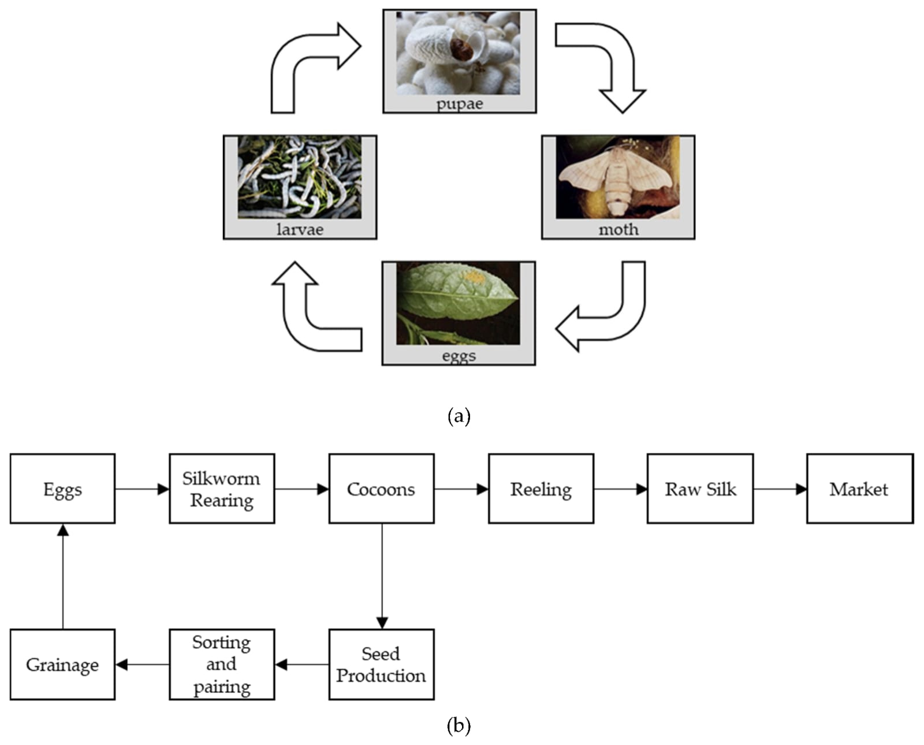

The silkworm caterpillar creates a”cocoon by surrounding itself in a long, continuous fibre, or filament. When the insect is approached by air, liquid secretions from two large glands within the insect emerge across the spinneret, a single exit tube in the head, forming twin filaments of fibroin, a protein substance. A second pair of glands releases sericin, a sticky substance that connects the two strands. Because an emerging moth could break the cocoon strand, the larva can be eliminated in the cocoon by steam or hot air during the chrysalis stage.
Pure silk is silk that includes sericin. The sticky component should be protected until it reaches the yarn or fabric stage, following which it should be removed by boiling the silk in soap and water, leaving it soft and glossy with a weight decrease of up to 30%. Spun silk is made by twisting together short lengths of silk extracted from affected cocoons or broken off during the process of production. The thickness of silk filament yarn is measured in denier, which is the number of grammes of weight per 9,000 metres (9,846 yards) of length. Weighting is a procedure that involves processing silk with a finishing agent, such as metallic salts, in order to increase weight, density, and drape quality.

There has long been an incentive to establish methods for manufacturing silk that is stronger and more elastic than silkworms or common sericulture techniques. The addition of spider silk genes into the silkworm genome has been one method; spider silk is known for its exceptional strength and elasticity, but it cannot be mass produced by farming spiders. Silkworms that have been genetically engineered spin a robust composite silk with many applications.

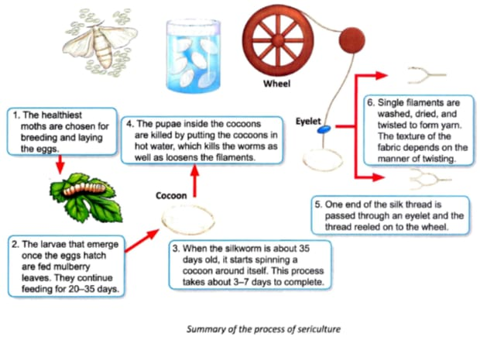

Challenges Faced in sericulture

a) Challenges of Indian silk Industry:-
:- Products are becoming less in demand in the US and Europe.
:- Fabric and raw silk are becoming more expensive.
:- The market for synthetic fibres is becoming more competitive.
:- Additionally, competition is shown with silk-blend fibres.
:- In the Indian market, it is getting harder to find high-quality raw silk.
:-In terms of premium raw silk and silk products, China is a competitor.

b) Sericulture's difficulties and future in Kenya:-
-: Despite the industry's seemingly endless potential, sericulture has only just been introduced in Kenya, over forty years ago.Through live interviews and completed questionnaires, a random sample of respondents provided information on the difficulties faced by the research and extension organisations (International Centre of Insect Physiology and Ecology (ICIPE) and Kenya Agricultural Research Institute (KARI)) and stakeholders in the sericulture industry value chain.It was determined that the industry is currently characterised by negligible cocoon production quantities that are unable to maintain the local and global market. As a means of reducing poverty, silkworm raising is primarily carried out by individuals and a few self-help farming organisations made up primarily of women and young people. Poor agricultural, silkworm-rearing, and cocoon-reeling technologies frequently result in low-quality cocoon and silk thread. According to preliminary statistics, farmers mostly struggle with the following issues: inadequate quality control tools and methods (87%), a lack of technical skills (74%), and a lack of investment money (62%). As a result, it was discovered that despite efforts to advance sericulture in Kenya, some obstacles jeopardise its future.
Economic and Industrial value:-
a)Indian sericulture industry for sustainable rural economy:-
In Indian, silk is a way of life and no ceremoney is complete without it. It is an integral component of Indian culture and traditions. The science and practise of making silk is known as sericulture. It has been in Indian from the second century BC and is a very old industry. India has histrocically been a rural nation, and because more than 70% of the population depends on agriculture and related farm operations for their survival, the country’s economy is heavily reliant on these industries.
b) Economic analysis of sericulture: Raigarh District, Chhattisgarh, India:-
Due to its short gestation periods, low capital requirements, high employment potential, and rapid return on investment, sericulture the cultivation of silk worms and ultimately silk fiber has emerged as promising rural industry in India. Sericulture is split into the farm and industry sectors. Growing food plants for silkworms and raising them to generate cocoons and eggs both part the farm industry. The industry sector is made up of reeling, twisting, dying, printing, finishing and knitting. Per square metre of land, sericulture produces a lot of work and cash. Sericulture offers many opportunities for improving human resource employability and can successfully slow down population migration to cities.
c)Sericulture industry in India:-
Given that the majority of the world’s poor still live in rural areas, such as India, eradieating rural poverty remains a top priority for emerging nations. According to estimates from the world bank, more than 70% of the world’s impoverished reside in rural areas. Rural employment generation is one of the main solutions that have been used to date to solve this issue. However, the agriculture industry has had to deal with a variety of issues that have hindered its ability to create more new jobs in rural areas. Rural employment generation is one of the main solutions that have been use3d to date to solve this issue. However, the agriculture industry has had to deal with a variety of issues that have hindered its ability to create more new jobs in rural areas. An effort has been made to develop a strategy model to support and strengthen India’s sericulture industry in order to increase silk production and quality, among other things. This article will be useful in identifying the sericulture industry’s potential, strengths, and challenges in India so that appropriate policies and strategies for socioeconomic development can be developed.

d)Sericulture as a profit-based industry :-
Sericulture, which combines industrial and agricultural activities, is one of the labour-intensive sectors. As an agro-based business, sericulture significantly influences the economic future of the rural population. Sericulture is agro-based industry, practiced in India for many centuries. Agro-based sericulture has been practised for many millennia in India. With its most beautiful craftsmanship and beauty that no other nation has ever been able to match, India’s labour-intensive industry continues to be one of its core competitive advantages. Since it has always been in style, silk has continued to play a significant role in current global fashion trends. Mulberry leaf production, silkworm rearing (producing cocoons), silkworm egg production, silk reeling (producing yarn), twisting, warp and weft production, printing and dyeing, weaving, finishing, designing clothing, marketing, etc. are all part of sericulture, a multidisciplinary activity. This cottage and small-scale sector activity is labour-intensive, focused on farms, and commercially appealing. It is especially suited to farmers, business owners, and artisans who operate in rural areas because it takes little capital but has the potential for relatively larger returns.
Current Scenario of Sericulture in India
Sericulture is well known as the Queen of Textile.This whole study is based Secondary source of data, it is Obtained from central silk board, Mysore. Karnataka. The study of maintained that India has produced 28523 metric tons of raw silk during the 2015-2016. As far in silk production sericulture industries have been newly established in Brazil,Egypt,Bulgaria and Madagascar too. The major production is done in Asia with an approx of 90% mulberry products and almost 100% non mulberry silk.

For the production of silk, Sericulture is referred as the art of rearing. India has been ranked in the 2nd position in terms of silk production. Karnataka is considered as the highest sericulture producing state in India. In our country India sericulture has major rearing states like Tamil Nadu,Andhra Pradesh,West Bengal, Assam,Jammu and Kashmir.It produced 4 varieties of silk in 2020-21. Among them, Mulberry accounted for 70.72℅(23,860 MT), Tasar has 8.02℅(2,705 MT), Eri 20.55℅(6,935 MT) and Muga 0.71℅(239 MT) of the entire raw silk production of 33,739 MT(provisional). In Indian market size has reached INR 451.6 billion in 2022 in sericulture. Hopefully IMARC group expects the market to reach INR 1,194.5 Billion by 2028, expositing a grwoth rate (CAGR) of 17.7℅ during 2023-2028. Simultaneously, the states experience challenges like price inconsistency of cocoon, insufficient of storage facility, lack of proper market, races difficulties in financial support and many more. In our country there is very good prospect in terms of activities related to sericulture. Accordance to this trend in future the state will become 65℅ bi-voltine silk worms rearing in mulberry. Sericulture is labour intensive, which refers to a process or industry that requires a large amount of labours to produce it's goods and services.
Conclusion
Sericulture or silk farming is the process of developing silk from the silkworms insects.
Agro-base of rural industries are increasing rapidly in India which is very important to sericulture. In India, Morus alba is commonly used to obtained high quality silk used sericulture is beneficial in various aspects. More, over it is budget friendly provides self employment and high income platforms to marginal farmers also it educate of the unemployed youth in varied sectors.As it involves the high investment required in the collection and manufacturing of silk, Nowadays silk textiles has become a symbol of status.Silk is involved in the production of silk, cartridge bags, telephone cable insulation for dying, screen printing etc.The future aspects of silk is enhance the quality and quantity production of seed cocoon and reeling cocoons with economic supports. Silk farming makes the silk weaving. sector & from by providing training and diversification. Sericulture intensify, the silk tourism in the state in convergence with the Tourism Mission. It nourish the muga production in the state by encouraging valve addition. It also put forward the technology upgradation among the sericulture farmers. Sericulture brings significant change in various the spheres like socially, economically and culturally also,in
both the areas rural as well as urban with unique features. As we know, India's most famous handloom is Mysore silk, which makes Karnataka special. India's second-largest weaver aver population is Odisha, which has variety and larged mainly inspired by tribal communities, which is the third greatest in India. With an exquisite weaving caving offering a unique identity, the state's textiles represent its cultural identity. Most famous weavs of Odisha is Sambalpuri ikat weavers which are made by complex method called bandha.One of the best silk is Tassar silk which is produced in Sambalpur, Mayurbhanj and many places of Odisha.
There are variety of Paata which is also weaved in Odisha like Berhampuri paata, Bomkai silk, Khandwa paata and many more.The production of these items will enhance the economic state of the country by trading by at the improvements and development of relationship between the countries, hence the country's aspects will be better benifited.
ACKNOWLEDGEMENT
This work is guided by our lecturer DR. R. PRAVALLIKA SREE .
We thank C.V RAMAN GLOBAL UNIVERSITY for giving us this opportunity.
CONFLICT OF INTEREST
The authors declare no conflicts of interest.
REFERENCES
1.Annual report (2009-10) Central silk Board, Ministry of Textiles, Government of India
2. Seri Business Manual – A user’s guide (Farm sector), Central Silk Board publication, Bangalore.
3. T H Somashekar (2005) Keynote address on Indian Silk Industry - Future prospects and challenges in view of
globalization
4. http://www.ffymag.com/admin/issuepdf/17-22_silk_dec11.pdf (Vigneshwara Varmudy Silk Industry: Need to
become competitive, Market survey)
5. http://silkmarkindia.com/
6. http://www.csb.gov.in/assets/Uploads/pdf-files/Note-on-SERI.pdf
7. http://news.oneindia.in/2006/12/28/exhibition-to-showcase-indian-varieties-of-non-mulberry-silk-
1167282649.html
Vigneshwaravarmudy, “Silk Industry: Need To Become Competitive”, Facts For You, December 2011, pp. 18-19.

Geetha, G. S. Srinivasa, G. Jayaram, M. N. S. Iyengar and N. B. VijayaPrakash, “Socio-Economic Determinants of Farmer Oriented Technology Packages for Sericulture: A Field Study”, Indian Journal of Sericulture, Vol. 40, No.1, pp. 96-99, 2001.

R. Anitha, “Indian Silk Industry in the Global Scenario”, EXCEL International Journal of Multidisciplinary Management Studies, Vol. 1, No. 3, pp. 100-110, December 2011.
Gangopadhyay, Debnirmalya, Sericulture Industry in India – A Review (September 14, 2009). India Science and Technology (Online) 2008,

