Dielectric Behaviour of CuO Nanoparticles at Elevated Temperatures

Vinayakprasanna N. Hegde
Vidyavardhaka College of Engineering
Mysuru, India
vinayak.phy@vvce.ac.in

ABSTRACT
Copper Oxide (CuO) nanoparticles were synthesized by the solution combustion method. The crystal structure and crystallite size of the particles were determined using X-ray diffraction (XRD). The dielectric properties of CuO nanoparticles were carried out at room and elevated temperatures. The variation of the ac conductivity (σ_{dc}), dielectric constant (k), dielectric loss (tanδ) and impedance (Z) were studied as a function of frequency and temperature. The results showed that dielectric properties of the prepared nanoparticles were depending on frequency and temperature.

Keywords—CuO; nanoparticles; XRD; dielectric; coductivity

INTRODUCTION

In the realm of nanomaterials research, the investigation of structural, dielectric, and AC conductivity properties holds paramount significance, shaping technological advancements across various domains [1-4]. This research paper delves into a comprehensive exploration of CuO nanoparticles, probing their multifaceted characteristics and potential applications. At the forefront of the nanotechnology landscape, CuO nanoparticles have garnered substantial attention due to their unique properties arising from size effects and increased surface-to-volume ratio. The article embarks on a meticulous analysis of the structural attributes of CuO nanoparticles, unravelling the intricate crystallographic arrangements that underscore their behavior. Dielectric properties constitute a pivotal aspect, governing the material's response to electric fields and paving the way for electronic, photonic, and energy storage applications. By delving into the dielectric characteristics of CuO nanoparticles, this study sheds light on their polarization mechanisms and electronic interactions, thereby contributing to the burgeoning field of dielectric nanomaterials. Furthermore, the research delves into the AC conductivity properties of CuO nanoparticles, elucidating their behavior in alternating electric fields. This facet bears substantial relevance for applications such as sensors, capacitors, and electronic devices [5]. The investigation presented in this chapter encompasses both experimental findings and theoretical insights, fostering a holistic understanding of CuO nanoparticles' behavior. This research amalgamates structural elucidation with dielectric and AC conductivity analyses, offering a profound comprehension of CuO nanoparticles' intrinsic attributes.

EXPERIMENT

Synthesis
The copper (II) nitrate trihydrate Cu(NO₃)₂·3H₂O and glycine C₂H₅NO₂ were used for the synthesis of copper oxide nanoparticles. The copper (II) nitrate trihydrate (Cu(NO₃)₂·3H₂O) is an oxidizer and glycine (C₂H₅NO₂) is a fuel. A stoichiometric composition of redox mixture is dissolved in double distilled water and stirred at a constant speed for 1 h to form a homogenous mixture. Subsequently, the blend was subjected to heat using a furnace, and upon reaching the ignition temperature, it spontaneously ignited, propelling gases vigorously in a substantial volume to yield a finely powdered product. The resulting powder was calcinated at 750ºC, thoroughly milled and subjected to characterization to investigate its properties.

Characterization
The XRD patterns of the synthesized samples were obtained using CuKα radiation (λ=1.54Å), the 2θ range used was from 20 to 80°. The dielectric constant and the dielectric loss of the pellets of CuO nanoparticles in disk form (Diameter: 10mm, Thickness: 2mm) were studied at different temperatures (30, 50, 100, 150, 200 ºC) in the frequency range of 50 Hz to 1 MHz. The computer interfaced NF LCR meter (Model: ZM-2376, Make: Japan) was employed to study the ac conductivity (σ_{dc}), dielectric constant (k), dielectric loss (tanδ) and impedance (Z) of the prepared samples.

RESULT AND DISCUSSION

Structural Properties
The structural properties of the prepared nanoparticles were studied using X-ray diffraction. Figure 1 shows the XRD pattern of the CuO nanoparticles. The broad peak indicates the nanocrystalline behavior of the particles. The crystallite size was calculated using Scherrer formula [6]. The synthesized nanoparticles have good crystallinity, and the average particle size obtained using the diffraction pattern was 26 nm. The high intensity peak was observed and compared with the JCPDS card no (89–5895).
Figure 1: XRD Pattern for CuO nanoparticles. unavoidable.

Dielectric Properties
Dielectric investigations illustrate how temperature and frequency impact the conduction phenomenon within nanostructured materials. The behavior of dielectrics offers a valuable approach to scrutinizing the electrical characteristics of grain boundaries. The dielectric characteristics of substances predominantly stem from various polarizations: electronic, ionic, dipolar, and space charge. Among these, the preeminent impact on bulk polycrystalline materials emerges from electronic polarization, manifesting within the optical frequency spectrum. Following this is the influence of ionic polarization, which arises due to the relative displacement of positive and negative ions. Dipolar polarization, or orientation polarization, materializes from molecules possessing a lasting electric dipole moment that can alter their orientation in response to an electric field. Furthermore, space charge polarization arises from molecules carrying a sustained electric dipole moment that can reorient upon application of an electric field. Fundamental electrical characteristics of CuO nanoparticles are encapsulated by dielectric parameters, including the dielectric constant (εr) and dielectric loss (tanδ). Analyzing variations in the dielectric constant and loss concerning frequency and distinct temperatures uncovers the electrical mechanisms transpiring within CuO nanoparticles. These parameters have been diligently gauged to unravel the underlying phenomena.
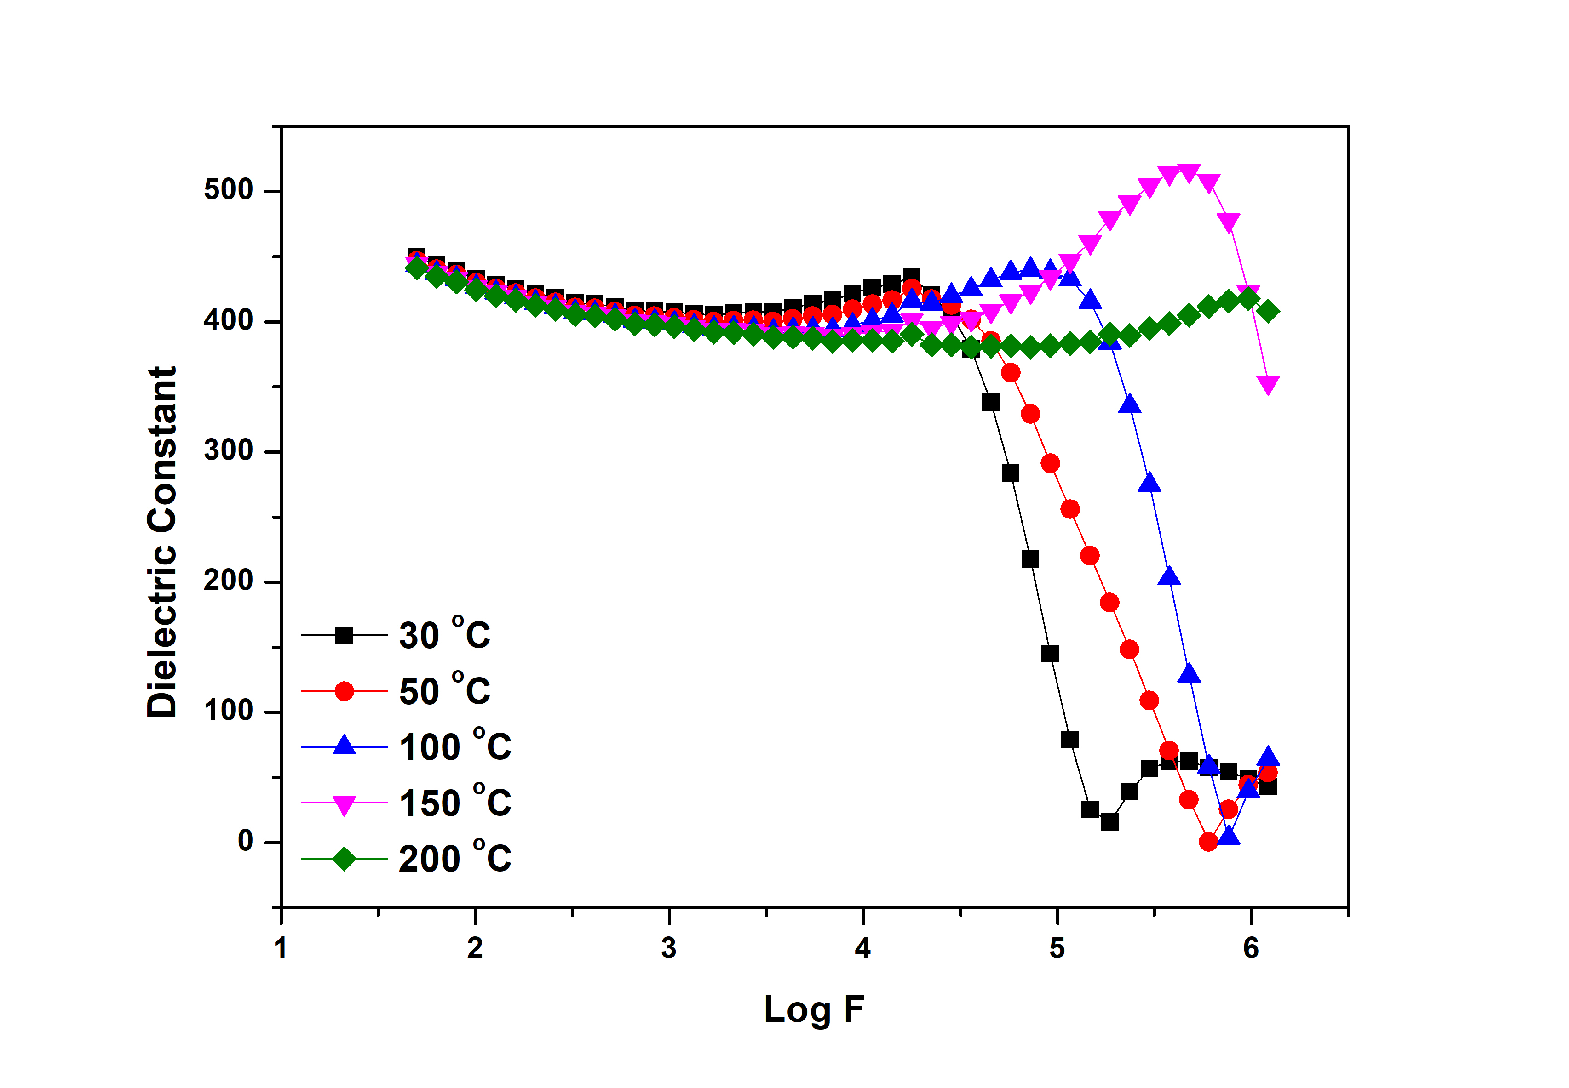
Figure 1: Dielectric constant as a function of frequency.
Variation of the dielectric constant with frequency at different temperature is shown in Figure 1. From the figures it is observed that the dielectric constant is found to decrease with increasing frequency. The charge carriers are bound to different localized states and would have different dipole orientations in the absence of AC field. In the presence of an AC field, a charge carrier can hop between a pair of these centers and leads reorientation of an electric dipole. This results in frequency dependent complex dielectric constant which represents the amount of energy stored in a dielectric material as polarization and the energy loss [7]. Therefore, the decrease of dielectric constant as frequency increases. It is also observed that the dielectric constant increases with the increase in temperature. This is due to the fact that the increase in temperature results in sufficient thermal excitation energy obtained by the bound charge carriers, which enhances the polarization leading to the increase in the dielectric constant [8]. The temperature increases, the dipoles relatively become free, and they respond to the applied electric field. Consequently, the polarization increased, and hence dielectric constant also increases with the increase in temperature.
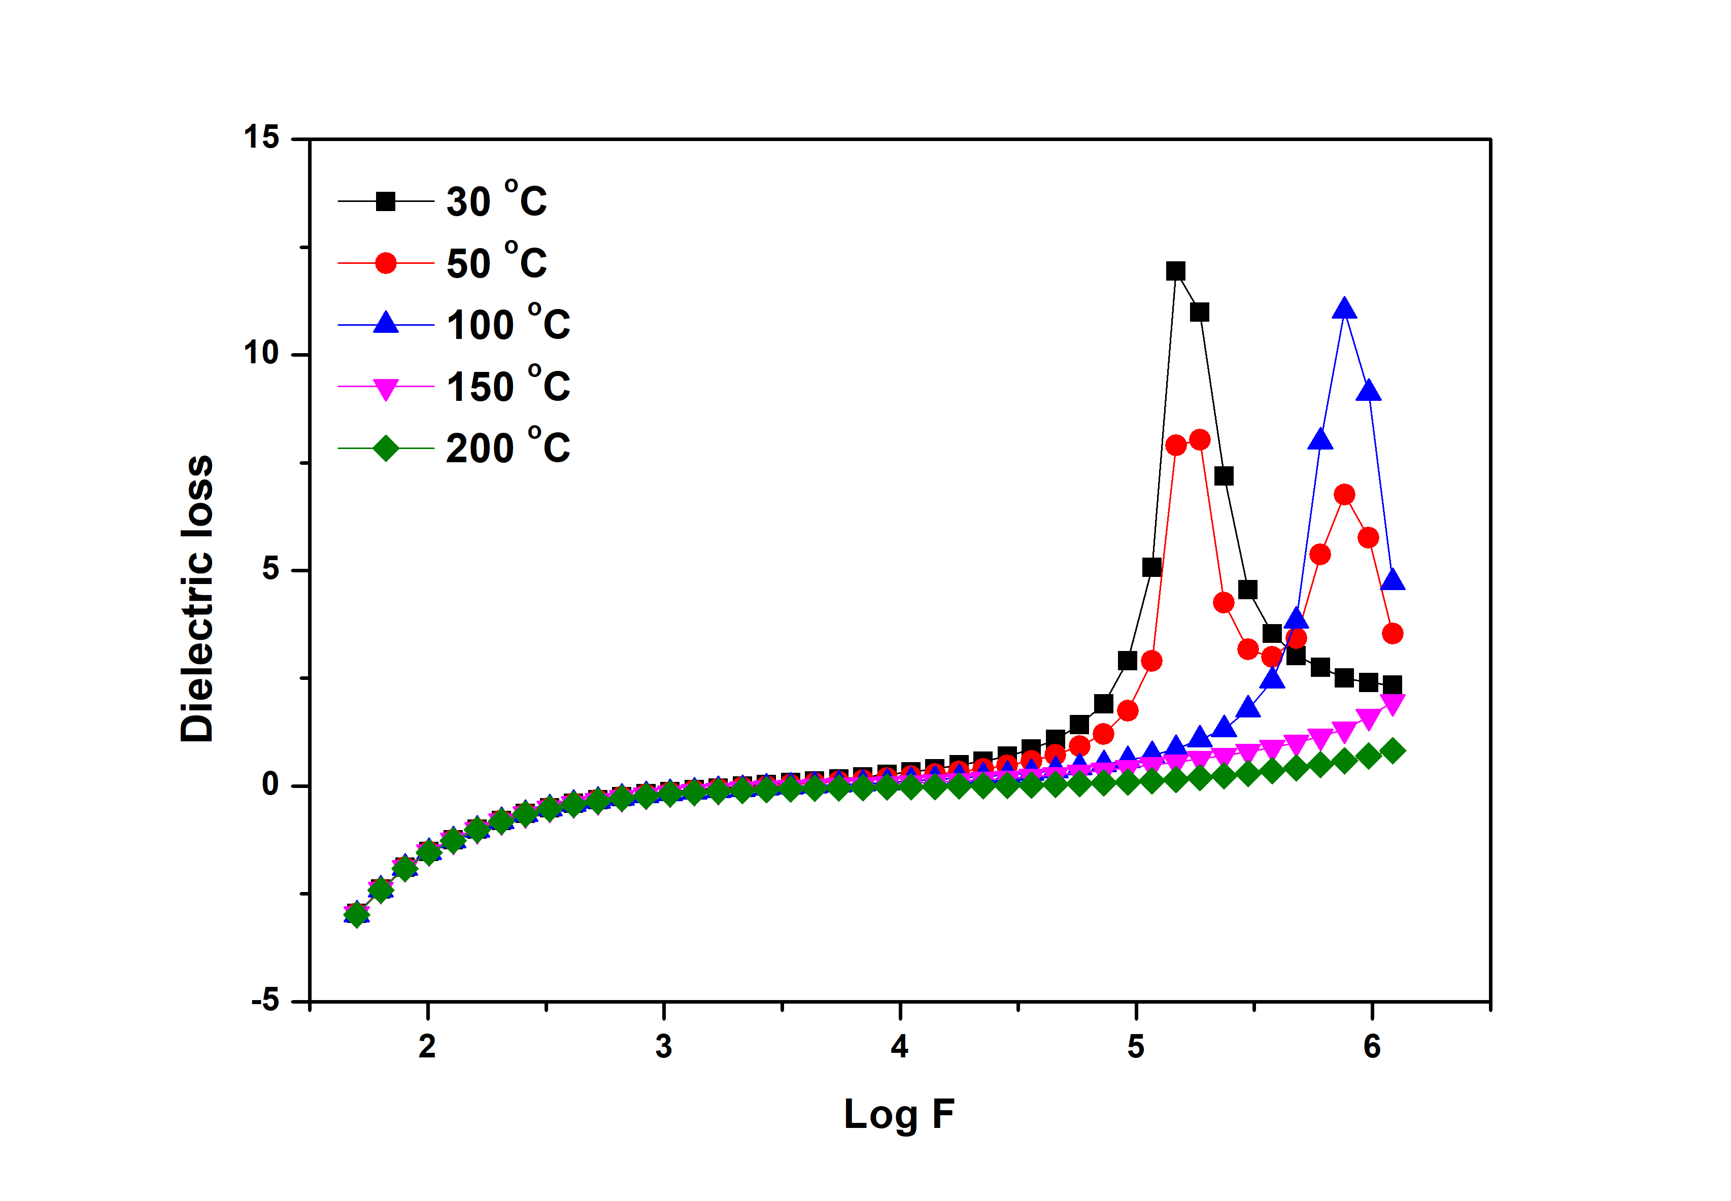
Figure 2: Dielectric Loss as a function of frequency.
From the Dielectric loss (tanδ), the relaxation of the charge carrier can be attained. The loss tangent (tanδ) can be defined as the ratio of energy loss to energy stored in a periodical field and is given by,
$tanδ= \frac{ϵ^{''}}{ϵ^{' }}$ (1)
where ϵ' and ϵ'' are real and imaginary part of dielectric constant. Figure 2 represent the variation of frequency dependent tanδ at different temperatures. The dielectric loss decreases with increasing with increasing frequency at lower frequencies and reverse trend observed at higher frequency regime. The increase of loss tangent may be attributed to the dominance of Ohmic (active) component than capacitive component (reactive). The decrease in tanδ owing to the independent nature of Ohmic part and growth of reactive component with frequency [9].
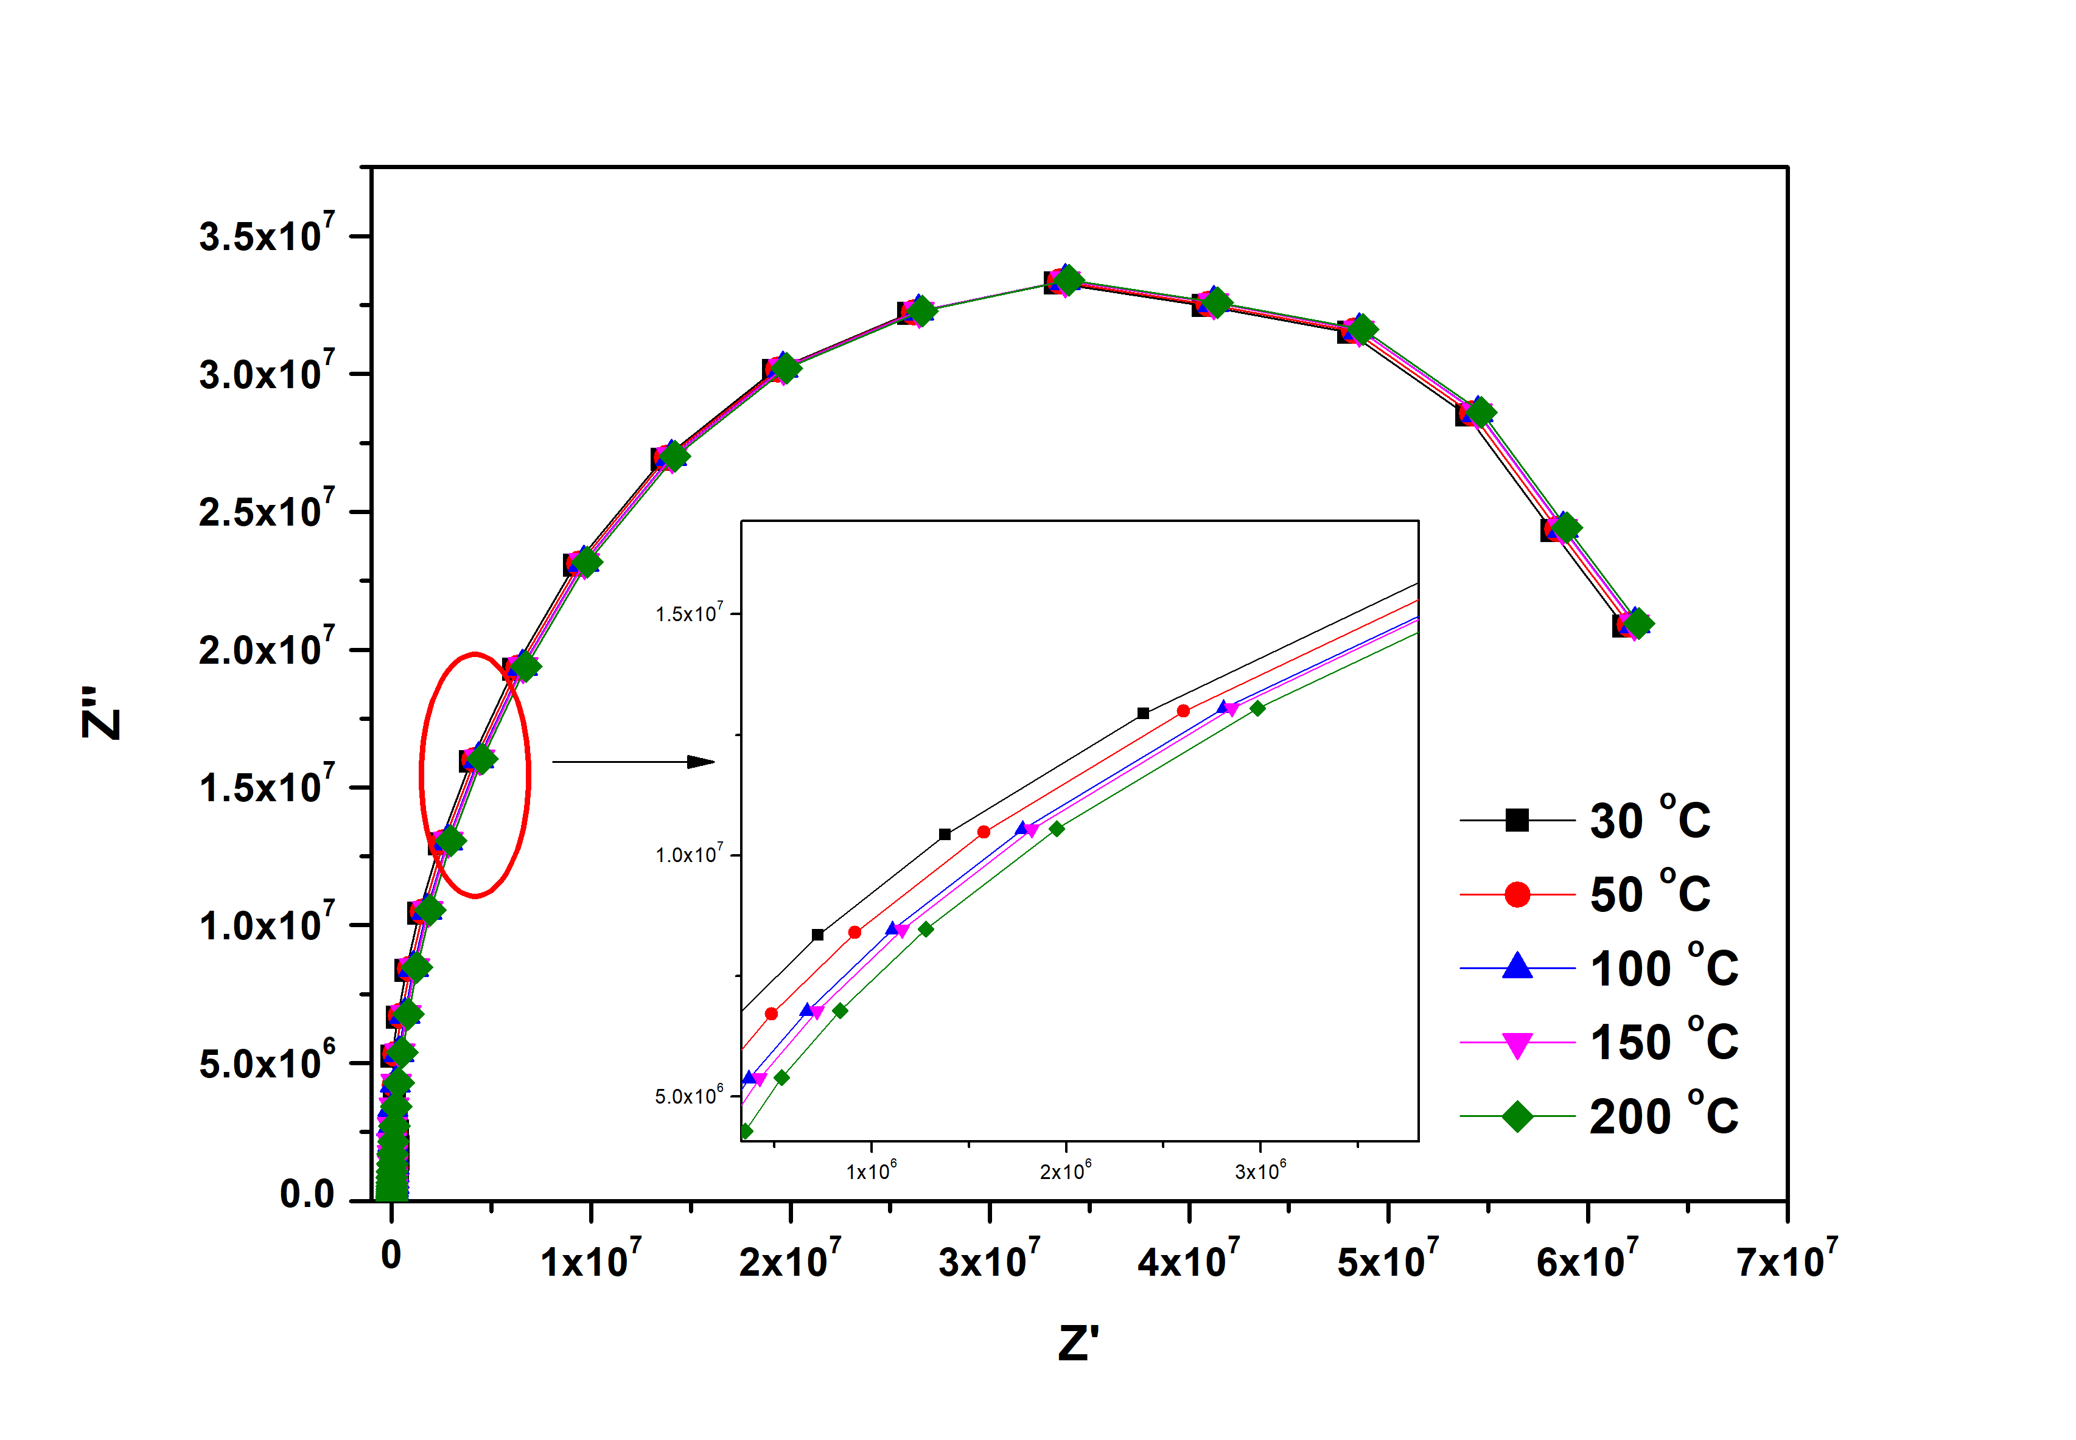
Figure 3: Cole-Cole plot of Z.
The impedance data of the prepared sample is presented in the Cole-Cole plot (Zꞌ vs. Zꞌꞌ) for temperatures of 30 ºC and 200 ºC in figure 3. For all temperatures a tendency to semicircle behavior can be observed that is indicative of the presence of both localized and non-localized conduction processes. The size of these arcs was found to decrease as temperature increased, as typically observed in many semiconducting oxides [10].
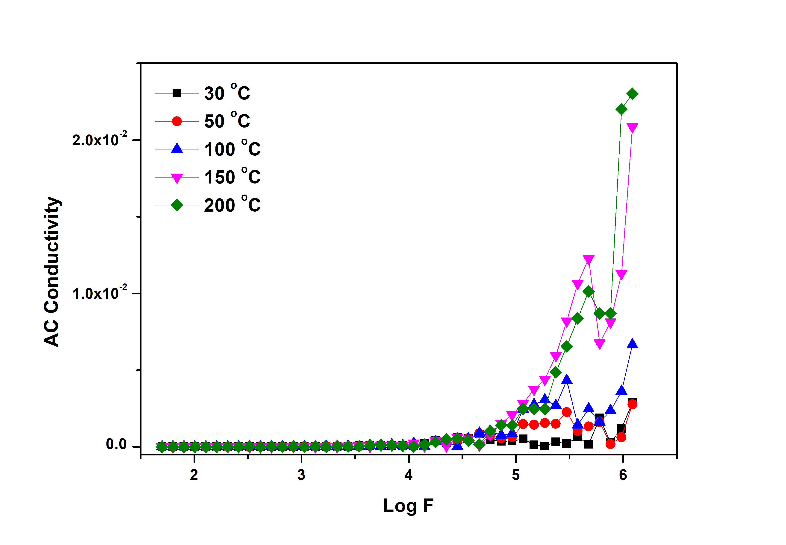
Figure 5: AC conductivity as a function of frequency.
The frequency dependence of the AC conductivity for different temperatures is shown in Figure 5. The conductivity follows the equation given by,
$σ\left(ω\right)= σ_{dc}+Aω^{n}$ (2)
where, σ_{dc} is the dc conductivity, A is the temperature dependent factor, ω=2πf is angular frequency and n is the frequency exponent of the mobile ions which measures the interaction of the charge carriers with the lattice. From the figure it can be observed that the conductivity is found to be constant in the lower frequency region which defines the dc part of conductivity at the lower region which is independent of frequency and increase with the increase in frequency which represents the ac part. It is also observed that the ac conductivity increases with increase in temperature at higher frequencies and is due to the occurrence of hopping type of conduction mechanism.

REFERENCES

- Oruç, Çiğdem, and Ahmet Altındal. "Structural and dielectric properties of CuO nanoparticles." Ceramics international, Vol. 43, no. 14 (2017): 10708-10714.
- Bouazizi, N., R. Bargougui, A. Oueslati, and R. Benslama. "Effect of synthesis time on structural, optical and electrical properties of CuO nanoparticles synthesized by reflux condensation method." advanced materials letters, Vol. 6, no. 2 (2015): 158-164.
- Yathisha, R. O., Y. Arthoba Nayaka, P. Manjunatha, H. T. Purushothama, M. M. Vinay, and K. V. Basavarajappa. "Study on the effect of Zn2+ doping on optical and electrical properties of CuO nanoparticles." Physica E: Low-dimensional Systems and Nanostructures, Vol. 108 (2019), pp. 257-268.
- Bhalerao-Panajkar, Rohini S., Mandar M. Shirolkar, Raja Das, Tuhin Maity, Pankaj Poddar, and S. K. Kulkarni. "Investigations of magnetic and dielectric properties of cupric oxide nanoparticles." Solid state communications, Vol. 151, no. 1 (2011) ), pp. 55-60.
- Hameed, S. T., Talal F. Qahtan, A. M. Abdelghany, and A. H. Oraby. "Structural, optical, and dielectric characteristics of copper oxide nanoparticles loaded CMC/PEO matrix." Journal of Materials Science, Vol. 57, no. 15 (2022) ), pp. 7556-7569.
- Mustapha, S., M. M. Ndamitso, A. S. Abdulkareem, J. O. Tijani, D. T. Shuaib, A. K. Mohammed, and A. Sumaila. "Comparative study of crystallite size using Williamson-Hall and Debye-Scherrer plots for ZnO nanoparticles." Advances in Natural Sciences: Nanoscience and Nanotechnology, Vol. 10, no. 4 (2019) ), pp. 045013.
- Schrödle, Simon, Gary Annat, Douglas R. MacFarlane, Maria Forsyth, Richard Buchner, and Glenn Hefter. "High frequency dielectric response of the ionic liquid N-methyl-N-ethylpyrrolidinium dicyanamide." Australian journal of chemistry, Vol. 60, no. 1 (2007) ), pp. 6-8.
- Izgorodina, Ekaterina I., Maria Forsyth, and Douglas R. MacFarlane. "On the components of the dielectric constants of ionic liquids: ionic polarization?." Physical chemistry chemical physics, Vol. 11, no. 14 (2009) ), pp. 2452-2458.
- Chopra, Sonalee, Seema Sharma, T. C. Goel, and R. G. Mendiratta. "Structural, dielectric and pyroelectric studies of Pb1− XCaXTiO3 thin films." Solid state communications, Vol. 127, no. 4 (2003) ), pp. 299-304.
- Li, Ming, Derek C. Sinclair, and Anthony R. West. "Extrinsic origins of the apparent relaxorlike behavior in CaCu3Ti4O12 ceramics at high temperatures: a cautionary tale." Journal of Applied Physics, Vol. 109, no. 8 (2011).

