PRO-DRUG DEVELOPMENT

ANJALI PALWAR, MOHD.ARSHAD*, ANJALI,
AMAN BHARTI, ANKIT SINGH, SUNIL PRATAP SINGH RAJA BALWANT SINGH ENGINEERING TECHNICAL CAMPUS, BICHPURI (AGRA) - 283105

Introduction

- Prodrug is one of the effective methods of modern research in the field of medicine.[4]
- The development of prodrug have gained increasing more importance in current medication system and therapy.[4]
- Prodrugs refer to a pharmacologically inactive compound which is transformed into an active substance by either chemically or metabolic process.[4]
- Prodrug in modern therapy is actually demonstrated by the fact that in the last ten years several books in this field have been published and thousands of article in scientific database are investing new potential molecules.[4]
- About half or most of prodrugs are hydrolyzed to the active form in particular by hydrolysis of ester.[4]
- Now a day‘s approximately 10% of drugs used in therapy are administered as prodrug.[4]

Prodrugs have been around for more than a century despite the fact that the idea behind them was only originally outlined in the late 1950s. [1]

Aspirin is one of the first prodrug that was widely used and also first marketed prodrug in 1899.[1] It turns into a substance called salicylic acid after it enters the body.[1]
In the past, the prodrugs used to be considered as last resort in drugs development not only is this no longer the case. But now days the prodrug approach is considered at very initial stages of drugs research and development.[2]

Making a prodrug indeed means dealing with a new chemical entity, which eventually may save time money and efforts.[2]

History of prodrugs

- Chloramphenicol is the first synthesized drugs as prodrugs. The concept of prodrug, the concept of prodrug was intentionally used for the first time by the Parke Davis Company.
- The Parke Davis Company modifies the structure of chloramphenicol in order to improve the antibiotics bitter taste and poor solubility in water.
- Chloramphenicol sodium succinate with a good water solubility and chloramphenicol palmitate used in the form of suspension in children. Were two synthesized prodrugs form of chloramphenicol?
- Another historical prodrugs was synthesized German scientific. Aspirin is that historical prodrugs.
- Dresser introduced aspirin into medicine in 1899.
- Acetanilide was the first compound that fulfilling the classicalteria of prodrugs. Introduced into the medical practice by Cahn and help in 1867 as antipyretic agents.

- Acetanilide is hydrolated to biologically active acetaminophen.

What are prodrugs?
The international union of pure and applied chemistry. Defines a prodrug as a chemical that is transformed before it has pharmacological effects. [1]

A prodrug can be defined as a prodrug substance that is inactive in the intended pharmacological action and it must to be converted in to the pharmacologically active agent by metabolic physio-chemically transformation.[1]

In other words, after you take prodrug, it changes in your body before it starts working.
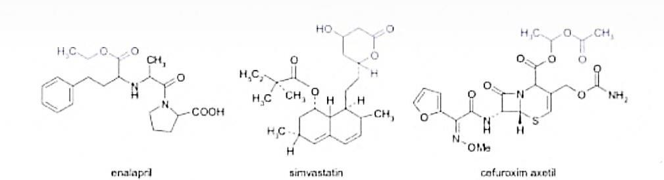
Fig.1 the chemical structure of a few frequently used prodrugs.[4] The prodrug concept has been used to improve undesirable properties of drug.
The actual term ‗prodrug‘ was introduced for the first time by ―ADRIAN ALBERT‖ for drug‘s that are inactive by themselves but which formed an active derivative by biotransformation.

The concept was completed by ―HARPER‖ in 1959 was introduced the term of drug latentiation referring to drug that were specifically designed to require bio-activation.

A prodrug is a chemically modified inert precursor of the drug that on the biotransformation liberates the pharmacologically active parent compound. A prodrug is also called proagent, bio reversible derivative of latentiated drug. The design of prodrug approach is also called drug latentiation.

The place and speed of biotransformation are closely related to chemically structure, as well as the pharmacokinetic properties of the molecules.

The concept of prodrug has to be differentiated from drugs that are active of their own, but by biotransformation are forming one or more active metabolites and the biologically effects occur as a common result of the original drug and metabolites.

In some cases, a prodrug may consist of two pharmacologically active drugs that are coupled together in a single molecule, so that each acts as a promoiety for the others. Such derivative are called ―CODRUGS‖.[4] (E.g. sultamicillin, sulfasalazine, benorylate)
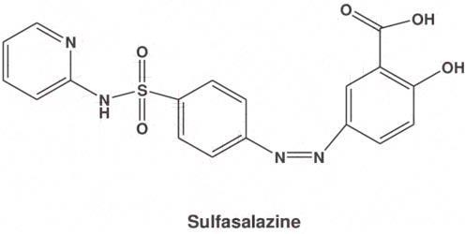

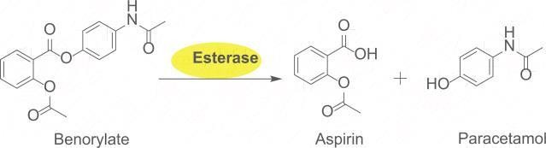
Fig.2 structures of some prodrugs

Ideal properties of prodrugs

The ideal properties of a prodrug are as follows:

- Drugs and the carrier linkage must be cleared in vivo.
- It should not have intrinsic pharmacologic activity.
- IT should rapidly transform, chemically or enzymatically, into that active form where desired.
- The metabolic fragments, apart from the active drug, should be nontoxic.

The purpose of designing prodrugs

The purpose of designing prodrugs are mainly based on two objectives:-

  - Improving bioavailability when the drug candidate is not drug like due to unfavorable physical properties as:-
    - Poor water solubility
    - Low lipophilicity
    - Chemical instability
    - Unacceptable taste or smell
    - Local irritation, pain
  - Improving bioavailability when the drug candidate is not drug-like, due to pharmacokinetics properties
    - Low bioavailability
    - Poor penetration through biological membranes
    - Increased first-pass metabolism
    - Slow absorption by parental route
    - Rapid absorption/elimination instead of long lasting effect
    - Lack of specificity in certain tissues

The main specific objective of prodrug design is to optimize unfavorable physiochemical properties to increase chemical and metabolic stability to achieve planned delivery.[4]

  - Pharmaceutical objectives
- To improve solubility, chemical stability, and organoleptic properties.
- To reduce problem related with the pharmaceutical technology of the active agent.
- To decrease irritation and pain after local administration.

  - Pharmacokinetic objective
- To improve absorption (oral and non-oral routes).
- To increase organ/tissue selective delivery of the active agent.
- Presystemic metabolism should be reduced in order to enhance the time profile.
  - Pharmacodynamics objectives
- In order to reduce toxicity and increase therapeutic index
- To create dual-drug combinations as single chemical entities (co-drugs technique).
The prodrug is used to overcome many complication related to biopharmaceutical, pharmacokinetic or pharmacodynamics obstacles, including poor chemical stability, solubility limitation lack of site specificity, extensive drug metabolism passing through biological barriers, exploiting endogenous metabolic pathways, toxicity.
Prodrugs design to give optimal oral bioavailability and consequent therapeutic effects, the prodrug is used for the optimization of newly discovered chemical entities.
These approaches improve the properties of already marketed drugs.[3]

Classification of prodrugs
Prodrugs can exist naturally such as many phytochemical/botanical constituents and endogenous substance. They can result from synthetic or semisynthetic process.[2]
There are potentially many methods of classifying prodrugs. These could include:
- Based on therapeutic categories for example, anticancer prodrugs. Antiviral prodrugs.
- Based on the categories of chemical linkage or moiety/carriers that attach to the active drug; for example esoteric prodrugs, glycoside prodrugs, bipartite prodrugs.
- Based on functional categories using strategic approaches to circumvent deficiencies inherent to the active drugs; for example,
  - Prodrugs for improving site specificity
  - Prodrugs to bypass high first pass metabolism.

Classification based on conversion in body:
- Type Ist Prodrugs turn into their active forms inside the cells. These are also called intracellular prodrugs.
- Type IInd Prodrugs turns into their active forms outside of cells such as in blood or other fluids. These are also called extracellular prodrugs.[3]

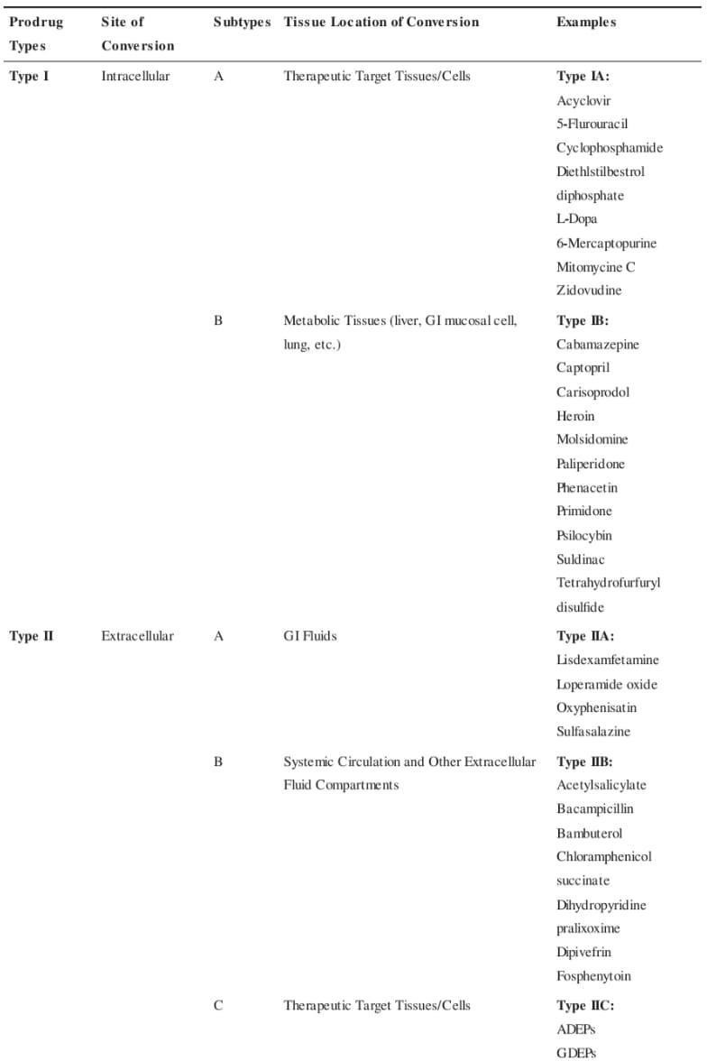

Classification based on chemical criteria

- Carrier linked prodrugs or simple prodrugs-
They are generally esters or amide carrier linked prodrugs are those ones where the active drug is covalently linked to an inert carrier or transport moiety. Such prodrugs modify the lipophilicity due to the attached carrier. The active drug is released by hydrolytic cleavage, either chemically or enzymatically.[6]
These are also called conventional prodrugs obtained by chemical derivatization the desired objective is to optimize transport properties; as on the parent molecule are grafted functional groups that promote absorption.[4]

Ideal properties of carrier
- It does not alter the structure of prodrug until reaches the site of action.
- It must be nontoxic and unstable molecule.
- It does not affect the chemical or enzymatic action of drug and helps to release in active form of drugs.
- It must bear biochemical inertness
- The drug at the location of action does not alter by the carrier and maintained by carrier.

Example- chloramphenicol succinate

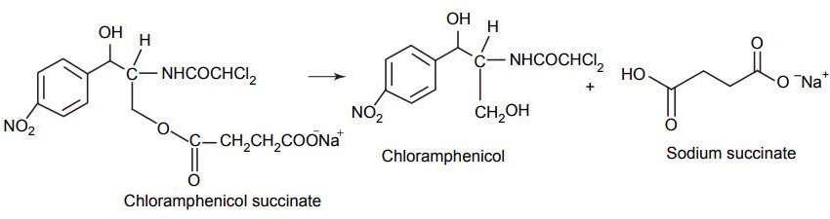

Fig.4 Chloramphenicol[6]

It consist the attachment of a carrier group to the active drug to alter its physiochemical properties. The succeeding enzymatic or non-enzymatic mechanism releases the active drug moiety

Carrier linked prodrugs can be divided into 3 categories:

➔ Bipartite prodrug

➔ Tripartite prodrug
➔ Mutual prodrug

Bipartite Prodrug
    - Bipartite prodrug consist one carrier (group) directly attached to the drugs.
    - The attached carrier have greatly modified lipophilicity in such prodrugs the active drug is released by hydrolytic cleavage either chemically or enzymatically.[5]
    - E.g. Tolmetin- glycine prodrug
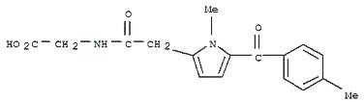
Fig.5 Tolmetin

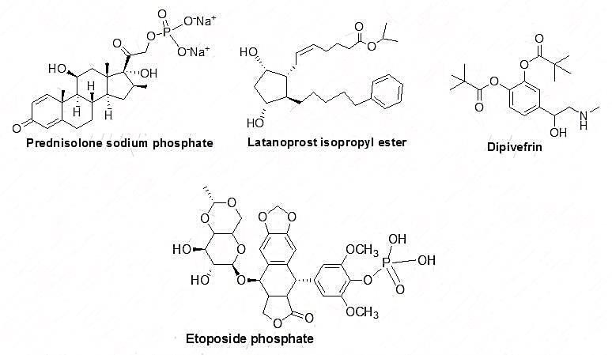

Most of the carrier linked prodrug is bipartite.

- Tripartite Prodrug: in this type of prodrug uses a spacer or linkage between the drug and a pro moiety.
- To overcome the unstable nature of bipartite prodrug due to the inherent nature of the drug promoiety bonding. Tripartite prodrugs are developed and synthesize.
EX: - pivampicillin and bacampicillin are some example of tripartite prodrug.

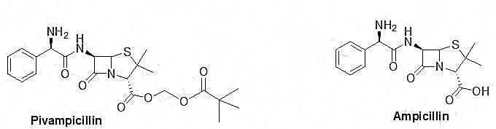
Fig.6

- It consists of pivaloyloxymethly ester, B lactam, ampicillin, and –CH₂- group as a linker to connect to ampicillin and the pivallic acid.
- Pivampicillin has better bioavailability than ampicillin because the ester group creates higher lipophilicity.[5]

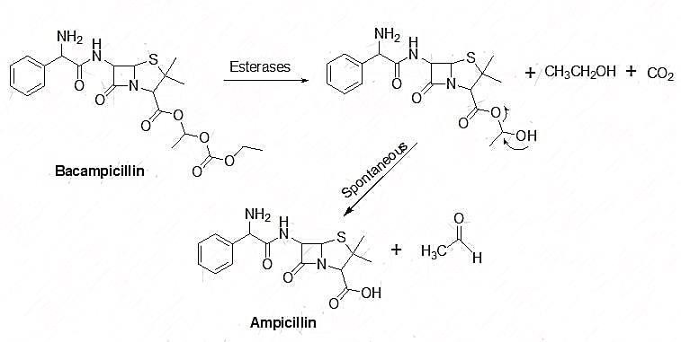

- Mutual prodrugs: these are the prodrugs which consist of two pharmacological active agent coupled together so that each acts as a promoiety for the other agent and vice versa.
- In this type of prodrug the carrier is a synergistic drug with the drug to which it is linked. It is both a bipartite or tripartite prodrugs.
- A mutual prodrug has two potent agent bound together in such a way acts as two synergistic drugs linked to each other where one drug serves as the carrier for the other and opposite.
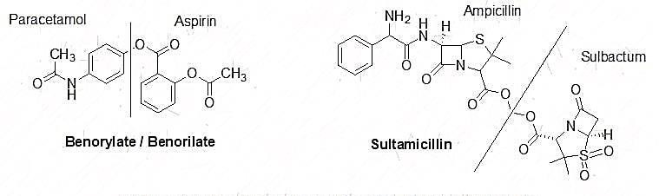
Fig.7
EX; benorylate and sultamicillin are the some ideal examples of mutual prodrugs. In benorylate aspirin is linked covalently to pracetamol through an ester linkage. This drug is suitable for improved analgesic power and decrease gastric irritation.[5] Bio precursors
Bio precursor does not contain a carrier. They are the prodrugs which are inert molecule and obtained from the chemical modification of the active drug.

The bio-precursors are different from the carrier linked prodrug on the basis of metabolic activation they are activated by oxidation and reduction by oxidation and reduction rather than hydrolysis.

These medication based on the active principle itself. And designed from a molecule modification.

They have no carrier and do not contain a temporary linkage between the active drug and carrier moiety.

The molecule must be metabolized to undergo functional be metabolized to undergo functional group transformation for example, if a drug contains a carboxylic acid group, the bio-precursor can be a primary amine that can be metabolized first to the aldehyde and then to the acid.

EX: - nabumetone, pronslosil
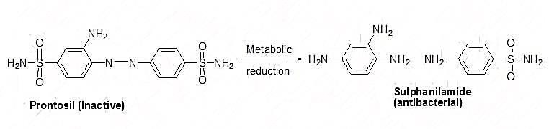

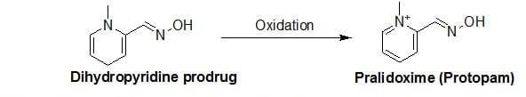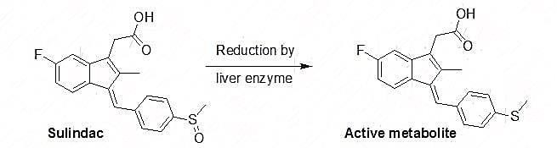

There are some ideal example of bio precursor like sulindac an anti-inflammatory agent. It contains sulfoxide group. Which has activation by the reduction mechanism by liver enzymes. The sulfoxide transformed to a thither and the active metabolite generates after reduction.
It is used to treat chronic and acute inflammatory problems on the comparison it has lower concentration so, decrease GI irritation and side effects than other non-steroidal anti-inflammatory drug like ibuprofen.

Pralidoxime is the another example of bio precursor. It is used to treat poisoning organ phosphorus molecules as an antidote. It is activated through oxidation process in this pyridine group is replaced with dihydropyridine to generates a prodrug and thus enhances lipophilicity to cross the blood brain barrier because pralidoxime is very polar and unable to crosses the blood brain barrier to overcome this problem. The dihydropyridine is converted to pyridine is converted to pyridinium to give the parent drug Pralidoxime.[5]

Characteristics | Carrier prodrugs | Bio precursors
Bio activation | Hydrolytic | Oxidative or reductase
Lipophilicity | Stronger modified | Slightly modified
Catalysis | Chemical or enzymic | Only enzymatic
Constitution | Active principle 1 carrier group | No carrier

Fig.9 differences between bio-precursor and carrier prodrugs[6]

polymeric prodrug- this is the arrange in which drug mint of the drug diffused and contain the polymer (both) naturally occurring and synthetically prepared system between drug and polymer. It is also called as macromolecular prodrug.

EX: - an ideal example of macromolecular prodrug is includes p-phenylene diamine mustered is covalently attached to polyamino polymer
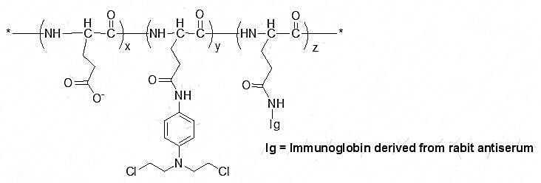
Fig.10

This poly (methacrylate chain was linked to the polymer due to an increase of water solubility it is a synthetic polymer linking & a linking of poly (methacrylate with testosterone &does not have and androgenic effect. So to overwhelm this problem an insertion of a linker between the polymer and testosterone has effects like testosterone.[5]

Classification based on the functional groups.
- Prodrugs are also classified according to the functional group, as follow:

Carboxylic acids and alcohols
- Amines

Azo linkages
(vi) Carbonyl compound

- Carboxylic acids and alcohol – prodrugs of carboxylic and alcohols functioning based on the conversion of esters. The esters can be easily hydrolyzed by esterase enzymes (e.g. lipase, ester hydrolase, cholesterol esterase, acetyl cholinesterase, and carboxy peptidase) present in plasma and other tissue to give active drugs. [6]

EX: - chloramphenicol, palmitate
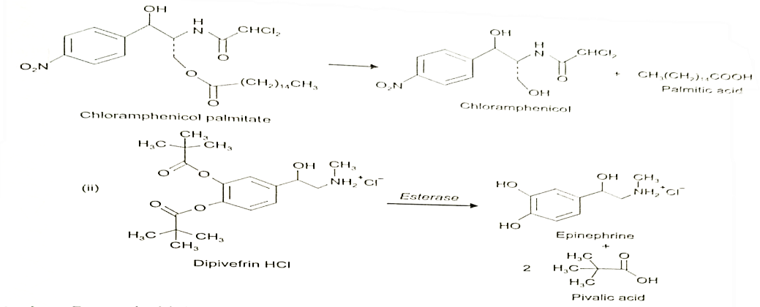
Fig.11

- Amines- prodrug of amines has high stability and lack of amides enzymes necessary for hydrolysis, due to lack of conversion amides enzymes of amines to amide as a prodrugs is not been used for most

of the drug. The adaption of mannich bases as prodrug form of amines is a more common approach of amines.[6]

EX: - hetacillin is a prodrug form of ampicillin in which amide nitrogen and amino functionalities have been allowed to react with acetone to give a mannich base imidazolidine ring system. This leads to decrease in the basicity and increase in the lipophilicity and absorption.
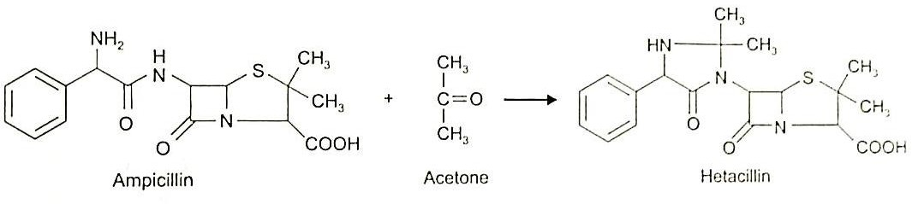
Fig.12 Hetacillin

- AZO linkages- these are the prodrugs often prepared by incorporating them in to an AZO Linkages with prodrugs of amines. Conversion of prodrugs is occur by the action of AZO reductaze the amino compounds are released in vivo.[6]

EX: - prontosil drug is inactive in vitero, but it is active in vivo since it is converted to sulphanilamide by azo reductase enzymes.
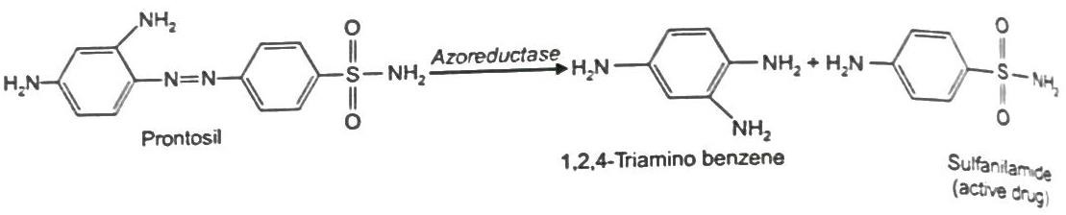
Fig.13
- Carbonyl moiety- these prodrug function on the conversion of carbonyl moiety, in to aldehyde and ketone.[6]

  - These prodrugs have not been found wide clinical use. The sp² carbonyl carbon is converted as sp³ hybridized carbon attached to heteroatom. To form a derivatives.
  - These prodrugs are re-converted to carbonyl compound by hydrolysis.[6]
EX: - Hexamine releases formaldehyde in the urine (acidic pH), which acts as an antibacterial agents.
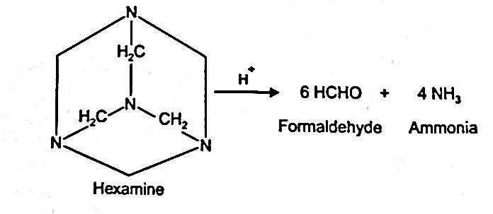
Fig.14 Hexamine

Designing prodrug using different functional group as carrier
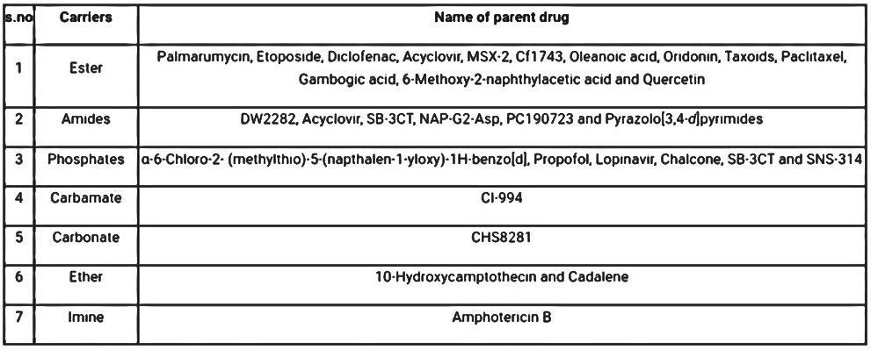

Fig.15

Development of prodrug

(1) Recent development in therapeutic nanoparticles based on prodrug:

In order to deal with a some of the innate challenges in drug development, this article provides two principles for drug design and formulation that can be utilized separately or together. The first is using a prodrug technique, which highlights how chemically altering An API is an active component of a medication flexible tactic to enhance the key component of a drug for therapeutic and physiological benefits. Prodrugs can be used to improve an API's pharmacokinetics (PK), pharmacodynamics (PD), formulation characteristics, and toxicity profile, as shown in the examples that support this section. Several of the difficulties faced in the creation of prodrugs are also explored. [7]

The main advantages of a nanoparticle-based drug delivery method are then emphasized. These advantages include enhanced bioavailability and stability, regulated reduced toxicity, better therapeutic efficacy, and drug release and biodistribution. This overview offers the foundation for using nanoparticles as a means of controlling the use of prodrugs in PNDDS. Although PNDDS is a relatively new and emerging field.[7]

Example of PNDDS products under development provide evidence in favor of the case for combining the benefits of the prodrugs and NP methods into a single product. A PNDDS‘s increased complexity will be tolerable, nevertheless, only if it offers substantial advantages.[7]

These include strengthening the prodrug's selecting sick tissue to release to, enhancing the prodrug's systemic exposure, stability, or bioavailability, enhancing the prodrug's efficacy and safety. There is a tendency toward adopting a combined prodrug nanoparticle strategy in a range of disease domains, including infectious, inflammatory, cardiovascular, neurological, and pulmonary issues, even if the majority of examples involve cancer-related reasons. This section underlines that while PNDDS is an emerging field with a lot of potential and promise, more work is still needed to get these novel technologies from the lab to the clinic and establish PNDDS as a strategy for commercially successful drug creation. Improvements in the prodrugs stability, bioavailability, or systemic exposure, as well as better targeting and release to sick tissue, may boost the prodrugs effectiveness and safety. Even though the majority of cases have cancer indications, there is a tendency to use a combined prodrug nanoparticle technique in a number of disease domains, such as infectious, inflammatory, cardiovascular, neurological, and pulmonary problems.

This section underlines the need for additional research to confirm PNDDS as a commercially viable drug development technique and get these unique technologies from the bench to the bedside, despite the fact that PNDDS is an emerging field with a lot of potential and promise. [7]

(2). Nanoparticle- Based drug delivery system

Since they can transport significant therapeutic drug payloads and preferentially deliver them to particular tissue or place, nanoparticle have attracted increasing interest as treatment in recent years. Cover different nanoparticle based delivery strategies, include liposomes, solid lipid nanoparticle, micelle, cub some, polymeric nanoparticle, and inorganic nanocarrier. The PK properties of their APIs may be altered by using nanoparticle-based drug delivery strategies, resulting in a potential increase in distribution to the site of action and a lengthened half-life, which can enhance efficacy and lessen negative effects. Thanks to nanoparticle production, poorly soluble hydrophobic medications can be made better and dispersed via a number of delivery methods. In addition to their biological availability, Drugs may be delivered to the site of action more precisely by using targeting molecules or by carrying them in nanoparticles with a synergistic molar ratio to maximize clinical efficacy. Once the nanoparticle has reached the desired location, other design components are concentrated on the optimal release of the medicine. When temperature, pH, or other physiological variables vary and allow the matrix to release medications gradually or continuously, environmentally sensitive nanoparticle-based delivery systems are used. [7]

Additionally, certain inorganic nanoparticle exhibits stimuli responsive properties, such as the ability to remotely initiate the release of medicine using either an external magnetic field or their surface plasma resonance feature. The creation of nanoparticle is a process that is intrinsically complex and necessitates a thoroughly grasp of the fundamental principle that underline particle production, stability, and perform. Schematic representation of various uses are shown in and have been explored elsewhere. Although clinical settings have been using nanoparticle-based drug delivery methods since the early 1990s, the area has continued to expand as technology has improved therapeutic delivery. A thorough examination of the growth and development of clinically authorized nanoparticle-based drug delivery systems that contained unaltered medicines was conducted. The difficulties and prospects for these platforms will be the key topics of this section..[7]

(2.1) Difficulties and direction for the future:

Nanoparticle technologies can be advantages, but there is still a poor success rate for clinical translation. Some difficulties. SPI-77, a long-circulation liposome encapsulating cisplatin currently undergoing clinical research, failed in one case because the medication leaked slowly and ineffectively from the encapsulation. Another example is L-NDPP (Aroplatin), a cisplatin analog (cis-bis-neodecanoato-Trans-R,R-1,2-diaminocyclohexane platinum II) contained in non-PEGylated multilamellar liposome, which has a limited clinical efficacy because of adverse liver accumulation.
Additionally, after reconstition, there were significant amounts of complex degradation, which rendered the medication inactive. Another example is LiPlaCis, a brand-new liposomal cisplatin formulation with the potential to induce release. In tumor regions, secretory phospholipase A2 is supposed to break it down. Renal toxicity caused an initial infusion reaction in a large number of people, although the unimpressive safety profile shows that additional reformulation and optimization are needed. Understanding how biology influences Nano carrier PK is crucial in order to deliver the best toxicity and pharmacological profiles. Plasma proteins in vivo absorption on nanoparticle can change the by that nanoparticle interact with biomolecules, changing their pharmacological.[7]

Characteristics, therapeutic efficacy, and toxicity, which helps explain by in vitro and in-vivo results don‘t always correlate. This mechanism known as protein corona (or bio corona) creations is perhaps the most important one influencing how nanoparticle behave and end up when given intravenously. The clinical translational potential of the formulation may also be hampered by their structural and physicochemical

complexity because it can be difficult to pharmaceutically produce complicated nanoparticle system on a big scale. Overcoming inadequate batch-to-batch stability and consistency, low product output, poor quality control, and lack of product purity is expensive. The therapeutic potential of nanoparticle drug delivery systems is exciting, nevertheless, and as these current obstacles are removed, the evidence for their considerable impact on human health will become stronger.[7]

(3) Prodrug formulation in nanoparticle is progressing:

Two major approaches were discussed in the portion of this review that comes before them for enhancing pharmaceutical PK, safety profile, and therapeutic effectiveness. In first involve directly altering an API chemically to create a prodrug, while the second involves encapsulating medicines inside of Nano carriers. Despite the benefits listed in both tactics have obstacles to overcome, as discussed in the preceding section. Prodrugs without protection may dissolve quickly and expire before their expiration date, while delivery systems based on nanoparticles may not load drugs sufficiently and may leak medication. Combining these two methods enables formulation scientists to have better control over the biological and chemical properties of therapies, which may enhance clinical translation. For instance, the degradation of prodrugs can be reduced with the protection of Nano carriers to explore different administration methods. Improved efficacy can be attained by changing the nanoparticle surface chemistry. This section reviews a number of PNDDS articles from 2018 or later, showing their potential benefits over prodrug or nanoparticle only approaches.[7]

(3.1) Oncology

Many candidates are in the clinical developments stage, even though there is only one PNDDS that is now approved without a doubt, oncology has produced the most prodrug based nanoparticle formulation that is being used in clinical setting. This is perhaps because more acceptable cancer treatment are so desperately needed. These attempts are discussed needed. These attempts are discussed in numerous publications, many of which have also been examined elsewhere. The most present PNDDS for the treatment of cancer are listed here by API.[7]

(3.1.1) Platinum based substance

Despite a number of serious drawbacks, platinum based medication is among the most effective chemotherapeutics now on the market. The main ones are medication resistance brought on by in effective cellular intake, glutathione (GSH) inactivation, and metallothionein detoxification, as well as dose limiting adverse effects. Many efforts have been made to create novel platinum-based medications with reduced toxicity and increased therapeutic efficacy in an effort to get beyond these restrictions. One of these is a class of prodrugs made of platinum known as pt(IV)n, which are redox responsive and have various hydrophobic carboxylate ligands. When platinum is treated with thiols, lead formulations brought on by exposure to intracellular GSH and endocytosis have an exhausting impact that decreases the likelihood of platinum detoxification. Nanoparticles' PEG functionalization led to enhanced tumor accumulation and extended blood circulation in vivo. Our PEGylated P6 in vivo tumor xenograft mice mode . Improved treatment was produced by the NP delivery platform. The micellar nanoparticle formulation NC 6004, also known as nanoplatin, uses carboxylate from PEG poly (glutamic acid) block copolymers.. The platinum metal center of this type of Pt medication is cross-linked to block co-polymers by co-ordination bond, forming labile bond that enables it to be categorized as prodrug and causes micelles to self-assemble. In a variety can cancer animal model, nanoplatin was more well tolerated than cisplatin and provide more antitumor efficacy. Advanced solid tumor patients receiving nanoplatin plus gemcitabine in phase IB/II clinical trials were able to receive larger cisplatin equivalent doses without experiencing clinically significant toxicity problems, indicating a potential wider therapeutic window. [7]

DACH-Pt, 1,2-diaminocyclohexane platinum II, a platinum-based prodrug, was investigated as a potential treatment for recurrent ovarian cancer using several formulations and a similar design method. These formulations are often utilized. Among these are a copolymer that lengthens plasma half-life and a chelator that binds inactive platinum spaces at physiological pH to lessen target effects. The low pH environment typical of a tumor causes the active platinum spaces to release to accomplish targeted dispersion. For nanoparticle production to occur, the platinum the species must be chelated the most sophisticated formulation, known as ProLinDac or AP5346, contains and amidomalonato chelator and a hydroxypropylmethacryamide (HPMA) copolymer and was both secure and affective in a phase II clinical trials. As part of a recently developed multi-drug resistant lung cancer treatment (NP-TPGS-Pt), a self-assembled, biodegradable dendritic copolymer-based drug delivery system was developed. It is based on the DACH-Pt prodrug. Drug resistance was stopped by the formulation NP-TPGS-Pt. A unique approach to treating tumors that are resistant to many drugs is to treat cancer cell in vivo.[7]

(3.1.2) Camptothecin

Camptothecin is another frequently used chemotherapeutic medication. Since its discovery, a great deal of research has concentration on creating novel camptothecin analog in an effort to increase its water solubility and anticancer activity. Irinotecan and topotecan, two camptothecin analog, have been authorized for use in cancer treatment. As a result, the most in-depth research has been done on the prodrug irinotecan, which non-specific carboxylesterases convert into its active metabolite SN-38. Rapid drug clearance and major dose-limiting toxicities like neutropenia and diarrhea are just two of this medication's many unfavorable clinical effects. By preventing irinotecan from being metabolized too soon, a carefully thought-out drug delivery system might provide a way to get past these restrictions. The liposomal formulation of irinotecan, which was developed for the treatment of metastatic pancreatic cancer, is one example of such a system. It was approved by the FDA in 2015 and administered along with leucovorin and 5-fluorouracil. Patients who have previously undergone gemcitabine therapy are supposed to use it. Because monotherapy was associated with more side effects than combination therapy and did not demonstrate greater efficacy when compared to treatment with 5-fluorouracil/leucovorin, oniyde is only authorized for use in conjunction with this medicine. [7]

The safety, tolerability, and dose-limiting toxicities of onivyde when administered as a first-line therapy for persons with metastatic pancreatic cancer are also being investigated in a phase I/II open-label study (NCTO2551991) that is presently underway. In this experiment, onivyde is contrasted with oxaliplatin, leucovorin, and 5-fluorouracil. This additional onivyde combination therapy has the potential to enhance the clinical outcome for the treatment of a variety of tumor types by addressing the limitation of anticancer single-drug therapy. This sample delivered the active metabolite SN-38 in a liposomal format, as was previously covered in the prodrug part of this review article. However, multiple prodrug design approaches may be conjured for practically any active molecule by changing the pro-moiety structure and the labile bond type. Alternative methods of administering prodrugs and nanoparticles for SN-38 have been developed by researchers. [7]

Another camptothecin analog is the substance 10-hydroxcamptothecin (HCPT), which has higher potency and lower toxicity than camptothecin. HCPT cannot be widely employed in clinical settings due to its poor water solubility and chemical instability, which is caused by the opening of its labile lactone ring at physiological pH. Different Nano medicines have been created to assist HCPT in achieving more efficacies with lesser toxicity.[7]

The most recent development was a nano carrier for phenylboronic acid pinacol ester that reacts to ROS and contains HCPT-Gu, a guanidine-modified HCPT prodrug. Applying a poly (L-glutamic acid)-g-methoxy PEG (PLG-g-mPEG) nanoparticle that has already been produced to a hyper- branched aliphatic polyester (HAPE) using steglich esterification, PLG-g-mPEG-HAPE (PgP-HA) was created. In terms of stability and drug loading capacity, the PgpHA Nano carriers for the drug HCPT-Gu displayed very good performance. Resulting from interactions between hydrophobic molecules, stacking of the pinacol ester group of phenylboronic acid between the PgP-HA and the medication HCPT, and hydrogen bonding between the guanidine and carboxyl groups. [7]

Due to guanidine's propensity for cell penetration, an in vitro absorption experiment shown that HCPT-Gu enhanced cellular uptake in contrast to HCPT alone. In vivo PK experiments showed that PgP-HA/HCPT-Gu nanoparticles were more able than HCPT-Gu alone to deliver and maintain high levels of medication at the target tumor location. PgP-Ha-/HCPT-Gu nanoparticle demonstrated an 80.6% growth inhibition rate with little toxicity in vivo antitumor effectiveness studies, which is consistent with the better PK profile. However, HCPT and HCPT-Gu only considerably reduced tumor development by 27.4% and 34.6%, respectively, despite having a mild level of systemic toxicity. The potential of PNDDS manufacture for the development for the development of cancer therapy is overall shown in this study.[7]

(3.1.3) Etoposide

As a targeted treatment for a variety of tumor types, glycoside prodrug like etoposide have been created. However, their use has been constrained by the prodrug‘s complicated production and poor in vivo API modification. There was a ketal glycoside prodrug created a overcome these problems.[7]

Recently created to release its active metabolite after coming into contact with both glycosidase enzymes and low pH circumstances. By combining hydroxyl group-containing ETP with hydroxyl group-containing monosaccharides via pH-sensitive acetone-based ketal linkages, the ketal glycoside etoposide (ETP) prodrug was produced. By means of nano precipitation, the resultant amphiphilic ketal glycoside prodrug was later self-assembled into glucose-coated nanoparticles. The prodrug produced using this method revealed glycosidase and acid induced self immolative hydrolysis, as evidenced by a hydrolysis assay that showed the ketal glycoside prodrug released exclusively native ETP and glucose.. [7]

Due to the overexpression of glucose transporters in A549 cells , which are lung cancer cells, these prodrug Nano particles showed substantial cellular accumulation , indicating that this technique . The prodrug nanoparticles were also shown to preferentially concentrate in tumors in a mouse model of an A549 xenograft by a combination of the EPR effect and absorption mediated by glucose transporter binding. Because of the acidic, high-glucosidase environment of tumor cells, tumor tissue was more hydrolyzed than tissue from other organs.The prodrugs embellished with glucose can be used as immunotherapies or as a building block to make prodrugs that self-immolate in response to stimuli for targeted chemotherapy without causing any harm.[7]

(3.1.4) Gemcitabine:

A nucleoside derivative called gemcitabine is used to treat certain cancers. Early metabolism, poor PK, and off-target action, however, have made it difficult to utilize in clinical settings. Gemcitabine has been conjugated with long fatty acids in a variety of prodrug ways to get around the issues with squalenic acid chains. Aiming to increase anticancer effectiveness by attaining effective gemcitabine accumulation at the humor site and lengthening systemic circulation time, Recently, pH-sensitive nanoparticles of the prodrug gemcitabine polyketal were created. Gemcitabine was combined with a polyketal backbone using pH-sensitive ketal linkages to create the prodrug for this investigation, which was subsequently encased in the Nano precipitation. This work shows that diol nucleoside analogues' antiviral and anticancer effects may be enhanced by pH-sensitive polyketal prodrugs. [7]

(3.1.5). Dual - drug treatment

The use of a dual-drug cocktail has become common in cancer therapy to combat drug resistance, increase overall therapeutic efficacy, and reduce side effects brought on by the need for higher doses when administering the same medications separately. Contrarily, co-delivery PK differences between different medications in clinical settings may lead to lower efficacy, making it difficult to combine multiple therapies. One co-delivery strategy, which has lately attracted attention due to its benefits compared to delivery methods based on free drug cocktails, delivers two pharmaceuticals simultaneously. To provide a more promising form of chemotherapy, these PNDDS combine a range of APIs, either as covalently linked co-drugs or with at least one being a prodrug. About 15% of all breast cancer cases are triple negative breast cancer (TNBC), which is identified by tumors lacking the cellular expression of the estrogen receptors (ER) and progesterone receptors (PR). Furthermore, the HER2 protein is not overexpressed on their surface. Due to their negative response to HER2-targeted therapy or hormone-targeted drugs like tamoxifen (TAM), these triple negative tumors are more aggressive and have prognoses. Histone deacetylase (HDAC) inhibitors can be used to increase the expression and, hence, the use of functional ER. It is noteworthy that numerous studies have demonstrated that histone DE acetylation aids in the inhibition of ER gene expression. Vorinosat the first pan-HDAC inhibitor is called (suberoylanilide hydroxamic acid, SAHA). licensed by the FDA for the treatment of a range of malignancies, was utilized to carry out this method.According to studies, when combined with TAM, SAHA treated TAM-resistant cells with hormone therapy and improved TAM's efficiency. Combination therapy does face some significant hurdles because of SAHA's poor stability, its low oral bioavailability, and the uneven distribution of the two drugs to the tumor sites. To get past these limitations, researchers developed a SAHA prodrug-based nanoparticle delivery technology to co-deliver SAHA and TAM for a more effective combo therapy. A lipid-PLGA nanoparticle was employed to carry out a two-in-one co-delivery design in another instance of co-drug nanoparticle-based combination therapy. In this instance, the co-drug (Tolfplatin) was made by combining cisplatin hydrate with tolfenamic acid (Tolf), a highly specific COX-2 inhibitor. Tolfplatin nanoparticles (LPTP NPs) were made by an inhibitor that attached cisplatin to the very hydrophobic Tolf, reducing its polarity. Tolf and cisplatin hydrate are the two active compounds that cause apoptosis through various modes of action. While cisplatin hydrate increases p53 expression, tolf destroys DNA. In an animal model of breast cancers, when cisplatin hydrate and Tolf were released after intracellular endocytosis, the LPTP NPs passively localized to and aggregated at the tumor site via an EPR effect of combined anticancer activities. Comparing this co-drug-based nanoparticle delivery technique to free cisplatin, free Tolf, and the combination of the two free medications, it demonstrated superior tumor accumulation and enhanced treatment efficacy. No damage to tissue off-target was also apparent. [7]

(4) Other indications:

PNDDS have been studied in a number of indications, including infectious, inflammatory, cardiovascular, neurological, and pulmonary illnesses, however cancer has given them the greatest focus. [7]

(4.1). Including infectious diseases:

Some PNDDS have been used to treat infectious disorders caused by viruses and bacteria. Sofosbuvir, a proTide-type prodrug authorized to treat hepatitis C, was, for instance, adsorbed onto amino-decorated mesoporous silica nanoparticles. Using a nanoparticle vehicle is preferable than not doing so, Sofosbuvir's plasma exposure increased and its time to C tripled, according to a rat PK trial. [7]

The mesoporous silica nanoparticle APTES coating, as an example, demonstrated a burst release of approximately 30% of the sofosbuvir in the first hour, followed by a continuous release of the remaining sofosbuvir over the course of 16 hours. It should be underlined that PVA-coated particles did not achieve 100% release. Instead, the PVA-coated particles showed a slow within four hours, up to 85% of the sofosbuvir is released, with an initial release of 10% or less of sofosbuvir in the first hour. These results highlight the impact of nanoparticle shape on drug delivery once more and show that, frequently, To achieve the intended results, the entire formulation must be fine-tuned. [7]

By boosting compliance, the development of a drug delivery system for the prodrug tenofovir alafenamide, It is tailored for greater cell absorption in anti-HIV combination therapy and was also discussed in the prodrug portion of this review study, may further improve results for groups who are at high risk of contracting HIV. preventing exposure before it happens. The multiple delivery times or adaptability of the suggested dosing regimens often reduce compliance. One example of a medication that may improve adherence comes from a recent study by Mandal et al., who developed a long-acting release formulation encasing the antiHIV prodrug combo therapy tenofivir alafenamide-emtricitabine (TAFFTC) inside pluronic F-127 and PLGA-based nanoparticles. [7]

The nanoparticles Formulation's AUC was three to five times greater and its half-life in vaginal tissue at the infection site was at least 6.5 times longer than that of TAF/FTC medicine solution. Controlled release nanoparticles were found to be 60% more effective at preventing infection when given 7 or 14 days prior to the viral challenge than the free drug control group in a humanized mouse model of HIV infection. Together, our data suggest that a pre-prophylaxis drug strategy based on nanoparticles may allow for a reduction in dose frequency, which may have a major impact on compliance and treatment outcomes. [7]

A "shock and kill" therapy strategy has undergone extensive research as a means of circumventing the virus's defense mechanism in latent reservoirs. In this approach, cytotoxic drugs targeted at HIV-1 cells or immune-mediated clearance are used to activate viral replication in the infection utilizing latency-reversing agents (LRAs). This strategy is still debatable and has given rise to inconsistent outcomes in clinical settings. These outcomes might be brought on by inadequate drug concentration at the target locations, inefficient LRA immunotherapy, toxicities off-target, or non-specific T cell activation. An intriguing solution to these problems would be to use delivery techniques based on nanoparticles. [7]

Infected patients who were still receiving suppressive highly active antiretroviral medication experienced a synergistic rise in HIV-1 mRNA expression levels after receiving treatment with this combination. After subcutaneous injection, the Ing3A - LCNPs collected in lymph nodes, where they precisely interacted with and activated CD4 T cells in mice by including CD4 antibodies as the active targeting motif on their surfaces. Despite the need for more investigation to fully understand latency reactivation in a non-human monkey simian immunodeficiency virus model, the encouraging outcomes of this growing field for developing an HIV treatment are worth noting. [7]

For the treatment of bacterial infections, nitric oxide (NO)-releasing polymers and NO-prodrugs that are polymer-encapsulated are being studied. By eradicating DNA, turning off metabolic enzymes, and weakening bactericidal effectiveness without increasing the risk of the development of antibiotic resistance. However, the non-specific nature of the one-of-a-kind interest in finding a solution to this issue poses difficulties for the therapeutic efficacy of this strategy. One study found that NO, at pico- and nanomolar concentrations, caused bacterial biofilms to dissolve, resulting in planktonic microorganisms that were resistant to antibiotic treatment. In light of this finding, Nguyen et al. A NO-donor, micelles, or free gentamicin treatment alone, as well as minor reductions following treatment, were compared to in vitro treatment of biofilm mass. A dispersing agent might be useful in enhancing the efficacy of traditional antibiotic treatments against biofilm-related infections, as evidenced by similar results when analyzing the biofilms' capacity to survive. [7]

(4.2).Inflammatory diseases:

Studies on the effects of PNDDS medication on inflammatory diseases, such as arthritis, have also been conducted. Non-prodrug nanoparticle-based delivery techniques that physically contain pharmaceuticals include polymeric micelles and protein nanoparticles; nevertheless, one drawback is that these systems frequently rupture release. low drug loading behavior or both. In order to improve the design of the delivery systems, cutting-edge prodrug techniques can be implemented, which can help to increase the clinical translation of these techniques. In order to treat rheumatoid arthritis, Xu et al. Dexamethasone-based acetone-based modular ketal linked prodrugs (AKP-dexs) were developed. Eight AKP-Dexs of different chain lengths were made, and they were combined with the amphiphilic polymer DSPE-mPEG200 to form nanoparticles. Because of their longer carbon chains, long-chain alcohols were more potent pro-moies. The ability to produce stable nanoparticles with exceptional encapsulation efficiency is made possible by dexamethasone's compatibility with DSPE-mPEG2000. In a collagen-induced arthritis rat model, the AKP-dex-loaded nanoparticles showed improved accumulation in arthritic joints and effective dexamethasone release. In contrast to dexamethasone sodium phosphate, a free water soluble prodrug, the microenvironment of arthritic joints is acidic. This study suggests that pH-sensitive prodrug nanoparticles may offer a suitable platform for their enhanced therapeutic efficacy and negligible systemic adverse effects. [7]

For example: polymeric micelles containing diclofenac are another example of a PNDDS that may be used to treat inflammatory illnesses. Some of the most frequently given treatments for pain and inflammation are non-steroidal anti-inflammatory drugs like diclofenac.
They do, however, have a number of negative effects, including increased cardiovascular to the level of drug present in the heart. By limiting the heart's exposure to diclofenac. Diclofenac's cardiovascular risks were reduced by administration with polymeric micelles, according to research by AI- Lawati et al. [7]

Diclofenac ethyl ester was combined with the block copolymer PEO-b-PCL, the near-infrared probe cyanine -5.5 azide, and traceable polymeric micelles (DFEE-TM) via a solvent evaporation approach in this study. Following a single IV injection, joints affected by adjuvant arthritis (AA) displayed increased fluorescence levels. Ex vivo near-infrared optical whole-body imaging of rat joints was compared to the joints of healthy rats to show that the DFEE - TM were localized in the inflamed areas because the inflammation was partially brought on by the long-term effects of the PEO. This study showed that polymeric micelle-containing prodrugs can modify the biodistribution of conventional drugs and increase their accumulation in the subject's permeable vasculature, hence reducing their toxicity. [7]

(4.3) Cardiovascular diseases:

A thrombus-targeting aspirin particle for the treatment of thrombotic illness is a PNDDS with potential for use in cardiovascular medicine. DSPE-PEG-GPRPP, a lipid compound of the fibrin-binding peptide Gly- Pro- Arg- Pro- Pro (GPRPP), was linked with APP. In H202-stimulated artery endothelial cells, ESA release from T-APP was examined, and the results demonstrated the presence of intracellular ROS. When T-APP was examined in a mouse model of blood vessel thrombosis and tail bleeding, it was shown that therapy with TAPP increased the bleeding time by over two times when compared to treatment with free aspirin, indicating a higher anti-thrombotic impact. After IV injection in a rat model of carotid artery thrombosis, T- APP was also closely linked to a synthetic thrombus. Once the, this result was ruled out. Free fibrin-targeting GPRPP - peptide has previously been administered to rats to block T- APP binding. [7]

In addition to the substantial anti-inflammatory capabilities of the T-APP, these investigations indicate a potential new application for aspirin in the management of life-threatening blood clots in the body. Nanoparticles composed of chitosan and alginate have also enhanced the therapeutic benefits of FDA-approved prodrugs like lovastatin. In vivo hydrolysis of the active hydroxyl acid form of the cholesterol-lowering prodrug lovastatin stops changes in Coenzyme A with 3-hydroxy-3-methylglutaryl that could affect cholesterol synthesis. Despite the fact that its short (three-hour) half-life mandates evening dosing, lowering patient compliance and limiting its use. To control the release of a drug and create a favorable absorption and distribution profile, lovastatin encapsulating alginate/chitosan nanoparticles were created in this study. The shape and structure of the nanoparticles are controlled by the interaction between the polymer and lovastatin in the final formulation (ACL nanoparticles), which takes place through hydrogen bonding and dipolar-dipolar interactions. ACL nanoparticles released lovastatin more quickly and at a higher rate when the pH of a solution was increased. For the first 10 hours, the release was quick (80%–90%), then the remaining 10%–20% trickled out gradually for up to 30 hours. In tests of acute and subchronic toxicity following oral administration to healthy animals, the ACL nanoparticles were also found to be safe. These findings show that the controlled release capability of ACI nanoparticles makes them suitable for use in enhancing the pharmacological effect of lovastatin. [7]

(4.4) Neurological disease:

The treatment of neurological problems has also been carried out using mixed prodrug nanoparticles. The dopamine prodrug, an FDA-approved Parkinson's medicine, is described under the prodrug section. A medication called levodopa (L-DOPA) has high BBB absorption. However, it quickly deteriorates due to the digestive process and systemic circulation. Even though other more dopamine prodrugs are being developed to address this problem, using a Nano carrier to protect levodopa from serum decarboxylase activity as it successfully crosses the BBB and concentrates on the brain offers a novel solution. L-DOPA-AuNFs, which have been functionalized with the targeting ligand L-DOPA, were created by Gonzalez-Carter et al. As a potential brain-penetrating delivery mechanism.

Furthermore, the pace at which they were transported across the BBB monolayer matched that of a monolayer comprised of cells from the exterior of the human umbilical vein. Brain macrophages ingested L- DOPPA-AuNFs extensively in vitro without manifesting inflammation. Even though the pharmacological role of these prodrug-loaded gold nanoparticles has not been investigated, these promising discoveries raise the possibility of improvements in the way brain disorders are treated. [7]

(4.5) Pulmonary diseases:

The use of PNDDS as a type of treatment for pulmonary conditions is possible. For example, pulmonary arterial hypertension (PAH), a disease characterized by elevated pulmonary arterial pressure sustained by occulted and/or restricted pulmonary vasculature, persists despite the use of a number of powerful medications. [7]

In 5 year survival rate is still low for PAH treatment. Numerous PAH medications already in use are also liked to negative side effects induced on by systemic exposure. Analogue of one of the three prostacyclins that have been approved to treat analogues that have been approved to treat PAH is the vasodilator treprostinil, which comes in the form of an oral tablets (Orenitram), a continuous infusion (Remodeling) and an inhalable solution (tyvaso). Although local API administration to the lung is made possible by the nebulized tyvaso formulation, it requires four dosages per day and is linked to serious side effects brought on by systemic exposure. One or three prostacyclin analogues have been licensed for the treatment of PAH, including the vasodilator treprostinil, which comes in the forms of oral tablets (Orenitram), an inhalation solution (Tyvaso), and a continuous infusion (remodeling). even so. The tyvaso formulation, which required four dosages per day and was associated with local side effects like coughing and sore throats, delivered the API to the lungs. A unique treprostinil-based nanoparticle formulation was created to get around these restrictions, and it is currently being tested in patients to treat PAH. [7]

Treprostinil acid API and treprostinil palmitate's medicinal components. Because DSPE-PES2000 has a higher lipophilicity than squalane, the prodrug can be incorporated into a lipid nanoparticle made of these two substances. The DSPE-PEG2000's "stealth coating" enhances formulation stability and lowers prodrug discharge, while squalane acts as a hydrophobic filler. [7]

Why the prodrugs are used:

- Improved chemical consistency:

Every medicinal agent needs to maintain its chemistry. The prodrug technique, as stated above, depends on changing the functionality responsible for the unstable character. This technique aims to alter the drug's physical properties as well, which reduces the drug's ability to interact with the media. Propranolol, for instance, is used as an antihypertensive medication (Figure 27, R = R' = H). An oral dose has a lower bioavailability than an intravenous injection dose due to first-pass exclusion of the medication. The three main metabolites of this medication are p-hydroxy propranolol (Figure 27, R = OH, R' =H), propranolol, and its O-glucuronide synthesis. The plasma levels of propranolol can be eight times higher when propranolol hemi succinate is taken orally as compared to when propranolol is used.[5]

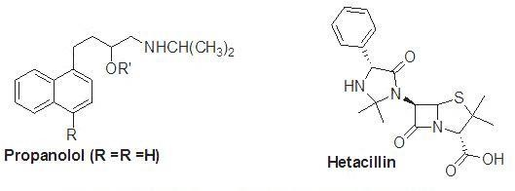

A member of the beta-lactam antibiotic family is hetacillin. This prodrug has no antibacterial properties; however it can convert acetone into the antibiotic ampicillin in the body. The Ampicillin produces polymeric species by preventing auto-aminolysis, which is made possible by the NH2 group's ability to connect to the other molecules -lactam structure. A prodrug of ampicillin binds up the amino functionality and inhibits auto-aminolysis by forming hetacillin.[5]

Improvement of bioavailability:

The gastrointestinal absorption of multiple drugs, including vitamins, natural purine and pyrimidine nucleosides, dopamine, ampicillin and carbenicillin, phenytoin, and GI toxin, is poor. These chemicals' weak lipophilicity, polarity, and metabolic tendency are the main causes of their weak immersion. The thiolate ion is treated to create a fat-soluble prodrug, which enhances the absorption of vitamins. The medical benefits of dopamine are achieved by L-Dopa, its precursor. A polar molecule is L-dopa. This is transmitted by the L- amino acid active transport process and dopamine is reborn via a decarboxylation pathway.[5]
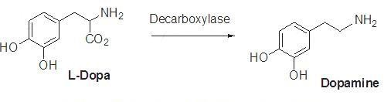
A prodrug of zanamivir called L-valyl zanamivir has been created. Through the PepT transporters, this prodrug is more easily absorbed. Its oral absorption can be improves by this procedure.[5]

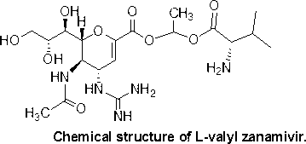

Because it is unstable under physiological settings, cur cumin has a low bioavailability. Due to poor absorption and a fast metabolism, it exits the body. The bioavailability of cur cumin has been improved using a variety of techniques that solve problems. Diacids, amino acids, and glucose are conjugated. This process appears in.[5]
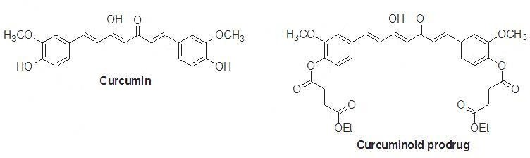

Preventing presystemic metabolism:

A successful drug should pass using the liver and digestive system before reaching the transmission. Many medications can be metabolized through oxidative N- and O-DE alkylation, ester hydrolysis, or peptide breaking. The stomach's acid swiftly breaks down the first category of medications. The liver and digestive mucosa's enzymatic processes break down the second group of medicines. If a specific capability is safeguarded by derivatization, the metabolism of the medication is blocked. The drug's physicochemical properties can also be changed. For example, naltrexone, an opioid addiction treatment drug, is rapidly absorbed in the digestive tract and undergoes presystemic metabolism.[5]
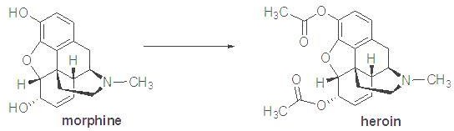

Presystemic metabolism extension:

The activity duration of a drug can be maintained by the prodrug if a medication has a short half-life period and is administered frequently with an equal dosage. Prodrugs like testosterone propionate, estradiol propionate, and fluphenazine deaconate have the respective active substances of testosterone, estradiol, and fluphenazine as the main components.[5]

Drugs with a prolonged half-life are essential for treating psychosis. This group's patients need their medications for a longer period of time. The maximal plasma level of the sedative and tranquilizer haloperidol is observed 2 to 6 hours after intake. If administered intramuscularly, the prodrug haloperidol deconate remain active for one month.[5]
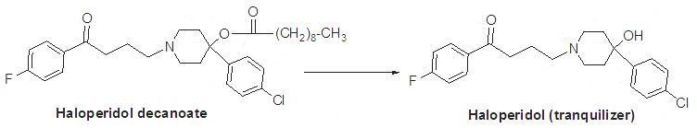
Antipsychotic medication's effect lasts for 6–8 hours, but fluphenazine's activity lasts for a month.

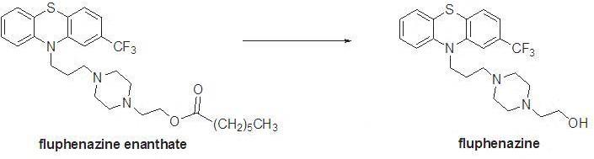
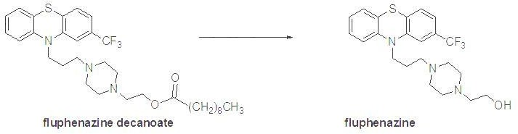

Tolmetin sodium, an anti-inflammatory medication, is changed into a glycine conjugate to improve action and extend its highest concentration to about 9 hours. the prodrug amide bond's weak hydrolysis can result in this.[5]

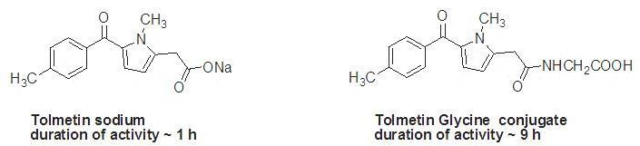

Decrease in toxicity:

Prodrug toxicity should be minimal or absent. Eye medication epinephrine causes numerous ocular and systemic adverse effects. Prodrug dipivaloyl epinephrine has a better profile and is more active than

epinephrin. Doxorubicin is a cancer-fighting medication. However, due to its cardio toxicity, this medication must be used with caution. Designing medications that would boost doxorubicin availability in cancer cells but minimizing its effects on heart function was significant. To do this, a galactoside prodrug with doxorubicin and a carbamate group was created.[5]
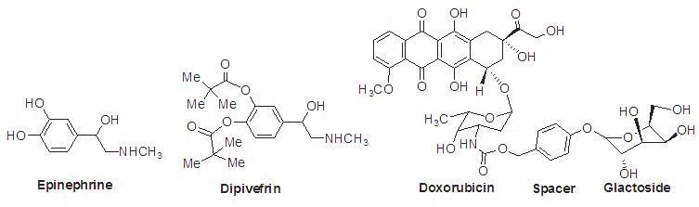
The negative effects of sulindac are much less than those of indomethacin and it has no impact on the stomach. A diisobutyrate ester of terbutaline used to treat glaucoma is called ibuterol. Number 38 This prodrug is 100 times stronger, takes up to three times as long, and doesn't have any local or systemic side effects.[5]
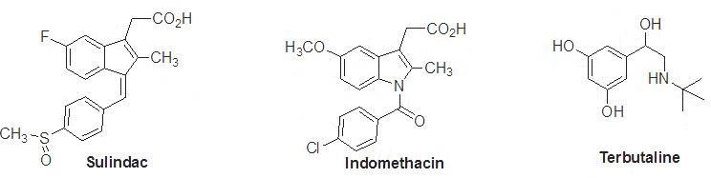

Particular delivery to the site:

If the physicochemical properties of the original drug and the prodrug are suitable with the target site, the targeting of medications to the internal organs using conversion to a prodrug works well. Different body parts are targeted by the medications. By prodrug-designing the medication to target the actual source of the issues, this constraint is overcome. After that, the target tissue undergoes the prodrugs conversion to the drug's active form. Specific enzymes or acidity can cause this process to happen. Phosphate and amides are present in higher concentrations in tumor cells than normal cells. If these enzymes are needed for the prodrug to be activated, a cytotoxic prodrug is then administered to the tumor cells. For the site-specific administration of diethylstilbestrol to patients with prostate cancer, diethylstilbestrol di-phosphate has been developed. Given rectally, oxyphenisatin is a bowel sterilant. Oxyphenistatin acetate, an acetylated prodrug, is taken orally. Finally, it is converted to oxyphenisatin at the digestive level.[5]
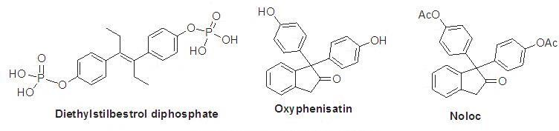

Structures, applications, and use of a few prodrugs with FDA approval from 2008 to 2018 [80– 89]:

- Fesoterodine Fumarate:

To obtain the active substance, 5-hydroxymethyl tolterodine, esterase hydrolyzes the prodrug fesoterodine fumarate (trade name: Toviaz). It helps to use a muscarinic receptor antagonist to treat hyperactive bladder muscles that cause problems with frequency, urgency, and leaking.[5]
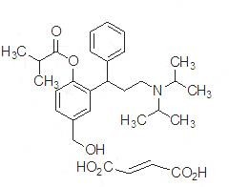

Fospropofol disodium:

Alkaline phosphatase transforms the prodrug fospropofol disodium (which is marketed as Lusedra) into its active component, propofol. An intravenous sedative-hypnotic drug called fospropofol, which is frequently given as disodium injection, is advised for adult patients having supervised local anesthesia care sedation, such as endoscopy.[5]
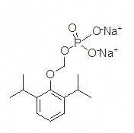

Fosaprepitant dimeglumine:

The prodrug fosaprepitant dimeglumine, also known as Emend, is activated by phosphatase-catalyzed DE phosphorylation to produce the substance that acts aprepitant. In chemotherapy regimens, fosaprepitant dimeglumine is used together with other antiemetics to minimize both early and delayed nausea and vomiting following the application of some cancer chemotherapy treatments.[5]
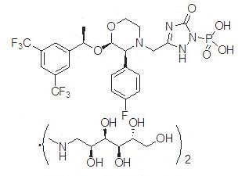

Prasugrel:

The prodrug of prasugrel (brand name: Effient) decreases by esterase and CYP450 metabolism to produce the active drug, R-138727. Patients with acute coronary syndrome with heart disease who have a specific heart operation as well as those with specific heart or blood vessel changes take prasugrel in combination with aspirin to prevent blood clots.[5]

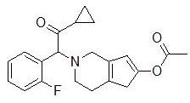

Romidepsin Prasugrel:

Intracellular glutathione activates the prodrug romidepsin prasugrel (trade name Istodax), resulting in the production of the drug's active metabolite, which has a free thiol group. Patients with cutaneous T-cell lymphoma who have had at least one prior systemic therapy and at least one additional type of treatment should be given an injection of the HDAC inhibitor romidepsin. [5]

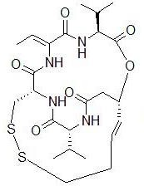

Application of prodrugs:

In most situations, the objective of pro -drug development is to address certain pharmaceutics, pharmacological, and pharmacokinetic issues. The following are the primary objective of pro -drum:(8)

  - Taste improvement
  - Odor improvement
  - Bioavailability is improved
  - improvement to the qualities of stability and solubility
  - Decreased toxicity and negative effects
  - Enhanced site specificity
  - Increase duration of pharmaceutical effect
  - Pharmacokinetics is affected by drug absorption, distribution, metabolism, and excretion.

Taste improvement

The bitterness, acidity, or causticity of the medicine is one of the factors contributing to low patient compliance, particularly in children. The foul taste of the medication is addressed using two methods. The bitterness is marked by the first strategy, which reduces the drug‘s solubility in saliva, and the second involves lowering the drug‘s a few example of medication with enhanced flyover.

Table Of Drugs With Improved Taste
Parent drug | Pro-drug with improved taste
Chloramphenicol | Palmitate ester
Clindamycin | Palmitate ester
Sulfisoxazole | Acetyl ester
Erythromycin | Estolate

Oder improvement
The vapor pressure of a substance affects its smell; a liquid with a high vapour pressure will have a strong smell. Ethyl mercaptan, for instance, is a leprosy therapy that uses a foul – smelling liquid. A diethyl dithioisophthalate with a higher boiling point and no Oder is created when this is converted to phthalate ester.
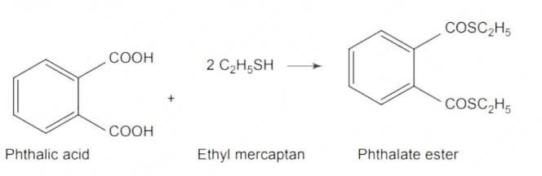

Bioavailability is improvement

Ampicillin has a low lipophilicity and is only 30% -40% absorbed when taken orally since chain contain an amino groups .By esterifying the free carboxy group , this antibiotic ‗s polarity can be changed , resulting in compounds that are more bioavailable than the parent ampicillin because they are entirely absorbed.
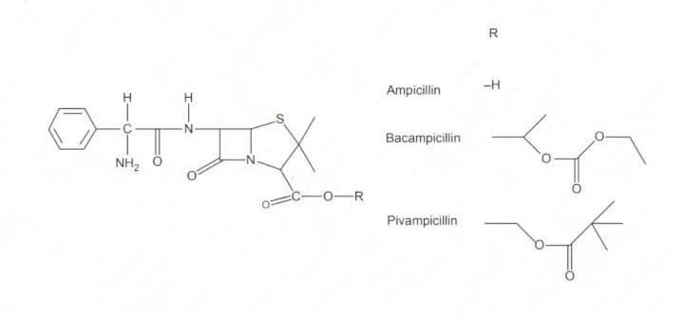

Improvement to the qualities of stability and solubility

Stability: The prodrug method is a useful technique to increase their stability. When taken orally, a no. of medications can decrease during their shelf life or in the gastro intestinal tract [ GLT]. Azacytidine easily in an acidic pH, although its bisulphite prodrug is more stable. Solubility: In order to formulate such

medication for parenteral or ophthalmic use, hydrophilic or water – soluble compound are required. By using half ester like hemi – glutarate or hemi -phthalates, which carry sodium, potassium, or amine ions on their other half and make the moiety soluble, drugs having hydroxyl functional groups can be transformed into their hydrophilic form.
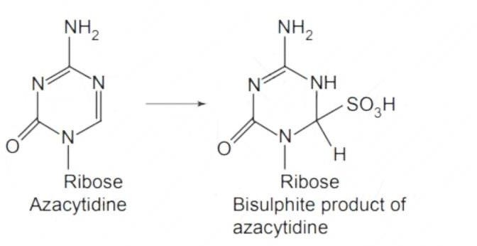
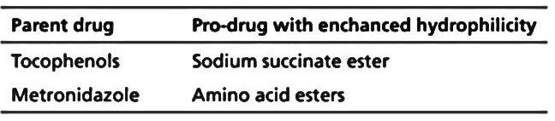

Decreased toxicity and negative effects

In some case, phenols and carboxylic acids are too harmful to be used in therapeutic setting. The absence of stomach ulcer genic activity in ester prodrugs of acidic non-steroidal anti-inflammatory drugs is thoughts to be one of the causes of these medication negative side effects.
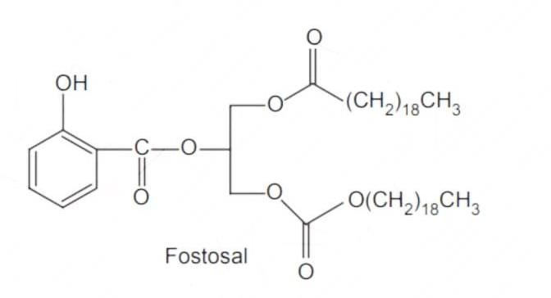

Enhanced site specificity

Many pro-drugs may be designed in such a way that they are only toxic to certain organs when they are administered to a chemical to the brain, the dihydropyridine / pyridinium redox system is particularly useful.

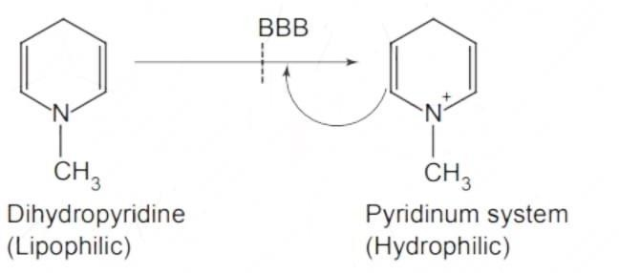

Increase duration of pharmaceutical effects

N-butyl noradrenaline‗s pro-drug di-p-toluate ester gives bronchodilator activity that lasts longer then the parents medication. The bronchodilator action is produced because the pro-drug is preferentially transported into the lung tissues compared to the plasma or the heart.

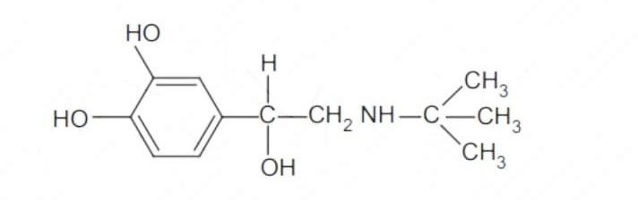

# BIO-PRECURSOR PRODRUG

A bio-precursor pro-drug contains a latent ability instead of a carrier or a promoiety, which is transformed into an active drug molecule through metabolic or chemical processes. Chemical activation processes including oxidation, reduction, and phosphorylation are examples of phase I activation.
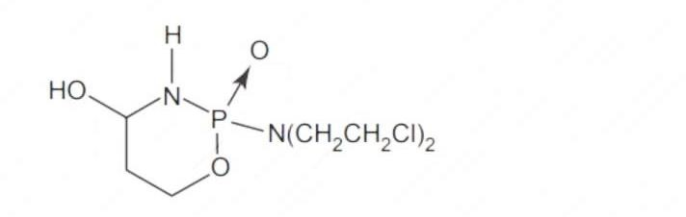
Bio – activities: The pro-drug is transformed into the cytotoxic phosphoxamide mustard by cyclophosphamide‗s breakdown. N-DE alkylation: This chemical process changes several drug into their active metabolites form.

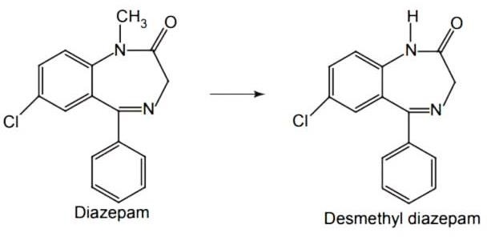

Oxidation: The prodrug nabumetone, in which the formyl groups was generated, a carboxylate group is formed, resulting in the production of the active substance.

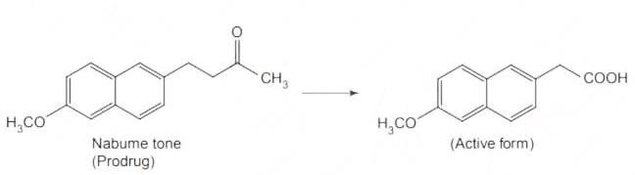
Reduction: sulindac is converted in vivo from its nonsteroidal anti - inflammatory drug form to its active form.

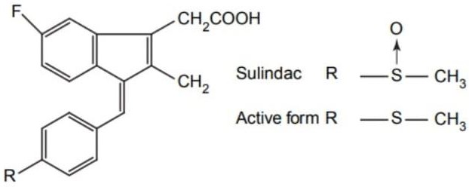

Conclusion

In this chapter we have completer prodrugs about prodrugs, what is prodrug & history of prodrugs,, ideal properties of prodrugs, the purpose of designing prodrugs, classification of prodrugs, development of prodrugs, uses of prodrugs and application of prodrugs. These all topics are important for prodrugs. These all topics are important for prodrugs information and used for better formulation to inhance safety, stability and other parameters.

Reference
- https://www.goodrx.com/healthcare-access/medication-education/what-is-a-prodrug (Accessed on 05/07/2023).
- Milica M , Shimon S.B , Arik D, Prodrugs for improved Drug delivery: lesson learned from recently developed and marketed products, Journal of pharmaceutics 2020,12 (11),1-15.
- Kuei-Meng W, A New Classification of prodrugs: regulatory perspectives, Journal of Pharmaceutical, 2009, 2(3), 1-7.
- https://www.researchgate.net/publication/309383341_Prodrug_Strategy_in_Drug_Development
(Accessed on 10/07/2023)
- Pal A, Banik B.K, Highly efficient prodrug design and therapeutic applications, Oriental journal of Chemistry. An international research journal of pure & Applied chemistry, 2022, 36(6),1-19.
- V. Alagarsamy [Published by CBS Publisheds & Distribution Pvt Ltd Volume 1, Edition fourth] textbook of Medicinal chemistry Prodrugs, 157-164.
- Juchin K , Adam J. P, Franziska L G, kang J Y, Cipoola D, Recent Advance in prodrug-based nanoparticle therapeutics, European Journal of Pharmaceutics and Biopharmaceutics, 2021, 1-25.
- https://www.pharmacy180.com/article/application-of-pro-drugs-2096/ (Accessed on 15/07/2023)

